Dao实现查询所有客户功能

工程目录：
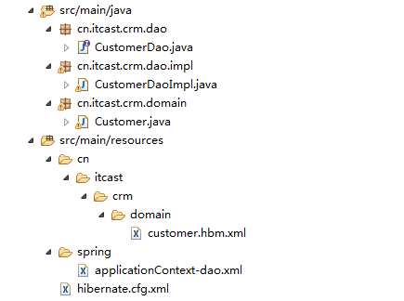

创建Customer实体类
package cn.itcast.crm.domain;

import java.io.Serializable;

/**
* PO (Persinstent Object)持久化对象
* 7个规范
* 1. 公有类
* 2. 私有的属性
* 3. 提供getter与setter
* 4. 提供公有默认无参构造方法
* 5. 实现java.io.Serializable接口
* 6. 不能用final修饰
* 7. 如果是基本数据类型，则使用它们的包装类
* @author Administrator
*
*/
public class Customer implements Serializable {

private Long custId;
private String custName;
private Long custUserId;
private Long custCreateId;
private String custIndustry;
private String custLevel;
private String custLinkman;
private String custPhone;
private String custMobile;
public Long getCustId() {
return custId;
}
public void setCustId(Long custId) {
this.custId = custId;
}
public String getCustName() {
return custName;
}
public void setCustName(String custName) {
this.custName = custName;
}
public Long getCustUserId() {
return custUserId;
}
public void setCustUserId(Long custUserId) {
this.custUserId = custUserId;
}
public Long getCustCreateId() {
return custCreateId;
}
public void setCustCreateId(Long custCreateId) {
this.custCreateId = custCreateId;
}
public String getCustIndustry() {
return custIndustry;
}
public void setCustIndustry(String custIndustry) {
this.custIndustry = custIndustry;
}
public String getCustLevel() {
return custLevel;
}
public void setCustLevel(String custLevel) {
this.custLevel = custLevel;
}
public String getCustLinkman() {
return custLinkman;
}
public void setCustLinkman(String custLinkman) {
this.custLinkman = custLinkman;
}
public String getCustPhone() {
return custPhone;
}
public void setCustPhone(String custPhone) {
this.custPhone = custPhone;
}
public String getCustMobile() {
return custMobile;
}
public void setCustMobile(String custMobile) {
this.custMobile = custMobile;
}
}

创建CustomerDao接口：
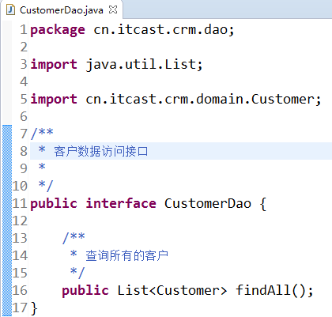

创建CustomerDaoImpl：
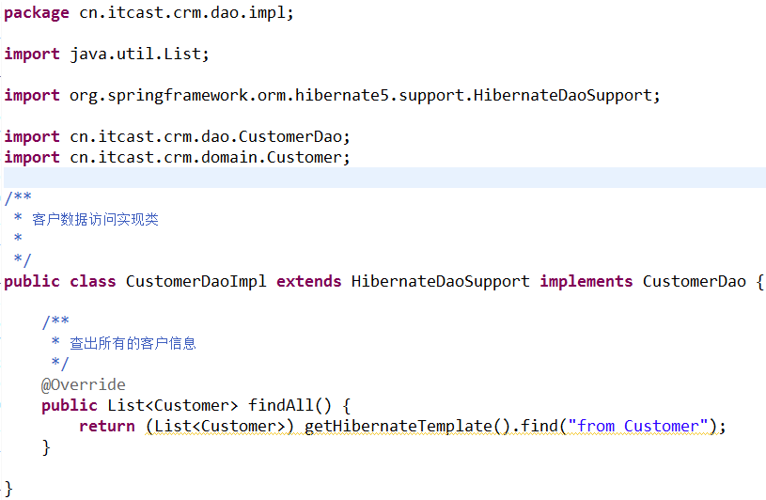

创建映射文件Customer.hbm.xml：
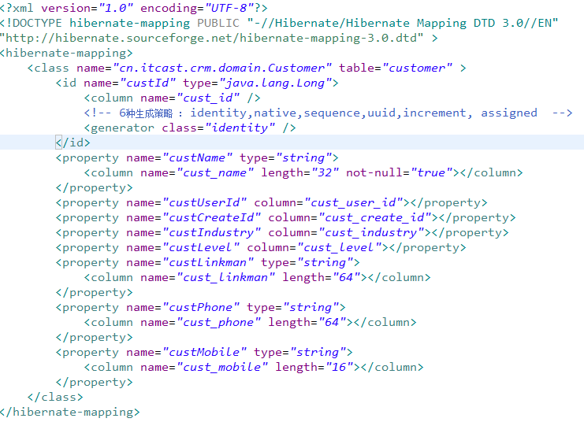

创建hibernate.cfg.xml
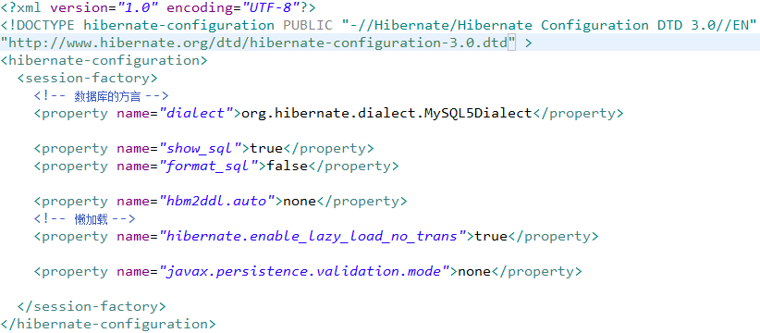

创建applicationContext-dao.xml
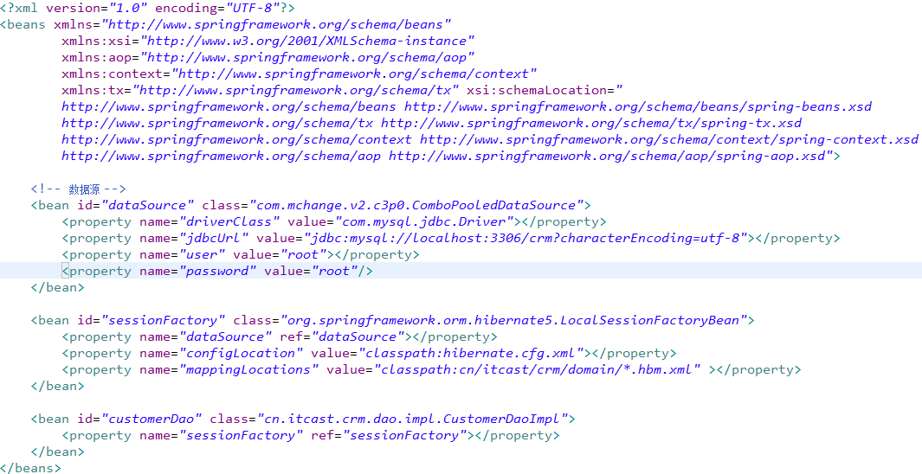

创建CustomerDaoTest测试
