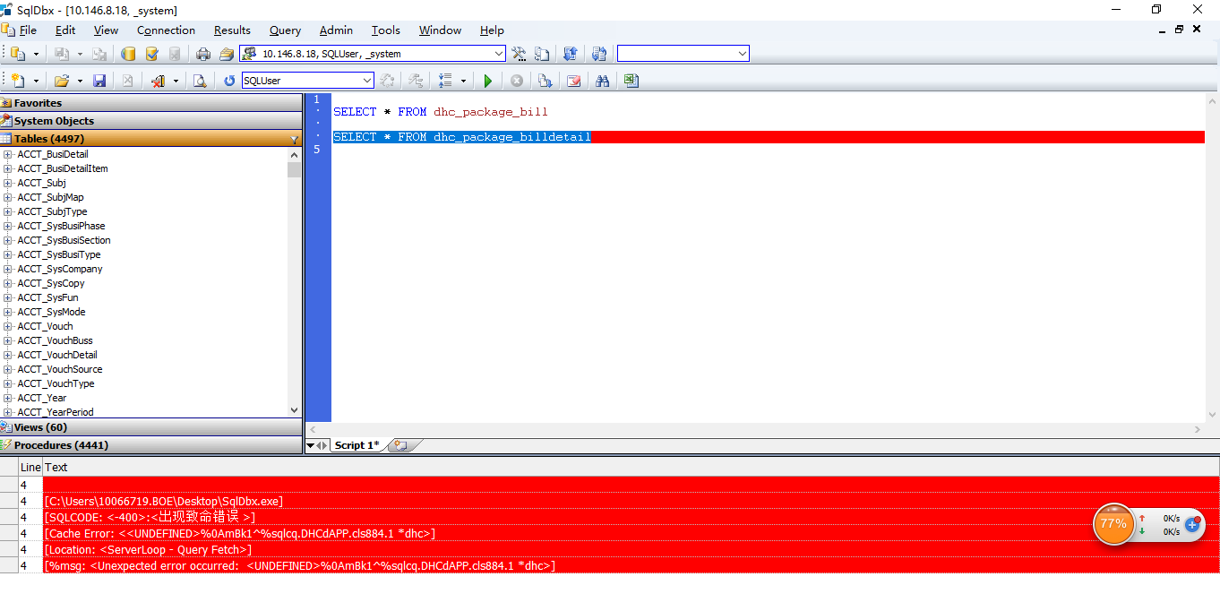

问题一：

[C:\Users\10066719.BOE\Desktop\SqlDbx.exe]

[SQLCODE: <-400>:<出现致命错误 >]

[Cache Error: <<UNDEFINED>%0AmBk1^%sqlcq.DHCdAPP.cls884.1 \*dhc>]

[Location: <ServerLoop - Query Fetch>]

[%msg: <Unexpected error occurred: <UNDEFINED>%0AmBk1^%sqlcq.DHCdAPP.cls884.1 \*dhc>]