ECE 637 Lab 3 Report
Neighborhoods and Connected Components

Xihui Wang

Section 1 – Area Fill
In this section, I think the description of the problem is not clear enough. At the beginning, it said that m represents the row index, n represents the column index. Then in the middle, the pixels are represented as img[m][n]. Then in the end of this problem, it said that for s = (67, 45), 67 is the column index, and 45 is the row index. Therefore, I think s=(67,45) should be img[45][67]. But in this section, I just provide the two possible results.

1.1 The Image img22gd2.tif
Fig 1-1 img22gd2.tif

1.2 The Image Showing the Connected Set of and T = 2
Fig 1-2-1 The image showing the connected set for row=45, col=67
Fig 1-2-2 The image showing the connected set for row=67, col=45

1.3 The Image Showing the Connected Set of T = 1
Fig 1-3-1 The image showing the connected set for row=45, col=67
Fig 1-3-2 The image showing the connected set for row=67, col=45

1.4 The Image Showing the Connected Set of s = (67,45), and T = 3
Fig 1-4-1 The image showing the connected set for row=45, col=67
Fig 1-4-2 The image showing the connected set for row=67, col=45

1.5 A Listing of C Code
#include <stdio.h>
#include <math.h>
#include <stdlib.h>
#include "tiff.h"
#include "allocate.h"
#include "randlib.h"
#include "typeutil.h"

/*gcc -ansi -Wall -std=c99 lab3_sec1.c tiff.c allocate.c randlib.c*/

struct pixel {
int m,n;
};

void ConnectedNeighbors(
struct pixel s,
double T,
unsigned char ** img,
int width,
int height,
int *M,
struct pixel c[4]);

void ConnectedSet(
struct pixel s,
double T,
unsigned char **img,
int width,
int height,
int ClassLabel,
unsigned char **seg,
int *NumConPixels);

int main(int argc, char const *argv[])
{
/* code */
FILE *fp;
struct TIFF_img input_img, output;
struct pixel s;
double T;
int ClassLabel = 0;
int NumConPixels = 0;

s.m = 45;
s.n = 67;
T = 3.0;

/* open image file */
if ( ( fp = fopen ( "img22gd2.tif", "rb" ) ) == NULL ) {
fprintf ( stderr, "cannot open file %s\n", argv[1] );
exit ( 1 );
}

/* read image */
if ( read_TIFF ( fp, &input_img ) ) {
fprintf ( stderr, "error reading file %s\n", argv[1] );
exit ( 1 );
}

/* close image file */
fclose ( fp );

get_TIFF ( &output, input_img.height, input_img.width, 'g' );

int i, j;
for(i=0; i<input_img.height; i++)
{
for(j=0; j<input_img.width; j++)
{
output.mono[i][j] = 255;
}
}
output.mono[s.m][s.n] = ClassLabel;

ConnectedSet(s, T, input_img.mono, input_img.width, input_img.height, ClassLabel, output.mono, &NumConPixels);

/* open output image file */
if ( ( fp = fopen ( "output.tif", "wb" ) ) == NULL ) {
fprintf ( stderr, "cannot open file output.tif\n");
exit ( 1 );
}

/* write output image */
if ( write_TIFF ( fp, &output ) ) {
fprintf ( stderr, "error writing TIFF file %s\n", argv[2] );
exit ( 1 );
}

/* close output image file */
fclose ( fp );

free_TIFF ( &(input_img) );
free_TIFF ( &(output) );
return 0;
}
void ConnectedNeighbors(struct pixel s, double T, unsigned char ** img, int width, int height, int *M, struct pixel c[4])
{
if(((s.m-1)>=0)&&(abs(img[s.m][s.n]-img[s.m-1][s.n])<=T))
{
c[*M].m = s.m-1;
c[(*M)++].n = s.n;
}

if(((s.m+1)<height)&&(abs(img[s.m][s.n]-img[s.m+1][s.n])<=T))
{
c[*M].m = s.m+1;
c[(*M)++].n = s.n;
}

if(((s.n-1)>=0)&&(abs(img[s.m][s.n]-img[s.m][s.n-1])<=T))
{
c[*M].m = s.m;
c[(*M)++].n = s.n-1;
}

if(((s.n+1)<width)&&(abs(img[s.m][s.n]-img[s.m][s.n+1])<=T))
{
c[*M].m = s.m;
c[(*M)++].n = s.n+1;
}
return;
}

void ConnectedSet(struct pixel s, double T, unsigned char **img, int width, int height, int ClassLabel, unsigned char **seg, int *NumConPixels)
{
int M = 0;
struct pixel c[4];

ConnectedNeighbors(s, T, img, width, height, &M, c);

while(M>0)
{
if (seg[c[M-1].m][c[M-1].n] != ClassLabel)
{
seg[c[M-1].m][c[M-1].n] = ClassLabel;
(*NumConPixels)++;
ConnectedSet(c[M-1], T, img, width, height, ClassLabel, seg, NumConPixels);
}
M--;
}
return;
}

Section 2 – Image Segmentation
2.1 Randomly Colored Segmentation for T = 1, T = 2, and T = 3
Fig 2-1-1-1 segmentation.tif for T = 1
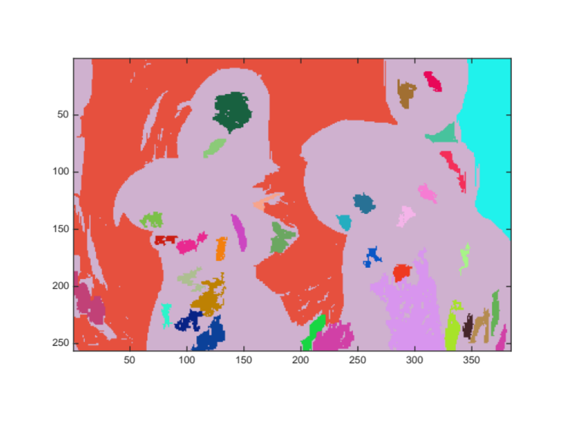
Fig 2-1-1-2 Randomly colored segmentation for T = 1

Fig 2-1-2-1 segmentation.tif for T = 2

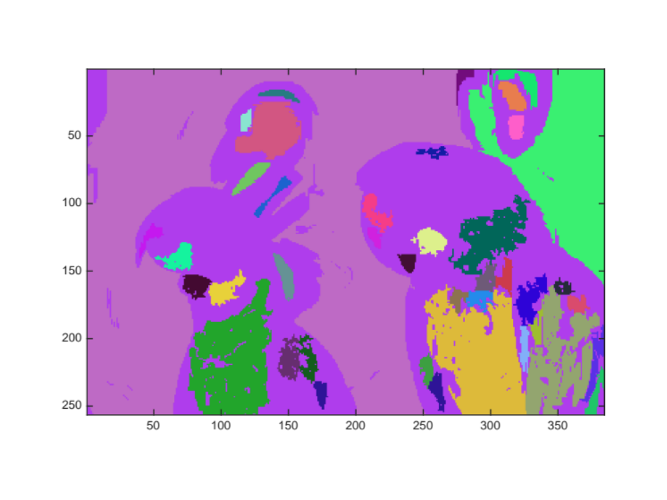
Fig 2-1-2-2 Randomly colored segmentation for T = 2

Fig 2-1-3-1 segmentation.tif for T = 3

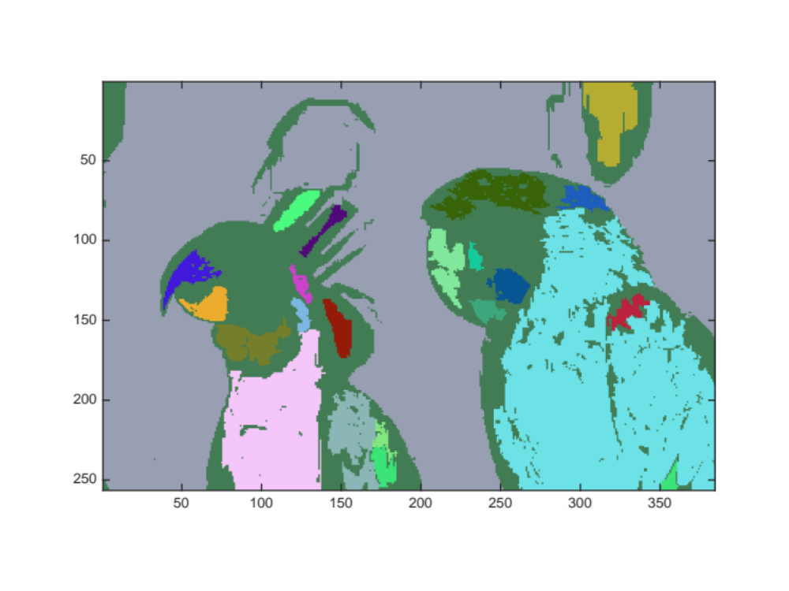
Fig 2-1-3-2 Randomly colored segmentation for T = 3

2.2 A Listing of the Number of Regions Generated for Each of the Values of T = 1, T = 2, and T = 3
Threshold | Number of Regions
1 | 36
2 | 41
3 | 23

2.3 A Listing of C Code

#include <stdio.h>
#include <math.h>
#include <stdlib.h>
#include "tiff.h"
#include "allocate.h"
#include "randlib.h"
#include "typeutil.h"

struct pixel {
int m,n;
};

void ConnectedNeighbors(
struct pixel s,
double T,
unsigned char ** img,
int width,
int height,
int *M,
struct pixel c[4]);

void ConnectedSet(
struct pixel s,
double T,
unsigned char **img,
int width,
int height,
int ClassLabel,
unsigned char **seg,
int *NumConPixels);

int main(int argc, char const *argv[])
{
/* code */
FILE *fp;
struct TIFF_img input_img, output;
struct pixel s;
double T;
int ClassLabel = 1;
int NumConPixels = 0;

T = 1.0;

/* open image file */
if ( ( fp = fopen ( "img22gd2.tif", "rb" ) ) == NULL ) {
fprintf ( stderr, "cannot open file %s\n", argv[1] );
exit ( 1 );
}

/* read image */
if ( read_TIFF ( fp, &input_img ) ) {
fprintf ( stderr, "error reading file %s\n", argv[1] );
exit ( 1 );
}

/* close image file */
fclose ( fp );

get_TIFF ( &output, input_img.height, input_img.width, 'g' );

int i, j;
for(i=0; i<input_img.height; i++)
{
for(j=0; j<input_img.width; j++)
{
output.mono[i][j] = 0;
}
}

for(i=0; i<input_img.height; i++)
{
for(j=0; j<input_img.width; j++)
{
if (output.mono[i][j] == 0)
{
s.m = i;
s.n = j;
output.mono[i][j] = ClassLabel;
ConnectedSet(s, T, input_img.mono, input_img.width, input_img.height, ClassLabel, output.mono, &NumConPixels);
if(NumConPixels > 100)
{
ClassLabel++;
NumConPixels = 0;
}
else
{
output.mono[i][j] = 255;
NumConPixels = 0;
ConnectedSet(s, T, input_img.mono, input_img.width, input_img.height, 255, output.mono, &NumConPixels);
}
}
}
}

for(i=0; i<input_img.height; i++)
{
for(j=0; j<input_img.width; j++)
{
if(output.mono[i][j] == 255)
{
output.mono[i][j] = 0;
}
}
}

/* open output image file */
if ( ( fp = fopen ( "segmentation.tif", "wb" ) ) == NULL ) {
fprintf ( stderr, "cannot open file output.tif\n");
exit ( 1 );
}

/* write output image */
if ( write_TIFF ( fp, &output ) ) {
fprintf ( stderr, "error writing TIFF file %s\n", argv[2] );
exit ( 1 );
}

/* close output image file */
fclose ( fp );

free_TIFF ( &(input_img) );
free_TIFF ( &(output) );
return 0;
}

void ConnectedNeighbors(struct pixel s, double T, unsigned char ** img, int width, int height, int *M, struct pixel c[4])
{

if(((s.m-1)>=0)&&(abs(img[s.m][s.n]-img[s.m-1][s.n])<=T))
{
c[*M].m = s.m-1;
c[(*M)++].n = s.n;
}

if(((s.m+1)<height)&&(abs(img[s.m][s.n]-img[s.m+1][s.n])<=T))
{
c[*M].m = s.m+1;
c[(*M)++].n = s.n;
}

if(((s.n-1)>=0)&&(abs(img[s.m][s.n]-img[s.m][s.n-1])<=T))
{
c[*M].m = s.m;
c[(*M)++].n = s.n-1;
}

if(((s.n+1)<width)&&(abs(img[s.m][s.n]-img[s.m][s.n+1])<=T))
{
c[*M].m = s.m;
c[(*M)++].n = s.n+1;
}

return;
}

void ConnectedSet(struct pixel s, double T, unsigned char **img, int width, int height, int ClassLabel, unsigned char **seg, int *NumConPixels)
{
int M = 0;
struct pixel c[4];

ConnectedNeighbors(s, T, img, width, height, &M, c);

while(M>0)
{
if (seg[c[M-1].m][c[M-1].n] == 0)
{
seg[c[M-1].m][c[M-1].n] = ClassLabel;
(*NumConPixels)++;
ConnectedSet(c[M-1], T, img, width, height, ClassLabel, seg, NumConPixels);
}
M--;
}
return;
}

