ECE 637 Lab 4 Report
Pointwise Operations and Gamma

Xihui Wang

Section 1 – Histogram of an Image
  - The Sample Images and Their Labeled Histogram
Fig 1-1 Sample Image race.tif
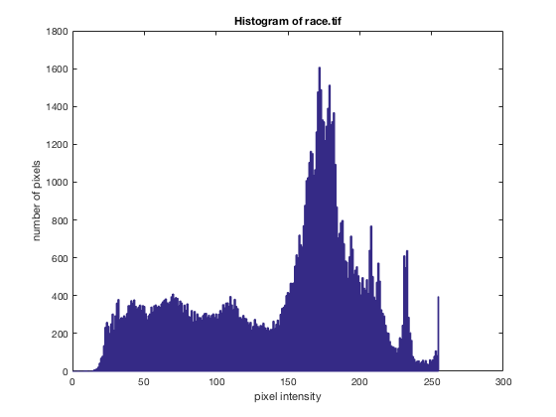
Fig 1-2 Histogram of race.tif
Fig 1-3 Sample Image kids.tif
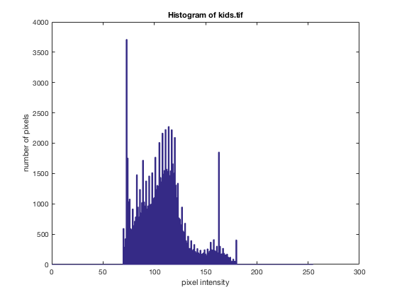
Fig 1-4 Histogram of kids.tif
Section 2 – Histogram Equalization
In this section, after equalization, the image is much clearer than the original one. The pixels were locating in interval [70,180] in the original image, but in the equalized image, the pixels are extending to [0, 255], and the histogram seems more uniform.

2.1 The Matlab Function equalize.m
function [Y] = equalize(X)
counts = hist(X(:),[0:255]);
total = sum(counts);
Y = counts; % 0 - 255
for (i=1:255)
Y(i+1) = Y(i) + Y(i+1);
end
Y = Y./total;
Ymin = Y(min(X(:)));
Ymax = Y(max(X(:)));
Z = uint8(255*((Y(X) - Ymin)/(Ymax - Ymin)));

figure(1)
plot([0:255],Y);
xlabel('pixel intensity')
ylabel('Cumulative Distribution')
title('cumulative distribution function of kids.tif')
grid on
xlim([0, 255])
figure(2);
image(Z+1);
axis('image');
graymap = [0:255;0:255;0:255]'/255;
colormap(graymap);
figure(3)
hist(Z(:),[0:255])
xlabel('pixel intensity')
ylabel('number of pixels')
title('Histogram of equalized kids.tif')
xlim([0 255])

end

2.2 The Labeled Plot of ${\hat{F}}_{x}(i)$ for the Image kids.tif
Fig 2-2 The Labeled Plot of ${\hat{F}}_{x}(i)$ for the Image kids.tif

2.3 The Labeled Plot of the Equalized Image’s Histogram
Fig 2-3 The Labeled Plot of the Equalized kids.tif’s Histogram
2.4 The Equalized Image
Fig 2-4 The Equalized kid_equ.tif
Section 3 – Contrast Stretching
3.1 The Matlab Function stretch.m
function output = stretch(input, T1, T2)
[m,n] = size(input);
output = zeros(m,n);
for (i=1:m)
for (j=1:n)
if (input(i,j) < T1)
output(i,j) = uint8 (0);
elseif (input(i,j) > T2)
output(i,j) = uint8 (255);
else
output(i,j) = uint8 (255 / (T2-T1) * (input(i,j)-T1));
end
end
end

figure(1);
image(output+1);
axis('image');
graymap = [0:255;0:255;0:255]'/255;
colormap(graymap);
figure(2)
hist(output(:),[0:255])
xlabel('pixel intensity')
ylabel('number of pixels')
title('Histogram of stretched kids.tif')
xlim([0 255])
end
3.2 The Transformed Image and Its Histogram
Fig 3-2 The Transformed Image of kids_trans.tif

Fig 3-3 The Stretched Image Histogram
In this section, I choose T1 = 70, and T2 = 180, then the stretched image is much clearer than the original one. Also the histogram is stretched from [70, 180] to [0, 255].
Section 4 – Gamma ($γ$)
Section 4.2 Determining the Gamma of Your Computer Monitor
4.2.1 The Image Corresponding to the Matching Gray Level

Matching gray level = 190 on my monitor.
Fig 4-2-1 The Image Corresponding to the Matching Gray Level

4.2.2 Derivation of the Expression Which Relates the Matching Gray Level to the value of $γ$

We know that $I_{c}=\frac{I_{255}+0}{2}$, and $I_{g}=I_{255}{(\frac{g}{255})}^{γ}$.
Then for matching case, if $I_{c}=I_{g}$, then $\frac{I_{255}+0}{2}= I_{255}{(\frac{g}{255})}^{γ}$.
If we divide by $I_{255}$ on both side, we get $\frac{1}{2}= {(\frac{g}{255})}^{γ}$.
Then take log on both side, we get
$\log\left(\frac{1}{2}\right)=-\log\left(2\right)=\log\left({\left(\frac{g}{255}\right)}^{γ}\right)=γ∙log⁡(\frac{g}{255})$
Then we can get
$$γ=-\frac{log⁡(2)}{log⁡(\frac{g}{255})}$$

4.2.3 The Values of the Measured Gray Level and the measured $γ$

In my case, g=190, therefor, $γ=-\frac{\log\left(2\right)}{\log\left(\frac{190}{255}\right)}=2.3557$

Section 4.3 Gamma Correction
4.3.1 The Original and Corrected Images
Fig 4-3-1-1 The Original Image
Fig 4-3-1-2 The Corrected Image

4.3.2 The Formula Used to Transform the Original Image
We have $I_{g}=I_{255}{(\frac{g}{255})}^{γ}$, then we can get $g=255{(\frac{I_{g}}{I_{255}})}^{\frac{1}{γ}}$, and use this formula to correct image.

4.3.3 The Procedure Used to Change the Gamma Correction of the Original Image
Fig 4-3-3 The Corrected Image of gamma15.tif

Since gamma15.tif is already gamma corrected for $γ=\frac{1}{1.5}$, therefore, we need to apply the gamma correction function oppositely, and get the original image by applying $g=255{(\frac{I_{g}}{I_{255}})}^{1.5}$
Then change $γ=2.3557$, and apply the gamma correction again, by using $g=255{(\frac{I_{g}}{I_{255}})}^{\frac{1}{2.3557}}$.

