ECE 637 Lab 5 Report
Eigen-decomposition of Images

Xihui Wang

Section 2 – Multivariate Gaussian Distributions and Whitening
  - Generating Gaussian Random Vectors
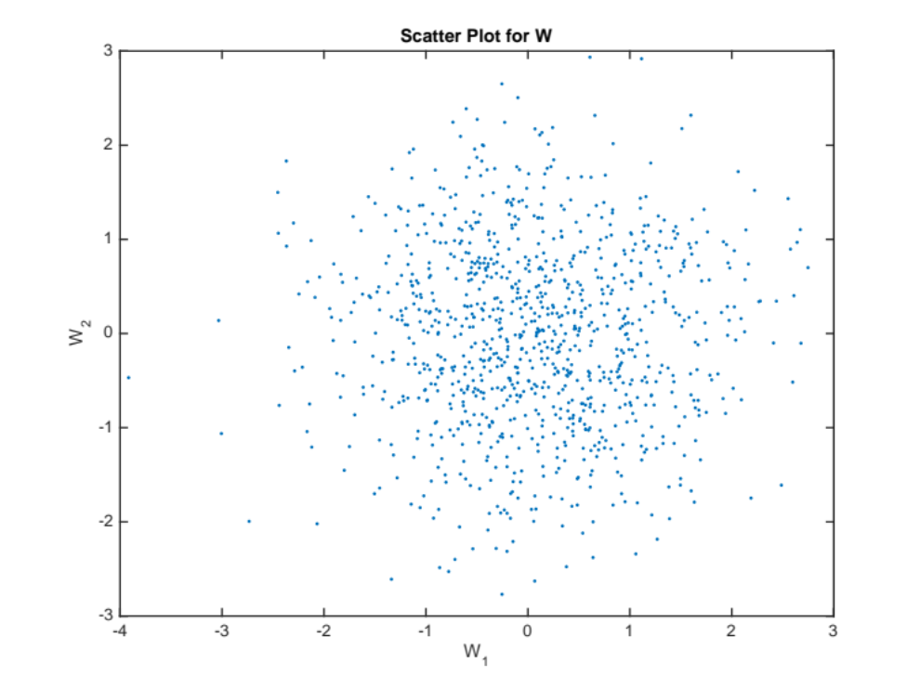
Fig 2-1-1 Scatter Plot for W
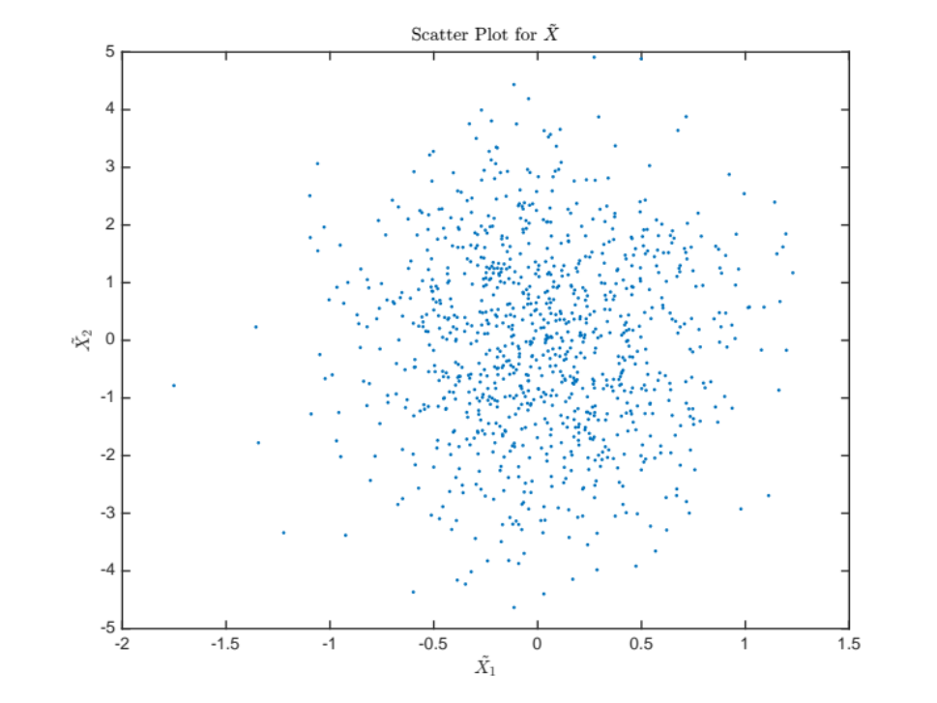
Fig 2-1-2 Scatter Plot for $\tilde{X}$
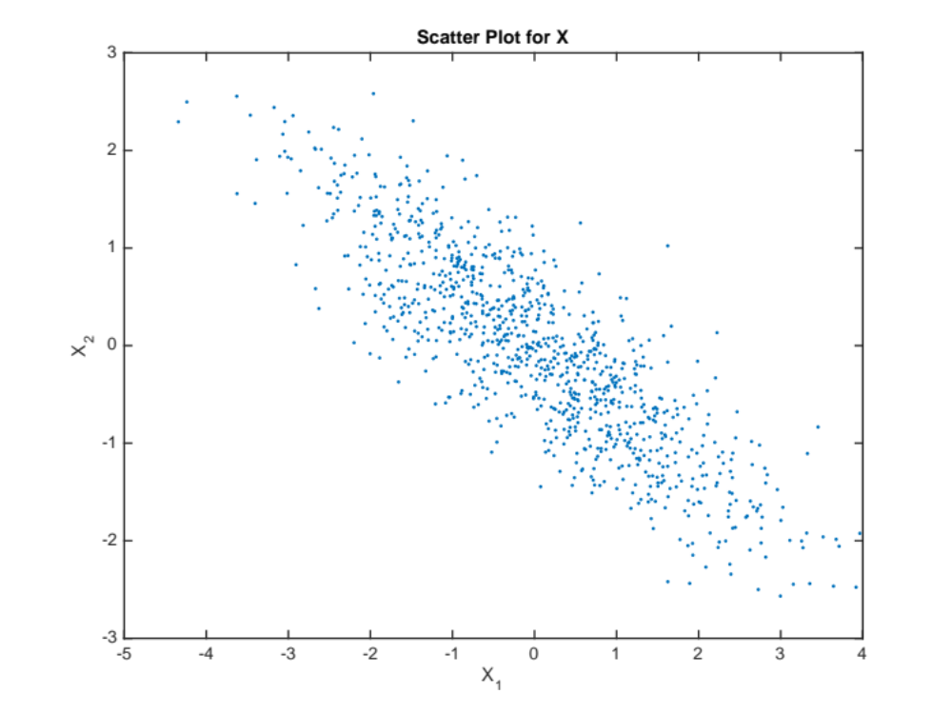
Fig 2-1-3 Scatter Plot for X

  - Covariance Estimation and Whitening
    - Theoretical Value of the Covariance Matrix, $R_{X}$
$$R_{X}=\left[\begin{matrix}2 & -1.2 \\ -1.2 & 1\end{matrix}\right]$$

    - Numerical Listing of my Covariance Estimate $R_{X}$
$$R_{X}=\left[\begin{matrix}1.924185514616801 & -1.115564061498433 \\ -1.115564061498433 & 0.895057288341874\end{matrix}\right]$$

    - Scatter Plot for ${\tilde{X}}_{i}$ and $W_{i}$
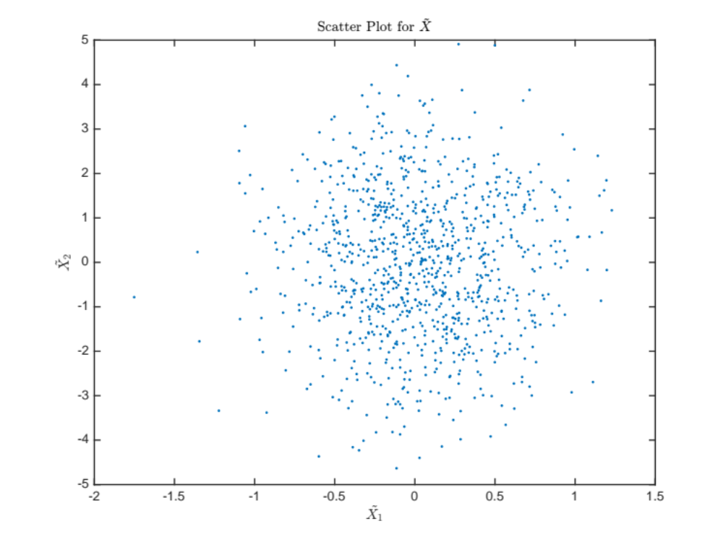
Fig 2-2-3-1 Scatter Plot for ${\tilde{X}}_{i}$

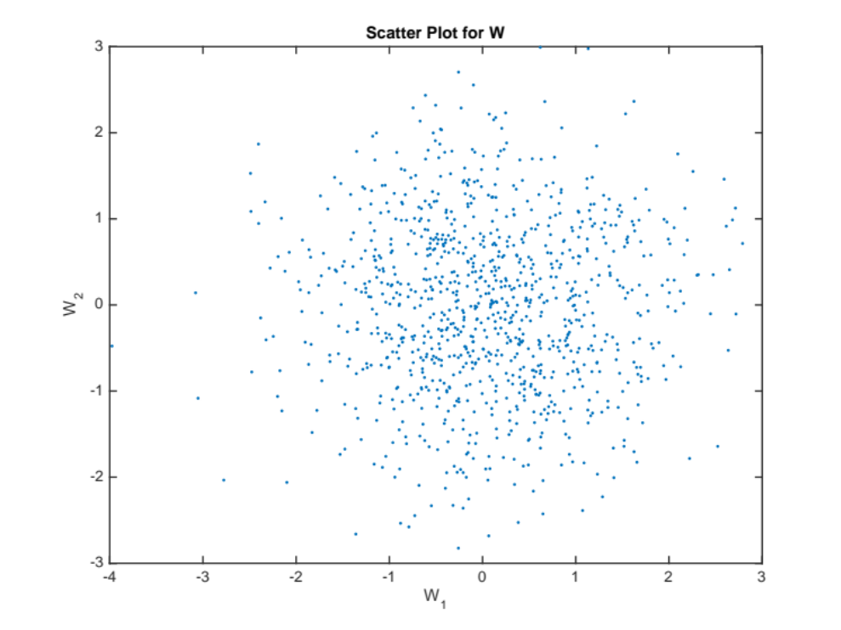
Fig 2-2-3-2 Scatter Plot for $W_{i}$

    - Numerical Listing of the Covariance Estimate ${\tilde{R}}_{W}$
$${\tilde{R}}_{W}=\left[\begin{matrix}0.999999999999999 & -0.000000000000000 \\ -0.000000000000000 & 1.000000000000000\end{matrix}\right]$$

Section 4 – Eigenimages, PCA, and Data Reduction
4.1 The Figure with the First 12 Eigenimages
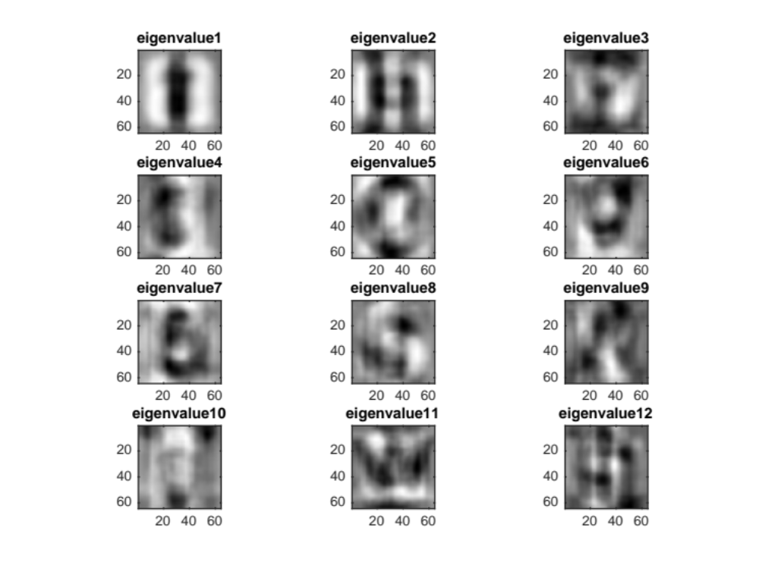
Fig 4-1 First 12 Eigenimages

4.2 The Plots of Projection Coefficients V.S. Eigenvector Number
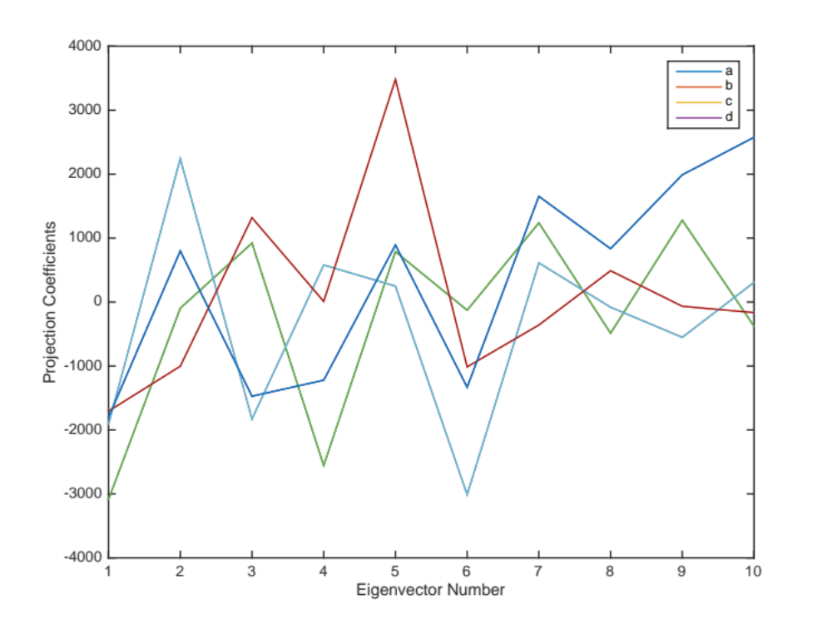
Fig 4-2 Plot of Projection Coefficients V.S. Eigenvector Number

4.3 The Original Image, and the 6 Resynthesized Versions
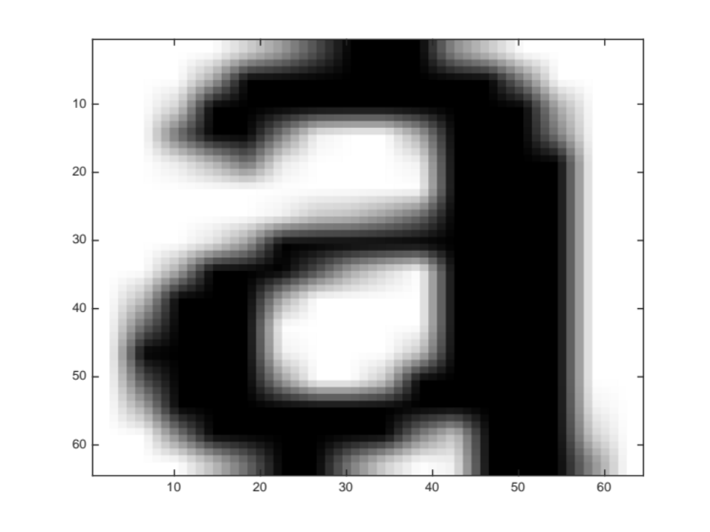
Fig 4-3-1 The Original Image

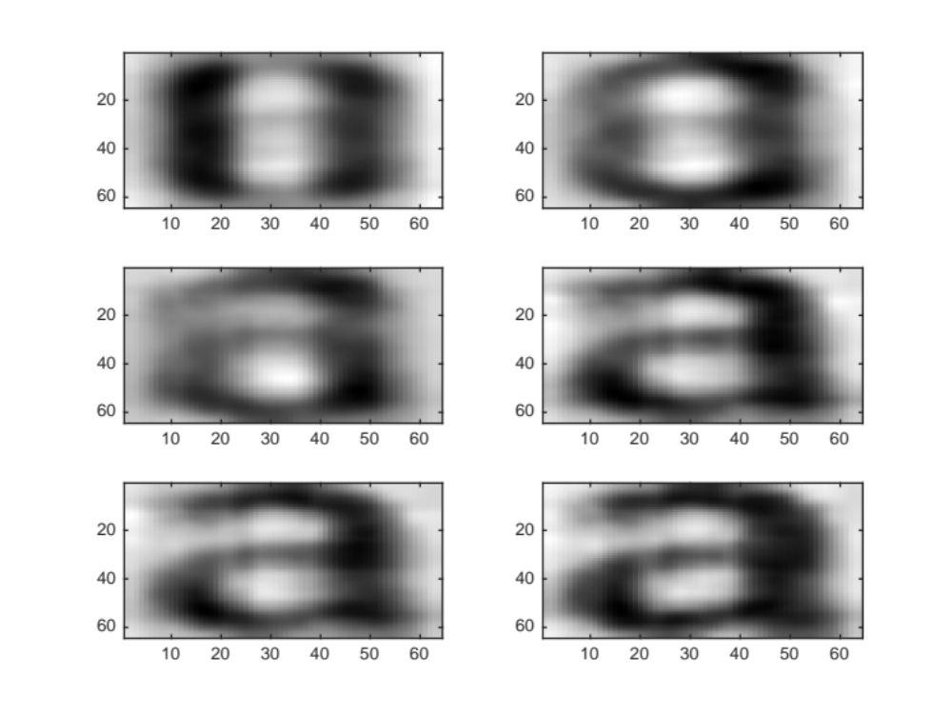
Fig 4-3-2 The 6 Resynthesized Versions
Section 5 – Image Classification
5.1 A 2-Column Table Showing for Each Mis-classified Input Images: (1) the Input Character and (2) the Output from the classifier
Table 5-1 Mis-classified Input Images ($B_{k}$)
Input Character | Output from the classifier
d | a
J | y
l | i
n | v
p | e
q | a
u | a
y | v

5.2 For Each Modification, Submit A 2-Column Table Showing for Each Mis-classified Input Images: (1) the Input Character and (2) the Output from the classifier
Table 5-2-1 Mis-classified Input Images ($B_{k}= Λ_{k}$)
Input Character | Output from the classifier
i | l
y | v

Table 5-2-2 Mis-classified Input Images ($B_{k}= R_{wc}$)
Input Character | Output from the classifier
g | q
y | v

Table 5-2-3 Mis-classified Input Images ($B_{k}= Λ$)
Input Character | Output from the classifier
f | t
y | v

Table 5-2-4 Mis-classified Input Images ($B_{k}=I$)
Input Character | Output from the classifier
f | t
g | q
y | v

5.3 Which of the Above Classifiers Worked the Best in this Experiment?
($B_{k}= Λ_{k}$, $R_{wc}$, $Λ$) worked best in this experiment, and they all generated two mis-classified inputs.

5.4 In Constraining the Covariance, what is the Trade Off Between the Accuracy of the Date Model and the Accuracy of the Estimates?
In constraining the covariance, the accuracy of the data model will be lower, but the accuracy of the estimates will be higher.

