ECE 637 Lab 6 Report
Introduction to Colorimetry

Xihui Wang

Section2 – Plotting Color Matching Functions and Illuminants
2.1 The plot of the $x_{0}(λ)$, $y_{0}(λ)$, and $z_{0}(λ)$ color matching functions
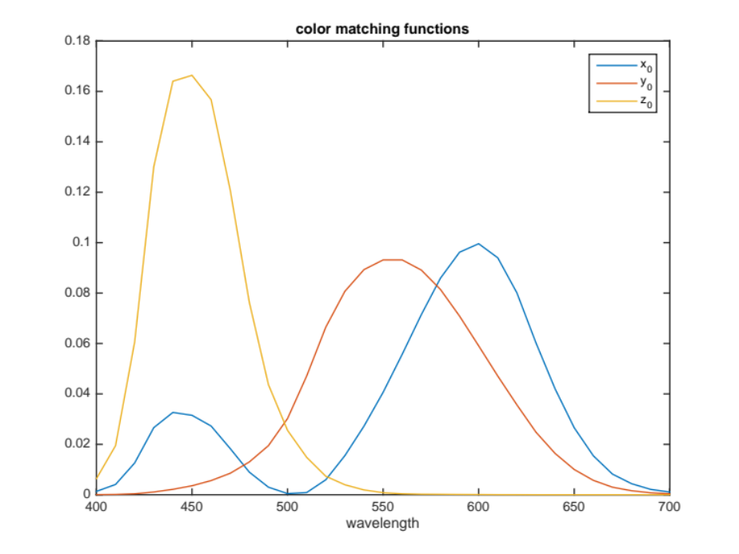
Fig 2-1 Color matching functions versus wavelength
2.2 The plot of the $l_{0}(λ)$, $m_{0}(λ)$, and $s_{0}(λ)$ color matching functions
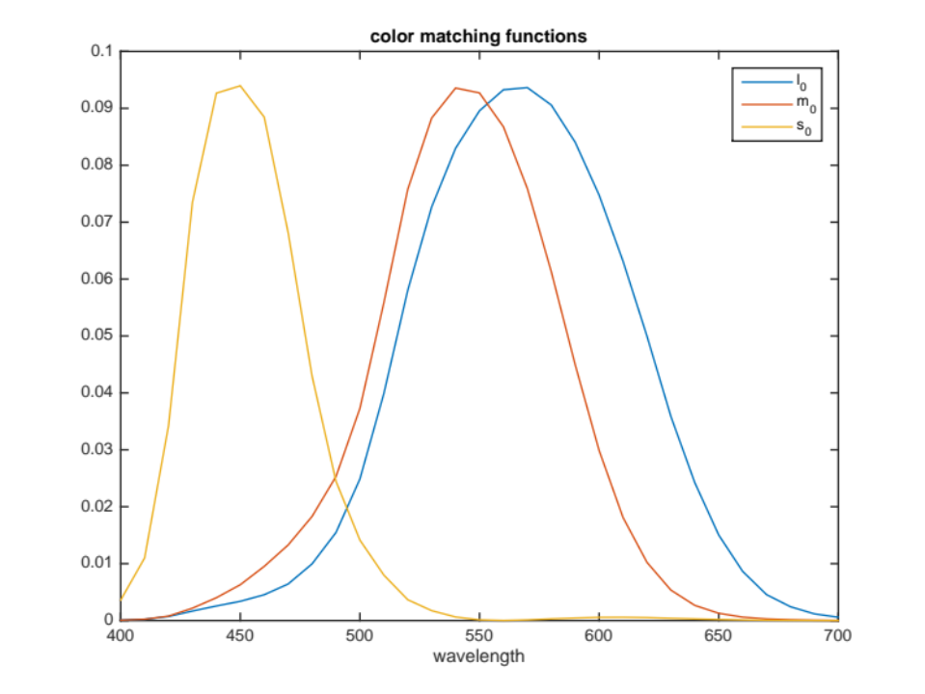
Fig 2-2 Color matching functions corresponding to the long medium and short cones versus wavelength
2.3 The plot of the $D_{65}$ and fluorescent illuminants
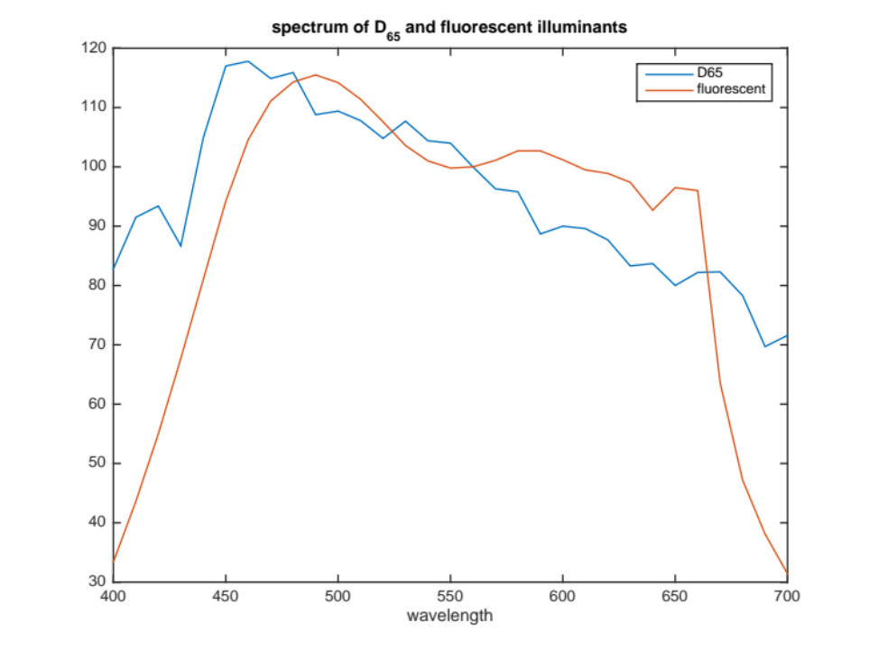
Fig 2-3 The spectrum of the $D_{65}$ and fluorescent illuminants versus wavelength
Section3 – Chromaticity Diagrams
3.1 Labeled chromaticity diagram
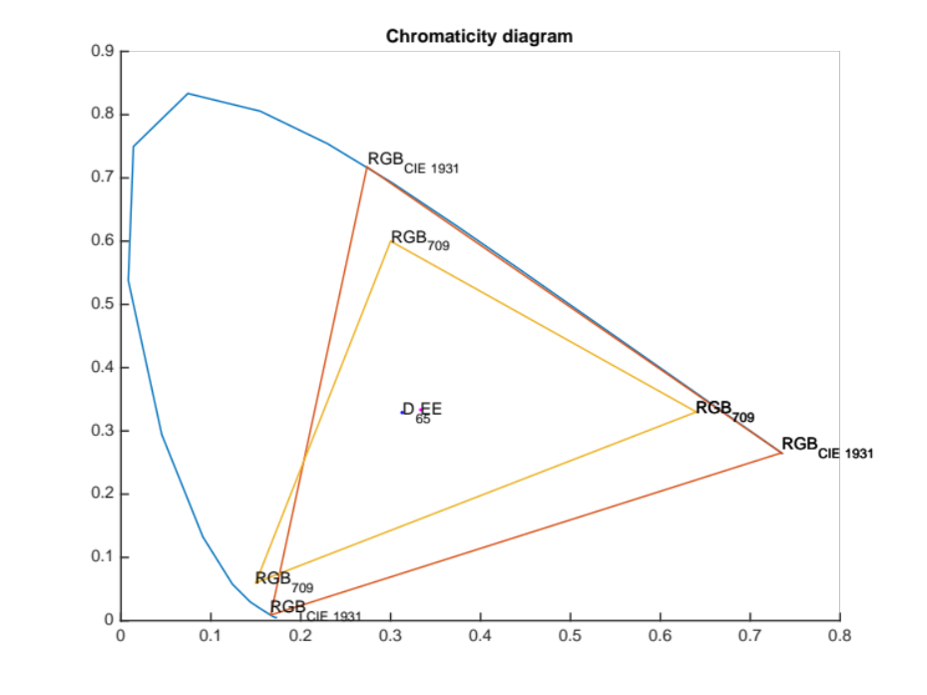
Fig 3-1 Chromaticity Diagram
Section4 – Rendering an Image from Illuminant, Reflectance, and Color Matching Functions
4.1 The matrix $M_{709_D65}$
We know that the XYZ tristimulus values for the primaries will be related to the chromaticities through a set of scaling constants $k_{r}, k_{g},k_{b}$ and represented as
$$M= \left[\begin{matrix}X_{r} & X_{g} & X_{b} \\ Y_{r} & Y_{g} & Y_{b} \\ Z_{r} & Z_{g} & Z_{b}\end{matrix} \right]=\left[\begin{matrix}x_{r} & x_{g} & x_{b} \\ y_{r} & y_{g} & y_{b} \\ z_{r} & z_{g} & z_{b}\end{matrix} \right]\left[\begin{matrix}k_{r} & 0 & 0 \\ 0 & k_{g} & 0 \\ 0 & 0 & k_{b}\end{matrix} \right]$$
and if we know the white points, we can get scaling constants $k_{r}, k_{g},k_{b}$ by
$$\left[\begin{matrix}k_{r} \\ k_{g} \\ k_{b}\end{matrix}\right]={\left[\begin{matrix}x_{r} & x_{g} & x_{b} \\ y_{r} & y_{g} & y_{b} \\ z_{r} & z_{g} & z_{b}\end{matrix} \right]}^{-1}\left[\begin{matrix}x_{wp}/y_{wp} \\ 1 \\ z_{wp}/y_{wp}\end{matrix}\right]$$
So we can plug the $\left[\begin{matrix}x_{r} & x_{g} & x_{b} \\ y_{r} & y_{g} & y_{b} \\ z_{r} & z_{g} & z_{b}\end{matrix} \right]$ values and $\left[\begin{matrix}x_{wp}/y_{wp} \\ 1 \\ z_{wp}/y_{wp}\end{matrix}\right]$ values into the above function, and get the $\left[\begin{matrix}k_{r} \\ k_{g} \\ k_{b}\end{matrix}\right]$ values. Then the last step is plugging $\left[\begin{matrix}x_{r} & x_{g} & x_{b} \\ y_{r} & y_{g} & y_{b} \\ z_{r} & z_{g} & z_{b}\end{matrix} \right]and \left[\begin{matrix}k_{r} \\ k_{g} \\ k_{b}\end{matrix}\right]$ into the first function, and get
$$M= \left[\begin{matrix}0.4124 & 0.3576 & 0.1805 \\ 0.2126 & 0.7152 & 0.0722 \\ 0.0193 & 0.1192 & 0.9505\end{matrix} \right]$$

4.2 The two images obtained from $D_{65}$ and fluorescent light sources
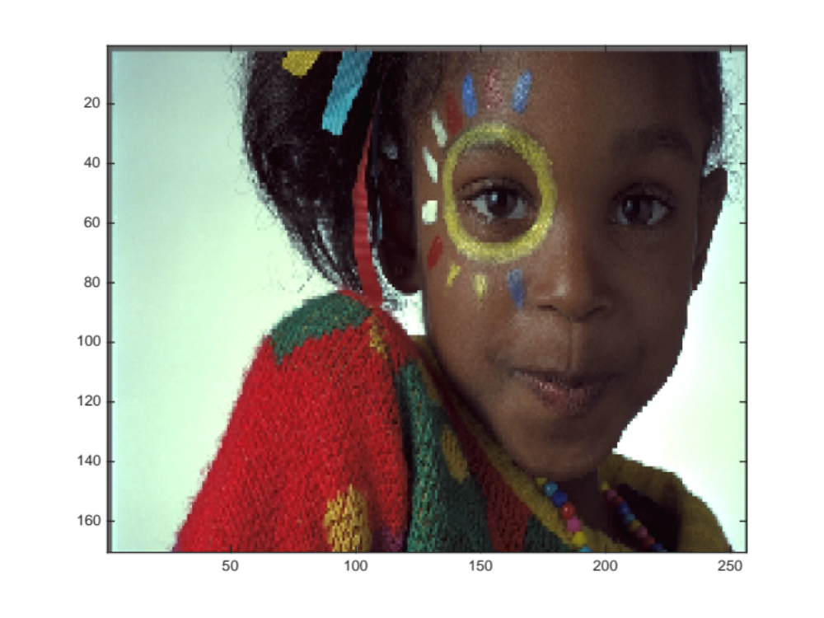
Fig 4-2-1 Image obtained from $D_{65}$

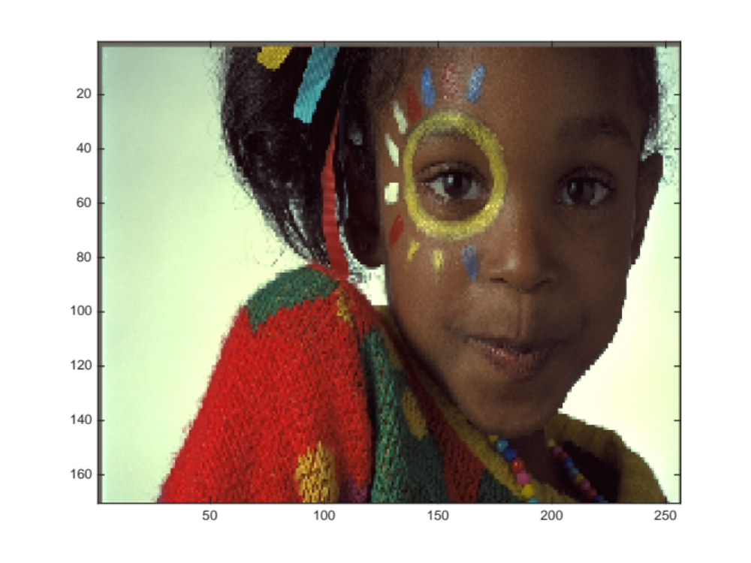
Fig 4-2-2 Image obtained from fluorescent light sources
4.3 A qualitative description of the differences between the two images
The image obtained from $D_{65}$ (image A) is much cooler than the image obtained from fluorescent light sources (image B). Image B is brighter and warmer than image A.

Section5 – Color Chromaticity Diagrams
5.1 Color diagram
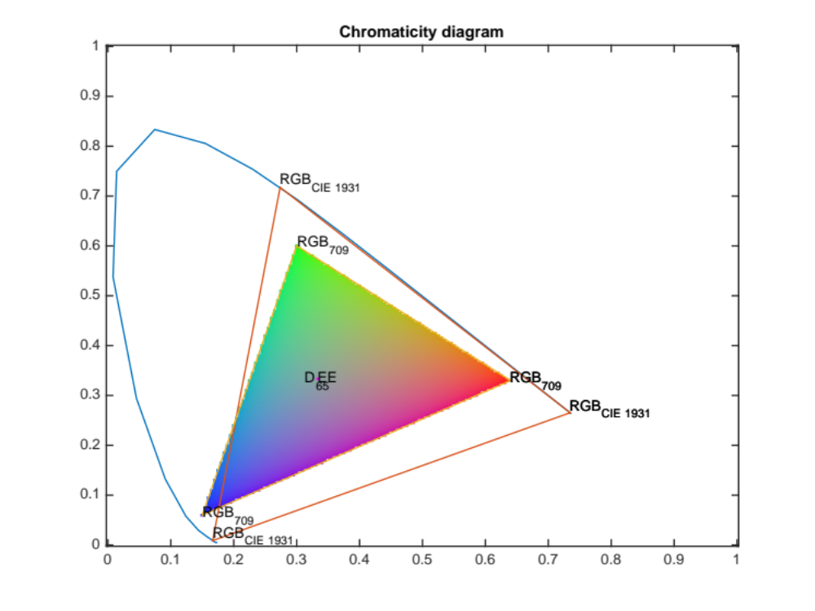
Fig 5-1 Color Diagram

