ECE 637 Lab 8 Report
Image Halftoning

Xihui Wang

Section3 – Thresholding and Random Noise Binarization
3.1 The original image and the result of thresholding
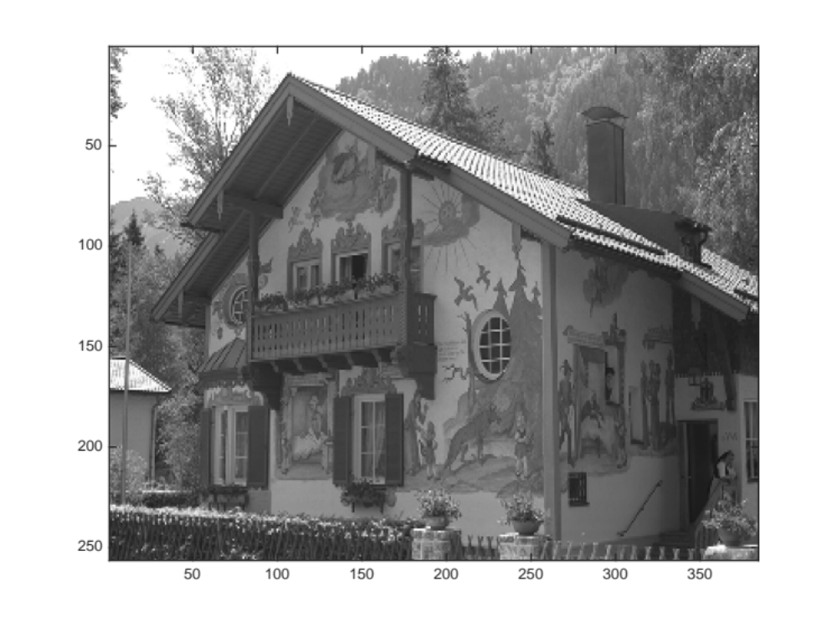
Fig 3-1-1 The original image house.tif
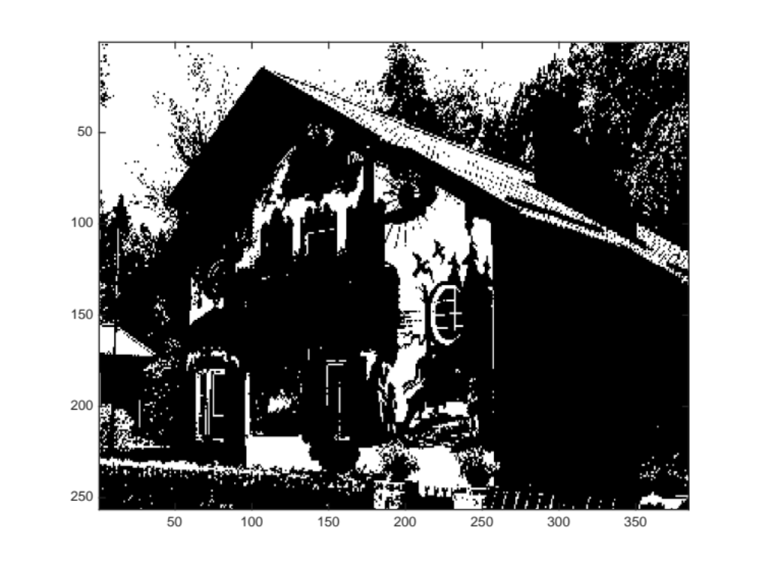
Fig 3-1-2 The image after applying the sample thresholding T = 127
3.2 The computed RMSE and fidelity values
The RMSE value is 87.3933.
The fidelity value is 77.3371.

3.3 The code for my fidelity function
function [fid] = fidelity(f, b)

fid = 0;
[m,n] = size(f);

fl = 255*(f/255).^(2.2);
bl = 255*(b/255).^(2.2);

sigma2 = 2;
h = zeros(7,7);
for i=1:7
for j=1:7
h(i,j)=exp(-((i-4)^2+(j-4)^2)/(2*sigma2));
end
end
h = h/(sum(sum(h)));
flp = conv2(fl, h, 'same');
blp = conv2(b, h, 'same');

ff = 255*(flp/255).^(1/3);
bb = 255*(blp/255).^(1/3);

for i = 1:m
for j = 1:n
fid = fid+ (ff(i,j)-bb(i,j))^2;
end
end
fid = sqrt(fid/(m*n));

Additional matlab code:
img = imread('house.tif');
[m, n] = size(img);
T = 127;
img = double(img);
b = zeros(m,n);
b((img>127)) = 255;
% colormap(gray(255));
% image(b);

RMSE = 0;
for i = 1:m
for j = 1:n
RMSE = RMSE+ (img(i,j)-b(i,j))^2;
end
end
RMSE = sqrt(RMSE/(m*n))

fid = fidelity(img, b)
Section4 – Ordered Dithering
4.2.1 The three Bayer index matrices of sizes 2 x 2, 4 x 4, and 8 x 8
$$I_{2}=\left[\begin{matrix}1 & 2 \\ 3 & 0\end{matrix}\right]$$

$$I_{4}=\left[\begin{aligned}\begin{matrix}\begin{matrix} 5 & 9\end{matrix} & \begin{matrix} 6 & 10\end{matrix} \\ \begin{matrix}13 & 1\end{matrix} & \begin{matrix}14 & 2\end{matrix}\end{matrix} \\ \begin{matrix}\begin{matrix} 7 & 11\end{matrix} & \begin{matrix} 4 & 8\end{matrix}\end{matrix} \\ \begin{matrix}15 & \begin{matrix} 3 & \begin{matrix}12 & 0\end{matrix}\end{matrix}\end{matrix}\end{aligned}\right]$$

$$I_{8}=\left[\begin{matrix}\begin{matrix}\begin{matrix}21 & 37\end{matrix} & \begin{matrix}25 & 41\end{matrix} \\ \begin{matrix}53 & 5\end{matrix} & \begin{matrix}57 & 9\end{matrix} \\ \begin{matrix}29 & 45\end{matrix} & \begin{matrix}17 & 33\end{matrix}\end{matrix} & \begin{matrix}\begin{matrix}22 & 38\end{matrix} & \begin{matrix}26 & 42\end{matrix} \\ \begin{matrix}54 & 6\end{matrix} & \begin{matrix}58 & 10\end{matrix} \\ \begin{matrix}30 & 46\end{matrix} & \begin{matrix}18 & 34\end{matrix}\end{matrix} \\ \begin{matrix}\begin{matrix}61 & 13\end{matrix} & \begin{matrix}49 & 1\end{matrix} \\ \begin{matrix}23 & 39\end{matrix} & \begin{matrix}27 & 43\end{matrix} \\ \begin{matrix}55 & 7\end{matrix} & \begin{matrix}59 & 11\end{matrix}\end{matrix} & \begin{matrix}\begin{matrix}62 & 14\end{matrix} & \begin{matrix}50 & 2\end{matrix} \\ \begin{matrix}20 & 36\end{matrix} & \begin{matrix}24 & 40\end{matrix} \\ \begin{matrix}52 & 4\end{matrix} & \begin{matrix}58 & 8\end{matrix}\end{matrix} \\ \begin{matrix}\begin{matrix}31 & 47\end{matrix} & \begin{matrix}19 & 35\end{matrix} \\ \begin{matrix}63 & 15\end{matrix} & \begin{matrix}51 & 3\end{matrix}\end{matrix} & \begin{matrix}\begin{matrix}28 & 44\end{matrix} & \begin{matrix}16 & 32\end{matrix} \\ \begin{matrix}60 & 12\end{matrix} & \begin{matrix}48 & 0\end{matrix}\end{matrix}\end{matrix}\right]$$

4.2.2 The three halftoned images produced by the three dither patterns
Fig 4-2-2-1 Halftoned Image Produced by I2

Fig 4-2-2-2 Halftoned Image Produced by I4

Fig 4-2-2-3 Halftoned Image Produced by I8

4.2.3 The RMSE and fidelity for each of the three halftoned images.
 | RMSE | Fidelity
I2 | 97.6690 | 50.0569
I4 | 101.0069 | 16.5583
I8 | 100.9145 | 14.6918

Section5 – Error Diffusion
5.1 The error diffusion Matlab Code
img = imread('house.tif');
[m, n] = size(img);
T = 127;
img = double(img);

f = 255 * (img / 255).^2.2;
e = zeros(m,n);
b = zeros(m,n);

for i=1:m-1
for j=1:n
b(i,j) = (f(i,j)>127)*255;
e = f(i,j) - b(i,j);
if(j<n)
f(i,j+1) = f(i,j+1) + e*7/16;
f(i+1,j+1) = f(i+1,j+1) + e*1/16;
end
if(j>1)
f(i+1,j-1) = f(i+1,j-1) + e*3/16;
end
f(i+1,j) = f(i+1,j) + e*5/16;
end
end

colormap(gray(256));
image(b);
truesize
imwrite(b,'errordiffusion.tiff')

RMSE = 0;
for i = 1:m
for j = 1:n
RMSE = RMSE+ (img(i,j)-b(i,j))^2;
end
end
RMSE = sqrt(RMSE/(m*n))

fid = fidelity(img, b)

5.2 The error diffusion result
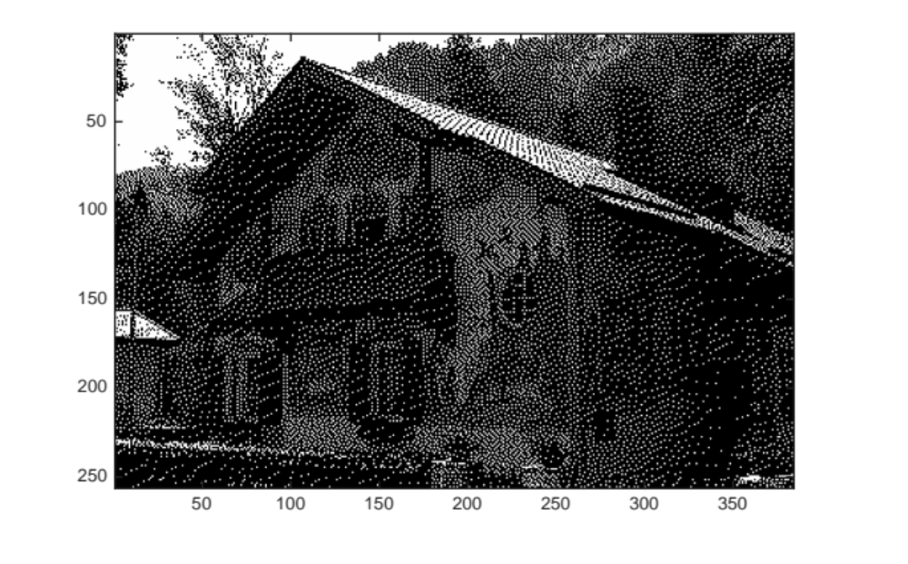
Fig 5-2 The Error Diffusion Result

5.3 The RMSE and fidelity of the error diffusion result
RMSE = 98.8489
Fidelity = 13.7005

5.4 Tabulate the RMSE and fidelity for the simple thresholding, ordered dithering, and error diffusion results.

 | RMSE | Fidelity
Simple Thresholding | 87.3933 | 77.3371
2nd ordered Dithering | 97.6690 | 50.0569
4th ordered Dithering | 101.0069 | 16.5583
8th ordered Dithering | 100.9145 | 14.6918
Error Diffusion | 98.8489 | 13.7005

The RMSEs are similar for each method, comparing to Fidelity, and the simple thresholding result has the smallest root mean square error. The Fidelity is decreasing from simple thresholding method to dithering method to error diffusion method. As shown in the result images, the larger the Fidelity, the worse the image quality.
By comparing RMSE values and Fidelity values for each method, it seems like the Fidelity will gives us more information about the image quality.

