

本科实验报告

|  |  |
| --- | --- |
| 课程名称： | 编译原理 |
| 姓 名： | 王俊 |
| 学 院： | 海洋学院 |
| 专 业： | 海洋工程与技术 |
| 学 号： | 3170100186 |
| 指导教师： | 鲁东明 |

2020年 3 月 21 日

Lab1—利用LEX计算文本文件的字符数

1. 实验内容

* Experimental purpose: to understand the basic programming methods of LEX.
* Experimental requirements: Write a LEX input file to generate a program that can calculate the number of characters, words and lines in a text file and report these numbers. A word is a sequence of letters and/or numbers without punctuation or spaces. Punctuation and blank spaces are not counted as words.

1. 实验过程以及截图

* **Install flex&bison on the mac OS**

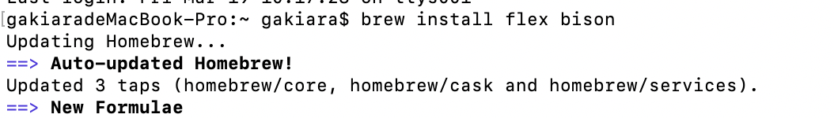

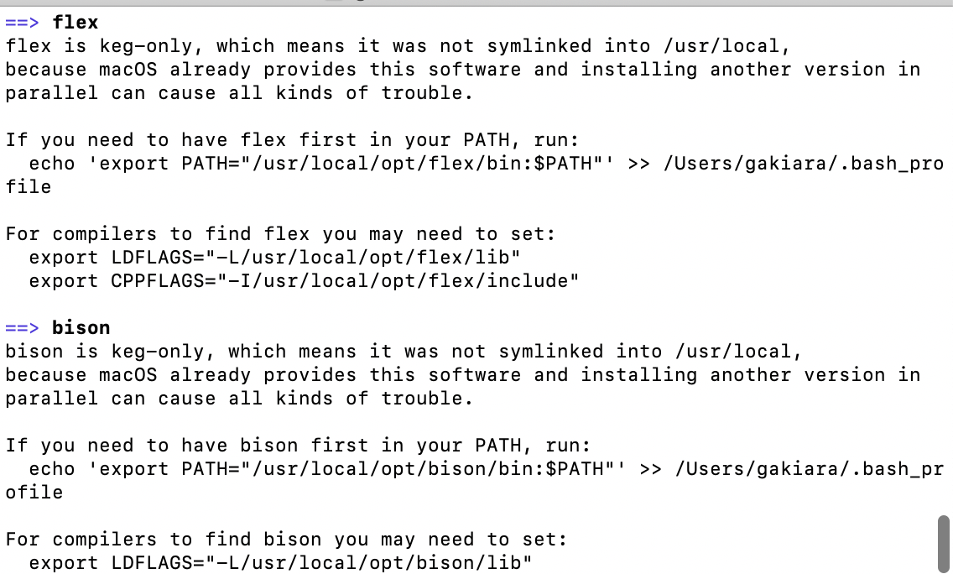

* **Code writing**

1. **Initial the variable that is used for counting：**



1. **Initial the state:**

State value :

0: words acceptable 1: reading a word



1. **When meet a ‘\n’:**

char_count++;

line_count++;

If it is reading a word and does not have a space in the end: word_count++;

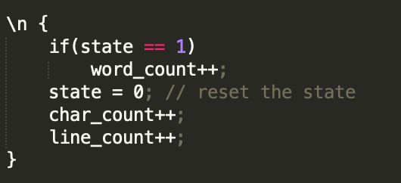

1. **When meet a [" "\n\t]**

If it is reading a word: word_count++;

char_count++

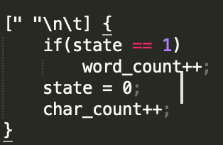

1. **When meet number or letter**

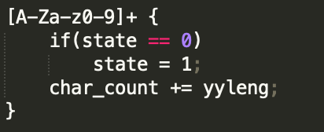

1. **when finding a symbol**

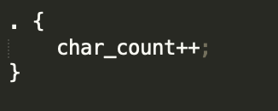

* **Compile**

**Make file:**

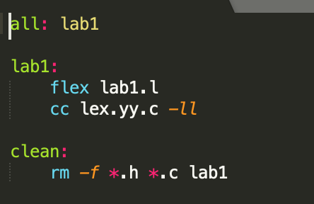

1. 测试和结果

Test0:

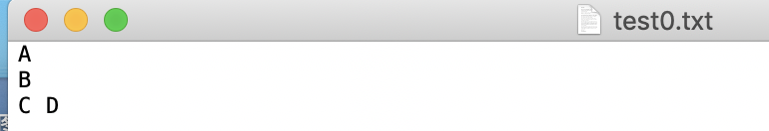

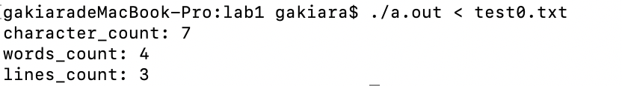

Test1:

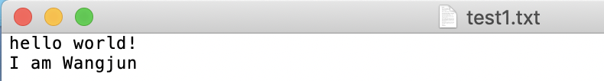

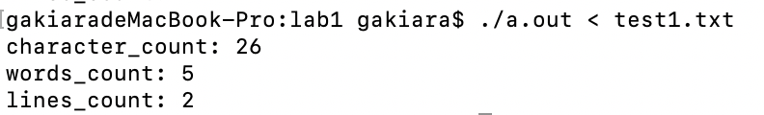

Test2: (I’m) counts for one world

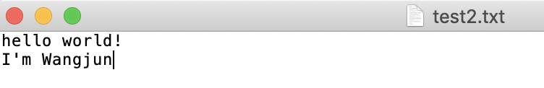

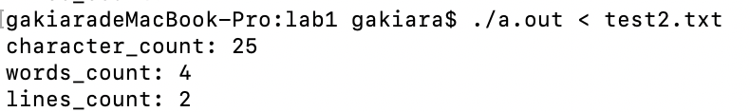

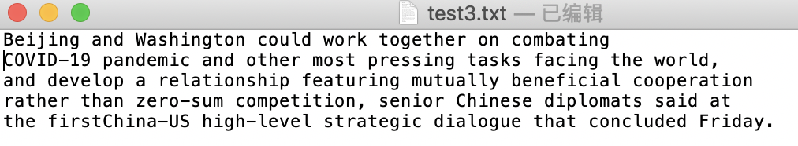

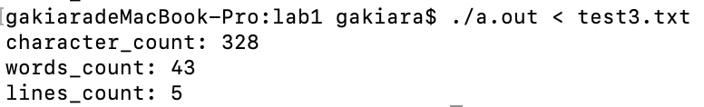

1. 总结和反思

* We should change the type to int, but it doesn’t matter.

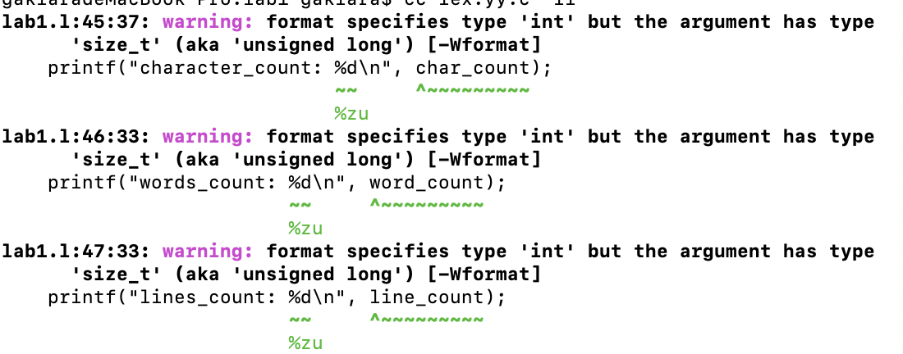

* The letter count should be initialized to 1:

