

本科实验报告

|  |  |
| --- | --- |
| 课程名称： | 编译原理 |
| 姓 名： | 王俊 |
| 学 院： | 海洋学院 |
| 专 业： | 海洋工程与技术 |
| 学 号： | 3170100186 |
| 指导教师： | 鲁东明 |

2020年 3 月 21 日

Lab2—利用LEX进行字母的大小写转换

1. 实验内容

* Experiment purpose: to understand the basic programming methods of LEX
* Experimental requirements: Write a LEX input file to generate a program that capitalizes all keywords (reserved words) except the program (language pre-defined) comments. The program generated by the LEX must be able to analyze the source program and convert all non-capital keywords to uppercase.

1. 实验过程以及截图

* **Install flex&bison on the mac OS**

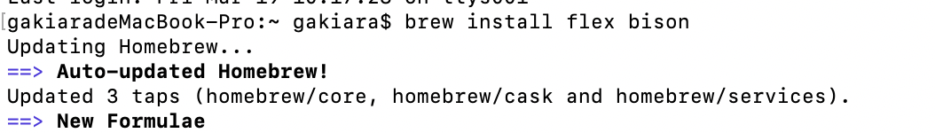

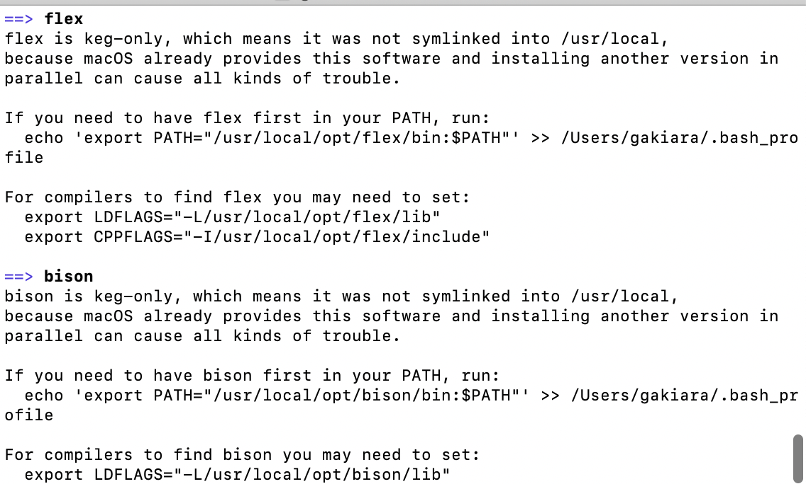

* **Reserved words in C:**

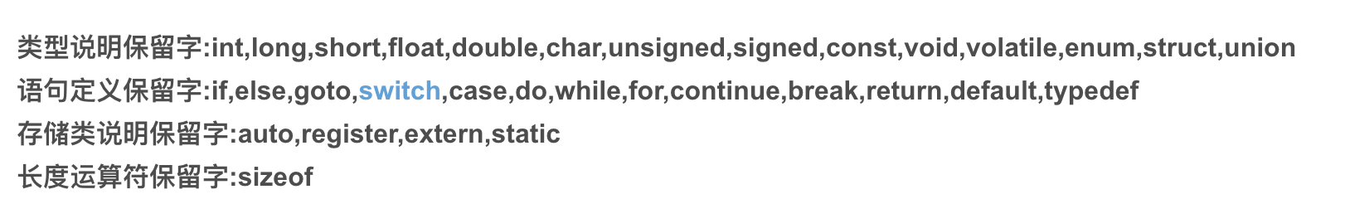

* **Code writing**

1. **Initial the state:**

State value :

0: reserved words acceptable 1: reading a reserved word

2: exit / error



1. **start of reading a reserved word:**

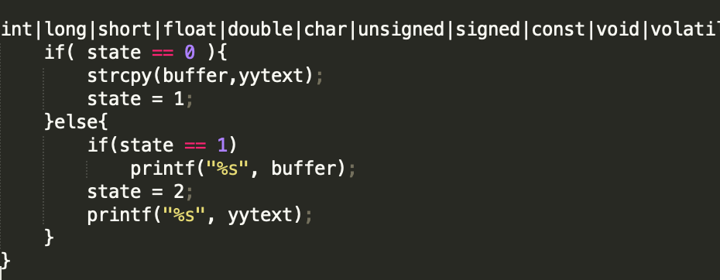

1. **End of reading a reserved word**

If it is a reserved word, change it, then reset the state

And would never change a word in the comment

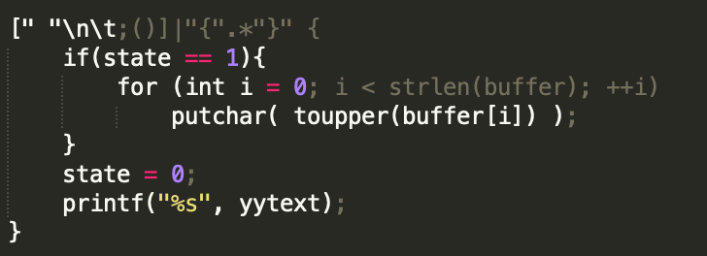

1. **When finding a symbol**

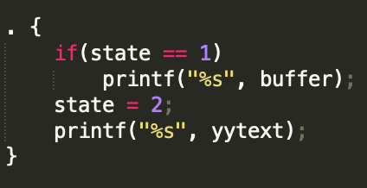

1. **When finding a comment : // /* just print it out:**

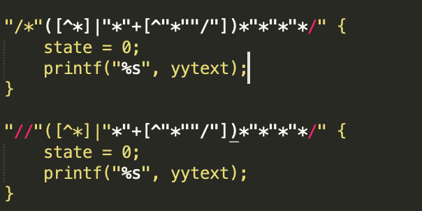

* **Compile**

**Make file:**

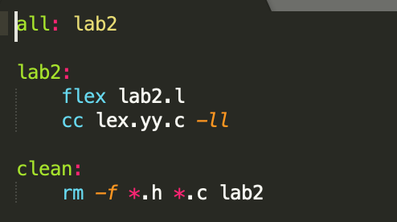

1. 测试和结果

* test0.c:

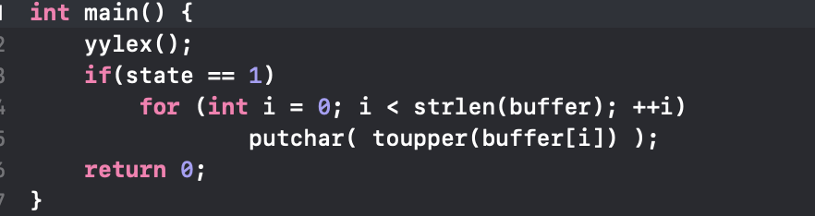

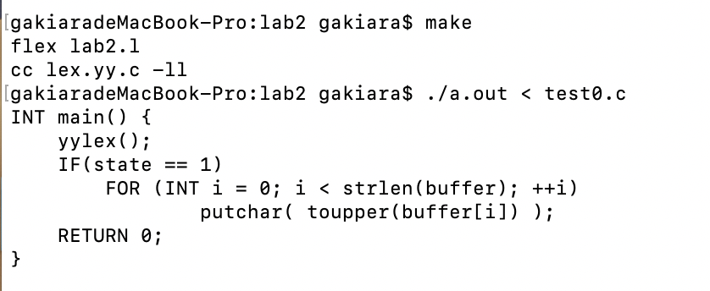

* lex.yy.c:

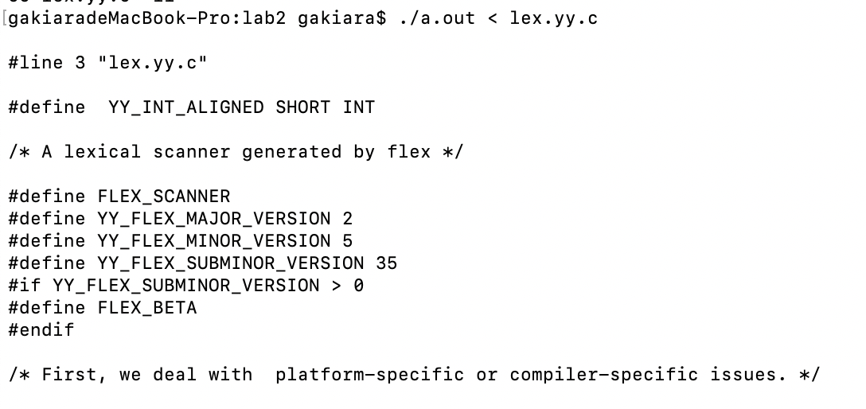

**Like If in the following comments would not be changed:**

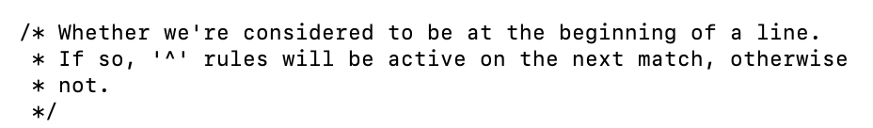

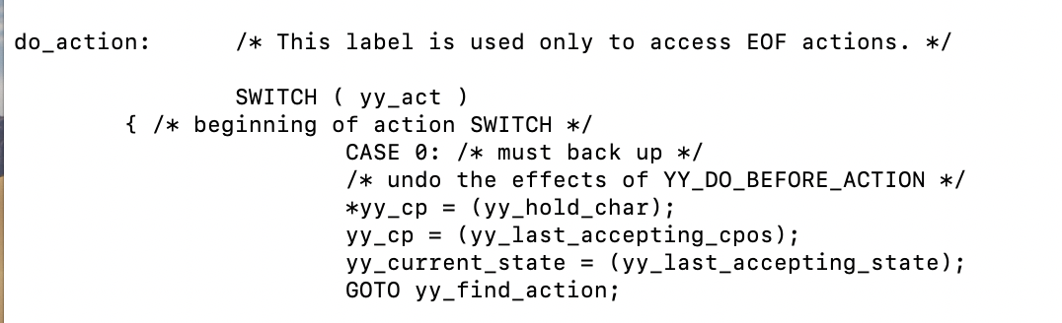

* test1.c

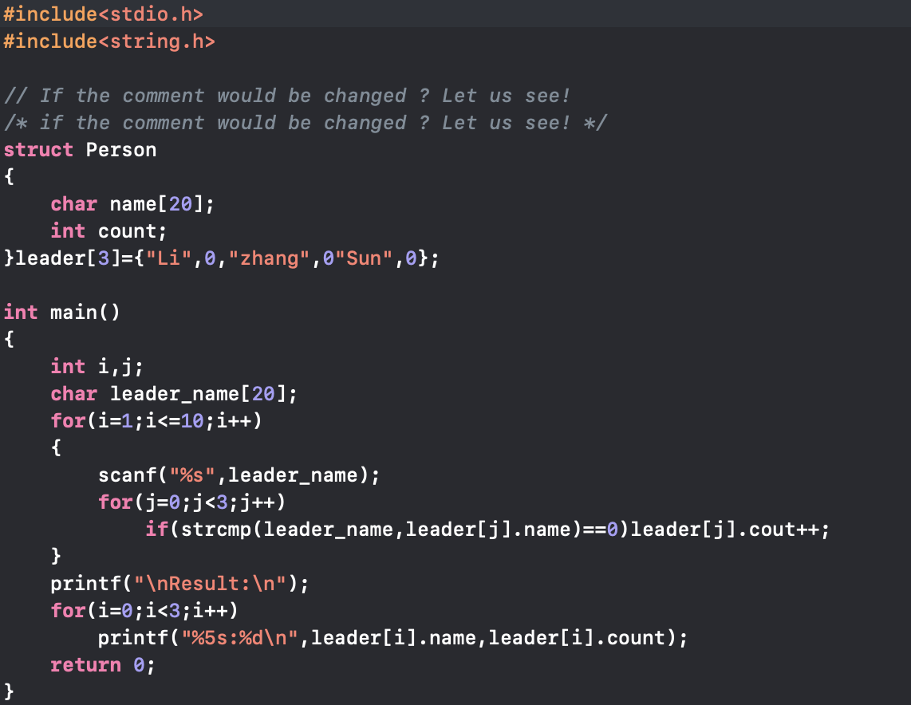

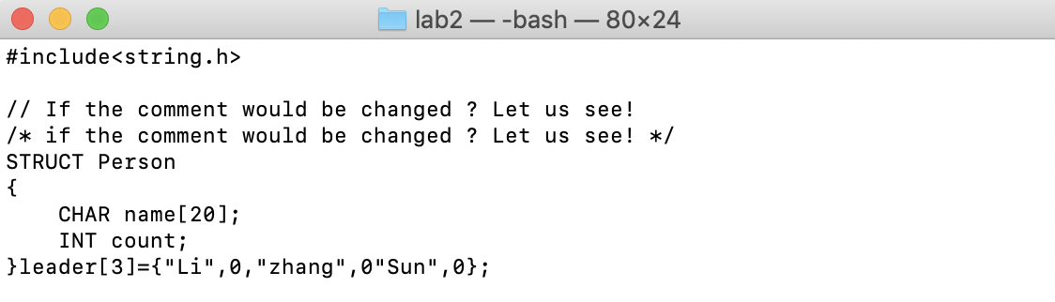

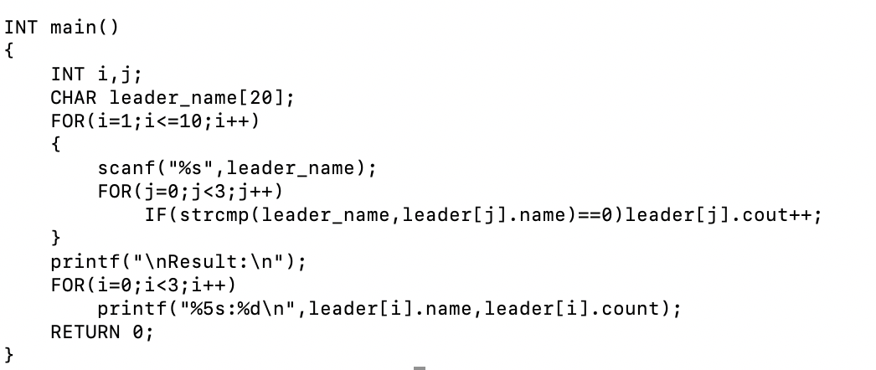

1. 总结和反思

* Except for 0 and 1, another state should be set to exit the reading mode Or the following would happen:

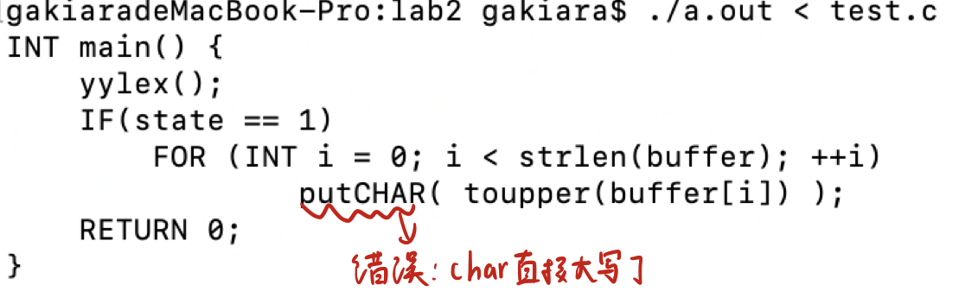

* Remember to add ‘//’ situation in comment:

