

本科实验报告

|  |  |
| --- | --- |
| 课程名称： | 编译原理 |
| 姓 名： | 王俊 |
| 学 院： | 海洋学院 |
| 专 业： | 海洋工程与技术 |
| 学 号： | 3170100186 |
| 指导教师： | 鲁东明 |

2020年 4 月 4 日

Lab3—利用YACC生成中缀表示的计算器

1. 实验内容

* Experiment purpose: Understand how YACC handles ambiguity.

Experimental requirements: Generate a calculator corresponding to the expression expressed in the following grammar

Exp->exp + exp | exp – exp

| exp * exp |exp / exp

|exp ^ exp |-exp

|(exp) |NUM

For the input infix expression, the result must be given. For example, the result of 3 + (4 * 5) should be 23. It is required to be able to process several mathematical expressions continuously until the end of input or the end of the file.

1. 实验过程以及截图

* **Install flex&bison on the mac OS**

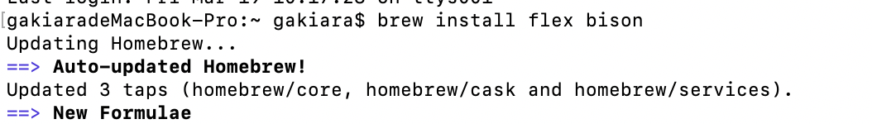

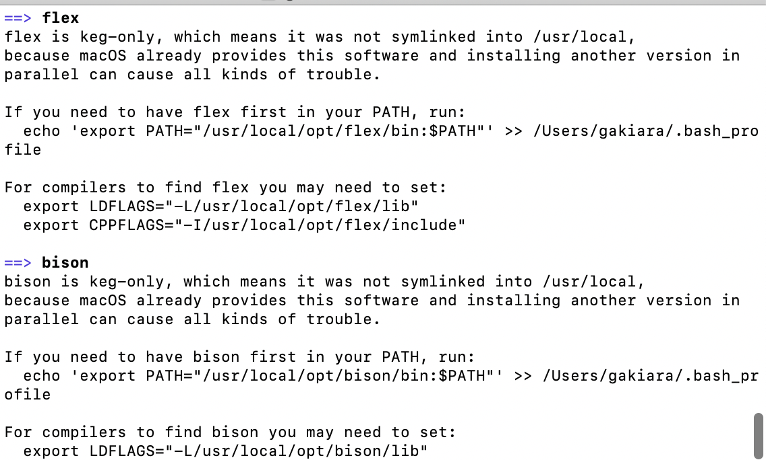

* **Code writing**

**Lex:**

**Return the number and text**

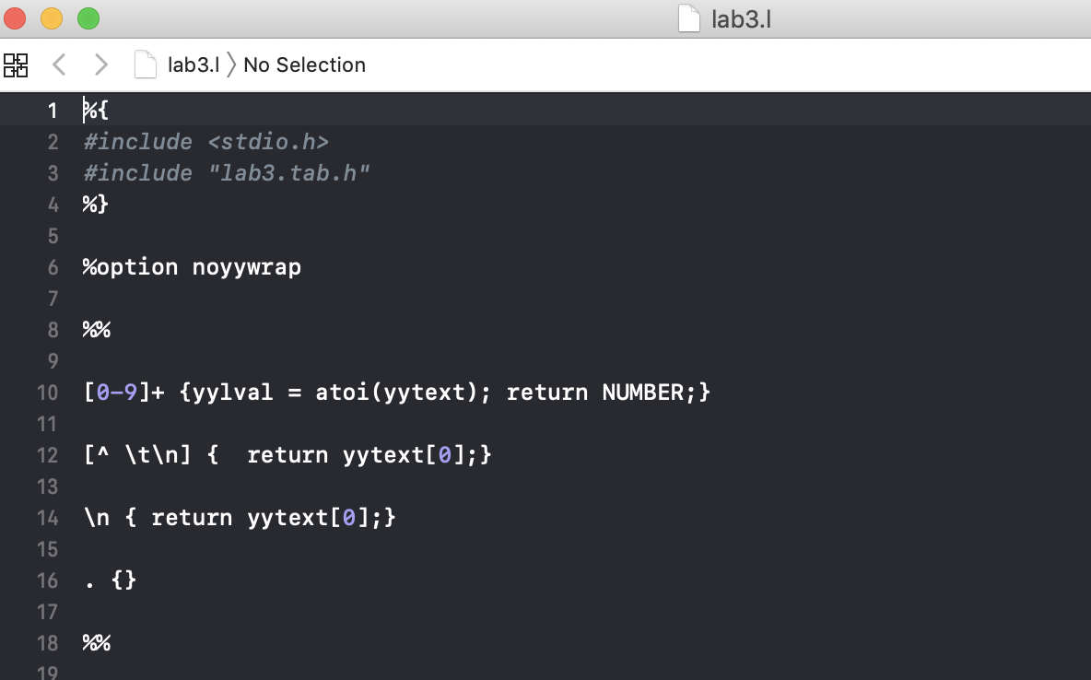

**Yacc:**

* **定义优先级，获取number**

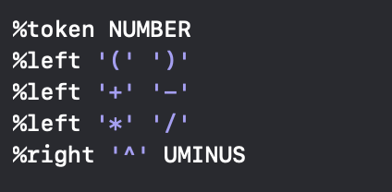

* **定义输入和输出，按行读取**

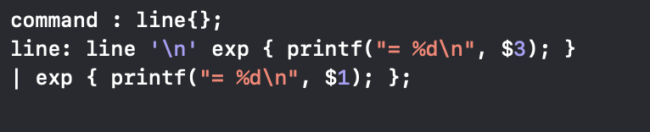

* **根据文化生成规则**

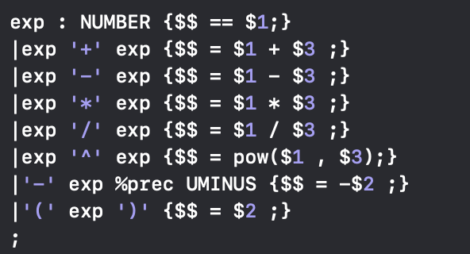

* **主程序**

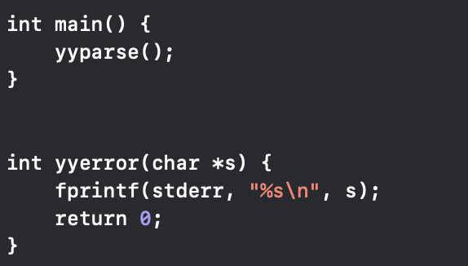

1. 测试和结果

**编译：**

**bison -d lab3.y**

**flex lab3.l**

**gcc lab3.tab.c lex.yy.c**

**./a.out < test.txt**

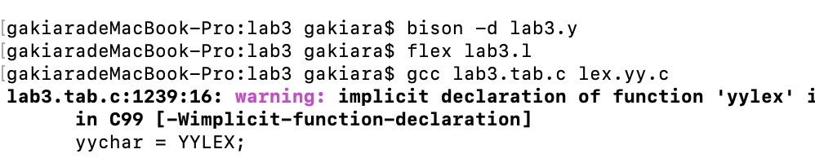

* test.txt:

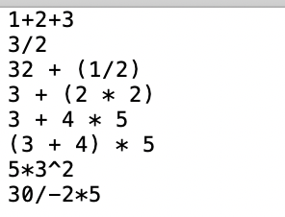

**Result:**

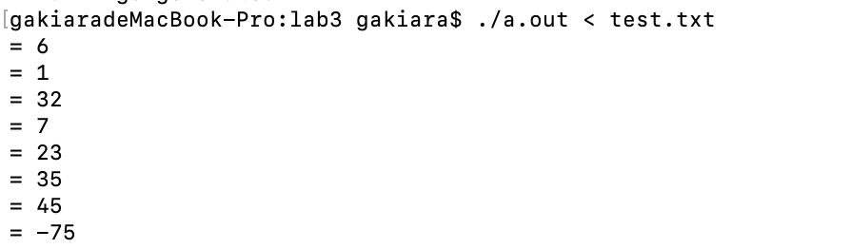

* test2.txt:

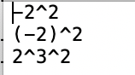

**Result:**

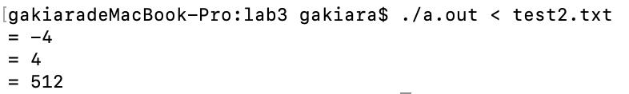

1. 总结和反思

* Should be $3:

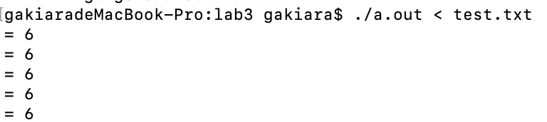

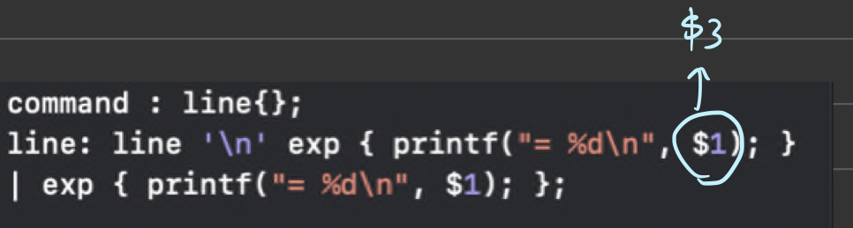

* The situation that the last line in the test.txt without ‘\n’ must be considered:

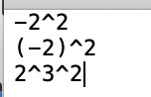

**Otherwise, the last line would have syntax problem;**