# Database System Lab 2

学号：3170100186 姓名：王俊

## 实验目的

* Master the use of relational database language SQL
* Make all SQL jobs pass on the machine

## 实验平台：

* MySQL（全平台）

网上教程<http://www.runoob.com/mysql/mysql-tutorial.html>

## 实验内容

**1) Establish a database;**

**2) Data definition: table creation / deletion / modification; index creation / deletion; view creation / deletion;**

**3) Data update: use insert / delete / update commands to insert / delete / modify table data;**

**4) Data query: single-table query, multi-table query, nested sub-query;**

**5) View operation: query and modify data through views;**

**6) Use the correct instructions to complete the above operations;**

**7) Complete the experiment report.**

## 实验步骤

（根据实验说明中的实验步骤，将每个步骤中输入的sql语句和输出结果截图）

1. **Establish the database:**

* **Select the current database: use ....**

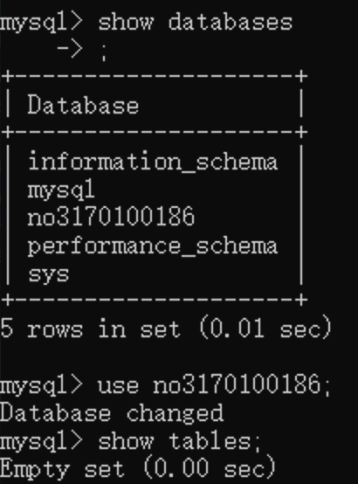

**2) Use SQL statements to create the following book (book), card (borrowing card) and borrow (borrowing record) tables, select the appropriate data type for each field of the table, and fill the corresponding data.**

* **Create table book:**

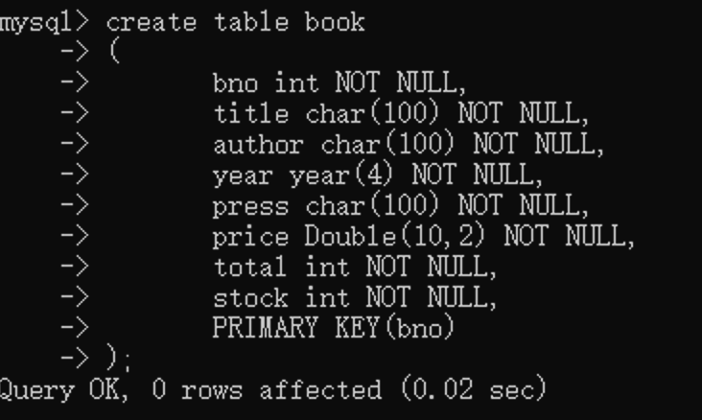

**Insert data:**

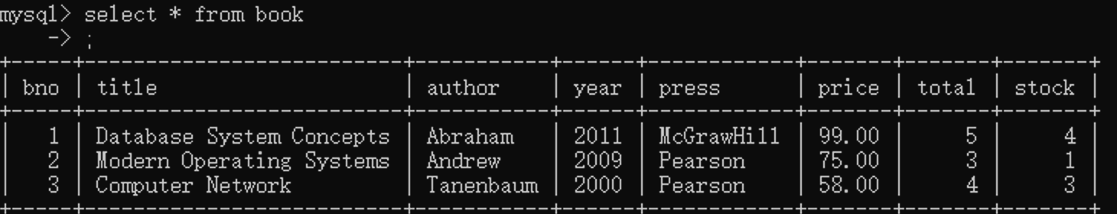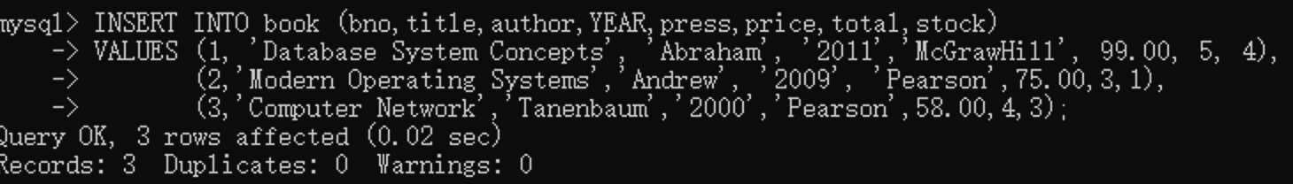**Check:**

* **Create table card:**

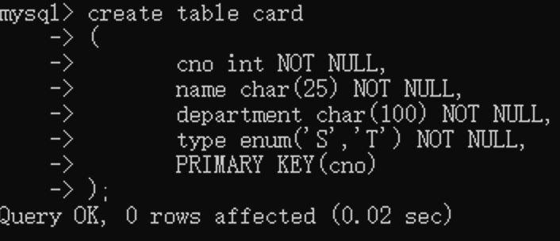

**Insert data:**

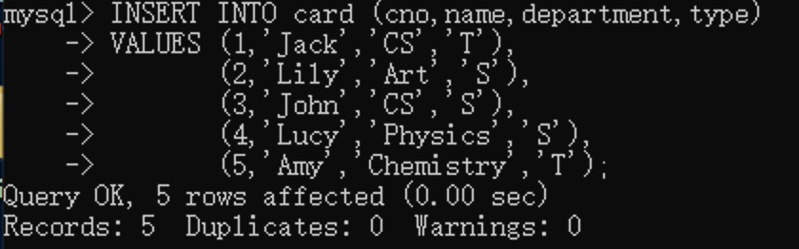

**Check:**

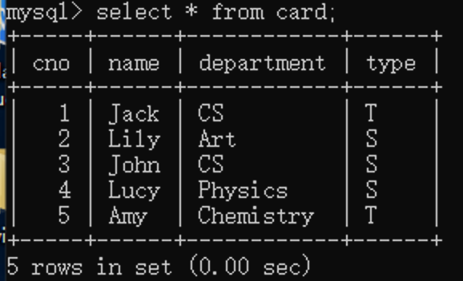

* **Create table borrow:**

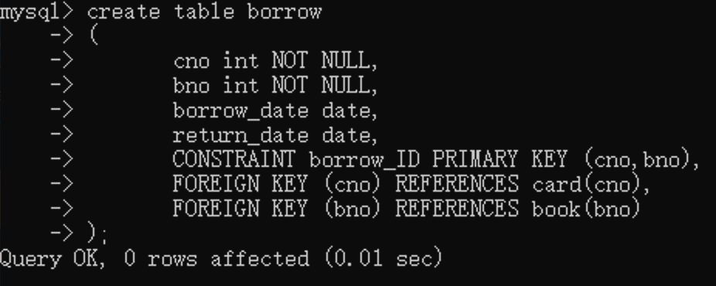

**Insert data:**

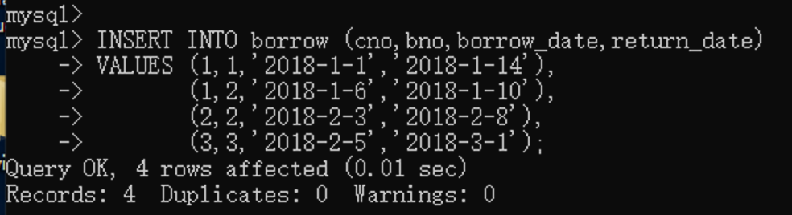

**Check:**

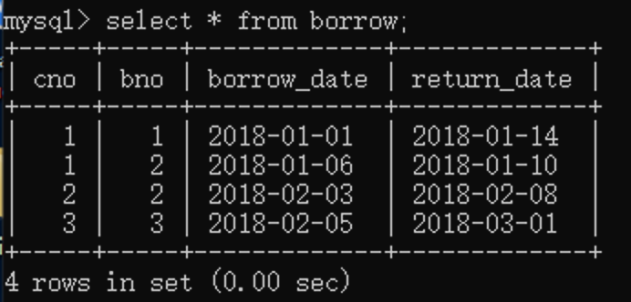

3) Add a field category to the book table; then delete the added category field.

Add and drop code:

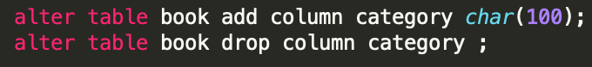

Actual running:

Add and show:

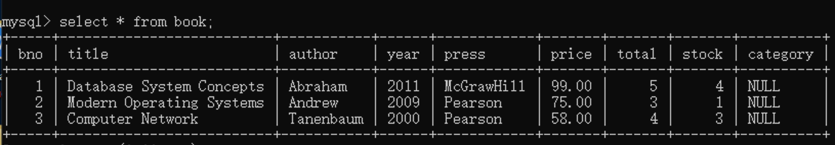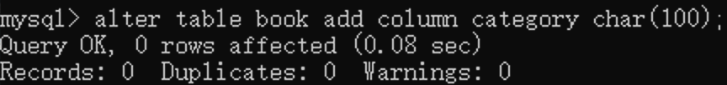

Drop and show:

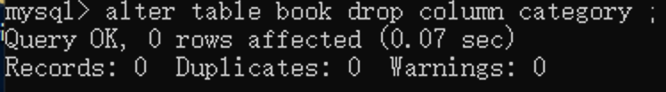

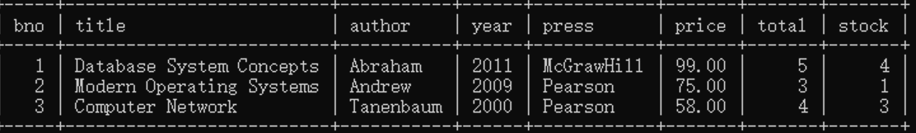

1. Create an index on the title field of the book table; then delete the index:

2 ways to create：

**alter table book add index index_test(title) ;**

**create index index_test on book(title);**

Delete:

**drop index index_test on book ;**

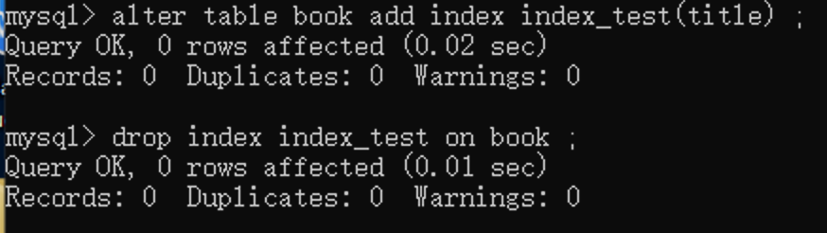

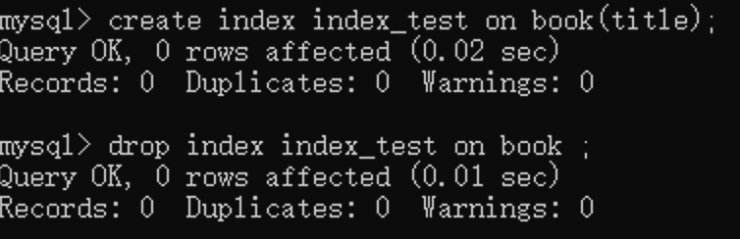

1. Create a view book_view for the book table, including five fields: bno, title, press, year, price.



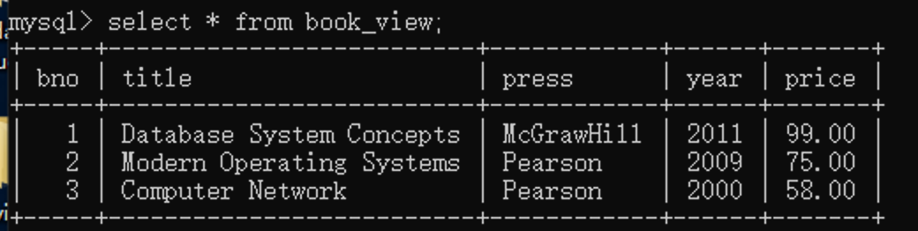

1. Modify the debit card named Lucy in the card table and change its category from student to teacher; then delete Amy's debit card.

## 

## Show:

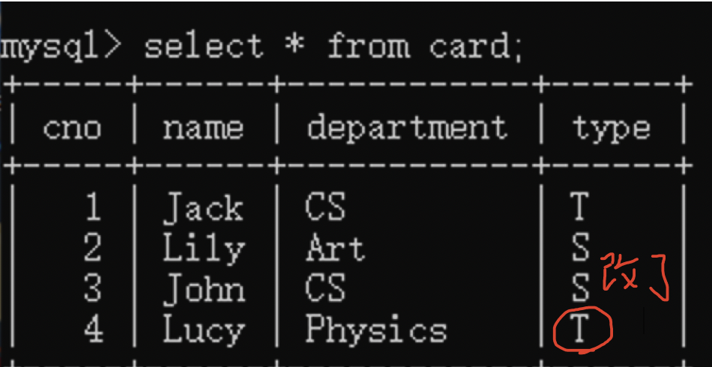

## 

## 

## List the number of library cards for each department

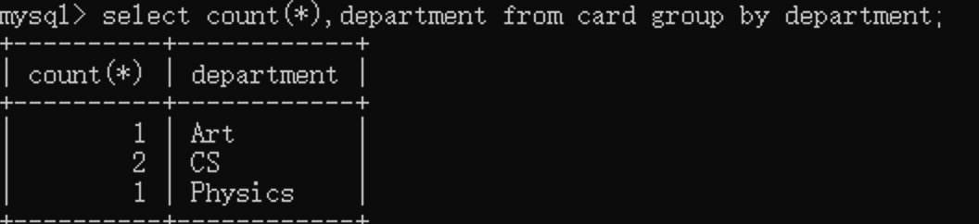

1. List the names of all books borrowed by the student:



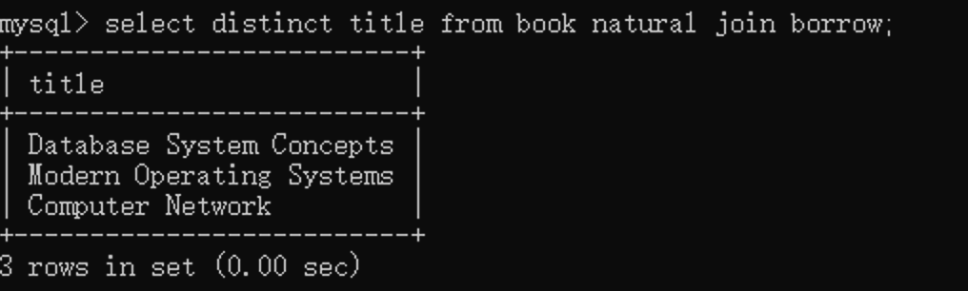

1. List the books with the most stocks:

Code:



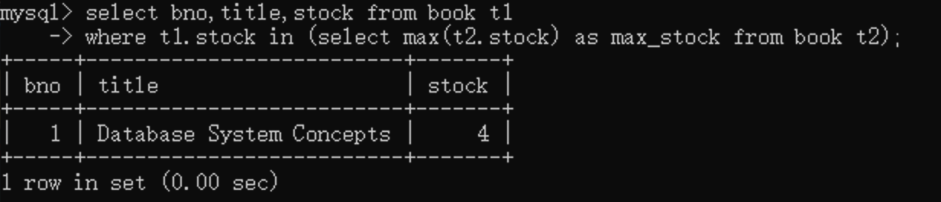

10) Use the book_view view to query the information of books published by Pearson

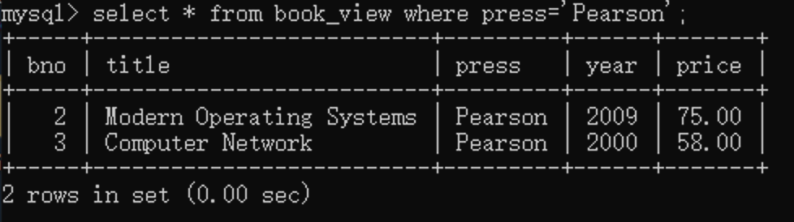

1. Update the book_view view to change the year of the Modern Operating Systems book to 2011. Then observe whether the data in the book table changes accordingly.

Code:

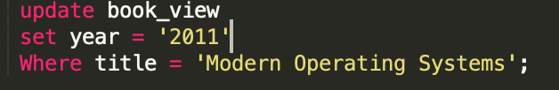

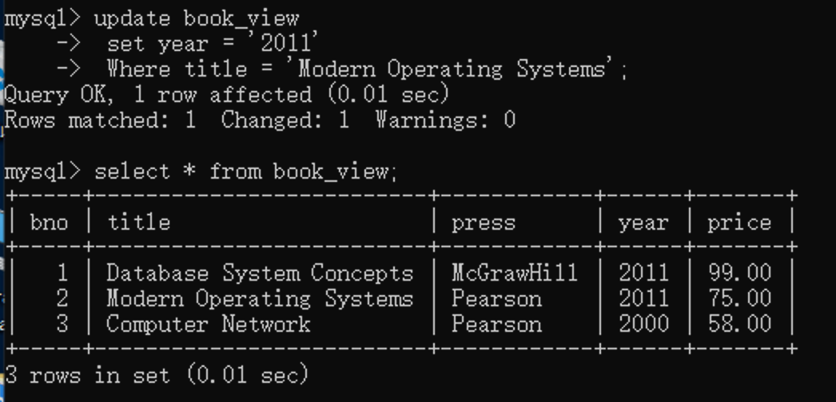

The result is that the original table will change too;

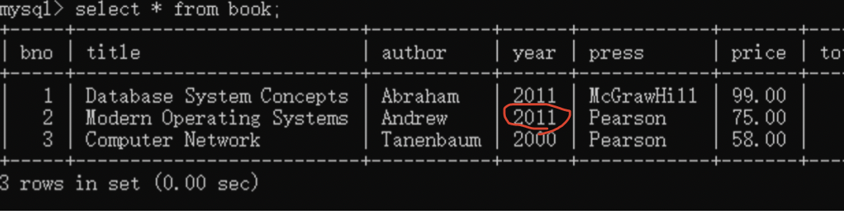

## 实验感想

1. **Many types of data version 5.7 is not supported;**

Number is not supported

create table T_BOOKS

(

cno number(10) primary key,

name varchar(25),

Department varchar(25)

type enum('S','T') not null;

);

1. **At the end of building the table, you cannot add ‘,’;**

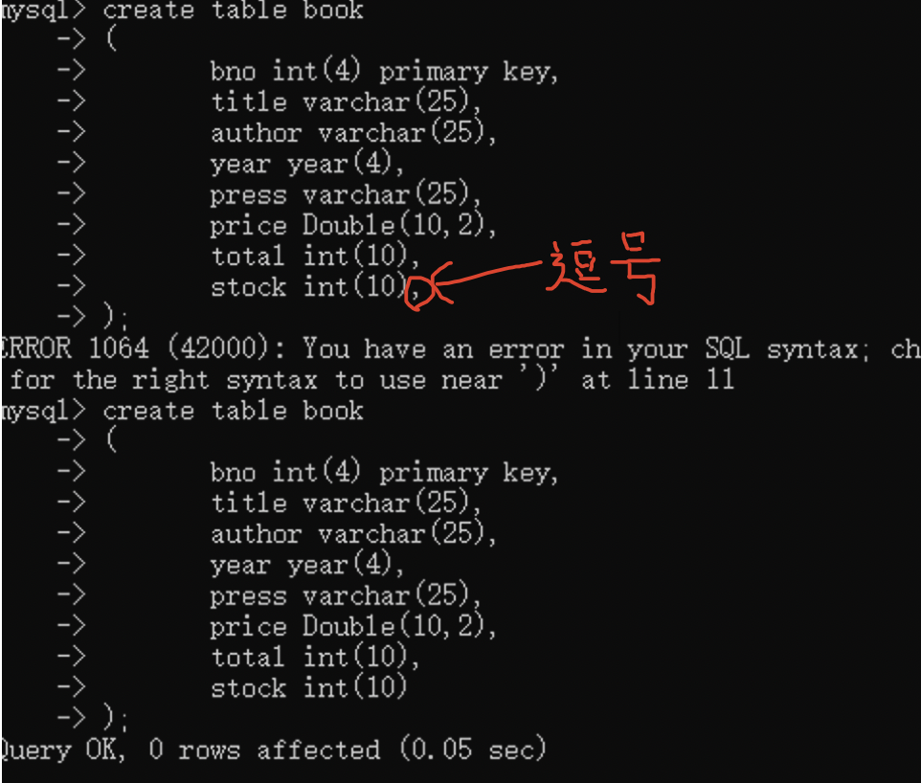

1. **Many problems were found in the process of using the database:**

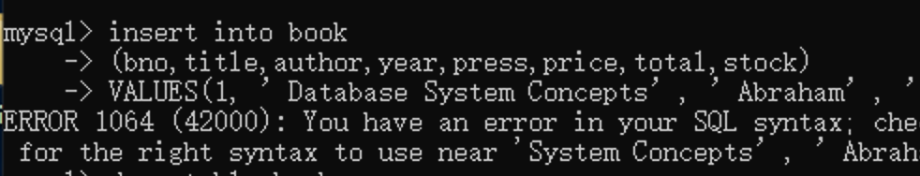

* Because there is not enough data space for ’Database System Concepts'(only 25)：

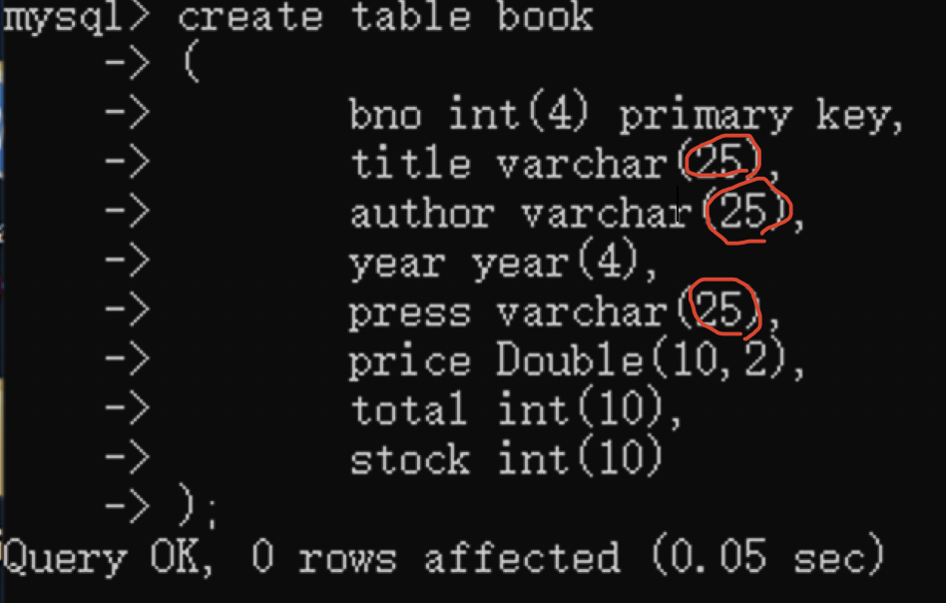

* Because the quotation marks is not in the right form and it will get to this:

And in this case, you need to input a quotation to get back to the original mode;

* The capitalization is the same in the code, but the table names and column names are different.

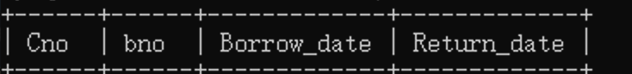

1. **when using add and drop like this:**

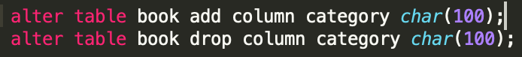



Drop can not add the type of data in the end;