# Database System Lab 3

学号：3170100186 姓名：王俊

## 实验目的

* Familiar with the method of data integrity control through SQL

## 实验平台：

* MySQL（全平台）

网上教程<http://www.runoob.com/mysql/mysql-tutorial.html>

## 实验内容

**1) Define several tables, including the definition of primary key, foreign key, and check.**

**2) Insert data into the table and examine how the primary key controls entity integrity.**

**3) Delete the rows in the referenced table, and examine how the on delete clause in the foreign key controls the referential integrity.**

**4) Modify the primary key of the row in the referenced table, and examine how the on update clause in the foreign key controls the referential integrity.**

**5) Modify or insert data in the table, and examine how the check clause controls the integrity of the check**

**6) Define an assertion and examine how assertions control data integrity by modifying the data in the table**

**7) Define a trigger and examine how the trigger works by modifying the data in the table**

**8) Complete the experiment report**

## 实验指导

（根据实验说明中的实验步骤，将每个步骤中输入的sql语句和输出结果截图）

**Integrity constraints ensure that the integrity of the data will not be destroyed when the database is modified. The integrity constraints include the following aspects:**

* **Constraints on a single relationship (not null, unique, check, default)**

**Example:**

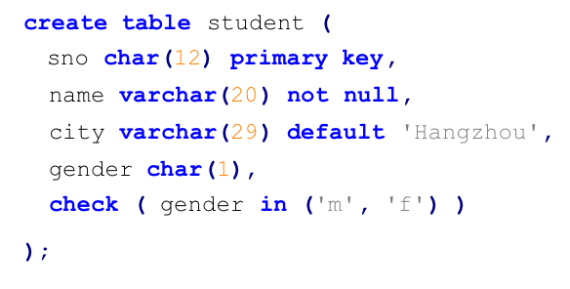

（mysql does not support check, so we use enum)

* **referential integrity:**

**By using a foreign key, a field in one table refers to another table, and you can specify how the corresponding row of the reference table should react when the data in the referenced table changes. You can use on delete [action] or on update [action] to specify the action performed by the corresponding row in the referenced table when the row in the referenced table is deleted or updated, respectively. actions include:**

* **no action: When a row is deleted or updated, if an existing row in another table references the key of the row, an error is generated and rolled back. (When no on delete or on update is specified, the default is no action);**
* **Cascas: When a row is deleted or updated, if an existing row in another table references the key of that row, the corresponding row in other tables will be deleted or updated together.**

**There are other actions such as set null and set default. When the corresponding row of the referenced table is deleted, the foreign key can be set to the specified value, which will not be described in detail here.**

**Example of use:**

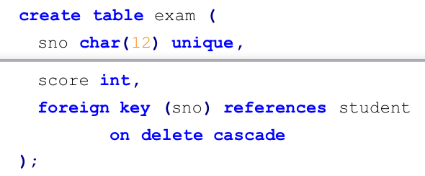

* **assertion**

**The assertion expresses the constraints on the database. The constraints on the single relationship and referential integrity are special forms of assertion. You can express more and more complex constraints by creating new assertions. The format for creating assertion is:**

**create assertion <assertion_name> check <predicate>;**

**(But MySQL does not support assertion, just for understanding)**

* **trigger**

**trigger specifies the command to be executed when the database is modified. In SQL Server, it is divided into after trigger and instead of trigger. The after trigger specifies the action to be performed after the update / insert / delete operation; the instead of trigger does not perform the original update / insert / delete operation when the corresponding action is triggered, and instead performs the user-specified action. MySQL is slightly different, divided into after triggers and before triggers. Students are advised to consult the relevant materials first to understand the trigger principle and writing method before performing this experiment.**

## 实验步骤

（根据实验说明中的实验步骤，将每个步骤中输入的sql语句和输出结果截图）

1. **On the basis of the table created in Experiment 2, add the following constraints: (Add the constraint condition using the statement ALTER TABLE <table_name> ADD CONSTRAINT <constraint_name> <constraint>):**

**Actual Code:**

**Since when I built the table, I have already took this into consideration and have no need to change it now：**

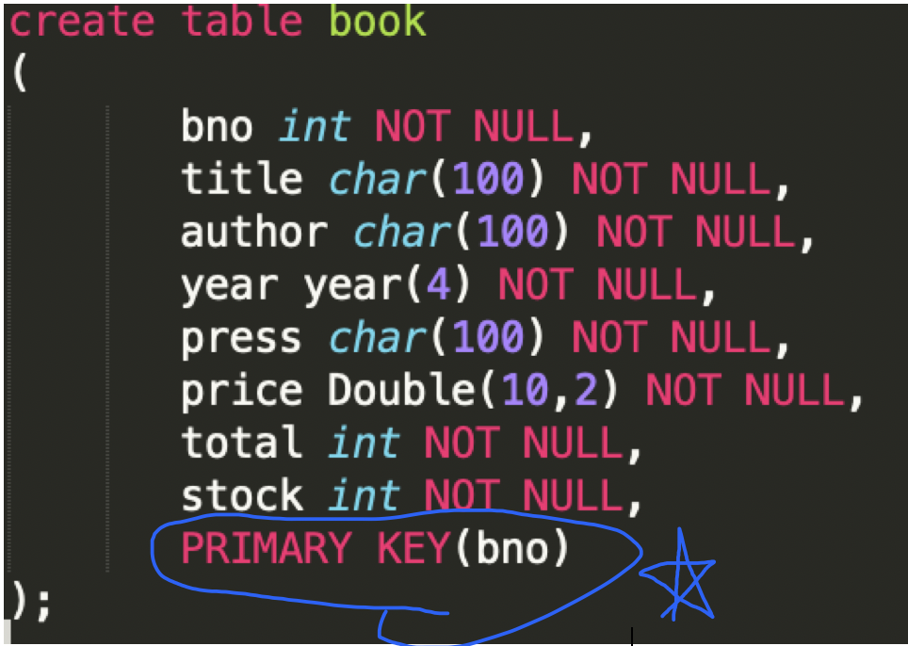

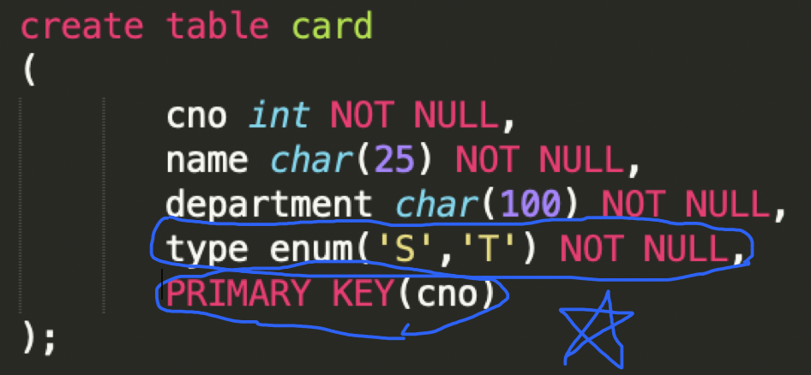

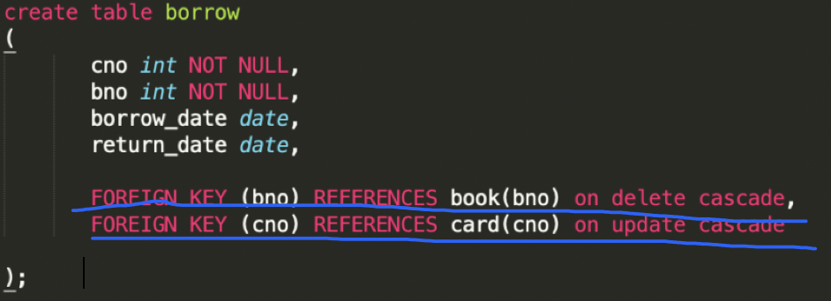

**a) The book table uses bno as the primary key**



**Because I have already created one, it would come out with a warning:**



**b) The card table uses cno as the primary key, and the type field can only take values in 'T' and 'S' (the enum field type can be used instead of the check statement)**



**Because I have already created one, it would come out with a warning:**



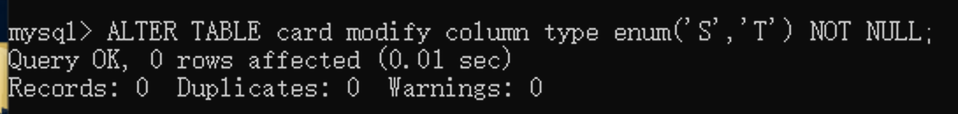

**c) In the borrow table, bno is used as the foreign key to refer to the book table. When the record in the book table is deleted, the corresponding record in the borrow table is also deleted (cascade delete); cno is used as the foreign key to refer to the card table. When the record is updated, the corresponding record in the borrow table is also updated (cascade update).**

**Code：**



1. **Insert the following line into the book table to see the system prompt:**

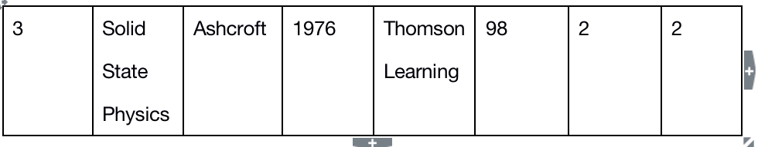

**There are two duplicate primary keys**

1. **Insert the following line into the card table to see the system prompt：**



**Original:**

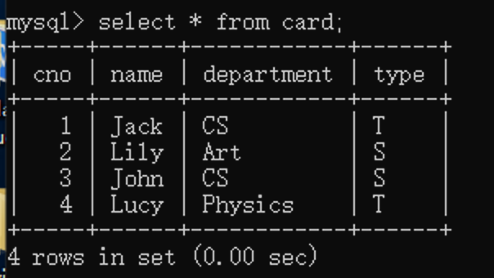

**Insert:**

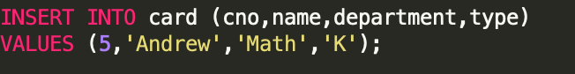

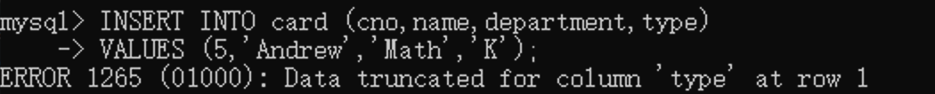

Data type does not match

1. **Can I delete Lily's library card in the card table? why?**

No, because it's the main table, as a foreign key to another table.

So you need to delete the data in borrow first, and then it is possible for you to delete it. Otherwise, you cannot delete it because there has a foreign key constraint.

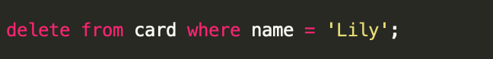

**5) In the book table, change the bno of the Computer Network book to 0004. Check the system prompt. Why is this happening? If we want to update this field successfully, and the corresponding record of the borrow table can also be updated automatically, how should we define the borrow table?**

**Check data in book:**

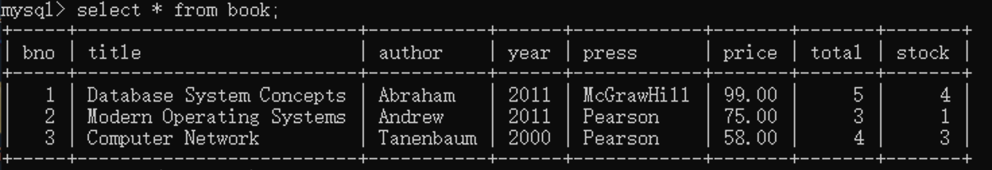

**The reason: it lacks the constraint about on update cascade, you need to add it.**

**In order to do that, first, you need to drop the constraint, and add a new constraint;**

**Code:**

**ALTER TABLE borrow drop Foreign Key book_no;**

**ALTER TABLE borrow ADD CONSTRAINT book_no FOREIGN KEY(bno) REFERENCES book(bno) on delete cascade on update cascade;**

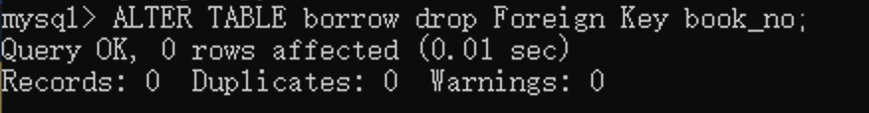**Code:**

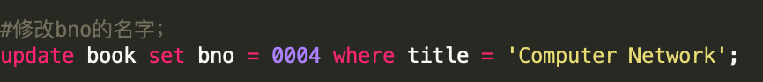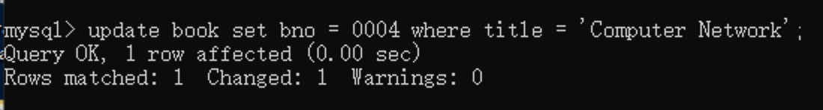

**After changing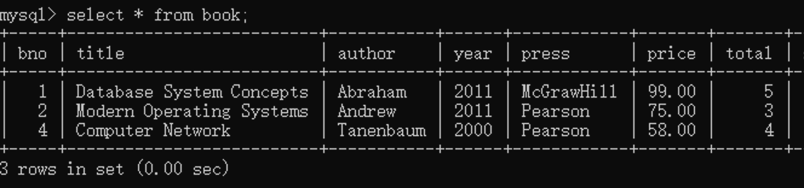:**

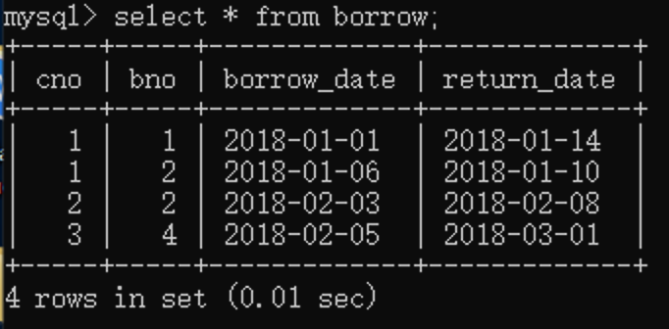

**6)Create a trigger so that when inserting a record into the borrow table, first check whether the book in the book table is in stock. If the inventory is not 0, then successfully lend it and reduce the book inventory in the book table by 1 ; If the inventory is 0, the lending operation is rejected (an exception can be thrown using the SIGNAL SQLSTATE statement), and the inventory is unchanged.**

**(Hint: you can use after trigger or before trigger, it is recommended to search the relevant information on the Internet first, familiar with the principle and use of trigger).**

**After setting the trigger, first try to borrow a book with sufficient inventory, and then check whether the book inventory has changed, and whether a record has been inserted into the borrow table. Then, try to borrow a book with 0 inventory, and then check The above information. In both cases, screenshots were taken and written in the experimental report.**

**After trigger code:**

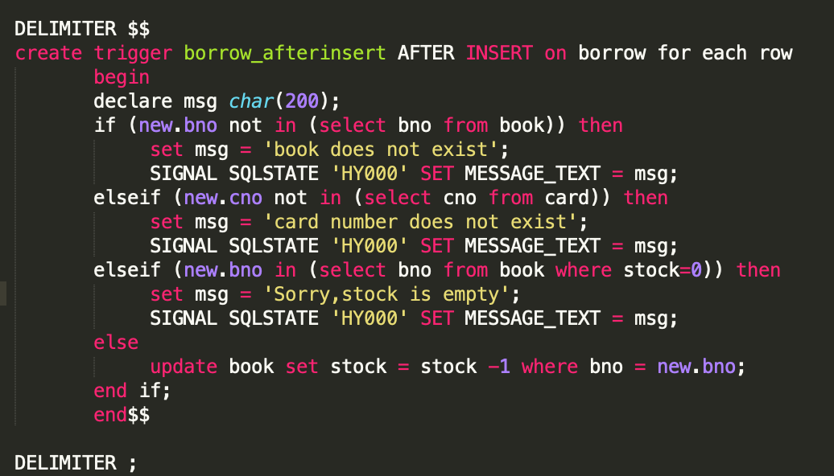

Test:

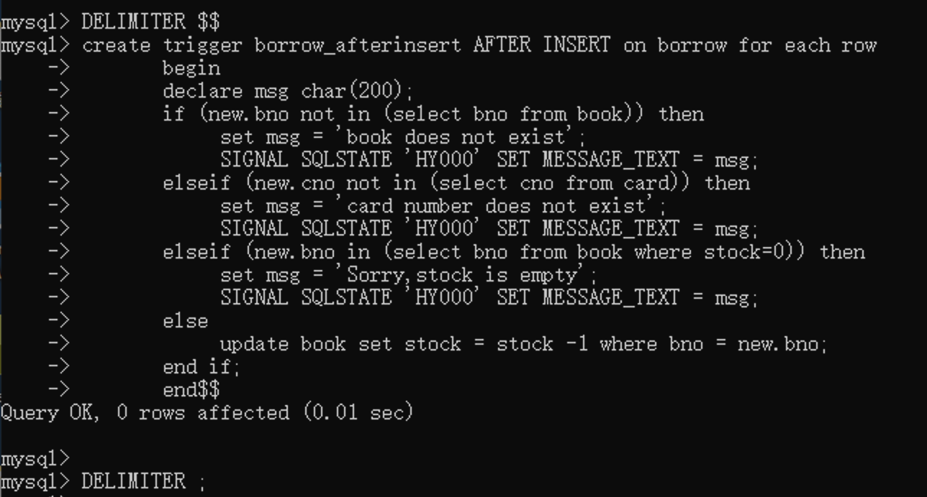

* **First situation:**

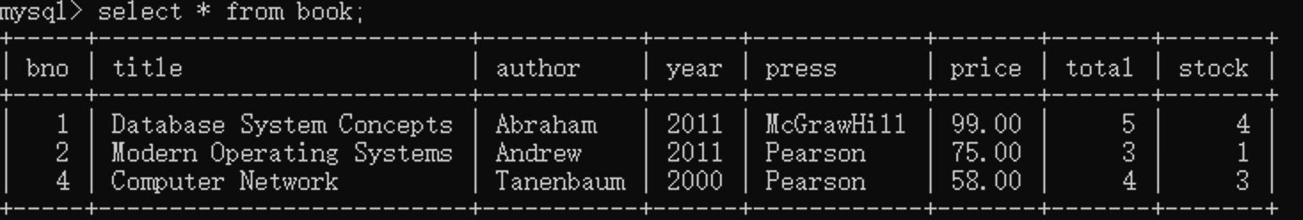Check the book:

insert

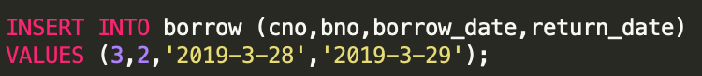

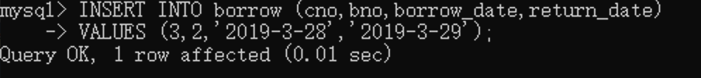

**Check in book and borrow;**

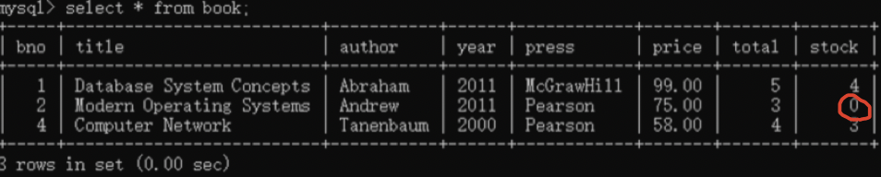

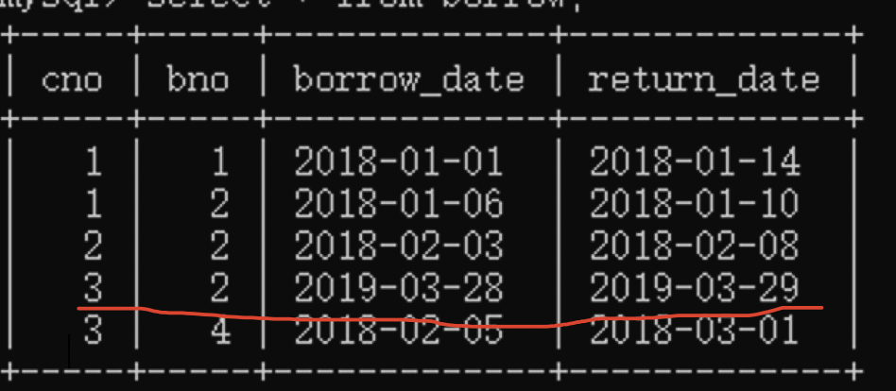

* **Second situation:**

**The stock of bno 2 now is 0!!!**

**Second insert:**

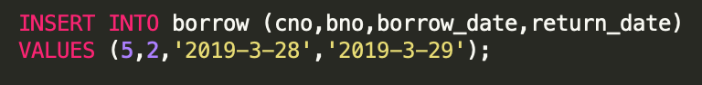

Since the book is empty we will get a warning;

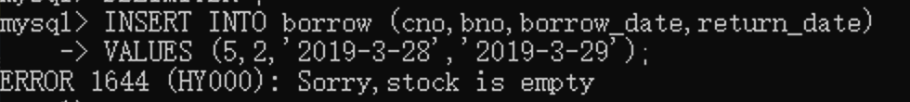

Check in borrow:

The record does not exist:

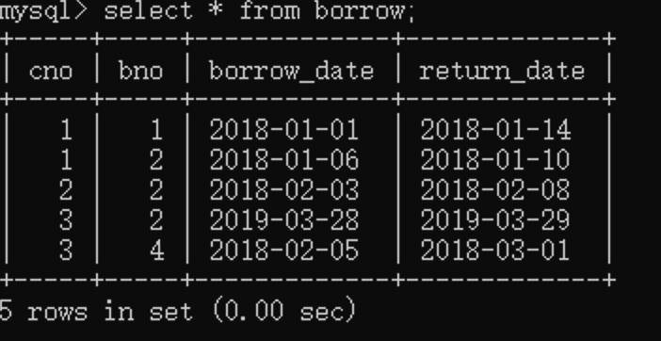

## 实验感想

1. **Can't add primary key repeatedly**

**Original:**





1. **After changing the foriegn key, it has another error:**

**Cannot add or update a child row: a foreign key constraint fails (`no3170100186`.`borrow`, CONSTRAINT `borrow_ibfk_2` FOREIGN KEY (`bno`) REFERENCES `book` (`bno`))**

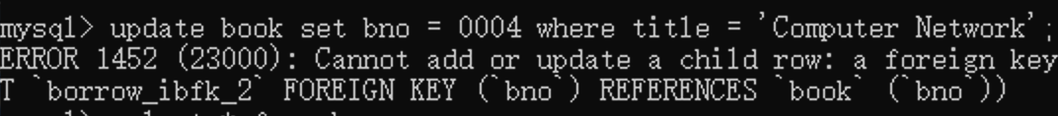

**Solution:**

**Drop the table and rebuild one;**

**Because at first when i created the table, it has an original foreign key which automatically name itself an index. And you need to drop it and create a new one**

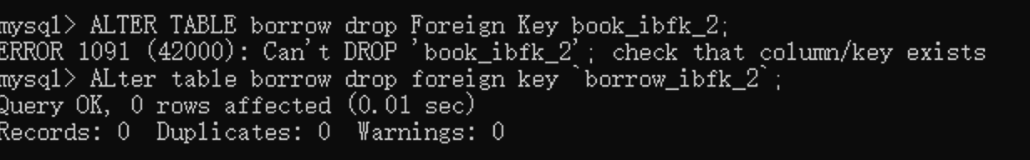

1. **Spelling problem:**

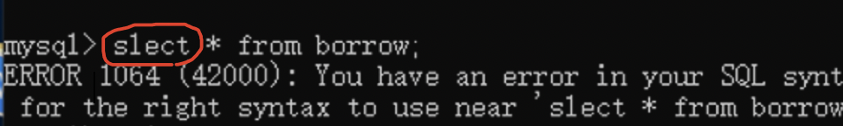

Use end if to Substitute endif：

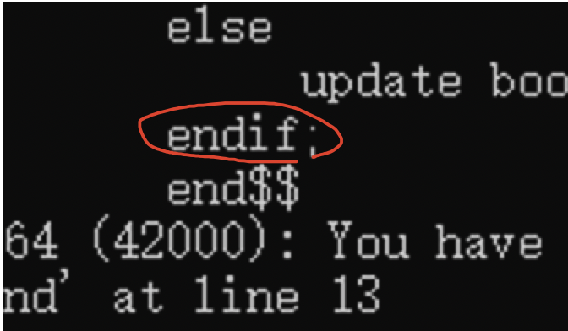

1. **Many problems were found in the process of using the database:**

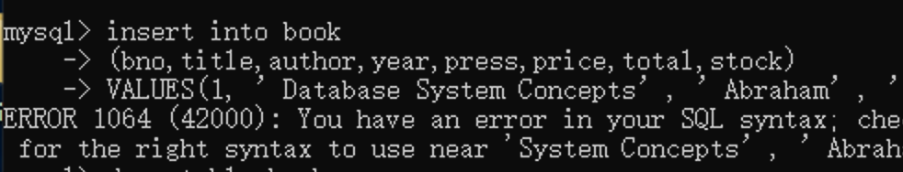

* Because there does not exist a use of ‘==’ to judge the equal;

You need to change it into ‘=’;

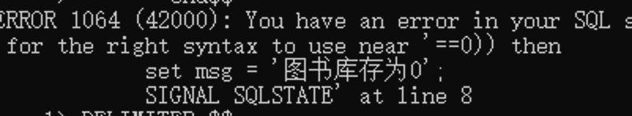

* Because the quotation marks is not in the right form and it will get to this:

And in this case, you need to input a quotation to get back to the original mode;



* The capitalization is the same in the code, but the table names and column names are different.

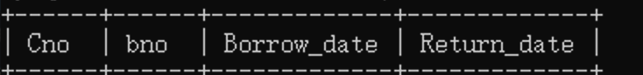

1. **when using add and drop like this:**

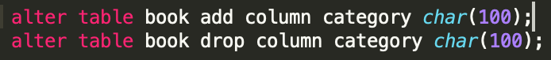



Drop can not add the type of data in the end;

**5.when use constraint like it :**



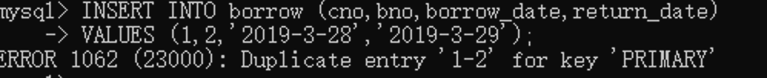

**Error would happen, because the primary key is wrong;**

1. **chinese can not be shown, you need to change it into english:**

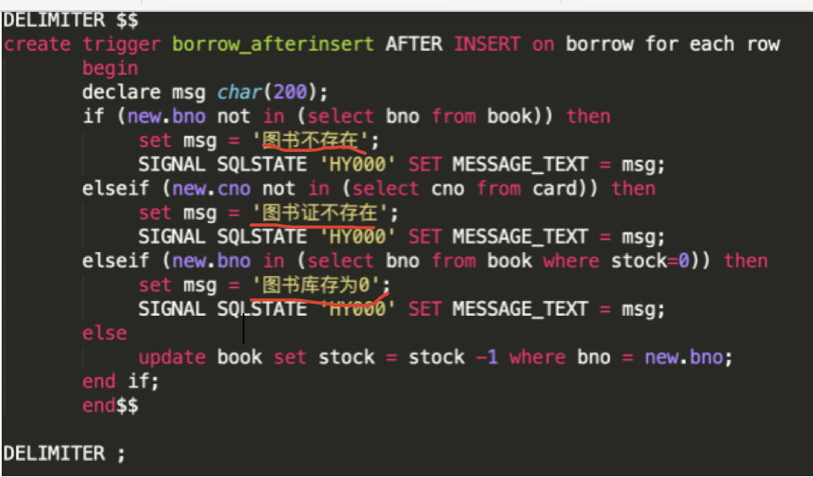

After changing into english:

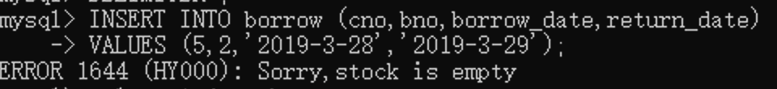

1. **The use of DELIMITER:**

The delimiter command specifies the terminator of the mysql interpreter command line. The default is ";"

To put it plainly is to tell where the command ends, and you can execute this command.

But generally there are multiple semicolons in the stored procedure. We don't want to execute the command as soon as we encounter the semicolon, so we can use the delimiter command to specify other terminator instead of ";"

This terminator can be defined by yourself. Commonly used are "//" and "$$"



You can use $$ to end it.



Pay attention to change it back.

