# Database System Lab 4

学号：3170100186 姓名：王俊

## 实验目的

* Familiar with the method of data integrity control through SQL

## 实验平台：

* MySQL（全平台）

网上教程<http://www.runoob.com/mysql/mysql-tutorial.html>

## 实验内容

* **Establish a table, check which permissions the table generator has**
* **Use SQL grant and revoke commands to authorize and recycle power for other users, and check the corresponding role**
* **Establish a view, and grant query permissions to other users to investigate the role of permission control through data**
* **Complete the experiment report**

## 实验指导

（根据实验说明中的实验步骤，将每个步骤中输入的sql语句和输出结果截图）

Before MySQL 5.7, you can directly create an account using the following command and give it corresponding access permissions:

**GRANT** **[**privilege**]** **ON** **[**database**].[**table_name**]** **TO**

**[**username**]**@**[**hostname**]** **IDENTIFIED** **BY** **[**password**];**

Among them, privilege indicates the permissions that need to be granted (select, insert, etc., or all indicates all permissions), hostname specifies which hosts users can log in from, set to localhost to indicate local login only, and% to indicate that they can be accessed from any host. remote access.After MySQL 5.7, you must first create users:

**CREATE** **USER** **[**username**]**@**[**hostname**]** **IDENTIFIED** **BY** **[**password**];**

Then use the authorization command:

**GRANT** **[**privilege**]** **ON** **[**database**].[**table_name**]** **TO** **[**username**]**@**[**hostname**]**

Note: In MySQL, by default, all users can access and operate the test database and the database whose name starts with test_ (even if they are not explicitly granted permissions), so in this experiment, the name of the new database cannot be test or Start with test_!

## 实验步骤

（根据实验说明中的实验步骤，将每个步骤中输入的sql语句和输出结果截图）

1. **Create two users A and B with root account**

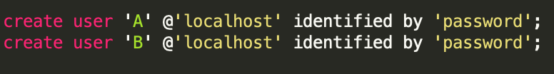

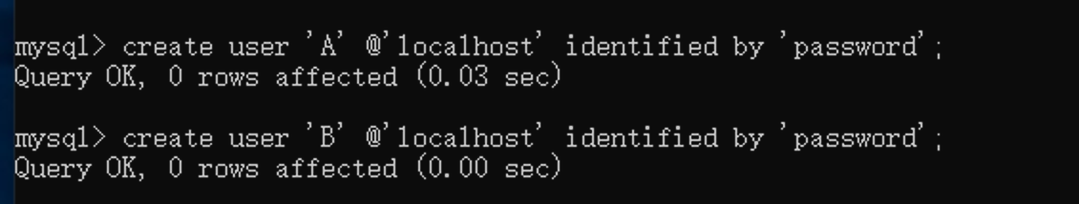

1. **Use the root account to create the database db1, and use the grant statement to give user A all permissions to the database (add the with grant option to the end of the command to grant permissions, so that user A can grant database permissions to other users);**

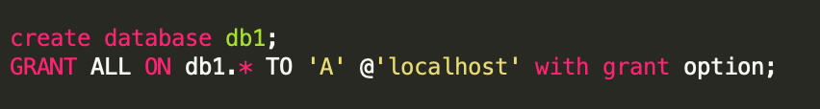

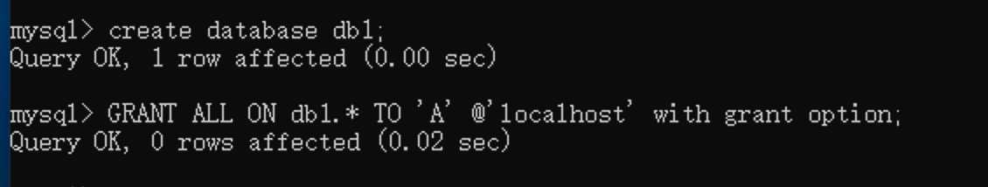

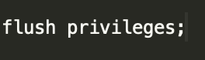

**Flush the privileges:**

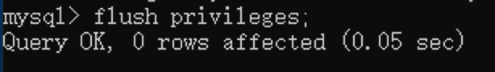

1. **Use user A to log in to the database db1, create a table book (bno char (4), stock int), and insert a record (‘0001’, 4)**

**Exit the root user:**



**Log in the A user:**



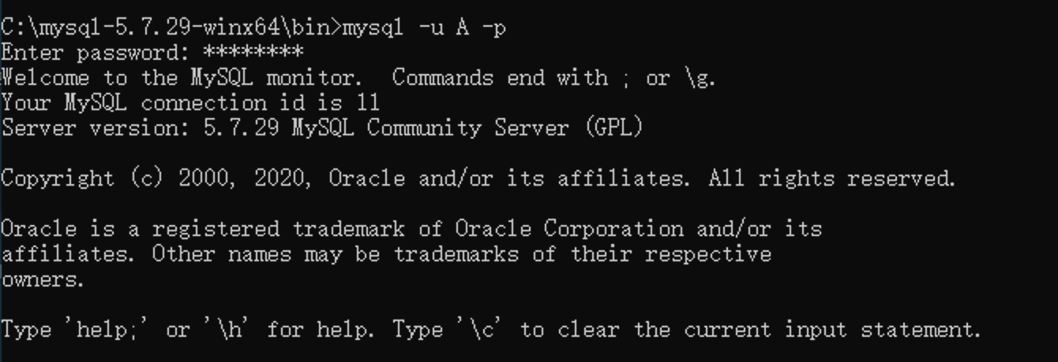

**Use db1 to create a table and insert a value:**

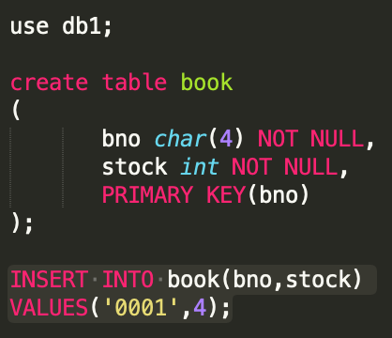

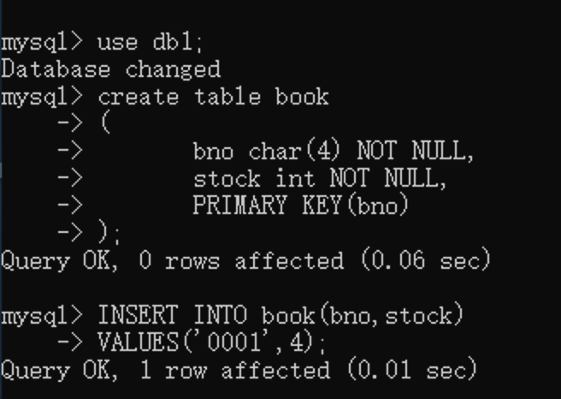

1. **Login with user B and see if you can access the database db1**

**First you need to exit：**

**First, you need to exit and then log into B:**

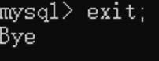



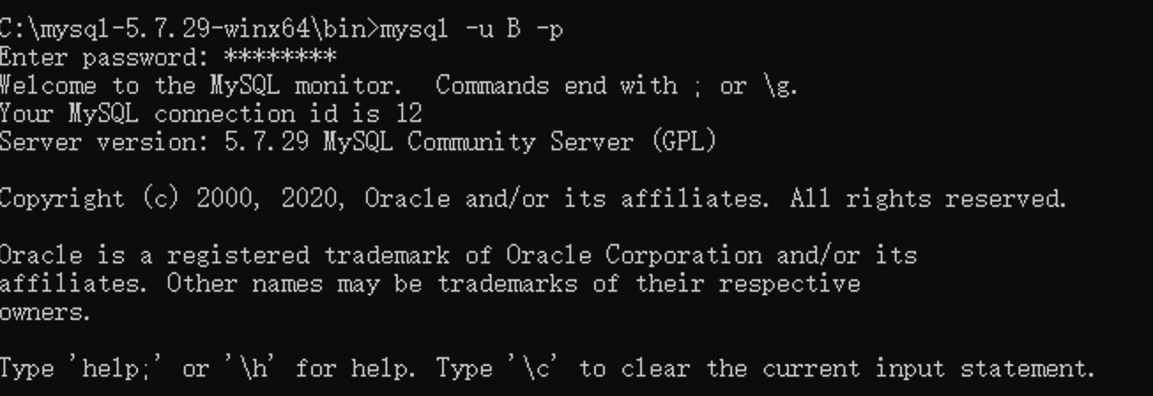

**you** **don’t have the access to db1;**

**5) Login with user A, and grant select and insert permissions to the book table by user B with the grant statement**

**First, you need to exit and then log into A:**



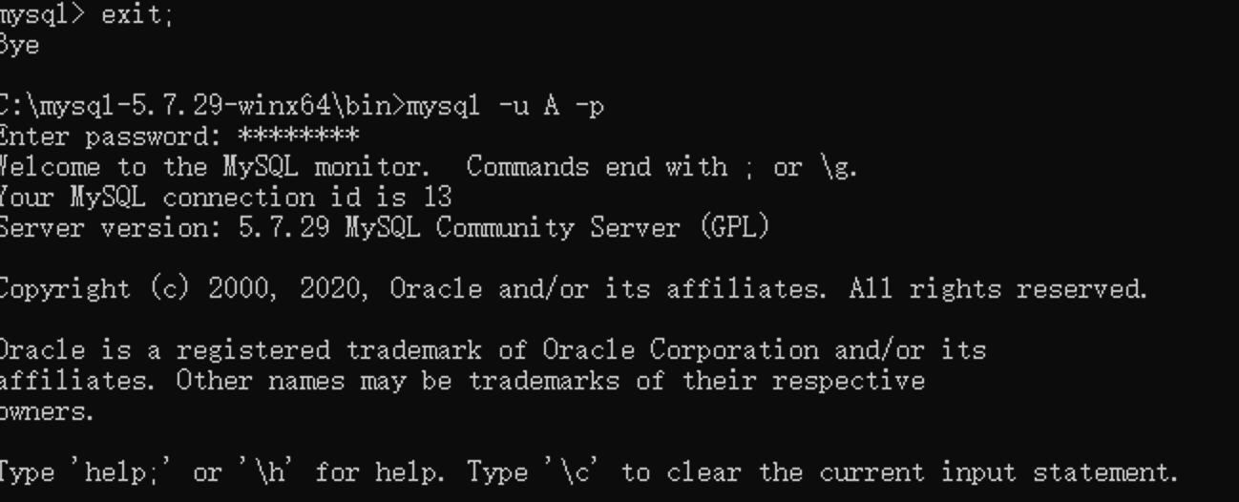

**Code:**



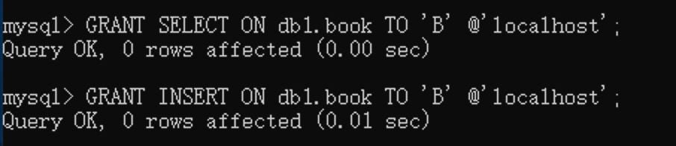

1. **Login with user B and test its query and insert operations on the book table**

**First, you need to exit and then log into B:(here we omit the process)**

**Code:**

**Exit;**

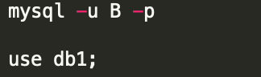



**Test Insert and select:**

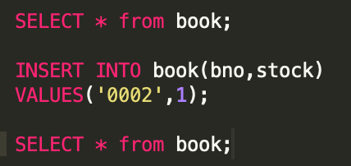

**RESULT:**

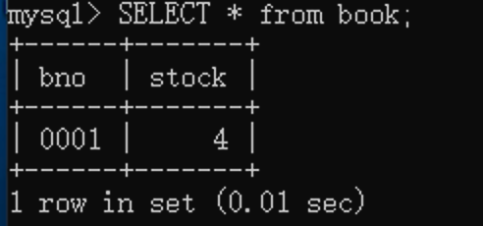

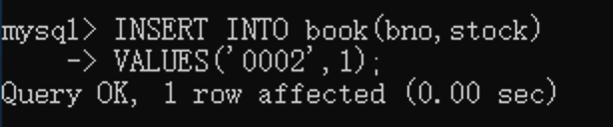

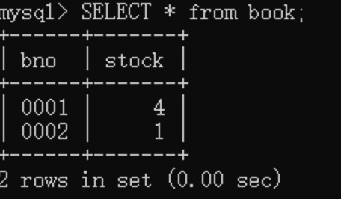

1. **Login with user A, use revoke command to recover user B's insert permission to book, and test permission with user B again**

**Code:**

**First exit and enter root:**

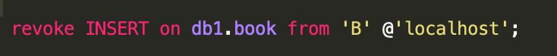





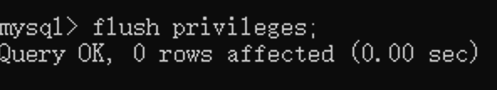

**Don’t Forget!!!**

**Then exit and enter B:**



**TEST RESULT**

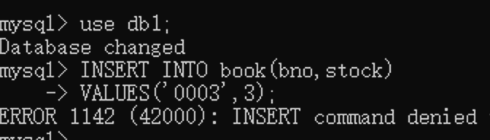

1. **Log in as the root user, create a view of the book table in the database db1, and test user A and user B's access to the view**

**First, exit and log into the root:**

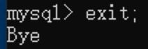

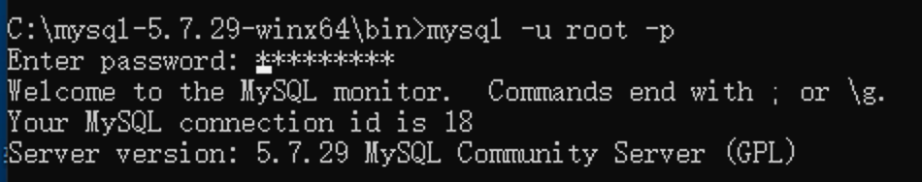

**Main code:**

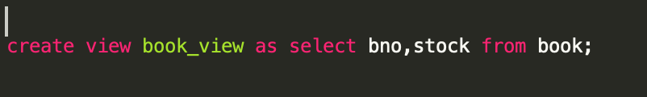

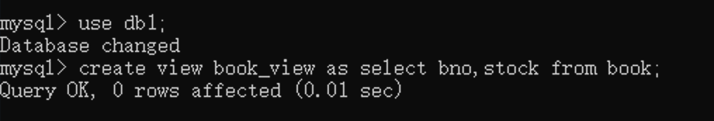

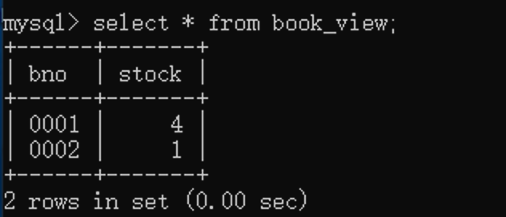

Log into A and B:

**A:**

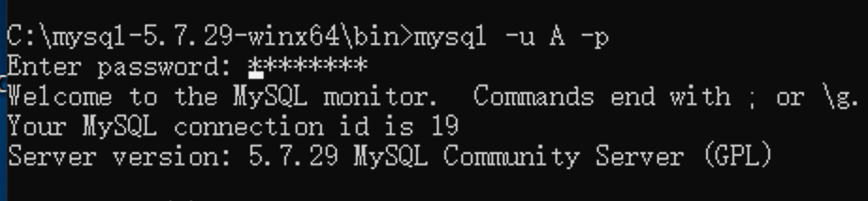

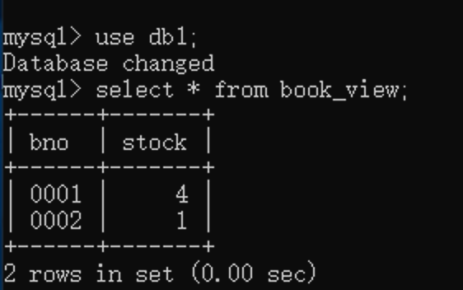

**A is able to access;**

**B:**

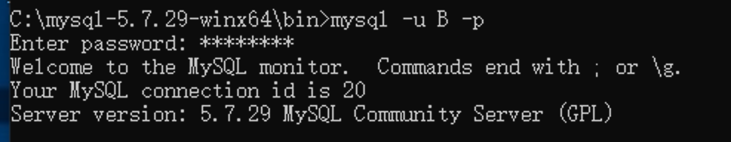

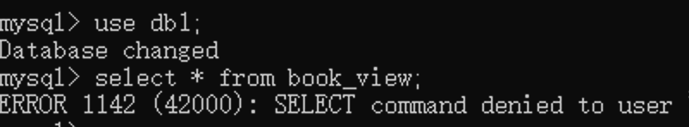

**B is not able to access;**

**9) Log in as root, give user B the select permission on the view, and test user B's access to the view again**

**First enter the root:**

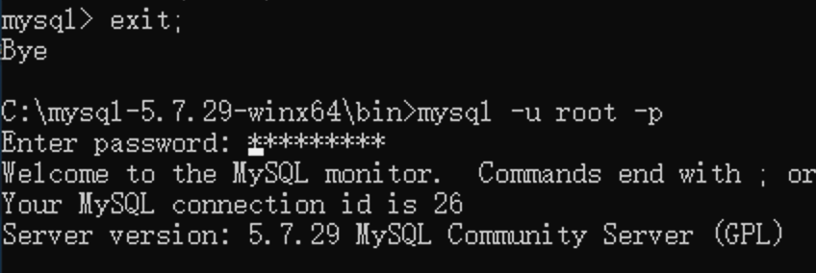

**Main code:**





**Enter into B and Test:**

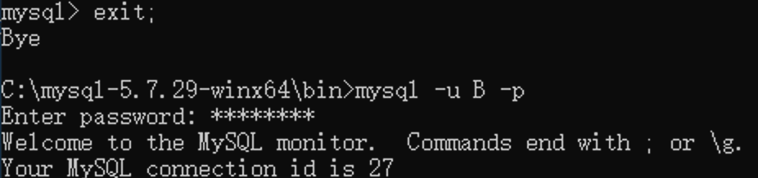



**B does have the privilege to do it:**

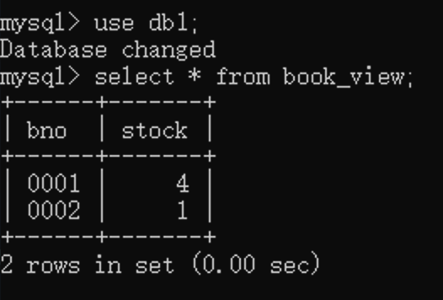

## 实验感想

1. **Can't use the format like this:**

**Original:**

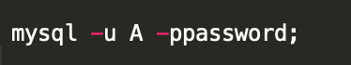

**The system does not allow the password to be displayed directly**

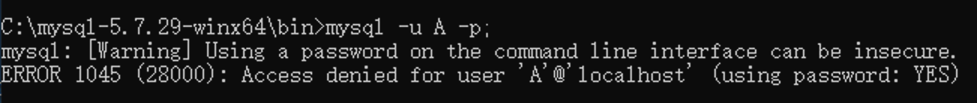

1. **After changing the privilege, it needs a flush，otherwise it would not work；**





1. **Spelling problem:**

* **@’localhost’ does not permit space in it:**

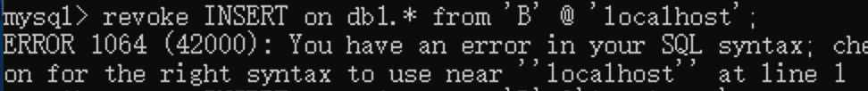

* **Use select and you don’t need to add table:**

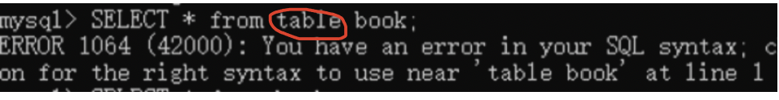

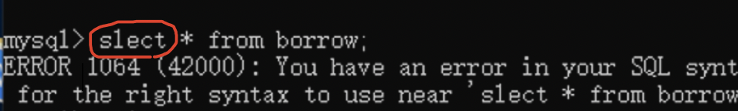

* **Use end if to Substitute endif：**

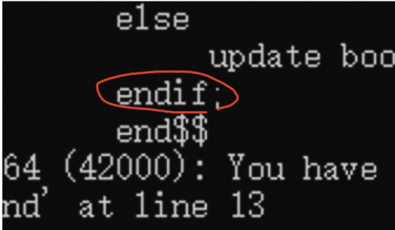

* **Because there does not exist a use of ‘==’ to judge the equal;**

**You need to change it into ‘=’;**

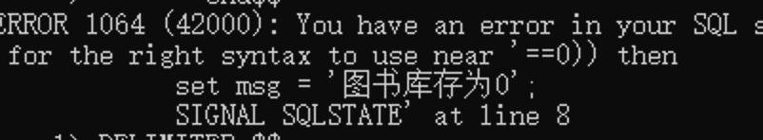

* **The capitalization is the same in the code, but the table names and column names are different.**

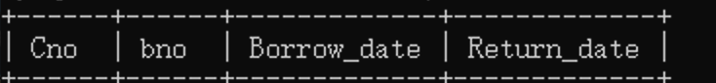

1. **Before you log into other user, you need to exit the current one:**

**Otherwise, it would show like this:**

**Code: mysql -u -p**

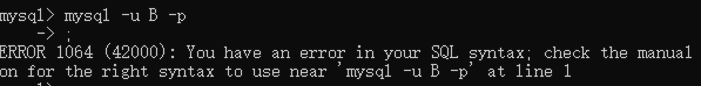

1. **If you want to share your privilege,you need to add “with grant option” in the end:**

**GRANT OPTION, the user is granted a certain permission, then by default, the user cannot grant this permission to others.**

**But you can use the WITH GRANT OPTION clause to allow the user to grant permissions to others**



1. **chinese can not be shown, you need to change it into english:**

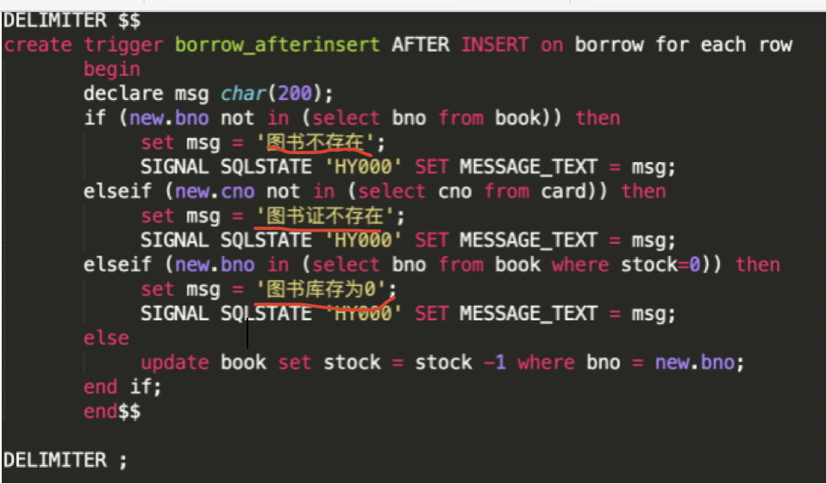

After changing into english:

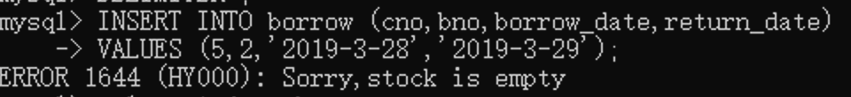

1. **When you log into the user A, you don’t have the access to do it:**



1. 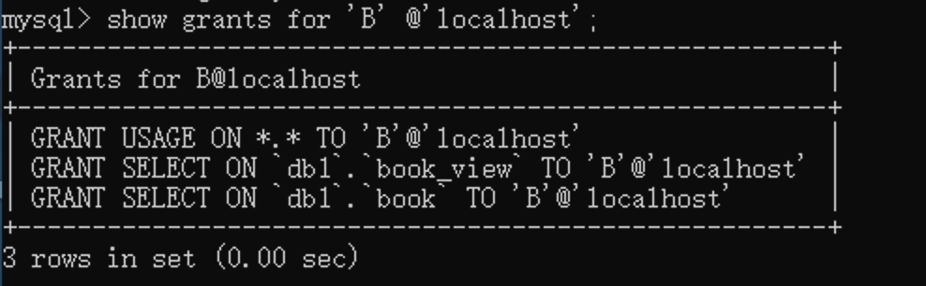**When you miss @’localhost’, you can not find the grants:**