**浙江大学2018 –2019 学年 春夏 学期**

**《Artificial Intelligence》课程期末考试试卷**

课程号： 21191890 ，开课学院：_计算机科学与技术学院_

考试试卷：**A卷**、~~B卷~~（请在选定项上打√）

考试形式：**闭**、~~开~~卷（请在选定项上打√），允许带___________入场

考试日期： 2019 年 7 月 1 日,考试时间： 120 分钟

**诚信考试，沉着应考，杜绝违纪。**

**考生姓名：**_____________**学号：**_____________**所属院系：**_____________

|  |  |  |  |  |  |  |  |  |  |
| --- | --- | --- | --- | --- | --- | --- | --- | --- | --- |
| **题序** | **一** | **二** | **三** | **四** | **五** | **六** | **七** | **八** | **总 分** |
| **得分** |  |  |  |  |  |  |  |  |  |
| **评卷人** |  |  |  |  |  |  |  |  |  |

1. **Fill in the blanks (20 points, 1 points/each blank)**
2. As shown in the figure below, we start from the state S and search the path to the goal sate G. Using the depth-first search approach, we expand the search node by going in depth and preserve the node list in a stack. When we reach to the goal state G, the depth-first search expand the node sequence as {S, __________, G } and finally stops at the node list as {__________} . With the edge cost on the search tree branches, the returned search cost is __________. Please write the search sequence of the visiting nodes and the final node list.

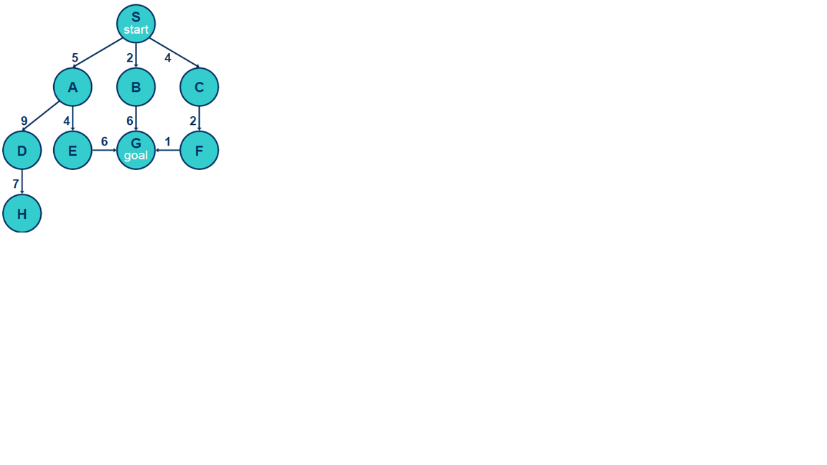

1. To measure the performance of the proposed search algorithm, we will evaluate its __________ ability that guarantees to find a solution when there is one. Moreover, we also want to analyze its __________, which is whether our search algorithm can find the optimal solution. Besides, the time complexity and space complexity of the algorithm are another two metrics we want to know exactly.
2. In a reinforcement learning problem, given two reward sequence (1,1,0,0) and (0,0,1,1) ) due to state transitions, assume γ=0.99, the discounted sum of rewards is________ and ________.
3. In an adversarial search, we want to compute an optimal strategy. __________ tell us how to evaluate the leaf states at the cut-off. To spare the search time cost, we can prune unnecessary parts of the search tree using the __________ approaches.
4. In the two-player adversarial search, for the MIN node achieved α denoted in the upper left site, we can prune the MIN node (at the lower-right site) and all its children when α is __________ than *n*. Symmetrically, for a MAX node achieved β in the upper left site, we also can prune a MAX node (at the lower-right site) and all its children when β is __________than *n*.

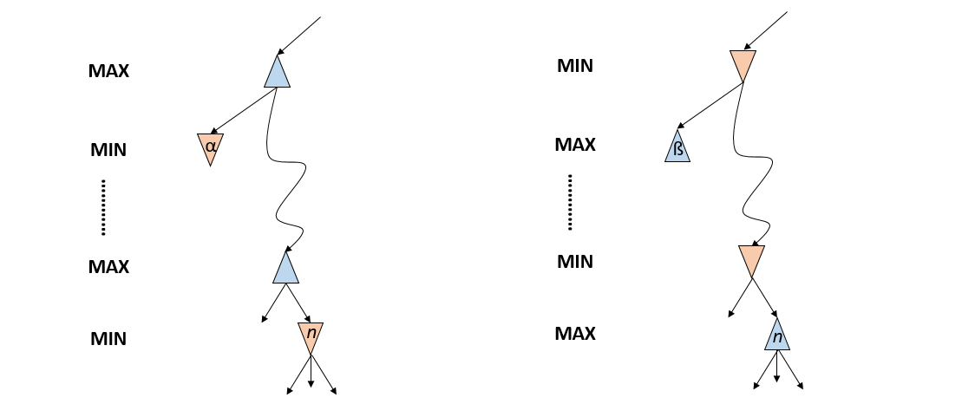

1. For the distribution $p\left(t | x, w,β\right)=N(t|y\left(x, w\right),β^{-1})$, where we have the assumption that the additive noise obeys to the standard normal distribution $N(0,β^{-1})$. The maximization of the logarithm likelihood solution of $w$ is equivalent to solve $w$ when the __________ (between estimated y(**x**n, **w**) and the labelled output tn) achieves its minimum value. The maximization posterior solution of w is equivalent to solve this cost function with a __________ term as the form of $λw^{T}w$.
2. Given the limited training data, we should divide the available data into three parts, including the training set, _________ and _________. We will select the model with the best generalization performance.
3. There are several approaches to solving decision problems in statistical learning method, all of which have been used in practical applications. One (i.e., the generative models) solves the inference problem usually by modeling the _________ distribution for each class individually, especially in the Bayesian learning theory. The second method (i.e., discriminant models) inferences the class label by calculating the _________probability directly.
4. As shown in the black diagram of the long-short term memory (LSTM) recurrent network “cell”, an input feature is computed with a regular artificial neuron unit. Its value can be accumulated into the state if the sigmoidal _________ gate allows it. The state unit has a linear *self-loop* whose weight is controlled by the ___________ gate. Please find the answer words in the following LSTM figure.

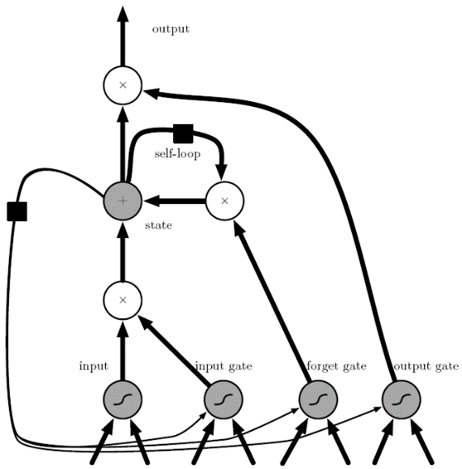

1. Fill in the values of each of the nodes in the following Minimax tree. The upward pointing trapezoids correspond to maximizer nodes (layer 1 and 3 for Player 1), and the downward pointing trapezoids correspond to minimizer nodes (layer 2 for Player 2). Each node has two actions available, Left and Right. Mark the sequence of actions in the following figure that correspond to Minimax play.

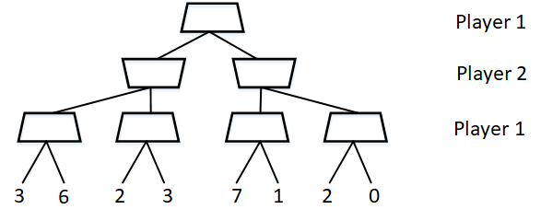

**2. Single Choice (50 points, only one of the options is correct. 2 points/one question)**

**1) Consider a graph search problem where for every action, the cost is at least $ϵ$, with $ϵ>0$. Assume the used heuristic is consistent. Which of the following statement is TRUE?**

A. Depth-first graph search is guaranteed to return an optimal solution

B. Greedy graph search is guaranteed to return an optimal solution

C. A* graph search is guaranteed to expand no more nodes than depth-first graph search.

D. A* graph search is guaranteed to expand no more nodes than uniform-cost graph search.

**2) Which of the following statement(s) is / are TRUE for Gradient Decent (GD) and Stochastic Gradient Decent (SGD)?**

(i) In GD and SGD, you update a set of parameters in an iterative manner to minimize the error function. (ii) In SGD, you have to run through all the samples in your training set for a single update of a parameter in each iteration. (iii) In GD, you either use the entire data or a subset of training data to update a parameter in each iteration.

A.i B. ii C. iii D. i, ii E. ii, iii F. i, ii, iii

**3) Below are the 8 actual values [0,0,0,1,1,1,1,1] of target variable in the train file. What is the entropy of the target variable?**

A. $-$ (5/8 log(5/8) + 3/8 log(3/8)) B. 5/8 log(5/8) + 3/8 log(3/8)

C. $–$ (3/8 log(5/8) + 5/8 log(3/8)) D. 5/8 log(3/8) – 3/8 log(5/8)

**4) Here are the defining equations for a LSTM cell.**

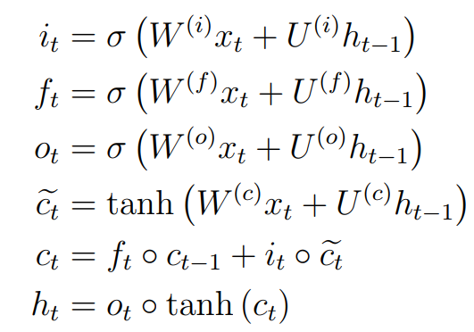

**Recall that ◦ denotes element-wise multiplication and that σ denotes the sigmoid function. Which of the following statement is TRUE?**

A. If xt is the 0 vector, then ht = ht-1.

B. If ft is very small or zero, then error will not be back-propagated to earlier time steps.

C. The entries of ft, it, ot are non-negative.

D. ft, it, ot can be viewed as probability distributions. (i.e., their entries are non-negative and their entries sum to 1.)

**5) Minmax is the canonical game search algorithms, which can return an optimal action assuming we have a perfect opponent play. Which one of the following options is FALSE:**

1. When the search tree are too large, Minmax is completely infeasible
2. We can limit the search depth to spare the memory space
3. Theoretically, Minmax is complete and optimal
4. The space complexity of minmax is O(bm), where b is the branching factor, m is the search depth.
5. **Cut-off strategy is usually used to reduce the search space. The effectivity of the cut-off strategy depends on the heuristic evaluation function, which can tune nonterminal nodes into terminal leaves. Which choice is FALSE:**
6. The proposed evaluation function should order the terminal states in the same way as the true utility function.
7. To make the search faster, the computation of the heuristic evaluation function cannot cost too long time.
8. Cut-off strategy is an imperfect real-time decision making approach;
9. The heuristic evaluation function of nonterminal states should not correlated with the actual chances of winning.
10. **A data set $X={\{x_{1},x_{2},…,x_{N}\}}^{T}$, which are drawn independently *(independent and identically distributed, i.i.d )* from a Gaussian distribution $N\left(μ,σ^{2}\right)$ whose mean $μ$ and variance $σ^{2}$ are unknown. We can get the likelihood function for the Gaussian as:**
11. $\prod_{n=1}^{T}{N\left(x_{n}|μ,σ^{2}\right)}$ B. $\prod_{n=1}^{N}{N\left(x_{n}|μ,σ^{2}\right)}$

C. $\sum_{n=1}^{N}{N\left(x_{n}|μ,σ^{2}\right)}$ D. $\sum_{n=1}^{T}{N\left(x_{n}|μ,σ^{2}\right)}$

1. **The *Fisher*’s linear discriminant criterion is defined as be _________**

A. the ratio of the distance between the projected mean of the two classes vs. the projected mean of the whole data set

1. the ratio of the projected mean of the whole data set vs. the distance between the projected mean of the two classes
2. Generalized Rayleigh quotient
3. the sum of the within-class variance and the between-class variance.
4. **For the perceptron, we minimize the perceptron criterion to seek the weight vector w. Given dataset $X={\{x_{1},x_{2},…,x_{N}\}}^{T}$, Denote $M$ as the set of all misclassified patterns , $ϕ_{n }$ as the feature of the input pattern $x_{n}$, and $t_{n}$ as the output class label for the input $x_{n}$. We want to minimize the error function ________ using the stochastic gradient descent algorithm in the iterative form as _______. $η$ is the learning rate parameter and $τ$ is the iterative step number.**
5. $-\sum_{n∈M}{w^{T}ϕ_{n }t_{n}}$, $w^{(τ+1)}= w^{τ}+ηϕ_{n }t_{n}$
6. $-\sum_{n=1}^{N}{w^{T}ϕ_{n }t_{n}}$, $w^{\left(τ+1\right)}= w^{τ}+ηϕ_{n }t_{n}$
7. $-\sum_{n=1}^{N}{w^{T}ϕ_{n }t_{n}}$, $w^{(τ+1)}= w^{τ}-ηϕ_{n }t_{n}$

$-\sum_{n∈M}{w^{T}ϕ_{n }t_{n}}, w^{\left(τ+1\right)}= w^{τ}-ηϕ_{n }t_{n}$

**10) Since K-means clustering is an iterative process, we need to set its iteration termination conditions. Which of the following sentences correctly describes the iteration termination condition of K-means clustering?**

A. Has formed K clustering sets, or has reached the upper limit of iteration times.

B. Has reached the upper limit of iteration times, or the centroid of clustering remains basically unchanged in the two iterations before and after.

C. Has reached the upper limit of iteration times, or each sample to be clustered belongs to a unique cluster set.

D. K clustering sets have been formed, or each sample to be clustered belongs to a unique clustering set.

**11) Assume $q(z)$ is a distribution defined over the latent variables, and we have defined $L\left(q, θ\right)=\sum_{z}{q(z)ln⁡\{\frac{p(X,Z|θ)}{q(z)}\}}$ and $KL(q|\left|p\right)=-\sum_{z}{q(z)ln⁡\{\frac{p(Z|X, θ)}{q(z)}\}}$, for any choice of $q(z)$, which of the following decomposition holds? _______**

A. $L\left(q, θ\right)=lnp\left(X | θ\right)+KL(q|\left|p\right)$ B. $lnp\left(X | θ\right)=L\left(q, θ\right)+KL(q|\left|p\right)$

C. $KL(q|\left|p\right)= lnp\left(X | θ\right)+L\left(q, θ\right)$ D. $L\left(q, θ\right)= lnp\left(X, Z | θ\right)+KL(q|\left|p\right)$

**12) According to the intuitive definition of reinforcement learning, which one is TRUE in the following choices?**

A. Reinforcement Learning learns the map from environment input *x* to the corresponding label *y*

B. Reinforcement Learning discover data structures and patterns of the dataset in the unsupervised manner

C. With the environment feedback, reinforcement learning conducts the sequential decision process to find the optimal trajectory

D. Reinforcement learning algorithms require a fully-observable and accurately sensible environment model

**13) Which method is NOT utilized in expectation-maximization (EM) algorithm to find out the suboptimal solution?**

A. Closed-form solution

B. Gradient-descent solution

C. Iterative method

D. Expectation estimation

**14) Which of the following statements about the properties of A* search is NOT correct? _____**

A. The tree-search version of A* is optimal if the heuristic function h(n) is admissible

B. The graph-search version of A* is optimal if the heuristic function h(n) is consistent

C. If h(n) is an admissible heuristic function, then it overestimates the cost to reach the goal

D. Every consistent heuristic is also admissible.

1. **KL(*p*||*q*) is the relative entropy or KL divergence between the distributions *p*(x) and *q*(x) and I[x, y] is the mutual information between two sets of variables x and y. Consider the joint distribution between x and y given by *p*(x, y). If two sets of variables x and y are independent, then which of the following statements is FALSE? ____.**

A. I[**x**, **y**] $>0$ B. KL(*p*||*q*) $≥0$ C. KL(*p*||*q*) $≢$ KL(*q*||*p*) D.I[**x**, **y**] $=0$

**16）Assume that we have one input sequence $(x_{1},x_{2},x_{3})$ as well as its ground-truth output sequence $(y_{1},y_{2},y_{3})$ and the predicted output sequence $(O_{1},O_{2},O_{3})$. The error is defined as $E_{i}=\frac{1}{2}{(y_{i}-O_{i})}^{2}$. Which one is the correct derivative of the error $E_{3}$ with respect to $W_{x}$?**

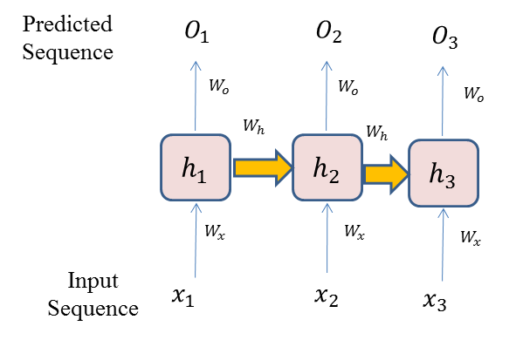



$\frac{∂E_{3}}{∂W_{x}}=\frac{∂E_{3}}{∂O_{3}}\frac{∂O_{3}}{∂h_{3}}\frac{∂h_{3}}{∂W_{x}}+\frac{∂E_{3}}{∂O_{3}}\frac{∂O_{3}}{∂h_{3}}\frac{∂h_{3}}{∂h_{2}}\frac{∂h_{2}}{∂W_{x}}+\frac{∂E_{3}}{∂O_{3}}\frac{∂O_{3}}{∂h_{3}}\frac{∂h_{3}}{∂h_{2}}\frac{∂h_{2}}{∂h_{1}}\frac{∂h_{1}}{∂W_{x}}$

$\frac{∂E_{3}}{∂W_{x}}=\frac{∂E_{3}}{∂O_{3}}\frac{∂O_{3}}{∂h_{3}}\frac{∂h_{3}}{∂W_{x}}$

C. $\frac{∂E_{3}}{∂W_{x}}=\frac{∂E_{3}}{∂O_{3}}\frac{∂O_{3}}{∂h_{3}}\frac{∂h_{3}}{∂W_{x}}+\frac{∂E_{2}}{∂O_{2}}\frac{∂O_{2}}{∂h_{2}}\frac{∂h_{2}}{∂W_{x}}+\frac{∂E_{1}}{∂O_{1}}\frac{∂O_{1}}{∂h_{1}}\frac{∂h_{1}}{∂W_{x}}$

D. $\frac{∂E_{3}}{∂W_{x}}=\frac{∂E_{3}}{∂O_{3}}\frac{∂O_{3}}{∂h_{3}}\frac{∂h_{3}}{∂W_{x}}+\frac{∂E_{3}}{∂O_{3}}\frac{∂O_{3}}{∂h_{3}}\frac{∂h_{3}}{∂W_{h}}$

**17) Which sentence is FALSE in terms of the traditional recurrent neural network (RNN) and LSTM (long short-term memory) model?**

A. In LSTM, there are input gate, output gate and forget gate.

B. LSTM can avoid the problem of gradient vanishing.

C. Unlike LSTM, RNN cannot encode the temporal dependence among sequential data.

D. The parameters in LSTM and RNN can be optimized by error backpropagation.

**18) We can structure the correlation degree between two groups of variables to a certain value range. The Pearson Correlation between X and Y is denoted as $corr\left(X,Y\right)$. Which description sentence is FALSE in the following sentence?**

1. Pearson Correlation coefficient measures the degree of linear correlation between variable X and Y. The bigger $|corr\left(X,Y\right)|$, the greater linear correlation between these two variables is.
2. $\left|corr\left(X,Y\right)\right|=0$ means no linear correlation between X and Y (There might be nonlinear correlation between them).
3. If X and Y are independent, then $\left|corr\left(X,Y\right)\right|=0$, and there is no linear or nonlinear relationship between X and Y.
4. If X and Y are uncorrelated, they must be independent.

**19) What are some practical problems with the sigmoidal activation function in neural nets?**

A. It is convex, and convex functions cannot solve nonconvex problems.

B. It can have negative values.

C. It does not work well with the entropy loss function.

D. Gradients are small for values away from 0, leading to the “Vanishing Gradient” problem for large or recurrent neural nets.

**20) Which of the following statements is FALSE in describing probability approximately correct (PAC) ?**

A. Strong learnable model means that the learning model can recognize and classify most samples with high accuracy.

B. Strong learnable model means that the learning model can only recognize and classify some samples, and its accuracy is slightly higher than that of random guess.

C.Strong learning and weak learning are equivalent, that is, if a "weak learning algorithm" has been found, it can be boosted to a "strong learning algorithm".

D. Under the background of approximate correctness of probability, there are "strong learnable model" and "weak learnable model".

**21) Which search algorithm imposes a fixed depth limit on nodes?**

A. Depth-limited search

B. Depth-first search

C. Iterative deepening search

D. Bidirectional search

**22) Which of the following machine learning methods does not utilize annotated data?**

A. Semi-supervised Learning

B. Unsupervised Learning

C. Regression analysis

D. Supervised learning

**23) Since K-means clustering is an iterative process, we need to set its iteration termination conditions. Which of the following sentences correctly describes the iteration termination condition of K-means clustering?**

A. Has formed K clustering sets, or has reached the upper limit of iteration times.

B. Has reached the upper limit of iteration times, or the centroid of clustering remains basically unchanged in the two iterations before and after.

C. Has reached the upper limit of iteration times, or each sample to be clustered belongs to a unique cluster set.

D. K clustering sets have been formed, or each sample to be clustered belongs to a unique clustering set.

**24) In reinforcement learning, through which two steps of iteration, to learn the best strategy?**

A. Dynamic Programming and Q-Learning

B.Q-learning and greedy strategy optimization

C. Policy improvement and policy evaluation

D. Value function calculation and action-value function calculation

1. **Boosting is a typical ensemble learning method to construct a strong leaner by:**
2. training the weak base classifiers in parallel
3. the items in the dataset are treated equally with the same weight
4. the prediction is achieved by the weighted majority voting schema
5. only apply to the classification problem
6. **Calculus and Analysis (30 points)**
7. (**Neural Network, 8 points**) Backpropagation is used to efficiently train neural networks (NNs) following a gradient descent approach that exploits the chain rule. Given some function $f\left(x\right)$ where $x$ is a vector of inputs and we are interested in computing the gradient of $f\left(x\right)$ at $x$. Let $f\left(x\right)=σ(w_{0}x_{0}+w_{1}x_{1}+w_{2})$, where $w_{0}, w_{1} and w_{2}$ are the parameters and $σ()$ is sigmoid function (${dσ(x)}/{dx}=\left(1-σ\left(x\right)\right)σ\left(x\right), σ\left(1\right)=0.73,{\frac{dσ(x)}{dx}|}_{x=1}=0.2$), please compute the gradient ${∂f}/{∂w_{0}}$, ${∂f}/{∂x_{0}}$, ${∂f}/{∂w_{1}}$ and ${∂f}/{∂x_{1}}$, and at ($w_{0},x_{0},w_{1},x_{1}, w_{2}$)=(2,-1,-3,-2,-3):

w0

x0

w1

x1

w2

2.00

-1.00

-3.00

-2.00

-3.00

*f(x)*

*

*

+

+

$$σ$$

(a) ${∂f}/{∂w_{0}}=$___________ (b) ${∂f}/{∂x_{0}}=$___________ (c) ${∂f}/{∂w_{1}}=$___________ (d) ${∂f}/{∂x_{1}}=$

___________

1. (**Deep learning, 8 points**)

(a) Convolution is very important in deep convolutional neural network. Given 7*7 input shown in Figure (1) and 3*3 convolutional kernel in Figure (2), please calculate the convolution output of the top line with stride 2 and no padding. (2 points)

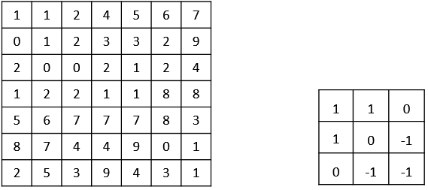

Figure (1) Figure (2)

(b) Given same input and filter as (a), please calculate the convolution output at the upper left corner with stride 1 and zero padding. (2 points)

(c) what are the output sizes of convolution layer in (a) and (b), respectively? (2 points)

(d) Given a single depth slice in Figure (3), please give out the max-pooling value of this slice with 2×2 filters and stride 2. (2 points)

|  |  |  |  |
| --- | --- | --- | --- |
| 1 | 1 | 2 | 4 |
| 5 | 6 | 7 | 8 |
| 3 | 2 | 1 | 0 |
| 1 | 2 | 3 | 4 |

Figure (3)

1. (**Reinforcement Learning, 8 points**) In robot movement problem, the definitions of state, action, decay factor, initial/terminal state, and reward are as follows:

states: $S=\{s_{1},s_{2},…,s_{9},s_{d}\}$

actions: $A=\{up, right\}$

decay factor: $γ=0.99$

initial state: $S_{0}=s_{1}$

terminal state: $S_{T}=\{s_{9},s_{d}\}$

reward: $R=\left\{\begin{aligned}1, if S_{t+1}=s_{9} \\ -1, if{ S}_{t+1}=s_{d} \\ 0, otherwise\end{aligned}\right.$

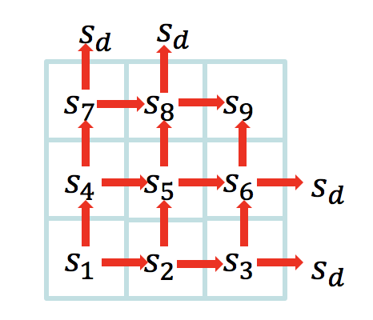

**Referring to** the given Q-learning algorithm and initialization, compute the corresponding q value function and policy after the first and second episode. (The q function and policy is required to provide in separate tables. Keep 3 digits after the decimal point.)

**Initialize $q_{π}$** : $a/b$ represents $q_{π}\left(s, up\right)=a$, $q_{π}\left(s, right\right)=b$. The value of the $q$ function of all terminal states is set to $0/0$, and the rest of the state can be randomly initialized, here set $0.2⁄0$.

**Initialize** s: $s_{1}$.

The algorithm of Q-Learning is as follows:

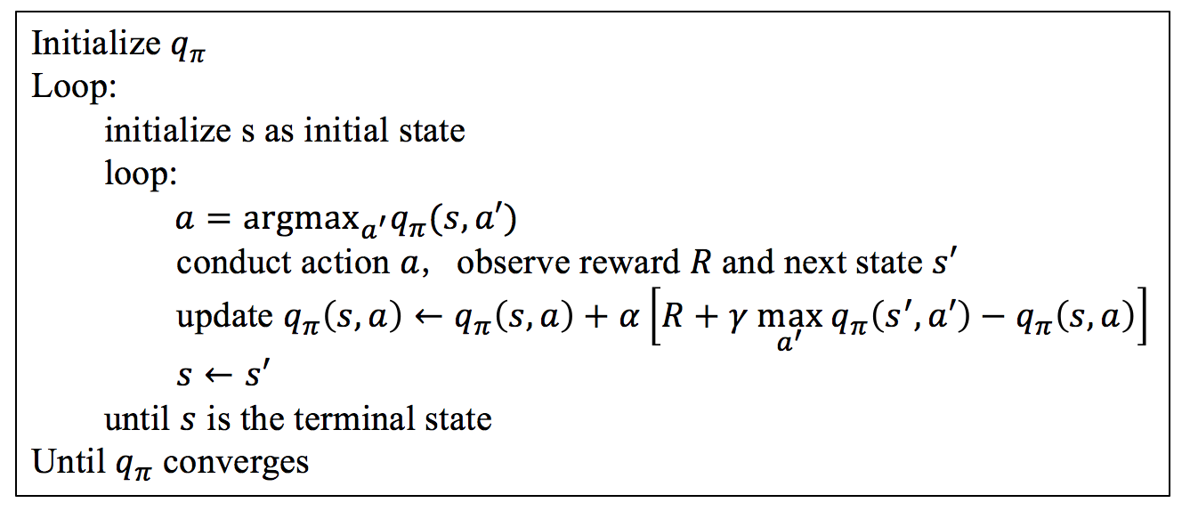

1. Please list out the initial state and the action policy before the first episode (both in a 3*3 table) (2 points)
2. Please denote all the terminal states in the state table (2 points).
3. Please calculate the q value and present the policy for each state after the first episode (2 points)
4. Please calculate the q value and present the policy for each state after the second episode (2 points)
5. (**PCA, 6 points**) Eigenface method is a principal component analysis method for face image dimensionality reduction.
6. Please give out the summary description of the Eigenface method (3 points).
7. Please describe the advantages and disadvantages of the Eigenface method (3 points).

**《Artificial Intelligence》**

**Final Examination Answer Sheet**

**Name： Student ID： Dept.： _**

|  |  |  |  |  |
| --- | --- | --- | --- | --- |
| **Section** | **1** | **2** | **3** | **Total** |
| **Score** |  |  |  |  |
| **Reviewer** |  |  |  |  |

1. **Fill in the blanks (20 points, 1pt/per)**

**1).______________________, _______________________, _______________________**

**2). _____________________, _______________________**

**3)._____________________ , _______________________**

**4). _____________________, _______________________**

**5)._____________________ , _______________________**



**6). _____________________, _______________________**

**7)._____________________, _______________________**



**8)._____________________ , _______________________**

**9)._____________________ , _______________________**

**10).**



1. **Multiple Choice (50 points, 2pt/per)**

|  |  |  |  |  |  |  |  |  |  |
| --- | --- | --- | --- | --- | --- | --- | --- | --- | --- |
| **1** | **2** | **3** | **4** | **5** | **6** | **7** | **8** | **9** | **10** |
|  |  |  |  |  |  |  |  |  |  |
| **11** | **12** | **13** | **14** | **15** | **16** | **17** | **18** | **19** | **20** |
|  |  |  |  |  |  |  |  |  |  |
| **21** | **22** | **23** | **24** | **25** |  |  |  |  |  |
|  |  |  |  |  |  |  |  |  |  |

**3. Calculus and Analysis (30 points)**

**1) (Neural Network, 8 points)**

(a) ${∂f}/{∂w_{0}}=$___________ (b) ${∂f}/{∂x_{0}}=$___________ (c) ${∂f}/{∂w_{1}}=$___________ (d) ${∂f}/{∂x_{1}}=$

___________

**2) (Deep Learning, 8 points)**

**(a) (2 points)**

**(b) (2 points)**

**(c) (2 points)**

**(d) (2 points)**

**3) (Reinforcement Learning, 8 points)**

**(a) (2 points)**

**(b) (2 points)**

**(c) (2 points)**

**(d) (2 points)**

**4) (PCA, 6 points)**

1. **(3 points)**
2. **(3 points)**