1. **Fill in the blanks (20 points, 1 points/each blank)**
2. (A,D, H,E; B, C; 15)
3. (completeness, optimality)
4. (1.99;1.9504)
5. (evaluation function; alpha-beta pruning)
6. (larger; less)
7. (sum of square error, SSE; regularization)
8. (validation set, test set)
9. ([class] conditional; posterior [class])
10. (input, forget)

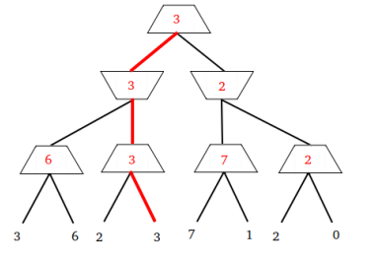

**2. Single Choice (50 points, only one of the options is correct. 2 points/ one question)**

DAACD DBCAB

BCACA ACDDB

ABBCC

1. **Calculus and Analysis (30 points)**
   1. **(Answer: -0.2, 0.4, -0.4, -0.6)**

2)

(a) **(Answer: 0, 2, -1)**

(b) **(Answer: -2)**

(c) **(Answer: 3*3, 7*7)**

(d) **(Answer: 6, 8,**

**3, 4)**

3)Answer：

(a) S1; (b) Sd, S9

(c) (d)

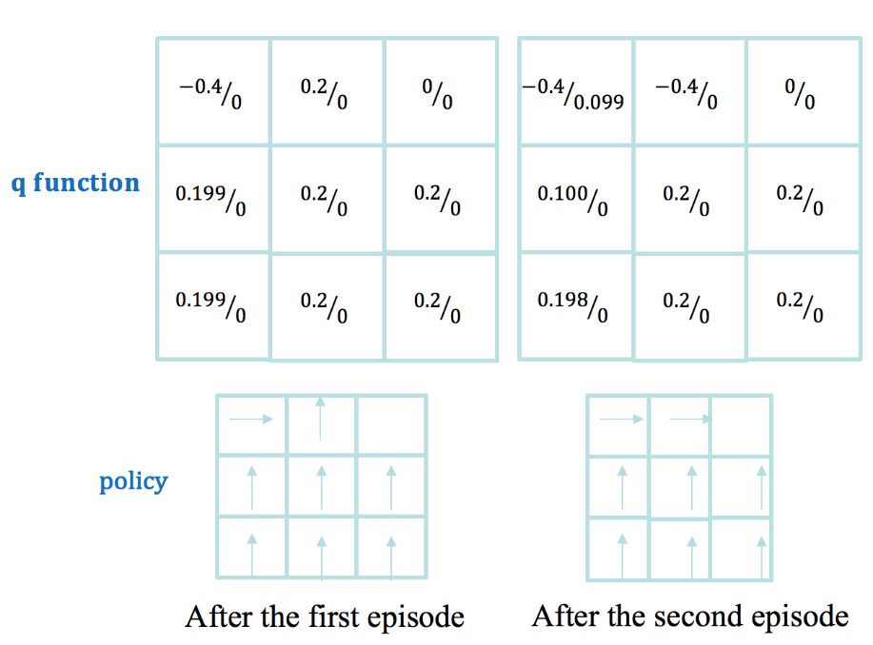

4)

Answer:

a. Summary: Eigenfaces is the name given to a set of eigenvectors when they are used in the computer vision problem of human face recognition. Eigenface method is a principal component analysis method for face image dimensionality reduction. The original face image is represented by a linear combination of eigenvectors which are called ‘eigenface’.

b. Advantages: Its training process is completely automatic and easy to code. Eigenface adequately reduces statistical complexity in face image representation. Once eigenfaces of a database are calculated, face recognition can be achieved in real time. Eigenface can handle large databases.

Disadvantges: It is very sensitive to lighting, scale and translation, and requires a highly controlled environment. Eigenface has difficulty capturing expression changes. The most significant eigenfaces are mainly about illumination encoding and do not provide useful information regarding the actual face.