Exp13—Design of Counters and Timer
姓名： | 杨振宇 |  | 学号： | 3130104727 |  |  | 专业： | 软件工程
课程名称： |  | 逻辑与计算机设计基础实验 |  |  | 同组学生姓名： | 李朝阳
实验时间： |  | 2016-12-22 | 实验地点： |  | 紫金港东4-509 |  | 指导老师： |  | 洪奇军

一、Experiment Purpose
- Master the principle and design of synchronized 4-bit binary counter 74LS161.
- Master the principle and design of counter/timer.

二、Experiment Principle
The pin of 74LS161 :
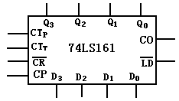

The function of 74LS161:
Q3Q2Q1Q0 is output, D3D2D1D0 is input.
CR is clear pin, when CR is 0, the output Q3Q2Q1Q0 is 0000.
LD is set pin, when CR is 1 and LD is 0, the ouput Q3Q2Q1Q0 is equal to D3D2D1D0.
CTp and CTt is enable pin,CO is carry output pin.
When CR and LD are 1, at the CP rising edge valid, D3D2D1D0 adds 1.
CO = Q0·Q1·Q2·Q3·CTt.

The function table of 74LS161:
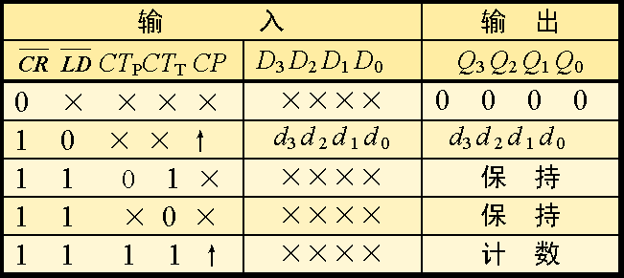

The principle of decimal counter.
When CR and LD are 1, at the CP rising edge valid, the output will add 1.So it and change from 0000 to 1111.But the decimal count if from 0000 to 1001,when output is 1010(10),it should carry-over.So we can make CR is 0 and CO is 1 when the output is 1010.The circuit is as follow.The counter more than 4 digits can use many 74LS161 in series.The princeple is the same as decimal counter.

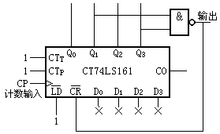

三、Instruments and Materials
- Experiment Instruments
  - PC with ISE 14.7 1
  - SWORD Board 1
- Experiment Materials
  - None
四、Content and Steps

- New project
  - the project name My74LS161
  - Top Level Source Type: HDL
- Design with behavior description
  - CR is asynchronous clear.
  - LD is synchronization set.

The code are as follows:
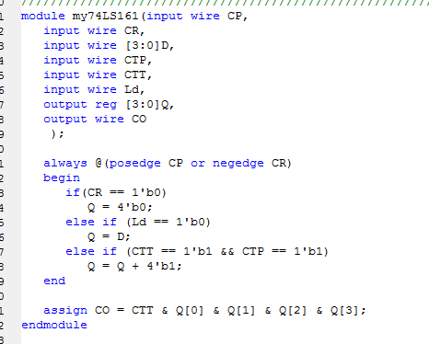

Excitation code
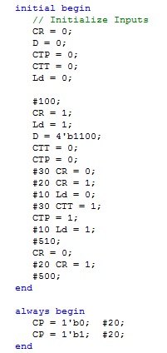

Simulation:
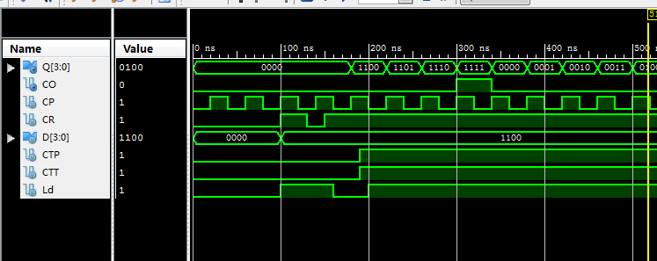

Design digital clock based on 74LS161
- New project
  - project name MyClock
  - Top Level Source Type: HDL
- Design with structural description
  - call module My74LS161
  - call frequency division module, drive minute with 100ms clock
  - call display module
- Download and verification

The code of top module:
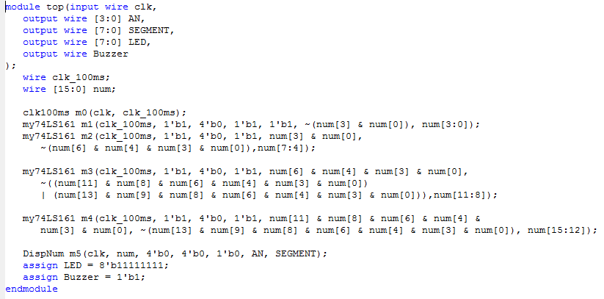

五、Experiment results
Simulation analysis:
0-100ns: The clear pin CR is 0, so the output Q is 0.
100-130ns,LD=1,CR=1, but the cp is not on rising edge,so the output holds on.
130-150ns,The clear pin CR is 0,so the output Q is 0.
150-160ns, LD=1,CR=1, but the cp is not on rising edge,so the output holds on.
160-200ns,LD=0,CR=1,when cp is on rising edge, Q add 1.
After 200ns,LD=1,CR=1,CTT=1,CTP=1,so the output holds on.

Download and verify:

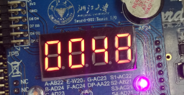
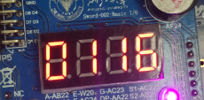
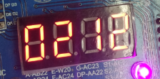
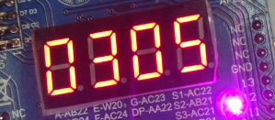
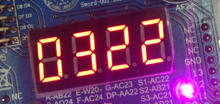
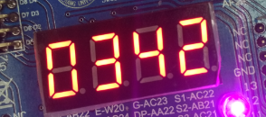
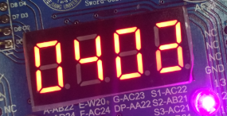
The program runs as expected.

六、Experience
In this experiment, I master the principle and design of synchronized 4-bit binary counter 74LS161 and how to design a counter. And I accomplished a clock. The experiment is simple, so I never meet any problem.

Exp13—Design and Application of Shift Register
姓名： | 杨振宇 |  | 学号： | 3130104727 |  |  | 专业： | 软件工程
课程名称： |  | 逻辑与计算机设计基础实验 |  |  | 同组学生姓名： | 李朝阳
实验时间： |  | 2016-12-22 | 实验地点： |  | 紫金港东4-509 |  | 指导老师： |  | 洪其军

一、Experiment Purpose
- Master the principle of shift register with parallel input .
- Master the design of shift register with parallel input.

二、Experiment Principle
The function of shift register:
When a pulse comes,the data in register shift left or right one bit.

The principle of shift register:
Shift register can be designed by using many D flip-flops. Use one D flip-flop’s output as next’s input, so the data can translate from D flip-flops.
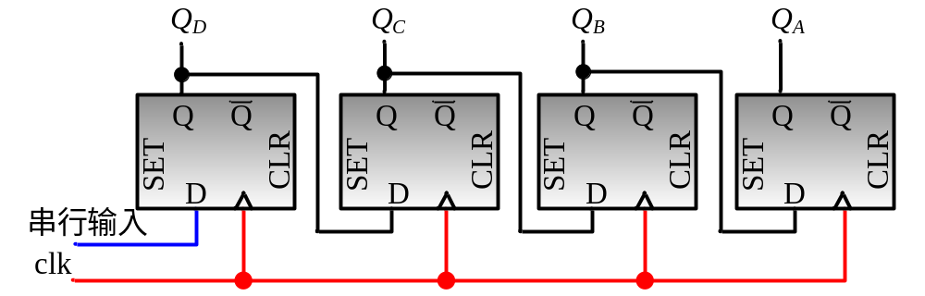

The principle of cyclic shift register:
Cyclic shift register use the last D flip-flop’s out put as the first one’s input.
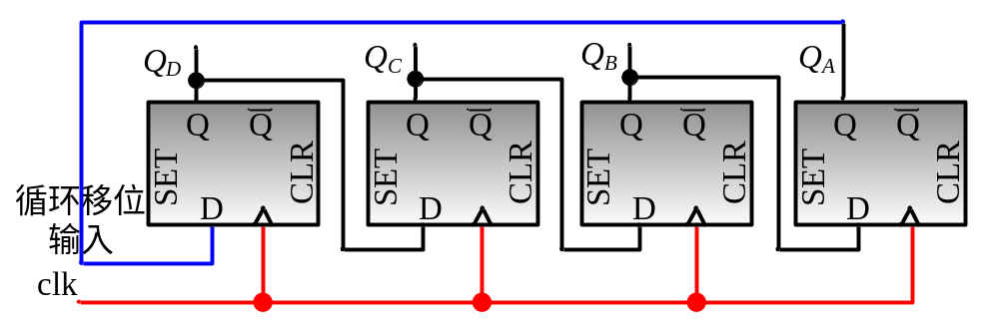

The principle of Right shift register with parallel input:
Use a switch S to choose shift or input:
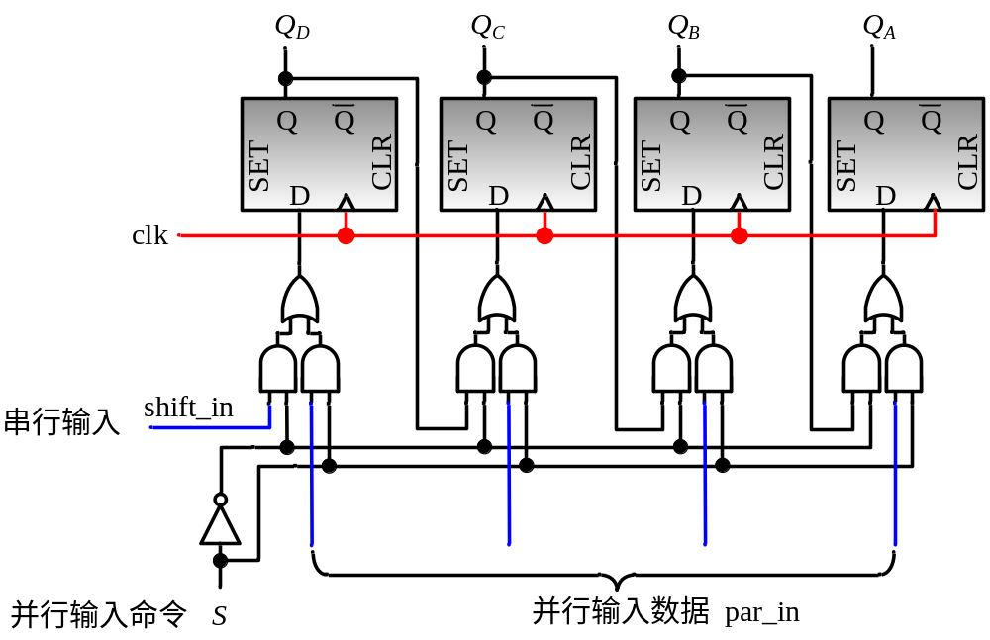
The principle of Parallel - serial converter:
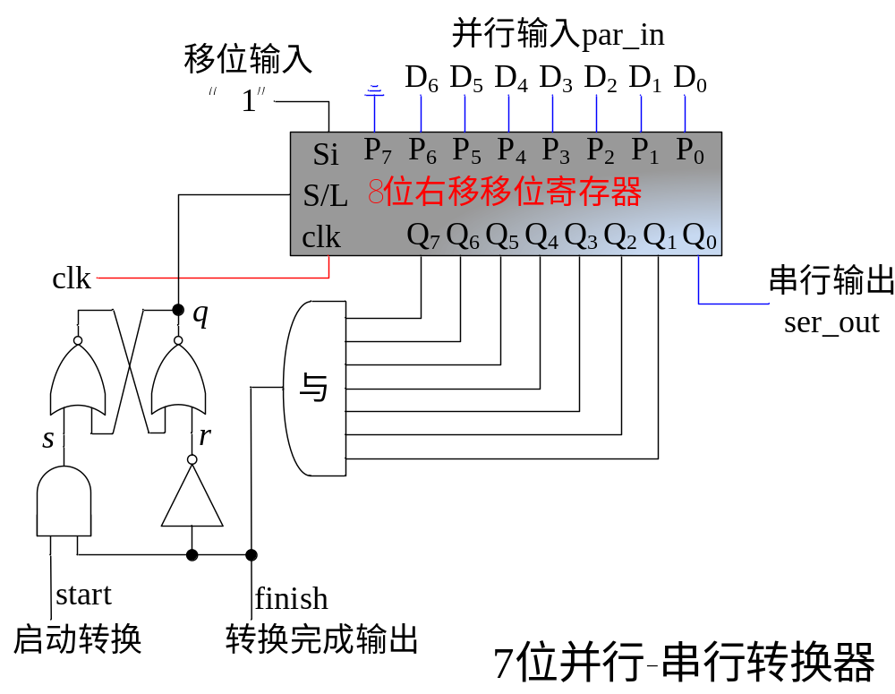
When start=0,q=0,Q=0,the circuit reaches steady state.
When start=1,q=1,the shift begins, and Q7=0.Then it works as shift register.

三、Instruments and Materials
- Experiment Instruments
  - PC with ISE 14.7 1
  - SWORD Board 1
- Experiment Materials
  - None
四、Content and Steps

Design 8-bit cyclic right-shift register with parallel input
- New project
  - the project name ShiftReg8b
  - Top Level Source Type: HDL
- Design with structural description
- Simulation waveforms

The code of shiftReg8b:

module ShfitReg8b(
input wire clk, S, s_in,
input wire [7:0] p_in,
output wire [7:0] Q
);
wire [7:0] D;
wire sbar;

FD F0(.C(clk), .D(D[0]), .Q(Q[0])),
F1(.C(clk), .D(D[1]), .Q(Q[1])),
F2(.C(clk), .D(D[2]), .Q(Q[2])),
F3(.C(clk), .D(D[3]), .Q(Q[3])),
F4(.C(clk), .D(D[4]), .Q(Q[4])),
F5(.C(clk), .D(D[5]), .Q(Q[5])),
F6(.C(clk), .D(D[6]), .Q(Q[6])),
F7(.C(clk), .D(D[7]), .Q(Q[7]));
OR2 D0(.I0(L_0), .I1(R_0), .O(D[0])),
D1(.I0(L_1), .I1(R_1), .O(D[1])),
D2(.I0(L_2), .I1(R_2), .O(D[2])),
D3(.I0(L_3), .I1(R_3), .O(D[3])),
D4(.I0(L_4), .I1(R_4), .O(D[4])),
D5(.I0(L_5), .I1(R_5), .O(D[5])),
D6(.I0(L_6), .I1(R_6), .O(D[6])),
D7(.I0(L_7), .I1(R_7), .O(D[7]));
AND2 L0(.I0(Q[1]), .I1(sbar), .O(L_0)),
L1(.I0(Q[2]), .I1(sbar), .O(L_1)),
L2(.I0(Q[3]), .I1(sbar), .O(L_2)),
L3(.I0(Q[4]), .I1(sbar), .O(L_3)),
L4(.I0(Q[5]), .I1(sbar), .O(L_4)),
L5(.I0(Q[6]), .I1(sbar), .O(L_5)),
L6(.I0(Q[7]), .I1(sbar), .O(L_6)),
L7(.I0(s_in), .I1(sbar), .O(L_7));
AND2 R0(.I0(p_in[0]), .I1(S), .O(R_0)),
R1(.I0(p_in[1]), .I1(S), .O(R_1)),
R2(.I0(p_in[2]), .I1(S), .O(R_2)),
R3(.I0(p_in[3]), .I1(S), .O(R_3)),
R4(.I0(p_in[4]), .I1(S), .O(R_4)),
R5(.I0(p_in[5]), .I1(S), .O(R_5)),
R6(.I0(p_in[6]), .I1(S), .O(R_6)),
R7(.I0(p_in[7]), .I1(S), .O(R_7));

INV sbar(.I(S), .O(sbar));
Endmodule

Excitation code:

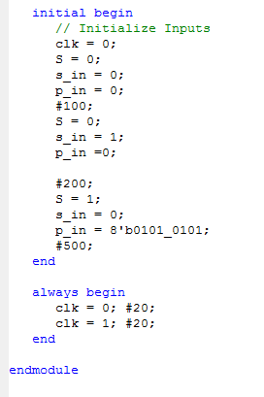
Simulation:
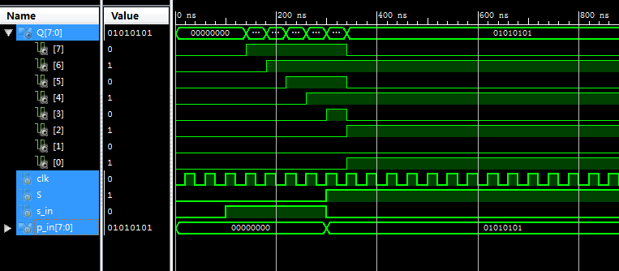
- New project
  - the project name MyMarquee
  - Top Level Source Type: HDL
- Design with structural description
  - call ShfitReg8b
  - call frequency division module, drive shift register with 1s clock
  - call display module
  - call CreateNumber module

The code of top module:
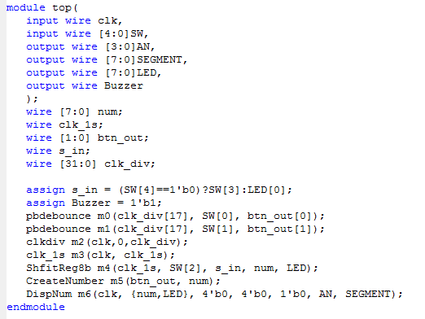

五、Experiment results
Simulation analysis:
When S=0,S_in=0,the ouput holds on.
When S=0,S_in=1,The ouput is right shift.
When S=1,S_in=0,the output is input.

Download and verify:
SW[3]=1,SW[4]=0serial right shift, serial input value is 1
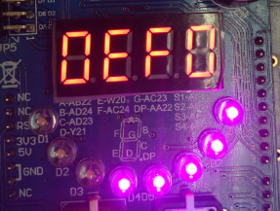
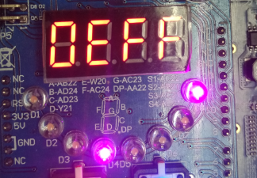
sw[4]=1, cyclic right shift.
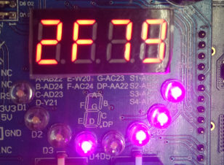
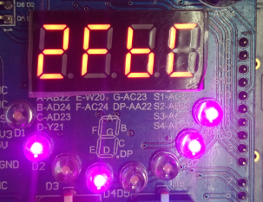
When sw [2] = 1, parallel input, assign {RegA, RegB} to the shift register
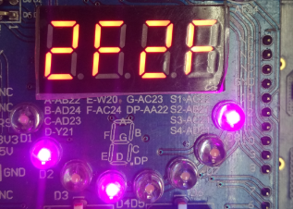

六、Experience
In this experiment, I master the principle and design of shift register with parallel input .

