它的基本排版单位是LINE（行），也就是显示行。在LINE的内部存储了数个RUN。每个RUN仅对应一个DOC中的元素，但是一个DOC中的元素可以对应多个RUN（被拆分成多行的情况）。

**The Core Text Object Model**

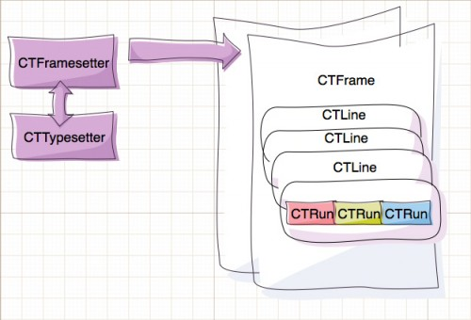

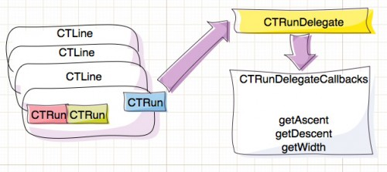

[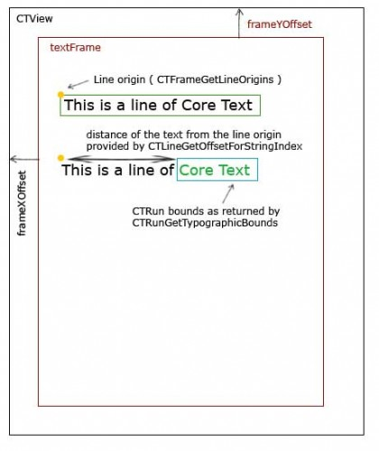](http://cdn3.raywenderlich.com/wp-content/uploads/2011/07/runBounds.jpg)

而由于连写(Ligatures)的存在，多个字符也会存在对应一个字形的情况。

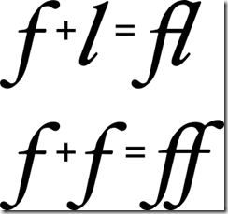

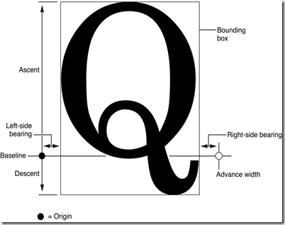

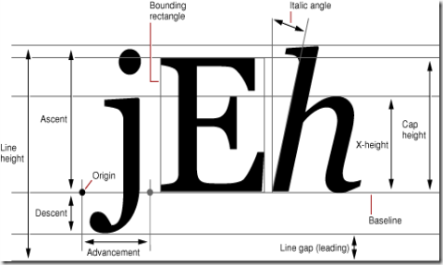

# About Paragraph Styles

NSParagraphStyle and its subclass NSMutableParagraphStyle encapsulate the paragraph or ruler attributes used by the NSAttributedString classes. Instances of these classes are often referred to as paragraph style objects, or when no confusion will result, as paragraph styles.

A paragraph style object represents a complex attribute value in an attributed string, storing a number of subattributes that affect paragraph layout for the characters of the string. Among these subattributes are alignment, tab stops, and indents. Figure 1 illustrates these and other paragraph style attributes.

**Figure 1**  Paragraph style attributes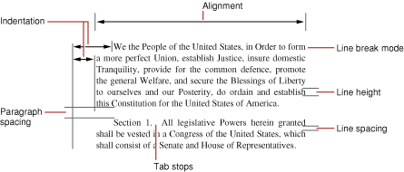

These are the paragraph style attributes the text system uses:

* alignment is the text alignment. It is [NSLeftTextAlignment](https://developer.apple.com/library/mac/documentation/Cocoa/Reference/ApplicationKit/Classes/NSText_Class/index.html#//apple_ref/doc/c_ref/NSLeftTextAlignment), [NSRightTextAlignment](https://developer.apple.com/library/mac/documentation/Cocoa/Reference/ApplicationKit/Classes/NSText_Class/index.html#//apple_ref/doc/c_ref/NSRightTextAlignment), [NSCenterTextAlignment](https://developer.apple.com/library/mac/documentation/Cocoa/Reference/ApplicationKit/Classes/NSText_Class/index.html#//apple_ref/doc/c_ref/NSCenterTextAlignment), [NSJustifiedTextAlignment](https://developer.apple.com/library/mac/documentation/Cocoa/Reference/ApplicationKit/Classes/NSText_Class/index.html#//apple_ref/doc/c_ref/NSJustifiedTextAlignment), or [NSNaturalTextAlignment](https://developer.apple.com/library/mac/documentation/Cocoa/Reference/ApplicationKit/Classes/NSText_Class/index.html#//apple_ref/doc/c_ref/NSNaturalTextAlignment).
* firstLineHeadIndent is the distance in points from the leading margin of a text container to the beginning of the paragraph’s first line.
* headIndent is the distance in points from the leading margin of a text container to the beginning of lines other than the first.
* tailIndent is the distance in points from the margin of a text container to the end of lines.
* tabStops is an array of NSTextTab objects, sorted by location, that define the tab stops for the paragraph style.
* lineBreakMode is the mode that should be used to break lines when laying out the paragraph's text. It can be one of the following:
  + [NSLineBreakByWordWrapping](https://developer.apple.com/library/mac/documentation/Cocoa/Reference/ApplicationKit/Classes/NSParagraphStyle_Class/index.html#//apple_ref/doc/c_ref/NSLineBreakByWordWrapping) wraps at word boundaries.
  + [NSLineBreakByCharWrapping](https://developer.apple.com/library/mac/documentation/Cocoa/Reference/ApplicationKit/Classes/NSParagraphStyle_Class/index.html#//apple_ref/doc/c_ref/NSLineBreakByCharWrapping) wraps at character boundaries.
  + [NSLineBreakByClipping](https://developer.apple.com/library/mac/documentation/Cocoa/Reference/ApplicationKit/Classes/NSParagraphStyle_Class/index.html#//apple_ref/doc/c_ref/NSLineBreakByClipping) clips lines past the edge of the text container.
  + [NSLineBreakByTruncatingHead](https://developer.apple.com/library/mac/documentation/Cocoa/Reference/ApplicationKit/Classes/NSParagraphStyle_Class/index.html#//apple_ref/doc/c_ref/NSLineBreakByTruncatingHead) displays each line so that the end fits in the container and the missing text at the beginning is indicated by an ellipsis glyph.
  + [NSLineBreakByTruncatingTail](https://developer.apple.com/library/mac/documentation/Cocoa/Reference/ApplicationKit/Classes/NSParagraphStyle_Class/index.html#//apple_ref/doc/c_ref/NSLineBreakByTruncatingTail) displays each line so that the beginning fits in the container and the missing text at the end is indicated by an ellipsis glyph.
  + [NSLineBreakByTruncatingMiddle](https://developer.apple.com/library/mac/documentation/Cocoa/Reference/ApplicationKit/Classes/NSParagraphStyle_Class/index.html#//apple_ref/doc/c_ref/NSLineBreakByTruncatingMiddle) displays each line so that the beginning and end both fit in the container and the missing text in the middle is indicated by an ellipsis glyph.
* maximumLineHeight is the maximum height that any line in the receiver can occupy, regardless of the font size or size of any attached graphic.
* minimumLineHeight is the minimum height that any line in the receiver can occupy, regardless of the font size or size of any attached graphic.
* lineHeightMultiple is a factor by which the default line height (a metric of the font) is multiplied before being constrained by minimum and maximum line height.
* lineSpacing is extra space in points added between lines within the paragraph.
* paragraphSpacing is space in points added at the end of the paragraph to separate it from the following paragraph.
* paragraphSpacingBefore is space in points added between the top of the paragraph and the beginning of its text content.

<http://msdn.microsoft.com/en-us/library/dd317792(v=vs.85).aspx>

ScriptItemize 例子：

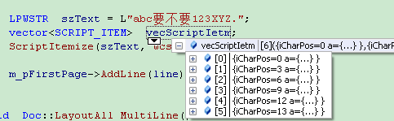

[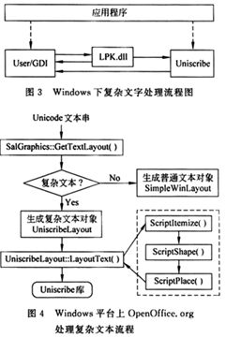](http://img.qkzz.net/magazine/1003-0077/2007/02/865024_1_o.jpg)   
　　Uniscribe把字符串细分为项(Item)、串(Run)和簇(Cluster)，其中“项”为具有相同文字和方向属性的一个字符串；“串”为文本中具有连续格式属性项的组成成份；“簇”为编码点之间的字符或字型序

平台目前是IOS和WIN32。IOS下字体使用的是CORETEXT+COREGRAPHICS来实现的。WIN32下用的是GetGlyphOutline API。渲染使用的OPENGLES 1.1，内部用glTexSubImage2D来实现了一个字形的贴图缓冲。