## 

## oss/oss_core/prov/monitor/workorder/views/

## 1 查找修改文件的关键字

这个copy的按钮

'copyClip'

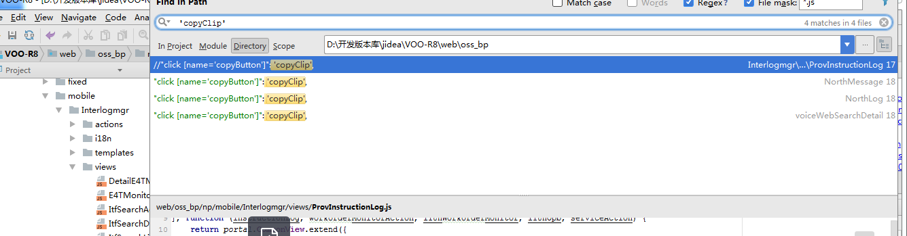

# 修改点

## 修改点1

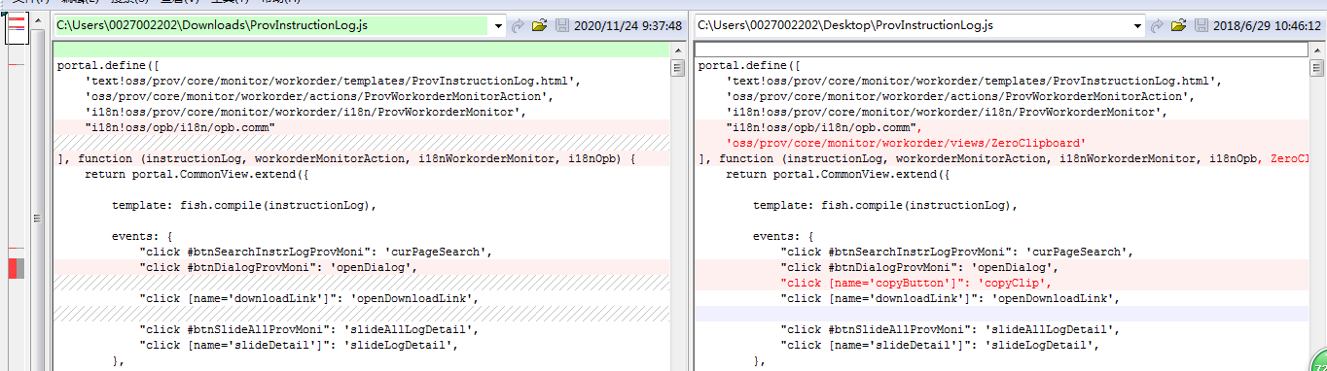

## 修改点2

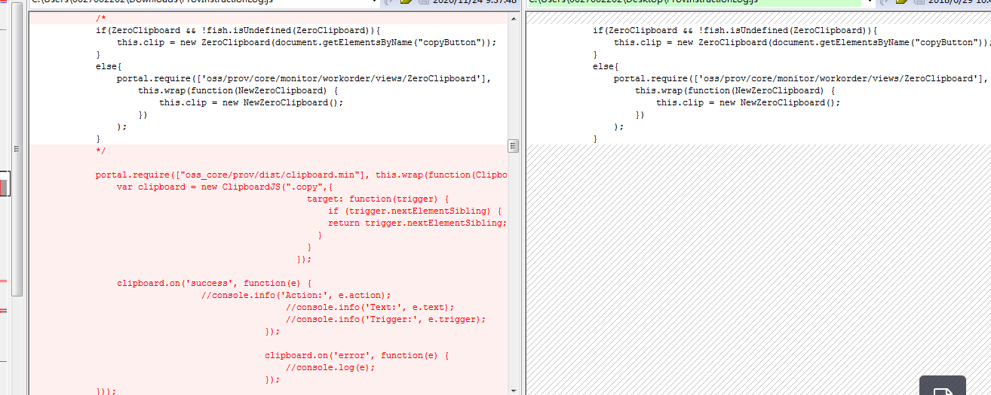

## 修改点3

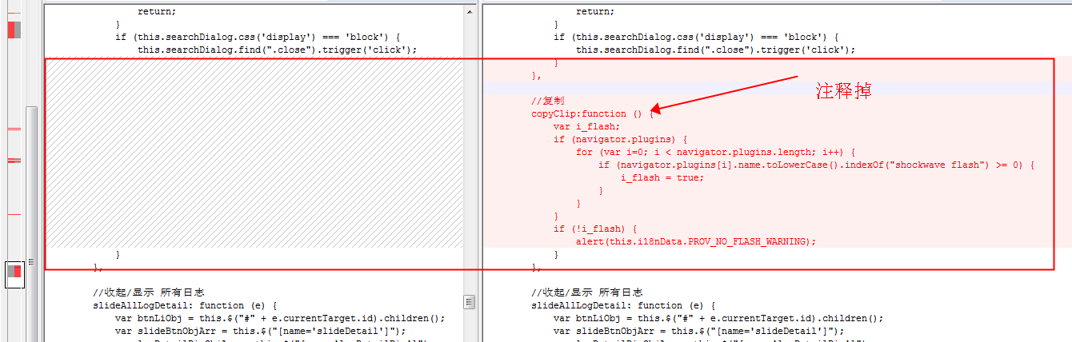

# 页面分析

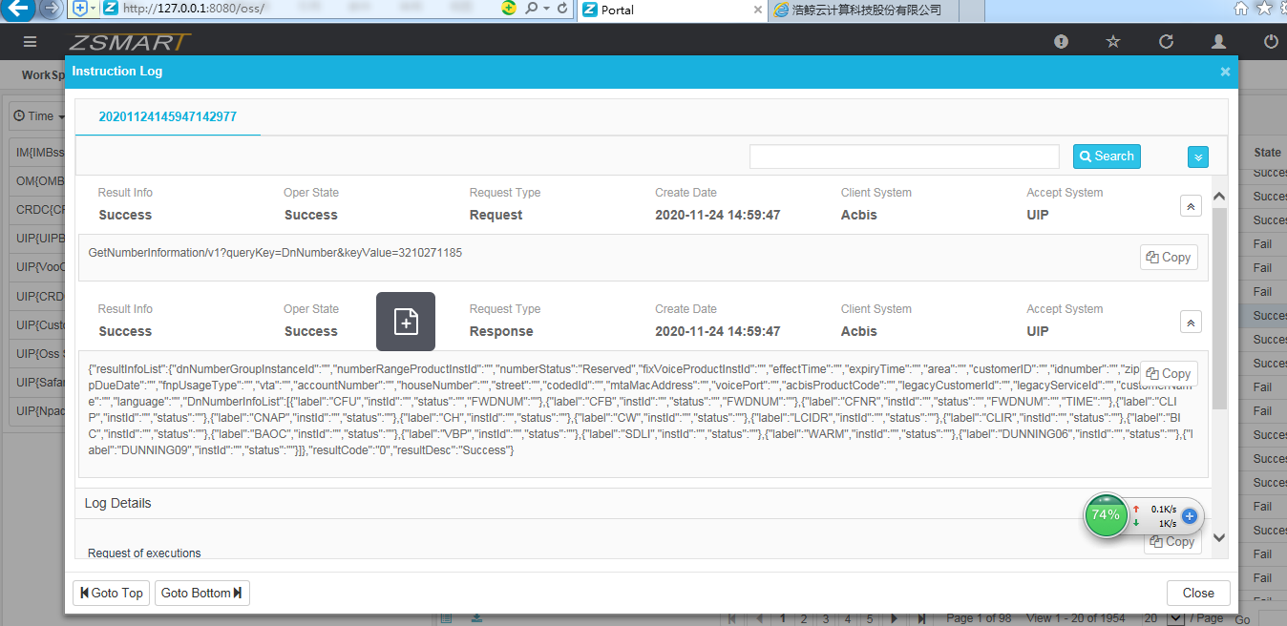

## Log Monitor

**oss/oss_bp/np/mobile/Interlogmgr/views/ItfSearchMain**

**oss/oss_bp/np/mobile/Interlogmgr/views/NorthLogDialog**

**oss/oss_bp/np/mobile/Interlogmgr/views/NorthLog**

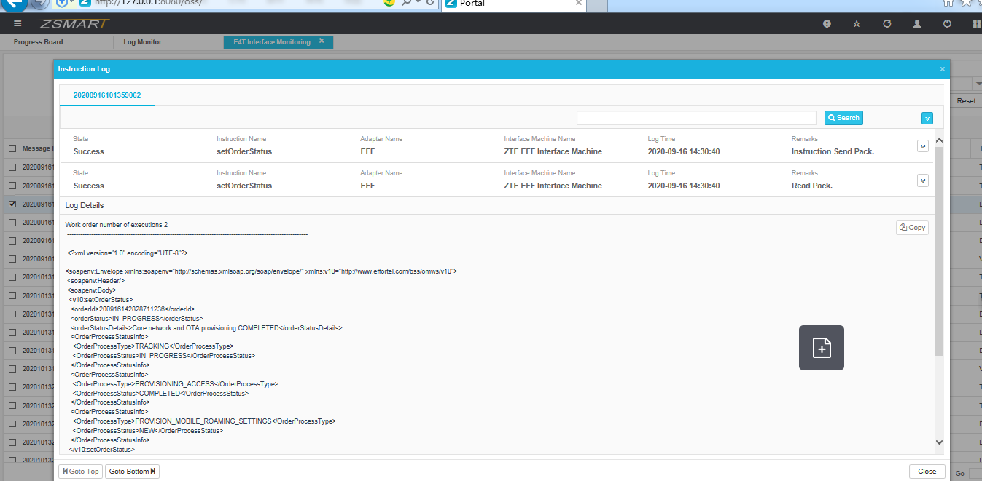

## E4T Interface Monitoring

**oss/oss_bp/np/mobile/Interlogmgr/views/E4TMonitor**

**oss/oss_bp/np/mobile/Interlogmgr/views/ProvInstructionLogDialog**

**oss/oss_bp/np/mobile/Interlogmgr/views/ProvInstructionLog**

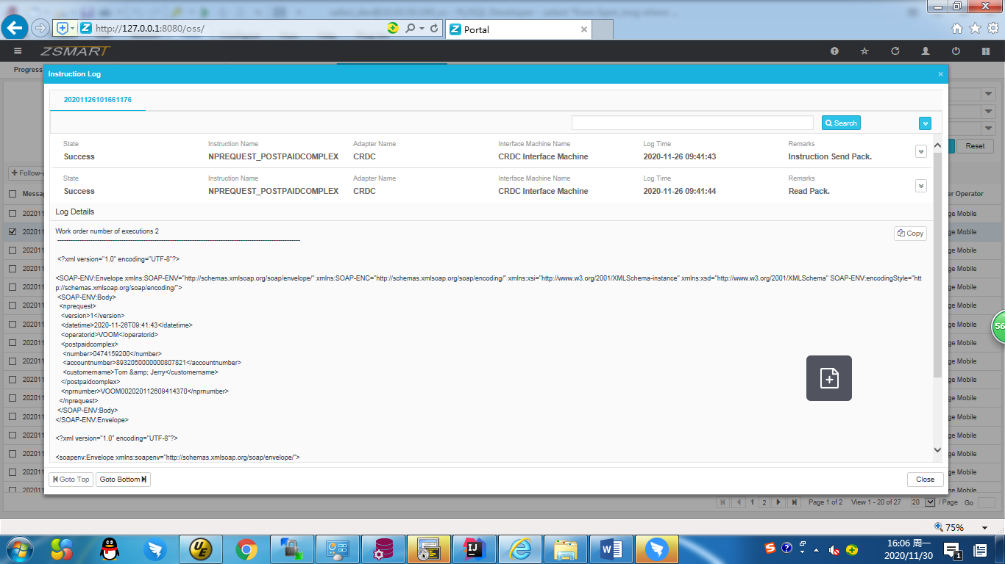

## CRDC Monitor

**oss/oss_bp/np/mobile/numbersap/views/cdrcMonitor**

**oss/oss_bp/np/mobile/Interlogmgr/views/ProvInstructionLogDialog**

**oss/oss_bp/np/mobile/Interlogmgr/views/ProvInstructionLog**

**oss/oss_bp/np/mobile/numbersap/views/cdrcMonitor**

**oss/oss_bp/np/mobile/Interlogmgr/views/NorthMessageDialog**

**oss/oss_bp/np/mobile/Interlogmgr/views/NorthMessage**

## Voice Web Log Detail

**oss/oss_bp/voo/om/voiceweb/views/voiceWebSearchList**

**oss/oss_bp/voo/om/voiceweb/views/voiceWebDialog**

**oss/oss_bp/voo/om/voiceweb/views/voiceWebSearchDetail**