Supplementary Appendix
Data justice in overdose surveillance: a governance framework for counting drug-overdose deaths before crises become visible
Hongjuan Fang, Lili Wang, Qiang Wang

Contents
Section 1. Supplementary Methods
Section 2. Supplementary Tables S1–S6
Section 3. Supplementary Figures S1–S3
Section 4. Study protocol (version 1.2)
Section 5. STROBE checklist
Section 6. Data and code availability

Section 1. Supplementary Methods

S1.1 Data sources and country eligibility
The primary sample comprised 47 European and OECD countries meeting three eligibility criteria over 1990–2021: (i) GBD 2021 drug-use-disorder mortality estimates with uncertainty intervals; (ii) WHO Mortality Database records sufficient to compute annual WHO–GBD divergence; and (iii) a complete World Bank GDP-per-capita series. Data sources were GBD 2021 (IHME; age-standardised death rates and uncertainty intervals), the WHO Mortality Database, the World Bank World Development Indicators, the WHO Global Health Observatory (cause-of-death completeness, ill-defined-cause fraction, forensic-monitoring indicators), published INCB-based controlled-opioid consumption estimates (Richards et al., Br J Pain 2021), the World Mortality Dataset (Karlinsky & Kobak), and EMCDDA reports for opioid-agonist therapy coverage and policy context. The exploratory predictive-validation analysis used 63 countries: the 47-country primary sample plus 16 additional countries with sufficient annual data (Argentina, Brazil, Colombia, Dominican Republic, Ecuador, Greece, Guatemala, Hungary, Ireland, Montenegro, Panama, Peru, Romania, Slovakia, Sweden, Uruguay).

S1.2 DODJI construction
For each country, the raw overdose data-quality score Q combined two standardised features averaged over 1990–2021: (i) mean relative GBD uncertainty-interval width, (upper UI − lower UI)/estimate; and (ii) mean absolute WHO–GBD divergence, |GBD rate − WHO rate|. Q was regressed on log GDP per capita, and DODJI was defined as the studentised residual, DODJI_i = (Q_i - beta_0 - beta_1 log(GDP_i)) / SE_resid_i, where SE_resid_i = sqrt(MSE × (1 − h_ii)) and h_ii is the hat-matrix diagonal. Studentisation makes the residual scale-invariant and robust to outlier influence. Positive DODJI indicates worse-than-expected surveillance quality for a country’s resource level. DODJI is a governance signal that observed overdose-mortality evidence is less stable or less concordant than expected; it is not an undercount estimate.

S1.3 Governance-regime classification
Countries were classified into four governance regimes with an explicit burden-by-surveillance matrix applied to the mortality-burden rank and the primary cross-sectional DODJI: insufficient-exposure-data for bottom-quartile reported burden (mortality rank ≥36) with worse-than-expected surveillance (DODJI >0; n=6; median mortality rank 44, median DODJI 1.04); data-quality-limited for worse-than-expected surveillance outside the bottom burden quartile (n=10; median mortality rank 24, median DODJI 0.60); medical-system-driven for the highest-burden half (mortality rank ≤23) with surveillance at or better than GDP-adjusted expectation (n=18; median mortality rank 12, median DODJI -0.47); and low-burden/protected otherwise (n=13; median mortality rank 35, median DODJI -0.24). The complete per-country classification is given in Table S4, and the classification code is deposited in the repository (build_reclassification_v18.py).

S1.4 Combined preparedness-priority score and tiers
Countries were ranked first by mortality burden and then by combined preparedness priority. The combined priority score integrates mortality-burden need and surveillance need with equal weights: burden need B=(47 − mortality rank)/46 and surveillance need S=(DODJI percentile rank − 1)/46, each bounded in [0,1]; score = 1 + 3.5 × (0.5B + 0.5S), rounded to 0.05 (observed range 1.30–4.10). Combined priority ranks follow the descending score, with ties broken by higher burden need, then higher surveillance need. Priority tiers were assigned by combined-priority-rank quartiles: Priority I, ranks 1–12 (score ≥3.10), 12 countries; Priority II, ranks 13–24 (score 2.70–3.05), 12 countries; Priority III, ranks 25–36 (score 2.50–2.70), 12 countries; Priority IV, ranks 37–47 (score 1.30–2.50), 11 countries. Tied scores occur on both sides of the II–III boundary (2.70: Austria in Priority II; Czechia and San Marino in Priority III) and of the III–IV boundary (2.50: Russian Federation, Switzerland, Spain, and South Korea in Priority III; Republic of Moldova and Bosnia and Herzegovina in Priority IV). Reclassification was defined as mortality rank minus combined-priority rank.

S1.5 Validation and sensitivity analyses
The prespecified validation battery comprised: measurement validity (raw Q vs DODJI correlation with log GDP); internal consistency (DODJI vs WHO–GBD divergence, r=0.91; vs GBD uncertainty width, r=0.83); external credibility (death under-registration, r=0.51, n=43; composite surveillance-capacity indices, r=−0.47); specificity (OAT coverage, r=0.09, p=0.72; generic GBD garbage coding, r=−0.08, p=0.61); robustness to alternative specifications (Spearman ρ 0.71–0.89; Table S5); prespecified small-state sensitivity excluding Monaco, San Marino, Andorra, Iceland, Malta, and Luxembourg (Table S6, Figure S3); mechanism analysis (exploratory regression with regime fixed effects and Benjamini–Hochberg adjustment; no predictor retained after adjustment); and exploratory predictive validation of annual DODJI trajectories (1992–2018; 63 countries) against subsequent 3-year mortality change (Table S2). Policy associations were estimated with exploratory two-way fixed-effects event-study methods and are interpreted as descriptive ecological associations only (Table S3).

S1.6 Statistical software and reproducibility
Analyses were performed in R (version 4.4.2; packages stats, ggplot2, cowplot, sf) and Python (version 3.13; pandas, numpy, statsmodels, scipy). All analytic code, pinned derived tables, and figure-generation scripts are deposited in the repository listed in Section 6.

Section 2. Supplementary Tables

Table S1. Pinned mechanism variables used for main-text Table 2 and the mechanism regression
Country | Ill-defined causes (%) | COD completeness (%) | Civil-reg. death coverage (%) | Forensic alcohol monitor | Forensic drug monitor | GDP per capita (US$) | Population | Life expectancy (y) | Communicable-dz deaths (%)
Monaco | — | 100.0 | — | — | — | 256800 | 38956 | 86.4 | —
Albania | 23.5 | 53.3 | 53.3 | 1.0 | 1.0 | 9741 | 2411658 | 79.6 | 23.0
Iceland | 6.8 | 100.0 | 100.0 | 1.0 | 1.0 | 82201 | 385663 | 82.5 | 4.2
United States of America | 7.2 | 100.0 | 98.3 | 1.0 | 1.0 | 82587 | 336755052 | 78.4 | 16.5
Bulgaria | 26.6 | 100.0 | 100.0 | — | — | 15854 | 6446596 | 75.8 | 21.6
North Macedonia | 15.5 | 100.0 | 100.0 | 1.0 | 1.0 | 8674 | 1827816 | 75.3 | 27.7
Estonia | 6.7 | 100.0 | 100.0 | 1.0 | 1.0 | 30264 | 1370286 | 78.8 | 12.9
Canada | 5.1 | 100.0 | 99.8 | 1.0 | 1.0 | 54848 | 40049088 | 81.6 | 8.4
Malta | 5.6 | 100.0 | 100.0 | 1.0 | 1.0 | 40933 | 552747 | 83.4 | 12.9
Slovenia | 11.2 | 100.0 | 100.0 | 1.0 | 1.0 | 32660 | 2120461 | 81.9 | 17.3
Australia | 5.4 | 100.0 | 100.0 | 1.0 | 1.0 | 65058 | 26659922 | 83.1 | 4.2
Austria | 8.9 | 100.0 | 100.0 | 1.0 | 1.0 | 56580 | 9131761 | 81.8 | 11.3
New Zealand | 3.0 | 100.0 | 100.0 | 1.0 | 1.0 | 49302 | 5200000 | 81.8 | 4.5
Luxembourg | 12.0 | 100.0 | 100.0 | — | — | 133231 | 666430 | 83.3 | 14.9
San Marino | 6.1 | 100.0 | — | — | — | 59871 | 33860 | 85.7 | —
Belarus | 12.0 | 99.9 | 100.0 | 1.0 | 1.0 | 7897 | 9178298 | 74.2 | 16.0
Cyprus | 11.0 | 67.5 | 85.5 | 1.0 | 1.0 | 36624 | 1344976 | 81.6 | 13.0
Lithuania | 3.2 | 99.2 | 100.0 | 1.0 | 1.0 | 27983 | 2871585 | 77.3 | 17.2
Czechia | 9.1 | 100.0 | 100.0 | 1.0 | 1.0 | 31762 | 10864042 | 79.8 | 23.5
Latvia | 4.0 | 100.0 | 99.9 | 1.0 | 1.0 | 22710 | 1883710 | 75.4 | 14.8
Andorra | 6.6 | 100.0 | — | 1.0 | 1.0 | 46812 | 80856 | 84.0 | —
Finland | 2.3 | 100.0 | 100.0 | 1.0 | 1.0 | 52865 | 5583911 | 81.6 | 2.6
Belgium | 15.1 | 100.0 | 99.6 | 1.0 | 1.0 | 55245 | 11779946 | 82.4 | 17.9
Croatia | 5.7 | 100.0 | 100.0 | 1.0 | 1.0 | 22183 | 3859686 | 78.5 | 15.3
Serbia | 15.1 | 94.1 | 90.2 | 0.0 | 0.0 | 12282 | 6623183 | 76.1 | 25.8
Bosnia and Herzegovina | 20.3 | 95.0 | 89.5 | 0.0 | 0.0 | 8663 | 3185073 | 77.8 | 21.9
Portugal | 13.7 | 100.0 | 100.0 | 1.0 | 1.0 | 27635 | 10578174 | 82.3 | 15.4
Denmark | 12.7 | 100.0 | 97.5 | 1.0 | 1.0 | 68044 | 5946952 | 81.8 | 9.1
Republic of Moldova | 1.8 | 79.6 | 90.5 | 1.0 | 1.0 | 6800 | 2457783 | 71.2 | 23.8
Poland | 31.3 | 100.0 | — | — | — | 22145 | 36687353 | 78.3 | 23.7
Spain | 8.5 | 100.0 | 100.0 | 1.0 | 1.0 | 33493 | 48352528 | 83.9 | 12.8
Israel | 9.1 | 100.0 | 100.0 | 1.0 | 1.0 | 52126 | 9849000 | 83.2 | 19.0
South Korea | 13.3 | 100.0 | 99.3 | 0.0 | 0.0 | 35674 | 51712619 | 83.4 | 14.7
Russian Federation | 7.8 | 100.0 | 99.5 | 1.0 | 1.0 | 13987 | 143826130 | 73.3 | 26.9
Ukraine | 2.4 | 92.3 | 98.6 | 1.0 | 1.0 | 5140 | 37732836 | 73.4 | 18.3
Turkey | 9.6 | 91.6 | 78.2 | — | 1.0 | 13375 | 85325965 | 77.2 | 22.3
Germany | 10.7 | 100.0 | 99.6 | 0.0 | 1.0 | 54777 | 83287273 | 81.0 | 10.7
Switzerland | 10.2 | 100.0 | 100.0 | 1.0 | 1.0 | 104450 | 8888822 | 84.2 | 12.4
Netherlands | 13.0 | 100.0 | 99.8 | 1.0 | 1.0 | 63516 | 17877117 | 81.9 | 16.5
Costa Rica | 5.2 | 87.4 | 91.2 | 1.0 | 1.0 | 17141 | 5105525 | 80.8 | 24.4
France | 15.4 | 100.0 | 100.0 | 0.0 | 0.0 | 44700 | 68372286 | 82.8 | 14.7
United Kingdom | 5.3 | 100.0 | 100.0 | 1.0 | 1.0 | 49920 | 68526000 | 81.2 | 17.0
Norway | 10.7 | 100.0 | 100.0 | 1.0 | 1.0 | 90984 | 5519601 | 83.0 | 7.6
Japan | 15.7 | 100.0 | 100.0 | 1.0 | 1.0 | 35215 | 124516650 | 84.0 | 9.9
Italy | 8.7 | 100.0 | — | — | — | 39280 | 58984216 | 83.4 | 15.0
Mexico | 4.0 | 100.0 | 99.0 | 1.0 | 1.0 | 13831 | 129739759 | 75.1 | 38.8
Chile | 4.6 | 94.9 | — | — | — | 17082 | 19658835 | 81.2 | 21.3
This pinned table is the authoritative version used to generate main-text Table 2 and the mechanism regression (no predictor retained after Benjamini–Hochberg adjustment; weakest nominal signal: civil death-registration coverage, β=-0.032, SE=0.016, p=0.049, BH-adjusted p=0.243). WHO Global Health Observatory civil-registration and forensic indicators were last updated around 2013–2014 (death-coverage data around 2009–2013; forensic-monitoring indicators around 2014); World Bank economic and demographic indicators span 2015–2023. — = not available. WHO civil-registration birth coverage had no usable data and is omitted. Reproducibility caveat: re-querying the GHO API may return slightly different values (see DATA_PROVENANCE_NOTE.md in the repository); use this pinned CSV to reproduce the exact manuscript numbers.

Table S2. Exploratory predictive validation: annual DODJI vs subsequent 3-year mortality change (1992–2018)
Model | n (obs) | n (countries) | β | SE | p | R²
Pooled OLS | 1701 | 63 | -0.062 | 0.011 | p<0.001 | 0.018
Country FE | 1701 | 63 | 0.078 | 0.032 | p=0.015 | 0.356
Country FE + cluster SE | 1701 | 63 | 0.078 | 0.050 | p=0.117 | 0.356
Country + Year FE + cluster SE | 1701 | 63 | 0.042 | 0.048 | p=0.380 | 0.384
Pooled OLS, secondary outcome (log mortality change) | 1701 | 63 | -0.0085 | 0.0036 | p=0.018 | 0.003
Outcome: change in the drug-use-disorder mortality rate from year t to t+3. The panel comprises 1701 country-years from 63 countries (the 47-country primary sample plus 16 additional countries with sufficient annual data: Argentina, Brazil, Colombia, Dominican Republic, Ecuador, Greece, Guatemala, Hungary, Ireland, Montenegro, Panama, Peru, Romania, Slovakia, Sweden, Uruguay). The small pooled-OLS association reverses sign and loses significance once country fixed effects and country-clustered standard errors are introduced, and weakens further with year fixed effects. DODJI is a cross-sectional surveillance-governance diagnostic, not a mortality-forecasting tool.

Table S3. Planned policy event-study: specification and reporting note
Item | Description
Design | Planned staggered-adoption event study. The intended exposure was the first year of broad implementation of opioid-agonist therapy scale-out, naloxone distribution, or supervised consumption services.
Estimator | Exploratory two-way fixed-effects (country and year) event-study regression with country-clustered standard errors; event-time window −5 to +5 years; joint F-test on pre-treatment coefficients for parallel trends.
Outcome | Log age-standardised drug-use-disorder death rate (GBD 2021).
Controls | Not-yet-treated countries.
Interpretation | Adoption is non-random and correlated with unobserved surveillance capacity and political will; estimates are descriptive ecological associations, not causal effects, and are reported qualitatively in the main text. Their purpose is to show that credible surveillance is a prerequisite for evaluating such policies.
Reproducibility | The repository includes did_policy_analysis.py as a transparent analysis template, deposits the source-verified adoption-year dataset (policy_adoption_years.csv with codebook and validator), and deposits the annual mortality panel derivable from the predictive dataset. No event-study point estimates are reported, and this component is excluded from reproducibility claims.
No event-study point estimates are reported. This table documents the planned exploratory specification and its interpretive guardrails. A source-verified policy-adoption-year dataset (30 harmonised-scope countries, with codebook and executable validator) is deposited in the repository; because all 30 included countries eventually adopted, no verified never-treated controls exist, so this component remains outside the repository's reproducibility claims.

Table S4. Complete DODJI-informed priority reclassification, 47 countries
Country | Regime | Mortality rank | DODJI | Priority score | Combined priority rank | Rank shift | Priority tier | Recommended action
Iceland | Data-quality-limited | 3 | 0.7 | 4.10 | 1 | 2 | Priority I | Invest in vital-registration modernisation, medical-examiner capacity, and external mortality audits; prioritise verbal autopsy and sentinel surveillance research to quantify undercount.
Belarus | Data-quality-limited | 12 | 0.71 | 3.80 | 2 | 10 | Priority I | Invest in vital-registration modernisation, medical-examiner capacity, and external mortality audits; prioritise verbal autopsy and sentinel surveillance research to quantify undercount.
Estonia | Data-quality-limited | 7 | 0.28 | 3.75 | 3 | 4 | Priority I | Invest in vital-registration modernisation, medical-examiner capacity, and external mortality audits; prioritise verbal autopsy and sentinel surveillance research to quantify undercount.
Australia | Medical-system-driven | 6 | -0.05 | 3.65 | 4 | 2 | Priority I | Maintain mortality surveillance; conduct implementation research on high-burden subpopulations and health-service integration.
Luxembourg | Data-quality-limited | 14 | 0.57 | 3.60 | 5 | 9 | Priority I | Invest in vital-registration modernisation, medical-examiner capacity, and external mortality audits; prioritise verbal autopsy and sentinel surveillance research to quantify undercount.
United States of America | Medical-system-driven | 1 | -0.25 | 3.45 | 6 | -5 | Priority I | Maintain mortality surveillance; conduct implementation research on high-burden subpopulations and health-service integration.
Canada | Medical-system-driven | 2 | -0.25 | 3.45 | 7 | -5 | Priority I | Maintain mortality surveillance; conduct implementation research on high-burden subpopulations and health-service integration.
Slovenia | Data-quality-limited | 27 | 0.97 | 3.30 | 8 | 19 | Priority I | Invest in vital-registration modernisation, medical-examiner capacity, and external mortality audits; prioritise verbal autopsy and sentinel surveillance research to quantify undercount.
Albania | Data-quality-limited | 32 | 2.3 | 3.30 | 9 | 23 | Priority I | Invest in vital-registration modernisation, medical-examiner capacity, and external mortality audits; prioritise verbal autopsy and sentinel surveillance research to quantify undercount.
Malta | Data-quality-limited | 22 | 0.52 | 3.25 | 10 | 12 | Priority I | Invest in vital-registration modernisation, medical-examiner capacity, and external mortality audits; prioritise verbal autopsy and sentinel surveillance research to quantify undercount.
Lithuania | Medical-system-driven | 11 | -0.25 | 3.15 | 11 | 0 | Priority I | Maintain mortality surveillance; conduct implementation research on high-burden subpopulations and health-service integration.
New Zealand | Medical-system-driven | 18 | -0.13 | 3.10 | 12 | 6 | Priority I | Maintain mortality surveillance; conduct implementation research on high-burden subpopulations and health-service integration.
Cyprus | Data-quality-limited | 26 | 0.34 | 3.05 | 13 | 13 | Priority II | Invest in vital-registration modernisation, medical-examiner capacity, and external mortality audits; prioritise verbal autopsy and sentinel surveillance research to quantify undercount.
Portugal | Data-quality-limited | 29 | 0.62 | 3.05 | 14 | 15 | Priority II | Invest in vital-registration modernisation, medical-examiner capacity, and external mortality audits; prioritise verbal autopsy and sentinel surveillance research to quantify undercount.
Finland | Medical-system-driven | 5 | -0.56 | 3.00 | 15 | -10 | Priority II | Maintain mortality surveillance; conduct implementation research on high-burden subpopulations and health-service integration.
Bulgaria | Insufficient exposure data | 36 | 0.8 | 2.95 | 16 | 20 | Priority II | Develop targeted prevalence surveys and mortality sentinel sites; research emerging synthetic opioid and stimulant market dynamics; strengthen diagnostic and certification capacity.
North Macedonia | Insufficient exposure data | 38 | 0.97 | 2.95 | 17 | 21 | Priority II | Develop targeted prevalence surveys and mortality sentinel sites; research emerging synthetic opioid and stimulant market dynamics; strengthen diagnostic and certification capacity.
Croatia | Low-burden / protected | 24 | -0.12 | 2.90 | 18 | 6 | Priority II | Sustain prevention and harm-reduction coverage; monitor cross-border synthetic drug flows through passive and active surveillance.
Israel | Low-burden / protected | 25 | -0.09 | 2.90 | 19 | 6 | Priority II | Sustain prevention and harm-reduction coverage; monitor cross-border synthetic drug flows through passive and active surveillance.
Monaco | Insufficient exposure data | 43 | 2.28 | 2.85 | 20 | 23 | Priority II | Develop targeted prevalence surveys and mortality sentinel sites; research emerging synthetic opioid and stimulant market dynamics; strengthen diagnostic and certification capacity.
United Kingdom | Medical-system-driven | 4 | -0.77 | 2.80 | 21 | -17 | Priority II | Maintain mortality surveillance; conduct implementation research on high-burden subpopulations and health-service integration.
Latvia | Medical-system-driven | 15 | -0.35 | 2.80 | 22 | -7 | Priority II | Maintain mortality surveillance; conduct implementation research on high-burden subpopulations and health-service integration.
Norway | Medical-system-driven | 8 | -0.71 | 2.75 | 23 | -15 | Priority II | Maintain mortality surveillance; conduct implementation research on high-burden subpopulations and health-service integration.
Austria | Medical-system-driven | 19 | -0.34 | 2.70 | 24 | -5 | Priority II | Maintain mortality surveillance; conduct implementation research on high-burden subpopulations and health-service integration.
Czechia | Data-quality-limited | 33 | 0.05 | 2.70 | 25 | 8 | Priority III | Invest in vital-registration modernisation, medical-examiner capacity, and external mortality audits; prioritise verbal autopsy and sentinel surveillance research to quantify undercount.
San Marino | Insufficient exposure data | 46 | 1.12 | 2.70 | 26 | 20 | Priority III | Develop targeted prevalence surveys and mortality sentinel sites; research emerging synthetic opioid and stimulant market dynamics; strengthen diagnostic and certification capacity.
Netherlands | Low-burden / protected | 28 | -0.2 | 2.65 | 27 | 1 | Priority III | Sustain prevention and harm-reduction coverage; monitor cross-border synthetic drug flows through passive and active surveillance.
Serbia | Low-burden / protected | 34 | -0 | 2.65 | 28 | 6 | Priority III | Sustain prevention and harm-reduction coverage; monitor cross-border synthetic drug flows through passive and active surveillance.
Andorra | Insufficient exposure data | 47 | 1.11 | 2.65 | 29 | 18 | Priority III | Develop targeted prevalence surveys and mortality sentinel sites; research emerging synthetic opioid and stimulant market dynamics; strengthen diagnostic and certification capacity.
Denmark | Medical-system-driven | 10 | -0.75 | 2.60 | 30 | -20 | Priority III | Maintain mortality surveillance; conduct implementation research on high-burden subpopulations and health-service integration.
France | Medical-system-driven | 16 | -0.53 | 2.60 | 31 | -15 | Priority III | Maintain mortality surveillance; conduct implementation research on high-burden subpopulations and health-service integration.
Belgium | Medical-system-driven | 20 | -0.43 | 2.55 | 32 | -12 | Priority III | Maintain mortality surveillance; conduct implementation research on high-burden subpopulations and health-service integration.
Russian Federation | Medical-system-driven | 9 | -0.93 | 2.50 | 33 | -24 | Priority III | Maintain mortality surveillance; conduct implementation research on high-burden subpopulations and health-service integration.
Switzerland | Medical-system-driven | 13 | -0.74 | 2.50 | 34 | -21 | Priority III | Maintain mortality surveillance; conduct implementation research on high-burden subpopulations and health-service integration.
Spain | Medical-system-driven | 23 | -0.35 | 2.50 | 35 | -12 | Priority III | Maintain mortality surveillance; conduct implementation research on high-burden subpopulations and health-service integration.
South Korea | Low-burden / protected | 30 | -0.24 | 2.50 | 36 | -6 | Priority III | Sustain prevention and harm-reduction coverage; monitor cross-border synthetic drug flows through passive and active surveillance.
Republic of Moldova | Low-burden / protected | 31 | -0.2 | 2.50 | 37 | -6 | Priority IV | Sustain prevention and harm-reduction coverage; monitor cross-border synthetic drug flows through passive and active surveillance.
Bosnia and Herzegovina | Insufficient exposure data | 45 | 0.65 | 2.50 | 38 | 7 | Priority IV | Develop targeted prevalence surveys and mortality sentinel sites; research emerging synthetic opioid and stimulant market dynamics; strengthen diagnostic and certification capacity.
Ukraine | Medical-system-driven | 21 | -0.51 | 2.45 | 39 | -18 | Priority IV | Maintain mortality surveillance; conduct implementation research on high-burden subpopulations and health-service integration.
Poland | Low-burden / protected | 35 | -0.22 | 2.35 | 40 | -5 | Priority IV | Sustain prevention and harm-reduction coverage; monitor cross-border synthetic drug flows through passive and active surveillance.
Germany | Medical-system-driven | 17 | -0.87 | 2.25 | 41 | -24 | Priority IV | Maintain mortality surveillance; conduct implementation research on high-burden subpopulations and health-service integration.
Turkey | Low-burden / protected | 39 | -0.31 | 2.00 | 42 | -3 | Priority IV | Sustain prevention and harm-reduction coverage; monitor cross-border synthetic drug flows through passive and active surveillance.
Japan | Low-burden / protected | 44 | -0.49 | 1.60 | 43 | 1 | Priority IV | Sustain prevention and harm-reduction coverage; monitor cross-border synthetic drug flows through passive and active surveillance.
Costa Rica | Low-burden / protected | 41 | -0.59 | 1.55 | 44 | -3 | Priority IV | Sustain prevention and harm-reduction coverage; monitor cross-border synthetic drug flows through passive and active surveillance.
Chile | Low-burden / protected | 42 | -0.66 | 1.50 | 45 | -3 | Priority IV | Sustain prevention and harm-reduction coverage; monitor cross-border synthetic drug flows through passive and active surveillance.
Italy | Low-burden / protected | 37 | -1.12 | 1.40 | 46 | -9 | Priority IV | Sustain prevention and harm-reduction coverage; monitor cross-border synthetic drug flows through passive and active surveillance.
Mexico | Low-burden / protected | 40 | -0.99 | 1.30 | 47 | -7 | Priority IV | Sustain prevention and harm-reduction coverage; monitor cross-border synthetic drug flows through passive and active surveillance.
Countries are ordered by combined preparedness-priority rank. Rank shift = mortality-burden rank − combined-priority rank (positive = upward reclassification). Priority scores and regimes derive from the explicit v18 algorithm (Methods; build_reclassification_v18.py). Rank shifts of microstates (Monaco, San Marino, Andorra, Iceland, Malta, Luxembourg) should be read as sparse-event surveillance flags, not stable league-table positions.

Table S5a. Robustness of DODJI to specification choices (main-text Figure 7)
Variant | Definition | Spearman ρ vs primary DODJI | n
WHO-GBD divergence variant | Alternative DODJI based on WHO-GBD divergence alone | 0.89 | 47
GBD uncertainty variant | Alternative DODJI based on GBD uncertainty width alone | 0.78 | 47
Opioid-only variant | Opioid overdose only | 0.78 | 47
All-ages variant | No age standardisation | 0.79 | 47
Age-band standardisation (15-49) | Age-band standardisation | 0.77 | 47
Age-band standardisation (50-69) | Age-band standardisation | 0.81 | 47
Age-band standardisation (70+) | Age-band standardisation | 0.84 | 47
WHO Mortality Database cross-source variant | Independent WHO mortality data source | 0.71 | 30
Civil-registration-proxy variant | Civil registration proxy source | 0.19 | 47
All correlations are Spearman rank correlations with the primary cross-sectional DODJI. Range ρ=0.71–0.89 across the eight alternative DODJIs; the civil-registration-proxy variant (ρ=0.19) confirms that DODJI is not a proxy for generic registration quality.

Table S5b. Extended robustness and stability checks
Check | n | Spearman ρ (p) or mean [95% CI] | Regime stability | Priority-I Jaccard
Primary vs 15–49 years age-standardised (extended set) | 37 | 0.829 (p<0.001) | 0.811 | 0.667
Primary vs 15–64 years age-standardised (extended set) | 37 | 0.840 (p<0.001) | 0.838 | 0.667
Primary vs 65+ years age-standardised (extended set) | 37 | 0.770 (p<0.001) | 0.811 | 0.538
Primary vs GBD+WHO divergence (European subset) | 30 | 0.710 (p<0.001) | 0.900 | 0.600
Non-GBD WHO-GHO/WB DODJI variant | 47 | 0.185 (p=0.212) | 0.511 | 0.333
DODJI score perturbation (SD=0.5, n=1000 simulations) | 1000 sims | 0.783 [0.674–0.874] | 0.817 [0.723–0.915] | 0.625 [0.412–0.846]
Regime stability = proportion of countries assigned to the same four-regime class under the alternative specification; Priority-I Jaccard = overlap of the top-priority country sets. Both were re-derived within each variant using the same explicit v18 rules (primary mortality ranks; variant DODJI). Spearman correlations for the primary specification variants are reported in Table S5a. The age-band checks here use the extended 37-country age-band set (15–49, 15–64, 65+ years); the primary age-band variants in main-text Figure 7 (15–49, 50–69, 70+ years; n=47; ρ=0.77–0.84) are listed in Table S5a. Perturbation analysis: DODJI scores perturbed with Gaussian noise (SD=0.5) over 1000 simulations; values are means with 95% percentile intervals.

Table S6. Prespecified small-state sensitivity analysis
Sample | Validation | r | n
all_countries | DODJI vs death under-registration | 0.51 | 43
all_countries | DODJI vs external surveillance capacity | -0.467 | 43
all_countries | DODJI vs log GDP | 0.0 | 47
excluding_microstates | DODJI vs death under-registration | 0.39 | 37
excluding_microstates | DODJI vs external surveillance capacity | -0.316 | 37
excluding_microstates | DODJI vs log GDP | -0.385 | 41
Six microstates (Monaco, San Marino, Andorra, Iceland, Malta, Luxembourg) were excluded in the prespecified sensitivity analysis. External correlations persisted but weakened (0.51→0.39; −0.47→−0.32), and GDP decoupling was less stable (r=0.00→−0.39). Microstate rankings should be read as sparse-event surveillance flags.

Section 3. Supplementary Figures

Figure S1. Annual DODJI trajectories, 1992–2018, by governance regime
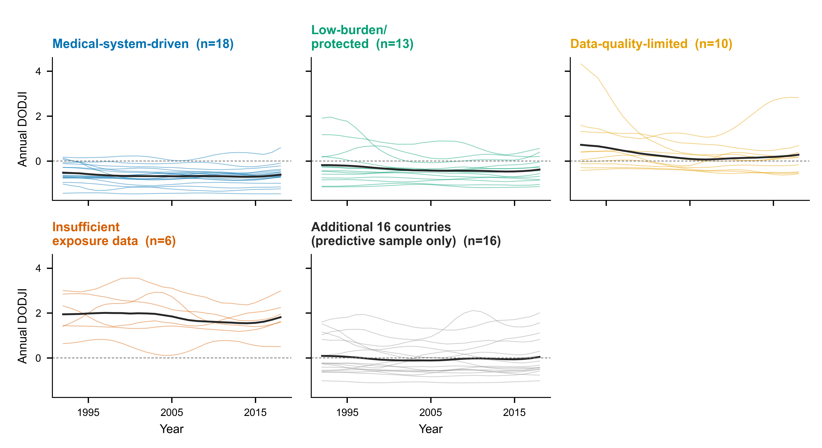
Thin coloured lines: country-level annual DODJI for the 47-country primary sample, faceted by governance regime; grey panel: the 16 additional countries (Argentina, Brazil, Colombia, Dominican Republic, Ecuador, Greece, Guatemala, Hungary, Ireland, Montenegro, Panama, Peru, Romania, Slovakia, Sweden, Uruguay) with sufficient annual data, used only in the exploratory predictive validation. Thick black line: panel mean. Dashed line: DODJI = 0 (surveillance as expected for resource level). Annual DODJI is noisier than the cross-sectional index reported in the main text and is used only for the exploratory predictive analysis.

Figure S2. Specification-variant scatterplots
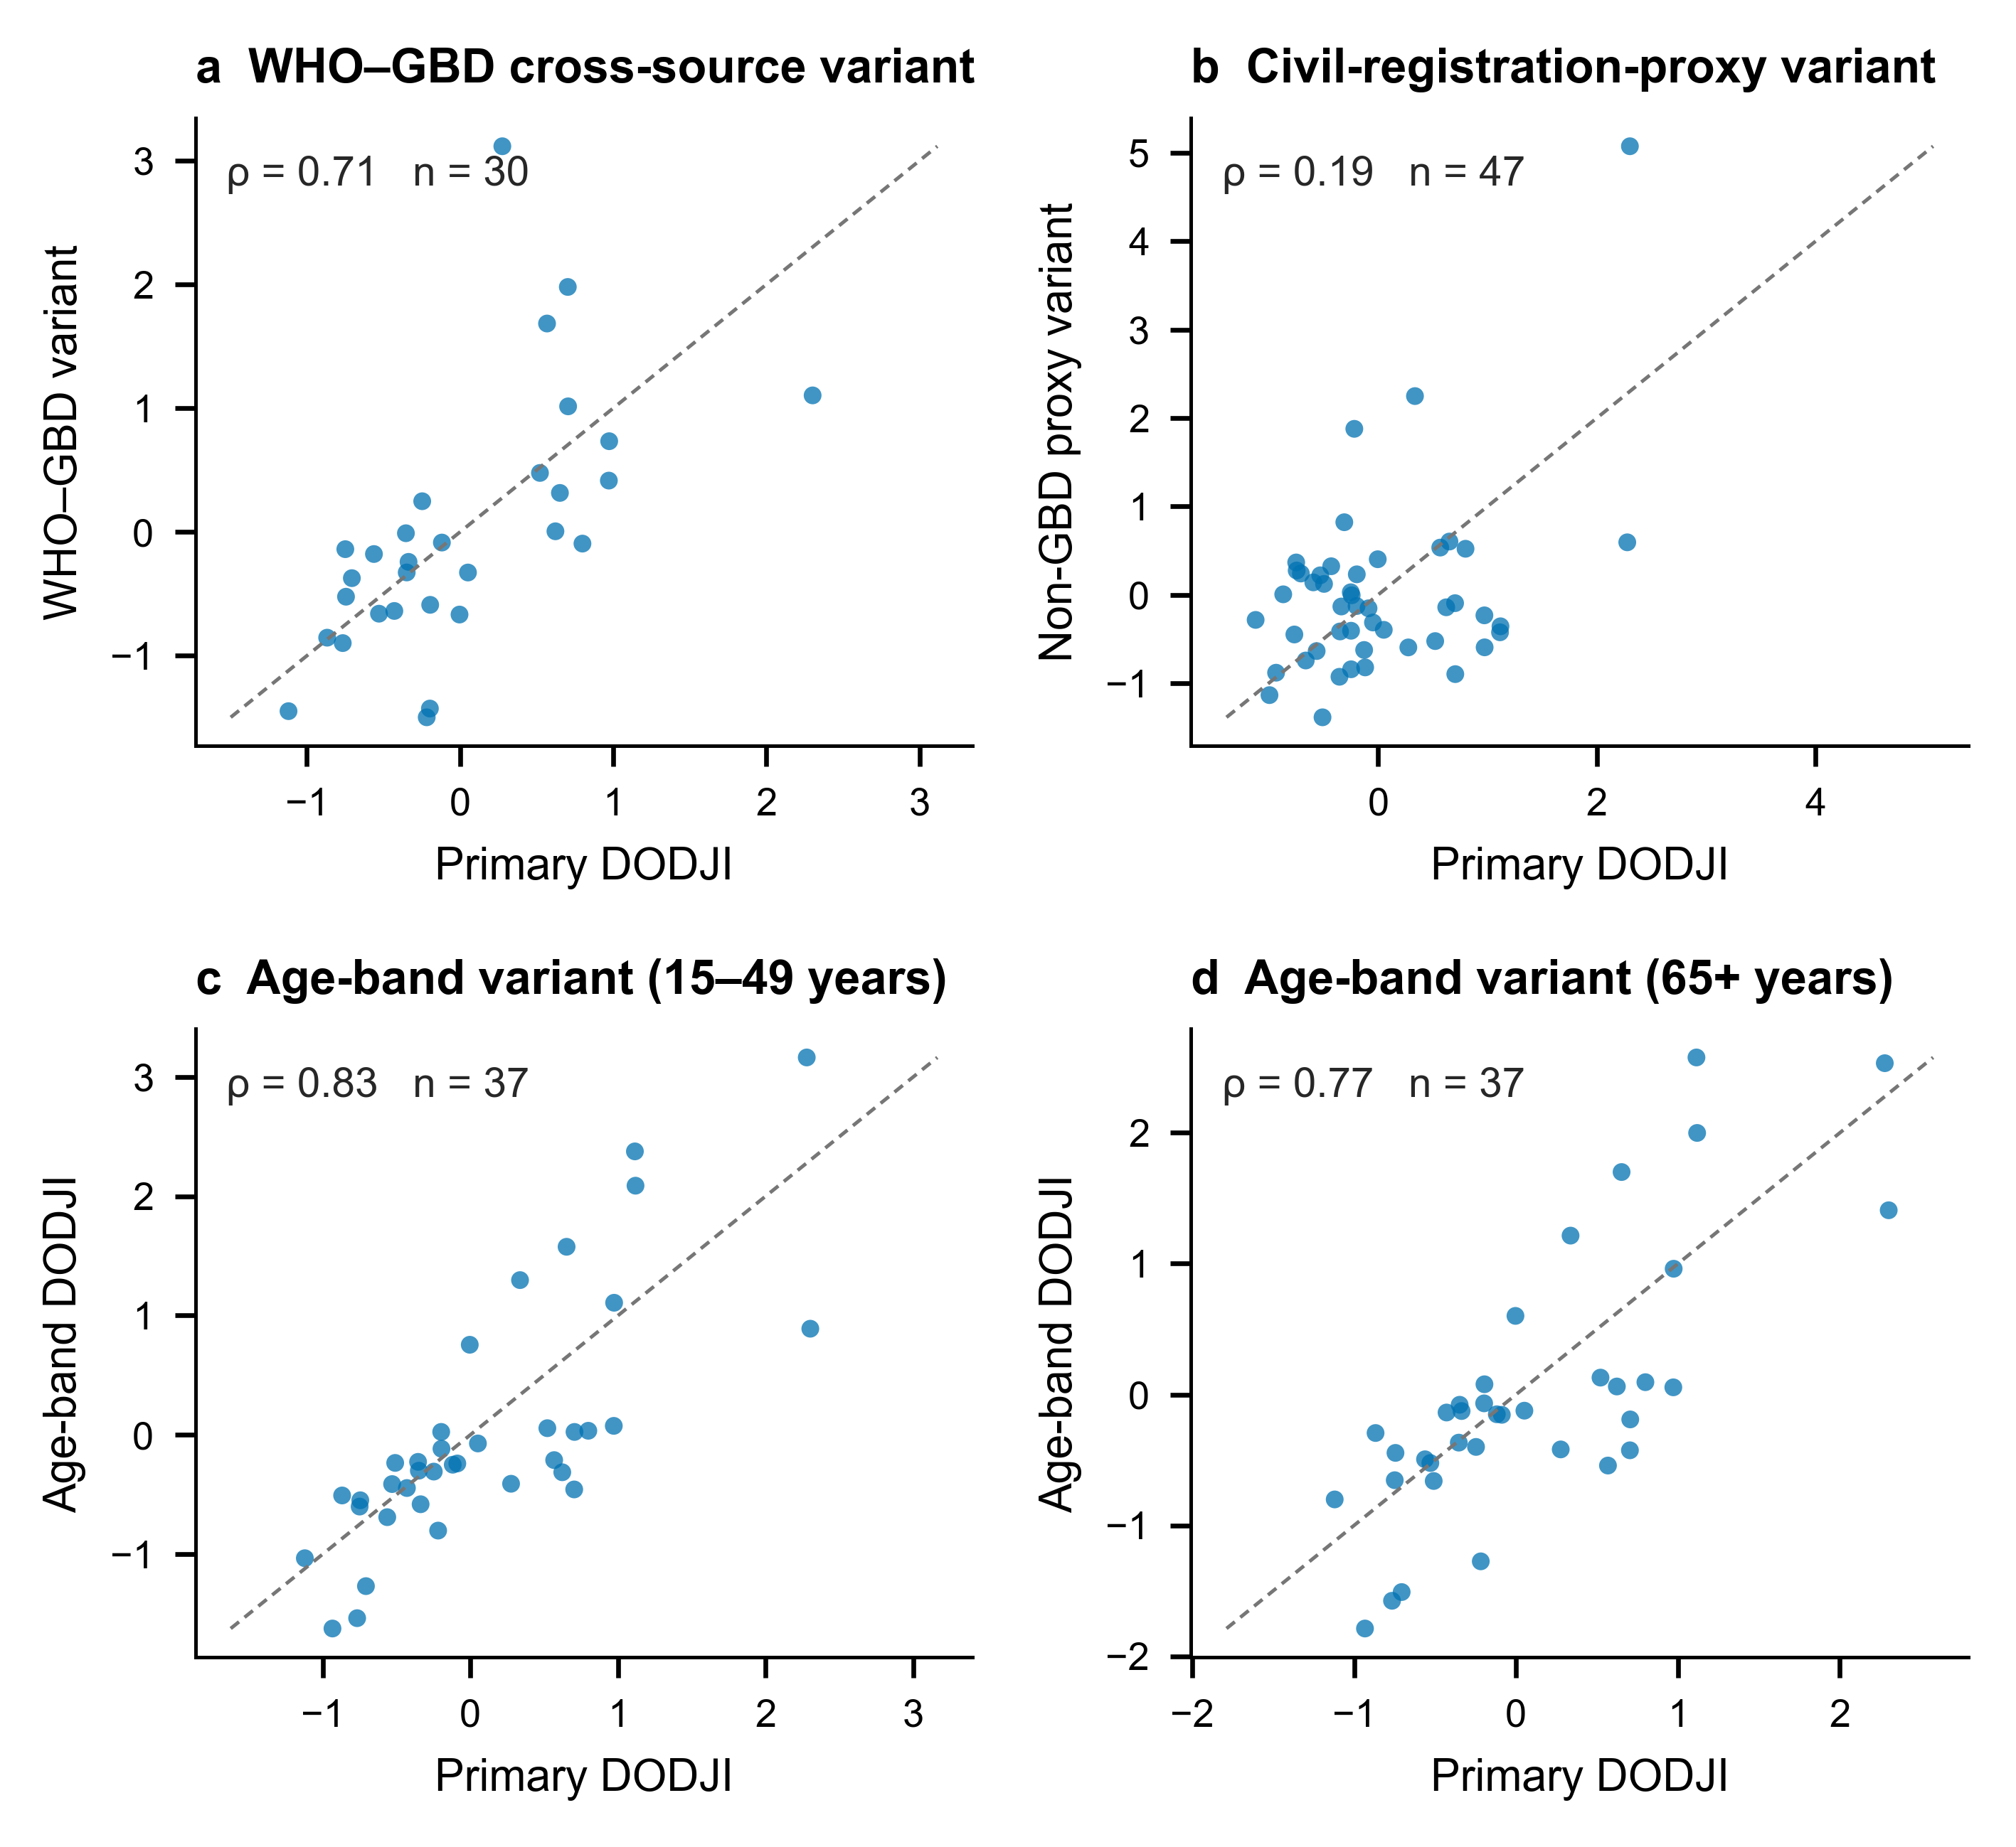
Each panel plots an alternative DODJI specification against the primary DODJI; dashed line: identity; ρ: Spearman correlation. (a) WHO Mortality Database cross-source variant (30 European countries; ρ=0.71). (b) Civil-registration-proxy (non-GBD, WHO-GHO/World Bank) variant (n=47; ρ=0.19), confirming that DODJI is not a proxy for generic registration quality. (c, d) Extended age-band variants for 15–49 and 65+ years (n=37; ρ=0.83 and 0.77). Panels c–d show the extended 37-country age-band sensitivity set; the primary age-band variants reported in main-text Figure 7 (15–49, 50–69, 70+ years; n=47; ρ=0.77–0.84) are listed in Table S5a.

Figure S3. Small-state sensitivity of external correlations and GDP decoupling
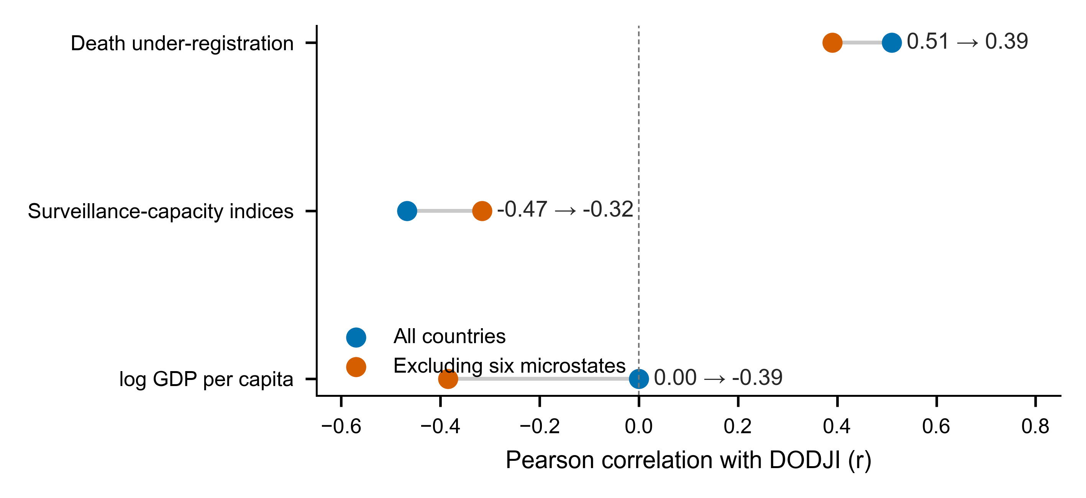
Pearson correlations of DODJI with death under-registration, composite surveillance-capacity indices, and log GDP per capita, in the full sample (blue) and after excluding six microstates (Monaco, San Marino, Andorra, Iceland, Malta, Luxembourg; vermillion). External correlations persisted but weakened (0.51→0.39; −0.47→−0.32), and GDP decoupling was less stable after exclusion (0.00→−0.39). Numeric values are given in Table S6.

Section 4. Study protocol (version 1.2)
Finalised before locking of the analysis dataset; archived in the reproducibility package (GitHub + Zenodo).

Administrative information
Study type: Ecological cross-national governance study (observational, secondary analysis of publicly available aggregate data).
Investigators: Hongjuan Fang (Aviation General Hospital, Beijing), Lili Wang and Qiang Wang (Chinese PLA Center for Disease Control and Prevention, Beijing).
Registration: Not prospectively registered (secondary analysis of public aggregate data; no intervention). The protocol, analysis code, and pinned data versions are timestamped in the reproducibility repository.
Funding: None. Conflicts of interest: None declared.
Ethics: Not required — publicly available, aggregated country-level data.

1. Background and rationale
International comparisons of drug-overdose mortality assume that deaths are counted in the same way across countries. Surveillance quality, however, varies with forensic toxicology capacity, medical-examiner systems, ICD coding, death-scene investigation, reporting timeliness, record linkage, and the extent to which modelled estimates substitute for observed records. A low reported mortality rate can therefore mean protection, or it can mean that deaths are hidden, misclassified, delayed, or estimated with substantial uncertainty. Surveillance determines whose deaths become evidence; unequal visibility is a data-justice problem. No existing index separates the credibility of overdose-mortality surveillance from mortality burden itself.

2. Objectives
Primary objective: to develop and validate the Drug Overdose Data Justice Index (DODJI), a GDP-residualised measure of overdose data quality that is independent of mortality burden, for 47 European and OECD countries, 1990–2021.
Secondary objectives: (i) to quantify how preparedness priorities are reordered when mortality burden is combined with DODJI-informed surveillance credibility; (ii) to classify countries into governance regimes linking burden and surveillance; (iii) to define minimum surveillance packages by maturity stage.

3. Study design and setting
Ecological cross-national study of 47 European and OECD countries with data from 1990 to 2021. The unit of analysis is the country. The sample frame was defined by data availability in GBD 2021 and the WHO Mortality Database and by comparability of high-income mortality infrastructure.

4. Eligibility criteria (countries)
Inclusion: countries with (i) GBD 2021 drug-use-disorder mortality estimates with uncertainty intervals, (ii) WHO Mortality Database records sufficient for WHO–GBD divergence over 1990–2021, and (iii) World Bank GDP-per-capita series. Exclusion: countries failing any data-availability criterion, and countries whose mortality infrastructure is not comparable with high-income registration systems. 47 countries met all criteria.

5. Data sources
• GBD 2021: age-standardised drug-use-disorder death rates (ASDRs) and uncertainty intervals (IHME).
• WHO Mortality Database: independent observed mortality source for WHO–GBD divergence.
• World Bank World Development Indicators: GDP per capita.
• WHO Global Health Observatory: cause-of-death registration completeness, ill-defined-cause fraction, forensic-monitoring indicators.
• Published INCB-based estimates: controlled-opioid consumption (Richards et al., Br J Pain 2021).
• World Mortality Dataset (Karlinsky & Kobak): death-registration completeness.
• EMCDDA reports and peer-reviewed policy histories: opioid-agonist therapy (OAT) coverage and policy-adoption dates.

6. Variables
Primary measure: DODJI (see Section S1.2). Burden measure: mortality-burden rank from GBD 2021 ASDRs. Mechanism variables: cause-of-death registration completeness, ill-defined-cause fraction, forensic-pathology capacity, OAT coverage, policy-adoption timing, GDP per capita (Table S1). Mechanism indicators use the most recent available year (2013–2014 for most civil-registration and forensic variables; 2015–2023 for economic and demographic variables); the pinned mechanism-variables table is archived in the reproducibility package.

7. DODJI construction
As described in Section S1.2: raw quality score Q from standardised mean relative GBD uncertainty-interval width and mean absolute WHO–GBD divergence, averaged over 1990–2021; DODJI defined as the studentised residual of Q regressed on log GDP per capita.

8. Statistical analysis plan
Prespecified analyses:
• Measurement validity: correlation of raw Q and of DODJI with log GDP per capita (success criterion: residualisation removes GDP dependence).
• Internal consistency: correlations of DODJI with its two components (descriptive; not independent validation).
• External credibility: correlation of DODJI with death under-registration and with composite surveillance-capacity indices.
• Specificity: correlations with OAT coverage and generic GBD garbage-coding proxies (success criterion: null).
• Actionability: rank reclassification — difference between mortality-burden rank and combined preparedness-priority rank; priority tiers I–IV from combined-priority scores (score = 1 + 3.5 × (0.5B + 0.5S), with burden need B=(47 − mortality rank)/46 and DODJI-percentile surveillance need S; tiers by combined-priority-rank quartiles).
• Governance regimes: countries classified into four regimes by an explicit burden-by-surveillance matrix (bottom-quartile burden and DODJI >0 → insufficient-exposure-data; DODJI >0 otherwise → data-quality-limited; highest-burden half and DODJI ≤0 → medical-system-driven; remainder → low-burden/protected).
• Small-state sensitivity (prespecified): all analyses repeated excluding Monaco, San Marino, Andorra, Iceland, Malta, and Luxembourg; microstate rankings reported as sparse-event flags.
• Robustness: Spearman correlations between the primary DODJI and alternative variants (Table S5).
• Mechanism analysis: exploratory regression of DODJI on mechanism proxies with regime fixed effects; Benjamini–Hochberg adjustment across mechanism tests.
• Policy analysis: exploratory two-way fixed-effects event-study estimates, reported as descriptive ecological associations, not causal effects (Table S3).
Exploratory analysis (added during revision, labelled exploratory in the manuscript): predictive validation — annual DODJI trajectories (1992–2018; 63 countries) regressed on subsequent 3-year mortality change under pooled OLS, country fixed effects, and country-and-year fixed effects with country-clustered standard errors (Table S2, Figure S1).
Significance: two-sided p<0.05, with multiplicity adjustment where families of tests were prespecified. Analyses used R (version 4.4.2) and Python (version 3.13); all code is archived.

9. Bias and limitations
Ecological design precludes individual-level and causal inference. DODJI is GBD-dependent and inherits GBD modelling assumptions. Several civil-registration and forensic indicators were last updated around 2013–2014. Microstate estimates are based on sparse events. Policy adoption is non-random; event-study estimates are descriptive. Predictive validation found no robust within-country forecasting signal, so DODJI is interpreted as a cross-sectional diagnostic, not a forecasting tool.

10. Data management and reproducibility
Analytic code, derived result tables (including the pinned mechanism-variables table, Table S1), figure-generation scripts, figure outputs, and source data for figures are deposited in a public GitHub repository and archived via Zenodo (Section 6). Input data are publicly available from the original providers.

11. Amendments and deviations
Version 1.2 amendments: (i) predictive validation added as an explicitly exploratory analysis during revision; (ii) regime descriptions reported as median-based summaries verified against the classification table; (iii) priority-tier thresholds reported as observed score ranges with boundary ties noted; (iv) the combined priority score and the governance-regime classification were replaced with an explicit, fully reproducible algorithm (v18; build_reclassification_v18.py), and all downstream tables and figures were recomputed. No change was made to the DODJI construction or to the primary validation battery after dataset lock.

12. Dissemination
Results are submitted to The Lancet. There are no publication restrictions.

Section 5. STROBE checklist (cross-sectional version, adapted for an ecological country-level study)
Item | Recommendation | Where reported / response
TITLE & ABSTRACT
1a | Indicate the study design with a commonly used term in the title or the abstract. | Summary, Methods paragraph: "ecological governance study"; Methods, "Study design and data sources".
1b | Provide an informative, balanced summary of what was done and found. | Structured Summary (Background, Methods, Findings, Interpretation, Funding), 169 words.
INTRODUCTION
2 | Explain the scientific background and rationale. | Introduction, paragraphs 1-3.
3 | State specific objectives, including any prespecified hypotheses. | Introduction, final paragraph; Methods (DODJI construction; validation criteria). Protocol (Section 4), item 2.
METHODS
4 | Present key elements of study design early in the paper. | Methods, "Study design and data sources": ecological cross-national governance study, 47 countries, 1990-2021.
5 | Describe the setting, locations, and relevant dates. | Methods: countries and data window 1990-2021; mechanism indicators 2013-2023 as available; predictive validation 1992-2018.
6 | Give eligibility criteria, and the sources and methods of selection of participants (countries). | Methods: sample defined by GBD 2021 and WHO Mortality Database availability and comparability of high-income mortality infrastructure (47 countries). Section S1.1.
7 | Clearly define all outcomes, exposures, predictors, potential confounders, and effect modifiers. | Methods, "DODJI construction" and "Mechanism variables and regime description"; Tables 2 and S1.
8 | For each variable of interest, give sources of data and details of methods of assessment. | Methods: GBD 2021, WHO Mortality Database, World Bank WDI, WHO GHO, INCB-based estimates, World Mortality Dataset, EMCDDA (references 7-13).
9 | Describe any efforts to address potential sources of bias. | Methods, "Validation and sensitivity analyses"; prespecified small-state exclusion; robustness variants; mechanism regression with multiplicity adjustment; predictive validation with fixed effects. Discussion, "Boundary conditions".
10 | Explain how the study size was arrived at. | Methods: all 47 countries meeting eligibility criteria; no a-priori sample-size calculation (full eligible sample). Predictive analysis used 63 countries with sufficient annual data.
11 | Explain how quantitative variables were handled in the analyses. | Methods: standardisation of Q components, regression on log GDP, studentised residuals; Spearman correlations for robustness; standardised coefficients in mechanism model. Section S1.2.
12a | Describe all statistical methods, including those used to control for confounding. | Methods (residualisation on log GDP; regime fixed effects in mechanism model; country and year fixed effects in predictive validation).
12b | Describe any methods used to examine subgroups and interactions. | Governance-regime classification and regime-level comparisons (Figure 3, Tables 2 and S4); priority tiers (Figure 2).
12c | Explain how missing data were addressed. | Country eligibility required complete DODJI inputs; mechanism variables use the most recent available year with per-indicator n reported in Table 2 (e.g., civil registration n=8 of 9 for data-quality-limited) and full per-country availability in Table S1.
12d | Cross-sectional studies - describe analytical methods taking account of sampling strategy (if applicable). | Not applicable - complete country sample, no sampling; sensitivity analyses instead (small-state exclusion; robustness variants).
12e | Describe any sensitivity analyses. | Prespecified small-state exclusion (Table S6, Figure S3); alternative DODJI specifications (rho 0.71-0.89; Table S5, Figure S2); perturbation analysis (Table S5b).
RESULTS
13a | Report the numbers of individuals (countries) at each stage of the study. | 47 countries in the primary analysis; 63 in the exploratory predictive validation; 43 with external-validation data; 30 for the WHO cross-source variant; 41 after microstate exclusion.
13b | Give reasons for non-participation at each stage. | Methods: exclusion solely by data availability; reasons (missing WHO-GBD divergence or GDP series) listed in the reproducibility package.
13c | Consider use of a flow diagram. | Country-inclusion flow (data-availability funnel) provided in the reproducibility package.
14a | Give characteristics of study participants (countries) and information on exposures/confounders. | Table 2 (regime characteristics), Table S4 (full 47-country classification), Table S1 (mechanism variables).
14b | Indicate the number of participants with missing data for each variable of interest. | Table 2 reports per-indicator n for every mechanism variable; DODJI inputs complete for all 47 countries; Table S1 shows per-country availability.
14c | Cross-sectional studies - summarise follow-up time (if applicable). | Not applicable for the cross-sectional index; predictive validation window 1992-2018 reported in Methods/Results and Table S2.
15 | Cross-sectional studies - report numbers of outcome events or summary measures. | Results and Figures 1-3: mortality-burden ranks, DODJI scores, priority tiers, regime counts (18/13/10/6); Table S4.
16a | Give unadjusted estimates and, where applicable, confounder-adjusted estimates and their precision. | Results: raw Q-GDP r=-0.46 (p=0.0013) vs residualised DODJI-GDP r~0; mechanism beta=-0.032 (SE 0.016; civil registration coverage); predictive beta with SE under three specifications (Table S2).
16b | Report category boundaries when continuous variables were categorised. | Methods: priority-tier observed score ranges (I >=3.10; II 2.70-3.05; III 2.50-2.70; IV 1.30-2.50; ties at 2.70 and 2.50 noted). Section S1.4.
16c | If relevant, consider translating relative risks into absolute risks. | Not applicable - no risk estimates; ranks, correlations, and standardised coefficients reported instead.
17 | Report other analyses done. | Results: robustness battery (Figure 7, Table S5), mechanism proxies (Figure 6a), exploratory predictive validation (Figure 6b, Table S2), descriptive policy event-study (Table S3).
DISCUSSION
18 | Summarise key results with reference to study objectives. | Discussion, first paragraph.
19 | Discuss limitations, direction and magnitude of potential bias. | Discussion, "Boundary conditions and future directions": GBD dependence, ecological design, indicator vintage, microstate sparse events, no forecasting signal.
20 | Give a cautious overall interpretation considering objectives, limitations, multiplicity, and other studies. | Discussion ("Validation supports cautious use"; "descriptive associations, not causal effects"); BH-adjusted mechanism result reported.
21 | Discuss the generalisability of the study results. | Discussion, "Global health implications": high-income proof-of-concept; adaptation needed for LMICs.
OTHER
22 | Give the source of funding and the role of the funders. | "No external funding was received"; Role of the funding source statement.

Note: This ecological study uses countries as units of analysis; participant-level items are answered at country level. STROBE does not provide a dedicated ecological checklist; the cross-sectional version is the closest applicable standard.

Section 6. Data and code availability
Analytic code, pinned derived result tables (including the mechanism-variables table reproduced as Table S1), figure-generation scripts, figure outputs, and source data for figures are deposited at https://github.com/wang76qiang/DODJI-overdose-surveillance and archived via Zenodo at https://doi.org/10.5281/zenodo.21823299.
Repository contents:
• Code: DODJI construction, validation, robustness checks, mechanism regression, predictive validation, the explicit classification and scoring pipeline (build_reclassification_v18.py, build_v18_derived.py), a source-verified policy-adoption-year dataset with codebook and executable validator, a guarded policy event-study template, and figure-generation scripts in R and Python.
• Data tables: reclassification_table_v18.csv (Table S4), mechanism_variables_47countries.csv (Table S1, pinned), robustness summaries (Table S5), microstate_sensitivity_v17.csv (Table S6), predictive-validation outputs (Table S2), annual_dodji_panel.csv (Figure S1), variant score files (Figure S2).
• Figures: all main and supplementary figures as 600-dpi PNG and editable PDF.
• Protocol and provenance: this appendix; DATA_PROVENANCE_NOTE.md documenting the pinned mechanism-variables table and API re-query caveats.
Input data are publicly available from IHME GBD 2021, the WHO Mortality Database, the World Bank World Development Indicators, the WHO Global Health Observatory, the World Mortality Dataset, EMCDDA reports, and published controlled-opioid consumption estimates (Richards et al., Br J Pain 2021).

