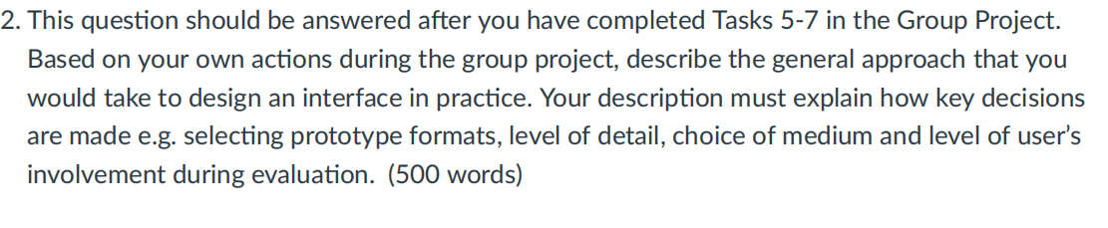

Firstly, I need to develop a solid conceptual model about the platform we are going to build. Basically, our team is going to build a comprehensive psychotherapy platform that allows for online therapy, as well as some comfort. In order to build an appropriate interface, I need to decide which kind of prototype is most suitable for our needs. Through brain-storm, I prefer manipulating method due to its friendly use and high efficient. I write down all the possible ways such as website, VR, hand writing and mobile phone generated from the brainstorm. Then by comparing the drawbacks and advantages of each term, I choose to use mobile device with touch screen for users to click button or fill words as the interface due to its high functionality and interactivity and most convenient and widely accepted by people.

Secondly, I need to implement what kind of terms users can interact with the interface which is significant in practice. I break the scenario into a series of steps which made things easier to explore through stories. From the picture of stories, I can add life, show time progression and explore dynamics which help to decide the sequence of functions. As a result, I assume users should register firstly, fill the profile page and then choose the interesting areas which will then all be stored in the software. After that people could use the functions of APP freely such as enjoy entertainment, communicate in groups or inquire experts for details.

At last, how to evaluate is important to judge and develop functions for the interface. Through mind storm, I could write down ideas as diagrams and sketches to choose. Because we have to evaluate with users, so I prefer the usability testing and experiments which means I will let people trying to use it directly. Meanwhile, I will record the finish time, the times the try and if they need extra help from manual docs. All these will contribute to improve our design and judge the usability of the prototype which will be developed as a final product. In additional, field studies is also useful to collect data about how people react naturally and how the product impact them in nature field.

In conclusion, I communicate with group members to understand the conceptual model and then generate many ideas through brainstorm to decide the appropriate prototype type for our interface. And then by using story board, I could decide the use steps for the interface. Lastly, the usability testing and field studies is chosen by the method of sketch to help me improve functions and find the unforeseen issues.

