官网:https://op-irs.zj.gov.cn/mobile/login?goto=/mobile/gateway/api/add/preview/1001969736

mgop.rainbow.fishEasier.
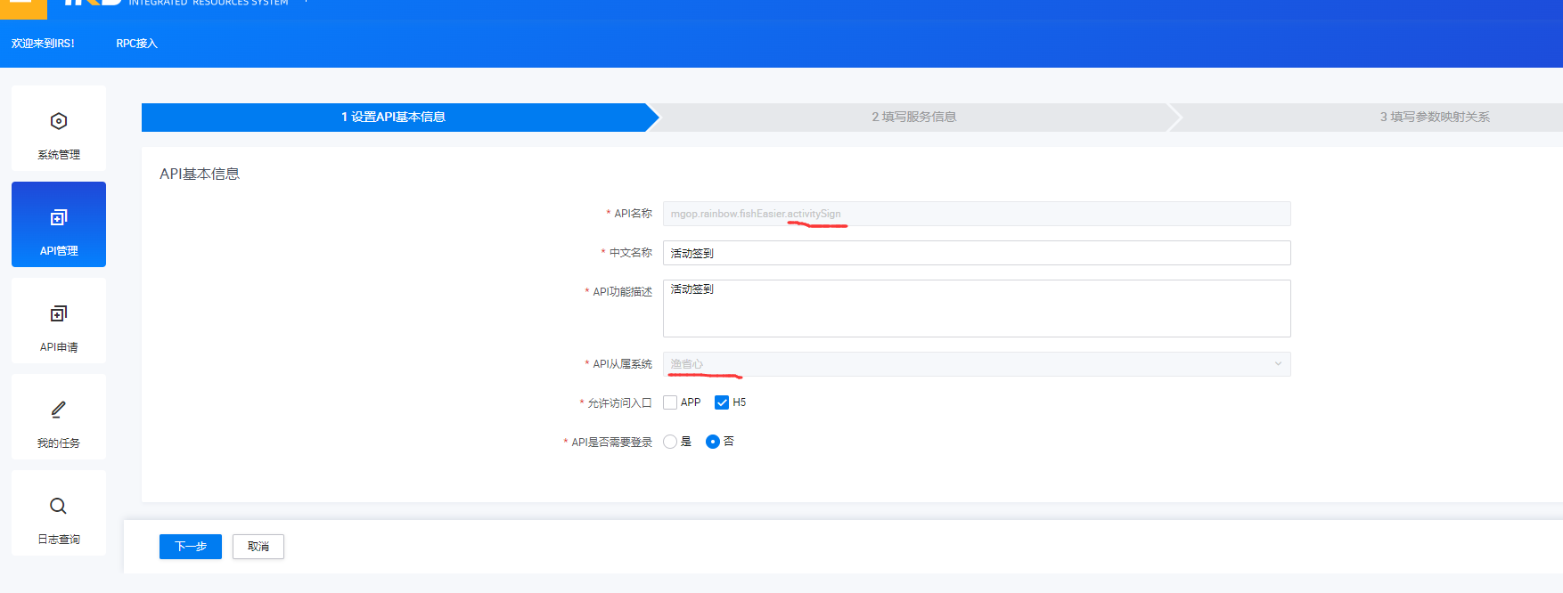
生产环境地址： https://hy2api.tian-wang.com/fish-easy
联调地址： https://betahy2api.tian-wang.com/fish-easy
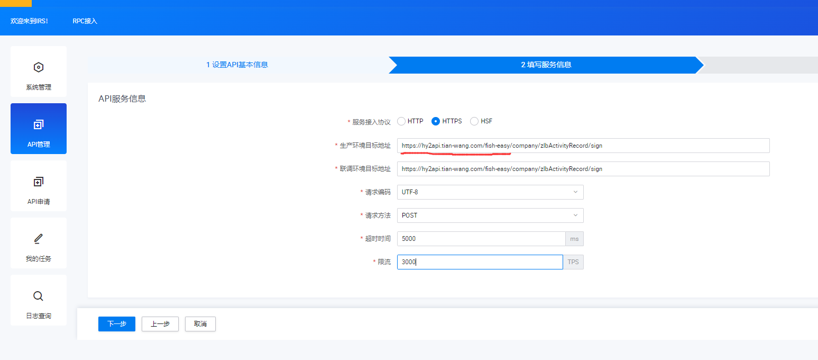

Post选择
