# 雷达后台部署

## 1、环境配置

Linux环境下

### 1.1 docker安装

yum install docker

使用下面的命令来启动 docker 服务，并将其设置为开机启动

systemctl start docker.service
  
systemctl enable docker.service

测试

docker version

### 1.2 docker-compose安装

可以再安装之前先更新一下curl

yum update curl

下载

sudo curl -L https://github.com/docker/compose/releases/download/1.20.0/docker-compose-`uname -s`-`uname -m` -o /usr/local/bin/docker-compose

安装

chmod +x /usr/local/bin/docker-compose

查看版本

docker-compose version

**2.安装docker compose(方式二)**  
安装pip

yum -y install epel-release
  
yum -y install python-pip

确认版本

pip --version

更新pip

pip install --upgrade pip

安装docker-compose

pip install docker-compose

查看版本

docker-compose version

## 2、后台部署

### 2.1 修改服务器对应路径下的ip,修改服务器IP端口为ip

文件路径下/louyu/dist/assets/js/app.b6a263e1.js

检索 1.116.114.89:8089，修改为当前主机的ip:端口:8089

### 2.2 解压louyu压缩包，运行以下命令

docker-compose up -d
  
  
[root@VM-16-12-centos louyu]# docker-compose up -d
  
Creating network "louyu_app_net" with driver "bridge"
  
Creating louyu_mysql ... done
  
Creating louyu_redis ... done
  
Creating louyu_serv ... done
  
Creating louyu_show ... done
  
[root@VM-16-12-centos louyu]#

### 2.3 部署后查看docker状态

[root@VM-16-12-centos louyu]# ls
  
dist dist_3.zip dist_4.zip dist.zip docker docker-compose.yml Dockerfile louyu.sql target
  
[root@VM-16-12-centos louyu]# docker-compose ps
  
 Name Command State Ports
  
-----------------------------------------------------------------------------------------------------
  
louyu_mysql docker-entrypoint.sh --def ... Up 3306/tcp, 33060/tcp
  
louyu_redis docker-entrypoint.sh redis ... Up 6379/tcp
  
louyu_serv java -jar ./wisdom_monitor.jar Up 0.0.0.0:1081->1081/tcp, 0.0.0.0:8088->8088/tcp
  
louyu_show /docker-entrypoint.sh ngin ... Up 80/tcp, 0.0.0.0:8089->8089/tcp
  
[root@VM-16-12-centos louyu]#

### 2.2 前端显示页面 访问服务器IP+端口8089

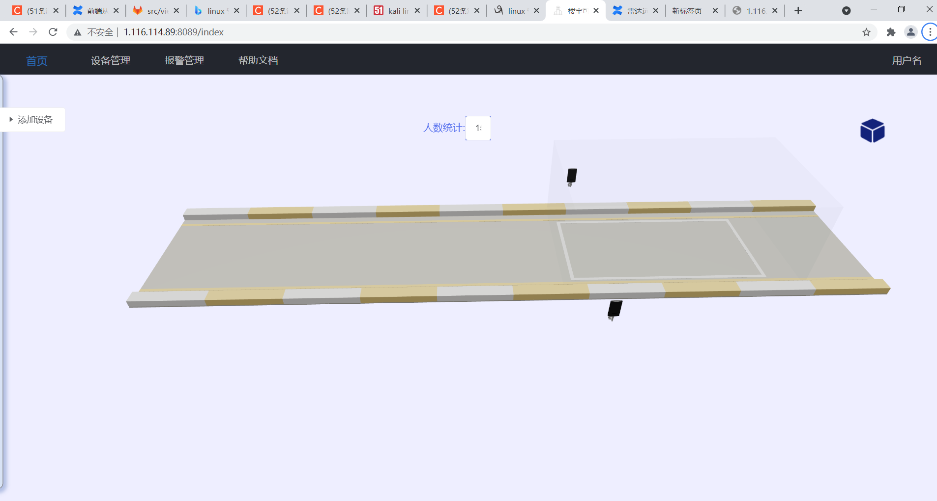

### 2.3 配置雷达

* 参考雷达配置文档
* 雷达配置 TCP 服务器地址：http://服务器IP:端口1081