1. Abstract
2. Keywords
3. Introduction
4. Method

Preparation and parcellation

Structural and functional MRI data from 30 patients with AD, 29 patients with LMCI, 40 patients with EMCI and 33 HCs from Alzheimer`s disease neuroimaging initiative (ADNI) database were analyzed in this study. To ensure the uniformity of data acquisition protocols and formats, all images were downloaded from ADNI2 (Philips Medical Systems, MRI: matrix = 256 x 256, slice thickness = 1.2mm, TE/TR = 3.2/6.8ms; fMRI: matrix = 64 x 64, slice thickness = 3.3mm, slices = 6720, TE/TR = 30/3000ms). Table 1 listed the basic information of healthy controls subjects, patients with EMCI, LMCI and AD. Supplementary Table 1 listed the reference IDs of all subjects.

T1-weighted MPRAGE and resting-state fMRI data were processed firstly by J-HCPMMP [1] preprocessing method. In this paper, a multi-modal parcellation of human cerebral cortex HCP MMP was used to parcellate human brain into 180 areas per hemisphere. Although HCP MMP explicitly requires MRI data to follow HCP sampling protocols, J-HCPMMP helps to achieve converting non-HCP style ADNI2 data into HCP CIFTI space using only T1W and fMRI data, without T2W data or field map information. Several brain data processing toolkits were used in J-HCPMMP including FreeSurfer, fMRIPrep, CIFTIFY and HCP minimal preprocessing pipeline, and necessary preprocessing steps like slice-timing, realignment, normalization, smoothing and registering fMRI data into T1W space were integrated in J-HCPMMP. The original data stored in DICOM or NIFTI format were registered into standard CIFTI gray-ordinates space in which consist of 32,492 vertices per hemisphere for cortical surface and 26,298 NIFTI voxels for subcortical volume. In HCP MMP, 360 areas in cortical surface were delineated based on these 32,492 x 2 = 64,984 vertices. All the fMRI data within these areas were then used for constructing the brain connectivity network.

Connectivity network construction

To study the functional association between brain regions, Pearson correlation coefficients were calculated using fMRI signals in the 360 parcellated areas. Brain connectivity network was constructed by defining each area as a graph node and correlation coefficient as the weight of the graph edge between nodes. Thus, for each subject, functional connectivity of human brain was represented by a 360 x 360 correlation adjacency matrix, and all diagonal weights (representing self-connections) were set to zero. Initially, the matrix would be dense because there existed plenty noisy correlations and spurious connections due to scanning environment. An appropriate thresholding is necessary prior to further network analysis. Various methods for de-noising were described in literatures, in this study, the well-known Brain Connectivity Toolbox (BCT) was adopted to generate sparse network by preserving a dynamic proportion of the strongest weights (dynamic PSW, dPSW). It was defined as the number of retained strong weights divided by the total number of weights, given by Eq. (1). In ref [2], the optimal threshold value was determined by graph theory-based measures global cost efficiency (GCE) and global efficiency (E), described in Eq. (2) and Eq. (3):

|  |  |
| --- | --- |
|  | (1) |
|  | (2) |
|  | (3) |

Where is the efficiency of node , is the shortest path length between node and , is the total number of nodes in the correlation network, and is the vector of all nodes. A range of candidate PSWs from 0.01 to 1 with a step 0.05 was tested for maximizing the GCE value. For each subject, the optimal PSW was different.

Binary brain connectivity network was also constructed in this study. After the optimal PSW was determined, the remaining strongest connections in the network would be set to 1 and others would be 0.

Measures of brain networks

Previous studies reported that graph-based measures of brain network could be effective to reveal characteristics of topological or functional connectivity in human brain. We computed various global and local measures, respectively for both weighted and binary networks, to quantitatively analyze the significant differences among subjects, and further used them as machine learning features to achieve distinguishing patients and HCs.

Global measures, including global efficiency (E), maximized modularity, assortativity coefficient, optimal number of modules, small-worldness index (SWI), characteristic path length (CPL) and mean clustering coefficient (MCC), were thought to take the ability to rapidly evaluate the overall performance of the human brain. They had only one value (1 x 1) in the whole connectivity network for each subject. All these measures could be computed directly through BCT software except for SWI which was given by Eq. (4):

|  |  |
| --- | --- |
|  | (4) |

Where the subscript represented the average value came from the randomized networks. In this study, we set the number of randomized networks to be 100. Different local measures in weighted and binary networks were calculated, which characterized areal behavior in the brain. As a consequence, a vector of 360 values (1 x 360) made up each local measure. Strength (S), clustering coefficient (CC), local efficiency (LE), betweenness centrality (BC), eigenvector centrality (EC), page rank centrality (PC) and degree (D) were computed in weighted network. Strength was defined as the sum of neighboring edge weights of a node, and degree was the number of edges connected to a node. In binary network, they were the same. In addition to these local measures calculated in weighted network, other measures like k-coreness centrality (KC) and flow coefficient (FC) were computed in binary network.

Analysis of variability

For each subject, a vector of 5,414 measures (including 7 x 1 global and 7 x 360 local measures in weighted network, 7 x 1 global and 8 x 360 local measures in binary network) was set up. All the measures were standardized to [-1, 1] ahead for subsequent analysis. To examine the inter-group variability among EMCI, LMCI, AD and HC, we averaged all the global and local measures within each group. Thus, a 4 x 5,414 matrix representing the average of the four groups was formed. On the basis of previous studies that regional abnormalities in brain causes cognitive impairment, we tested the hypothesis that significant alterations with specifically progressive relationship (AD>LMCI>EMCI>HC or the inverse direction) must exist in certain regions rather than the whole brain. Due to the unknown of data distribution, non-parametric null hypothesis Kruskal-Wallis H test was carried out to determine whether any two subjects were sampled from the same group and to confirm the results showed with significance. Confidence in varying level (90%, 95%) and IBM SPSS software were used for statistics analysis in this study. Eq. (5) to Eq. (7) depicted the analysis above.

|  |  |
| --- | --- |
|  | (5) |
|  | (6) |
|  | (7) |

Where was each of the 360 regions from HCP MMP. was the set of specific areas containing progressive relationship among groups, was the set of areas showing significant measure results, in which 0.05 and 0.1 were considered as *Criteria*. was the intersection of and .

Supervised machine learning

In order to verify the effectiveness of drawn above, network-based brain characteristic measures in each area of that were preserved as the keep-in features in machine learning to distinguish subjects in different groups. In the other areas, BCT measures were passed through feature selection progress. Many algorithms could be used for reducing dimensions of training data before classification, in this study, we carried out two steps to select the optimal features: filter and wrapper feature selection. In filter-based selection, Relief algorithm provided by Matlab was applied to rank and select top scoring features. It was classifier independent which considered only interactions among individual values rather than the final effectiveness of machine learning. Strongly correlated features would be considered redundant and assigned lower scores. Then top 1/5 of the ranked features with the highest discrimination ability was treated as the candidate features for the following wrapper-based selection. As a supervised strategy, wrapper algorithm was classification dependent. The selected features varied with machine learning methods. There mainly existed two methods in wrapper selection: forward and backward sequential feature selection (FSFS and BSFS). In FSFS, an empty feature set was initially created. Different features were tested successively in training model. Features that helped improve classification accuracy would be added to the set. By contrast, in BSFS, a set of the whole candidate features selected by Filter algorithm was initially set up. Features that had no effect on recognition for groups would be eliminated.

Various classifiers, including decision tree, K-nearest neighbor (KNN), support vector machine (SVM) and ensemble method, were examined in this study. Balanced data were used in training, testing and validation to avoid biased results. MATLAB Classification Toolbox were used to achieve multi-class classification. Previously binary classification for EMCI, LMCI, AD and HC was implemented, while it was complicated to be directly applied in multi-class situation.

There were two ways to enhance the ability of classifier: one-vs-one and one-vs-all. In one-vs-one method, four binary classification models were trained firstly, namely EMCI vs others, LMCI vs others, AD vs others and HC vs others. Each subject was scored by these four models to determine how much it belonged to the class, and it would be judged based on the highest score among the four results. In one-vs-all, it should firstly establish binary classifiers for any two classes, in this study classes and , respectively represented classifiers for HC vs EMCI, HC vs LMCI, HC vs AD, EMCI vs LMCI, EMCI vs AD, and LMCI vs AD. Each classifier had a decision about the subject. Finally, subject was classified with the most votes.

To evaluate the performance of classifiers, four indicators were computed in this study including true positive (TP), true negative (TN), false negative (FN) and false positive (FP). 5-fold cross validation was also employed for robust classification.

1. Results hub ROIs Brainnet Viewer

**Table 1 Basic information of subjects acquired from ADNI2**

|  |  |  |  |  |
| --- | --- | --- | --- | --- |
|  | HC | EMCI | LMCI | AD |
| Number | 33 | 40 | 29 | 30 |
| Male: Female | 14:19 | 14:26 | 16:13 | 12:18 |
| Age (mean ± SD) | 75.6±5.8 | 71.8±6.5 | 72.9±7.8 | 73.1±6.8 |

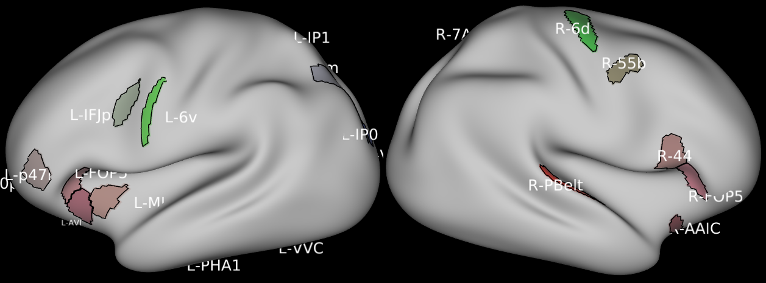

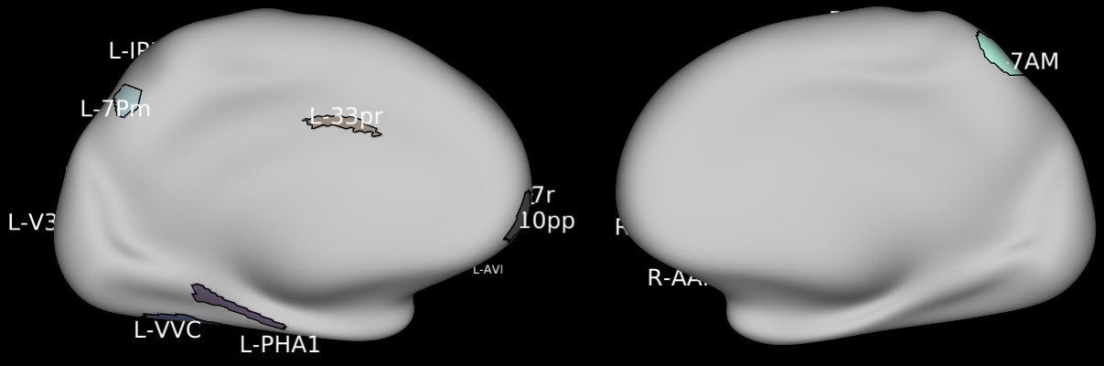

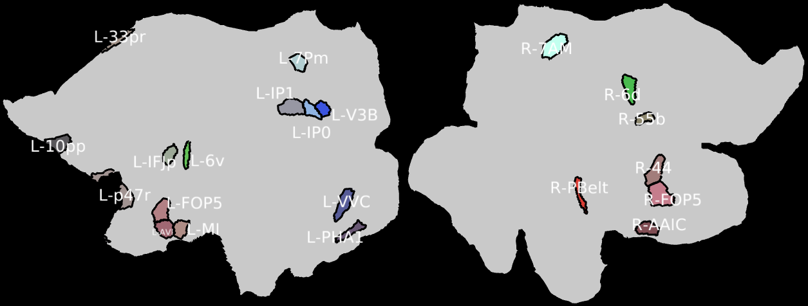

1. Discussion
2. Conclusion
3. Reference

[1] J. Sheng *et al.*, “A novel joint HCPMMP method for automatically classifying Alzheimer’s and different stage MCI patients,” *Behavioural brain research*, 2019.

[2] A. Khazaee, A. Ebrahimzadeh, and A. Babajani-Feremi, “Application of advanced machine learning methods on resting-state fMRI network for identification of mild cognitive impairment and Alzheimer’s disease,” *Brain imaging and behavior*, vol. 10, no. 3, pp. 799–817, 2016.

Appendix A.

**Detail information of acquired ADNI2 subjects**

|  |  |  |  |  |  |  |  |  |  |  |  |
| --- | --- | --- | --- | --- | --- | --- | --- | --- | --- | --- | --- |
| HC | | | EMCI | | | LMCI | | | AD | | |
| ID | Sex | Age | ID | Sex | Age | ID | Sex | Age | ID | Sex | Age |
| 002_S_0413 | F | 76 | 002_S_2010 | F | 68 | 002_S_4171 | M | 70 | 002_S_5018 | M | 74 |
| 002_S_0685 | F | 90 | 002_S_2043 | F | 73 | 002_S_4219 | F | 80 | 006_S_4153 | M | 80 |
| 002_S_1261 | F | 72 | 002_S_2073 | F | 64 | 002_S_4229 | M | 67 | 006_S_4867 | M | 75 |
| 002_S_1280 | F | 71 | 002_S_4237 | F | 82 | 002_S_4251 | M | 72 | 013_S_5071 | M | 76 |
| 002_S_4213 | F | 78 | 012_S_4987 | M | 70 | 002_S_4521 | M | 71 | 018_S_4696 | F | 73 |
| 002_S_4225 | M | 72 | 013_S_2324 | F | 57 | 002_S_4654 | F | 76 | 018_S_4733 | M | 76 |
| 002_S_4262 | F | 73 | 013_S_2389 | F | 59 | 002_S_4746 | F | 72 | 018_S_5074 | F | 75 |
| 002_S_4264 | F | 74 | 013_S_4268 | F | 64 | 006_S_4363 | F | 74 | 018_S_5240 | F | 63 |
| 002_S_4270 | F | 79 | 013_S_4768 | F | 62 | 006_S_4515 | M | 75 | 019_S_4252 | F | 87 |
| 006_S_0731 | M | 72 | 013_S_4791 | F | 69 | 006_S_4713 | M | 71 | 019_S_4477 | F | 82 |
| 006_S_4150 | M | 74 | 013_S_4917 | M | 76 | 010_S_4135 | F | 57 | 019_S_4549 | M | 80 |
| 006_S_4357 | F | 74 | 018_S_2133 | F | 64 | 013_S_4395 | F | 73 | 019_S_5012 | M | 77 |
| 006_S_4449 | F | 68 | 018_S_2155 | F | 70 | 013_S_4985 | F | 79 | 019_S_5019 | F | 63 |
| 010_S_4345 | M | 72 | 018_S_4597 | F | 70 | 018_S_4889 | M | 76 | 031_S_4024 | F | 56 |
| 012_S_4026 | M | 74 | 018_S_4868 | M | 78 | 019_S_4293 | M | 70 | 053_S_5070 | M | 72 |
| 012_S_4545 | F | 69 | 019_S_4285 | M | 75 | 031_S_4029 | M | 61 | 053_S_5208 | M | 69 |
| 012_S_4643 | F | 66 | 031_S_2018 | F | 77 | 031_S_4042 | M | 57 | 100_S_5106 | M | 74 |
| 013_S_4580 | F | 72 | 031_S_2022 | M | 67 | 031_S_4203 | F | 75 | 130_S_4589 | F | 75 |
| 013_S_4616 | M | 85 | 031_S_4149 | M | 74 | 031_S_4590 | F | 61 | 130_S_4641 | F | 74 |
| 013_S_4731 | F | 83 | 031_S_4476 | M | 89 | 031_S_4721 | M | 86 | 130_S_4660 | F | 77 |
| 018_S_4257 | M | 79 | 031_S_4947 | M | 75 | 100_S_4970 | M | 88 | 130_S_4730 | F | 81 |
| 018_S_4313 | F | 78 | 041_S_5026 | F | 71 | 130_S_4294 | F | 76 | 130_S_4971 | M | 77 |
| 018_S_4349 | F | 72 | 053_S_2357 | M | 72 | 130_S_4542 | F | 80 | 130_S_4982 | F | 59 |
| 018_S_4400 | M | 72 | 053_S_2396 | F | 71 | 130_S_4605 | F | 85 | 130_S_4984 | F | 73 |
| 019_S_4835 | M | 80 | 053_S_4557 | F | 84 | 130_S_4817 | M | 61 | 130_S_4990 | F | 76 |
| 031_S_4021 | M | 70 | 053_S_4661 | M | 74 | 130_S_4925 | M | 75 | 130_S_4997 | F | 61 |
| 031_S_4218 | M | 82 | 053_S_4813 | M | 68 | 136_S_4189 | F | 74 | 130_S_5006 | F | 69 |
| 031_S_4474 | M | 86 | 100_S_4512 | F | 68 | 136_S_4408 | M | 74 | 130_S_5059 | M | 73 |
| 031_S_4496 | F | 77 | 100_S_4556 | M | 74 | 136_S_4932 | M | 79 | 130_S_5231 | F | 74 |
| 053_S_4578 | F | 73 | 100_S_4884 | F | 74 |  |  |  | 136_S_4993 | F | 72 |
| 100_S_5246 | F | 66 | 130_S_2373 | F | 79 |  |  |  |  |  |  |
| 130_S_4343 | M | 81 | 130_S_2391 | F | 72 |  |  |  |  |  |  |
| 130_S_4352 | M | 84 | 130_S_2403 | F | 80 |  |  |  |  |  |  |
|  |  |  | 130_S_4405 | M | 72 |  |  |  |  |  |  |
|  |  |  | 130_S_4415 | F | 76 |  |  |  |  |  |  |
|  |  |  | 130_S_4417 | M | 75 |  |  |  |  |  |  |
|  |  |  | 130_S_4468 | F | 63 |  |  |  |  |  |  |
|  |  |  | 130_S_4883 | F | 77 |  |  |  |  |  |  |
|  |  |  | 136_S_4517 | F | 71 |  |  |  |  |  |  |
|  |  |  | 136_S_4956 | F | 68 |  |  |  |  |  |  |