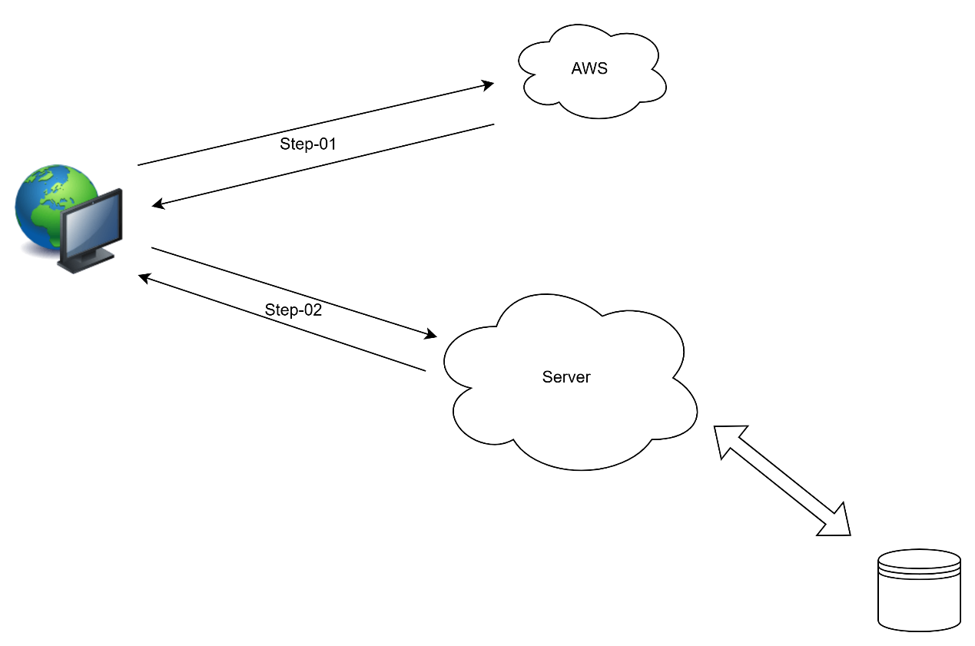

Step-01:

前端把照片往云存储平台(AWS)发送请求, 把图片存入云存储平台(AWS),获得图片的URL(img_url)

Step-02:

前端把图片URL及钱包地址(wallet_address)作为参数发送请求到云服务端(Server),服务端返回消息

|  |  |  |
| --- | --- | --- |
| 变量说明 | | |
| 图片地址 | img_url | <Http://xxxx.xxxxx.xxxx.xxx>(格式为png,jpg,jpeg,gif等) |
| 钱包地址 | wallet_address | 以0x开头的字符串类型 |

Step-02:后台返回消息格式:

错误码（我们自己业务错误定义的错误码以3开头）

|  |  |  |
| --- | --- | --- |
| 200 | "操作成功" |  |
| 400 | "请求参数错误" |  |
| 401 | "未授权" |  |
| 403 | "禁止访问" |  |
| 404 | "资源未找到" |  |
| 500 | "服务器内部错误" |  |
| 503 | "服务不可用" |  |
| 301 | "该小票相关信息不完整" |  |
| 303 | “参数不完整” |  |
| 305 | "Your receipt doesn't meet the requirements" |  |

失败时:

{

    "code": 500,

    "message": "服务器内部错误",

    "data": null,

    "timestamp": "2025-03-25T12:15:53.483"

}

成功时:

{

    "code": 200,

    "message": "操作成功",

    "data": {

        "id": 14,

        "walletAddress": "0xc402cfaf48f7a145b9c95242601e6bb26162fe8d",

        "imgUrl": "<Http://xxxx.xxxxx.xxxx.xxx>",

        "retinfoIsAvaild": null,

        "retinfoDrinkName": "ありがとう",

        "retinfoDrinkCapacity": null,

        "retinfoDrinkAmout": null,

        "retinfoReceiptTime": "2025-03-10 12:30:14",

        "remark": null,

        "isDelete": null,

        "createId": null,

        "createTime": "2025-03-25 12:04:45",

        "updateId": null,

        "updateTime": "2025-03-25 12:04:45"

    },

"timestamp": "2025-03-25T12:15:53.483"

}

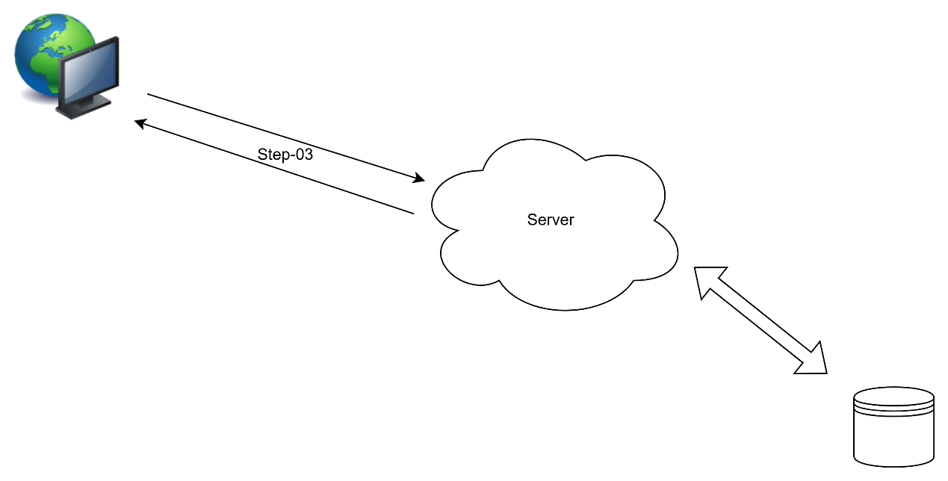

Step-03 获取首页卡片信息CardInfo

接口URL：

前端向后 端发送送请求获取最后一张小票的基本信息和积分：

|  |  |  |
| --- | --- | --- |
| 变量说明 | | |
| 钱包地址 | wallet_address | 以0x开头的字符串类型 |

失败时返回如下失败信息：

{

    "code": 305,

    "message": "Your receipt doesn't meet the requirements",

    "data": null,

    "timestamp": "2025-03-28T16:33:47.259"

}

成功时返回如下信息：{

    "code": 200,

    "message": "操作成功",

    "data": {

        "drinkName": "Lm アールグ レイムトウ",

        "drinkCapacity": 600,

        "drinkAmout": 2,

        "points": 7

    },

    "timestamp": "2025-03-28T16:29:23.666"

}