F74031190 王昶鈞

UML diagram

|  |  |
| --- | --- |
| 2048 | |
| main(argv:int ,argc:char) | widget |
| <<constructor>>+widget(parent:QWidget*)  +keyPressEvent(event:QKeyEvent*)  +int box[16];  +int check[4];  +int max;  +int last[16];  +int round;  +int point;  +bool change;  +bool ge;  +up()  +down()  +right()  +left()  +paint()  +start()  +generate()  - on_pushButton_clicked();  -on_start_clicked();  -Ui::Form *gui |

Screen shot

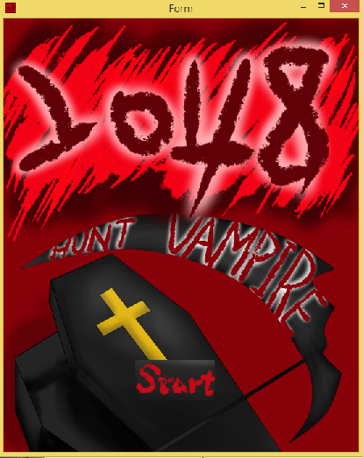Start the game

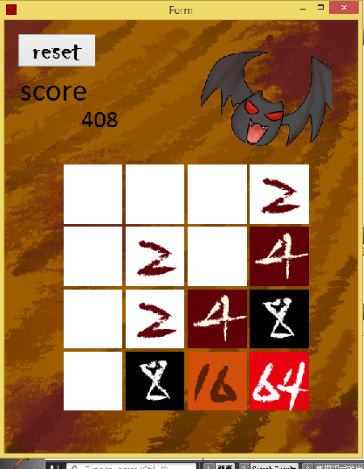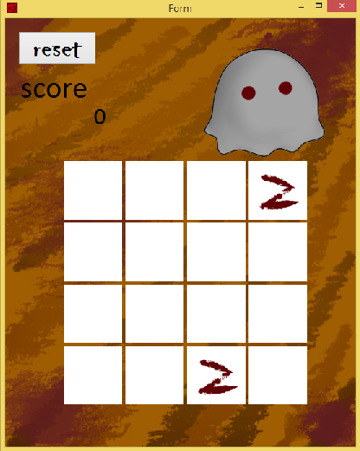if the maximum number<32 32<=max<256

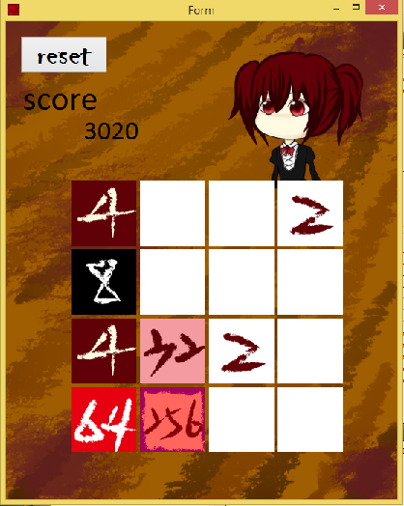256<=max<1024 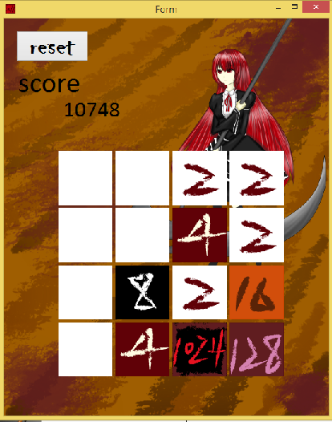 max=1024

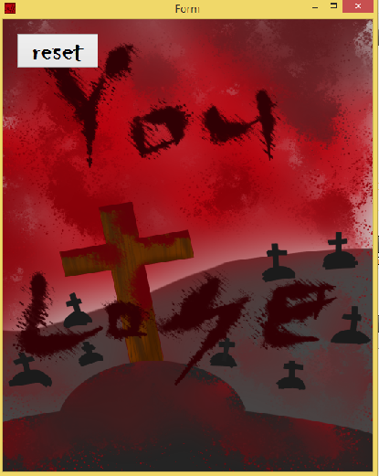Win and lose

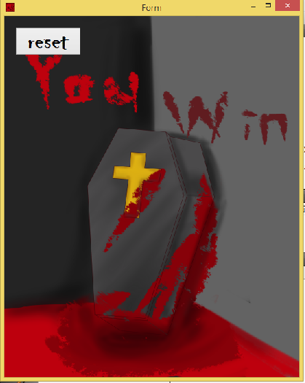

If you take over (max number/5+20+r) steps,you will be attack.

(r is a random number from 0 to 9)

If you are attack,all number in the box will become half.

