F74031190 王昶鈞

1.

(1)true

(2)false, not is-a ,is has-a

(3)true

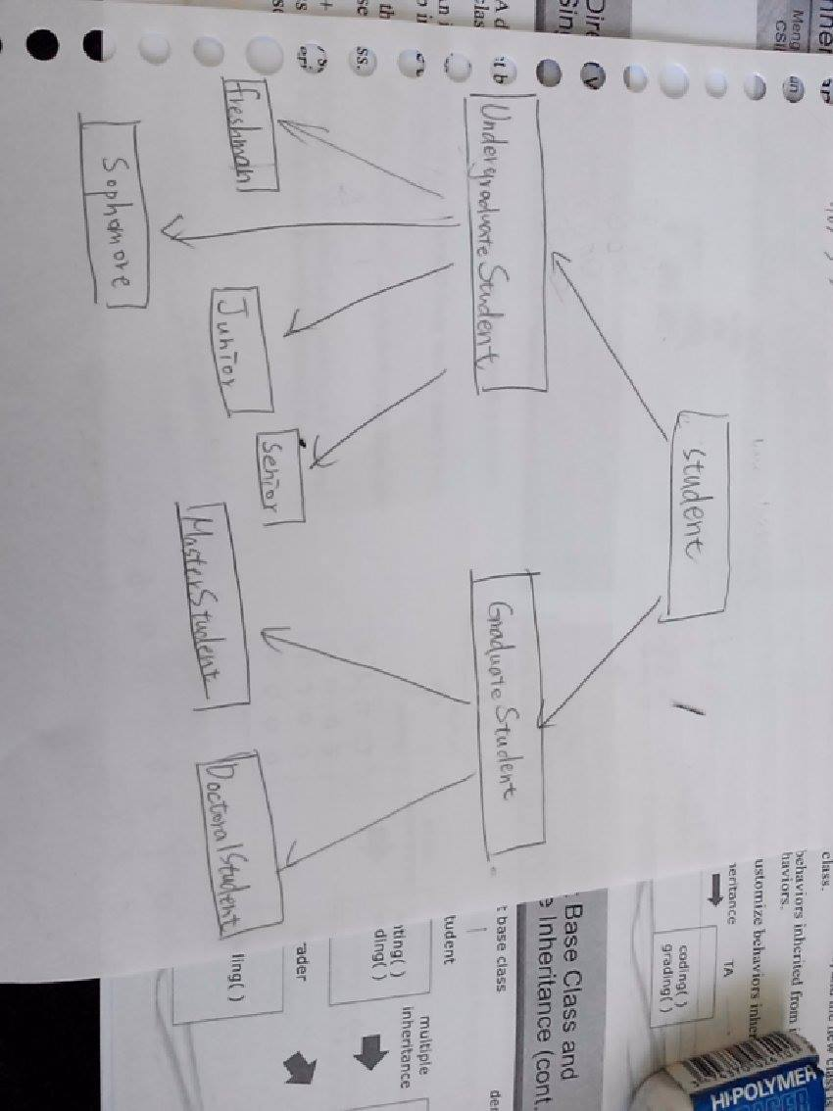(4)true

(5)false,it can’t be accessed in its friend’s derived,and its inherence type determine if it can be accessed or not.

2.

**Student** class is base class of **UndergradurateStudent** class and **GraduateStudent** class,and undirect base class of **Freshman** class ,**Sophomore** class, **Junior** class , **Senior** class,**MasterStudent** class and **DoctoralStudent** class.

**UndergradurateStudent** class is the derived class of student class,and the base class of **Freshman** class ,**Sophomore** class, **Junior** class and **Senior** class.

**GradurateStudent** class is the derived class of student class,and the base class of **MasterStudent** class and **DoctoralStude**nt class.