xqt-saas 财务模块完整方案 v3.3
Graphviz 高清图 + 10 个 PR 完整代码改动（前/后对照）
2026-06-08 ｜ A3 横版 ｜ 打开即可照抄写代码

0. 5 分钟速读
本文档把财务模块从"现状"到"成品"的所有改动写齐了。
颜色约定：
🟥 浅红底 = 改动前代码
🟩 浅绿底 = 改动后代码（开发同事直接复制）
🟨 黄底 = 重要提示
⬜ 灰底 = SQL 或一般代码
阅读路线：
• §1-§3 现状盘点 + 3 张高清架构图
• §4 6 个 GAP / 4 个缺字段 总览
• §5 10 个 PR 的"前后对照"代码（每个 PR 一节，可单独干）
• §6 自测命令
★ 已部署的基础：tenant_id 单租户化（commit 49659e5）— 新代码省略该字段

1. 完整 ER 图
按业务域配色：● 蓝=客户 ● 紫=供应商 ● 绿=订单 ● 红=费用核心 ● 橙=账单 ● 青=收款 ● 金=余额 ● 灰=审计
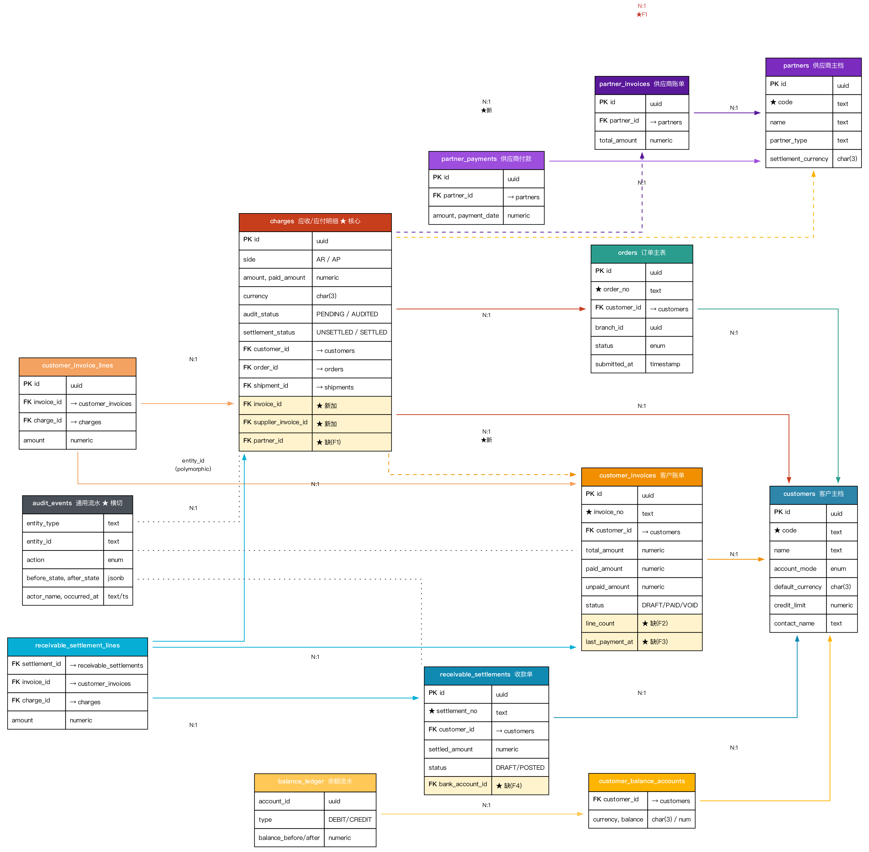
图 1：财务模块完整 ER - 12 张表 + cardinality + 缺字段高亮

2. 业务数据流
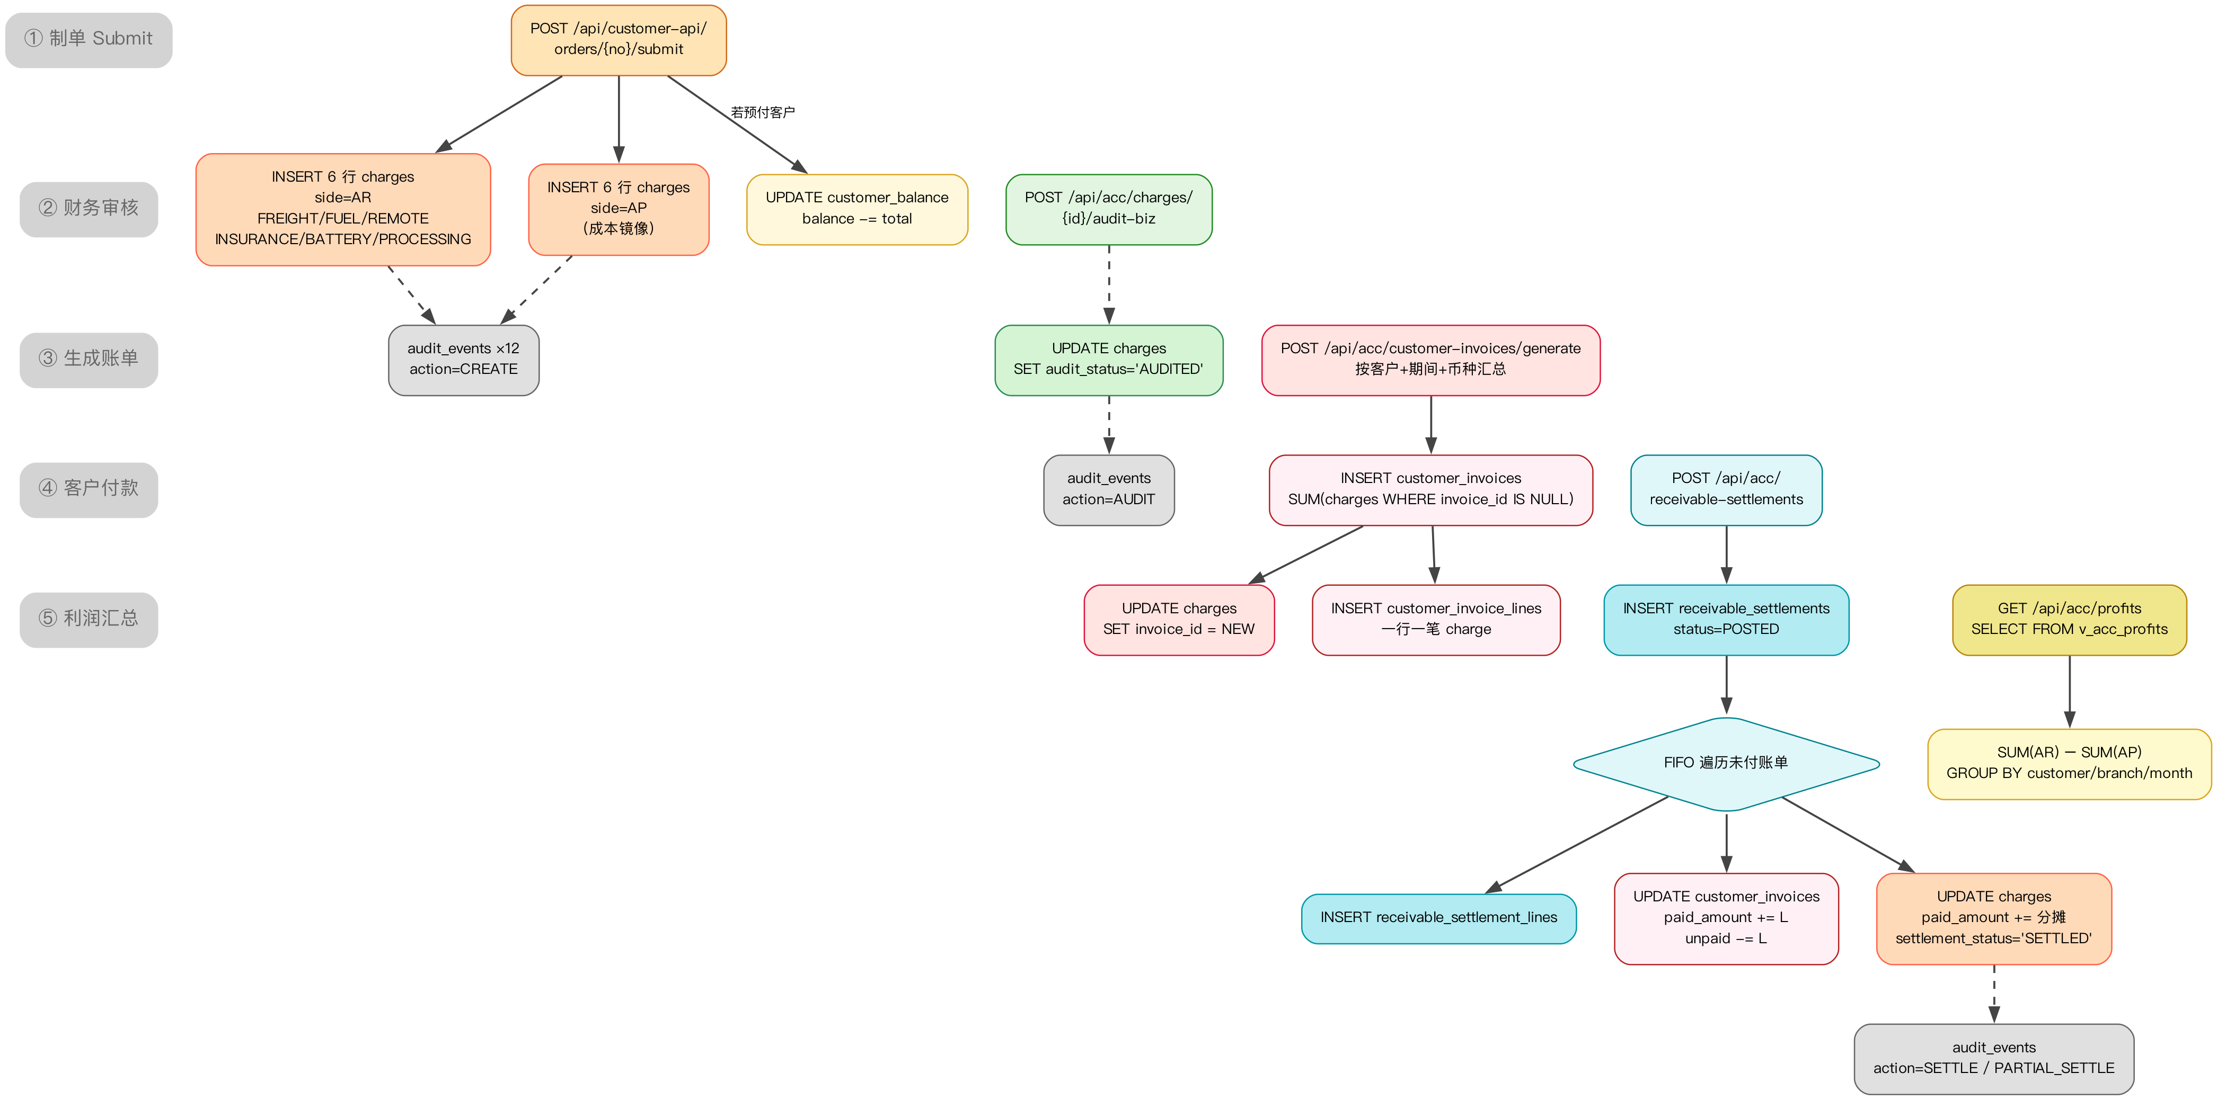
图 2：5 阶段数据流 - Submit → 审核 → 出账 → 收款 → 利润

3. charges 表完整字段
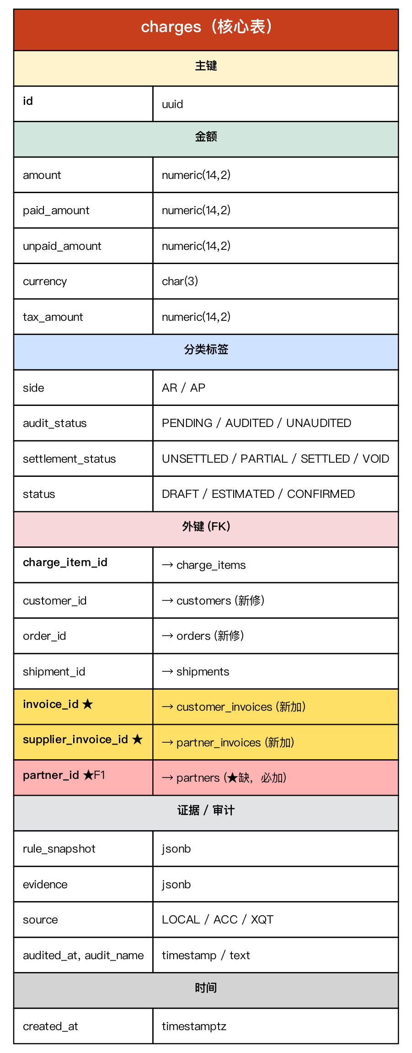
图 3：charges - 5 组字段分类，黄底=新加，红底=缺字段 F1

4. GAP 与缺字段总览

4.1 6 个 GAP
# | GAP | 工作内容 | PR | 工作量
G1 | 审计框架注册 | enum + Map | PR-1 | 30 分钟
G2 | 批审 endpoint | 自动可用 | PR-1 | 0
G3 | 生成账单 | 聚合 + INSERT | PR-8 | 半天
G4 | 收款核销 | FIFO + 联动 | PR-9 | 半天
G5 | 利润视图 | CREATE VIEW + 切端点 | PR-2 + PR-10 | 2h
G6 | 追加费用 | INSERT + 流水 | PR-7 | 2h

4.2 4 个缺字段
# | 字段 | 用途 | PR
F1 | charges.partner_id | 应付按供应商聚合 | PR-2
F2 | customer_invoices.line_count | 账单总数量 | PR-2
F3 | customer_invoices.last_payment_at | 最后付款 | PR-2
F4 | receivable_settlements.bank_account_id | 资金账户 | PR-2

5. 10 个 PR 完整代码改动
每个 PR 独立可执行。代码块"红底=改前"、"绿底=改后"，开发同事直接复制即可。

PR-1 ── 注册 charges 进审计框架（30 分钟）
目标：让 /api/acc/charges/{id}/audit-biz 等 4 个端点自动可用。
改动 1：扩 AuditAction enum
文件: apps/backend/src/main/java/com/xqt/saas/framework/audit/AuditAction.java
public enum AuditAction {
AUDIT, UNDO_AUDIT, BATCH_AUDIT,
CREATE, UPDATE, DELETE
}
public enum AuditAction {
AUDIT, UNDO_AUDIT, BATCH_AUDIT,
CREATE, UPDATE, DELETE,
// ↓ 本次新加
VOID, // 作废（cancelOrder）
SETTLE, // 全额核销
PARTIAL_SETTLE, // 部分核销
APPEND // 财务事后追加
}
改动 2：注册 charges 进 TAB_TO_TABLE
文件: apps/backend/src/main/java/com/xqt/saas/acc/AccAuditController.java（顶部 Map）
private static final Map<String, String> TAB_TO_TABLE = Map.ofEntries(
Map.entry("orders", "orders"),
Map.entry("shipments", "shipments"),
Map.entry("bills", "customer_invoices"),
// ...其他已注册的表
);
private static final Map<String, String> TAB_TO_TABLE = Map.ofEntries(
Map.entry("orders", "orders"),
Map.entry("shipments", "shipments"),
Map.entry("bills", "customer_invoices"),
// ...其他已注册的表
Map.entry("charges", "charges"), // ← 新加
Map.entry("costs", "charges") // ← AR/AP 同表别名
);
自动获得的端点：
POST /api/acc/charges/{id}/audit-biz # 单审
POST /api/acc/charges/{id}/undo-biz # 反审
POST /api/acc/charges/batch-audit # 批审
GET /api/acc/charges/{id}/audit-history # 查流水

PR-2 ── DDL：新字段 + 利润视图（30 分钟）
文件: db/migrations/059_finance_module_fields.sql （新建）
-- ════════════════════════════════════════════════════════════
-- 059_finance_module_fields
-- 财务模块补缺：F1+F2+F3+F4 字段 + v_acc_profits 视图
-- ════════════════════════════════════════════════════════════
BEGIN;
-- F1: charges.partner_id（应付按供应商聚合）
ALTER TABLE charges
ADD COLUMN IF NOT EXISTS partner_id uuid REFERENCES partners(id) ON DELETE SET NULL;
CREATE INDEX IF NOT EXISTS charges_partner_idx
ON charges (partner_id, created_at) WHERE partner_id IS NOT NULL;
COMMENT ON COLUMN charges.partner_id IS
'AP 行供应商关联（对应 ACC Express_Cost.ChannelAccount）';
-- G3 配套：charges 加 invoice 关联
ALTER TABLE charges
ADD COLUMN IF NOT EXISTS invoice_id uuid
REFERENCES customer_invoices(id) ON DELETE SET NULL,
ADD COLUMN IF NOT EXISTS supplier_invoice_id uuid
REFERENCES partner_invoices(id) ON DELETE SET NULL;
CREATE INDEX IF NOT EXISTS idx_charges_invoice ON charges (invoice_id)
WHERE invoice_id IS NOT NULL;
-- F2 + F3: customer_invoices 加 2 个展示字段
ALTER TABLE customer_invoices
ADD COLUMN IF NOT EXISTS line_count integer NOT NULL DEFAULT 0,
ADD COLUMN IF NOT EXISTS last_payment_at timestamptz;
-- F4: receivable_settlements 加 bank_account_id
ALTER TABLE receivable_settlements
ADD COLUMN IF NOT EXISTS bank_account_id uuid
REFERENCES financial_accounts(id) ON DELETE SET NULL;
CREATE INDEX IF NOT EXISTS receivable_settlements_bank_idx
ON receivable_settlements (bank_account_id);
-- G5: 利润视图
CREATE OR REPLACE VIEW v_acc_profits AS
SELECT
o.customer_id, c.code AS customer_code, c.name AS customer_name,
o.branch_id, b.name AS branch_name,
date_trunc('month', o.submitted_at)::date AS period_month,
ar.currency,
count(DISTINCT o.id) AS order_count,
sum(ar.total_amount) AS revenue,
sum(ap.total_amount) AS cost,
sum(ar.total_amount - coalesce(ap.total_amount, 0)) AS profit
FROM orders o
LEFT JOIN customers c ON c.id = o.customer_id
LEFT JOIN organizations b ON b.id = o.branch_id
LEFT JOIN LATERAL (
SELECT sum(amount) AS total_amount, currency FROM charges
WHERE order_id = o.id AND side='AR' AND settlement_status <> 'VOID'
GROUP BY currency
) ar ON true
LEFT JOIN LATERAL (
SELECT sum(amount) AS total_amount FROM charges
WHERE order_id = o.id AND side='AP'
AND settlement_status <> 'VOID' AND currency = ar.currency
) ap ON true
WHERE o.status NOT IN ('DRAFT', 'CANCELLED')
GROUP BY o.customer_id, c.code, c.name, o.branch_id, b.name,
date_trunc('month', o.submitted_at), ar.currency;
COMMIT;

PR-3 ── 历史数据回填（30 分钟）
文件: db/migrations/060_finance_backfill.sql
-- F2: 回填 customer_invoices.line_count
UPDATE customer_invoices ci
SET line_count = (
SELECT count(*) FROM customer_invoice_lines WHERE invoice_id = ci.id
);
-- F3: 回填 customer_invoices.last_payment_at
UPDATE customer_invoices ci
SET last_payment_at = (
SELECT max(rs.settled_at)
FROM receivable_settlement_lines rsl
JOIN receivable_settlements rs ON rs.id = rsl.settlement_id
WHERE rsl.invoice_id = ci.id
);
-- F1: 回填 charges.partner_id（AP 行）
UPDATE charges ch
SET partner_id = p.id
FROM shipments s
JOIN acc_channel_accounts aca ON aca.channel_id = s.channel_id
JOIN partners p ON p.code = aca.account_no
WHERE ch.shipment_id = s.id
AND ch.side = 'AP'
AND ch.partner_id IS NULL;
-- 验证
SELECT 'line_count' AS field, count(*) FILTER (WHERE line_count > 0) AS filled,
count(*) AS total FROM customer_invoices
UNION ALL
SELECT 'last_payment_at', count(*) FILTER (WHERE last_payment_at IS NOT NULL),
count(*) FROM customer_invoices
UNION ALL
SELECT 'partner_id (AP)', count(*) FILTER (WHERE partner_id IS NOT NULL),
count(*) FROM charges WHERE side='AP';

PR-4 ── Submit / Cancel 写流水（2 小时）
目标：每次新建/作废 charges 都自动写入 audit_events。
改动 1：CustomerApiService 构造器注入 AuditService
文件: apps/backend/src/main/java/com/xqt/saas/customerapi/CustomerApiService.java
public CustomerApiService(
CustomerApiRepository repository, JsonSupport json, JdbcTemplate jdbc,
CarrierGatewayRegistry carrierGateways, RateEngine rateEngine,
SubmitCompensationService compensationService,
com.xqt.saas.webhook.WebhookService webhook
) { ... }
public CustomerApiService(
CustomerApiRepository repository, JsonSupport json, JdbcTemplate jdbc,
CarrierGatewayRegistry carrierGateways, RateEngine rateEngine,
SubmitCompensationService compensationService,
com.xqt.saas.webhook.WebhookService webhook,
com.xqt.saas.framework.audit.AuditService auditService // ← 新加
) { ... this.auditService = auditService; }
改动 2：insertArLine 写 CREATE 流水（line 637 后）
// 现状
String id = repository.insertChargeLine(tenantId, shipmentId, chargeItemId,
"AR", amount, currency, json.toJson(ev), customerId, orderId);
return firstChargeId == null ? id : firstChargeId;
String id = repository.insertChargeLine(tenantId, shipmentId, chargeItemId,
"AR", amount, currency, json.toJson(ev), customerId, orderId);
// ↓ 新增：写流水
auditService.recordEvent("charges", id, AuditAction.CREATE, "system",
Map.of(),
Map.of("side", "AR", "code", code, "amount", amount, "currency", currency));
return firstChargeId == null ? id : firstChargeId;
insertApLine（line 651）同样改法，参数 side="AP"。
改动 3：cancelOrder 写 VOID 流水（line 452 前后）
// 现状
chargeIds.add((String) row.get("id"));
}
repository.voidPrepaidCharges(principal.tenantId(), chargeIds);
chargeIds.add((String) row.get("id"));
}
// ↓ 改成：先抓 before 快照
List<Map<String, Object>> beforeRows = repository.snapshotCharges(chargeIds);
// 业务动作
repository.voidPrepaidCharges(principal.tenantId(), chargeIds);
// 逐条写 VOID 流水
for (Map<String, Object> b : beforeRows) {
auditService.recordEvent("charges", (String) b.get("id"),
AuditAction.VOID, principal.customerCode(),
b,
Map.of("settlement_status", "VOID",
"voided_at", java.time.Instant.now().toString()));
}
改动 4：CustomerApiRepository 新加 snapshotCharges
public List<Map<String, Object>> snapshotCharges(List<String> ids) {
if (ids == null || ids.isEmpty()) return List.of();
return jdbc.queryForList(
"SELECT id::text AS id, side, amount, currency, audit_status, " +
" settlement_status, paid_amount " +
"FROM charges WHERE id = ANY(?::uuid[])",
ids.toArray(new String[0]));
}

PR-5 ── 应收聚合 endpoint + 前端 tab（半天）
改动 1：新建 controller
文件: apps/backend/src/main/java/com/xqt/saas/acc/AccCustomerReceivablesController.java (新)
@RestController
@RequestMapping("/api/acc/customer-receivables")
public class AccCustomerReceivablesController {
private final JdbcTemplate jdbc;
public AccCustomerReceivablesController(JdbcTemplate jdbc) { this.jdbc = jdbc; }
@GetMapping
public Map<String, Object> list(
@RequestParam(required = false) Integer page,
@RequestParam(required = false) Integer pageSize,
@RequestParam(required = false) String keyword
) {
int limit = AccPaging.pageSize(pageSize);
int offset = AccPaging.offset(page, pageSize);
String kw = keyword == null || keyword.isBlank() ? null : "%"+keyword+"%";
List<Map<String, Object>> rows = jdbc.queryForList("""
SELECT
c.code, c.name, c.contact_name,
c.account_mode AS settlement_method,
c.default_currency, c.credit_limit AS credit_amount,
ch.currency,
sum(ch.amount) AS turnover,
sum(ch.amount - ch.paid_amount) AS unpaid_amount,
sum(ch.amount - ch.paid_amount
- coalesce(cb.balance, 0)) AS estimated_balance,
rs.last_payment_at
FROM charges ch
JOIN customers c ON c.id = ch.customer_id
LEFT JOIN customer_balance_accounts cb
ON cb.customer_id = c.id AND cb.currency = ch.currency
LEFT JOIN LATERAL (
SELECT max(settled_at) AS last_payment_at
FROM receivable_settlements
WHERE customer_id = c.id AND status='POSTED'
) rs ON true
WHERE ch.side='AR' AND ch.settlement_status <> 'VOID'
AND (?::text IS NULL OR c.name ILIKE ? OR c.code ILIKE ?)
GROUP BY c.code, c.name, c.contact_name, c.account_mode,
c.default_currency, c.credit_limit, ch.currency,
cb.balance, rs.last_payment_at
ORDER BY unpaid_amount DESC NULLS LAST
LIMIT ? OFFSET ?
""", kw, kw, kw, limit, offset);
return Map.of("data", rows, "total", rows.size());
}
}
改动 2：前端 App.vue
文件: apps/web/src/App.vue
// accTabs 末尾加入
{ key: "customer-receivables", label: "应收款项目", icon: TrendingUp,
api: "customer-receivables" },
// accFinanceTabs 数组加上
accFinanceTabs.push(T("customer-receivables"));
// accColumns 加入
"customer-receivables": [
{ key: "code", label: "客户编码" },
{ key: "name", label: "名称" },
{ key: "contact_name", label: "联系人" },
{ key: "estimated_balance", label: "预估结余款", fmt: "money" },
{ key: "settlement_method", label: "结算方式" },
{ key: "currency", label: "结算币种" },
{ key: "unpaid_amount", label: "结算币种欠款", fmt: "money" },
{ key: "credit_amount", label: "欠款额度", fmt: "money" },
{ key: "last_payment_at", label: "最后付款", fmt: "datetime" },
],
// readOnlyTabs 加入
const readOnlyTabs = new Set([..., 'customer-receivables']);

PR-6 ── 应付聚合 endpoint + 前端 tab（半天）
对称 PR-5，关键依赖 F1 (charges.partner_id)。
文件: apps/backend/src/main/java/com/xqt/saas/acc/AccSupplierPayablesController.java (新)
@RestController
@RequestMapping("/api/acc/supplier-payables")
public class AccSupplierPayablesController {
private final JdbcTemplate jdbc;
public AccSupplierPayablesController(JdbcTemplate jdbc) { this.jdbc = jdbc; }
@GetMapping
public Map<String, Object> list(@RequestParam(required = false) Integer page,
@RequestParam(required = false) Integer pageSize) {
int limit = AccPaging.pageSize(pageSize);
int offset = AccPaging.offset(page, pageSize);
List<Map<String, Object>> rows = jdbc.queryForList("""
SELECT
p.code, p.name, p.contact_name,
p.metadata->>'main_product' AS main_product,
ch.currency,
sum(ch.amount) AS payable,
sum(ch.amount - ch.paid_amount) AS unpaid_amount,
p.metadata->>'settlement_method' AS settlement_method,
pp.last_payment_at
FROM charges ch
JOIN partners p ON p.id = ch.partner_id -- ★ F1 必需
LEFT JOIN LATERAL (
SELECT max(payment_date) AS last_payment_at
FROM partner_payments WHERE partner_id = p.id
) pp ON true
WHERE ch.side='AP' AND ch.settlement_status <> 'VOID'
GROUP BY p.code, p.name, p.contact_name, p.metadata,
ch.currency, pp.last_payment_at
ORDER BY unpaid_amount DESC
LIMIT ? OFFSET ?
""", limit, offset);
return Map.of("data", rows, "total", rows.size());
}
}
前端 App.vue：同 PR-5 风格新加 supplier-payables tab + accColumns。

PR-7 ── 追加费用 endpoint G6（2 小时）
文件: apps/backend/src/main/java/com/xqt/saas/acc/AccChargesController.java（在已存在的 controller 加方法）
@PostMapping("/append")
@Transactional
public Map<String, Object> append(@RequestBody Map<String, Object> body) {
String orderId = (String) body.get("order_id");
String side = (String) body.getOrDefault("side", "AR");
String code = (String) body.get("code"); // SURCHARGE / PENALTY...
BigDecimal amount = new BigDecimal(body.get("amount").toString());
String currency = (String) body.get("currency");
String remark = (String) body.get("remark");
Map<String, Object> order = jdbc.queryForMap("""
SELECT customer_id::text AS customer_id,
(SELECT shipment_id::text FROM shipment_order_links
WHERE order_id=?::uuid LIMIT 1) AS shipment_id
FROM orders WHERE id::text=?
""", orderId, orderId);
if (order == null) throw ApiException.notFound("order: " + orderId);
String chargeItemId = chargeRepository.findChargeItemIdByCode(tenantId, code);
Map<String, Object> ev = Map.of("manual_append", true, "remark", remark);
String newId = chargeRepository.insertChargeLine(
tenantId, (String) order.get("shipment_id"), chargeItemId,
side, amount, currency, json.toJson(ev),
(String) order.get("customer_id"), orderId);
// 写流水
auditService.recordEvent("charges", newId, AuditAction.APPEND,
currentUserName(),
Map.of(),
Map.of("amount", amount, "code", code, "side", side, "remark", remark));
return Map.of("charge_id", newId);
}

PR-8 ── 生成客户账单 endpoint G3（半天）
文件: apps/backend/src/main/java/com/xqt/saas/acc/AccCustomerInvoicesController.java (新)
@PostMapping("/generate")
@Transactional
public Map<String, Object> generate(@RequestBody Map<String, Object> body) {
String customerId = (String) body.get("customer_id");
String currency = (String) body.get("currency");
String dateFrom = (String) body.get("date_from");
String dateTo = (String) body.get("date_to");
// 1. 找待出账的 charges
List<Map<String, Object>> charges = jdbc.queryForList("""
SELECT id::text AS id, amount FROM charges
WHERE customer_id=?::uuid AND currency=?
AND side='AR' AND audit_status='AUDITED' AND invoice_id IS NULL
AND settlement_status='UNSETTLED'
AND created_at BETWEEN ?::timestamptz AND ?::timestamptz
""", customerId, currency, dateFrom, dateTo);
if (charges.isEmpty())
throw ApiException.badRequest("期间内无可出账 charges");
BigDecimal total = charges.stream()
.map(c -> (BigDecimal) c.get("amount"))
.reduce(BigDecimal.ZERO, BigDecimal::add);
// 2. 建账单（line_count 直接填 F2 字段）
String invoiceNo = "CINV-" + LocalDate.now().toString().replace("-","") + "-" + ...;
String invoiceId = jdbc.queryForObject("""
INSERT INTO customer_invoices (customer_id, invoice_no, currency,
total_amount, unpaid_amount, line_count, status, invoice_date)
VALUES (?::uuid, ?, ?, ?, ?, ?, 'DRAFT', now())
RETURNING id::text
""", String.class, customerId, invoiceNo, currency, total, total,
charges.size());
// 3. 关联 charges → 账单
List<String> ids = charges.stream().map(c -> (String) c.get("id")).toList();
jdbc.update(
"UPDATE charges SET invoice_id=?::uuid WHERE id = ANY(?::uuid[])",
invoiceId, ids.toArray(new String[0]));
// 4. 建账单明细行 + 写流水
for (Map<String, Object> ch : charges) {
jdbc.update("""
INSERT INTO customer_invoice_lines (invoice_id, charge_id, amount)
VALUES (?::uuid, ?::uuid, ?)
""", invoiceId, ch.get("id"), ch.get("amount"));
auditService.recordEvent("charges", (String) ch.get("id"),
AuditAction.UPDATE, currentUserName(),
Map.of("invoice_id", null),
Map.of("invoice_id", invoiceId));
}
return Map.of("invoice_id", invoiceId, "invoice_no", invoiceNo,
"total_amount", total, "line_count", charges.size());
}

PR-9 ── 收款自动核销 endpoint G4（半天）
文件: apps/backend/src/main/java/com/xqt/saas/acc/AccReceivableSettlementController.java (新)
@PostMapping
@Transactional
public Map<String, Object> settle(@RequestBody Map<String, Object> body) {
String customerId = (String) body.get("customer_id");
String currency = (String) body.get("currency");
BigDecimal payment = new BigDecimal(body.get("settled_amount").toString());
String bankAccountId = (String) body.get("bank_account_id"); // ★ F4
String settleId = jdbc.queryForObject("""
INSERT INTO receivable_settlements (settlement_no, customer_id, currency,
settled_amount, status, bank_account_id, settled_at)
VALUES (?, ?::uuid, ?, ?, 'POSTED', ?::uuid, now())
RETURNING id::text
""", String.class, settleNo, customerId, currency, payment, bankAccountId);
List<Map<String, Object>> invoices = jdbc.queryForList("""
SELECT id::text AS id, unpaid_amount FROM customer_invoices
WHERE customer_id=?::uuid AND currency=?
AND unpaid_amount > 0 AND status <> 'VOID'
ORDER BY invoice_date
""", customerId, currency);
BigDecimal remaining = payment;
int matched = 0;
for (Map<String, Object> inv : invoices) {
if (remaining.signum() <= 0) break;
BigDecimal unpaid = (BigDecimal) inv.get("unpaid_amount");
BigDecimal apply = remaining.min(unpaid);
String invId = (String) inv.get("id");
jdbc.update("""
INSERT INTO receivable_settlement_lines (settlement_id, invoice_id, amount)
VALUES (?::uuid, ?::uuid, ?)
""", settleId, invId, apply);
jdbc.update("""
UPDATE customer_invoices SET
paid_amount = paid_amount + ?,
unpaid_amount = unpaid_amount - ?,
last_payment_at = now(),
status = CASE WHEN unpaid_amount - ? <= 0 THEN 'PAID' ELSE status END
WHERE id = ?::uuid
""", apply, apply, apply, invId);
settleChargesOfInvoice(invId, apply); // 内部按比例分摊 + recordEvent
remaining = remaining.subtract(apply);
matched++;
}
return Map.of("settlement_id", settleId, "matched", matched);
}
private void settleChargesOfInvoice(String invoiceId, BigDecimal apply) {
List<Map<String, Object>> chs = jdbc.queryForList(
"SELECT id::text AS id, amount, paid_amount, settlement_status " +
"FROM charges WHERE invoice_id=?::uuid", invoiceId);
BigDecimal totalAmt = chs.stream().map(c -> (BigDecimal) c.get("amount"))
.reduce(BigDecimal.ZERO, BigDecimal::add);
for (Map<String, Object> ch : chs) {
BigDecimal share = apply.multiply((BigDecimal) ch.get("amount"))
.divide(totalAmt, 2, RoundingMode.HALF_UP);
BigDecimal newPaid = ((BigDecimal) ch.get("paid_amount")).add(share);
boolean full = newPaid.compareTo((BigDecimal) ch.get("amount")) >= 0;
Map<String, Object> before = Map.of(
"paid_amount", ch.get("paid_amount"),
"settlement_status", ch.get("settlement_status"));
jdbc.update("UPDATE charges SET paid_amount=?, settlement_status=? WHERE id=?::uuid",
newPaid, full ? "SETTLED" : "PARTIAL", ch.get("id"));
auditService.recordEvent("charges", (String) ch.get("id"),
full ? AuditAction.SETTLE : AuditAction.PARTIAL_SETTLE,
currentUserName(), before,
Map.of("paid_amount", newPaid,
"settlement_status", full ? "SETTLED" : "PARTIAL"));
}
}

PR-10 ── 利润 endpoint 切 v_acc_profits（1 小时）
文件: apps/backend/src/main/java/com/xqt/saas/acc/AccProfitsController.java
@GetMapping
public Map<String, Object> list(...) {
// 现状：手工拼 SQL
return Map.of("data", jdbc.queryForList(
"SELECT order_no, customer_id, ..." +
" -- 一长串 join 计算 ..."));
}
@GetMapping
public Map<String, Object> list(
@RequestParam(required = false) String periodFrom,
@RequestParam(required = false) String periodTo,
@RequestParam(required = false) String customerId
) {
return Map.of("data", jdbc.queryForList(
"SELECT * FROM v_acc_profits " +
"WHERE (?::date IS NULL OR period_month >= ?::date) " +
" AND (?::date IS NULL OR period_month <= ?::date) " +
" AND (?::uuid IS NULL OR customer_id = ?::uuid) " +
"ORDER BY period_month DESC, customer_code",
periodFrom, periodFrom, periodTo, periodTo, customerId, customerId));
}

6. 自测 checklist（每个 PR 完后跑）
# 通用
[ ] mvn test
[ ] ./deploy/deploy-native.sh backend
[ ] 端点 200 / 400 / 401 case 各试一次
# PR-1
curl -X POST http://.../api/acc/charges/<id>/audit-biz -H "Auth: Bearer $T"
[ ] 应返 200，charges.audit_status = AUDITED
curl http://.../api/acc/charges/<id>/audit-history -H "Auth: Bearer $T"
[ ] 应返 1 条 action=AUDIT
# PR-2
psql -c "\d charges"
[ ] 看到 invoice_id / supplier_invoice_id / partner_id 三列
psql -c "SELECT * FROM v_acc_profits LIMIT 5"
[ ] 应返客户级利润数据
# PR-3
psql -c "SELECT count(*) FILTER (WHERE line_count > 0) FROM customer_invoices"
[ ] 大于 0
psql -c "SELECT count(*) FILTER (WHERE partner_id IS NOT NULL) FROM charges WHERE side='AP'"
[ ] 大于 0
# PR-4
# Submit 一笔订单后
SELECT count(*) FROM audit_events
WHERE entity_type='charges' AND action='CREATE'
AND occurred_at > now() - interval '5 min';
[ ] 应 >= 6 行（一笔订单 6 个 AR + 6 个 AP）
# Cancel 同笔订单后
SELECT count(*) FROM audit_events WHERE action='VOID' AND ...;
[ ] 应有 N 行
# PR-5 / PR-6
curl http://.../api/acc/customer-receivables
curl http://.../api/acc/supplier-payables
[ ] 都返聚合数据
# PR-9
POST /api/acc/receivable-settlements {customer_id, currency, settled_amount: 1000, bank_account_id}
[ ] customer_invoices 多张 unpaid_amount 递减
[ ] charges.settlement_status='SETTLED' / 'PARTIAL'
[ ] audit_events 出现 SETTLE / PARTIAL_SETTLE

7. 推荐时间线
Day | PR | 完成内容 | 累计
Day 1 AM | PR-1, PR-2, PR-3 | 审计注册 + DDL + 回填（关键路径 90min） | 90 min
Day 1 PM | PR-4 | Submit/Cancel 写流水 | ~3.5h
Day 2 AM | PR-7, PR-10 | 追加费用 + 利润视图切换 | ~5.5h
Day 2 PM | PR-5, PR-6 | 应收/应付聚合 + 前端 tab（并行） | ~10h
Day 3 AM | PR-8 | 生成账单 | ~12h
Day 3 PM | PR-9 | 收款核销 + 联调 | ~14h
合计 ~14 工时 / 3 个工作日。PR-1~3 是关键路径，必须先合；其余按团队并行。

