电阻阻值是由国际电工委员会（IEC）制定的，标准是E24和E96两个标准，E24是百分之五的精度，而E96是百分之一的精度。

通常见到的电阻都是E96标准的，这两个标准分别是有24个基准值和96个基准值。然后通过如下的公式去计算出来的



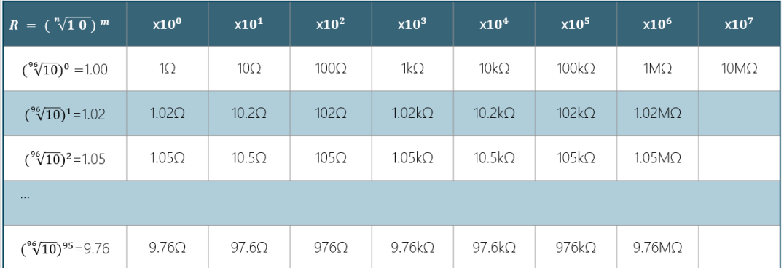

|  |  |  |  |  |  |  |  |
| --- | --- | --- | --- | --- | --- | --- | --- |
| 1.00 | 10 | 100 | 1K | 10K | 100K | 1M | 10M |
| 1.02 | 10.2 | 102 | 1.02K | 10.2K | 102K |  |  |
| 1.05 | 10.5 | 105 | 1.05K |  |  |  |  |
| 1.07 | 10.7 |  |  |  |  |  |  |
| 11 | 110 |  |  |  |  |  |  |
| 11.3 | 113 |  |  |  |  |  |  |
| 11.5 | 115 |  |  |  |  |  |  |
| 11.8 | 118 |  |  |  |  |  |  |
| 12.1 | 121 |  |  |  |  |  |  |
| 12.4 | 124 |  |  |  |  |  |  |
| 12.7 | 127 |  |  |  |  |  |  |
| 13 | 130 |  |  |  |  |  |  |
| 13.3 | 133 |  |  |  |  |  |  |
| 13.7 | 137 |  |  |  |  |  |  |
| 14 | 140 |  |  |  |  |  |  |
| 14.3 | 143 |  |  |  |  |  |  |
| 14.7 | 147 |  |  |  |  |  |  |
| 15 | 150 |  |  |  |  |  |  |
| 15.4 | 154 |  |  |  |  |  |  |
| 15.8 | 158 |  |  |  |  |  |  |
| 16.2 | 162 |  |  |  |  |  |  |
| 16.5 | 165 |  |  |  |  |  |  |
| 16.9 | 169 |  |  |  |  |  |  |
| 17.4 | 174 |  |  |  |  |  |  |
| 17.8 | 178 |  |  |  |  |  |  |
| 18.2 | 182 |  |  |  |  |  |  |
| 18.7 | 187 |  |  |  |  |  |  |
| 19.1 | 191 |  |  |  |  |  |  |
| 19.6 | 196 |  |  |  |  |  |  |
| 20 | 200 |  |  |  |  |  |  |
| 20.5 | 205 |  |  |  |  |  |  |
| 21 | 210 |  |  |  |  |  |  |
| 21.5 | 215 |  |  |  |  |  |  |
| 22.1 | 221 |  |  |  |  |  |  |
| 22.6 | 226 |  |  |  |  |  |  |
| 23.2 | 232 |  |  |  |  |  |  |
| 23.7 | 237 |  |  |  |  |  |  |
| 24.3 | 243 |  |  |  |  |  |  |
| 24.9 | 249 |  |  |  |  |  |  |
| 25.5 | 255 |  |  |  |  |  |  |
| 26.1 | 261 |  |  |  |  |  |  |
| 27.4 | 274 |  |  |  |  |  |  |
| 28 | 280 |  |  |  |  |  |  |
| 28.7 | 287 |  |  |  |  |  |  |
| 29.4 |  |  |  |  |  |  |  |
| 30.1 |  |  |  |  |  |  |  |
| 30.9 |  |  |  |  |  |  |  |
| 31.6 |  |  |  |  |  |  |  |
| 32.4 |  |  |  |  |  |  |  |
| 33.2 |  |  |  |  |  |  |  |
| 34 |  |  |  |  |  |  |  |
| 34.8 |  |  |  |  |  |  |  |
| 35.7 |  |  |  |  |  |  |  |
| 36.5 |  |  |  |  |  |  |  |
| 37.4 |  |  |  |  |  |  |  |
| 38.3 |  |  |  |  |  |  |  |
| 39.2 |  |  |  |  |  |  |  |
| 40.2 |  |  |  |  |  |  |  |
| 41.2 |  |  |  |  |  |  |  |
| 42.2 |  |  |  |  |  |  |  |
| 43.2 |  |  |  |  |  |  |  |
| 44.2 |  |  |  |  |  |  |  |
| 45.3 |  |  |  |  |  |  |  |
| 46.4 |  |  |  |  |  |  |  |
| 47.5 |  |  |  |  |  |  |  |
| 48.7 |  |  |  |  |  |  |  |
| 49.9 |  |  |  |  |  |  |  |
| 51.1 |  |  |  |  |  |  |  |
| 51.3 |  |  |  |  |  |  |  |
| 53.6 |  |  |  |  |  |  |  |
| 54.9 |  |  |  |  |  |  |  |
| 56.2 |  |  |  |  |  |  |  |
| 57.6 |  |  |  |  |  |  |  |
| 59 |  |  |  |  |  |  |  |
| 60.4 |  |  |  |  |  |  |  |
| 61.9 |  |  |  |  |  |  |  |
| 63.4 |  |  |  |  |  |  |  |
| 64.9 |  |  |  |  |  |  |  |
| 66.5 |  |  |  |  |  |  |  |
| 68.1 |  |  |  |  |  |  |  |
| 69.8 |  |  |  |  |  |  |  |
| 71.5 |  |  |  |  |  |  |  |
| 73.2 |  |  |  |  |  |  |  |
| 75 |  |  |  |  |  |  |  |
| 76.8 |  |  |  |  |  |  |  |
| 78.7 |  |  |  |  |  |  |  |
| 80.6 |  |  |  |  |  |  |  |
| 82.5 |  |  |  |  |  |  |  |
| 84.5 |  |  |  |  |  |  |  |
| 86.6 |  |  |  |  |  |  |  |
| 88.7 |  |  |  |  |  |  |  |
| 90.9 |  |  |  |  |  |  |  |
| 93.1 |  |  |  |  |  |  |  |
| 95.3 |  |  |  |  |  |  |  |
| 97.6 |  |  |  |  |  |  |  |
|  |  |  |  |  |  |  |  |

|  |  |
| --- | --- |
| 1 |  |
| 1.1 |  |
| 1.2 |  |
| 1.3 |  |
| 1.5 |  |
| 1.6 |  |
| 1.8 |  |
| 2 |  |
| 2.2 |  |
| 2.4 |  |
| 2.7 |  |
| 3 |  |
| 3.3 |  |
| 3.6 |  |
| 3.9 |  |
| 4.3 |  |
| 4.7 |  |
| 5.1 |  |
| 5.6 |  |
| 6.2 |  |
| 6.8 |  |
| 7.5 |  |
| 8.2 |  |
| 9.1 |  |