Linear regression data are showed the using the chimpanzee’s taking foods time and excreting time.

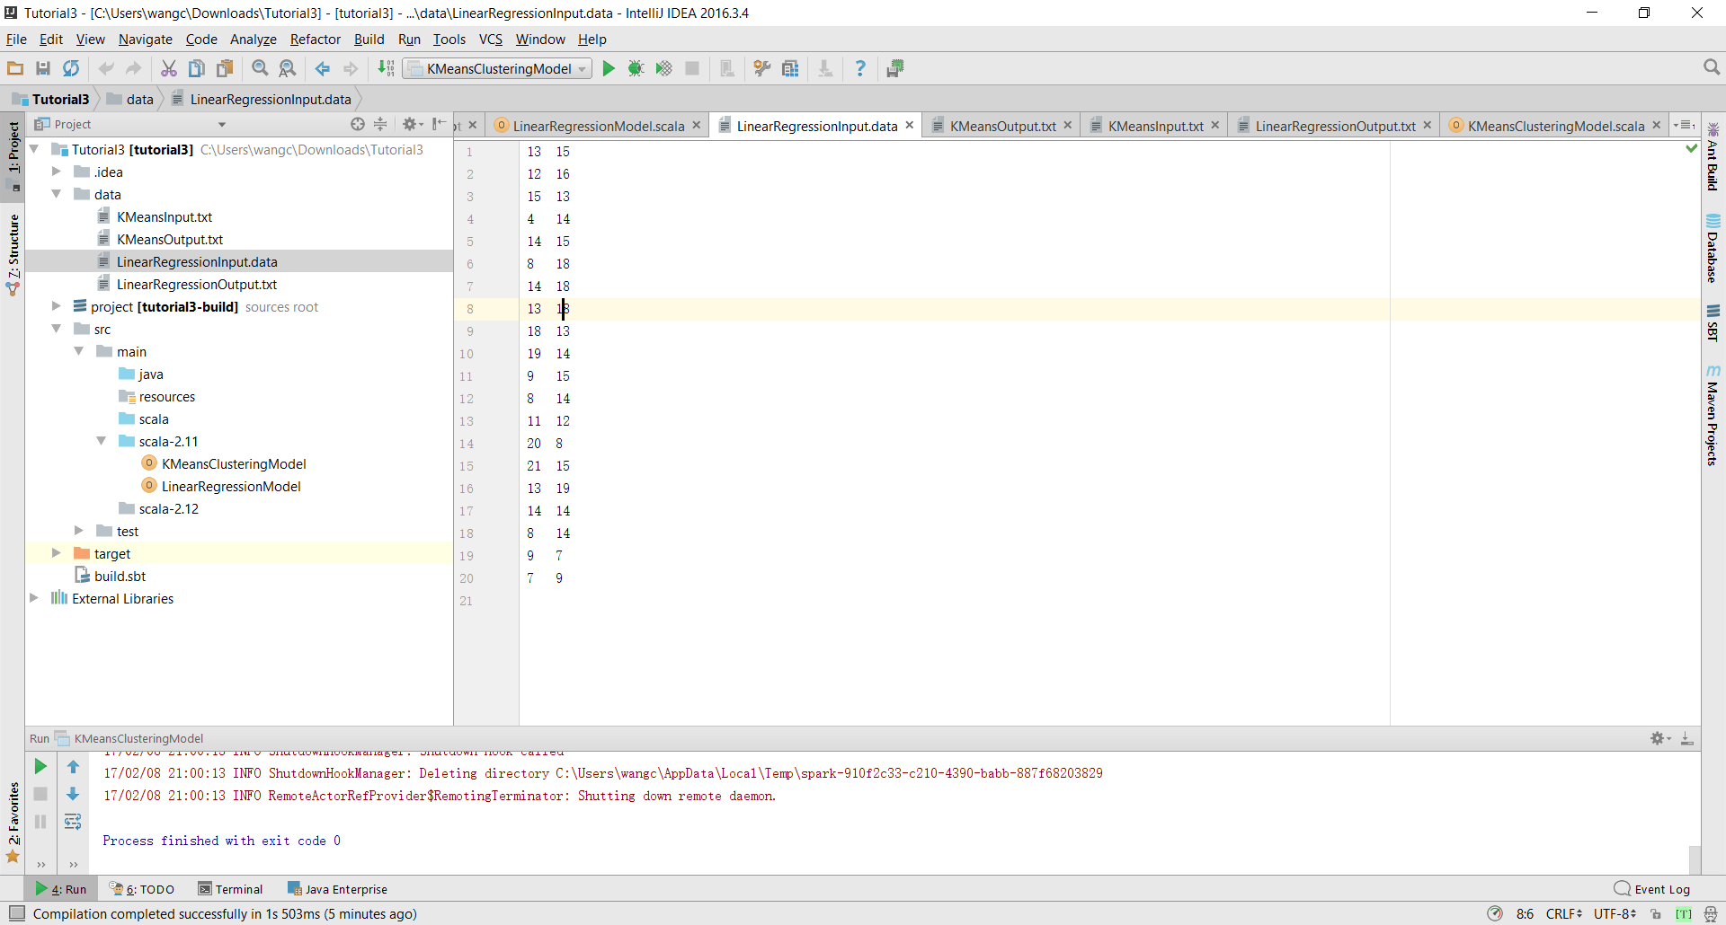

And the output of this data set is like this:

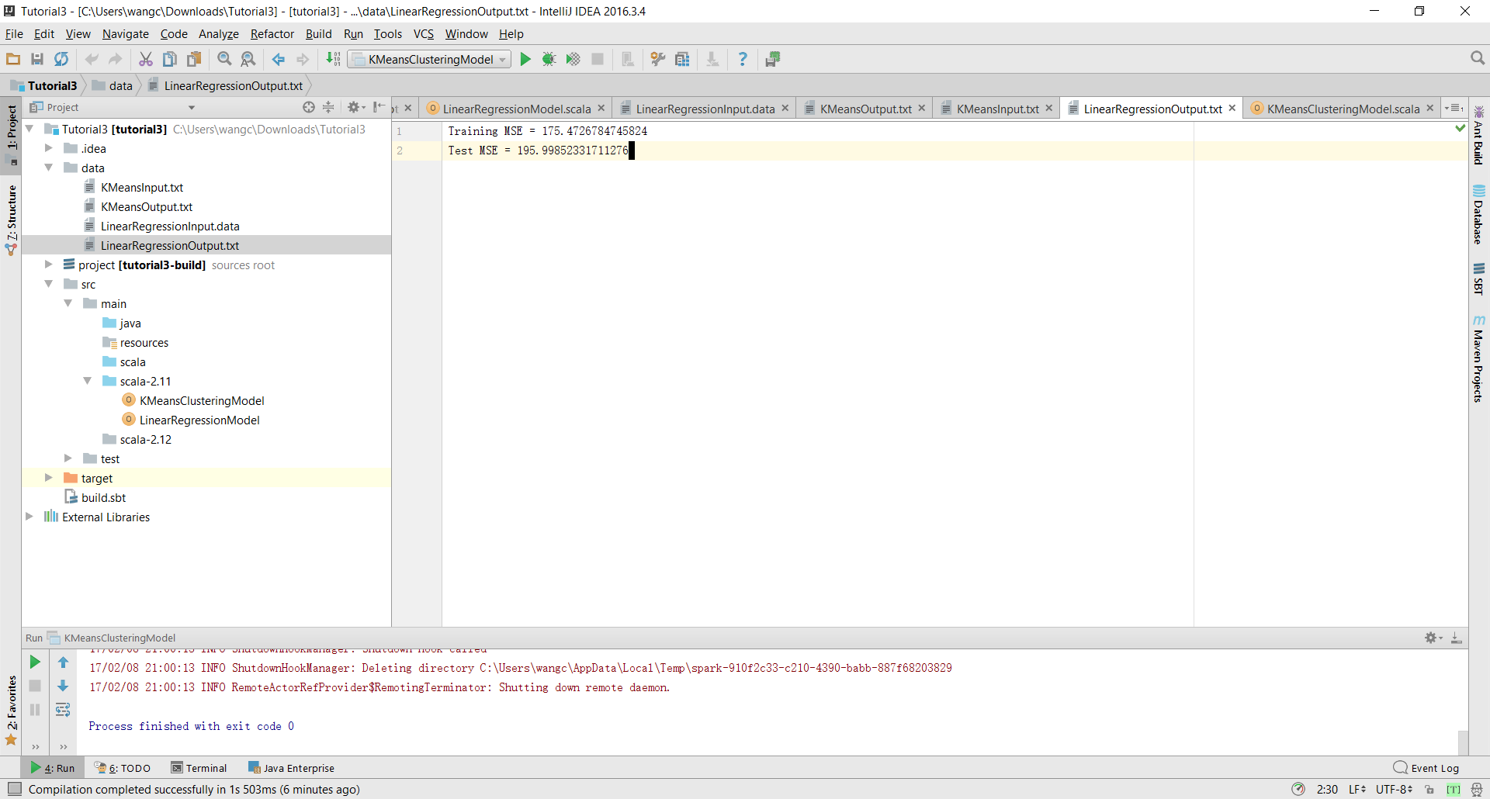

KMeans input data shows the place (coordinate) of the chimpanzee’s taking food.

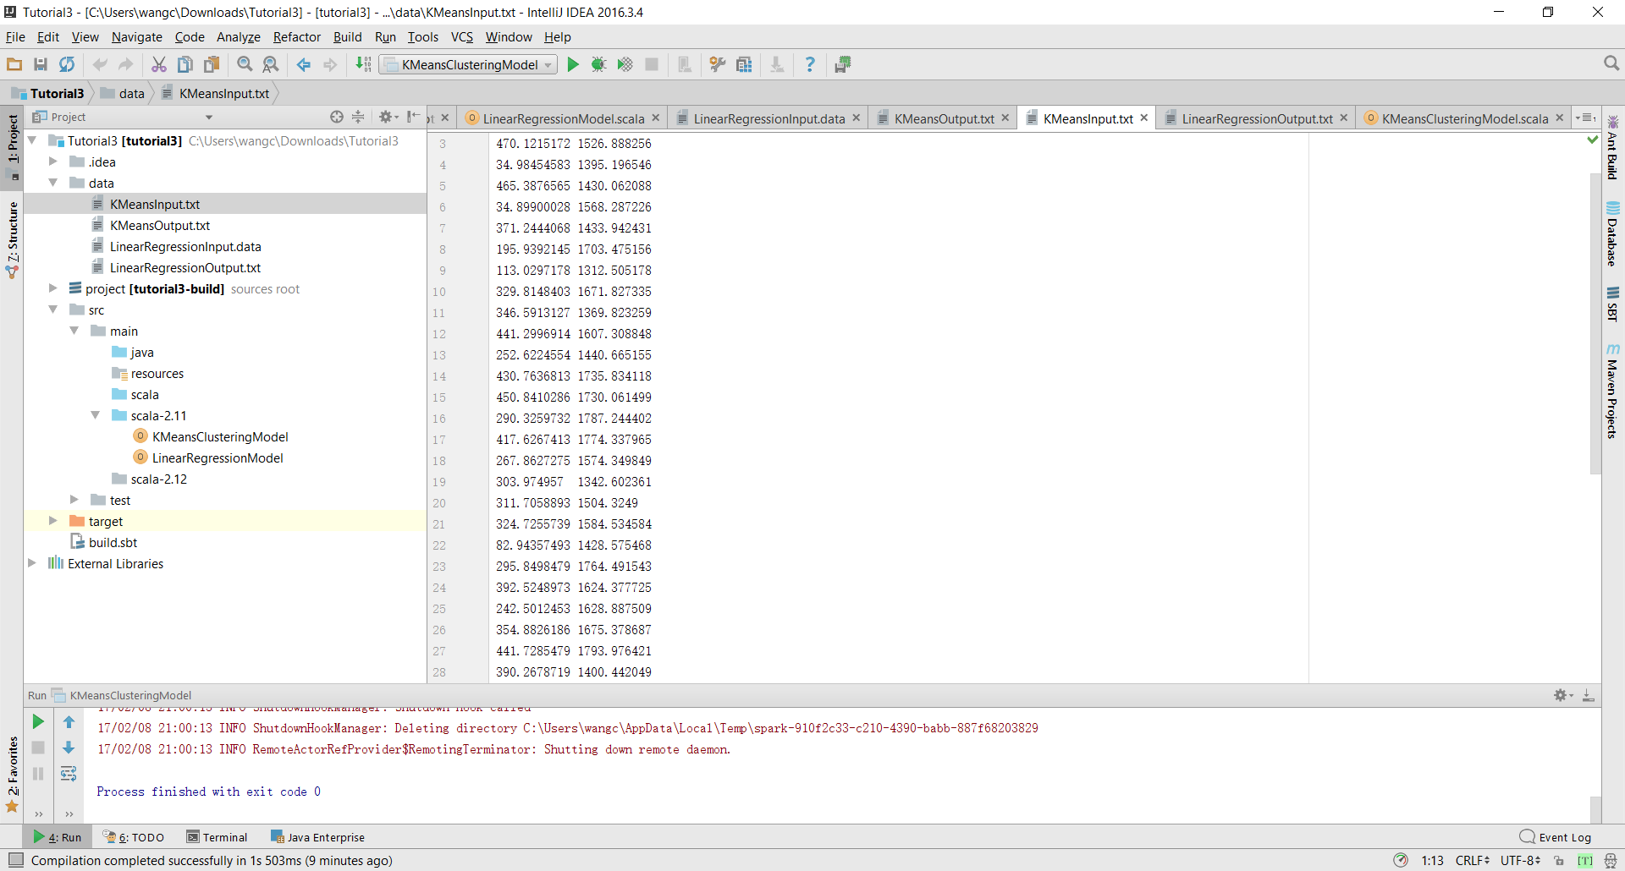

The output has been showed at following:

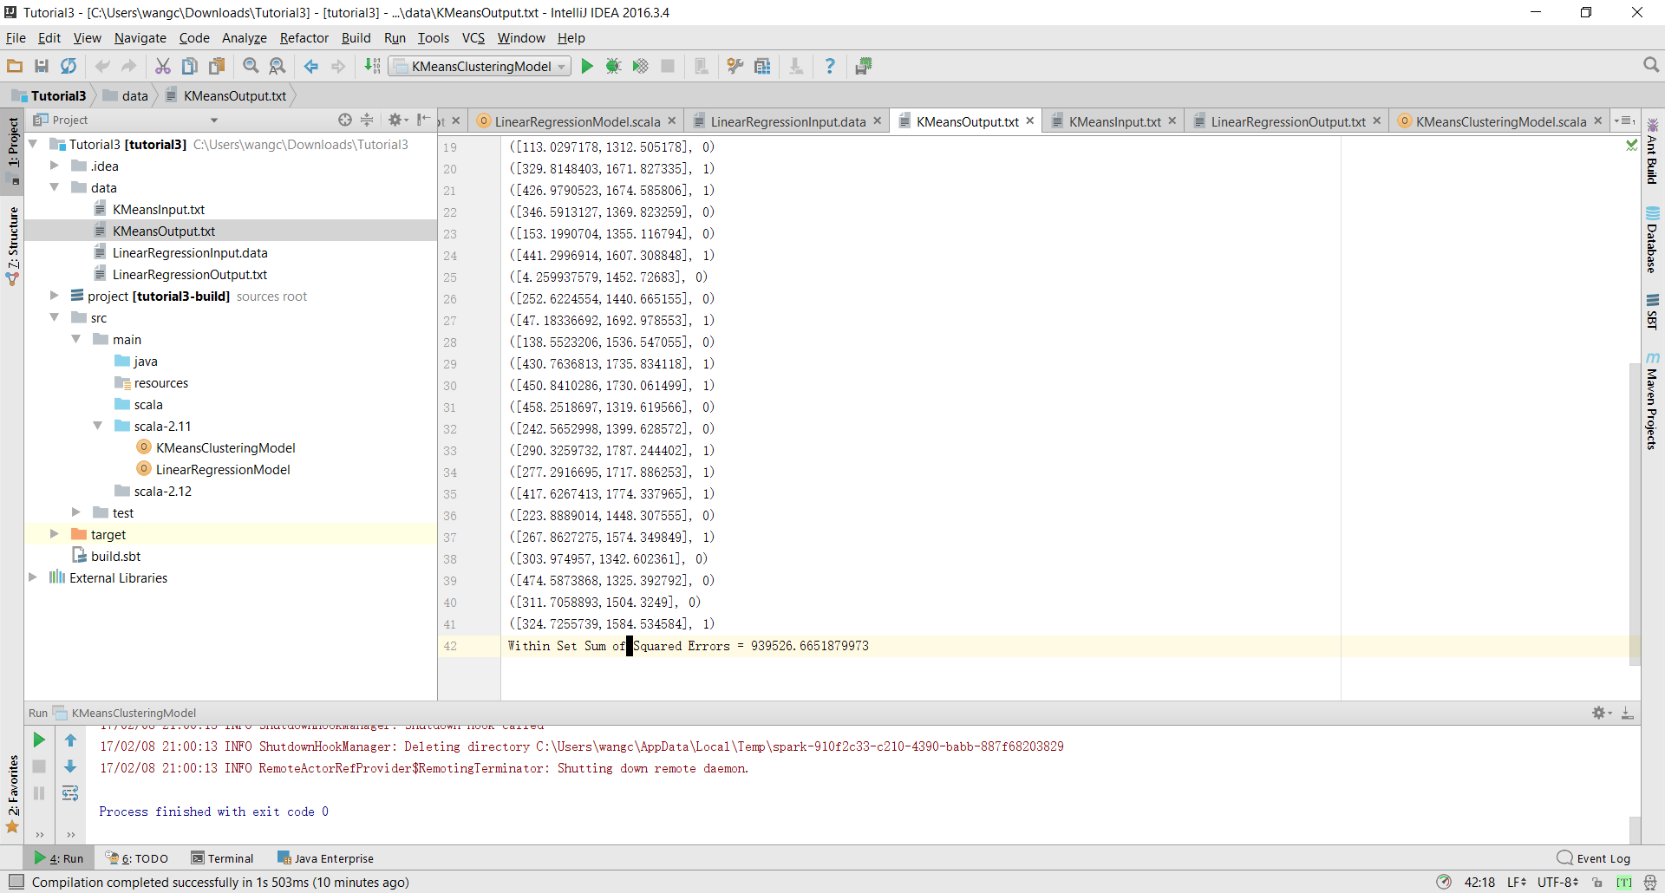

Image Annotation input file are a video about mew.

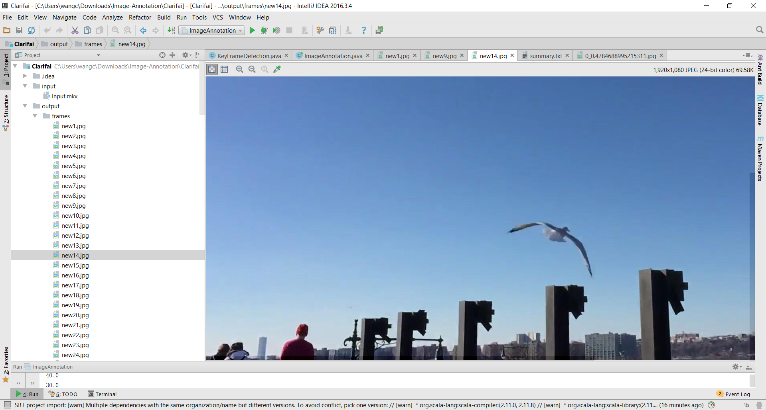

After processing and summarize about this video, the output shows this video is mainly talked about flying.

