**C# Guide:**

***STEP 1. Prerequisite: Install SqlClient to have SQL connection***

* Right Click on InventoryMgmt
* Select Manage NuGet Packet
* Search “sql”
* Install System.Data.SqlClient

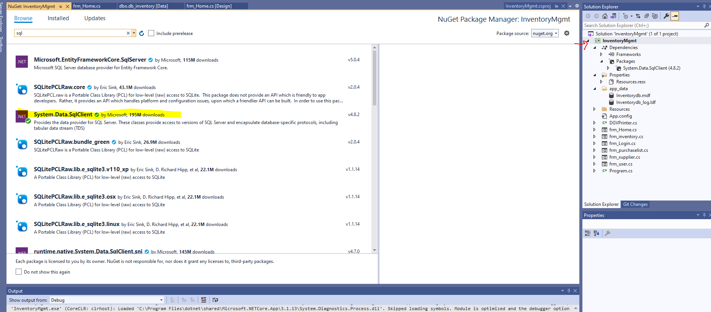

***STEP 2. Change to your Local Data Source Connection***

* In the **InventoryMgmt\app_data** folder copy the **Inventorydb.mdf** database file and paste to the default DataDirectory (ie. C:\USERS\Your*Name*\DOCUMENTS\)
* Connect database file in Server Explorer
* After Connected, select the database and go to properties
* Copy the address next to (Name) under (Identity) as shown below:

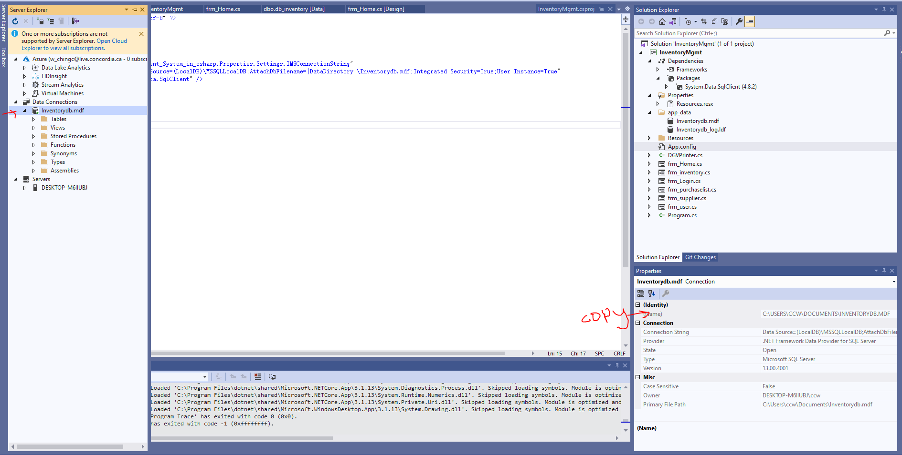

* Then Crtl+ F and type in **C:\USERS\CCW\DOCUMENTS\INVENTORYDB.MDF** and replace it with **C:\USERS\Your*Name*\DOCUMENTS\INVENTORYDB.MDF** Select “Replace all” and “Entire Solution” to change for all forms.

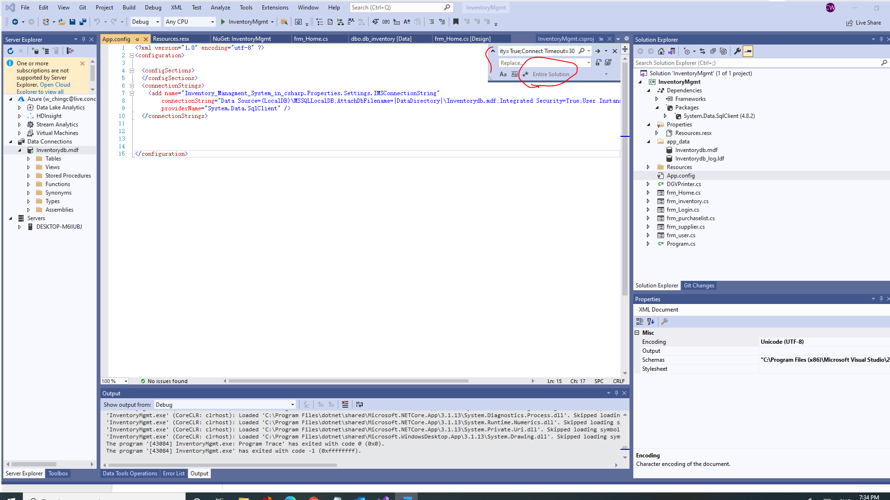

After the domain is changes to your default Data Directory. Its good to use!

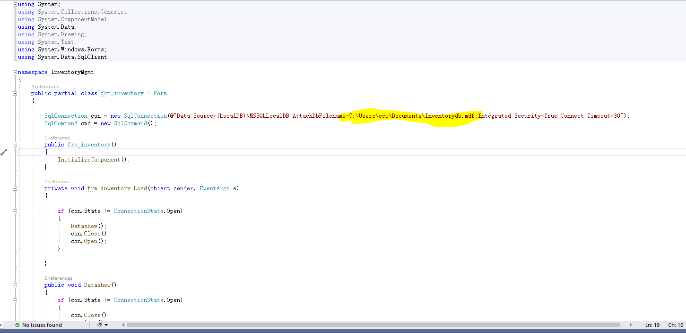

***Enjoy the App!***