# Introduction

This report describes information management system for the Magnetized Dusty Plasma Experiment (MDPX) project at Auburn University. The primary purpose of the system is to store and retrieve experiment calibration, setup, and summarized research data. The following are the design motivation of the database system:

* Fast retrieval of stored data that has not been a goal of older database systems[1].
* Sophisticated data search and filtering capability, which allows researchers to form relations and hypothetical research proposals across multiple experimental setup and scenarios.

In addition, the system was designed to be agile and modular. New features can be easily added to the database, and database can be accessed through any software package or language that supports data access via SQL.

The system is roughly divided into 3 major parts as shown in Figure 1: relational database management system, LabVIEW control and data acquisition subsystem, and web-based data manager. Our LabVIEW control software interfaces with (for the lack of proper technical term) the dusty plasma experimental hardware and stores setup and experiment data into the database. The web interface allows researchers and operators to monitor and search acquired data from experiment runs. This report will cover the design of the database and overview the capability of the web interface. The LabVIEW control software will not be covered.

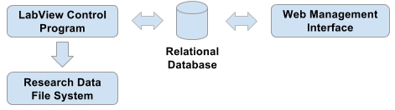

Figure 1Data Acquisition System overview

[Report outline]

# Comparative Systems

## MDSPlus

## Other Database Management Systems?

# Data Management

The acquired experiment research data is split into two categories: experiment metadata and bulk research data. Experiment metadata precisely describe repeatable experimental parameters. This information contains:

* Calibration
* Parts
* Part setup
* Parametric set-points
* If experiment is a systematic scan from a control program
* Recorded summarized research data
* Storage location of bulk research data
* User management

The metadata is stored in a MySQL relational database. There are three reason that we use MySQL to store this data. The first is that MySQL allow us to impose relations among experiments. A simple relationship would be two experiments sharing the same part setup (but not necessary the same set-points). Second, MySQL supports broad range of data searching capabilities, which facilitates researchers to quickly find experiments of interest. The final reason is that MySQL has great performance of data searching. MySQL is the most used relational database management system with proven data storage and retrieval performance. In addition, according to a publication by Princeton Plasma Physics Laboratory on data management for Plasma Physics Databases[2], a relational database is several factors faster than MDSplus[3] database with reasonable data compression ratio. The metadata can be thought as a research data index to find proper experiments.

The second broad category of data is the bulk research data. These include dense time-series pulse measurements, and video files. Much of these files are large files and they are stored on file system outside of the relational database. The location for each experiment is easily searchable via metadata database.

## Metadata Database

The database is a relational database that is used to store and to perform complex analytical query operations of the metadata. Figure 2 shows the database schema that contains all the tables. In addition to the tables shown in Figure 2, the database also contains a set of user defined views that are currently used by the web interface to show data merged from different tables.

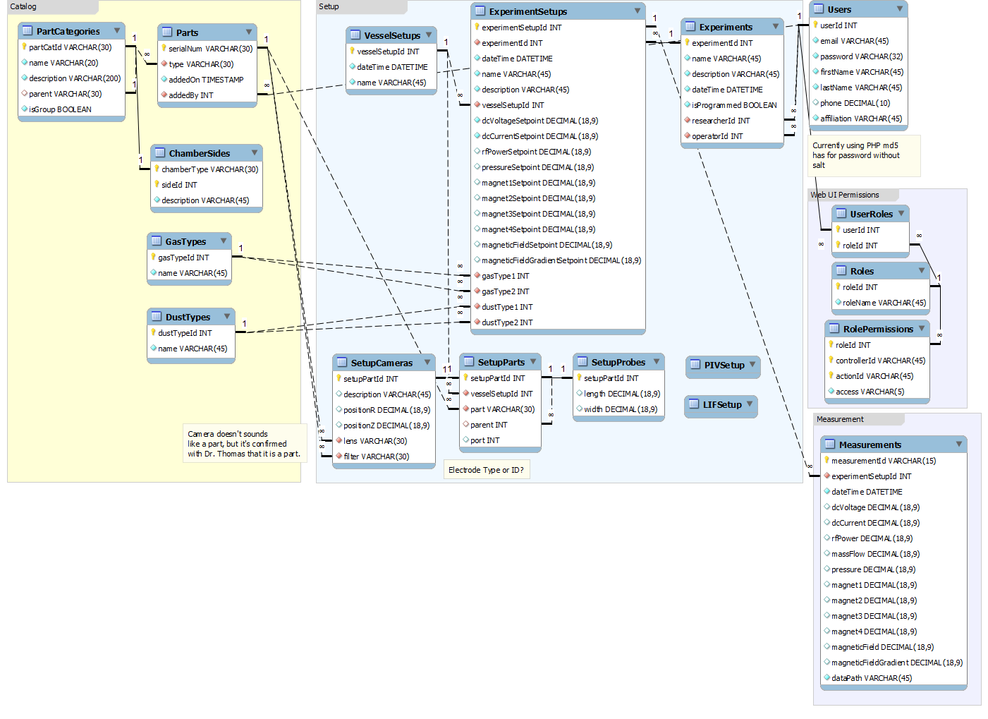

Figure Database Schema

The database tables are divided into 4 groups. The first is the catalog group (yellow group in Figure 2). This group keeps an inventory of parts and materials that we have at our facility and are used in the experiments. The following table describes the catalog.

|  |  |  |
| --- | --- | --- |
| Table | Description | Relationships |
| PartCategories | A hierarchy of parts. An example of a category is flanges, with side and top flanges as subcategories | Each category has many parts. |
| Parts | A catalog of experimental hardware parts. For example a flange, a hexagon chamber, or a camera. |  |
| ChamberSides |  |  |
| GasTypes |  |  |
| DustTypes |  |  |

## Bulk Research Data

Directory structure and how the data is stored.

1. <http://nstx.pppl.gov/nstx/Software/pdf_files/DbAccess-Paper.pdf>
2. <http://nstx.pppl.gov/nstx/Software/pdf_files/DbAccess-Paper.pdf>
3. <http://ieeexplore.ieee.org/xpl/freeabs_all.jsp?arnumber=4994733&abstractAccess=no&userType=inst>