The Trade-off between Tourism Carrying Capacity and Local Residents’ Quality of Life in Macao: Visualising Visitor Arrivals and Consumer Price Dynamics, 2010–2025
Coursework Item: Assignment 01 - Preliminary Project Proposal
Student ID: MC641431
Name: WANG CUI
Course Code: CISC7204
Date: September 2026

1. Project Topic and Research Question
Region and domain category: Macao SAR, China — tourism economics and the cost of living.
Research question: To what extent are surges in visitor arrivals associated with changes in Macao’s Composite Consumer Price Index (CPI) between January 2010 and December 2025?
We chose this topic because the tension is easy to feel in daily life in Macao but surprisingly hard to see in the data. For this preliminary stage we use monthly visitor arrivals as a proxy for tourism pressure and the Composite CPI as a proxy for the cost-of-living pressure on residents.
A first look at the data already makes the question more interesting. Visitor arrivals swing sharply with the seasons — Chinese New Year, summer holidays and Golden Week run hot, other months run quiet — yet the Composite CPI climbs steadily and almost never gives ground. Even during COVID-19, when visitors nearly disappeared, prices did not fall back. To us that points to strong price stickiness in Macao, so the real puzzle is not simply “do tourists raise prices” but “where, when, and through which channels would such pressure even show up.”
2. Purpose
Outcomes:
This project connects directly to the course learning outcomes on acquiring, cleaning, analysing and visualising real-world data, and on telling an honest story with it. For our group it is also useful practice for the kind of applied data work we expect to do after graduation — taking a messy public dataset, asking a question people care about, and resisting the temptation to overclaim.
Skills:
• Extracting and cleaning government Excel exports (mixed date formats, multi-row headers, footnotes that break parsing);
• Merging monthly time series and engineering meaningful features such as period labels and annual aggregates;
• Writing a justification that links each figure to the research question.
Knowledge:
The difference between a price index level and an inflation rate; what a Laspeyres-type CPI basket does and does not capture about residents’ lives; seasonality and structural breaks in tourism data.
3. Data Sources
The project uses three predefined reports from the Statistics and Census Service (DSEC) Time Series Database of the Macao SAR Government. They are freely accessible through the following links.
Dataset | Sourceandlink | Keyfields/coverage
Visitor arrivals by mode of transport (monthly) | DSEC Time Series Database  https://www.dsec.gov.mo/ts/#!/step2/PredefinedReport/en-US/18 | Period; total arrivals (persons); arrivals by sea, land and air. We use Jan 2010–Dec 2025. Excludes non-resident workers, students and other non-visitors.
Composite Consumer Price Index of main sections of goods and services (monthly) | DSEC Time Series Database  https://www.dsec.gov.mo/ts/#!/step2/PredefinedReport/en-US/14 | Period; Composite CPI and index points for 11 sections of goods and services. We use Jan 2010–Dec 2025 for the CPI-section analysis.
Composite Consumer Price Index, CPI (A) and CPI (B) (monthly) | DSEC Time Series Database  https://www.dsec.gov.mo/ts/#!/step2/PredefinedReport/en-US/15 | Period; headline Composite CPI index points, CPI (A) and CPI (B). We use Jan 2010–Dec 2025 for the main time-series analysis.

4. Tasks and Deliverables
The work breaks into concrete steps, most of which we have already prototyped in the accompanying notebook:
• Verify and clean the data. Parse the mixed period formats (“Jan./2010” vs “May/2010”), keep monthly rows only, and assert the merged table holds exactly 192 consecutive months with no duplicates or missing values.
• Engineer the analysis variables. Label three periods — pre-COVID (2010–2019), COVID disruption (2020–2022), and post-COVID recovery (2023–2025) — and aggregate to annual averages.
• Explore and visualise. Stacked level panels on a shared time axis, a period-coloured scatter plot, annual averages, a Granger causality check on first-differenced series, and a CPI-section correlation comparison.
• Interpret. Report what the associations are and what they cannot show; flag the proxies and the confounders (global inflation, wages, rents, policy) explicitly.
• Deliver. The complete project — including this proposal, the Jupyter notebook, the two source Excel files and all exported figures — has been published in a public GitHub repository:
https://github.com/wangcui92/CISC7204-MC641431-2026GitHub

5. Planned Visualisation and Justification

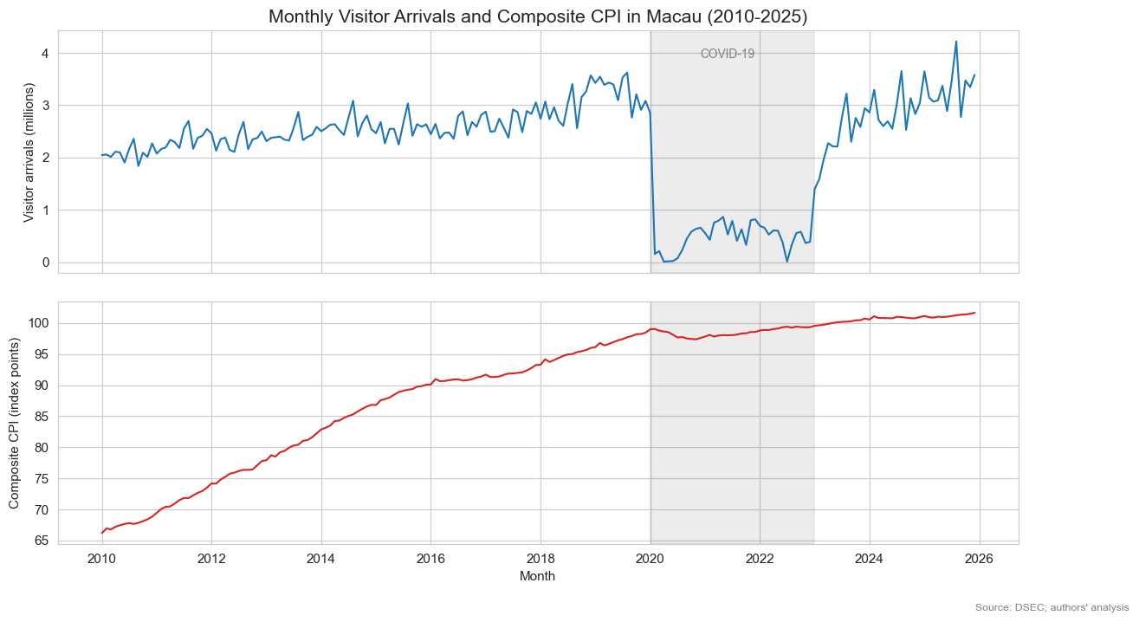
Preview figure: monthly visitor arrivals (top) and Composite CPI (bottom) on a shared time axis, Macao, 2010–2025. Grey band marks the COVID-19 disruption.
The preview figure above is the piece of the project that most directly answers our research question, and it is the one we intend to refine for the final report. Plotting the two series in stacked panels that share one time axis lets a reader judge, at a glance, whether swings in arrivals line up with swings in prices. What the chart shows is striking and slightly counter-intuitive: arrivals collapse almost to zero in 2020–2022, yet the CPI line hardly flinches — it bottoms out around 97 in late 2020, roughly its pre-COVID level, and then keeps climbing past 100 by 2023.
In the final version, this figure will be paired with a scatter plot that colours the same two series by period (pre-COVID, COVID, post-COVID) so the effect of the pandemic break is visible rather than buried in a single correlation coefficient. Read together: Macao’s consumer prices appear highly sticky — they rise in peak tourist seasons but do not come back down in quiet ones, and they kept rising even when arrivals nearly stopped. That suggests the “carrying capacity” cost borne by residents is less about month-to-month inflation and more about a persistently elevated price level, supported by structural factors like wages, rental contracts and supply-chain costs.
6. Criteria for Success
We will judge the finished product against the following checklist, which doubles as a simple rubric:
• The merged dataset covers exactly 192 consecutive months (Jan 2010 – Dec 2025) with no gaps, duplicates or missing values;
• Both data links are publicly accessible and match the files used;
• Every figure has a clear title, labelled axes with units, a source note, and a stated role in answering the research question;
• Limitations — proxies, confounders, the COVID structural break — are stated in the document rather than left implicit;
• The notebook runs top-to-bottom without errors and reproduces every figure and number quoted.
7. Collaboration
This is a two-person group project jointly completed by WANG CUI(MC641431) and LU YINHAI(MC641724). We discussed and selected the research topic together, confirmed the data sources, agreed on the analytical framework, and jointly interpreted the main findings.The expected division of work is as follows:
• WANG CUI — Progress Tracker. Responsible for checking the completeness and consistency of the merged dataset, refining the data analysis, optimizing and formatting the visualizations, and reviewing the time-series and Granger test results. Also drafted the project report, writing its main analysis, interpretations, and conclusions.
• LU YINHAI — Project Scribe. Responsible for developing the preliminary data processing workflow, including cleaning the mixed date formats. Generated the initial trend and scatter visualizations, conducted the CPI section correlation analysis and the initial Granger causality tests, and reviewed and revised the report.
Both members reviewed the code notebook, statistical results, and visualizations. The final content, interpretations, and conclusions were discussed and agreed upon jointly by both members.
Ground rules:
1. We will hold meetings to review progress and determine the next steps, while promptly discussing any areas of uncertainty.
2. Every figure or number quoted in the report must be reproducible from the notebook before it is included.
3. Decisions are made by consensus; if we disagree on an interpretation, we keep the more cautious wording.
References
Statistics and Census Service (DSEC), Macao SAR. Visitor arrivals by mode of transport — monthly time series. https://www.dsec.gov.mo/ts/#!/step2/PredefinedReport/en-US/18.
Statistics and Census Service (DSEC), Macao SAR. Composite Consumer Price Index of main sections of goods and services — monthly time series. https://www.dsec.gov.mo/ts/#!/step2/PredefinedReport/en-US/14.
Statistics and Census Service (DSEC), Macao SAR. Composite Consumer Price Index, CPI (A) and CPI (B) — monthly time series. https://www.dsec.gov.mo/ts/#!/step2/PredefinedReport/en-US/15.

