Riding Mechanic

A Manuscript
Submitted to
the Department of Computer Science
and the Faculty of the
University of Wisconsin-La Crosse
La Crosse, Wisconsin

by
Dezheng Wang
in Partial Fulfillment of the
Requirements for the Degree of
Master of Software Engineering
Feb 2017

Riding Mechanic

By Dezheng Wang

We recommend acceptance of this manuscript in partial fulfillment of this candidate’s requirements for the degree of Master of Software Engineering in Computer Science. The candidate has completed the oral examination requirement of the capstone project for the degree.

____________________________________ _______________________
<<Primary adviser's name>> Date
Examination Committee Chairperson

____________________________________ _______________________
<<Examiner’s name>> Date
Examination Committee Member

____________________________________ _______________________
<<Examiner’s name>> Date
Examination Committee Member

Abstract

Dezheng Wang, “Riding Mechanic”, Master of Software Engineering, Feb 2017 (Elliott Forbes).

On Board Diagnostics II (OBD II) was adopted for all cars since 1996 and OBD II systems are in most cars and light trucks on the road today. Sometimes people want to get some extra information of their cars, for example, people may want to get the average speed of their cars. OBD-II can provide data to allow a universal inspection and diagnosis method so that users can have good understanding of their cars. These inspection and diagnosis method can help users to identify if there exist problems in their cars before they become major malfunctions and give them useful help to users’ special needs. This manuscript describes the development of an iOS app used to reading in information from an OBD II scanner.

Acknowledgements

I would like to express my sincere thanks to my project advisors Dr. Elliott Forbes for his patience, kindness and valuable guidance. I would also like to express my thanks to the Computer Science Department and the University of Wisconsin-La Crosse for providing the computing environment for my project.

Table of Contents

Abstract iii
Acknowledgements iv
Table of Contents v
List of Figures vi
List of Tables vii
Glossary viii
1. Introduction 1
1.1 Onboard Diagnostic II 1
1.2 Onboard Diagnostic II scanner 2
1.3 Electronic Control Unit 3
1.4 Onboard Diagnostic Parameter IDs 4
1.5 Diagnostic Trouble Code 5
1.6 AT command set 5
2. Requirements analysis 6
2.1 User requirement analysis 6
2.2 Functional requirements analysis 8
2.4 Non-functional requirements analysis 12
3. System architecture design 13
3.1 Goals and constraints of architecture 14
3.2 Key scenarios 14
3.3 Application overview 15
3.4 Key issues and solution 16
4. Detailed system design 17
4.1 Database design 18
4.2 Use case diagram 20
4.3 Class diagram 21
4.4 Sequence diagram 23
4.5 User interface design 29
5. System implementation 30
5.1 Login module 30
5.2 Register module 30
5.3 Device connecting module 30
5.4 Start trip module 30
5.5 Route analysis module 30
5.6 Health scan module 30
5.7 Settings module 30
6. Testing 30
6.1 Testing methods 30
6.2 Functional testing 30
6.3 Unit testing 30
6.4 Integration testing 30
6.5 System testing 30
7. Conclusion 30
8. Bibliography 30
Appendices 31

List of Figures

Figure 1: Model-Based Testing Process 2
Figure 2: Example of an Object-Z Specification 3

List of Tables

Table 1: Concrete BVT of the operation Withdraw 4
Table 2: Valid test case for Withdraw 4

Glossary

Apache Ant (ANT)
Apache Ant is a Java-based build tool with many integrated tasks such as JUnit, Jar, and Javac.

Apache Tomcat
Apache Tomcat is an open source application server that implements the Java Server Pages and Java Server Faces Specifications.

Verification
A process that confirms a development process or activity or task to be correct.

Validation
A process that confirms that the product (or partial product) meets the expectations.

Testing
A type of validation applied to source code.

1. Introduction
The two main goals of this part are why I want to start working on this project and some introductions to relevant techniques of this project. In our daily life, it becomes more and more difficult to image life without driving. When you must go to work in a different city, go to school far away from your house, plan to travel to another state with your friends or you just want to make transportation faster and easier for you and your family, taking a car is really a good choice.
We almost drive every day but we have little knowledge about our cars. In that case, it is a good solution to on-board diagnostics systems to help us get close to our vehicles. Most OBD apps in the market can provide drivers with cars’ real-time information and diagnostic trouble codes along with what kind of kinds of problems. Instead of investigating the problems yourself, the app simply tells us what kinds of problems along with categories that they belong to.
Some early developed OBD applications do not make it very clear what problems you are confronted with because most developers have little knowledge about On-Board Diagnostics system. As time goes by, newer apps have become more and more comprehensive. There are also high-performance OBD apps that provide drivers with detailed information of cars, but users need to pay for it. So, my target is to develop a free mobile OBD app that can gather detailed diagnostic information over a long period that can be used to monitor a vehicle’s operation and discover potential concerns before they become serious faults. The app can also help drivers identify the effect certain configuration changes have on their car’s operation.

1.1 Onboard Diagnostic systems
On-Board Diagnostics, or “OBD,” was first introduced in early 1980s. Early OBD systems were developed to remind drivers of losing control and occurring malfunctions. As time went by, On-Board Diagnostics II, an advanced version over early OBD models, was adopted mandatory for all cars manufactured in the United States since 1996, as required by the Clean Air Act Amendments. Since that time, OBD system became an important role in helping fight emissions of greenhouse gasses and engine failures.
On-Board Diagnostics is additional computer software that monitors the emission control and emission-related components/systems, along with certain engine components that provide vehicle operational information [1]. OBD systems can monitor both running situations of engine and working status of emission control systems all the time. Once over standard emissions were detected, OBD systems would give alerts to users. If any systems in a car were broken, “Check Engine” or “Malfunction Indicator Lamp” light on the dashboard of the car. Meanwhile, OBD systems would store Diagnostic Trouble Codes(DTCs) which were related to those broken systems. By using a standard scan tool connected to vehicle’s OBD-II connector, an automotive technician can quickly know what the trouble is and where it occurs. This did save plenty of time for both drivers and technicians.
The biggest difference between OBD-II system and previous OBD systems is that OBD-II system is extremely strict with emissions. It can detect over standard emissions by monitoring power system and emission control system. OBD-II system also has unique features. The first one is that all data link connectors(DLC) in cars are standard 16-Pin OBD-II connectors which brings lot of convenience for people. The second one is that OBD-II DLC can help to transmit data between cars and scan tools. The third one is that OBD-II defines universal Diagnostic Trouble Codes(DTCs) and its meanings for all kinds of vehicles. The fourth one is that it has similar functions as car driving recorder (car DVR). The fifth one is that users can use scan tools to clear DTCs. The last one is that OBD-II can show those cleared DTCs. Although it’s very efficient to monitor emissions by using OBD-II system, sometimes drives don not accept or just ignore alerts from OBD-II system. For this reason, a more advanced version, OBD-III had been developed. The main purpose of OBD-III is to combine vehicle detection, maintenance and management. When over standard emissions occur, OBD-III will prevent users from keeping driving with high emissions. However, OBD-III techniques are still under developing. We may have access to OBD-III in the future.

1.2 Onboard Diagnostic II scanner
Since OBD-II systems are standardized, OBD-II scanners are relatively simple to use. They all use the same connector, which is defined by SAE J1962. Basic scanners function by simply inserting a universal plug into the Data Link Connector (DLC) in a vehicle. It is a 16-pin connector that can tell you which protocol your car communicates with, depending on which pins are populated in it. Some advanced scan tools also include keys or modules that augment the universal connector in order to access or interact with OEM-specific information or controls. Figure 1 will show the important roles played by OBD-II scanner in my project.
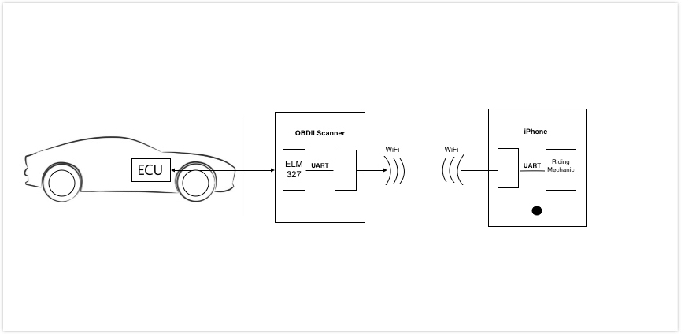
Figure 1. Relationship between OBD-II scanner and project

There are two basic categories of OBD-II scanners that you will come across in the wild. The first one is a code reader. A code reader is typically an inexpensive, no-frills device that can read and clear codes from any vehicle that is equipped with OBD-II. These devices have a few inherent limitations in that they typically lack any information on manufacturer-specific codes and offer limited or no access to other data. To read sensor data, history codes, pending codes, etc., you need a “real” scan tool. OBD-II scan tool is more expensive, and it can offer a variety of different features. A scan tool may provide more access to or information about manufacturer-specific codes, provide extensive, customizable access to live and recorded data and offer advanced troubleshooting information. Most DIY scan tools do not have bidirectional communications capability. This is done for liability reasons. Most late-model vehicles have quite a few built-in self-checks that can be performed with a dealer or professional level scan tool, but running these tests requires some know-how, experience and caution. For many situations, the advanced capabilities are not necessary. But when it is needed, there’s no substitute for having a professional-grade scan tool. Pro tools typically start in the $1,500 to $2,000 range, and go up depending on the tool’s capabilities and features. Considering for project requirements and cost, a code reader was used in project development.

1.3 Electronic Control Unit
As it mentioned above, OBD is the language of the Electronic Control Unit (ECU). In automotive electronics, Electronic Control Unit (ECU) is a generic term for any embedded system that refers to a single module or a collection of modules. These are the brains of the vehicle. They monitor and control many functions of the car. These can be standard from the manufacturer, reprogrammable, or have the capability of being daisy-chained for multiple features. Types of ECU include Electronic/engine Control Module (ECM), Powertrain Control Module (PCM), Transmission Control Module (TCM), Brake Control Module (BCM or EBCM), Central Control Module (CCM), Central Timing Module (CTM), General Electronic Module (GEM), Body Control Module (BCM), Suspension Control Module (SCM), control unit, or control module. Taken together, these systems are sometimes referred to as the car's computer (Technically there is no single computer but multiple ones.) Sometimes one assembly incorporates several of the individual control modules (PCM is often both engine and transmission) [2]. Tuning features on the ECU can allow the user to make the engine function at various performance levels and various economy levels. On new cars, these are all typically microcontrollers. Some more common ECUs will be briefly introduced in this part.
- Engine Control Module (ECM) – Also known as EMS (Engine management system). This controls the actuators of the engine, affecting things like ignition timing, air to fuel ratios, and idle speeds. All these controls are done based on data (like engine coolant temperature) received from various sensors.
- Vehicle Control Module (VCM) - Another module name that controls the engine and vehicle performance.
- Transmission Control Module (TCM) - This handles the transmission, including items like transmission fluid temperature, throttle position, and wheel speed.
- Powertrain Control Module (PCM) - Typically, a combination of an ECM and a TCM. This monitors and controls speed control, A/C, charging and Automatic Transmission.
- Electronic Brake Control Module (EBCM) - This controls and reads data from the anti-lock braking system (ABS).
- Body Control Module (BCM) - The module that controls vehicle body features, such as power windows, power seats, etc.

1.4 Onboard Diagnostic Parameter IDs
Onboard Diagnostic Parameter IDs (OBD-II PIDS) are codes used to request information from a vehicle. SAE standard J/1979 defines many universal PIDs that were used by many car manufacturers, but car manufacturers also define their own PIDs specific to their vehicles. The information requested by the codes includes current data of the car (e.g., engine RPM), vehicle information (e.g., VIN), troubles in the car and so on. In general, an automotive technician will send PIDS to the vehicle through a scan tool connected to the vehicle's OBD-II connector. This procedure includes following steps.
Firstly, the technician enters code in the scan tool and sent it to car (the scan tool sends it to controller–area network (CAN)-bus). Secondly, a device in the vehicle will recognize the PID as one it is responsible for, and then the device will return the value represented by the hexadecimal encoding for that PID. Finally, the scan tool receives the hex codes and converts them into commonly used value and displays it to technician. Based on the Onboard Diagnostic II scanner used in my project, the only codes I can send were PIDs described in the latest OBD-II standard SAE J1979. There are 10 modes of operations defined in the standard, including “01: Show current data”, “02: Show freeze frame data
”, “03: Show stored Diagnostic Trouble Codes”, “04: Clear Diagnostic Trouble Codes and stored values”, “05: Test results, oxygen sensor monitoring (non CAN only)”, “06: Test results, other component/system monitoring (Test results, oxygen sensor monitoring for CAN only)”, “07: Show pending Diagnostic Trouble Codes (detected during current or last driving cycle)”, “08: Control operation of on-board component/system”, “09: Request vehicle information” and “0A: Permanent Diagnostic Trouble Codes (DTCs) (Cleared DTCs)”. In this project, mode 01 and 03 will be used to get information of the vehicle.

1.5 Diagnostic Trouble Code
Diagnostic trouble codes (or fault codes) are codes that are detected by the car’s system and those trouble codes will also be stored by the on-board computer diagnostic system. People can use query tools on the internet to get diagnostic information associated with the trouble code. OBD-II DTCs are alphanumeric codes that are composed of five characters, one letter followed by four digits (e.g., P1000). The first character describes which system has that fault. This will be one of the following systems:
Letter | System
P | Powertrain (Includes Engine&Transmission&Drive Shafts& Differentials &The Final Drive)
U | User Network (Wiring Bus/UART)
B | Body (Includes A/C&Air Bag)
C | Chassis (Includes ABS)
Table 2. Letter prefix defines system group
The second character is an integer that indicates whether the trouble code is an OBD-II generic code or a manufacturer specific code that is also known as an enhanced diagnostic trouble code. If the second digit is zero, it is a generic code. If the second digit is one, it is a manufacturer specific code. The third character indicates the subsystem of the car that the fault occurs. The fourth and fifth characters identify the specific faults detected in that subsystem. The trouble code is hexadecimal and therefore the third, fourth and fifth characters can be either a number (0-9) or a letter (A-F).
Let’s use an example of the common C0300.The first letter C indicates a chassis problem. The zero indicates that it is a generic code. The number three indicates that the failure is in the misfire monitoring system. The last two digits indicate that it is rear prop shaft circuit malfunction.

1.6 AT command set
AT command set, also called Hayes command set, a kind of command language originally developed by Dennis Hayes [3] for the Hayes Smartmodem 300 baud modem.
AT commands are instructions used to control a modem. AT is the abbreviation of attention. Every command line starts with "AT" or "at." That is why modem commands are called AT commands. Here are parts of the tasks that can be done using AT commands with a GSM/GPRS modem or mobile phone [4]:
- Get basic information about the mobile phone or GSM/GPRS modem. For example, name of manufacturer (AT+CGMI), model number (AT+CGMM), IMEI number (International Mobile Equipment Identity) (AT+CGSN) and software version (AT+CGMR).
- Get or change the configurations of the mobile phone or GSM/GPRS modem. For example, change the GSM network (AT+COPS), SMS center address (AT+CSCA) and storage of SMS messages (AT+CPMS).
- Save and restore configurations of the mobile phone or GSM/GPRS modem. For example, save (AT+CSAS) and restore (AT+CRES) settings related to SMS messaging such as the SMS center address.
In this project, the app will use AT command to communicate with ELM237. ELM327 is a kind of OBD-II scanner, using one of the most popular PC-to-OBD interface standards. Here are some AT commands used in the app.
Version | Command | Description | Group
1.0 | @1 | Display the device description | General
1.3 | @2 | Display the device identifier | General
1.3 | SP 00 | Set protocol to auto and save it | OBD
1.0 | Z | Reset all | General
Table 3. AT commands table

2. Requirements analysis
This section lists specific requirements for Riding Mechanic. Requirements are divided into the following sections:
- User requirements. These are requirements written from the point of end-users and they describe functions that the product must have. User requirements are usually expressed in user stories and use case diagram.
- Functional requirements. These are detailed specifications describing the functions the system must be capable of doing. Functional requirements are defined by developers to satisfy user requirements.
- Non-functional requirements. These are requirements defining characteristics the system should have. Non-functional requirements are also called system quality.

2.1 User requirement analysis
In section one, we briefly talked about why OBD apps are needed in our daily life. This part will describe the requirements in detail from end-user’s perspective. A smart vehicle can optimize its performance to reduce fuel consumption, show the best path to follow considering current traffic and weather conditions, detect errors in the engine and collect information data to negotiate lower insurance rates. It’s a little bit hard for users to maintain the performance of cars because users can only view some basic information (e.g., speed) which give little help to user to improve the performance. What people should do if they want to get familiar with their cars without going to the auto shop?
As we mentioned above, users can use OBD-II adapter to read information from the car’s ECU. However, to handle all kinds of information form OBD-II device users still need OBD apps to figure that information out. The question is that what capabilities users want those apps to have.
To communicate with a car, the very first step for users is to connect to an OBD-II adapter through Wi-Fi or Bluetooth. So, users want an OBD app to help them get access to the car. After building connection successfully, users can communicate with the car through the adapter. It’s necessary for users to think about what kinds of information are needed so that users can take advantage of those information to help them. To improve driving habits, the best way is to analyze driving records to draw conclusions. So, users want the app to have functions of recording driving information. All data in driving records must be specific and accurate to guarantee correctness of those conclusions. Speed and RPM are two kinds of significant information in driving records. Although we can easily view speed and RPM on the dashboard in a car, they are not specific. So, users want the app to have specific speed and RPM in driving records. In addition, driving time and driving distance are very important for users to know how long and how far they had been driving. So, users want the app to count time and distance in records. Besides, average speed can help users to identify comfortable diving speed in different situations. So, users need that information in records. What’s more, real-time MPG can let users know how fuel consumption depends on road conditions and average MPG can help users assess fuel consumption of a car. So, real-time MPG and average MPG are both needed in driving records. Moreover, fuel consumption and fuel cost give user intuitional feelings of how much a car cost. So, those two kinds of information should be included in records. Furthermore, engine coolant temperature helps user identify if a car is at risk of damage from overheating and control module voltage helps user identify if a car is at normal voltage level. So, users want engine coolant temperature and control module voltage to be included in records. At last, driving records should contain bad driving habits like sharp acceleration times and sharp braking times. So, users want those two kinds of information to help them overcome bar driving habits.
When users are recording driving information, bad driving habits or unknown malfunction may result in data exception. Users may want the app to remind them of those exceptions. Users want to set up speed limit to build overspeed protection. Meanwhile, users also want to limit driving hours in case of tired driving. In addition, users also want to set up water temperature limit to remind them of high engine temperature. Besides, users want to set up fuel price to help them calculate how much they would pay for a journey. What’s more, different users use different units of measurement. So, they want to find their familiar units of measurement in the app. Because users want to record all kinds of driving information, they need to register accounts and then using them to log into the app. Meanwhile, they want the app to memorize their accounts at very first time so they don’t need to type username and password again and again. Only when users use log out function will they type username and password to login.
Once users have multiple driving records, they may want to search records for a date and get total fuel consumption, total fuel cost and total driving distance on that day. So, the app should show all records on that day. Besides, total fuel consumption, total fuel cost and total driving distance on that day should be included. Another important requirement for users is to make full inspections of cars. Users want to check their cars to find if there exist problems in cars. External problems (e.g., headlight malfunction) are easily to find and internal problem are hard to detect without using professional tools. Users want the app to be their professional tools.

2.2 Functional requirements analysis
Index: Access.1
Name: Register
Purpose: To register an account for Riding Mechanic.
Input parameters: Username, password, confirm password
Action: Ensure that username doesn’t exist in the system.
Ensure that password and confirm password should not be empty.
Ensure that password and confirm password are same.
Show information of registering an account successfully.
Output parameters: None
Exceptions: Username has already existed.
Password or confirm password is empty.
Password and confirm password are different.
Remarks: Application should show proper error message when users make mistakes.
Cross-references: None

Index: Access.2
Name: Login
Purpose: To login into Riding Mechanic.
Input parameters: Username, password
Action: Ensure that username exists in the system.
Ensure that username and password match with the corresponding entries stored in database.
If they match, jump to main screen.
Output parameters: None
Exceptions: Username does not exist.
Username and Password don’t match.
Remarks: Checking the format of inputs
before validating them and input validation.
Cross-references: None

Index: Access.3
Name: Logout
Purpose: To logout from Riding Mechanic.
Input parameters: None
Action: Ensure that a user has already logged in.
Ensure that the user does not have access to the system.
Terminate all pending activities.
Output parameters: None
Exceptions: Logout action takes long time.
Remarks: None
Cross-references: Access.2

Index: Connection.1
Name: Connect to a car
Purpose: To connect to a car.
Input parameters: None
Action: Ensure that an OBD-II adapter has already plugged into a car.
Ensure that Riding Mechanic is using the OBD-II adapter’s Wi-Fi.
Jump to main screen and change status to connected.
Output parameters: None
Exceptions: The OBD-II adapter hasn’t plugged into a car.
Riding Mechanic is not using the OBD-II adapter’s Wi-Fi.
Remarks: Let users perform actions step by step.
Cross-references: Access.2

Index: Get.1
Name: Get supported PIDs
Purpose: To get supported OBD-II PIDs of a car.
Input parameters: None
Action: Ensure that Riding Mechanic has already connected to a car
Store those information into database.
Output parameters: None
Exceptions: Riding Mechanic hasn’t connected to a car.
Remarks: Perform this activity in background.
Cross-references: Connection.1

Index: Get.2
Name: Get driving information
Purpose: To get real-time data while driving
Input parameters: None
Action: Ensure that Riding Mechanic has already connected to a car
Ensure that Riding Mechanic has already got supported PIDs.
Keep sending PIDs to the car, process return data and show it to users.
Output parameters: Real-time information of the car
Exceptions: Riding Mechanic hasn’t connected to a car.
Riding Mechanic hasn’t got supported PIDs.
Remarks: None.
Cross-references: Get.1

Index: Save.1
Name: Save driving information
Purpose: To save driving information
Input parameters: None
Action: Ensure that Riding Mechanic has already connected to a car
Ensure that Riding Mechanic has already got supported PIDs.
Ensure that Riding Mechanic is keeping reading data from the car.
Choose to stop reading data and save it.
Output parameters: None
Exceptions: Riding Mechanic hasn’t connected to a car.
Riding Mechanic hasn’t got supported PIDs.
Riding Mechanic is not keeping reading data from the car.
Remarks: Give users choice to save or not save.
Cross-references: Get.2

Index: Search.1
Name: Choose specific date
Purpose: To choose a specific date for searching
Input parameters: None
Action: Ensure that users have already logged in.
Output parameters: None
Exceptions: Users haven’t logged in.
Remarks: None
Cross-references: Access.2

Index: Search.2
Name: Search driving information
Purpose: To search driving information for a specific date.
Input parameters: None
Action: Ensure that users have already logged in.
Ensure that users have already chosen a specific date.
Output parameters: Driving Information
Exceptions: Users haven’t logged in.
Users haven’t chosen a specific date
Remarks: None
Cross-references: Search.1

Index: Check.1
Name: Check a car
Purpose: To check a car to find malfunctions
Input parameters: None
Action: Ensure that users have already logged in.
Ensure that Riding Mechanic has already connected to a car.
Start checking and show results.
Output parameters: Malfunctions
Exceptions: Users haven’t logged in.
Riding Mechanic hasn’t connected to the car.
Remarks: Give hint if no malfunctions occur.
Cross-references: Connection.1

Index: Alert.1
Name: Set up alert
Purpose: To close or open an alert for Riding Mechanic
Input parameters: None
Action: Ensure that users have already logged in.
Open or close an alert.
Output parameters: None
Exceptions: Users haven’t logged in.
Remarks: None
Cross-references: Access.2

Index: Alert.2
Name: Set up a speed limit alert
Purpose: To set up a speed limit alert while driving
Input parameters: Speed
Action: Ensure that users have already logged in.
Enter valid limited speed.
Output parameters: None
Exceptions: Users haven’t logged in.
Limited speed is invalid.
Remarks: None
Cross-references: Access.2

Index: Alert.3
Name: Set up tired driving hours alert
Purpose: To set up tired driving hour alert while driving
Input parameters: Hour
Action: Ensure that users have already logged in.
Enter valid tired driving hour.
Output parameters: None
Exceptions: Users haven’t logged in.
Tired driving hour is invalid.
Remarks: None
Cross-references: Access.2

Index: Alert.4
Name: Set up water temperature alert
Purpose: To set up water temperature alert while driving
Input parameters: Water temperature
Action: Ensure that users have already logged in.
Enter valid water temperature.
Output parameters: None
Exceptions: Users haven’t logged in.
Water temperature value is invalid.
Remarks: None
Cross-references: Access.2

Index: Set.1
Name: Set up fuel price
Purpose: To set up fuel price to calculate fuel cost
Input parameters: Fuel price
Action: Ensure that users have already logged in.
Enter valid fuel price.
Output parameters: None
Exceptions: Users haven’t logged in.
Fuel price is invalid.
Remarks: None
Cross-references: Access.2

Index: Set.2
Name: Set up unit of measurement
Purpose: To set up unit of measurement
Input parameters: None
Action: Ensure that users have already logged in.
Select unit of measurement.
Output parameters: None
Exceptions: Users haven’t logged in.
Remarks: None
Cross-references: Access.2

2.4 Non-functional requirements analysis
This section will discuss non-functional requirements for this application from following aspects.
The first one is platform constrains. Because this application was developed for IOS users, it can only be installed and run successfully on an IPhone. Meanwhile, this application is using some application programming interfaces(APIs) supported by APPLE and those APIs were only included in software development kit (SDK) whose iOS version is equal to version 8.0 or higher than 8.0. If users want to use this application successfully, they need to upgrade their IPhones’ system to IOS 8.0 or higher. The second one is operating constrains. Users need to register an account for this app and then use the account to login. The third one is accuracy and precision. This application will show real-time information of a car. Some of real-time data comes from the car and the other data were calculated by developers based on exist data. So, the accuracy and precision of the data is not absolutely right. There may exist some slight error which has little influence on driving. The fourth one is portability. As we mentioned above, this application needs IOS version 8.0 or higher. So, this app can run on any machines whose IOS version is equal to 8.0 or higher than 8.9. The fifth one is reliability. In case of system failure, this application will give proper error message to users when they do unexpected operations. When users want to register for an account which had already existed in database, the application will tell users that the account had been registered and then let users try again. When users want to have an empty password, the application will tell users that password field or confirm password field should not be empty. When users want to log into the system without using matched username and password, the application will tell users that username doesn’t match password. When users want to check a car without connecting to the car, the application will tell users that it must connect to the car and then users can perform this function. The next one is security. This application will read data from a car. Taking data protection into consideration, the application will allow users use their personal accounts to login. Meanwhile, the data can only be readable by people who use this application. The last one is usability. This application will give users appropriate message when users jump from one screen to anther screen. Users can easily know what functions this screen has and how to go to other screens. What’s more, this system will allow users perform functions step by step instead of giving all functions at very beginning. For example, when users want to use this application to connect to a car. Firstly, it only shows message that users need to open Wi-Fi. Once Wi-Fi opened, it will tell users that they have accomplished the first step and need to plug a Wi-Fi adapter into a car. If users close Wi-Fi at this step, it will return to the first step. After the adapter plugged in, it will tell users that they need to connect to the adapter’s Wi-Fi. If users select another Wi-Fi, it will show that connection fails and tell users to try again. If users close Wi-Fi at this step, it will return to the first step again. Finally, when users select correct Wi-Fi and connect to that Wi-Fi successfully, the system will go to main screen and let users perform other activities.

3. System architecture design
Software application architecture is the process of defining a structured solution that meets all of the technical and operational requirements, while optimizing common quality attributes such as performance, security, and manageability. It involves a series of decisions based on a wide range of factors, and each of these decisions can have considerable impact on the quality, performance, maintainability, and overall success of the application [5]. This section will firstly identity goals and constraints of architecture. Then, it will focus on figuring key scenarios out. After that, it will overview whole application including identifying application type, development architecture, architecture styles and technologies of connecting design to real world in which the application will operate. Finally, it will identify key issues that may occur during implementation and talk about how to deal with those issues.

3.1 Goals and constraints of architecture
One of the most important goals is to build a prototype for this project. This can help users to understand developers’ proposals for the eventual product. Meanwhile, users can easily describe and prove requirements that have not been considered and then communicate with developers to figure issues out. This system used incremental model. By the help of incremental prototyping the time gap between user and software developer will reduce. Users have opportunities to provide feedback while other components are still in development, and can thus influence the outcome of further development. During development, Dr. Elliott Forbes, advisor of this project, will represent customers and meet with me very week to give his advice for each development phrase in this project.
Another important goal is to identify key technical risks. The first key technical risk is to identify how to connect to a car through a mobile application. This process may involve hardware issues and will take some time to make it clear. After building connection successfully, another key technical risk is to identify how to read data from a car. This may take long time to figure out both sending requests to a car and receiving data from a car. The next key technical risk is to guarantee accuracy of the data read form the car. This phrase will allow developers to keep recording data read from the car and compare it with data displayed in the car. The last key technical risk is to take thread safety into consideration. When the application is running, both UI changing and communication between a car and the application must be executed in different threads and those threads shouldn’t have conflictions with each other.
As it mentioned in proposal, this application will use an OBD-II Wi-Fi adapter to read data from a car. This means that users must use the adapter’s Wi-Fi to get access to the car and can’t connect to network. This was the biggest constraint in this project. Another constraint is that the application doesn’t have enough storage to keep data. This means data should be saved in server database. The last constraint is that users need to buy an OBD-II Wi-Fi adapter and then they can use this application. There is no way to connect to a car directly without using any hardware products.

3.2 Key scenarios
In the context of architecture and design, a use case is a description of a set of interactions between the system and one or more actors (either a user or another system). A scenario is a broader and more encompassing description of a user's interaction with the system, rather than a path through a use case [5]. Key scenarios in this system include registering for an account, logging in, connecting to a car, reading data from a car, saving data into database and searching history data.
When users want to register for an account, they should go to registration screen. They should enter username and password and confirm password. There is no restrict for users to enter username first or enter password first. The restrictions are different formats for username and password. Both username and password should not be empty. In additional, username should be email address and should not be same with any usernames stored in database. After users complete those steps, they will register for accounts successfully.
When users want to login, they are required to enter username and password. Username should be email address and be same with one of usernames stored in database. Meanwhile, username should match with password. After account verification, users can login and perform functions in the system.
When users want to connect to a car, they should have logged in. Users go to connection screen and the first step is to open device’s Wi-Fi. Then users need to plug an OBD-II Wi-Fi adapter into a car. Finally, users connect to a car. Users must finish those actions step by step because this application needs an OBD-II Wi-Fi adapter to help it connect to a car. Users must have access to the OBD-II Wi-Fi adapter and then use it to get access to a car.
When users want to read data from a car, they are required to connect to the car first.
Besides, users should also start vehicle because no data is available when the vehicle is turned off. After building connections successfully, the application will keep reading data from the vehicle and show it to users. If users want to stop reading data, they just need to click stop button in the screen and then they will go back main screen.
When users want to save data into database, they should have stopped reading data from a car and they system will remind them of saving data into database. The system will save data into temporary database. The data couldn’t be saved into server database because network was unavailable when users had connected to a car through an OBD-II Wi-Fi adapter. Each time when users log in, temporary database will upload data to server database according to their accounts information.
When users want to search history data, they are required to go to trip analysis screen. Each time when users log in, temporary database will request data from server database according to their accounts information. Users can select specific date and the system will look up trip information according to that date from temporary database. If users don’t select any date, system will automatically show current date’s trip information to users.

3.3 Application overview
This section will create an overview of what the application will look like when it is complete. This overview will help users to make the architecture more tangible and build connections between architecture and real-word requirements. As it mentioned in capstone proposal, this software is designed to be a mobile application and will have a server database. The biggest deployment constraint is that this application can’t have access to the server database when it’s running on an IPhone. This means that some running data could only be stored in temporary database. All data fetching and saving must be executed between users logging in and users using reading data function.
This application will use a combination of architecture styles. This system will involve a separate server system and multiple clients. Each time when a client sends one or more requests (using GUI), the client will receive those requests and send corresponding responses using a range of protocols and data formats to communicate information to the client. There are three main benefits to use the client/server architectural style. The first one is higher security. Because all data is stored on the server, this will help the admin to get a greater control of security than client machines. The next one is centralized data access. Because data is stored only on the server, access and updates to the data are far easier to administer than in other architectural styles [5]. The last one is ease of maintenance. Roles and responsibilities of a computing system are distributed among several servers that are known to each other through a network. This ensures that a client remains unaware and unaffected by a server repair, upgrade, or relocation [5]. Another important architecture style is object-oriented architectural style which will divide system responsibilities into individual reusable and self-sufficient objects. Each individual module will take responsibilities for separate functionalities which can be used by other modules by providing corresponding interfaces. There are several advantages to use objective-oriented design [6]. The first one is understandable. It maps the application more closely to the real-world objects, making it more understandable. The second one is reusable. Some classes can be used by other classes through polymorphism and abstraction. The third one is testable. Encapsulation of classes can help users do both unit testing and integration testing. The last one is highly cohesive. By locating only related methods and features in an object, and using different objects for different sets of features, you can achieve a high level of cohesion [7].
This software is a mobile application running on IPhone. The programming language used for client part is objective-c and the integrated development environment is Xcode. As for the server part, the main programming language is Node.js and the integrated development environment is Visual Studio Code. This product will use MySQL as server database and use MySQL Workbench to manage the database.

3.4 Key issues and solution
It’s meaningful for developers to identify key issues based on quality attributes and crosscutting concerns where mistakes are most often made when designing an application.
Quality attributes represent areas of concern that have the potential for application-wide impact across layers and tiers. Some attributes are related to the overall system design, while others are specific to run-time, design-time, or user-centric issues [5].
The first quality attribute is system quality which will analyze the whole system from supportability and testability. This product can’t run individually without using an OBD-II Wi-Fi adapter. This is hardware restriction and can’t be solved in software development. Besides, this product is recommended to run on an IPhone. There may exist unknown problems when users launch it on an IPad. Because this product is designed for IPhone users, IPad version hasn’t been considered by now. As for testability, it’s not hard for users to do functional testing, unit resting, integration testing and system testing because this product will take object-oriented architecture design.
The second quality is run-time quality which will analyze the system from manageability, performance, reliability, scalability and security. Manageability describes how easy it is for system administrators to manage the application. This system will take client/server architecture design to make managers easier to manage the server database and deal with requests sent from different clients. Performance is an indication of the responsiveness of a system to execute any action within a given time interval [5]. In general, system will give proper message when users execute an action which will take a few seconds. Some actions which take tens of seconds or a few minutes will be executed in the background instead of keeping users waiting for a long time. Reliability defines how stable the system is when it’s running. For example, when users send request to system without getting any response, the application should give corresponding error message instead of breaking down suddenly. The system should never break down suddenly whenever users make mistakes. Scalability is the ability to create a more advanced version of the system. This product will use a generic OBD-II scanner which can only read some basic information from a car. More manufacturer-specific codes can be read from the car by using a real scan tool. More functionalities can be designed if developers use a real scan tool instead of a code reader. Usability defines how well the application meets the requirements of the user and consumer by being intuitive, easy to localize and globalize, providing good access for disabled users, and resulting in a good overall user experience [5]. This product will use incremental model which can help users communicate with developers directly. Users have more knowledge about the product and the product can easily satisfy users’ requirements.
Crosscutting concerns are the features of your design that may apply across all layers, components, and tiers. These are also the areas in which high-impact design mistakes are most often made [5]. This product requires users to register for an account to store their personal information. Users must log in first and then they can perform functionalities in this application. Meanwhile, the system will cache account information when a user types username and password to login. Once users use logout function in the application, the cache will clear.
As for communication between server side and client side, the system uses the Hypertext Transfer Protocol (HTTP). Both information from server side and information from client side must be configurable to be meaningful. What’s more, the server side should give client side proper response whenever a client submits an HTTP request to the server. For example, if a client sent a request to do account verification, the client received that request and dealt with that request. If no such account existed, the server would respond no such account existed. If network crashed suddenly, the server would respond internet occurred error. If a request is in wrong format, the server would respond method was not supported. If that account existed in database, the server would give response together with that account information to the client.
Exception management is an important part in the system. When a user wants to register for an account, the system must give notification if username or password is in wrong format. When a user wants to login, the system should also give error message when username doesn’t match password. When a user wants to connect to a car, the system should give error message if the user forgot to open Wi-Fi or didn’t connect to the adapter’s Wi-Fi. When a user wants to check a car, or read information from a car without connecting to the car, the system will also give error message.

4. Detailed system design
Detailed design focuses on all of the implementation details necessary to implement the architecture that is specified. Detailed system design is a low-level design and the main goal of it is to prepare a blue print of a system that meets the goals mentioned in system architecture design. This section describes procedures and methods which will be used in detailed system design. According to the requirements of Rational Unified Process (RUP) [8] and Unified Modeling Language (UML) [9], detailed system design will define the behavior of each architectural component in detail. This section will take advantage of use case diagram to give a graphic overview of the actors involved in a system, different functions needed by those actors and how these different functions are interacted. Class diagram will be used to shows the classes in the system, attributes and operations of each class and the relationship between each class. Sequence diagram will be used to show how objects interact with each other and the order those interactions occur for a particular scenario.

4.1 Database design
A well-structured database can save disk space by eliminating redundant data, maintain data accuracy and integrity and provide access to the data in useful ways. The first step in database design is to find out “entities” which exist in four kinds: people, things, events, and locations. Everything people could want to put in a database fits into one of these categories. In this project, user is absolutely one of the entities. Another entity is trip which contains information of a car during this trip.
The next step is to determine the relationships between the entities and to determine the cardinality of each relationship. In this project, a user can record a trip or multiple trips. Multiple users can’t record the same trip.
The third step is to find out “attributes” which will be saved as data elements for each entity. About a user, he or she uses auto increment id as primary key. Unique “username” and “password” are also needed. Besides, “totalAlertSwitch” should be one of the “attributes” because it can determine if a user wants to open or close alert during a trip. In addition, “speedLimit” and “speedAlertSwitch” are also “attributes” because “speedLimit” determines the warning speed value and “speedAlertSwitch” determines if a user wants to open speed limit alert or not. Similarly, we can get “attributes” like “tiredDrivingHour”, “tiredDrivingAlertSwitch”, “waterTemperatureLimit” and “waterTemperatureAlertSwitch”. What’s more, “fuelPrice” should be one of the “attributes” because users can use it to calculate fuel cost. “unit” should also be one of the “attributes” because users should be able to change unit of measurement. About a trip, it should use auto increment id as primary key and uses “userID” as a foreign key. In addition, it should have “startDateTime” and “endDateTime” to represent when users recorded the trip. Besides, “drivingDistance”, “averageMPG”, “averageSpeed”, “fuelCost”, “sharpAccelerationTime” and “sharpBrakingTime” are also “attributes” because they are necessary information for users to analyze a trip.
After finishing above steps, Entity Relationship Diagram (ERD) can be easily retrieved. ERD gives a graphical overview of the database. Figure 2 shows ERD for this project.
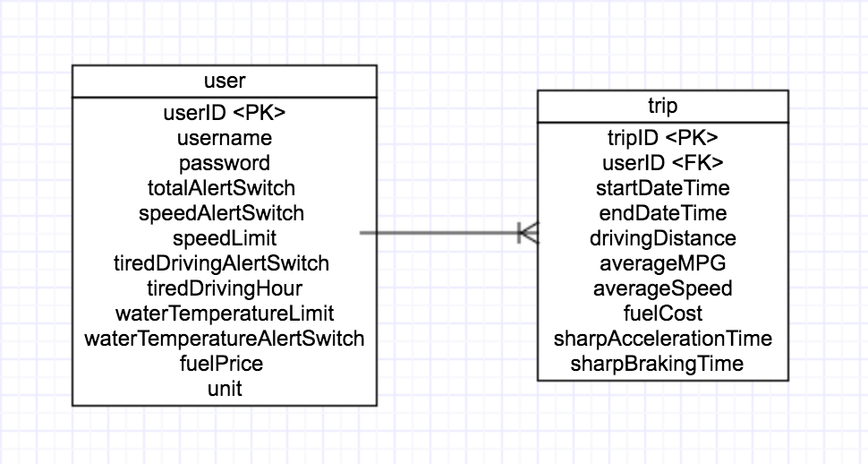
Figure 2. Entity relationship diagram

The final step to build database is to define attribute’s data type. There are a lot of different data types. A few are standardized, but many databases have their own data types that all have their own advantages. This project will use MySQL as a server database, so all types of data are defined by MySQL. For user table, all attributes should not be null. “userID” should be unique positive self-increasing integer. Type of “username” and “password” is “VARCHAR” and “username” should be unique. “totalAlertSwitch”, “speedAlertSwitch”, “tiredDrivingAlertSwitch”, “waterTemperatureAlertSwitch” and “unit” have the same type. The type is “TINYINT” which is equal to Boolean type. The reason to use “TINYINT” instead of using “Boolean” is that MySQL does not have internal “Boolean” data type. “speedLimit”, “tiredDrivingHour”, “waterTemperatureLimit” and “fuelPrice” use the type of “Double” because all of them are float values. For table trip, “tripID” should be unique positive self-increasing integer. It uses “userID” as foreign key and “userID” should be not null and unique. Besides, “startDateTime” and “endDateTime” represent specific date and time so their type is “DATETIME”. “drivingDistance”, “averageMPG”, “averageSpeed” and “fuelCost” are float values and their type is “DOUBLE”. “sharpAccelerationTime” and “sharpBrakingTime” recorded how many times users had sharp acceleration and sharp braking, so their type is “INT”.
After the final step, we can build the database through MySQL Workbench. Figure 3 shows user table and figure 4 shows trip table.
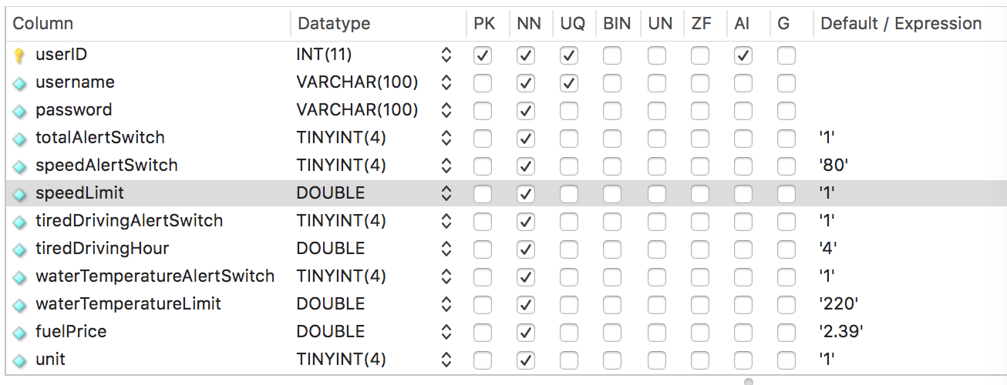
Figure 3. User table

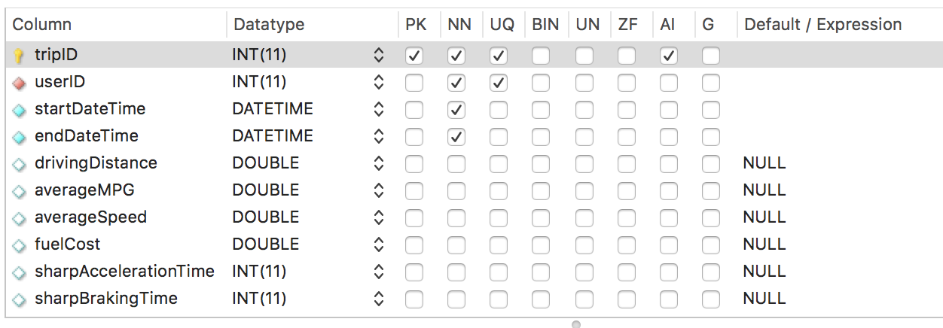
Figure 4. Trip table

4.2 Use case diagram
All use cases are retrieved from user requirements and the use case diagrams give an overview of usage requirements for a system. Figure 5 shows the use case diagram of this project.
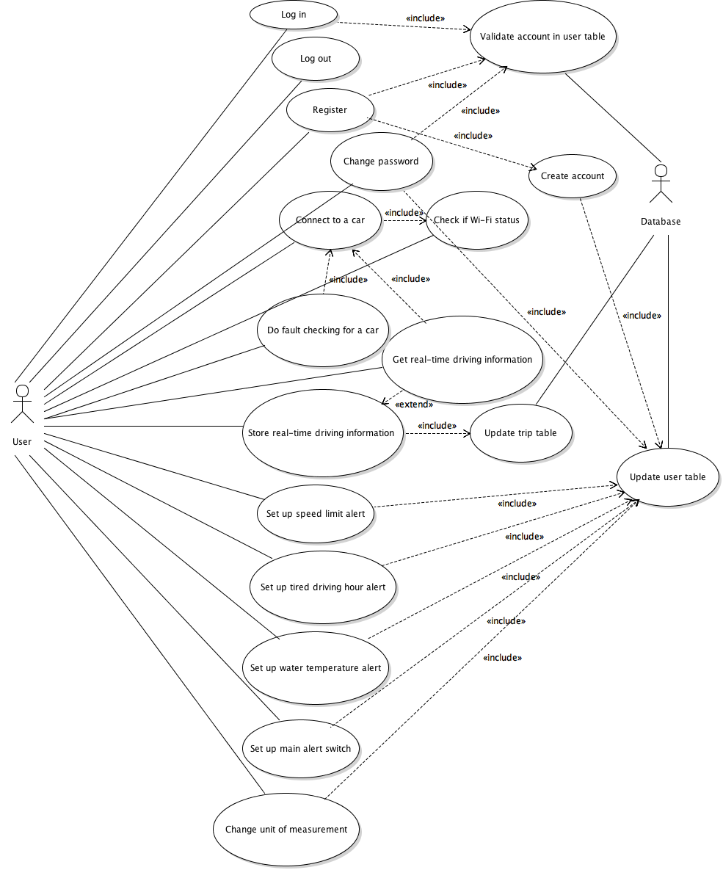
Figure 5. Use case diagram

4.3 Class diagram
Class diagram is the core part of UML diagram and it describes the structure of a system by modeling its classes, attributes, operations, and relationships between objects. There are serval benefits by using class diagram. It can help developers to illustrate data models for information systems and have a good understanding of a general overview of system. In addition, it provides an implementation which contains independent description of types used in a system and passed between its components. Figure 6 shows the class diagram of this project.
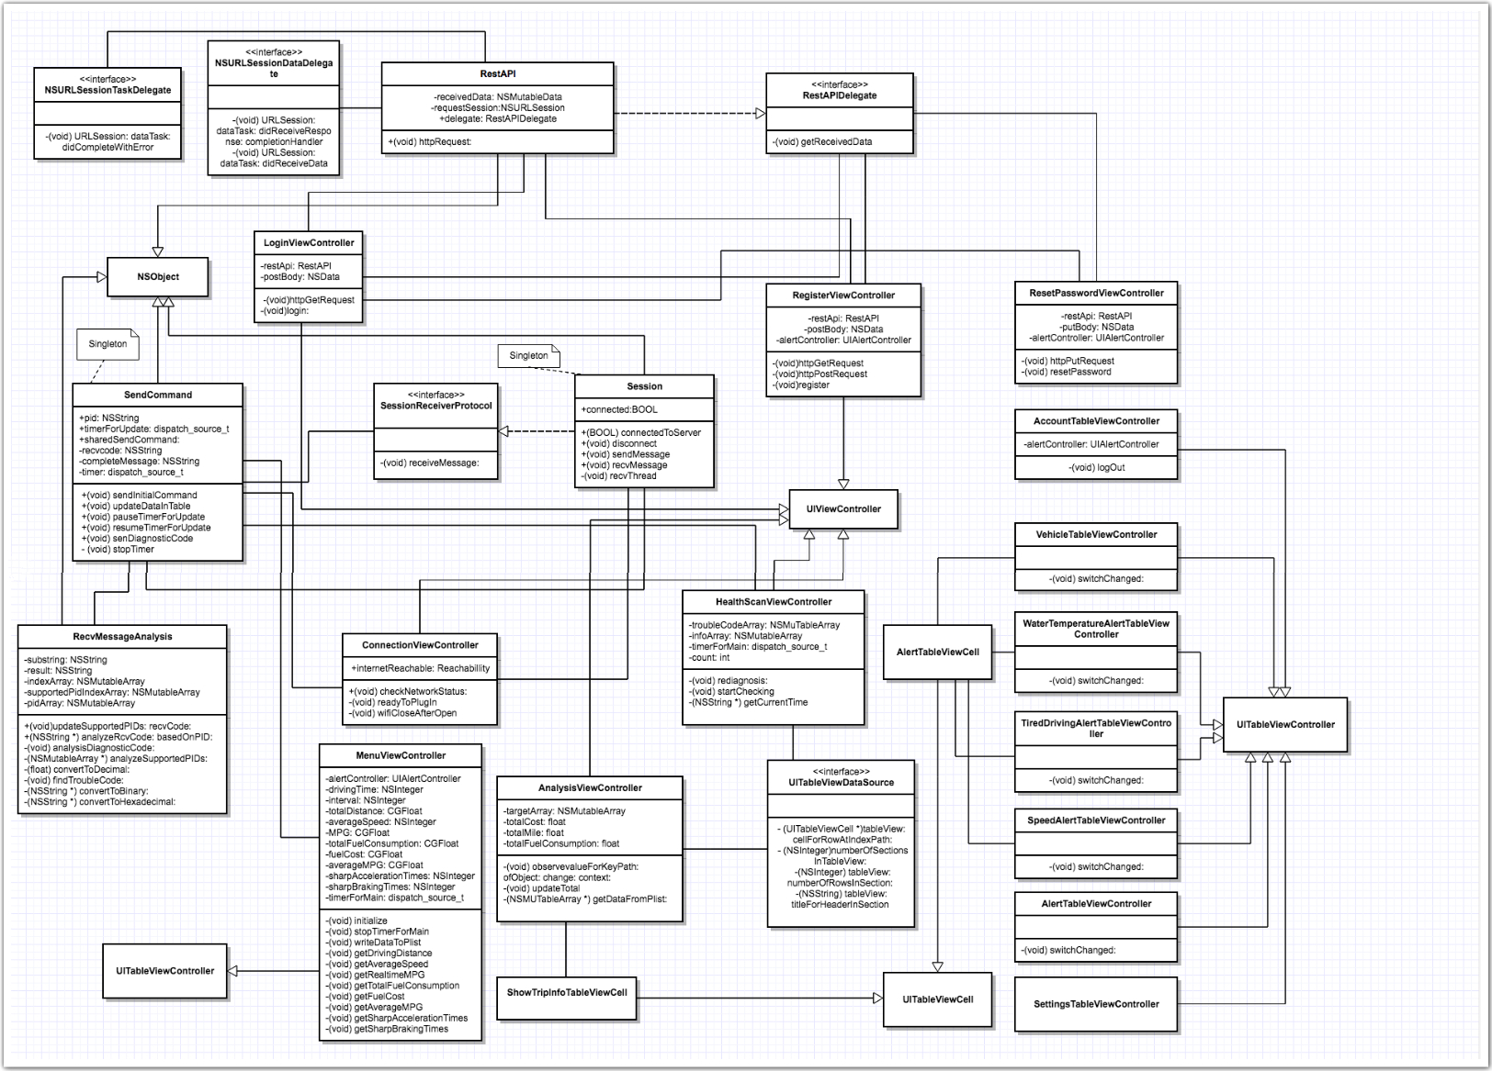
Figure 6. Class diagram

4.4 Sequence diagram
This section will mainly show the sequence diagrams of some important activities in this application. By using sequence diagram, we can clearly see how different components interact with each other and how messages passed between components in different activities.
Figure 7 shows login scenario; Figure 8 shows registration scenario; Figure 9 shows forgetting password scenario; Figure 10 shows connection scenario; Figure 11 shows reading data scenario; Figure 12 shows searching data scenario; Figure 13 shows checking a car scenario.

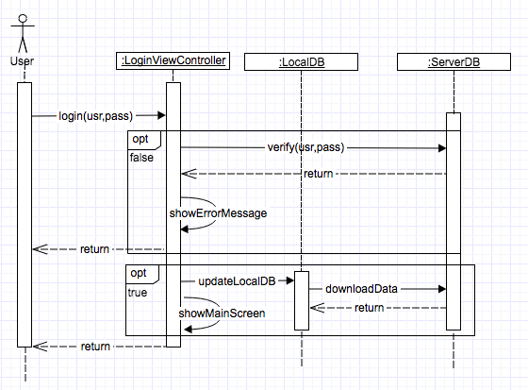
Figure 7. Sequence diagram of login

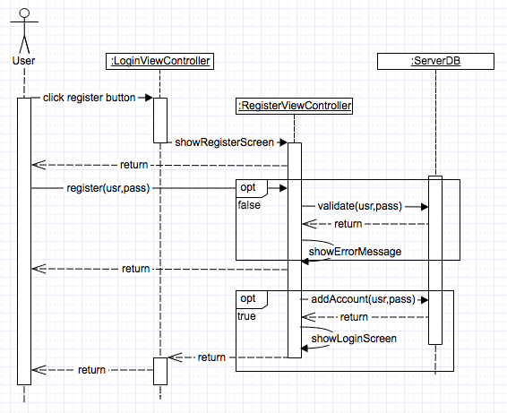
Figure 8. Sequence diagram of registration

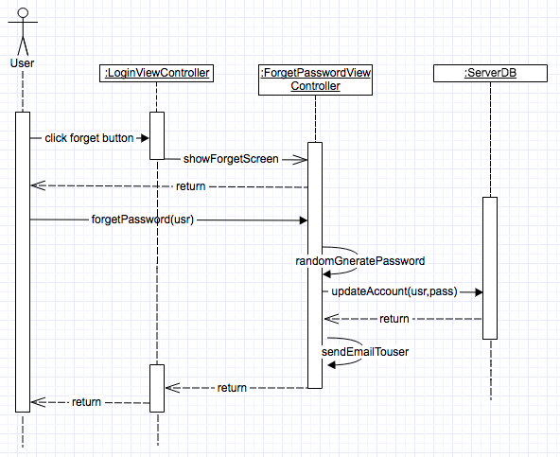
Figure 9. Sequence diagram of forgetting password

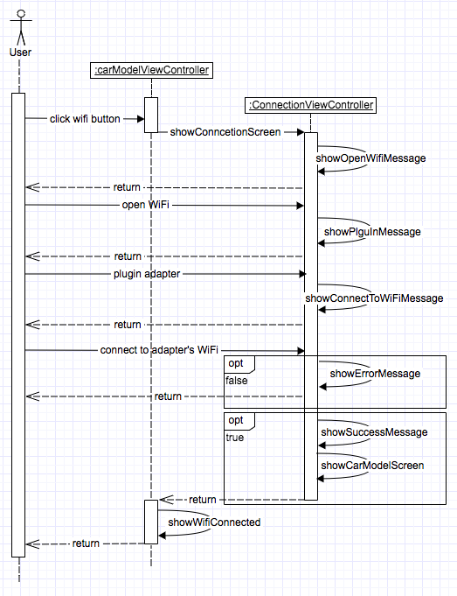
Figure 10. Sequence diagram of connection

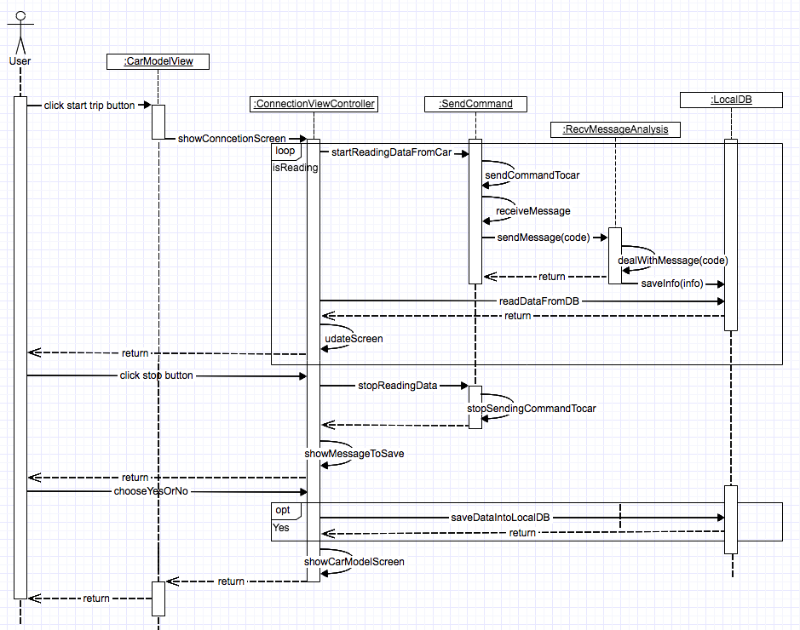
Figure 11. Sequence diagram of reading data

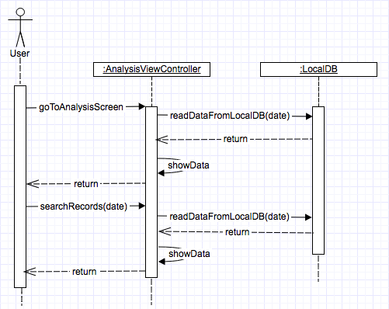
Figure 12. Sequence diagram of searching data

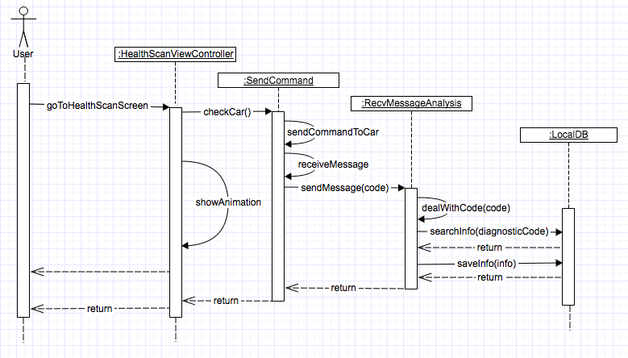
Figure 13. Sequence diagram of checking a car

4.5 User interface design
As we know, user interface design is one of the most important parts in software development. The quality of user interface has huge influence on user experience of the product. A good GUI (graphical user interface) not only catches a first-time user’s eye but also motivates the user to use the product again. I will introduce four principles of UI design which come from a paper [10] that I had read. The first one is reading gravity. The second one is minimization of cognitive load. The third one is using pre-existing mental models. The last one is use of color to direct attention. In addition, I also have my own GUI designing experience which come from Professor Kasi’s class. The first one is that GUI should be usable to as many as possible. The second one is that GUI must report appropriate error messages at the right time. The third one is that providing appropriate help at the right time and motivate the user to continue. The last one is that try to protect the users from introducing errors into the system (error prevention). Those UI design principles will be used as references to design UI of this product.
I will first introduce some basic patterns for mobile navigation. Tab bar pattern is one of the most frequently used patterns in mobile applications. Many popular applications, like Facebook, Instagram and Twitter, using tab bar pattern in their design. It was originally from desktop design. The tab bar usually puts navigation icons at the bottom of a screen to fit finger touch. Users can navigate directly to the screen associated with the item. By using tab bar navigation pattern, users can easily have access to all main functionalities without multiple touches; In addition, users know where they are and what they can do when they are using the application. In this product, all main functions were represented by bottom icons in tab bar. Figure 14 shows an example.
Another popular UI design pattern is navigation bar. Almost all popular mobile applications have navigation bars. In general, a navigation appears between the status bar and an app screen. Users can view the status and application screens without having any troubles. A navigation bar usually has title, back button and control button. Back button is always associated with previous screen and appears on the left side of the bar. Title always show information of current screen and appears on the middle of the bar. As for control button, it’s usually related to a Cancel or Done button and mainly used to manage users’ actions. This product had used lot of navigation bars. Figure 15 shows an example.
In addition to UI design patterns mentioned above, some popular UI elements are also frequently used in famous mobile applications. For example, Messenger uses table view to show contract list. The table view is usually used to manage data which has similar data structure or belongs to similar category. Table view can help us to show additional contents by scrolling with it. Some table views also have headers and footers which can make it easy to tract a long table. Figure 14 shows an example in this product.
Alert is another important UI element in mobile application design. Many applications use alert to remind users of something important. An alert usually contains a title and optional information. The title indicates what that alert means and optional information tells users what they can do. A widely-used example for using alert is AMBER Alert. Almost all people can view that information immediately once an AMBER Alert occurs. From this example, we can easily find out the advantages of using alerts in mobile application. Figure 15 shows an example in this product.

5. System implementation

5.1 Login module

5.2 Register module

5.3 Device connecting module

5.4 Start trip module

5.5 Route analysis module

5.6 Health scan module

5.7 Settings module

6. Testing

6.1 Testing methods

6.2 Functional testing

6.3 Unit testing

6.4 Integration testing

6.5 System testing

7. Conclusion

8. Bibliography
[1] United States Environmental Protection Agency, “On-Board Diagnostic (OBD) Regulations and Requirements: Questions and Answer”, 2003.
[2] National Instruments, ECU Designing and Testing using National Instruments Products, Nov 07, 2009.
[3] Georgi Dalakov, “The Modem of Dennis Hayes and Dale Heatherington”, January 8, 2015.
[4] http://www.developershome.com/sms/, “Short Message Service / SMS Tutorial”. Chapter 14. Feb 21, 2008.
[5] Microsoft Patterns & Practices Team, “Microsoft® Application Architecture Guide, 2nd Edition”, Nov 2009.
[6] Craig Larman, “Object-Oriented Analysis and Design”, Jan 21, 2005.
[7] Grady Booch, “Object-Oriented Analysis and Design with Applications (3rd Edition)”, 2004.
[8] Ahmad Shuja, Jochen Krebs, “RUP Reference and Certification Guide”, 2007.
[9] Scott W. Ambler, “The Elements of UML™ 2.0 Style”, May 2005.
[10] Noah Stupak, Nicholas DiFonzo *, Andrew J. Younge, Christopher Homan, “SOCIALSENSE: Graphical user interface design considerations for social network experiment software”, Available online 11 December 2009.

Appendices

