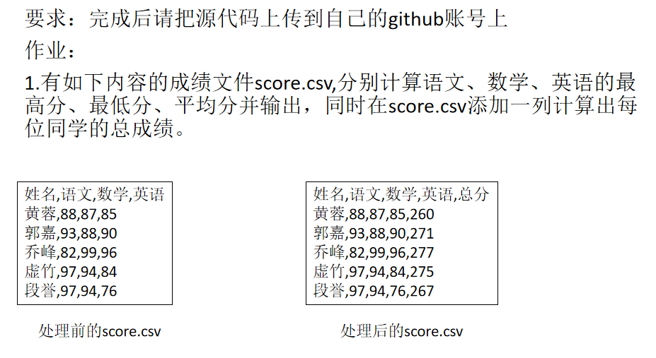

def calc():

with open('score.csv','r',encoding= 'utf-8') as fo:

str_info = ''

yuwen,math,English = 0,0,0

yuwen_max,math_max,English_max = 0,0,0

yuwen_min,math_min,English_min = 0,0,0

n = -1

for i in fo.readlines():

line = i.strip('\n').split(',')

sum = 0

n += 1

if len(str_info) == 0:

str_info += i.strip('\n') + ',' + '总分\n'

else:

for a in line[1:]:

sum += eval(a)

str_info += i.strip('\n') + ',' + str(sum) + '\n'

yuwen_max = eval(line[1]) if yuwen < eval(line[1]) else yuwen_max

math_max = eval(line[2]) if math < eval(line[2]) else math_max

English_max = eval(line[3]) if English < eval(line[3]) else English_max

yuwen_min = eval(line[1]) if yuwen > eval(line[1]) else yuwen_min

math_min = eval(line[2]) if math > eval(line[2]) else math_min

English_min = eval(line[3]) if English > eval(line[3]) else English_min

yuwen += eval(line[1])

math += eval(line[2])

English += eval(line[3])

str_info += '最高分' + ',' + str(yuwen_max) + ',' + str(math_max) + ',' + str(English_max) + '\n'

str_info += '最低分' + ',' + str(yuwen_min) + ',' + str(math_min) + ',' + str(English_min) + '\n'

str_info += '平均分' + ',' + '{:.2f}'.format(yuwen/n) + ',' + '{:.2f}'.format(math/n) + ',' + '{:.2f}'.format(English/n) + '\n'

return str_info

fo = open('scoressss.csv','w',encoding= 'utf-8')

fo.write(calc())

fo.close()

print(calc())