NWFPs Management Plan
Orong Gewog
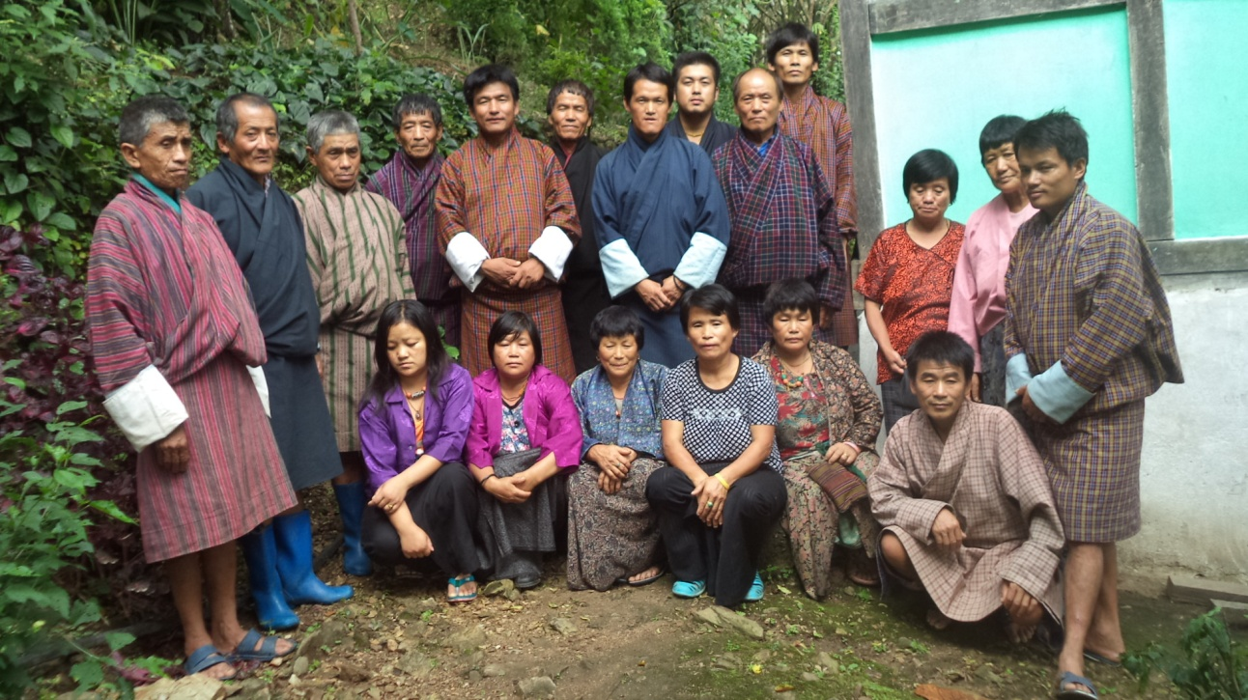
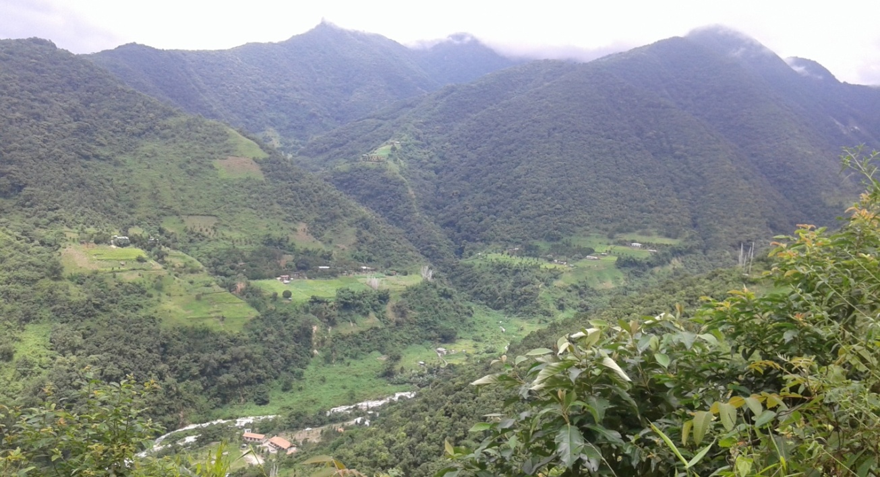
(Plan Period- July 2021 to June 2026)
Brungshingborang
Kharwa
Redumey
Nagla

Table of Contents
Section A: NWFP management and marketing plan 2
1. Background 2
2. Summary of NWFPs Management areas and Group 2
3. The objectives are 3
4. Brief review and achievement during the previous management plan period 3
4.1. Activity achievement 3
4.2. Financial achievement 3
5. Description of NWFPs 3
6. Harvesting prescriptions for sustainable NWFP harvesting 5
7. NWFPs harvesting rotation adopted in the past 7
8. Details of block-wise NWFPs information (Estimation drawn through group discussion with members) 8
9. Marketing and sales plan 9
9.1 Marketing arrangements 10
10. Benefits to the members 10
11. Benefits to the group 11
12. Members of the NWFP management & marketing group 12
13. Executive committee 14
14. Possible additional executive committee members 15
15. Compensation to the executive committee for marketing 16
16. Membership fee and purpose 16
17. Community development fund and utilization of fund 16
18. Conflict resolution 17
19. Penalties 17

Section A: NWFP management and marketing plan

1. Background
Redumey-Nagla is a small hamlets situated at upper corner of Jangchubling chewog under Orong Gewog, Samdrup Jongkgar Dzongkhag. There are 33 households (six households from Tokarong and two households from Narphu). These two households are currently residing by roadside as from the point of lucrativeness.

Unlike in the past years, all the four hamlets (excluding Tokarong & Narphu) of Redumey, Nagla, Kharwaand Brungshingborang are now connected with by Wooling to Jangchubling chewogs farm road. The communities are basically agrarian and depend mostly on agriculture. Further natural forest resources like NWFPs are found abundant in the village adjacent forest. The people in the community are hardworking and progressive farmers. They grow mainly maize and it is their staple crop. Also for they grow ginger, groundnuts and holds orange orchard to earn cash income. The communities also do good vegetable farming for their domestic consumption and for sales too. Though looks remote by location, the farming system is far better than any of the other villages in Orong Gewog.

Narphung is a main market for sale agriculture and NWFPs. The Redumey-Nagla community lies in the warm broadleaved forest zone and is well known for the good natural habitats of Ringshu (Neomicrocalamusandropogonifolius) in the past five year management plan period only. Handicraft products are made form a bamboo species in sold at Narphung once. However, today this could not be continued due to flowering and dying this species since 2019. The community can now explore on broom species Larishabu(Trachypacus spp.), mushrooms, Rubia species, variety of wild vegetables etc. to make livelihood through the sustainable harvesting as prescript in the plan.

2. Summary of NWFPs Management areas and Group
The name of the NWFPs management group is “Drupthop Shingmin Detshen”. The group consists the total of 33 households from different hamlets of Nagla, Redumey, Kharwa, Brungshingborang and even from Tokarong and Napphu too. They have identified three main different management blocks with due respect to their existing traditional boundaries. The management areas namely Lemnang block, Drupthopa block and Khashorong block are encompasses within the traditional boundaries of Drupthopa/Tokarong in the east, Bamnangchelo/Brungshingborangin the south, Gayzorin the north and Kezangag/Rebalingbe in the west. It falls under warm broadleaved forest and have around 29 different types of NWFP species within the total approximate areas of 1000 hectares.

3. The objectives are
- To sustainably manage and conserve the natural resources, NWFPs for future generations
- To improve the rural livelihood through income generation from the sales of NWFPs.
- To protect the NWFPs from illegal and unsustainable extraction by outsiders.

4. Brief review and achievement during the previous management plan period
The NWFP management plan period of five years for Drupthop Shingmin Detshen, Redumey-Nagla which was formed in 2015 has been completed by the end of December 2020. The communities are willing to continue with the task of further managing and protecting the natural resources for future generation. But due to the COVID-19 situation, NWFPs management plan revision could not take place on time. However, with the financial support from the Gewog Administration, the management plan revision exercise was conducted towards the last week of March 2021. The review and planning program was assisted by the GT Tshogpa of Jangchubling chewog till the end. It was very successful activity and the closing session was warmly attended by all the Gewog staff led by Gup.

4.1. Activity achievement
- Annual NWFP management group members meeting – conducted twice a year
- Patrolling on rotational basis (once in two months) – illegal activities drastically reduced
- Sustainable harvesting and sale of NWFPs – earned amount deposited in Bank
- Improvement of broom spp. cane spp.& Neshingjorma over the management plan period

4.2. Financial achievement
- Annual membership fees are Nu. 100 x 33 members’ x 5 years = Nu.16,500
- Sale of broom species during the plan period= Nu. 11000
- Sale of Damroo/fern tops -do- = Nu.1200
- Sale mushrooms -do- = Nu. 4000
- Sale of craft items made from Yula (Ringshu) = Nu. 1300
Total = Nu. 34,000

5. Description of NWFPs
There are around 29 types of NWFP species found in the three different blocks of Lemnang, Drupthop and Khashorong forests. But their distribution in the blocks mentioned is sporadic. Ringshu (Neomicrocalamus andropogonifolius) which is useful elsewhere was also found in the block. However, today harvestable size culms are not available as it flowered and died in 2019. Today, young seedlings are found growing in the area.

The semi-hard broom species called Larishabu (Trachypacus sp.) is the dominant NWFP followed by soft broom (Thysanolaena spp.), mushroom species and leafy vegetables etc. They are mentioned in table 1 in order of priority and abundance in the forests.
Table 1: Brief description of NWFPs for commercial harvesting
NWFP Name | Harvesting area(s) name | Parts harvested | Use purpose (traditional & others) | Harvesting season (month) | Estimated quantity that can be collected
Larishabu  (Trachypacus sp.) | Lemnang and Drupthopa | Leaf with branch | Semi-hard broom | 8thto 2nd of Bhutanese months | 50000 nos.
Beyshaba -soft broom (Thysanolaena sp.) | Lemnang, Drupthopa and Khashorong blocks | Upper parts, inflorescence | Soft broom, fodder | 11th to 2ndof Bhutanese months | 30000 nos.
Laniroo  (Rubia cordifolia) | -do- | Steam | Color/dye | 8th to 3rd of Bhutanese months | 5000 kg
Thormom  (TupistraNutans) | -do- | Flowers | Vegetable | 8th to 9th of Bhutanese months | 1000 kg
Mushroom | -do- | Whole parts except roots | -do- | 3rdto 8th of Bhutanese months | 1000 kg
Ferns  (Deplazium exculentum) | Drupthopa&Khashorong | Young shoots | -do- | 2nd to 8th of Bhutanese months | 600 bundles
Dawaisey  (fern tubers) | Lemnang, Drupthopa and Khashorong blocks | Rhizomes/root fruits | Medicine | Throughout the year | 1000 kg
Satse or saytsam (Arenga westerhoutii) | -do- | Branch with leaf | Hard brooms& fodder | 1st to 3rd of Bhutanese months | 1000 nos.
Damroo  (Elatostemelineolatum) | -do- | Stem with leaf | Vegetable | 8th to 3rd of Bhutanese months | 400 bundles
Yongjiba  (Pouzolzia spp.) | -do- | Bark | Adhesive, incense | -do- | 1000 kg
Famru (yeast making climbers) | -do- | Whole parts except roots | Yeast making | 9th to 3rd of Bhutanese months | 3000 kg
Bamboo spp.  (including rashu, wey&dem) | Lemnang, Drupthopa and Khashorong blocks | Culm | Bamboo crafts & mat | 9th to 11th of Bhutanese months | 2 T/L
Pan (Piper longum) |  | Leaf | Stimulant | Throughout the year | 500 kg
Pipla (Piper spp.) |  | Fruits | Medicine/spice | 4th to 8th of Bhutanese months | 100 kg
Daphne spp. |  | Bark | Traditional papers | 2nd to 5th of Bhutanese months | 500 kg

(T/L) – Truck Load, (Kgs) – Kilograms

Out of 29 (twenty nine) NWFP species found within their traditional jurisdiction of Drupthop Shingmin community, only fifteen of them are provided with the descriptions for commercial harvesting. However, if commercial importance of these species emerges in future, other 14 species which are not mention in the table 01 will be included and seek permission for harvesting from the CFO in future. These are Khatserim(Justicia adhatoda), walnut(Juglans regia), Khirtsim(Calamus erectus), Pagam, Gangmosey, yam, Poikar (Cannarium strictum) , pachala (Musa sp.), Toraichurpo(Citrus sp.), Kolokpo (Entada rheedii) , Rukhirtsim (Calamus sp), Grey (calamus latifolius),Thakchung (Acros urea) and Fagsu(Drepanostachyum sp.)

6. Harvesting prescriptions for sustainable NWFP harvesting
The user group members will strictly follow the guidelines and prescriptions in the plan to ensure sustainable harvesting of resources for present and future generations. Depending on the market demand, harvesting of other 14 species not listed will be carried out after seeking prior permission from the CFO.
Table 2: Harvesting prescriptions for sustainable harvesting
NWFP species | Harvesting prescription for sustainable harvesting
Larishabu (Broom spp.) | - Don’t cut whole plant.  - Cut matured branch and leave the seeds for regeneration.  - Retain the immature branches.  - Don’t cut nearby trees.
Beyshaba - Soft broom  (Thysanolaena spp.) | - Cut the foliage, inflorescence at 15cm from the ground.  - Do not damage the rhizomes in order to allow natural regeneration.  - Control from fire hazards in winter season.
Laniroo  (Rubiaspp.) | - Use sharp scissors for the collection of the upper part of the plant.  - Cut the plant at 5 cm above ground level.  - Leave at least 10% of the plants without collecting for next time regeneration purposes  - Do not collect roots.  - Do not uproot entire plants
Thormom (TupistraNutans) | - Do not collect whole flower parts  - Keep 30% of it for seed dispersal and natural regeneration  - Do not uproots the whole plants.
Mushroom spp. | - Do not uproot whole plant.  - Keep the root parts to soil/dead logs for next time sprouting  - Use basket with holes to allow the pores to disperse.  - Should not destroy mushroom growing area or habitat.
Fern  (Diplaziumesculentum) | - Harvests young shoot that are 15 cm length.  - Do not harvest the entire shoot coming up in season  - Do not harvest the shoots that have developed to leaves.  - Retain at least 50% of young shoot of last flush for the development of leaves.Do not cut down trees which provide shade to the plant.
Dawaisey  (fern rhizomes) | - Do not uproot the whole bunch of plant.  - Harvest the fruits which are matured and attend reasonable size  - Should not destroy the growing area or habitat.
Satse or Saytsam  (Hard broom spp. ) | - Cut only matured branches and retain immature branches.  - Do not cut whole plants and nearby trees.
Damroo/Gremom  (Elatostemelineolatum) | - Collect plants that are 15cm and above or matured ones.  - Retain stump of around 3’’ for sprouting of new shoots.  - Do not uproot whole plant.  - Should not cut down trees and create more opening.  - Should not disturb its catchment area.
Yongjiba  (Pouzolzia spp.) | - Cut the plant at 10 cm above the ground level  - Do not damage the remaining young stands/seedlings/saplings  - Felling of surrounding trees to ease harvesting is prohibited  - Leave at least 10% of the plants to allow natural regeneration  - Harvesting of roots is strictly prohibited for ecological reason
Famru (yeast making climbers) | - Do not cut the whole climbers and its supporting trees.  - Retain at least 40% of either leaves or the climber plants  - Harvest within the stipulated time frame only
Bamboo spp. | - Do not harvest during 12th – 8th of Bhutanese month.  - Do not cut the culms less than one year old (retain immature)  - Cut the culms above one node from the ground level  - Cut the culms of three years and older  - Do not harvest young shoot for sale purposes.  - Follow rest of prescriptions steps from interim framework guide book for management and marketing of NWFPs.
Pan (Piper spp.) | - Collect leaves only by hand picking without damaging the climber and its tender buds  - Collect at maximum 80% of the leaves from a single climber  - Harvesting of leaves from a single climber shall be allowed to maximum of 4 times a year
Pipla (Piper spp.) | - Collect fruits only when fully mature  - Harvest fruits only after the announcement of the starting date  - Harvest fruits only by hand picking without damaging, cutting or uprooting the entire plant  - Do not cut down the host tree to ease harvesting  - Do not cut down the entire fruiting portion of the tree
Daphne spp. | - Cut the plant at 10 cm above the ground level  - Cut only the stems that are 10 cm in diameter  - Do not damage the remaining young stands/seedlings/saplings  - Do not fell the surrounding trees in order to clear the area to ease harvesting  - Harvesting should be done on rotational basis, once in 5 years for every block.

7. NWFPs harvesting rotation adopted in the past
Harvesting year | Name of harvesting blocks | Remarks
1st year (2016) | Lemnang block | The harvesting of products like Bamboo spp. Mushroom spp. Zanthozylum spp. and Khatserim can be done annually throughout blocks.
2nd year (2017) | Drupthopa block
3rd year (2018) | Kharorong&Lemnangblock
4th year (2019) | Drupthopa block
5th year (2020) | Khashorong block

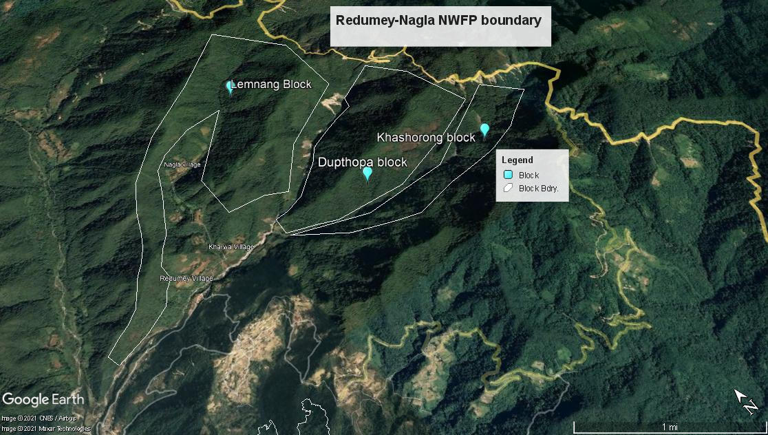

8. Details of block-wise NWFPs information (Estimation drawn through group discussion with members)
Sl No | Harvesting areas or block | Estimated size of harvesting areas | Distance from the village  (walking hours) | Estimated quantity of NWFP species that can collected per harvesting area
 |  |  |  |  | Larishabu  broom  (B) | Beyshabu  Broom  (B) | Rubia spp. (kg) | Thormom  (kg) | M/room  (kg) | Fern (B) | Fern rhizome  (kg) | Satse broom  (Nos.)
1 | Lemnang | 1500 acres | 1 - 3 |  | 30000 | 20000 | 1000 | 500 | 600 | - | 200 | 500
2 | Drupthopa | 900 acres | 2 - 3 |  | 20000 | 7000 | 1000 | 300 | 200 | 200 | 150 | 250
3 | Khashorong | 600 acres | 2 - 3 |  | ----- | 3000 | 3000 | 200 | 200 | 400 | 150 | 250

(P) - Protection, (T/L) - Truck Load, ( Kgs) - Kilogram, ( (B) - Bundle/bunch

Sl  No | Harvesting areas or blocks | Estimated size of harvesting areas | Distance from the village  (walking hours) | Estimated quantity of NWFP species that can collected per harvesting area
 |  |  |  | Gremom  (B) | Yongjibu  (Kg) | Famroo  (Kg)
1 | Lemnang | 1500 acres | 1 - 3 | 100 | 2000 | 2000
2 | Drupthopa | 900 acres | 2 - 3 | 150 | 250 | 500
3 | Khashorong | 600 acres | 2 - 3 | 150 | 250 | 500

(P) - Protection, (T/L) - Truck Load, ( Kgs) - Kilogram, ( (B) - Bundle/bunch

9. Marketing and sales plan

NWFPs management group members of Drupthop Shingmin Detshen have the plan to make arrangement of selling their natural available resources such as three types of broom species (hard, semi hard and soft broom), rubia species, mushroom species, wild vegetable species etc.. The availability status of these resources is at moderate condition according to our rough estimates and the firm statements assured by the community during management planning and preliminary resources assessment. The NWFP specieswill be selling locally at Narphu with prior permission from the CFO as per management prescriptions and annual work plan.

The management group chairperson will seek help from the Gewog Administrationand other relevant stakeholders if there happen to be huge quantity of NWFPs which cannot be absorbed in the local market. The buying and selling price of the products will fully depend on the timely fluctuations of the market demand situation.
Table 3: Marketing and sales plan
NWFPs | Potential market | Estimated quantity for sale per season (unit) | Expected selling price per unit  (Nu) | Total (Nu) | Remarks
Larishabu (broom spp.) | -do- | 50,000 nos. | Nu.20/broom | Nu.1000000 | Narphung+ local
Beyshabu | -do- | 30000 nos. | Nu.20/broom | Nu.600000
Rubia spp. |  | 5000 kg | Nu.35/kg | Nu.175000 | Farm gate price
Thormom |  | 1000 kg | Nu.100/kg | Nu. 100000 | -do-
Mushroom spp. :  Gowayanbamong  Tshatshsebamung  Nagorbamung  Yulaibamong  Tsintsirbamong  Betingbamong  Chergainbamong  Brengpabamong  Nuubamong  Serbamung | -do- | 500 kg  100 kg  50 kg  60 kg  5 kg  40 kg  50 kg  100 kg  50 kg  45kg | Nu.100/kg  Nu. 100/kg  Nu.50/kg  Nu. 70/kg  Nu.100/kg  Nu. 40/kg  Nu. 40/kg  Nu.30/kg  Nu. 20/kg  Nu.30/kg | Nu. 50000  Nu. 10000  Nu. 2500  Nu.4200  Nu. 500  Nu. 1600  Nu.2000  Nu. 3000  Nu. 1000  Nu. 1350 | -do-
Damroo | -do- | 400 bundles | Nu. 15/bundle | Nu. 6000 | -do-
Fern shoots | -do- | 600 bundles | Nu. 15/bundle | Nu. 9000 | -do-
Fern tubers (Dawaisey) | -do- | 500 kg | Nu. 150/kg | Nu.75000 | -do-
Satse | -do- | 1000 bundle | Nu. 20/bundle | Nu. 20000 | -do-
Famroo | -do- | 3000 kg | Nu. 50/kg | Nu. 150000 | -do-
Yongjibu(pouzolzia spp.) | -do- | 1000 kg | Nu.30/kg | Nu. 30000 | -do-
 |  |  |  | Nu. 801150 | -do-

9.1 Marketing arrangements

- Any NWFPs will be harvested as per the management prescription for sale with prior permission from the chairperson and the committee members.
- The quantity of products taking to market will be first assessed by the chairperson and secretary to ensure proper recording and payment towards community fund after coming back from the market.
- The group members shall market their products individually or in group, which ever find convenient to do so.
- If there happen to be huge quantity of NWFPs for marketing, the group with concern chairperson and committee members will seek support from GT Tshogpa, Gewog Administration and other relevant stakeholders.
- General consultation will be held upon call by chairperson and secretary to address issues related to marketing aspects and to fix any important programs for future goodness.
- Narphu is the only local market centre for the group at present and they are in the process of looking for other suitable locations for marketing the products.

10. Benefits to the members

- Every member can generate income through sale of NWFPs as well as even by making handicraft items if possible.
- Each member has right to get equal share from the accumulated group fund.
- The group members shall look after the welfare of sick old and needy people and render every possible help
- During emergencies (death), natural calamities etc. each member will contribute Nu. 150 (one hundred fifty) to the victim as “semso”.
- The group would assist the needy parents and bear the school fees and other expenditures for one year for the child who is willing to attend the school or is already attending the school.

11. Benefits to the group

- Sustainable harvesting guidelines and management plan in place.
- Easy access to permit for NWFPs harvesting and marketing
- Reduce illegal and unsustainable harvesting practice of NWFPs.
- Community development fund creation from the sale of NWFPs and craft items.
- Ensure safe deposits of group fund in the bank.

Section B: By-laws- Group regulations and norms

12. Members of the NWFP management & marketing group |  | Village | Number of member households | Geog
 |  | Redumey, Nagla, Kharwa&Brungshingborang | 33 | Orong
Membership arrangement and rights of members:

- Only the residents of Redumey, Nagla, Kharwa&Brungshingborang with definite gung and census are eligible to become a member of NWFPs mgt. group.
- Only the household under chepon Khawog will be accepted as member and therefore no opportunity for outsiders like Mandarpas and Woolingpas to become a member
- He/she will be accepted based on willingness and interest to join the group.
- Each member will contribute a sum of Nu.100 (one hundred) as annual membership fee in the month of January every year.
- If he/she fragmented from same gung and wanted to become as separate new member can do so upon realizing the normal annual membership fee of Nu.100 (one hundred) plus lump sum payment of Nu. 1500 (one thousand five hundred) only as registration fee to the group.
- The person wishing to join the group must apply to chairperson. His/her membership would be decided by the group members during the general assembly and then make aware of group’s objectives, plan and by-laws.
- The people who are currently residing in other Gewogs or Dzongkhags if later wanted to join as member should bear the normal entry fee of Nu.100 (one hundred) annually and also need to pay Nu. 5000 (five thousand) to the group as registration fee.
- An outsider settling in the village in future and if he/she wanted to become member of the group should also follow the same as above serial number VII.
- Any member wishing to opt-out from membership due to genuine problem or reason (resettlement program) shall be entitled 70 percent of individual share from the common fund and 30 percent shall be retained in the common fund.
- If he/she intentionally withdraws from the membership should pay Nu. 15000 (fifteen thousand) to the group and shall not eligible to claim any benefits and forest resources from the NWFPs delineated areas base on the traditional boundaries.
- Any member who involves in any activities against the welfare of the group shall be charged a lump sum fine of Nu.500 (five hundred) excluding the absent penalty of Nu.300 (three hundred) per day.

Responsibilities of members:

- Actively participate in meetings, trainings and also in general assembly twice a year i.e. on 4th and 12th of Bhutanese calendar while the frequency of executive committee meeting and any emergency meeting can be held on need basis.
- Members who are presently residing out of village like Tokorong and Narphu should compulsorily attend 2 times meeting in a year. However they are exempt from need of attending other ad hoc meetings.
- Members at Tokorong will take care of nearby areas like Dekorsai and Drupthopa while others will patrol rest of the areas designated for management and collection.
- All members should participate in protection, sustainable management and harvesting of NWFPs.
- All the group members will actively participate in patrolling their NWFPs growing areas twice a year on rotational basis.
- Inform/avail permit from chairperson for collection of NWFPs and provide correct information for proper recording after marketing.
- Members must follow annual harvesting calendar except for the collection of mushrooms.
- Marketing of NWFPs and Tsharzo products can be done either in group or individual whichever is convenient.
- Obey instructions of the chairperson and committee members with respect and interest, and jointly protect the resources from illegal doers.
- Harvest, manage and utilized the NWFPs on sustainable basis as per the management guidelines and prescriptions.
- Report promptly of any illegal encounter case to chairperson and committees for action.

13. Executive committee
The nine elected executive committee members will coordinate activities NWFP management and utilization of the resources. They are directly accountable to the Gewog Forest Office, Gewog Administration and CFO regarding the management and the utilization of NWFPs. The terms for this executive committee is for five years and work without incentives. However, they can resign or will be terminated before the completion of their terms if their performances are not satisfactory. The termination or resignation of executive committee will take place during the general assembly and the NWFP group members will approve the termination/resignation from the executive membership and nominate/elect the substitution through voting system.

Chairperson | Name of Chairperson: Dorji Singye
Responsibilities of Coordinator/Chairperson:
- Chair the meeting related to NWFPs management, utilization and marketing.
- Work in close coordination with other organizations, sectors and agencies, and seek assistance for the development of management group.
- To arrange and coordinate the marketing of NWFPs and handicraft items.
- Represent the group in meetings that will take place in local regional and national level. After return, share information and ideas acquired from the meeting with the group members.
- Resolve disputes and conflicts arising among the group members to
maintain good working relations.
- Organize/Coordinate the patrolling of NWFPs collection areas from time to time on rotational basis.
- Initiate annual planning and progress reporting to Gewog Forest Ranger and Chief Forest Officer.
- Jointly co sign on the cheque for withdrawal of community fund.
- Explore market for NWFP products.

Secretary | Name of Secretary: Rinzin Tshomo
Responsibilities of Secretary:
- Officiate as chairperson in his absence.
- Inform the date, time and venue of meeting to all the group members.
- Keep minutes of NWFPs related meetings and circulate to members and forestry officials.
- Assist the chairperson in solving conflicts arising among members and maintain good working relations, and also in marketing of NWFPs.
- Keep proper record and data of NWFPs collected and marketed.
- Co signatory on cheque for withdrawal of fund from bank.
- Maintain proper record of NWFPs collected and sold by each member.
- Main record of payment made to each member.

Treasurer | Name of Treasurer: Kintu Zangmo
Responsibilities Treasurer:
- Assist the chairperson and secretary in marketing.
- Issue a receipt to the individual for quantity of NWFPs collected for sale.
- Keep annual financial transaction records and present to the group members during the general assembly.
- Collect and deposit the money in the NWFPs group account maintained
with the nearest financial institution.
- Co signatory on the cheque for withdrawal of money community fund account.

14. Possible additional executive committee members | Name (s):  - KelzangWangdi - Nagla  - PemaDorji - Redumey  - Karchung - -do-  - SherabWangdi - Kharwa  - Wangyalpo - Tokarong  - NamgayDorji - Narphu
Responsibilities:
- Assist the chairperson, secretary and treasurer in implementation of NWFPs management plan and group by-laws.
- Provide help in coordinating of NWFPs collection and marketing
- Assist the chairperson, secretary and treasurer during the arrival of visitors and guests

15. Compensation to the executive committee for marketing | The committee members elected have unanimously agreed to work without any compensation from the group.
16. Membership fee and purpose | Every member shall contribute annual membership fee of Nu. 100 (one hundred) only. The amount will be deposited in the nearest bank and will be used for welfare purposes of the group members in the near future. The amount will also be used for pre-financing the marketing cost of NWFPs products and handicraft items.

17. Community development fund and utilization of fund | The community development fund will be generated through following means;  - Annual membership fees collection  - Deduction of 5% sale proceeds during sale of NWFP products and handicrafts.  - Fines and penalties of absentees and illegal doers  - Interest rate from the loan repayments  - Contribution and donation from visitors and other relevant agencies.  - Registration fee of new member.  The accumulated common fund will be managed & utilized for the welfare of group members as follows ;  - The common fund generated from above means will be maintained in the group saving account with the BDBL.  - The fund will be used for giving loan to members. However, Disbursement will be done only when the fund balance is more than Nu. 100,000.00 (One Hundred Thousand) only in their saving account.  - It will be disbursed only after deciding in annual general assembly. Further, a separate terms and conditions will be developed to avoid complication in future. To a sum loaned, interest rate of 2% will be charged every month.  - The fund will also be utilised for the procurement of office stationeries, seals, printing of permits books, money receipt etc.  - The sum of Nu. 3000 (three thousand) only will be maintained with committee members to meet emergency expenses. For further changes, the issue will discuss during the annual general assembly in future.

18. Conflict resolution | - The chairperson and the secretary shall solve the conflict arising among the group members.  - If the conflict arises between executive committee members and the group members, the matter shall be forwarded to Gewog Forestry staff followed by chewog Tshogpa and Gewog Administration by chairperson for final decision.  - If the problem arises between group members and the outsiders, the matter shall directly forward to the Gewog Administration for settlement followed by Dzongkhag Administration if it is not solved at gewog level.
19. Penalties |  | Collection or harvesting of NWFPs for home consumption purposes will be free of royalty. However, if the collection is made with intention of sale, he/she shall be liable for payment of 5% sale proceeds which will go into community development. The fines and penalties against the illegal doers will be imposed both for group members as well as non-members in the following ways;
 |  | Name of NWFPs | Fines and penalties for illegal collection
 |  | Broom spp. (3 types) | Nu. 1000/ head load or Nu.40/kg
 |  | Thormom (vegetable)  -do- (uprooting for plantation) | Nu. 300 per kg& seize  Nu. 500 per kg & seize
 |  | Fern shoot & Gremom | Nu. 25 per bundle& seize
 |  | Mushroom spp. (Gowayan &Tshatshi)  -do- other spp. | Nu. 200 per kg seize  Nu. 100 per kg & seize
 |  | Dawaisey (Fern fiddles) | Nu. 200 per kg& seize
 |  | Rubia spp. (Lanero)+ Yongjibu | Nu. 50 per kg & seize
 |  | Famroo (yeast making climber) | Nu. 60 perkg & seize
 |  | NeshingJorma | Nu. 500 per kg& seize (Raw)  Nu. 1000 per kg & seize (value added)
 |  | If illegal collection of any NWFPs not listed in the mgt. plan | As per the FNCRR with kind support from the forestry officials
 |  | Other norms and penalties of the group members
 |  | Misuse of fund by the executive committee members |  | Should repay the amount with existing bank interest rate
 |  | If any committee members fail to deliver service |  | Terminate him/her and appoint new ones through voting system
 |  | Conversion of Thakchung from any other tree species is not allowed except from the Brungshing (Caryota urens) on case by case basis. |  | As per the FNCRR 2017 and  FNCRR 2020 amendment
 |  | Failing to report on time (9.00 am) for meeting, works etc.  Late by few minutes  Late by 30 minutes  Late by more than 30 minutes  Absent for one day |  | - will be accepted with imposing penalties.  - should pay Nu. 50 to community  - should pay Nu. 100 and attend the  meeting too  - Need to pay Nu.200.00
- Seeing the improvement status of Nyashing Jorma over period of five year management plan, community has decided to the sustainable collection.
- Members are allowed to harvest cane species only for home uses with valid permit from chairperson.
- If delineated block for harvesting left untouched, continue in the following year instead of going to the other blocks with valid permit system.
- The royalty for the collection of different NWFPs are;
- NyashingJorma= Nu. 150 for period of one week
- Other spp. NWFPs = Nu. 100 for period of one month
- Permit cost = Nu. 10 per permit
- Farm gate selling price of the value added Nyashing Jorma (finished product) will be Nu. 400 per kg.
- During the peak mushroom season, the group patrolling will be conducted thrice a month. However, normal patrolling will be organizing on monthly basis from 9th to 3rd of Bhutanese Calendar.

