TOKARI NON-WOOD FOREST PRODUCT MANAGEMENT PLAN

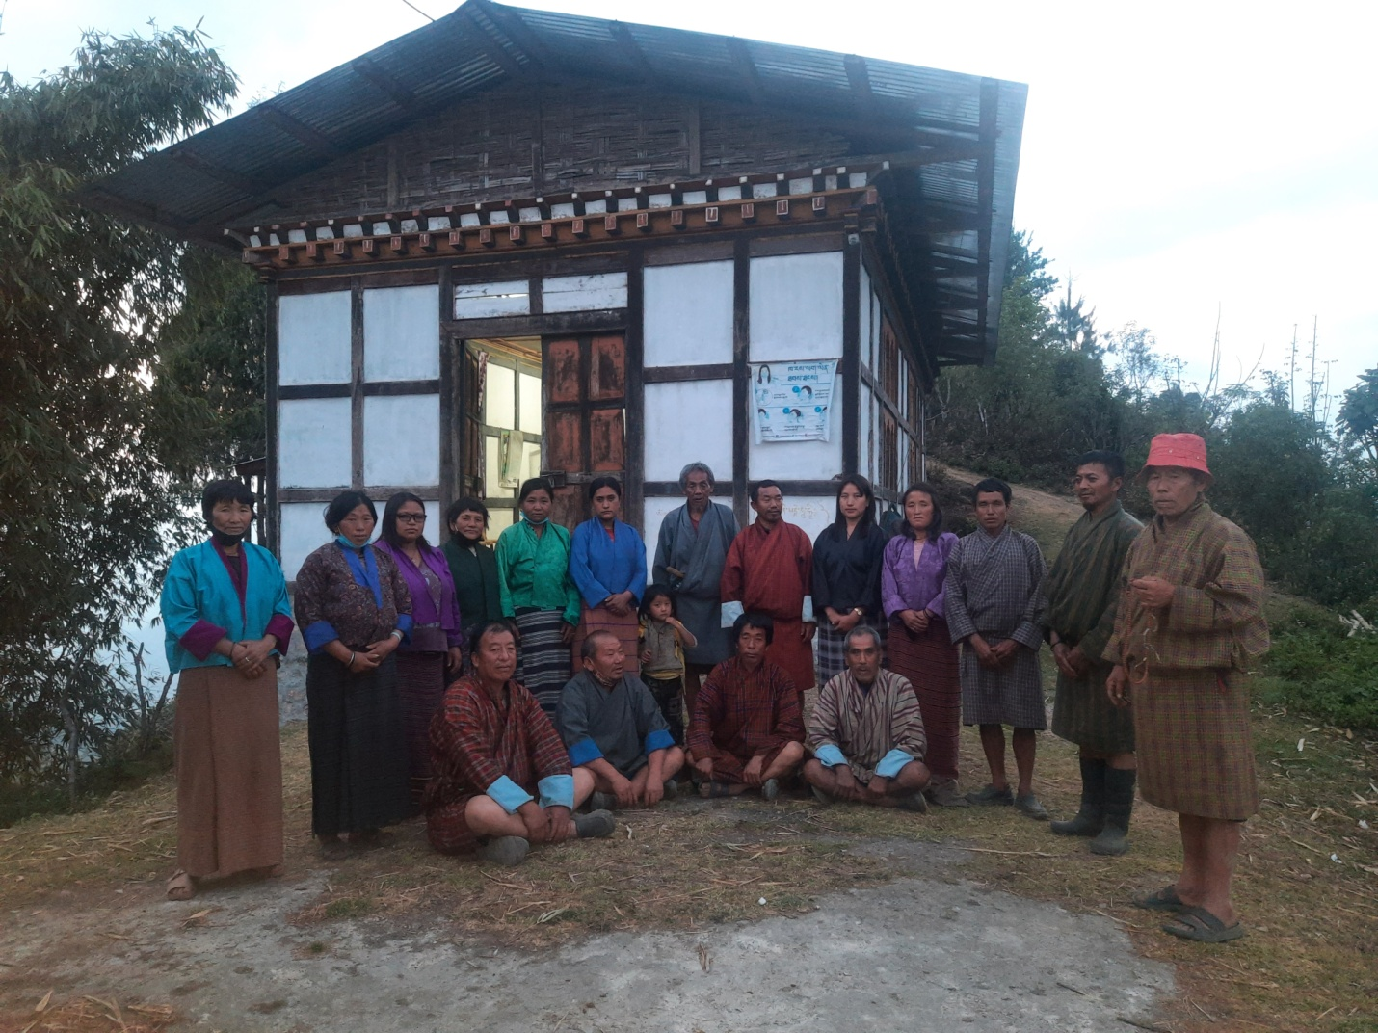
(PLN PERIOD: JUNE 2021-JUNE 2026)

TOKARI AND GAYREE VILLAGE NANONG GEWOG

Contents
PART I: MANAGEMENT PLAN 5
Executive Summary 5
Harvesting prescriptions for sustainable NWFP harvesting 7
Marketing and sales plan 8
Marketing arrangements 9
Part II: By-Laws: Group regulations and norms 15
1. Members of the NWFP management & marketing group 15
Eligibility criteria to become a membership he/she shall: 15
1.2 Admission procedures for new members 15
1.3. Resignation of members 15
1.3.1. Disinterested members: 15
1.3.2 Woman headed/Disability: 15
1.3.3. Dismiss of active member 16
2. Equity of labour contribution and Benefit sharing 16
3. General Assembly 16
4. Committee Members 17
4.1 Criteria to become committee members. 17
4.2 Election procedure for Office bearers: 17
5. Board meeting: 17
6. Terms of Reference for Committee members 17
6.1 Chairman 17
6.2 Secretary 17
6.3 Treasurer 18
7. Resignation of executive members 18
If Chairman resigns due to some unavoidable circumstances; 18
If Secretary/Accountant resigns due to some unavoidable circumstances: 18
8. Termination of Committee members 18
9. Compensation to the committee or any other members involved for marketing 19
10. Membership fee and purpose 19
11. Community development fund and utilization of fund 19
11.1 Source of group Fund: 19
12. Fund management & utilization: 19
13. Offences and Penalties 20
13.1 Penalties for absentee: 20
13.2 Penalties on violation of Harvesting time: 20
13.3 Penalties on violation of Harvesting guidelines: 20
13.4 Marketing. 20
13.5 Non group members: 20
13.6 Penalty for non-payment of fee/fine 20
14. Cash Deposit: 20
15. Non-Listed NWFP’s: 21
16. Conflict resolution 21
NWFP harvesting rules: 22
NWFP Group Member details 25
GLOSSARY AND ABBREVIATIONS 27

List of tables
Table 1: Brief description of NWFPs for commercial harvesting 6
Table 2: Harvesting prescriptions for sustainable harvesting 7
Table 3: Marketing and sales plan (in 5 year) 8
Table 4: Collection area and walking Distance information 10
Table 5: Tokari NWFP collection site with Location name and GPS coordinates 13

List of figures
Figure : Map and area information 11
Figure 2: Map (View of NWFP collection sites with location Name) 12

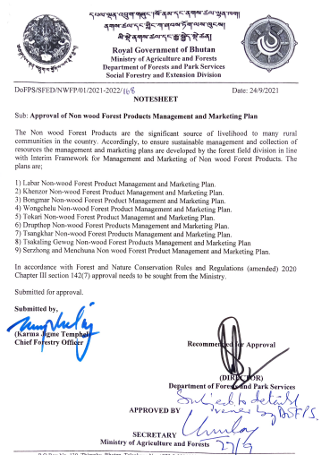

PART I: MANAGEMENT PLAN

Executive Summary
Tokari NWFP Group comprises of 17 interested households from Tokari, Bargonpa, Khedung, Garey, Sengdong and Rashigonpa villages under Nanong gewog in Pemagatshel Dzongkhag. These villages are connected with 13.5km farm road from the Gewog Centre and located at an altitude range of 1300-2000 masl. The community experience heavy rainfall during the monsoon with considerably hot and humid climatic condition favoring growth of diverse NWFPS. The vegetation type is mainly Cool Broadleaved Forest comprising of Quercus sp, Castanopsis sp, Persea sp, Betula and Engelhardia sp with under growth of Daphne sp, Rubia and Swertia sp stands.
Traditionally the people collected NWFP products within their locality and marketed small quantity of their products to generate cash income for their livelihood. In total of 5153 kgs of products collected during last 3 years (2017-2021). Out of which 2934 kgs of Rubia cordifolia sp, 971kgs of Pouzolzia sp and 526 kgs of Swertia sp respectively. The group will have right to collect NWFP products as per the harvesting guidelines prescribed in this management plan termed for five years, ensuring sustainability of resources in the future. The NWFP products mainly Rubia cordifolia (Laniroo), Pouzolzia spp (Yongibu), Swertia chirata (Khaloo) and Edgeworthia gartneri (Daphne) can be collected and marketed yearly during the period of five years. For this very purpose, in total of 430.8 acres of State Reserved Forest Land (SRFL) have been identified, mapped and designated for collection of NWFP Product (s) within their locality. Out of which 197.8 acres of land located at Shinagongri, Menzor, Khandomazor, Khochema and Drupchuri is mapped and identified for Rubia and Pouzolzia collection site. Further, Shinagongri and Menzor also designated for Swertia sp. collection site. Moreover, another 233 acres of SRF land located at Ngangshing is identified and mapped mainly for Daphne collection site.
The natural resources play vital role in day-to-day livelihood of the community. As a result, the NWFP Group formation has become necessary for sustainable management and conservation resources. The objective of NWFP Group is framed as follows:
For sustainable management of NWFP through community participation
Enhance income of the community through sales of NWFP (s)

Table 1: Brief description of NWFPs for commercial harvesting

NWFP name | Collection area  (name) | Parts harvested | Use purpose (traditional & others) | Farm-gate price (Nu) | Estimated quantity that can be collected
Laniroo (Rubia cordifolia) | Shinagongri,  Menzor,  Khandomazor, Khochema and Drupchuri | Stem (Entire plants) | Dye, medicine, incense making | Nu.55/kg | 2934 kg
Yongibu (Pouzolzia Spps) | Shinagongri,  Menzor, Khandomazor, Khochema and Drupchuri | Bark | Incense making, Gum | Nu. 40/kg | 971 kg
Khaloo (Swertia chirayata) | Shinagongri, Bargonpa and Menzor | Entire plant | Medicine | Nu.40/kg | 526 kg
Shogo (Daphne) | Ngangshing | Bark | Paper making, incense making, | Nu. 40 | 1000 kg

Note: NWFPs species that are found in negligible quantity but not described in above table shall be strictly protected by group (e.g; Thugsumpa, Mushrooms, ferns etc)

Harvesting prescriptions for sustainable NWFP harvesting
To harvest NWFP in sustainable basis, group must follow the procedures listed below.

Table 2: Harvesting prescriptions for sustainable harvesting

NWFP species | Harvesting prescription for sustainable harvesting
Laniroo  (Rubia cordifolia) | Use sharp scissor and knife for collection of the upper part of plant (harvesting the plant)  Cut the plant at 5 cm above the ground level  Leave at least 5-10% of plants without collecting/ harvesting for seed plant/ seed dispersal and natural regeneration  Shall collect/harvest only matured ones only without uprooting whole plant.  Shall not collect roots
Yongdiba (Pouzolzia spp) | Cut the plant at 10 cm above the ground level for coppice in next year  Do not collect young plants  Leave 10 % of plants for seed and natural regeneration  Do not collect the roots  Used sharp knife to cut it  Do not damage the remaining young ones including seedling/saplings
Daphne | Harvest/Cut stem above 1ft above ground and shall not harvest those plans which are 1 inch below girth  Use sharp knife to cut it  Do not damage remaining young stands or seedlings  Do not fell surrounding trees un-necessarily to avoid damages
Khalu(Swertia chirayata) | Harvest matured one after fall of seeds for regeneration  Shall not harvest unless seeds fall off completely

Marketing and sales plan

Table 3: Marketing and sales plan (in 5 year)
The marketing and sales plans prepared based on past record of quantity harvested/sold during last 3 years (2017-2021).

NWFP | Potential market | Estimated quantity for sale per season (unit) | Expected price per unit | Total (Nu)
Laniroo(Rubia cordifolia) | Pemagatshel, Samdrup jongkhar, Mongar,  Thimphu, Phuntsholling | 4890 kg | Nu.60/kg | 293400/-
Yongjebu (Pouzolzia Spps) | Pemagatshel, Samdrup jongkhar, Mongar,  Thimphu, Phuntsholling | 1618 kg | Nu. 50/kg | 64720/-
Khaloo (Swertia chirayata) | Pemagatshel, Samdrup jongkhar, Mongar,  Thimphu, Phuntsholling | 876 kg | Nu.40/kg | 35040/-
Shogo (Daphne) | Pemagatshel, Samdrup jongkhar, Mongar,  Thimphu, Phuntsholling | 1000 kg | Nu. 40/kg | 40000/-

Marketing arrangements

The group coordinator (Chairman/other executive member) in consultation with the Gewog Forest Office and Division Office will look for the possible traders for the selling of the NWFP as and when the product is collected and ready for the sale. The concerned authority/agency will consult with the Department of Agriculture Marketing Cooperatives (DAMC) for trading the product if traders are not willing to buy the product, which ensure and encourage the group. The following procedures shall be followed while conducting marketing:
The representative group and Gewog Forest Ranger will carry out the rapid assessment of NWFP available for collection and sell from the forest for two months ahead of collection.
The group members will carry out collection of NWFP products from the designated sites within a particular season (month) based on guidelines prior with obtaining collection permits.
The group will submit report on availability of NWFP products collected and ready for sale to the Division Office through Gewog Forest Office
Division Office will submit a report to the SFES or DAMC
Division in consultation with the group will form cluster and identify group and auction site.
The group will bring the NWFP products to identified auction sites on or one day ahead of conducting auction.
Division in close coordination with the DAMC will identify traders and conduct auction in present of Group coordinators.
Benefit sharing

The NWFP members will collect the NWFPs individually within a particular period (season/months) as reflected in the bylaws and store properly. After segregation of products as per the standard required in the market by the traders, the executive/other members will collect NWFP products from the individual household (Hhs) and transport to their identified auction site. After conduction of auction, the Executive member will deduct all expenditure such as transportation cost, DSA payment (wage rate of PWD-215) to executive/other members evolved in NWFP collection, transportation and auctioning before making final payment to the group. The deduction will be made on percentage (%) wise from the individual household earned money through NWFP products sold in the market. Further, from the eligible payment, 10% of total individual payment will be deducted and deposited into Joint Group account within one week. The balance money will be disbursed individually for income generation to enhance their livelihood. Thus, the individual household as well as group is benefited for income generation through sale of NWFP products.

Table 4: Collection area and walking Distance information

Name of NWFPs | Collection area/Block | Walking distance | Estimated | Total (Nu)
Laniroo (Rubia cordifolia) | Shinagongri,  Menzor,  Khandomazor, Khochema,  Drupchuri | 30 min  30 min  30 min  1 hour  30min | 2934kg | 176040/-
Yongjebu (Pouzolzia Spps) | Shinagongri,  Menzor,  Khandomazor, Khochema, Drupchuri | 30 min  30 min  30 min  1 hour  30 min | 971 kg | 38840/-
Khaloo (Swertia chirayata) | Menzor, Shinagongri | 30 min  2 hours | 526 kg | 21040/-
Shogo (Daphne) | Ngangshing | 1 hours | 1000 kg | 40000/-

Figure : Map and area information
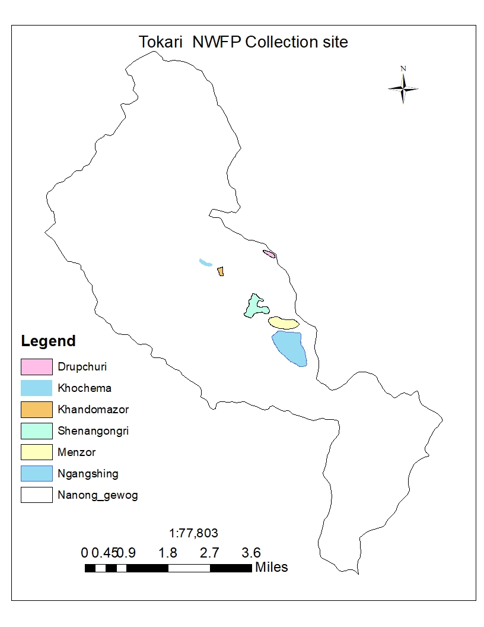

Google Map (View of google map showing Gewog boundary)
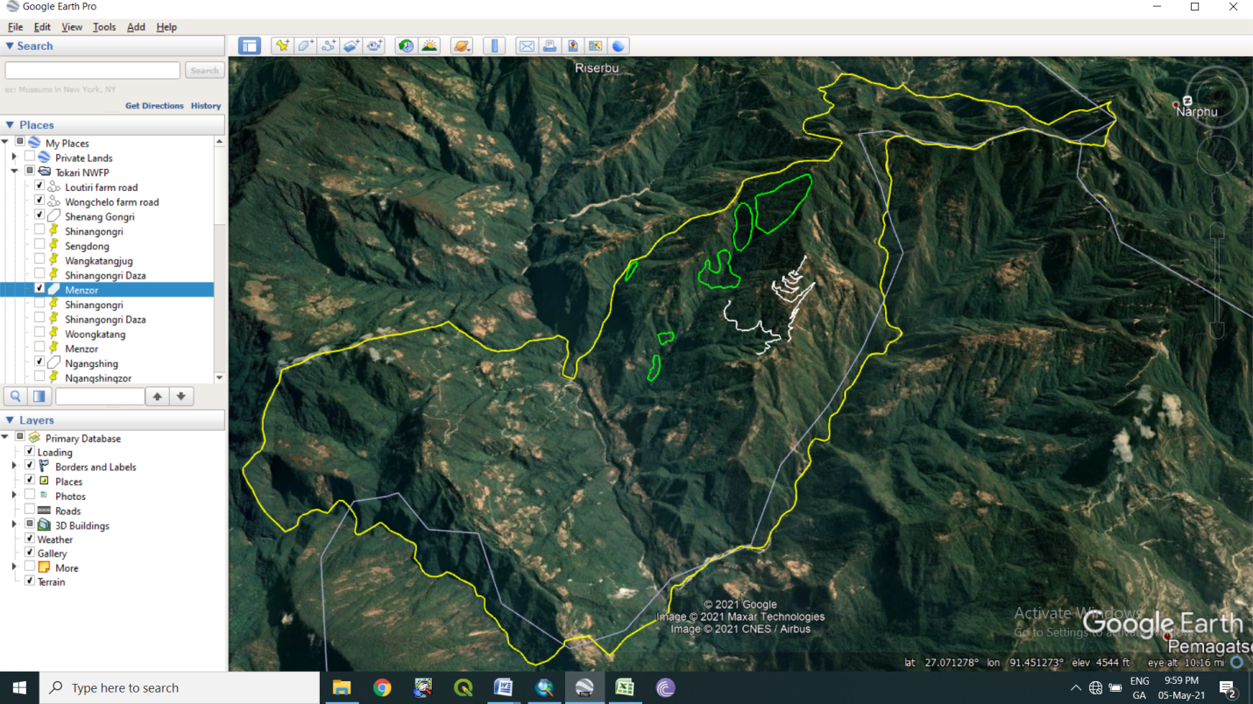

Figure 2: Map (View of NWFP collection sites with location Name)

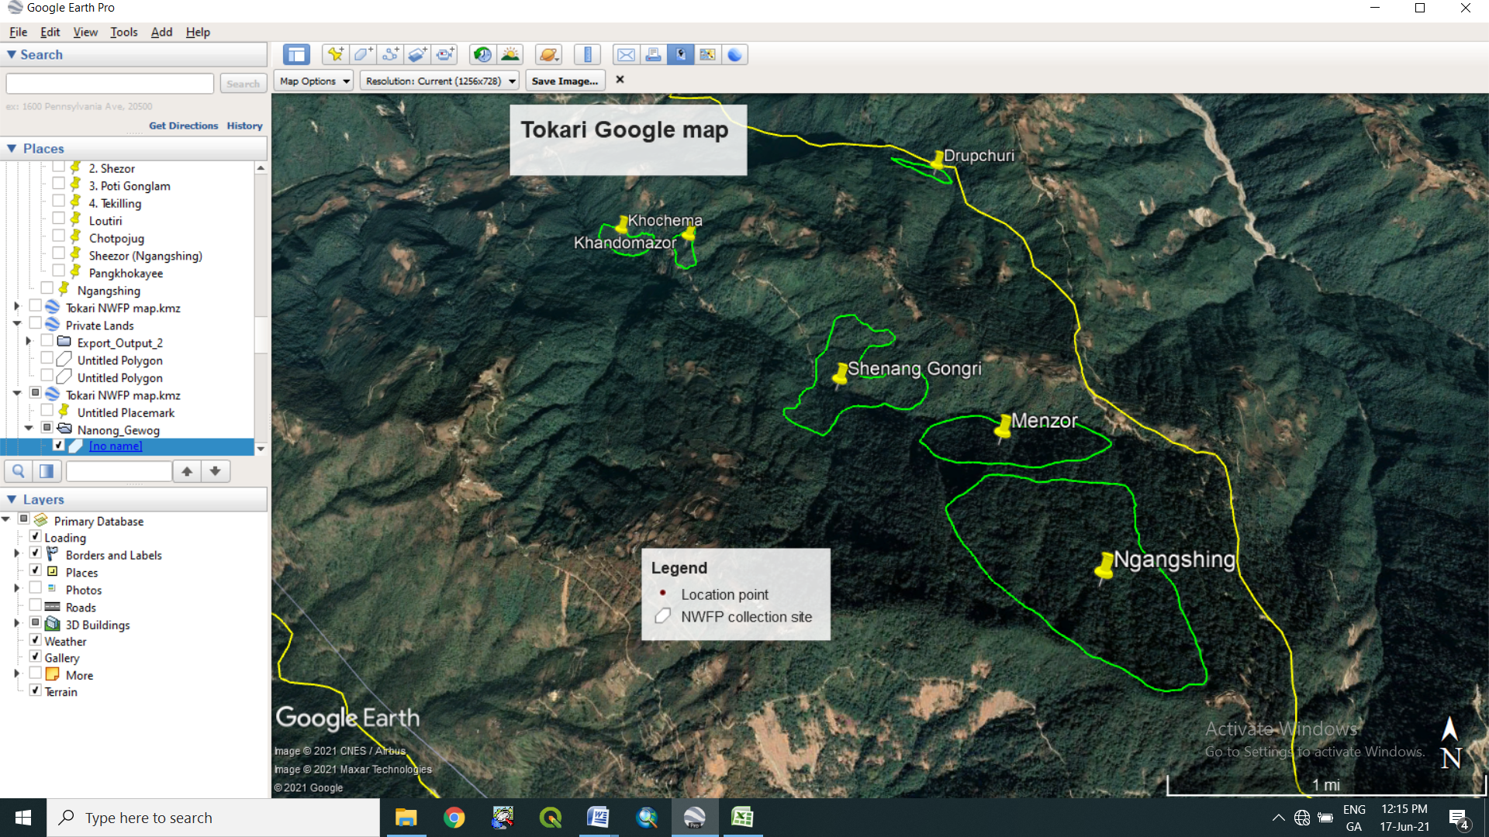

Table 5: Tokari NWFP collection site with Location name and GPS coordinates
Name of NWFP collection site | Area (Acres) | Species | Location point (name) | Northing | Easting | Remarks
Shenang Gongri | 84.1 | Rubia, Pouzolzia &  Swertia sp | Shinang Gongri | 27.099553° | 91.482078°
 |  |  | Sengdong | 27.103734° | 91.484254°
 |  |  | Wongkataongjug | 27.098346° | 91.489711°
 |  |  | Shinangongri | 27.096200° | 91.483350°
Menzor | 77 | Rubia, Pouzolzia & Swertia sp | Shinang Gongri | 27.095685° | 91.494276°
 |  |  | Shinangongri Daza | 27.095297° | 91.489143°
 |  |  | Woongkatang | 27.093548° | 91.499577°
 |  |  | Menzor | 27.092850° | 91.493203°
Ngangshing | 233 | Daphne | Ngangshingzor | 27.080907° | 91.502141°
 |  |  | Tshewang Poktor | 27.082796° | 91.496425°
 |  |  | Tagonpa | 27.091235° | 91.500212°
 |  |  | Menzor | 27.090225° | 91.490309°
Khandomazor | 10.7 | Rubia and Pouzolzia | Shingphunjug | 27.111310° | 91.471834°
 |  |  | Khandomayee | 27.109408° | 91.473603°
 |  |  | Yezoma | 27.112176° | 91.473447°
 |  |  | Shingphung | 27.111015° | 91.473486°
Khochema | 14.1 | Rubia and Pouzolzia | Leburijug | 27.112725° | 91.470046°
 |  |  | Shinangongri | 27.112419° | 91.467901°
 |  |  | Tshori | 27.114802° | 91.465614°
 |  |  | Khedong | 27.113484° | 91.467966°
Drupchuri | 11.9 | Rubia and Pouzolzia | Satsalupoktor | 27.115859° | 91.489303°
 |  |  | Monphuri | 27.115098° | 91.491817°
 |  |  | Monphurijug | 27.116839° | 91.490021°
 |  |  | Dupchuri | 27.117242° | 91.487526°
Total | 430.8

Part II: By-Laws: Group regulations and norms

Members of the NWFP management & marketing group

Eligibility criteria to become a membership he/she shall:

- be from same village (mention above) with proper Gung & Thram
- be interested to abide by the By-laws of the group
- willing to deposit the sum equivalent to individual share accumulated in bank at the time of he/she is joining (including membership fee, labour contribution and NWFP products sold)

1.2 Admission procedures for new members
- Registration of new members shall follow the following procedures:
- shall fulfil above eligibility criteria to become a membership conditions & may apply registration application to the Chairman
- chairman shall discuss during general meeting for acceptance or rejection of member shall be based on general consensus of existing members (Simple majority)
- After payment of the sum of amount (stated above) and register as member thereafter.

1.3. Resignation of members

1.3.1. Disinterested members:
- Any members resigning from group due to loss of interest shall follow the following procedures:
- shall apply resignation application to the Chairman
- chairman shall discuss the matter during general meeting and acceptance or rejection shall be based on general consensus of existing members (Simple majority)
- resignation shall be without any benefit from group

1.3.2 Woman headed/Disability:
- If misfortune transpire to any group member and he/she desires to resign from group shall apply an application to the Chairman:
- chairman shall discuss about it during general meeting
- acceptance shall be based on general consensus of existing members (Simple majority)
- shall clam 70% individual share from saving amount and shall resign from group

1.3.3. Dismiss of active member
- He/she passed away/dismissed due to certain problem/some unavoidable circumstance(disaster/sickness), any of his/her family member can be replaced
- Otherwise, he/she is eligible to get 70% of his/her shared accommodate in the joint account at the time of he/she resigned.

Equity of labour contribution and Benefit sharing
- To have equity and justice on labour contribution and allocation of products, the members shall follow the following system:
- Group members shall be informed about the harvesting time from particular season by the chairman /individual member within themselves and seek/obtain collection permit from the GFO.
- Harvesting shall be done together at the particular season for a particular period based on NWFP harvesting rules (given months).
- Interested group members (Only one member from one registered gung shall be allowed for collection) shall collect.
- Product collected shall belong to the NWFP Group recorded with individual names (Collectors)
- Any of the executive members shall keep track/record of NWFP collected on daily/monthly basis until till given time period for NWFP collection ended
- Any group member without sale of products minimum of 4 kgs and below (in group fund) shall bear/pay sum of Nu.300/-annually
- Group shall not have any rights over soil, stone, boulders etc. from their NWFPs collection area except permitted by FNCR.

General Assembly
- The general assembly meets at least once a year. The chairman calls for the general assembly by a week before in advance, furnishing the points of the agenda of the meeting:
Month: December
Date: Any announced date
Time: 9:00am
Venue: Tokari ORC
Agenda: Group progress report, fund read out and discuss other important issues.
(Responsibilities and rights are for example: Permitted to harvest and market NWFPs as per this plan)

Committee Members
Name | Designation | Gender | Phone
Tshering Wangdi | Chairperson | Male | 17631533
Kin Gyeltshen | Secretary: | Male | 17665507
Jangchu Dorji | Treasurer | Male | 17758979

4.1 Criteria to become committee members.
- He/she shall be
- Loyal, dedicative and sincere to group
- Literate person
- Approachable
- Truthful
- Maintain good relationship with others

4.2 Election procedure for Office bearers:
- He/She shall fulfil above criteria
- Election shall be based on general consensus by members during annual meeting (Simple majority).

Board meeting:
- Executive members shall have assembly as and when required as per command from chairman/GFEO and also once before the general meeting.

Terms of Reference for Committee members

6.1 Chairman
Responsibilities of Chairman:
- To chair all meetings related to this agreement
- To resolve disputes and conflicts among members
- To maintain contacts with traders
- To inform the group members on the date and venue for marketing, meeting etc.
- To coordinate the sale of collected NWFPs to the traders on the agreed dates and venues between traders and communities
- To ensure that a management plan is developed in the coming years with support of the District Forestry Services

6.2 Secretary
Responsibilities of Secretary:

- To support Chairman and Treasurer
- To convene the meeting in absence of Chairman
- To make records of meeting minutes
- To maintain record of NWFP collected
- To prepare a final report showing the NWFP quantities collected & sold per household, the buying price and details about the traders who bought the produce

6.3 Treasurer

- Responsibilities of Treasurer:
- To maintain cash transaction records
- To collect membership fees and take care of financial arrangements
- To read out cash balance during general meeting
- To collect fines and penalties

Resignation of executive members

If Chairman resigns due to some unavoidable circumstances;
- He shall apply an application of resignation to Secretary.
Secretary shall read out during general meeting.
- From the date of acceptance (simple majority) of resignation by group members, he shall participate as group member thereafter.

If Secretary/Accountant resigns due to some unavoidable circumstances:
- He/she shall apply resignation application to Chairman.
Chairman shall read out during general meeting.
From the date of acceptance (simple majority) of resignation by group members, he shall participate as group member.

8. Termination of Committee members

- Office bearers shall be dismissed, if he/she is accused of fraud or financial malpractices of group fund;
- He shall repay the amount within a month from the date of knowledge by any members with 10% fine of that amount and he shall vacate his post.
- Even after one month, if he refuses to repay the amount and fine, he shall be dealt through By-law of Conflict resolution

Compensation to the committee or any other members involved for marketing
- Any Committee or other member(s) who actively involved in monitoring of NWFP collection, transportation and marketing representing their NWFP Group, he/she is entitle for
- Payment of DSA equivalent to national wage rate (215/day).
- DSA payment will be made from the every individual whose NWFP sold in the market by deducting in percentage (%) wise.

Membership fee and purpose
- A sum of Nu. 100 per household shall be collected annually by the treasurer and deposit in the bank
- Any member whose NWFP collection is 4kg and below in quantity, he/she shall pay Nu. 100 per household annually and that member(s) who do not collect any NWFP products at all shall pay Nu. 300 per household annually.

Community development fund and utilization of fund

Source of group Fund:

Membership fee shall be collected annually during the general assembly by Accountant – Sum of Nu.100/- per H/H

From the sale of products
- 10% of the amount earned from sale of NWFPs shall be deposited to group fund by all the collected members.
- Any group member without any sale of products (in group fund) within a year shall bear/pay the sum of Nu.300/- annually. However, any group member whose collection is less than 4k in quantity shall pay Nu. 100 per member annually.

Fund management & utilization:
- For this management plan period, fund collected will be deposited to the Bank.
- Any group member travelling for group purpose shall claim the expended amount from the group with verified bills,
- Bill shall be forwarded to Geog Forestry for verification.
- Payment shall be done during general meeting, after discussing with members.
- Audit: Any members shall do auditing of financial matter at the time of suspect.

Offences and Penalties

13.1 Penalties for absentee:
- If any member does not turn up for meeting, he/she shall pay Nu.100 as fine per occasion
- If any member not attending meeting for three times consecutively, shall be dismissed from group without any benefit. Except for the gung tong.

13.2 Penalties on violation of Harvesting time:
- Any member violating harvesting time (collecting before starting & after time) shall bear the fined of Nu.10% of the total amount of NWFP collected by individual and confiscated the product by group.

13.3 Penalties on violation of Harvesting guidelines:
- Any members violating harvesting guidelines shall be fined with Nu.50% of market value of that product collected.
- If more than one member from registered gung collects the product, all the collected products by members of same gung shall be confiscated by group.

13.4 Marketing.
- If any member is not marketing in group, shall be fined with 50% of the products marketed.

13.5 Non group members:
- Any non-members collecting the NWFPs for marketing without harvesting permit from designated group areas shall be considered as illegal activities of group property, whether from his registered land or GRF and shall confiscate the collected product and shall be fined with Nu. 500/-.

13.6 Penalty for non-payment of fee/fine
- Any members not willing to pay fine/penalty/membership fee within 10 days from fixed date, shall be deemed as offence and shall be fined with Nu.25% of the amount. And even if member is not willing to pay within that year, shall be dismissed from group without any benefit.

Cash Deposit:
- If committee members do not deposit collected cash within 30 days, shall fine with Nu.10% of the amount per month.

Non-Listed NWFP’s:
- Any non-listed NWFPs but grown within group demarcated area shall be protected by the group, and collection of these products shall be deemed as illegal activities and shall be fined with Nu.50% of market value of collected products and also confiscated the collected product by group.

Conflict resolution

- In case disputes or conflicts among communities arise about access to certain areas for NWFP harvesting; the matter shall be put to the Geog Tshogchung (GT) Dzongkhag Tshogdue (DT) for further decision.

- Conflicts or disputes within the NWFP Management Group, which cannot be resolved by the group members shall be forwarded to the Coordinator for settlement. If the case cannot be resolved, it shall be forwarded to the Geog Administration.

- In case there is a conflict between the NWFP Group and outsiders, the case shall be forwarded to the DFO and Geog Administration by the Coordinator.

NWFP harvesting rules:

Sl No | Name |  | Part(s) used | Purpose | Time of harvesting | Guidelines for harvesting | Remarks
 | Scientific | Local
1 | Rubia cordifolia | Lanyi-roo (Sha) | Entire plant | Dye, Medicine | February to April | Upper part of the plant will be collected using sharp scissor.  Cut plant 5 cm above ground level.  Retain at least 10% of the plants to enhance natural regeneration  Do not uproot entire plants  Do not collect roots.
2 | Pouzolzia spp | Yongjebu (Sha) | Bark | Ingredients for incense making | October to April | Cut plant at 10 cm above the ground(the left stump will coppice in the following growing season)  Do not damage the remaining young stands/seedlings/saplings  Felling of surrounding trees to ease harvesting is prohibited  Leave at least 10 % of the plant to allow natural regeneration  Collection of roots is strictly prohibited for ecological reasons.
3 | Swertia chirayita | Chirata (San) | Entire plant | Medicine | November to January | Collection only after seed dispersal commenced.  To avoid high risk of damaging germination, collection should not be done in late season (February)  Right time for harvesting will be announced by GFEO or Co-coordinator who has the knowledge of collection date. | Guidelines for resource assessment & management.  ( FRDD’08)
4 | Edgeworthia gardneria | Dheykap (Dzo) | Bark | Paper making | March to June | Cut stems that are more than 3 cm in diameter.  Do not damage the young stands, seedlings and sapling.  To ease harvesting, do not fell the surrounding trees  Dividing in to 6 blocks, the harvesting will take place rotationally in these blocks ones in a year.
3 | Juglan regia | Tago (Dzo) | Fruit | Eating fruit | September to October | Harvesting based on local management system.  Retain seeds for regeneration  Regeneration through seed.
4 | Castonopsis spps. | Tshatshe (Sha) | Fruit | Delicious Nut | October to November | Harvesting rule based on local management system.  Regeneration through seed dispersal by birds
5 |  | Shingmar | Fruit | Oil | July-Sept | Cut small branches  Leave one third of the branches  DO not fell trees
6 |  | Thingkagpoo | Fruit | - | Oct-Nov | Hand picking  Do not fell trees

NWFP Group Member details

Membership registration
Sl. No | Date | Name | Address | CID No | Signature or thump print
1 | 10-04-21 | Tshering Wangdi | Gayrey | 11508003889
2 | 10-04-21 | Jangchu Dorji | Gayrey | 11508002963
3 | 10-04-21 | Yeshi Choden | Gayrey | 11508001670
4 | 10-04-21 | Tshering Dorji | Geshingzor | 11508003108
5 | 10-04-21 | Tenzin Wangdi | Khedong | 11508001625
6 | 10-04-21 | Tshering Zangmo | Moyong | 11508003055
7 | 10-04-21 | Dawa Norbu | Moyong | 11508003095
8 | 10-04-21 | Pema Jamtsho | Moyong | 11508003096
9 | 10-04-21 | Norbu | Moyong | 11508003017
10 | 10-04-21 | Nungkuu | Rashi Gonpa | 11508003032
11 | 10-04-21 | Kin Gyeltshen | Rashi Gonpa | 11508003137
12 | 10-04-21 | Yangzom | Rashi Gonpa | 11508002980
13 | 10-04-21 | Nidup Zamgmo | Rashi Gonpa | 11508002995
14 | 10-04-21 | Leki Wangmo | Sengdong | 11508003116
15 | 10-04-21 | Sherub Gyeltshen | Tokarey | 11508003822
16 | 10-04-21 | Sonam | Tokarey | 11508003831
17 | 10-04-21 | Cheten Dorji | Tokarey | 11508003844

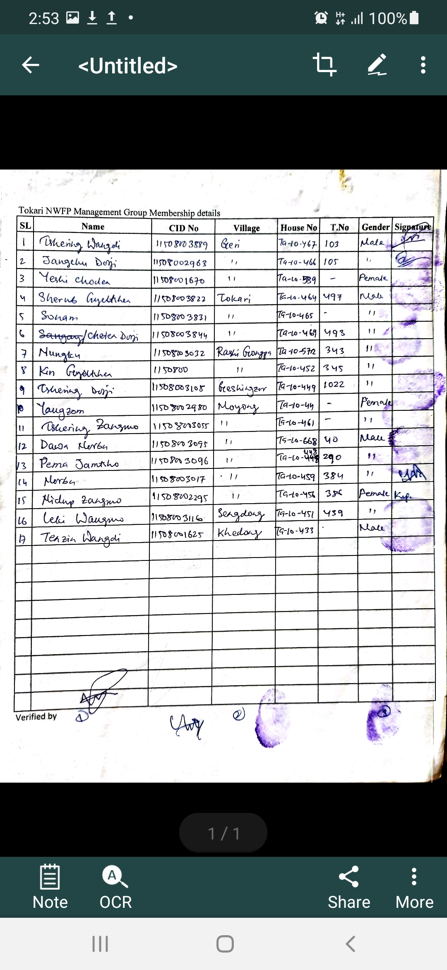

GLOSSARY AND ABBREVIATIONS

CFD Community Development Fund
CFO Chief Forest Officer
DAMC Department of Agriculture Marketing Cooperatives
DFO Divisional Forest Office
DoFPS Department of Forests and Park Services
DT Dzongkhag Tshogdue
GFO Gewog Forest Office
GFR Gewog Forest Ranger
GT Gewog Tshogdue
HHs Households
NTFPs Non-timber Forest Products
NWFPs Non Wood Forest Products
SRFL State Reserved Forest Land
ToR Terms of Reference

