WONGCHELO NON-WOOD FOREST PRODUCT MANAGEMENT PLAN

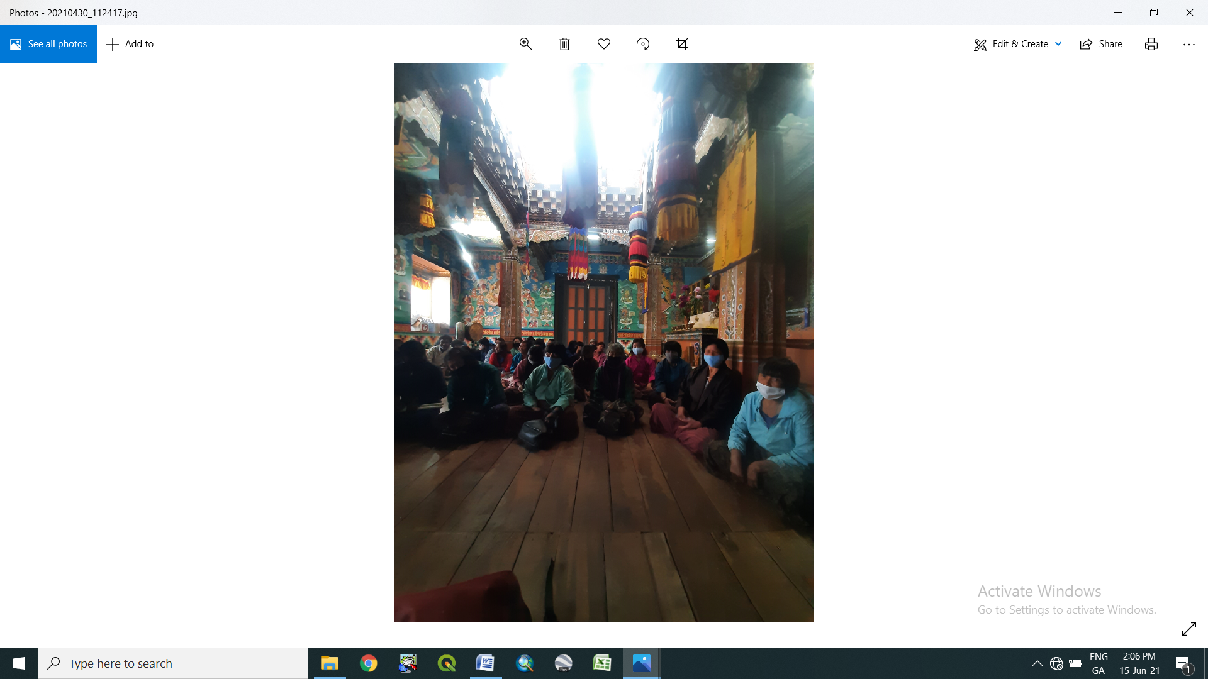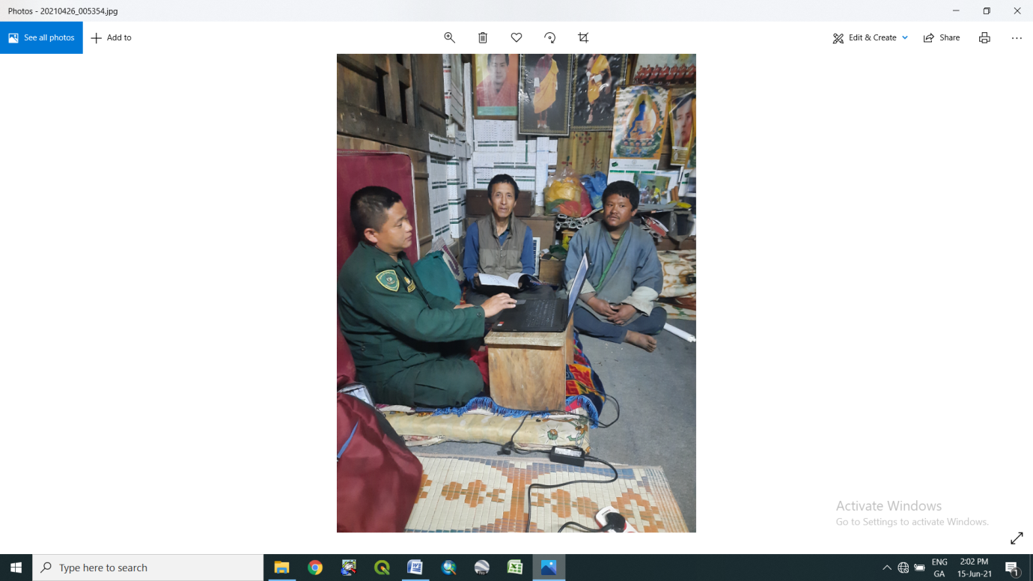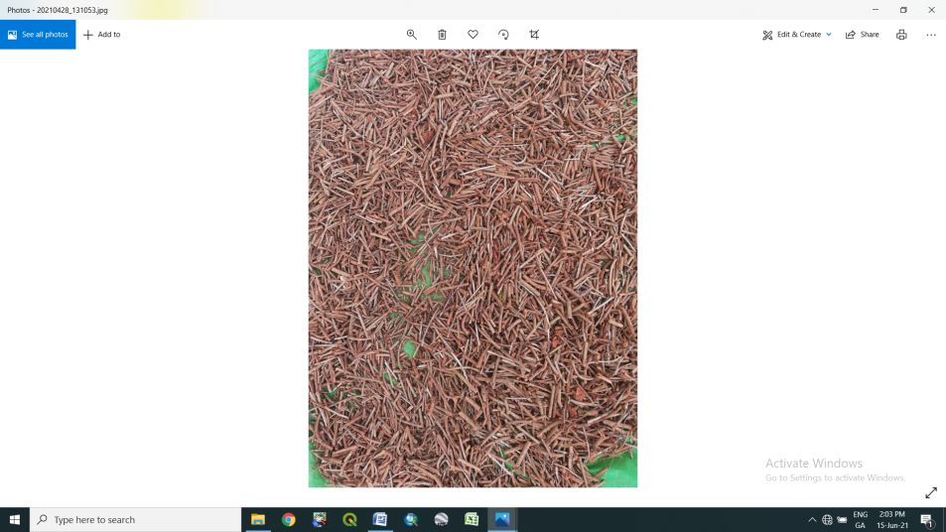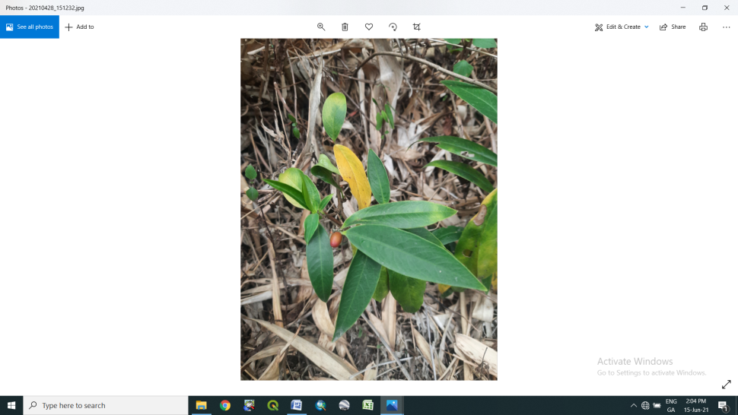

WONGCHELO, GAYREE AND TEPHU VILLAGE
NANONG GEWOG Plan Period: June 2021-June 2026)

Contents
Executive Summary 5
Harvesting prescriptions for sustainable NWFP harvesting 6
Marketing and sales plan 7
Marketing arrangements 8
Benefit sharing 8
Part II: By-Laws: Group regulations and norms 13
1. Members of the NWFP management & marketing group 13
1.1 Eligibility criteria to become a membership he/she shall: 13
1.2 Admission procedures for new members 13
1.3. Resignation of members 14
1.3.1. Disinterested members: 14
1.3.2 Woman headed/Disability: 14
1.3.3. Dismiss of active member 14
2. Equity of labour contribution and Benefit sharing 14
3. General Assembly 15
4. NWFP group Committee Members 15
4.1 Criteria to become committee members. 15
4.2 Election procedure for Office bearers: 15
5. Board meeting: 16
6. Terms of Reference for Committee members 16
6.1 Chairman 16
6.2 Secretary 16
6.3 Treasurer 16
7. Resignation of executive members 16
7.1 If Chairman resigns due to some unavoidable circumstances; 16
8. Termination of Committee members 17
9. Compensation to the committee or any other members involved for marketing 17
10. Membership fee and purpose 17
11. Community development fund and utilization of fund 17
11.1 Source of group Fund: 18
11.2 Membership fee: 18
11.3 From the sale of products 18
12. Fund management & utilization: 18
13. Offences and Penalties 18
13.1 Penalties for absentee: 18
Penalties on violation of Harvesting time: 18
13.2 Penalties on violation of Harvesting guidelines: 18
14. Marketing. 19
14.1 Non group members: 19
14.2 Penalty for non-payment of fee/fine 19
15. Cash Deposit: 19
16. Non-Listed NWFP’s: 19
17. Conflict resolution 19
GLOSSARY AND ABBREVIATIONS 29

List of figures

Figure 1: map and area information 10
Figure 2: google map (view of overall area showing gewog boundary) 11

List of tables
Table 1: Brief description of NWFP for commercial harvesting 6
Table 2: Harvesting prescriptions for sustainable harvesting 6
Table 3: Marketing and sales plan 7
Table 4: Collection site information with walking distance 9
Table 5: Wongchelo NWFP collection site and area information 12
Table 6: list of committee members 15
Table 7: NWFP harvesting rules: 21
Table 8: Membership details 24

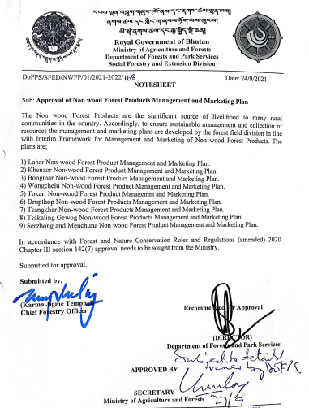

Executive Summary

Wongchelo Chigthuen Tshogpa (NWFP Group) is formed comprising of 54 interested households from three villages namely Wongchelo, Garrey and Tephu under Nanong Gewof in Pemagatshel Dzongkhag. The community is connected with farm road measuring 14.5km distance from the Centre. The altitude ranges between 1300-2000 m.a.s.l and experiencing considerably hot and humid climatic condition during summer, cold and dry during winter. The vegetation type is mainly Cool broadleaved forest comprising of Alnus sp, Engelhardia sp, Betula, Persea sp, Castanopsis sp, Albezia and Quercus sp with Rhus and Chimonobambusa sp (Large bamboo) stands.

The NWFP products mainly Rubia cordifolia (Laniroo), Pouzolzia spp (Yongibu), Swertia chirata (Khaloo) and Edgeworthia sp (Daphne) can be collected and marketed yearly. For this very purpose, in total of 600.24 acres (242.91ha) of land has been identified, mapped and designated for NWFP collection site within their locality in line with their traditional right for collection of natural resources. Out of which 345.54 acres (139.83 ha) of State Reserved Forest Land (SRFL) located at Menzor Yekatang, Chothpojug and Shezor is mainly for collection of Daphne sp and Swertia sp. Whereas 210.54 acres of Private Registered Land (PRL) located at Loutiri and Pangkhokayee is for collection of Rubia and Pouzolzia sp. As the private land holders are also the members of the NWFP Group and they mutually agreed to collect NWFP within their registered land as per the procedures in SRF land.

The natural resources play vital role in the day-to day livelihood of the community through income generation from sale of excess resources. The Wongchelo Chithuen Tshogpa NWFP Group formation has come up with utmost thought and inspiration for sustainable management and conservation resources. The objective of NWFP Group is outlined and highlighted as following

- To strengthen the sustainable management of NWFP through community participation
- Enhance income generation to community through sales of NWFP (s)

Table 1: Brief description of NWFPs for commercial harvesting

NWFP name | Collection area  (name) | Parts harvested | Use purpose (traditional & others) | Farm-gate price (Nu) | Estimated quantity that can be collected
Laniroo (Rubia cordifolia) | Pangkhokayee, Wongchelo Geri, Loutiri and Kolopowong | Stem (Entire plants) | Dye, medicine, incense making | Nu.55/kg | 1800 kg
Yongibu (Pouzolzia Spps) | Pangkhokayee, Wongchelo Geri, Loutiri and Kolopowong | Bark | Incense making, Gum | Nu. 40/kg | 800 kg
Khaloo (Swertia chirayata) | Shezor, Ngangshing, . Shezor, Poti Gonglam and Tekilling | Entire plant | Medicine | Nu.40/kg | 800 kg
Shogo (Daphne) | Menzor Yekatang, Menzor, Wongchelo, Zhudangshingthangkha, Chotphu Dangka | Bark | Paper making, incense making, | Nu. 40 | 2000 kg

Note: NWFPs species that are not described in above table but found in designated area, shall be strictly protected by group (e.g; Thugsumpa, Mushrooms, ferns etc)

Harvesting prescriptions for sustainable NWFP harvesting

To harvest NWFP through Sustainable basis, group must follow the procedures listed below.

Table 2: Harvesting prescriptions for sustainable harvesting

NWFP species | Harvesting prescription for sustainable harvesting
Laniroo  (Rubia cordifolia) | - Use sharp scissor and knife for collection of the upper part of plant (harvesting the plant)  - Cut the plant at 5 cm above the ground level  - Leave at least 5-10% of plants without collecting/ harvesting for seed plant/ seed dispersal and natural regeneration  - Shall collect/harvest only matured ones only without uprooting whole plant.  - Shall not collect roots
Yongdiba (Pouzolzia spp) | - Cut the plant at 10 cm above the ground level for coppice in next year  - Do not collect young plants  - Leave 10 % of plants for seed and natural regeneration  - Do not collect the roots  - Used sharp knife to cut it  - Do not damage the remaining young ones including seedling/saplings
Daphne | - Harvest/Cut stem above 1ft above ground and shall not harvest those plans whose girth are below 1 inch.  - Use sharp knife to cut it.  - Do not damage remain young stands or seedlings  - Do not fell surrounding trees un-necessarily to avoid damages
Khalu(Swertia chirayata) | - Harvest matured one after fall of seeds for regeneration  - Shall not harvest unless seeds fall off completely

Marketing and sales plan

The marketing and sales plans prepared based on past record of quantity harvested/sold during last 3 years (2017-2021).

Table 3: Marketing and sales plan

NWFP | Potential market | Estimated quantity for sale per season (unit) | Expected price per unit | Total (Nu)
Laniroo(Rubia cordifolia) | Pemagatshel, Samdrup jongkhar, Mongar,  Thimphu, Phuntsholling | 1800 kg | Nu.60/kg | 108000/-
Yongjebu (Pouzolzia Spps) | Pemagatshel, Samdrup jongkhar, Mongar,  Thimphu, Phuntsholling | 800 kg | Nu. 50/kg | 40000/-
Khaloo (Swertia chirayata) | Pemagatshel, Samdrup jongkhar, Mongar,  Thimphu, Phuntsholling | 800 kg | Nu.40/kg | 40000/-
Shogo (Daphne) | Pemagatshel, Samdrup jongkhar, Mongar,  Thimphu, Phuntsholling | 2000 kg | Nu. 40/kg | 80000/-

Marketing arrangements

The group coordinator (Chairman/Committee members) in consultation with the traders, Gewog Forest Office and Division Office will look for the possible traders for the sale of the NWFP when the product is collected and ready for the sale. The concerned authority/agency will consult with the Department of Agriculture Marketing Cooperatives (DAMC) for trading the product if traders are not willing to buy the product.
The following procedures shall be followed while conducting marketing:
The representative group and Gewog Forest Ranger will carry out the preliminary assessment of NWFP available for collection from the designated forest, two months ahead of collection season.
The group members will carry out collection of NWFP products from the designated sites within a particular season (month) upon obtaining collection permits and strictly adhering with the guidelines.
The Committee members will compile and submit report on availability of NWFP collected to the NWFP strategy committee through Gewog Forest Office to prepare for auctioning.
Division in collaboration with the DAMC, traders and NWFP committee members to fix date and identify strategic location for auction.
The group will bring the NWFP products to identified auction sites on or one day ahead of conducting auction.
Division in close coordination with the DAMC will identify traders and conduct auction in presence of Group coordinators.

Benefit sharing

The NWFP members will collect the NWFPs individually within a particular period (season/months) as reflected in the By-Laws and store properly. After segregation of products as per the standard required in the market. The committee members will collect NWFP products from the individual household (Hhs) and transport to their identified auction site. After conduction of auction, the Committee member will deduct all expenditure such as transportation cost, DSA payment (National wage rate 215/day) to members involved in NWFP collection, transportation and auctioning. The percent of expenditure incurred will be deducted from the individual based on quantity of products sold. Further, 10% of total individual income will be deducted and deposited into Group Joint account within one week. The balance income will be utilized for individual benefit to enhance their livelihood.

Table 4: Collection site information with walking Distance

Name of NWFPs | Collection area/Block | Walking distance | Estimated | Total (Nu)
Laniroo  (Rubia cordifolia) | Pangkhokayee, Wongchelo Geri,  Loutiri  Kolopowong | 30 min  30 min  30 min  30min | 1800 kg | 108000/-
Yongjebu  (Pouzolzia Spps) | Pangkhokayee, Wongchelo Geri,  Loutiri  Kolopowong | 30 min  30 min  30 min  30 min | 800 kg | 40000/-
Khaloo  (Swertia chirayata) | Ngangshing  Shezor  Poti Gonglam  Tekilling | 1 hour  1 hour  30min  30 min | 800 kg | 40000/-
Shogo (Daphne) | Menzor Yekatang, Wongchelo  Zhudangshingthangkha, Chotphu Dangka | 1 hour  30 min  45 min  30 min | 2000 kg | 80000/-

Figure 1: Map and area information
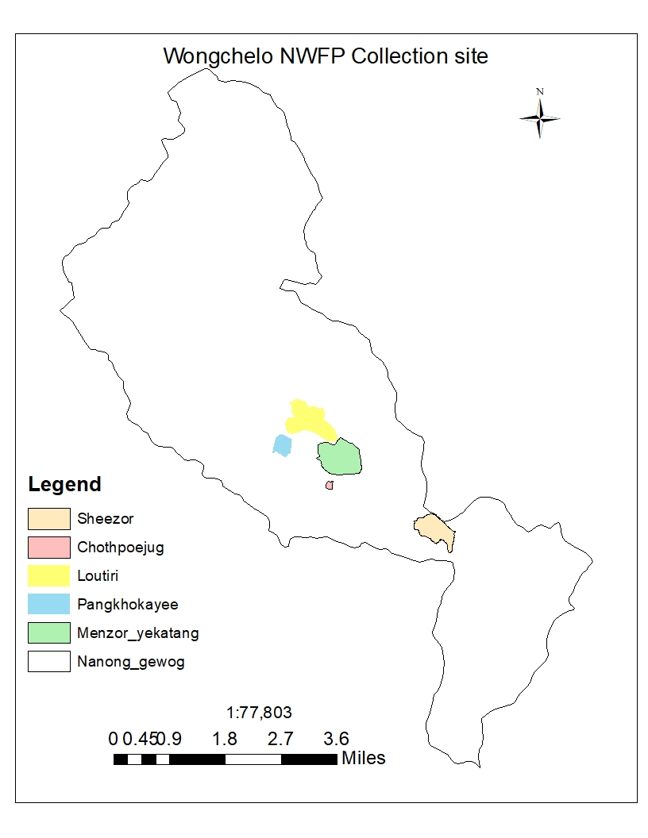

Figure 2: Google Map (View of overall area showing Gewog Boundary)

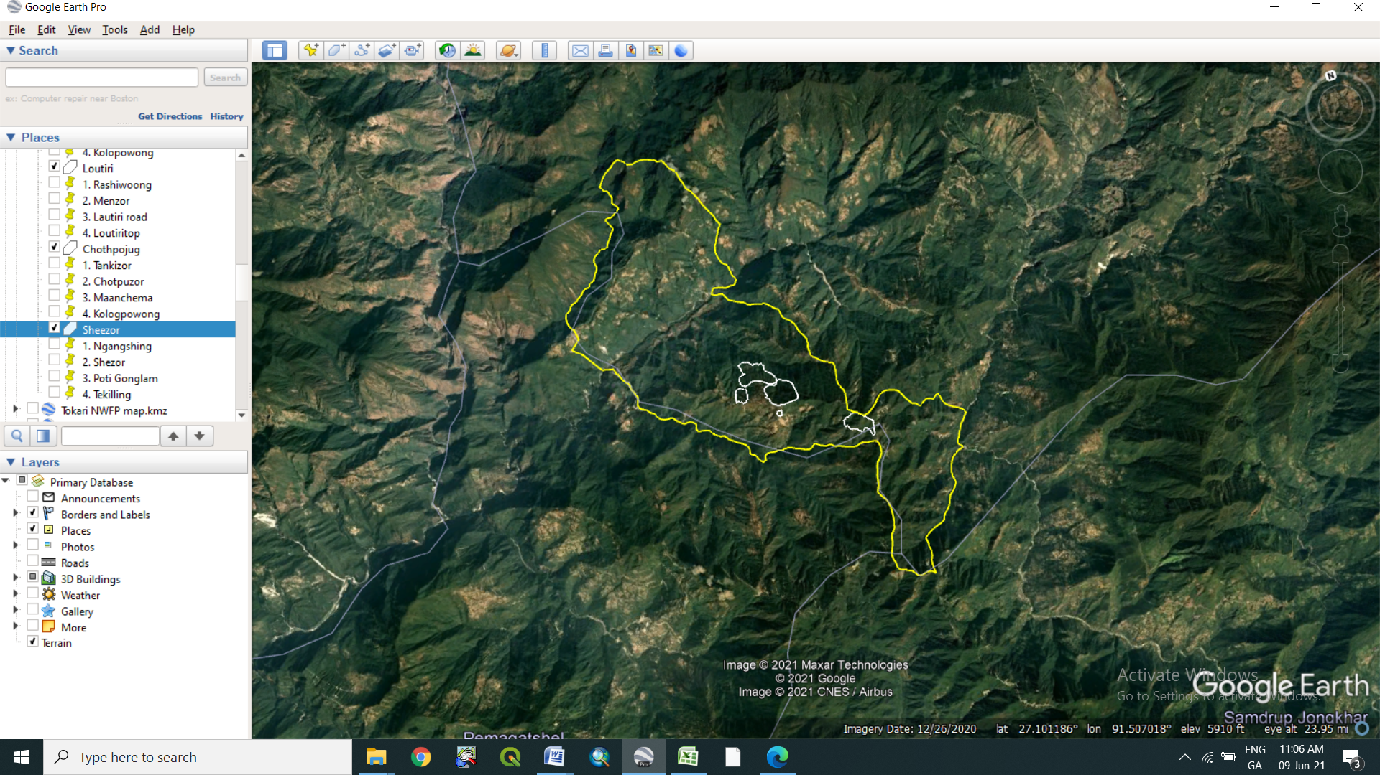
Google Map (View of NWFP collection sites with location Name)
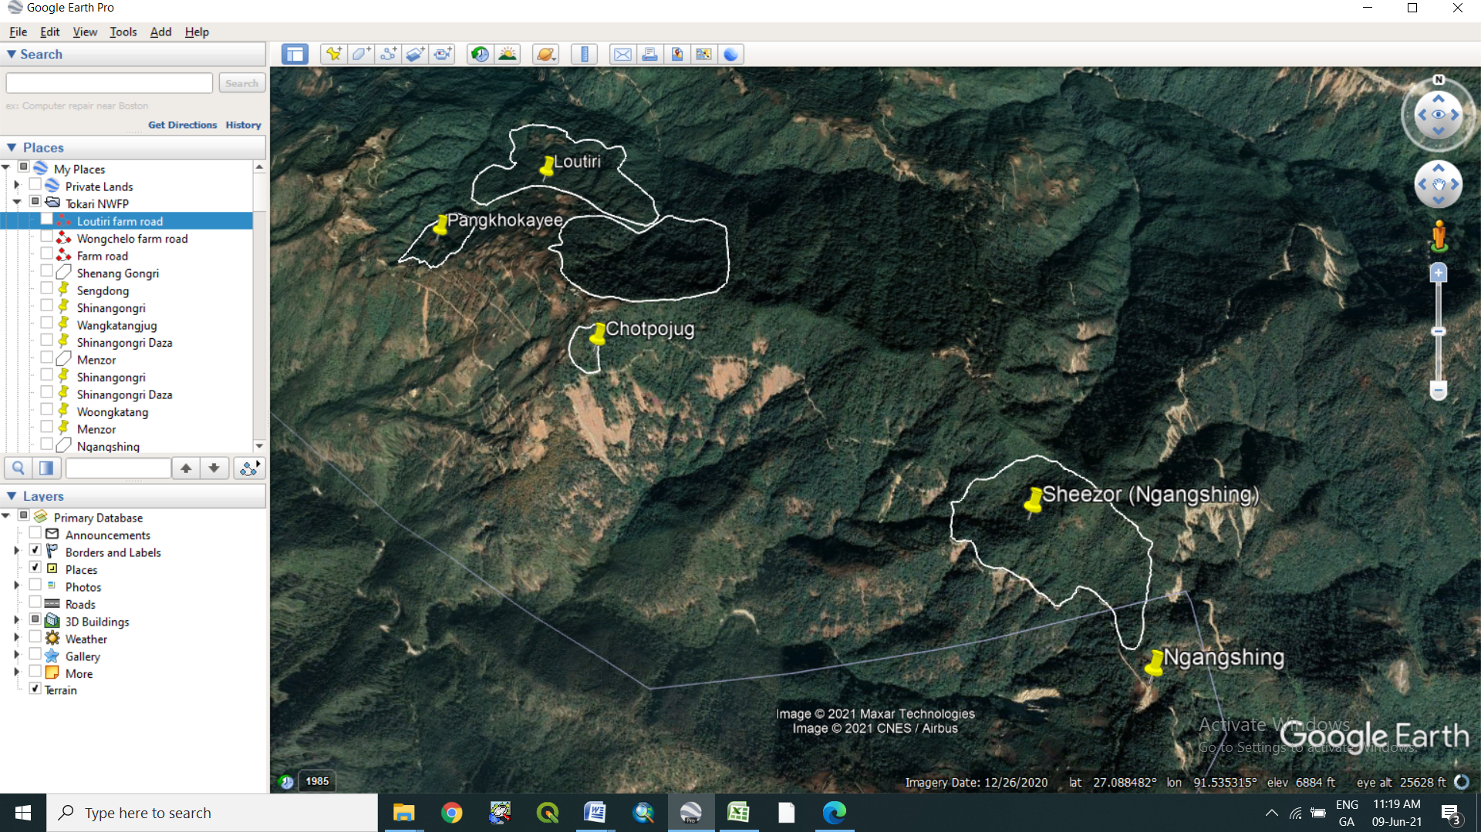

Table 5: Wongchelo NWFP collection site and area information

Sl.No | Name of NWFP collection site | Area (Acres) | Location point (name) | Northing | Easting | Species present
1 | Menzor Yekatang | 205 | 1. Zhudangshingthangkha | 27.084841° | 91.488773° | Daphne
 |  |  | 2. Menzor | 27.090527° | 91.488886° | Daphne
 |  |  | 3. Wongchelo road | 27.092008° | 91.484151° | Daphne
 |  |  | 4. Chotphu Dangka | 27.084592° | 91.483535° | Daphne
2 | Pangkhokayee | 51.7 | 1. Wongchelo Geri | 27.088842° | 91.470249° | Rubia and Pouzolzia
 |  |  | 2. Pangkhugpakhoi | 27.092588° | 91.471665° | Rubia and Pouzolzia
 |  |  | 3. Loutiri farm road | 27.090889° | 91.466837° | Rubia and Pouzolzia
 |  |  | 4. Kolopowong | 27.094051° | 91.468700° | Rubia and Pouzolzia
3 | Loutiri | 203 | 1. Rashiwoong | 27.093817° | 91.478671° | Rubia and Pouzolzia
 |  |  | 2.Menzor | 27.097178° | 91.480405° | Rubia and Pouzolzia
 |  |  | 3. Lautiri road | 27.097924° | 91.472257° | Rubia and Pouzolzia
 |  |  | 4. Loutiritop | 27.094858° | 91.474128° | Rubia and Pouzolzia
4 | Chothpojug | 7.54 | 1. Tankizor | 27.081106° | 91.481270° | Swertia
 |  |  | 2. Chotpuzor | 27.082980° | 91.482283° | Swertia
 |  |  | 3. Maanchema | 27.082983° | 91.480999° | Swertia
 |  |  | 4. Kologpowong | 27.082016° | 91.480311° | Swertia
5 | Shezor | 133 | 1. Ngangshing | 27.065961° | 91.512623° | Daphne, Swertia
 |  |  | 2. Shezor | 27.071367° | 91.512503° | Daphne, Swertia
 |  |  | 3. Poti Gonglam | 27.075136° | 91.507698° | Daphne, Swertia
 |  |  | 4. Tekilling | 27.073602° | 91.503286° | Daphne, Swertia

Part II: By-Laws: Group regulations and norms

Members of the NWFP management & marketing group

1.1 Eligibility criteria to become a membership he/she shall:

- be from same village (mention above) with proper Gung & Thram
- be interested to abide by the By-laws of the group
- willing to deposit the sum equivalent to individual share accumulated in bank at the time of he/she is joining (including membership fee, labour contribution and NWFP products sold)

1.2 Admission procedures for new members
- Registration of new members shall follow the following procedures:
- shall fulfil above eligibility criteria to become a membership conditions & may apply registration application to the Chairman
- chairman shall discuss during general meeting for acceptance or rejection of member shall be based on general consensus of existing members (Simple majority)
- After payment of the sum of amount (stated above) and register as member thereafter.

1.3. Resignation of members

1.3.1. Disinterested members:
- Any members resigning from group due to loss of interest shall follow the following procedures:
- shall apply resignation application to the Chairman
- chairman shall discuss the matter during general meeting and acceptance or rejection shall be based on general consensus of existing members (Simple majority)
- resignation shall be without any benefit from group

1.3.2 Woman headed/Disability:
- If misfortune transpire to any group member and he/she desires to resign from group shall apply an application to the Chairman:
- chairman shall discuss about it during general meeting
- acceptance shall be based on general consensus of existing members (Simple majority)
- shall clam 70% individual share from saving amount and shall resign from group

1.3.3. Dismiss of active member
- He/she passed away/dismissed due to certain problem/some unavoidable circumstance(disaster/sickness), any of his/her family member can be replaced
- Otherwise, he/she is eligible to get 70% of his/her shared accommodate in the joint account at the time of he/she resigned.

Equity of labour contribution and Benefit sharing
- To have equity and justice on labour contribution and allocation of products, the members shall follow the following system:
- Group members shall be informed about the harvesting time from particular season by the chairman /individual member within themselves and seek/obtain collection permit from the GFO.
- Harvesting shall be done together at the particular season for a particular period based on NWFP harvesting rules (given months).
- Interested group members (Only one member from one registered gung shall be allowed for collection) shall collect.
- Product collected shall belong to the NWFP Group recorded with individual names (Collectors)
- Any of the executive members shall keep track/record of NWFP collected on daily/monthly basis until till given time period for NWFP collection ended
- Any group member without sale of products minimum of 4 kgs and below (in group fund) shall bear/pay sum of Nu.300/-annually
- Group shall not have any rights over soil, stone, boulders etc. from their NWFPs collection area except permitted by FNCR.

General Assembly
The general assembly meets at least once a year. The chairman calls for the general assembly by a week before in advance, furnishing the points of the agenda of the meeting:

Month: December
Date: Any announced date
Time: 9:00am
Venue: Tokari ORC
Agenda: Group progress report, fund read out and discuss other important issues.
(Responsibilities and rights are for example: Permitted to harvest and market NWFPs as per this plan)

NWFP group Committee Members

Table 6: List of committee members
Name | Designation | Gender | Phone
Threnang Wangdi | Chairperson | Male | 17811667
Sonam Dorji | Secretary: | Male | 17864507
Sherub Chophel | Treasurer | Male | 17909739

4.1 Criteria to become committee members.
- He/she shall be
- Loyal, dedicative and sincere to group
- Literate person
- Approachable
- Truthful
- Maintain good relationship with others

4.2 Election procedure for Office bearers:
- He/She shall fulfil above criteria
- Election shall be based on general consensus by members during annual meeting (Simple majority).

Board meeting:
- Executive members shall have assembly as and when required as per command from chairman/GFEO and also once before the general meeting.

Terms of Reference for Committee members

6.1 Chairman
Responsibilities of Chairman:
- To chair all meetings related to this agreement
- To resolve disputes and conflicts among members
- To maintain contacts with traders
- To inform the group members on the date and venue for marketing, meeting etc.
- To coordinate the sale of collected NWFPs to the traders on the agreed dates and venues between traders and communities
- To ensure that a management plan is developed in the coming years with support of the District Forestry Services

6.2 Secretary
Responsibilities of Secretary:

- To support Chairman and Treasurer
- To convene the meeting in absence of Chairman
- To make records of meeting minutes
- To maintain record of NWFP collected
- To prepare a final report showing the NWFP quantities collected & sold per household, the buying price and details about the traders who bought the produce

6.3 Treasurer

- Responsibilities of Treasurer:
- To maintain cash transaction records
- To collect membership fees and take care of financial arrangements
- To read out cash balance during general meeting
- To collect fines and penalties

Resignation of executive members
7.1 If Chairman resigns due to some unavoidable circumstances;
- He shall apply an application of resignation to Secretary.
Secretary shall read out during general meeting.
- From the date of acceptance (simple majority) of resignation by group members, he shall participate as group member thereafter.
7.2 If Secretary/Accountant resigns due to some unavoidable circumstances:
- He/she shall apply resignation application to Chairman.
Chairman shall read out during general meeting.
From the date of acceptance (simple majority) of resignation by group members, he shall participate as group member.

8. Termination of Committee members

- Office bearers shall be dismissed, if he/she is accused of fraud or financial malpractices of group fund;
- He shall repay the amount within a month from the date of knowledge by any members with 10% fine of that amount and he shall vacate his post.
- Even after one month, if he refuses to repay the amount and fine, he shall be dealt through By-law of Conflict resolution

Compensation to the committee or any other members involved for marketing
- Any Committee or other member(s) who actively involved in monitoring of NWFP collection, transportation and marketing representing their NWFP Group, he/she is entitle for
- Payment of DSA equivalent to national wage rate (215/day).
- DSA payment will be made from every individual whose NWFP sold in the market by deducting in percentage (%) wise.

Membership fee and purpose
- A sum of Nu. 100 per household shall be collected annually by the treasurer and deposit in the bank
- Any member whose NWFP collection is 4kg and below in quantity, he/she shall pay Nu. 100 per household annually and that member(s) who do not collect any NWFP products at all shall pay Nu. 300 per household annually.

Community development fund and utilization of fund

11.1 Source of group Fund:

11.2 Membership fee: shall be collected annually during the general assembly by Accountant – Sum of Nu.100/- per H/H

11.3 From the sale of products
- 10% of the amount earned from sale of NWFPs shall be deposited to group fund by all the collected members.
- Any group member without any sale of products (in group fund) within a year shall bear/pay the sum of Nu.300/- annually. However, any group member whose collection is less than 4k in quantity shall pay Nu. 100 per member annually.

Fund management & utilization:
- For this management plan period, fund collected will be deposited to the Bank.
- Any group member travelling for group purpose shall claim the expended amount from the group with verified bills,
- Bill shall be forwarded to Geog Forestry for verification.
- Payment shall be done during general meeting, after discussing with members.
- Audit: Any members shall do auditing of financial matter at the time of suspect.

Offences and Penalties

13.1 Penalties for absentee:
- If any member does not turn up for meeting, he/she shall pay Nu.100 as fine per occasion
- If any member not attending meeting for three times consecutively, shall be dismissed from group without any benefit. Except for the gung tong.

Penalties on violation of Harvesting time:
- Any member violating harvesting time (collecting before starting & after time) shall bear the fined of Nu.10% of the total amount of NWFP collected by individual and confiscated the product by group.

13.2 Penalties on violation of Harvesting guidelines:
- Any members violating harvesting guidelines shall be fined with Nu.50% of market value of that product collected.
- If more than one member from registered gung collects the product, all the collected products by members of same gung shall be confiscated by group.

Marketing.
- If any member is not marketing in group, shall be fined with 50% of the products marketed.

14.1 Non group members:
- Any non-members collecting the NWFPs for marketing without harvesting permit from designated group areas shall be considered as illegal activities of group property, whether from his registered land or GRF and shall confiscate the collected product and shall be fined with Nu. 500/-.

14.2 Penalty for non-payment of fee/fine
- Any members not willing to pay fine/penalty/membership fee within 10 days from fixed date, shall be deemed as offence and shall be fined with Nu.25% of the amount. And even if member is not willing to pay within that year, shall be dismissed from group without any benefit.

Cash Deposit:
- If committee members do not deposit collected cash within 30 days, shall fine with Nu.10% of the amount per month.

Non-Listed NWFP’s:
- Any non-listed NWFPs but grown within group demarcated area shall be protected by the group, and collection of these products shall be deemed as illegal activities and shall be fined with Nu.50% of market value of collected products and also confiscated the collected product by group.

Conflict resolution

- In case disputes or conflicts among communities arise about access to certain areas for NWFP harvesting; the matter shall be put to the Geog Tshogchung (GT) Dzongkhag Tshogdue (DT) for further decision.

- Conflicts or disputes within the NWFP Management Group, which cannot be resolved by the group members shall be forwarded to the Coordinator for settlement. If the case cannot be resolved, it shall be forwarded to the Geog Administration.

Table 7: NWFP harvesting rules:

Sl No | Name |  | Part(s) used | Purpose | Time of harvesting | Guidelines for harvesting | Remarks
 | Scientific | Local
1 | Rubia cordifolia | Lanyi-roo (Sha) | Entire plant | Dye, Medicine | February to April | - Upper part of the plant will be collected using sharp scissor.  - Cut plant 5 cm above ground level.  - Retain at least 10% of the plants to enhance natural regeneration  - Do not uproot entire plants  - Do not collect roots.
2 | Pouzolzia spp | Yongjebu (Sha) | Bark | Ingredients for incense making | October to April | - Cut plant at 10 cm above the ground(the left stump will coppice in the following growing season)  - Do not damage the remaining young stands/seedlings/saplings  - Felling of surrounding trees to ease harvesting is prohibited  - Leave at least 10 % of the plant to allow natural regeneration  - Collection of roots is strictly prohibited for ecological reasons.
3 | Swertia chirayita | Chirata (San) | Entire plant | Medicine | November to January | - Collection only after seed dispersal commenced.  - To avoid high risk of damaging germination, collection should not be done in late season (February)  - Right time for harvesting will be announced by GFEO or Co-coordinator who has the knowledge of collection date. | Guidelines for resource assessment & management.  ( FRDD’08)
4 | Edgeworthia gardneria | Dheykap (Dzo) | Bark | Paper making | March to June | - Cut stems that are more than 3 cm in diameter.  - Do not damage the young stands, seedlings and sapling.  - To ease harvesting, do not fell the surrounding trees  - Dividing in to 6 blocks, the harvesting will take place rotationally in these blocks ones in a year.
3 | Juglan regia | Tago (Dzo) | Fruit | Eating fruit | September to October | - Harvesting based on local management system.  - Retain seeds for regeneration  - Regeneration through seed.
4 | Castonopsis spps. | Tshatshe (Sha) | Fruit | Delicious Nut | October to November | - Harvesting rule based on local management system.  - Regeneration through seed dispersal by birds
5 |  | Shingmar | Fruit | Oil | July-Sept | - Cut small branches  - Leave one third of the branches  - DO not fell trees
6 |  | Thingkagpoo | Fruit | - | Oct-Nov | - Hand picking  - Do not fell trees

Table 8: Membership details

Membership registration
Sl. No | Name | Address | CID No | House No | Thram No | Signature or thump print
1 | Choki Pema | Garrey | 11508004161 | Ta-10-30 | 134
2 | Choten | Garrey | 11508001194 | Ta-10-15 | 391
3 | Choten (Zangmo) | Garrey | 11508001132 | Ta-10-534 | 1182
4 | Choten wangdi | Garrey | 11508001093 | Ta-10-05 | 108
5 | Dorji | Garrey | 11508001110 | Ta-10-06 | 97
6 | Kelzang Wangdi | Garrey | 11311001335 | Ta-10-17 | 137
7 | Kota | Garrey | 11508001445 | Ta-10-02 | 1263
8 | Ten Dorji | Garrey | 10508001467 | Ta-10-667 | 155
9 | Thinang Wangdi | Garrey | 11508004579 | Ta-10-04 | 146
10 | Yangden | Garrey | 11508001454 | Ta-10-643 | 221
11 | Dorji | Terphu | 11508003610 | Ta-10-79 | 482
12 | Jigme Dorji | Terphu | 11508003506 | Ta-10-590 | 1129
13 | Kezang | Terphu | 11508003507 | Ta-10-66 | 477
14 | Kinzang Wangmo | Terphu | 11508003976 | Ta-10-75 | 1239
15 | Kota | Terphu | 11806002401 | Ta-10-574 | 474
16 | Loday | Terphu | 11508004621 | Ta-10-58 | 1149
17 | Muki | Terphu | 11508004660 | Ta-10-59 | 481
18 | Ngawang | Terphu | 11508003637 | Ta-10-84 | 484
19 | Phuntsho | Terphu | 11508003545 | Ta-10-70 | 492
20 | Sangay | Terphu | 11508003614 | Ta-10-80 | 483
21 | Sangay Tenzin | Terphu | 11508003487 | Ta-10-64 | 481
22 | Sangay Thinley | Terphu | 11508004652 | Ta-10-57 | 480
23 | Sherab Chophel | Terphu | 11508003560 | Ta-10-73 | 485
24 | Sonam Dhendup | Terphu | 11508003646 | Ta-10-85 | 436
25 | Sonam Dorji | Terphu | 11508004611 | Ta-10-54 | 472
26 | Tshering Dhendup | Terphu | 11508003441 | Ta-10-50 | 466
27 | Tshomo | Terphu | 11508004570 | Ta-10-53 | 437
28 | Wangdi | Terphu | 11508003468 | Ta-10-62 | 473
29 | Wangzom | Terphu | 11508003555 | Ta-10-72 | 476
30 | Yangki | Terphu | 11508000387 | Ta-10-63 | 435
31 | Yeshi Lhamo | Terphu | 11508003625 | Ta-10-81 | 469
32 | Zamtuk | Terphu | 11508003449 | Ta-10-56 | 48
33 | Choden | Woongchio | 11508004202 | Ta-10-35 | 31
34 | Chorten Tshering | Woongchio | 11508004170 | Ta-10-32 | 131
35 | Dema | Woongchio | 11508003178 | Ta-10-89 | 396
36 | Jigme | Woongchio | 11508000889 | Ta-10-178 | 3166
37 | Karma | Woongchio | 11213000083 | Ta-10-330 | 170
38 | Karma Tenzin | Woongchio | 11508004116 | Ta-10-26 | 124
39 | Kezang Norbu | Woongchio | 11508004271 | Ta-10-44 | 133
40 | Lhamo | Woongchio | 11508004109 | Ta-10-25 | 125
41 | Lobzang | Woongchio | 11508004029 | Ta-10-19 | 143
42 | Norbu Wangdi | Woongchio | 11508004133 | Ta-10-28 | 149
43 | Peldon | Woongchio | 11508000588 | Ta-10-111 | 47
44 | Sangay Dorji | Woongchio | 11508004338 | Ta-10-522 | 1272
45 | Sangay Tenzin | Woongchio | 11508004259 | Ta-10-42 | 42
46 | Seldema | Woongchio | 11202000381 | Ta-10-42 | 120
47 | Sherab Chezom | Woongchio | 11508004165 | Ta-10-31 | 135
48 | Sonam | Woongchio | 11508004037 | Ta-10-20 | 125
49 | Sonam Jamtsho | Woongchio | 11508004058 | Ta-10-22
50 | Sonam Yangchen | Woongchio | 11508000570 | Ta-10-383 | 783
51 | Tshering Wangdi | Woongchio | 11508001460 | Ta-10-166 | 110
52 | Wangdi | Woongchio | 11508004210 | Ta-10-30 | 5
53 | Yangzom | Woongchio | 11508001388 | Ta-10-170 | 242
54 | Yezhen Norbu | Woongchio | 11508004148 | Ta-10-29 | 145

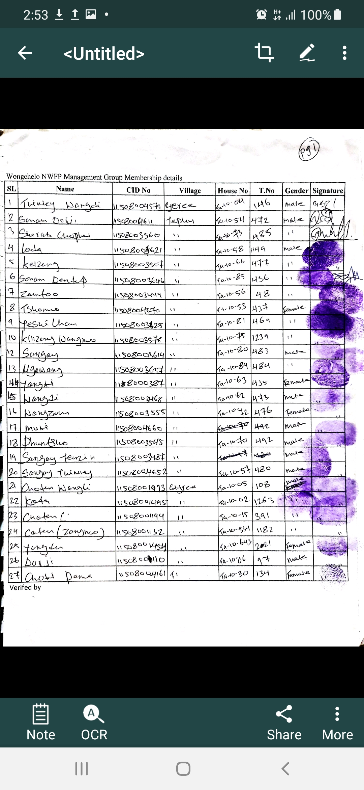

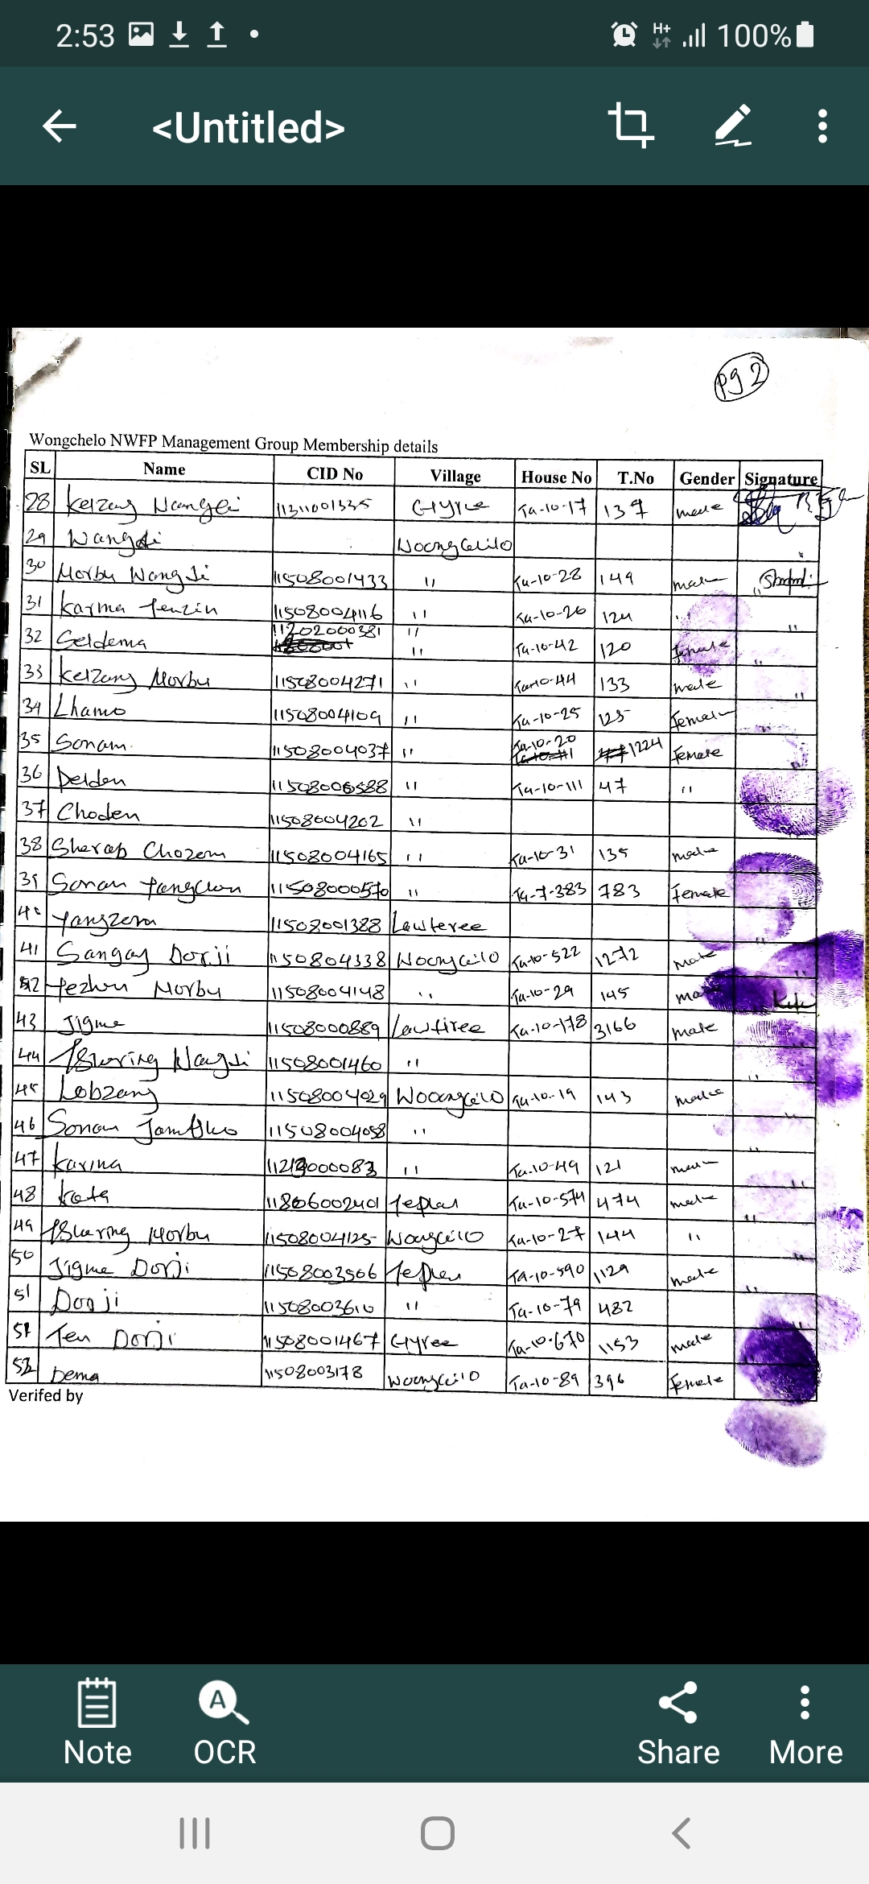
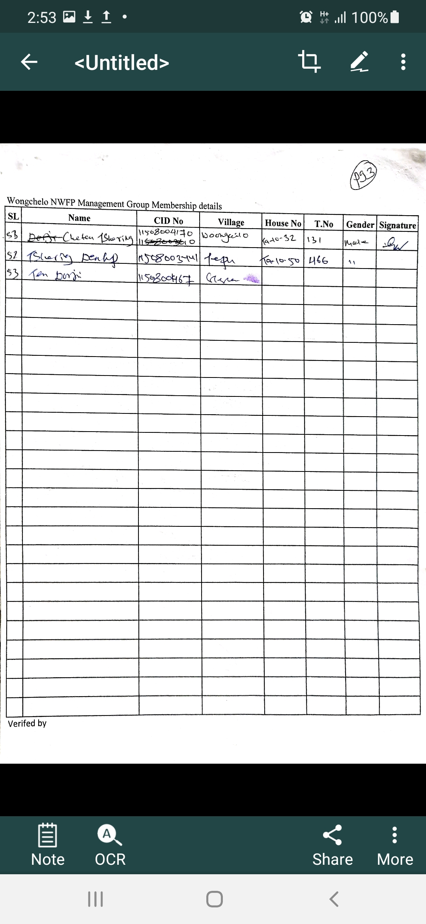

GLOSSARY AND ABBREVIATIONS

CFD Community Development Fund
CFO Chief Forest Officer
DAMC Department of Agriculture Marketing Cooperatives
DFO Divisional Forest Office
DoFPS Department of Forests and Park Services
DT Dzongkhag Tshogdue
GFO Gewog Forest Office
GFR Gewog Forest Ranger
GT Gewog Tshogdue
HHs Households
NTFPs Non-timber Forest Products
NWFPs Non Wood Forest Products
SRFL State Reserved Forest Land
ToR Terms of Reference

