Table of Contents
EXECUTIVE SUMMARY 3
PART 1: BACKGROUND INFORMATION 4
1.1: Rubia (Rubia cordifolia) 4
1.2 Youngjuva(Pouzolziasanguinea) 5
1.3 Fashi (Plectocomia himalayana) 5
1.4 Menji (Calamus acanthospathus) 6
PART 2: NWFPs MANAGEMENT AND MARKETING PLAN 6
2.1: The objectives of the management plan are given below: 6
2.2: NWFPs descriptions 7
2.3: Marketing and sales plan 9
2.5: Marketing arrangements 11
2.6: Benefits to the members 11
2.7: Benefits to the group 11
PART 3: BY-LAWS-GROUP REGULATIONS AND NORMS 13
3.1: Members of the NWFP management & marketing group 13
3.1.1 Responsibilities and rights of members: 13
3.2.1: Chairperson 14
Responsibilities of Coordinator/ Chairperson: 14
3.2.2: Secretary 14
Responsibilities of Secretary: 14
3.2.3: Treasurer 14
Responsibilities of Treasurer: 14
3.3: Compensation to the executive committee for marketing 15
3.4: Membership fee and purpose 15
3.5: Community development fund and utilization of fund 15
3.6: Conflict resolution 15

List Of figures
Figure 1 :Rubia chopped and ready for sell 4
Figure 2: Dried Bark of Pouzolzia 5
Figure 3: Plectocomia shoots 5
PART 1: Non wood Forest Products Management and Marketing

1. Background
Wongborang Non-wood Forest Product Group (NWFP) was formed in 2021 under technical guidance of Pemagatshel Divisional Forest Office. The group consists of 10 members from Nomey and Wongborang village. The group was formed to manage, collect and market Non wood resources such as Rubia cordifolia, Pouzolzia, Calamus acanthospathus, Plectocomia himalaya, Neomicrocalamus andropogonifolius and fern tops found growing in village adjacent forest. The people in these villages are agrarian society practice mixed farming system.
In order to ensure sustainable management and harvesting of NWFPs the group has developed guidelines and By-Laws for group governance and harvesting of products. The By-Laws clearly state that every member must sell their produce in group, to have better bargaining power and fetch higher price for the products sold. The members have planned to collect and sell other produce as well continue handicrafts.
The group agreed to work towards achieving their goal of poverty reduction through income generation from sale of NWFP and handicraft items. The group members have unanimously framed guideline for sustainable management and developed By-Laws for proper functioning of the groups. Management Plan consists of the brief description of NWFPs, descriptions of individual species including harvesting prescriptions, sketch map of NWFPs harvesting areas and marketing sales plan. The By-Laws of the management plan contained process of executive committee formation-ToR of Chairperson, Secretary and Treasurer, compensation to the executive committee for marketing, membership fee and community development fund, conflict resolution and penalties.
The term of management plan is for five years and will be effective from 2021 to 2025. During the period, they will have right to collect mentioned NWFPs as per the harvesting guidelines prescribed in the plan and ensure sustainability of resources in the future.

2. The objectives of the group
- To enhance income generation through sale of NWFPs.
- To promote the tradition of cane handicraft.
- To manage the NWFPs resources at local level through community participations.

3. Short description on Non wood Forest Products identified for management and marketing

Following are short descriptions of species and their uses. The descriptions are totally based on plant morphology. The descriptions of uses are based on interim Framework For management and Marketing of Non-Wood Forest Product, 2011 and local uses.

3.1: Rubia (Rubia cordifolia)
Rubia is local known as Laniru. It is a perennial climbing herb. It can grow in different height depending upon site conditions and other environmental factors. The evergreen leaves grow in whorls of 4-7 star like around the central stem. It climbs with tiny hooks at the leaves and stem. The flower usually appears from June to August. It grows along the disturbed forest land such as forest edge and clearings and it is sparsely found in grassland and open rock outcrops. It is said to be found even at the elevation up to 2600 meter above sea level (masl).
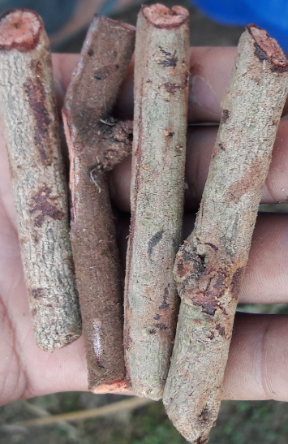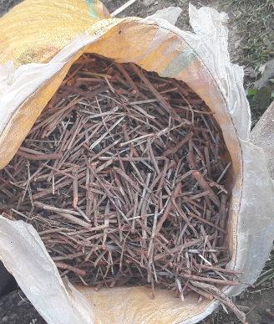

Figure 1: Post harvest adopted by after collection

Uses
Rubia is used for extraction of red pigment which is then used for dying purposes. Locally it is also used for healing purposes where tender leaves are crushed and used for healing body pain.

3.2 Youngjuva (Pouzolzia sanguinea)
It is an evergreen shrubs growing in warm broad leaved forests, thickets and edge of woods, dry valleys, roadside and in the patches of abandoned cultivation at elevations of 300-2300 masl.
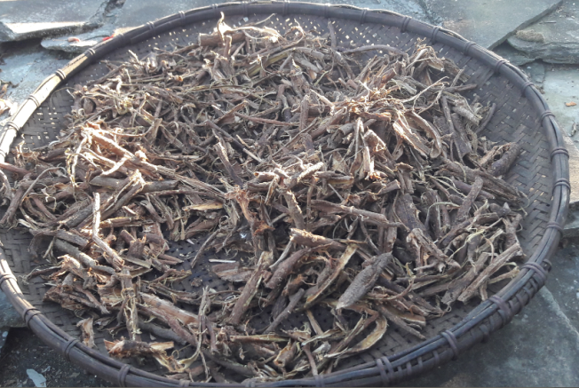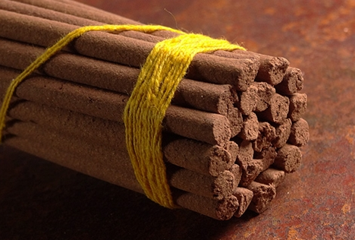

Figure 2: Dried Bark of Pouzolzia and final use

Uses
It is popularly used as an important raw-material in incense manufacturing process as an adhesive to bind ingredients.

3.3 Fashi (Plectocomia himalayana)
Plectocomia himalayana is a spiny, evergreen, climbing palm producing a cluster of stems that can climb high into the surrounding trees. The stems are unbranched for most of their length but can then branches freely to form entanglements in the tree canopy
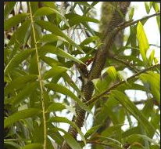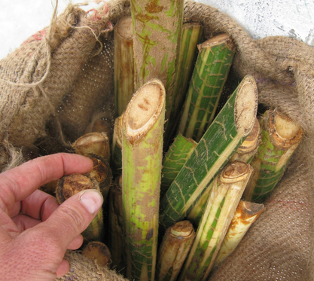

Figure 3: Plectocomia himalayana shoots collected for sale
Uses
The plants are harvested from the wild for local use as a food and source of materials for basketry, ropes etc.

3.4 Menji (Calamus acanthospathus)
It is a solitary stem cane which usually climbs on trees and grows to length of 50 m long and 5 cm diameter. Leaf sheaths green or pinkish-brown, with sparsely to densely arranged, sometimes in short rows, brown, flattened, to 1 cm long spines, these with sinuous, hairy margins initially; ocreas short, densely bristly; knees present; flagella present, to 5.6 m long; petioles short or absent; rachis to 1.4 m long with 8-15, broadly lanceolate leaflets per side, these regularly arranged, sometimes irregularly, especially near base of leaves, minutely bristly on the margins; cirri absent. Inflorescences to 3 m long, flagellate; bracts tubular; fruits ovoid to ellipsoid, to 2.5 cm long and 1.5 cm diameter, yellowish-brown. It flowers in the month of March and fruit matures in October and November.
Uses: It produces a best cane for handicraft purposes and used making case for Dung, Jaling and other religious items. It is woven to make decorative baskets. It is also used for making furniture in India. It is a perfect for binding rope.

Table 1: Block description of individual NWFPs species
NWFP name | Collection area (name) | Estimated areas (acres) | Parts harvested | Use purpose (traditional and others) | Harvesting season (months) | Estimated quantity that can be collected (Kg)
Laniri (Rubia sp) | Nomey | 50 | Whole plant | Dye, Medicine | Nov-Feb | 3000
 | Wongborang | 40 |  |  |  | 2000
Youngjuba (Pouzolzia sanguine | Yurimung | 70 | Bark | Adhesive for incense | Aug-Feb | 2000
 | Nomey | 30 |  |  |  | 1500
Menji (Calamus acanthopathus) | Serphujab | 100 | Shoot and cane | Handicraft | May-Nov. | 1200 dongs
Fashi (Plectocomia himalayana) | Dungphujab | 150 | Shoot and cane | Handicraft | Jan -Jun | 1500 dongs
Note: 1 dong is equal to 8 m length; on an average a matured cane can produce 3-4 dongs

Table 2: Prescriptions for sustainable Harvesting
NWFP species | Harvesting prescriptions for sustainable harvesting
Laniroo (Rubia cordifolia) | -Use sharp scissors for the collection of the upper part of the plant.  -Cut the plant at 5 cm above ground level.  -Leave at least 10% of the plants without collecting or harvesting any raw materials from them (these plants shall act as seed plants for natural regeneration).  -Do not collect roots.  -Do not uproot entire plants  -Leave the mother plant intact with small part of the root or rhizome in the soil (this left part of rhizome will regenerate in the following year).  -Harvest rhizomes only during the collection season.
Youngjuva (Pouzolzia sanguine) | -Cut the plant at 10 cm above the ground level (the left stump will coppice in the following growing season).  -Do not damage the remaining young stands/ seedlings/ saplings  -Felling of surrounding trees to ease harvesting is prohibited.  -Leave at least 10% of the plants to allow natural regeneration.  -Collection of roots is strictly prohibited for ecological reasons
(Fashi) Plectocomia himalayana | For mature stems  - Cut cane stem only when mature, to be recognized by:  - Loosening of leaf sheath from the lower part  of the cane stem  - Exposure of lowest part of the stem  - Turning to yellow-reddish along the entire  stem length  - Diameter over the entire length of the cane is  the same (the diameter at the lower part of  the cane is reduced)  For Shoot  - Cut young shoot by bending the cane stem with the help of long stick with hook.  - Do not cut the entire cane to collect shoot  - Care shall be taken to avoid damaging suckers buds
Menji (Calamus sp) | For mature stems  Cut cane stem only when mature, to be recognized by:  - Loosening of leaf sheath from the lower part  of the cane stem  - Exposure of lowest part of the stem  - Turning to yellow-reddish along the entire  stem length  - Diameter over the entire length of the cane is  the same (the diameter at the lower part of  the cane is reduced)  For Shoot  Cutting for shoot is prohibited

4. Map of NWFP collection area

4.1: NWFP collection area on Google map
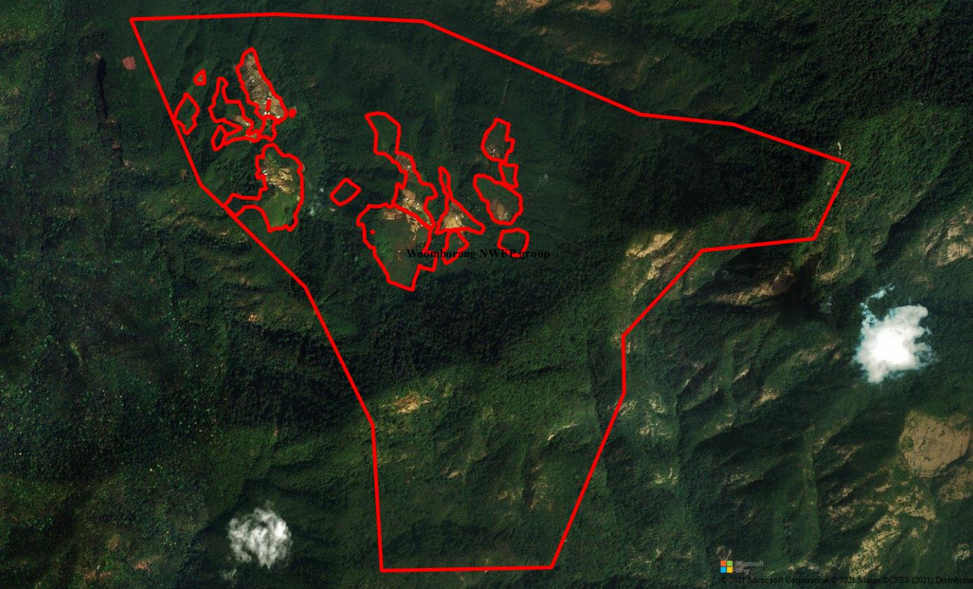Fig: Woomborang NWFP area google map
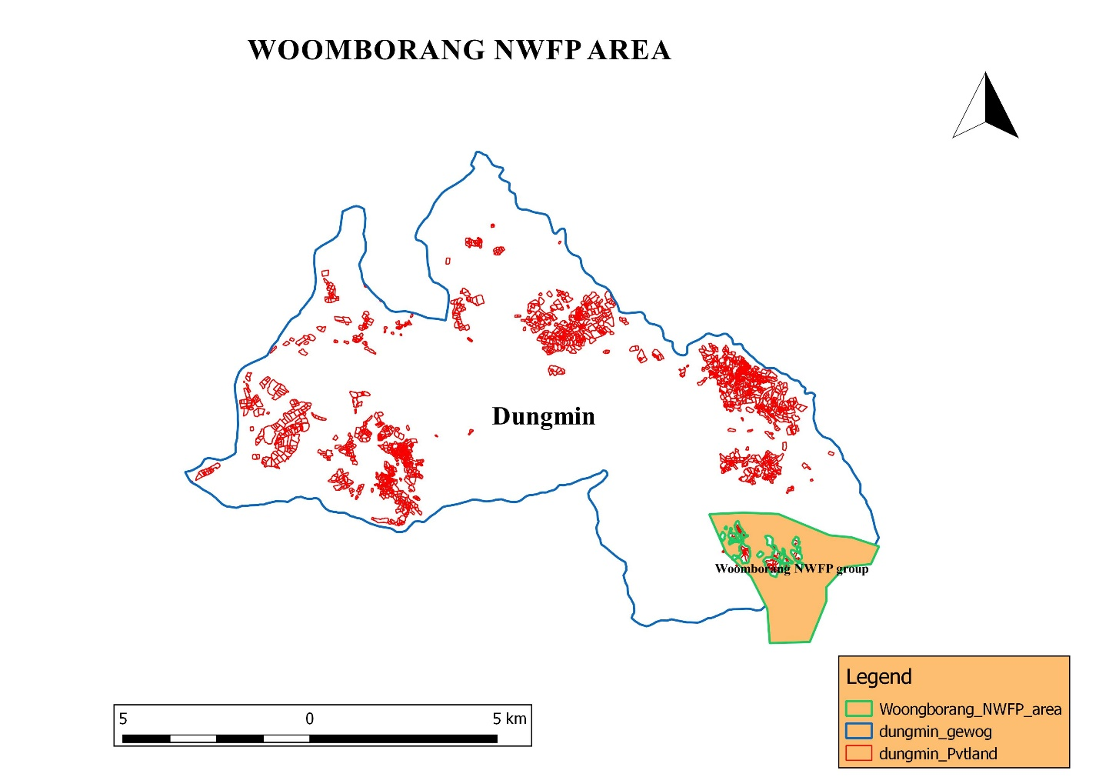

Table 3: Marketing and sales plan of NWFPs
NWFP name | Potential market | Estimated quantity for sale per season | Expected price per unit | Total Nu.
Laniru (Rubiacordifolia) | Local trader, Indian market | 1000kgs. | 55.00 | 55000.00
Yongjiba (Pouzolzia sanguine | Local trader, poi making factory and Indian market | 700kgs | 50.00 | 35000.00
Manji (Calamus sp) | local community | 240 dongs. | 200.00 | 48000.00
Plectocomia himalayana | Basket weavers of Bhutan | 300 dongs | 100 | 30000.00

5. Marketing arrangements

The members will collect the NWFPs individually and store properly. The members will segregate products as per the standards required by the trader. The executive committee members will inform to the concern forestry official/DAMC and collect the NWFPs product to the auction yard. The concern forestry official/DAMC will then organize NWFPs auction to various NWFPs traders. The auction will be organized in the presence of Chairperson from the respective NWFPs groups.
The cane craftsmen will sale their product at prevailing system until further notice by Division. However, they will have to obtain collection permit from Forest before collection. Also they will obtain transit permit from the nearest forest office if it is sold outside Dzongkhag. As of now there are five men from group whose earnings are mainly met from cane crafting. Apart from traditional craft, product diversification would meet prevailing market demand.
The executive members shall deduct the expenditure such as transportation, community fund and compensation before making payment to the group. Only after that the payment will be done to individual member.

2.6: Benefits to the members
The members can earn income from the sale of NWFPs. After decline of mandarin production NWFPs growing in village adjacent forest plays significant roles in income generation. Also a recently connected farm road is a boon to in collection and sale of NWFP. The income made from sale of NWFPs products will be able to meet expenses for basic necessities like salt, rice, sugar etc. Further, the income also helps in buying of clothes, shoes, books and pens for their school children.

2.7: Benefits to the group
By forming this functional group, all the individual members have equal rights and opportunities to access the resources. The group could able to collect the various NWFP products legally for sale which otherwise is limited only for domestic consumption. From the deduction made during sale, the group can make community development fund. Through this, the group can look into and support welfare of individual member. Also the group can provide loan at low rate to needy members which can be used for family livelihood support programms. All the NWFP members are member of Nomay Community Forest. As for today, members planted around 1500 rhizomes of cane in CF for future use.

PART 2: BY-LAWS-GROUP REGULATIONS AND NORMS

3.1: Members of the NWFP management & marketing group

3.1.1 Responsibilities and rights of members:
- The group members participating in management of NWFP will have equal rights and responsibilities for controlling, protection, management and harvesting in the identified collection areas. It is the responsibility of members to abide to rules set in the plan.
- It is a responsibility of each member to report offences to the committee members.
- Individual members will not be allowed to collect and harvest on their own unless the committee permits and fixed the date.
- The members should agree to sell collected NWFPs only through the group and not individually.
- Withdrawal of any group members without genuine reason will be allowed without any benefit from the accumulated fund and the entry fee. Once withdrawn he/she will not be allowed to re-join the group.
- Resignation from the group owing to old age or no children to carry out work will get equal share of benefit from accumulated fund till the date of his/her resignation.

3.2: Committee Members
Name | Designation | Contact details | Remarks
Yesel Dorji | Chairperson | 77371546
Ugyen Yeshi | Secretary | 77480157
Tashi Dorji | Treasurer | 77231228

3.2.1: Chairperson

Responsibilities of Coordinator/ Chairperson:
- To chair all kinds of meeting relating to NWFPs management matter in the group.
- To resolves the disputes and conflict among the members.
- To enforce the fine and penalty.
- To explore market for the products
- Fix date of collection and make an announcement to the group member
- Maintain contacts with traders, to arrange & coordinate marketing of NWFPs and record data, etc.

3.2.2: Secretary

Responsibilities of Secretary:
- Provide assistance to the Chairperson.
- Officiate Chairperson during his absence.
- Maintain records of the activities implemented, and also minutes of meeting.
- Write official correspondence.
- Compile the progress report and submitted to the GFO for further submission to the Divisional Forest annually.

3.2.3: Treasurer

Responsibilities of Treasurer:
- To maintain the financial matters and present the details funds to Committee and the group members.
- Officiate the Chairperson or Secretary in their absence.
- Maintain the cash transaction record, submit expenditure and cash balance report to Chairperson and present it to the group in meetings.
- Collection of membership fee from the group members.
- Taking care of financial arrangements in the group

3.3: Compensation to the executive committee for marketing
- The executive committee will work without compensation for the group for the tenure of next 3 years and they will not be resigned in between tenure except for extenuating circumstances.

3.4: Membership fee and purpose
- Membership fee for the existing group should pay Nu. 100/- annually.
- Any new members wishing to join the group will be allowed after payment of compensation equal to the share accumulated fund till the date. The collected fee will be deposited in the joint account as a Community Development Fund (CDF) that will be used for pre-financing marketing purposes and others.

3.5: Community development fund and utilization of fund
- The bank account will be jointly operated by Chairperson, Secretary and Treasurer, and they are signatory authority of the Bank Account. All sale and expenses done by the Chairperson, Secretary and Treasurer should be in the notice of members.
- All expenditure incurred on behalf of the group will be borne from the group fund. If designated committee has to go for important meeting on behalf of group and expenses not met by organizer, it will be met from Group’s fund. Technical support will be sought from the concerned Gewog ROs.
- The source of fund will be from fine imposition, membership fees and the selling of NWFP
- The group members will deposit Nu.250/- if the collection is less than 20 Kg or less/nil and 10% deposit for 20 Kg and above. Every craftsman must deposit Nu. 500/- annually irrespective of product types.
- The fund accumulated will be shared equally among the group members once the fund accumulation is enough for sharing.

3.6: Conflict resolution
- In case disputes or conflicts among communities arise about access to certain areas for NWFP harvesting; the matter shall be put to the Gewog Tshogchung (GT) or Dzongkhag Tshogdue (DT) for further decision
- In case there is a conflict between the NWFP Group and outsiders, the case shall be forwarded to the Divisional Forest and Gewog Administration by the Coordinator.
- The conflict arising among the group members regarding NWFP matters will resolved firstly to the Chairperson.
- If the nature of the conflict is unable to resolve by the Chairperson, the case will be forwarded to the Gewog RO for further settlement.
- Still if the conflict remains unresolved the case will be forwarded to the Gewog Administration.
- If the Gewog Administration cannot resolve the problems, the case will be forwarded to the Divisional Forest Office for further action

3.7: Penalties
- In case if the member of the NWFP Group violates the harvesting rules as set in this plan, he or she will not be allowed to harvest the NWFP for the next 2 seasons as punishment.
- Members collecting the NWFP prior to the fixed date/announcement made by the Coordinator/ GFO, the offender will be levied fine Nu. 215/day- and product will be seized by the group
- Number of days for the collection will depend on availability of resources and general consensus by the members.
- Those members who could not collect it owing to old age or death or other genuine reasons will be considered.
- Only one member from each household will be entertained and additional collectors will be fine Nu. 100/- per head and the quantity collected will be surrendered to the group.
- Non-members without registering will be not allowed to collect and fine of Nu. 200/- per kg will levied and product will be seized to the group.
- An absentee during meeting is liable to pay Nu. 150/- per head.
- An absentee during work is liable to pay Nu. 215/- per head. More than three times absentees during the work will be liable to expel from the group.
- An absentee owing to death and sick cases in a household or other genuine reasons are considered only after the approval from group’s Chairperson.
