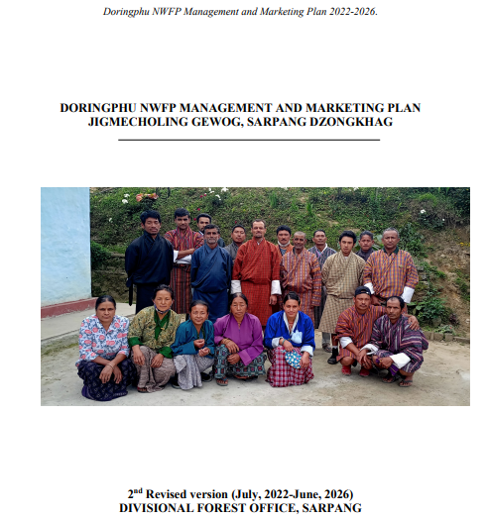
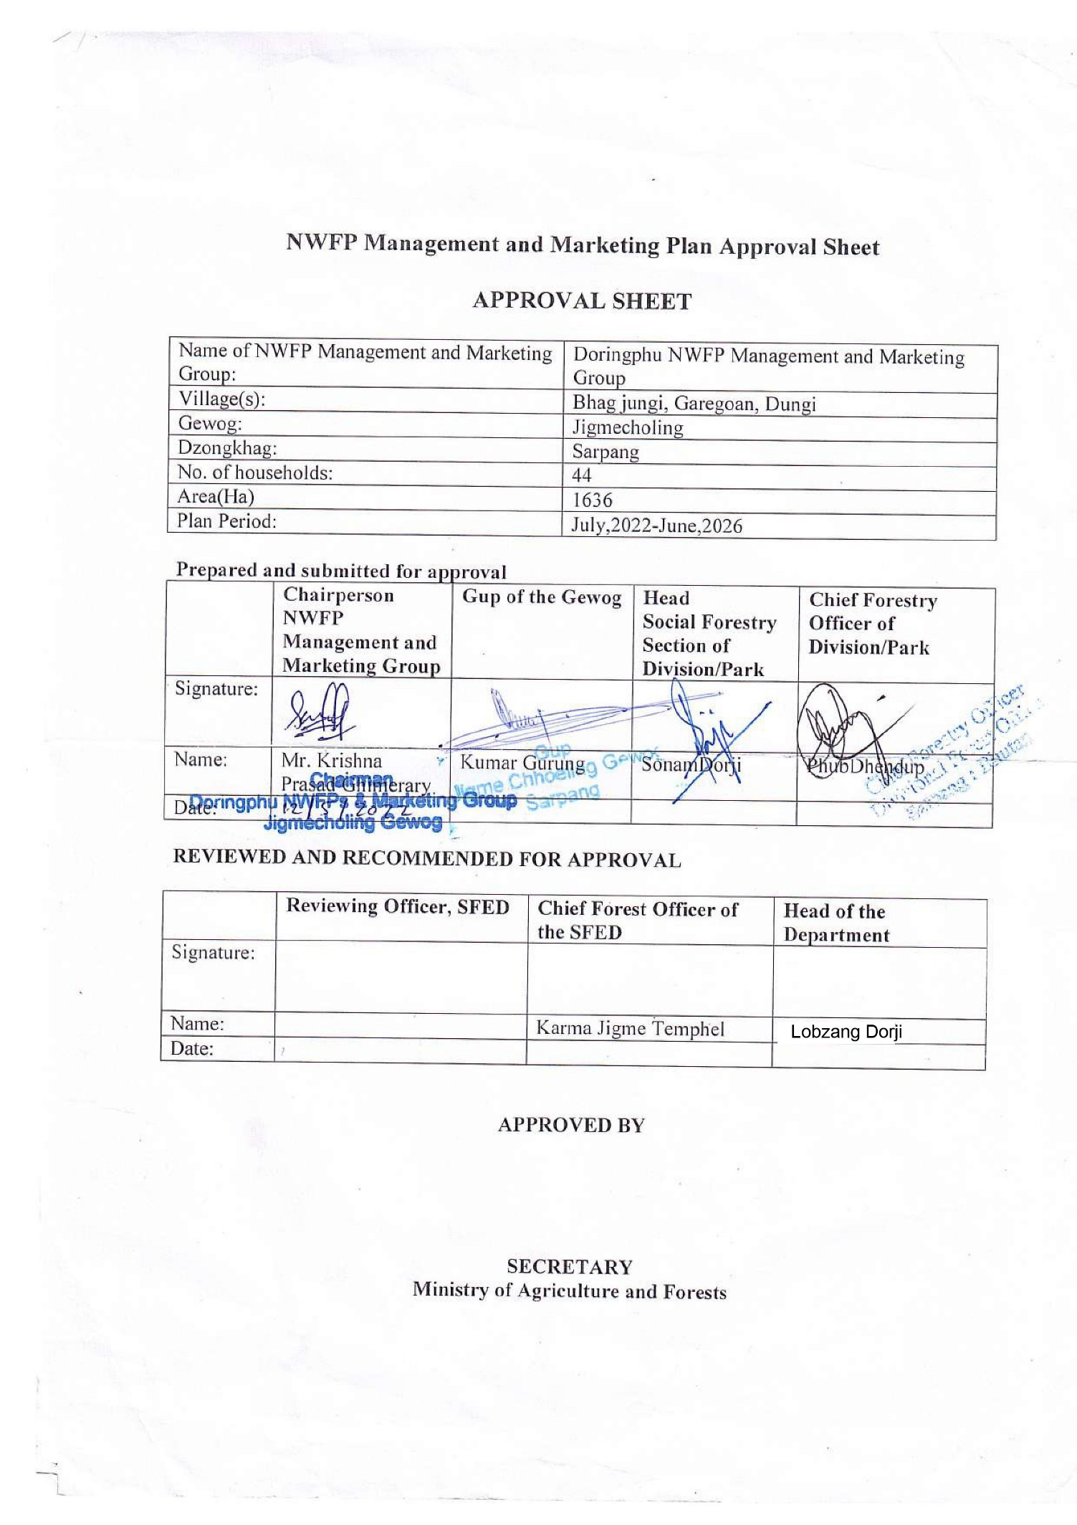

Table of Contents

1. Background 1
2. Goal 2
3. General objectives 2
4. Specific objectives 2
5. Description of NWFPs present in the area demarcated for management by the group 2
6. Harvesting prescription for sustainable harvesting of NWFPs. 4
7. Google/QGIS map of the NWFP harvesting areas 7
8. Marketing and sales plan 7
9. Marketing Arrangements 8
10. Benefits to members 9
11. Benefits to the group 12
12. NWFP management & marketing group members 13
12.1. Responsibilities and rights of members 13
13. NWFP Management and Marketing Group Management Committee 13
13.1. Responsibilities of Chairperson 13
13.2. Responsibilities of Secretary 14
13.3. Responsibilities of Treasurer 14
14. Possible committee members 15
14.1. Responsibilities: Group Audit 15
15. Tenure of committee member 15
16. Incentives to the committee members 15
17. Membership Registration fee and annual contribution 16
17.1 New registration and resignation 16
18. NWFP group fund management and utilization 17
19. Conflict resolution 17
20. Meeting and purpose 18
21. Fines and Penalties 18
22. Restrictions for the harvesting of NWFPs 19
23. Tenure of management and marketing plan 19
24. Power of the Department 19
25. Monitoring and evaluation scheme 19
Annexure I: Membership registration Doringphu NWFP Management and Marketing Group 21

Part A: NWFP management and marketing plan

1. Background

Doringphu NWFPs Group is formed by inhabitants from Bhag Jungi, Gareigoan and Dungi illages under Jigmecholing geog and consist of 43 households. The group will manage 1636 hactares of State Reserved Forest Land of Doringphu with bpundary demarcation of Towerdara-Devikholcha in the north, Gairegoan Khochi and Bans Gari in the east, Gongchu congluence and Topay kholchi in south and Moukhola river in the west. Around 88% of the total management area is under forest cover and 126 ha of the NWFP Mangaement area has slope greater than 45degree which has limited accesability for collection of forest products. The area is warm broad-leaved forest.
Table 01: The detail geographical boundaries of NWFPs collection area
Boundary No | Name | Latitude | Longitude
1 | Kharkhola Confluence | 27° 2'58.74"N | 90°23'28.71"E
2 | Tower dangra | 27° 3'3.68"N | 90°24'42.57"E
3 | Devikholchi B | 27° 3'24.52"N | 90°25'22.05"E
4 | Gairegoan Kholche | 27° 2'46.04"N | 90°26'34.60"E
5 | Bans gari | 27° 1'32.28"N | 90°26'33.88"E
6 | Gongchu Confluence | 27° 0'41.54"N | 90°26'8.43"E
7 | Topay kholchi | 27° 0'56.81"N | 90°25'33.22"E
8 | Below Dungi | 27° 1'27.65"N | 90°24'41.41"E

Doringphu NWFP collections area is nearby their settlements whereby it is easy for sustainable management and protection. The area faces towards south east and south west with the slope between 20-45degree.
NWFP species like Rubia cordifolia (Majeto), Piper longum (Pipla), Entada rheedii (Pangra), , Calamus erectus (Patsha), Piper hamiltonii (Jungle pan), Litsea cubeba (Sil timbur) Choerospondia axillaris (Labsi) and Swertia chirarta (Chirato) were mostly grownundergrowth in pocket/sporadic area where the vegetation of the area dominates by Utis (Alnus nepalenses), Katus (Castonopsis hystrix) and other Chelauni (Schima wallichii) species.
Therefore, formation of Doringphu NWFP Marketing Group will certainly help to improve their social livelihood development through income generation, capacity development, thereby ensuring balance socio-economic development within the community without compromising sustainable management of forest.

2. Goal
Enhance the livelihood of the group members through sustainable harvesting and marketing of Non-Wood Forest Products.

3. General objective
The sustainable utilization and management of NWFP resources in the locality.

4. Specific objectives
- To promote group collection and marketing of NWFP collected from the proximity of settlements;
- To earn income from sale of NWFPs for reducing extreme poverty;
- To initiate sustainable use and management of NWFP prevalent within the locality in the future

5. Description of NWFPs present in the area demarcated for management by the group

Depending upon the types of forest, different species of NWFPs grows. However, in case of Doringphu, Majito (Rubia cordifolia), Lambu pipla (Piper longum), Dolo Pipa (Piper pedicellatum), Phunchey (Persea fruitefera), Patsa (Plectocomia himalayana) Jungle pan (Piper hamiltonii), Siltimbur (Litsea cubeba), Chirato (Swertia chirayita),Labsi (Choerospondia axillaris, Thysanolaena latifolia (Kucho), Dendrocalamus hamiltonii (Bamboo shoot), Harchur (Viscum articulatum) are some of the commercially importance NWFP species (13 species) profusely growing within their designated area. NWFP has different life forms; hence, incomes can be generating at different season. Table below depicts about the detail description of available NWFP species.

Table 02: Brief description of NWFPs for commercial harvesting
NWFP name | Harvesting area(s)  (name) | Parts harvested | Use purpose (traditional & others) | Harvesting season (months) | Estimated quantity that can be collected^{in each season}
Piper mullesua (Pipla) | Kamarey, Dorangay, Lalicok | Fruits | Medicinal | September- October | 500kgs
Rubia cordifolia  (Majito) | Daragoan, Dungay | Entire plants | Dye, medicine | Nov-Feb. | 1200kgs
Litsea cubeba  (Sil timbur) | Dungay, Gongkhola | Fruits | Medicine | August- December | 1300kgs
Choerospondia axillaris  (Labsi) | Daragoan, Bakdungay | fruits | pickles | October- January | 500kgs
Swertia chirayita (Chirato) | Dawralidara | Entire plants | Medicines | Nov-December | 300kgs
Zanthoxylum bungeanum (Timbur) | Dungay, Gairegoan, Bhagjungay | Fruits | Spice | August-October | 250 kgs
Thysanolaena latifolia (Kucho) | Dungay, Gairegoan, Bhagjungay | Infloresence | Soft broom | November-February | 3000 kg/bundle
Dioscorea villosa  (Ban Tarul) | Dungay, Gairegoan, Bhagjungay | Tuber | Tuber | January- February | 200kgs
Dendrocalamus hamiltonii  (Bamboo shoot) | Dungay, Gairegoan, Bhagjungay | Shoot | Vegetable | July-  September | 100 kgs
Entada rheedii  (Pangra) | Dungay, Gairegoan, Bhagjungay | Fruit | Medicine | January-  March | 100 kgs
Shikhara Lara | Dungay, Gairegoan, Bhagjungay | Climber | Medicine | August-  February | 20 kgs
Stingless bee honey  (Putka) | Dungay, Gairegoan, Bhagjungay | Honey | Medicine | August-  April | 100 bottles
Viscum articulatum  (Hurchur) | Dungay, Gairegoan, Bhagjungay | Climber | Medicine | September-  February | 5 kg
Bokra hurchur | Dungay, Gairegoan, Bhagjungay | Bark | Medicine | October-  April | 20 kg
Trachycarpus fortune  (Hard broom) | Dungay, Gairegoan, Bhagjungay | Leaves | Hard broom | October-  April | 250 kg/bundle
Persia frutifera  (Phunchey) | Gairegoan, Bhagjungay | Fruits | Consumption | October-  January | 250 kg

6. Harvesting prescription for sustainable harvesting of NWFPs.

Table below shows measures prescribed for sustainable management of NWFP resources in an area. Prescription reflected both traditional approaches as well scientific management intervention base on Interim Framework for management and marketing of Non wood Forest Products, 2011.

Table 03: Harvesting prescriptions for sustainable harvesting

NWFP species | Harvesting prescriptions for Ssustainable harvesting
 | Who | Where | When | What | How
Piper pedicellatum  (Pipla) | NWFP Group members | Kanarey, Dorangay, Lalichok | September- October | Fruits | Collect fruits only when fully mature.  Harvest fruits only after the announced staring date for harvesting (Date is usually announced by the Chairman / Gewog Forest In-charge generally in September).  Harvest fruits only by hand picking without damaging, cutting or uprooting the entire plant
Rubia cordifolia  (Majito) | NWFP Group members | Daragoan, Dungay | November-February | Entire plants | Use sharp scissors for the harvesting of the upper part of the plant.  Cut the plant at 5 cm above ground level.  Leave at least 10% of the plants without collecting or harvesting any raw materials from them (these plants shall act as seed plants for natural regeneration).  Do not collect roots.  Do not uproot entire plant.
Piper hamiltonii (Jungle Pan) | NWFP Group members | Malagay | Throughout the year | Leaf | Collect leaves only by hand picking without damaging the climber and its tender buds.  Harvesting of leaves from a single (same) climber shall be allowed to maximum of 4 times per year.  Collect at maximum 80% of the leaves from a single climber.  Do not cut down the host tree to ease harvesting  Do not uproot or cut down the entire climber.
Viscum articulatum  (Hurchur) | NWFP Group members | Dungay, Gairegoan, Bhajungay | October-February | Bark | Collect only bark from trees with a DBH of more than 10 cm.  Collect the bark in strips with a maximum of 6 cm in width.  Strip the bark from down to up to avoid damaging the roots.  Harvest a maximum of two trips per tree trunk from opposite sides.  Do not damage the cambium layer of the tree while stripping off the bark.  Do not strip off the tree bark for 4 years after the first harvest from the same tree (it takes a tree about 4 years to heal / recover from stripping).  Collect the bark every four years from opposite sides of the same tree.
Litsea cubeba  (Sil timbur) | NWFP Group members | Gongkhola, Dungay | August-  September | Fruits | Harvest fruit by handpicking or by lightly lopping of outer branches  Do not cut down the tree for harvesting of fruit.
Swertia chirayita (Chirato) | NWFP Goup members | Dawralidara | November-January | Entire plants | Collect Chirata only after seed dispersal commenced.  Harvest plant only after the announcement of harvesting date (It is usually announced by the Chairman / Gewog Forest In-charge, generally in November).  Do not collect the plants late in the season (February) because at that time there is a high risk of damaging the germination of new seedlings
Choerospondia axillaris  (Labsi) | NWFP Goup members | BhagJungay, Garigoan | December-February | Fruits | Collect fruits by shaking trees  Use long bamboo poles to detach fruits form the trees.  If the fruits are collected for nursery raising purpose, pick fruits when it turns yellow
Thysanolaena latifolia  (Kucho) | NWFP Goup members | Dungay, Gairegoan, Bhag Jungay | December March | Inflorescence | Do not damage the rhizomes in order to allow natural regeneration  Cut the matured stem right from base
Trachycarpus fortunei  (hard broom) | NWFP Goup members | Dungay, Gairegoan, Bhag Jungay | October-April | Leaves | Do not cut whole plant.  Cut matured branches and leave seeds for regeneration.  Retain immature branches
Zanthoxylum bungeanum (Timbur) | NWFP Goup members | Dungay, Gairegoan, Bhag Jungay | August to September | Fruits | Harvest fruit by handpicking, if possible, climbing on trees.  Use long bamboo poles with a hook to facilitate picking of the fruit.  Collect only 70% of the fruits and leave 30% to allow natural regeneration.  Do not cut down the tree for collection of fruit.
Entada rheedii  (Pangra) | NWFP Goup members | Dungay, Gairegoan, Bhag Jungay | September | Fruits | Collect fallen beans from the ground.  Use ling poles to detached beans if beans are hanging from support tree.  Do not uproot the climber
Persia frutifera  (Phunchey) | NWFP Goup members | Dungay, Gairegoan, Bhag Jungay |  | Fruits | Don’t cut down tree and branches for collection of fruits.  Collect fruits only from the ground.  Shake the branches to fall fruits fromthe tree.

7. Google/QGIS map of the NWFP harvesting areas
DORINGPHU NWFPS MANAGEMET AREA

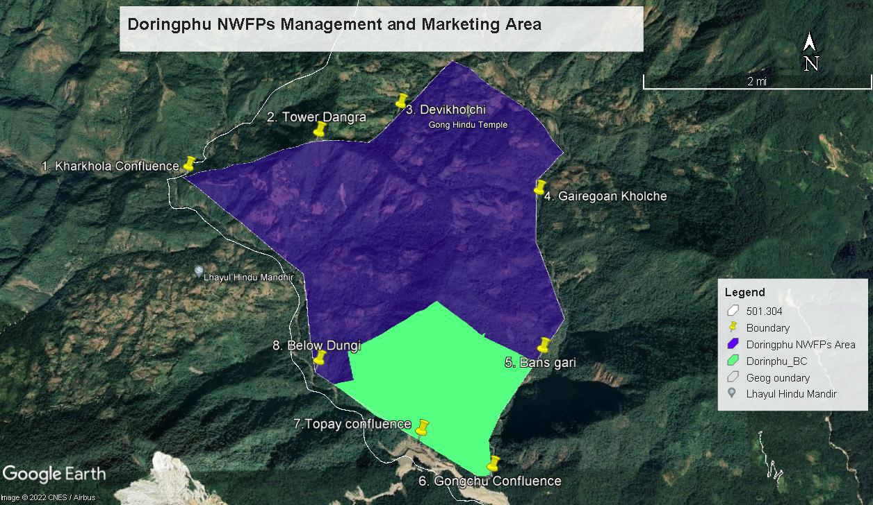
1646 HA

8. Marketing and sales plan

Total of 12 plant based NWFPs collected from the forest and one bees species raised at household will be sold by the group. Honey has been included in the plan as the group members have unanimously decided sell it through group to fetch batter price and raised group fund. The estimate for honey is based on experiences of 30 households who are raising it currently. Thus, total of 8350kgs products shall be collected and marketed annually base on the availability of markets. The details marketing and sale plans of the Doringphu Non-Wood Forest Products Management and Marketing Group is given in table 04.

Table 04: Marketing and sales plan
NWFP name | Potential market | Estimated quantity for sale per season (unit) | Expected price per unit | Total (Nu)
Piper pedicellatum (Pipla) | Domestic & Export | 800kgs | 85 | Nu. 68000.00
Rubia cordifolia (Majito) | Domestic & Export | 1200kgs | 35 | Nu. 42000.00
Zanthoxylum bungeanum (Timbur) | Domestic & Export | 250 kgs | 100 | Nu. 25000.00
Swertia chirayita (Chirato) | Domestic & Export | 300kgs | 50 | Nu. 15000.00
Thysanolaena latifolia (Kucho) | Domestic & Export | 3000 kg | 25 | Nu. 75000.00
Litsea cubeba (Sil timbur) | Domestic & Export | 1300kgs | 50 | Nu. 65000.00
Choerospondia axillaris  (Labsi) | Domestic & Export | 500kgs | 50 | Nu. 25000.00
Dendrocalamus hamiltonii  (Bamboo shoot) | Domestic & Export | 100 kgs | 50 | Nu. 5000.00
Dioscorea villosa  (Ban Tarul) | Domestic | 200 kg | 50 | Nu. 10000.00
Entada rheedii  (Pangra) | Domestic & Export | 100 kg | 50 | Nu. 5000.00
Trachycarpus fortunei  (hard broom) | Domestic & Export | 250 kg | 30 | Nu. 7500.00
Persia frutifera  (Phunchey) | Domestic | 250 kg | 60 | Nu. 15000.00
Stingless bee honey(Putka) | Domestic & Export | 100 kg/bottle | 5500 | Nu. 550000.00
Total Revenue |  | 8350kgs |  | Nu. 907500.00
Total benefits to members in a year |  | 907500/44=Nu.20625.00 |  | Nu.20625.00  =
Actual benefits/members if work for maximum of 20days |  |  |  | =(20625/20)  Nu.=1031/day

9. Marketing Arrangements

In order to prepare marketing of products a series of activities will be carried out by the group. Table 5: Financial projection of benefits to the members from NWFP sales

Table 05: Procedures for NWFP harvesting, marketing and sharing of income

Activity | Procedures
Harvesting of products | NWFPs will be harvested as per the harvesting prescriptions for sustainable harvesting prescribe in table 03.
Postharvest practices | NWFPs will be dried in the sun and packed in the cartoon box after weighing its quantity.
Marketing of products | All the dried Non-Wood Forest products will be collected and weigh individually. They will call open buyers and sellers in their area in consultation with Gewog Forestry In-Charge.
Income sharing | The payment will be made to the member s as per the quantity of collection made by them after deducting royalty, 3% Executive Committee service charge and 10% contribution to Community Development Fund.
Raising of community development fund | 10% contribution to Community Development Fund will be made in the account number of Tashiling NWFP Management and Marketing Group.
Payment to committee members for their service | 3% for committee service charge payment.

10. Benefits to members

The benefit or income from sale of Non-Wood Forest Product will be equally shared among the active members who have work for collection, transportation, seasoning and marketing of the products.

Table 06: Financial projection of benefits to the members from NWFP sales
Sl. No | Particulars | Products (names) refer to Table 4. |  |  |  |  |  |  |  |  |  |  |  |  | Total Amount (Nu)
 |  | 1  Pipla | 2  Majito | 3  Timbur | 4  Chirato | 5  Kucho | 6  Siltimbur | 7  Labsi | 8  B.shoot | 9  Tarul | 10  Pangra | 11  H.broom | 12  Phunchey | 13  Putka
1 | Revenues
a | Total quantity (unit) | 800 | 1200 | 250 | 300 | 3000 | 1300 | 500 | 100 | 200 | 100 | 250 | 250 | 100 | 8350.00-
b | Market price (Nu per unit) | 85 | 35 | 100 | 50 | 25 | 50 | 50 | 50 | 50 | 50 | 30 | 60 | 5500 | -
c | Total revenues from forest product sales (a*b) | 68000 | 42000 | 25,000 | 15000 | 75000 | 65000 | 25000 | 5000 | 10000 | 5000 | 7500 | 15000 | 550000 | 907500.00
A | Total revenues | 68000 | 42000 | 25000 | 15000 | 75000 | 65000 | 25000 | 5000 | 10000 | 5000 | 7500 | 15000 | 550000 | 907500.00
2 | Expenses
a | Packaging materials | 2000 | 1000 | 1000 | 1000 | 1000 | 1000 | 1000 | 2000 | 500 | 500 | 500 | 500 | 1000 | 13000.00
b | Royalty | 16000 | 19200 | 1000 | 7200 | 3000 | 1000 | 2000 | 200 | 150 | 250 | 100 | 250 | 2000 | 52350.00
c | Transportation costs | 1000 | 3000 | 500 | 1000 | 1000 | 1000 | 500 | 1000 | 1000 | 500 | 500 | 500 | 500 | 12000.00
d | Compensation fee to executive committee for marketing products (3%) | 2040 | 1260 | 750 | 450 | 2250 | 1950 | 450 | 150 | 300 | 150 | 225 | 450 | 16500 | 26925.00
e | Contribution to community development fund(10%) | 6800 | 4200 | 2500 | 1500 | 7500 | 6500 | 2500 | 500 | 1000 | 500 | 750 | 1500 | 55000 | 90750.00
f | Incidental expenses |  |  |  |  |  |  |  |  |  |  |  |  |  | 5000.00
B | Total expenses |  |  |  |  |  |  |  |  |  |  |  |  |  | 200025.00
C | Total benefit (net-income) of group members  (total revenues A – total expenses B) |  |  |  |  |  |  |  |  |  |  |  |  |  | 707475.00
D | Average income to group members (C/ no of group members) |  |  |  |  |  |  |  |  |  |  |  |  |  | 16079.00
E | Price per unit paid to group members (C/1a) |  |  |  |  |  |  |  |  |  |  |  |  |  | 85.00

11. Benefits to the group

The financial projection of benefits to the members from NWFP sales depict the actual benefits (Total revenue) acquired by the group members through marketing of listed NWFP species after deducting the all the total overhead expenses

Table 07: Financial projection of the benefits to the group, the community development fund

Sl. No | Particulars | Amount (Nu)
A | Revenues
1 | Membership fees | 4400.00
2 | Contribution to the Community Development Fund (CDF) from sales of product Piper longum (Pipla) | 6800.00
3 | Rubia cordifolia (Majito) | 4200.00
4 | Zanthoxylum bungeanum (Timbur) | 2500.00
5 | Swertia chirayita (Chirata) | 1500.00
6 | Thysanoleana latifolia (Kucho) | 7500.00
7 | Litsea cubeba (Siltimbur) | 6500.00
8 | Cherospondia axillaris (Labsi) | 2500.00
9 | Dendrocalamus hamiltonii (Bamboo shoot) | 500.00
10 | Dioscorea villosa (Tarul) | 1000.00
11 | Entanda Rheedii (Pangra) | 500.00
12 | Trachycarpus fortune (Hard broom) | 750.00
13 | Persea fructifera (Phunchey) | 1500.00
14 | Stingless bee honey (Putka) | 55000.00
 | Total revenues | 95,150.00
B | Expenses (only include expenses that will be paid from the group funds)
1 | Permit fees | 5000.00
2 | Annual Group Meeting | 10000.00
3 | Office stationeries procurements | 2000.00
4 | Other miscellaneous expenditures like visitors | 5000.00
 | Total Expenses | 23,000.00
C | Balance: Total revenues – total expenses | 72,150.00

Part B: Group’s BY-LAW

12. NWFP management & marketing group members | 12.1. Responsibilities and rights of members  - Members shall have authority to re-elect the executive committee members if they were disobedient  - Collect NWFP only after general meeting or upon receipt of harvesting permits from the Range office, Gelephu  - The group shall work for the interest of NWFP management and marketing group  - The group should explore market for the agreed NWFPs (14 species) and signed as per NWFP agreement protocol  - All group members should attend meeting (Annual/Quarterly/Emergency) voluntarily and with enthusiasm whenever requires  - Ensure and maintain quality products during the time of sale  - Labour hire beyond 2 labours is not allow from outside the groups as to ensure stringent management  - Collection of listed NWFPs within the family members of group members  - Pay membership fees annually  - Audit the executive members as per the situation  - Protect/stop outsiders from collecting 8 NWFPs species within the demarcated area  - Collect NWFPs which are listed in the signed agreement.  - The fund in the bank can withdraw by committee member only after the consensus of group member where the decision will take during Annual NWFPs Meeting  - Act as per the NWFP management and Marketing plan.
13. NWFP Management and Marketing Group Management Committee | Name of Chairperson:Krishna Prasad Ghimeray  Village: Dungay village  Contact No:+975-17977125

13.1. Responsibilities of Chairperson

- Coordinate and chair the meeting
- Coordinate the auctioning of the products in collaboration with the concern agencies (DFO, RO, SFED, DAMC, Traders and others )
- Solve conflicts arises within the group or with outsiders
- Explore market opportunities for 14 NWFP products specified in the signed agreement
- Seek training and technical support from relevant organizations
- Coordinate Auction for sale of products
- Direct the groups and executives members as per management plan
- Disseminate harvesting season as per the Management and marketing plan
- Represent group during the meeting or training outside the chewog
- He is the co-signatory (Secretary and Treasurer) for cash withdrawal from the bank
- Liaison with concern Agencies and traders then fix date, price and venues for marketing of NWFPs.
- Maintain attendances registers for the groups
Name of Secretary: Krishna Bahadhur Mongar,
Village:Bhag Jungi
Contact No:+975- 17879004

13.2. Responsibilities of Secretary

- Chair the meetings in the absence of the co-ordinator
- Provide assistance to the coordinator
- Maintain records and keep minutes of the meeting
- Conduct annual NWFP Meeting yearly
- Assist the Treasurer in maintaining the cashbook and bank book
- Check the quality of the products
- Maintain all the records (quantity collected and harvested records)
- Prepare annual progress reports of any other reports of group
- Exchange official correspondences
- Maintain stock registers for group
- Disseminate of information to group on the latest market information
- Resolve the boundary disputes in collaboration with coordinator
- He is the joint signatory (Chairman, Treasurer) for fund withdrawal from the bank.
- Compilation of annual work plan and progress reporting.

Name of Treasurer: Suk Kumar Mongar
Village: Gairegoan village
Contact No:+975-77248652

13.3. Responsibilities of Treasurer
- Maintain cash transaction records
- Keep record of activities carried out in the group
- Present accounts status during Annual Group Meetings.
- Attend the auction with other members of Executives Committees
- Deduct 10% from each sale of NWFP species from respective members and deposit to the group account
- Deduct 3% from each member for sale of listed NWFP species to meet incentive payment to the executive members (Coordinator, Secretary and Treasurer)
- Pay 1% each to Coordinator, Secretary and Treasurer as an annual incentive
- Assist secretary’s responsibilities when he is absent
- Collect membership fee annually and deposit in the group Account
- Collect the fine and penalties jointly with Chairman, Secretary, and deposit in the group account.
- Maintain all the sale records of listed NWFPs species during the auction.

14. Possible committee members | Name: Krishna Lal Pokerel  Village: Dungi village  Phone:+975- 17878972

14.1. Responsibilities: Group Audit

- Verify arithmetical accuracy of the accounting records.
- Verify statutory remittances and recoveries and pay roll.
- Verify physical existences of stores and NWFPS Group property.
- Verify expenditure with budget.
- Conduct physical verification of cash of Community Development Fund and its Management.

15. Tenure of committee member | The above executive members will serve for 5 years.
16. Incentives to the committee members | No salary will be paid to Chairman, Secretary and Accountant. However, a lump sum of Nu. 300/ day shall be incentivized when he/she is on duty of the NWFPs Group outside the Gewog. But, he/she shall not be eligible to such incentives if it is paid by other agencies or individuals.
17. Membership Registration fee and annual contribution | 17.1 New registration and resignation  - The communities residing and registered in the same chewog are eligible to join the Doringphu NWFP Management and Marketing Group without paying any penalties, if join within one month after the date of plan approval  - In case the family gets extended, son(s)/daughter(s) of the members can join in the group after paying only membership fees and become member.  - Others can become members outside their group must pay membership fees plus amount equivalent to one person’s shares accumulated till that year and become a member. However, he/she should have a Census and Thram in the same chewog.  - Annual membership fee is Nu. 100.  - The resignation will be accepted only after completion of formalities such as submitting an application to theChairman stating his/her problems and difficulties. The matter can further be discussed in the Annual NWFP Meeting and endorsed by all the members  - If members happen to resigned without informing to executive members or members shall fine sum of Nu.500/member plus he/she shall not entitle his or he accumulated shares till that year.  - If the members happen to transverse/migrate to other destination, then members shall allow, but without giving its benefits  - The actual share after calculating from gross amounts (Money in the group Account) will entitle only if the member is decease, retarded & no one to attend meeting on his/her behalf and it should endorse by all the group members  - If members among executive committee members does not delegate his duty as per their ToR, shall warn by the Group members (first time) and further if she/he repeat his disobediences, then shall fine Nu.500/member (second time) and terminated without benefits  - However, if the committee members/members did not function as per ToR then issues should be discussed in the annual/quarterly meeting and if he/she want to resign can do so without benefits and shall not entertain in group in the future;  - Any resignation and new comers name lists must report to DFO Officeand Beat Office for updating of member list;  - Above personal will not entertain in the group in the future.
18. NWFP group fund management and utilization | The group shall contribute 10% of the net price of NWFPs and Nu. 100/- per member annually, since the balance amount of the group fund is minimal, it will be retained un-utilized for another 5 years.  All the fines and penalties imposed and accumulated shall deposits in their account.  Donation and contribution, shall directly deposited in the account

19. Conflict resolution | In case disputes or conflicts among communities arise about access to certain areas for NWFP harvesting; the matter shall be put to the Gewog Yargay Tshogchung (GYT) Dzongkhag Yargay Tshogdue (DYT) for further decision.  Conflicts or disputes within the NWFP Management Group, which cannot be resolved by the group members shall be forwarded to the coordinator for settlement. If the case cannot be resolved, it shall be forwarded to the Gewog Administration.  In case there is a conflict between the NWFP Group and outsiders, the case shall be forwarded to the Gewog Administration by the Chairman.
20. Meeting and purpose | Group shall convene one annual meeting in the month of March to consolidate on annual work plan and progress. During that all the members shall congregated to discuss and hear their progresses. However, short meeting shall occur prior to harvest of every NWFP Products. Following information must deliberate:  Review of past minutes of meeting  Showcase and present financial statement and status to members.  Progress and challenges faced in implementation of activities.  Work planning for forth coming season or year  2/3 of members must consent as to adopt as resolution for the groups.
21. Fines and Penalties | The products from the private land can only sell to their group to avoid misuse of resources. If the product is sold directly to the trader, the group has an authority to seize and confiscate the products, sale thereof by group and amount generated shall be deposited in group account.  Anybody collecting NWFP resources before the prescript season shall fine sum of Nu.500/-defaulter. Those products shall be confiscated and revenue generated shall be credited in group account.  Collecting products inside delineated boundary by the non-member shall be liable for fine of Nu.1000/ and confiscation of products. The product confiscated shall be sold by the group and the fund generated from the sale will be deposited to the group account.  If the products bypass executive members and sale directly to the traders, defaulter shall be fine the triple market values of that products. Products shall be seized and sold by the groups and money shall be credited in group account.  Members not following the harvesting guideline prescribed in management plan during collection plan shall be fined Nu.300/occasion.  Group member not attending meeting/training/workshop, any activities related to NWFP management shall fine Nu.165/- per day and if repeated for three times, he/she shall be expelled from the group without benefits.  If the culprit refuses to pay the fines and penalties to the Committee member, the matter shall be forward to the Tshogpa and even to Gup, Gewog Administration for settlement.  Misuse of group resources by Committee members shall be an offence and shall be terminated from executive post on realization of refund of misuse amount.  Mis-users of group resources must impose double the misused resources  The re-elect the committee members during the same day of annual/quarterly meeting.
22. Restrictions for the harvesting of NWFPs | Harvesting of Non-Wood Forest Products species listed under Schedule I of the FNCRR 2017 is not permitted except under special approval by the Ministry/Royal Government of Bhutan. To harvest NWFP species listed under CITES, the CITES authorities based in the Nature Conservation Division shall be consulted before harvesting of products.
23. Tenure of management and marketing plan | The timeframe for the NWFP Management & Marketing plan shall be for a period of 5 years.
24. Power of the Department | The Department has the right to cancel the NWFP management and marketing plan in case of any violation of the management plan or in the event of inability to implement the activities as per the approved management plan.  The Department has provisional right to exercise NWFPMG base on the chapter III, section no.155 of FNCRR 2017  The Department shall:  - Suo moto or on the request by the NWFPMG take action against violator of the Act, Rules or Management plan;  - Department shall issue “NWFP Management Certificate” as per section 143 of FNCRR 2017  - Inspect, monitor, review the records of and otherwise supervise the activity of the NWFPMG

25. Monitoring and evaluation scheme

Expected result | Monitoring activities | Indicators | Means of verification | Responsible agencies | Frequency/ remarks
Application of harvesting guidelines results in sustainable resource base | Regular inspection of NWFP harvesting sites | Description on resource availability | Field trip reports | DoFPS | Regular field visits during the harvesting season
 | Recording of actual harvested quantities | Records on actual harvested quantities | No. of Harvesting & transit permits issued and record books of NWFP groups | DoFPS/ NWFP Groups | According to NWFP harvesting seasons
Income of NWFP groups enhanced | Recording of actual income from NWFP sales | Records of NWFP sales | Bank account/ record books of NWFP groups | NWFP groups | Seasonally
 | Recording of NWFP produce marketed and exported | Records of marketed and exported NWFP produce | Marketing reports  Transit permits Export permits and clearance | DoFPS | Regularly
Movement and export of NWFPs properly recorded | Regular patrols and checks of movement of NWFPs | All movement of NWFPs properly recorded | No of Harvesting/ transit/ export permits and phytosanitary certificate issued | DoFPS/  BAFRA | Regular
Implementation of NWFP framework properly monitored | Organization of coordination meetings with stakeholders | Data available about the implementation of the NWFP interim framework | Meeting minutes  Records on marketing and resources available | DoFPS/  NWFPs Group | Bi- annually
 | Annual compliance monitoring and preparation of report | Annual report showing data on marketed NWFPs, income generated and resource availability per NWFP group and district | Annual monitoring report | DoFPS/  NWFPs Group | Annually

Annexure I: Membership registration Doringphu NWFP Management and Marketing Group

Sl. No | Name | CID no | Gung no | Thram no | Village
1 | Rup Narayan Dhimal | 11308001522 | PA-8-176 | 275 | Dungay
2 | Bishnu lal Dhimal | 11308001621 | PA-8-174 | 279 | Dungay
3 | Megnath Mongar | 11308001406 | PA-8-166 | 274 | Dungay
4 | Dil Kumar Mongar | 11308001413 | PA-8-166 | 1785 | Dungay
5 | Tara Bir Mongar | 11308001405 | PA-8-531 | 274 | Dungay
6 | Sankar Dungana | 11308001490 | PA-8-166 | 274 | Dungay
7 | Kedar Nath Sharma | 11308001428 | PA-8-168 | 278 | Dungay
8 | Indra Prasad Pokherel | 11308001382 | PA-8-164 | 280 | Dungay
9 | Chandra Lal Pokherel | 11308001938 | PA-8-606 | 1148 | Dungay
10 | Padam Lal Homagai | 11308001391 | PA-8-165 | 281 | Gairegoan
11 | Tanka Nath Homagai | 11308001392 | PA-8-165 | 281 | Dungay
12 | Yad Bahadhur Lungali | 11308005955 | PA-2-178 | 282 | Dungay
13 | Dik Bir Lungali | 11308005355 | PA-8-178 | 282 | Dungay
14 | Devi Charan Phuyel | 11308001422 | PA-8-167 | 273 | Dungay
15 | Mitra Lal Bhandari | 11308005568 | PA-8-252 | 313 | Gairegon
16 | Mon Bahadur Bhandari | 11308001561 | PA-8-538 | 1758 | Gairegoan
17 | Kharka Bahadur Sarki | 113080001596 | PA-8-259 | 351 | Gairegoan
18 | Abi Narayan Sarki | 113080001596 | PA-8-253 | 356 | Gairegoan
19 | Budhi Maya Bastola | 11308005553 | PA-8-257 | 352 | Gairegoan
20 | Dal Bahadur Sarki | 11308001594 | PA-8-253 | 356 | Gairegoan
21 | Man Doj Mongar | 11308002130 | PA-8-123 | 314 | Gairegoan
22 | Bal Bahadur Mongar | 11308001541 | PA-8-180 | 282 | Gairegoan
23 | Janga Bahadur Sarki |  | PA-8-107 | 301 | Gairegoan
24 | Rabi Lal Mongar | 11308001623 | PA-8-141 | 1767 | Gairegoan
25 | Suk Man Sarki | 11308001597 | PA-8-544 | 1766 | Gairegoan
26 | Suk Kumar Mongar | 11308002789 | PA-8-544 | 1766 | Gairegoan
27 | Mothi Lal Mongar | 11308000150 | PA-8-266 | 324 | Bhag jungay
28 | Hem Lal Mongar |  | PA-8-269 | 324 | Bhag jungay
29 | Padam Lal Allay | 11308000093 | PA-8-265 | 325 | Bhag jungay
30 | Kirshna Bahadur Mongar | 11308000080 | PA-8-264 | 326 | Bhag jungay
31 | Chandra Bahadhur Fawali Mongar | 11308000058 | PA-8-262 | 327 | Bhag jungay
32 | Bal Bahadur Laya | 11308001678 | PA-8-64 | Nill | Bhag jungay
33 | Harka Man Kamey | 11308001648 | PA-8-256 | 355 | Gairegoan
34 | Ratna Bahadur Sarki | 11308001687 | PA-8-261 | 1769 | Gairegoan
35 | Padam Lal Maski Mongar | 11308002835 | PA-8-266 | 228 | Dungay
36 | Oma Kanta Ghimmery | 11308001434 | PA-8-169 | 277 | Dungay
37 | Nandey Maski Monger | 11308002838 | PA-8-266 | 228 | Dungay
38 | Sambu Mongar | 11308005313 | Pa-8-268 | 328 | Bhag jungay
39 | Bala Ram Mongar | 11308001416 | Pa-8-166 | 274 | Dungay
40 | Ramesh Mongar | 11308002790 | Pa-8-265 | 226 | Gairegoan
41 | Indra Prasad Dhimal | 11308001635 | PA-8-175 | 275 | Dungay
42 | Lal Bahadhur Sarki | 11308001674 | Pa-8-260 | 351 | Gairegoan
43 | Bishnu Lal Dhimal | 11308001621 | PA-8-178 | 275 | Dungay
44 | Dhan Bahadur Mongar | 11308002812 | Pa-8-548 | 168 | Dungay

