Document Title: PM_FW data processing module design description of Safety Control System
Document Number: 16-Q04-000394
Project Number: CT-RD-1601
Project Name: First phase of Safety Control System Development Project
Material Number: N/A
Document Version: A
Classification Level: Highly secret
Document Status: CFC
Controlled Status: Under control

Prepared by: Liu Yang | 2016-11-01
Checked by: Zhu Genghua | 2016-11-30
Countersigned by: Li Qi, Wang Dong
Approved by: Wen Yiming | 2016-12-30

Revision History
No. | Relevant Chapter | Change Description | Date | Version Before Change | Version After Change | Prepared by | Checked by | Approved by
 |  | Document created | 2016-11-1 | None | A | Liu Yang | Zhu Genghua | Wen Yiming
Relationship between this version and old versions: None.

文件名称：安全控制系统PM_FW数据处理模块设计说明书
文件编号：16-Q04-000394
项目编号：CT-RD-1601
项目名称：安全控制系统开发项目一期
物料编号：
版本号/修改码：A
文件密级：机密
文件状态：CFC
受控标识：受控

拟制：刘阳 | 2016年11月1日
审核：朱耿华 | 2016年11月30日
会签：李琦、王东
批准：温宜明 | 2016年12月30日

修订页

编  号 | 章节  名称 | 修订内容简述 | 修订  日期 | 订前  版本 | 订后  版本 | 拟制 | 审核 | 批准
 |  | 创建 | 2016-11-1 |  | A | 刘阳 | 朱耿华 | 温宜明
本版本与旧文件（版本）的关系：

Content 目录
1 Document overview 文档概述 1
1.1 Introduction 综述 1
1.2 Reference 参考文档 1
1.2.1 Project documents 内部参考文档 1
1.3 Terms and abbreviations 术语和缩略语 1
1.3.1 Terms 术语 1
1.3.2 Abbreviations 缩略语 2
2 Module overview 模块概述 3
3 Module design 模块设计 4
3.1 Function description 功能描述 4
3.2 Design concept 设计思路 4
3.2.1 IO data input/output IO数据输入输出 4
3.2.2 IO data exchange IO数据交换 5
3.2.3 IO data vote IO数据表决 6
3.3 Interface function 接口函数 8
3.4 Global variable 全局变量 9
3.5 Data structure 数据结构 9
3.6 List of sub-function 子功能列表 11
4 Design of sub-function 子功能设计 11
4.1 Module initialization 模块初始化 11
4.1.1 DataProcessInit 11
4.1.2 DataExChangeInit 12
4.2 IO data input/output IO数据输入输出 12
4.2.1 DataProcessInputHandle 12
4.2.2 DataProcessOutputHandle 14
4.2.3 DataProcessSlaveSendHandle 17
4.2.4 DataProcessSlaveRecvHandle 18
4.2.5 DataProcessGenerateSoftSOERecord 19
4.3 IO data exchange IO数据交换 21
4.3.1 DataExChange 21
4.4 IO data voting IO数据表决 23
4.4.1 DataExChangeVote 23
4.4.2 DataExChangeTriVote 24
4.4.3 DataExChangeDoulVote 28
4.4.4 DataExChangeSingleVote 33

Document overview 文档概述

Introduction 综述
This document describes the design description of data processing function of PM_FW of Safety Control System. The document describes the overall concept of the function of the module, and then the sub-function of the modules are described in detail.
This document is the output of module design phase of PM_FW, and is the input for the follow-up coding phase.
本文档描述了安全控制系统中PM_FW数据处理模块的设计方案。文档首先描述了模块功能的总体设计思路，然后将模块功能划分为若干子功能并进行详细说明。
本文档是PM_FW模块设计的输出，也是后续编码的输入。

Reference 参考文档

Project documents 内部参考文档
[1] Embedded software safety concept of Safety Control System [505], 15-Q02-000059
[1] 安全控制系统嵌入式软件安全概念说明书 [505], 15-Q02-000059
[2] PM_FW software overall design description of safety control system [506], 15-Q02-000074
[2] 安全控制系统PM_FW总体设计说明书 [506], 15-Q02-000074

Terms and abbreviations 术语和缩略语

Terms 术语
Table 1-1 Terms
表1-1 术语
No.  序号 | Term  术语 | Description  解释
 | IP_BUS | Communication between PM and IO modules.  PM与IO模块之间的通讯总线。
 | CM_BUS | Communication between PM and CM.  PM与CM之间的通讯总线。
 | PM_BUS | Communication between PMs.  PM之间的通讯总线。
 | System Net | Communication between control station and PC.  控制站与上位机之间的通讯网络。
 | Safety Net | Safe communication between control stations.  控制站之间的安全通讯。
 | Control station  控制站 | A set of triple redundant control system, which includes triple redundant PMs and IO modules under control.  一套三冗余的控制系统，包含三冗余PM和PM控制的各种IO模块。
 | System response time  系统响应时间 | Time interval from the moment that transition of demand signal generated at input ETP to the moment that transition of response signal generated at output ETP.  从系统输入端子板上产生需求信号跳变的时刻到输出端子板上产生相应的响应信号跳变之间的时间。
 | Control cycle  控制周期 | Time interval between adjacent two runs of user program execution.  PM两次执行用户程序间隔时间。
 | Project  工程 | Files which contain configuration information for control station and generated by IEC 61131 configuration software. These files contain all the information required by control station to implement control, including user control program (binaries) to be loaded and executed as well as configuration information of task, CM, PM and IO modules.  IEC 61131组态软件在完成编译后，为控制站生成的组态信息文件，该文件包含可加载执行的用户控制程序（二进制程序）、任务配置信息、CM配置信息、PM配置信息和IO模块配置信息等各种控制站完成控制所需的信息。
 | Source project  源工程文件 | Source file of the project before compiling.  工程在编译前的源文件。
 | User program  用户程序 | Part of project which contain user control program (binaries) to be loaded and executed and configuration information of task.  工程中的一部分：可加载执行的用户控制程序（二进制程序）和任务配置信息。

Abbreviations 缩略语
Table 1-2 Abbreviations
表1-2 缩略语
No.  序号 | Abbreviation  缩略语 | English description  英文 | Chinese description  中文
 | PM | Processor Module | 主处理器模块
 | CM | Communication Module | 通讯模块
 | BI | Bus Interface Module | 总线接口模块
 | AI | Analog Input Module | 模拟量输入模块
 | AO | Analog Output Module | 模拟量输出模块
 | DI | Digital Input Module | 数字量输入模块
 | DO | Digital Output Module | 数字量输出模块
 | OSP | Over Speed Protect Module | 超速保护模块
 | SOE | Sequence Of Events | SOE事件
 | SIL | Safety Integrity Level | 安全完整等级
 | PW | Power Module | 电源模块
 | OPC | OLE for Process Control | 用于过程控制的对象链接与嵌入式技术
 | UP | User Program | 用户程序

Module overview 模块概述
The location of the data processing module (marked red) in the software hierarchy is shown below.
数据处理模块（标红）在软件层次中的位置如下图所示。
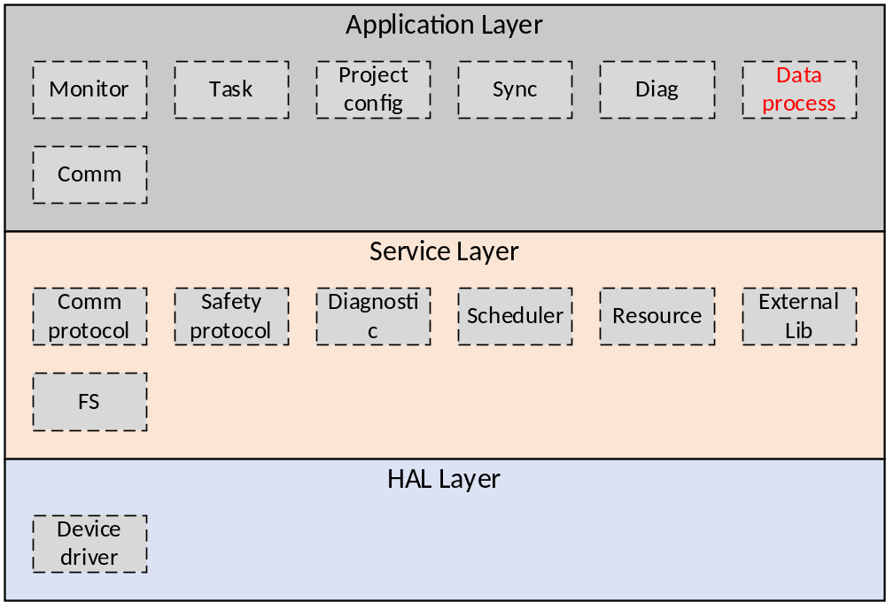Figure 2-1 the location of the data processing module
图2-1 模块位置
Data processing module is used to process IO input data and IO output data.
数据处理模块主要用于实现对IO从站数据的处理功能。

Module design 模块设计

Function description 功能描述
Each PM obtains IO input data, exchanges the input data with other PMs and votes the data. The voting results is the input to the user program. After executing the user program, three PMs exchange the output data of the user program and vote the data, and the voting result is the final output to the IO module.
各系PM模块获取IO输入数据，和其他两系交换输入数据并进行表决，表决后的结果作为各系运算的输入。运算后，三系之间交换运算结果并进行表决，表决后结果作为给IO模块的输出数据。
Therefore, this module includes three parts: IO data input/output, IO data exchange, and IO data voting.
因此，模块功能可以分为IO数据输入输出、IO数据交换和IO数据表决三个子功能。

Design concept 设计思路

IO data input/output IO数据输入输出

IO data output IO数据输出
Detailed output data process flow is shown as follows:
- Determine the IO modules which shall be polling in this cycle. Each FW cycle polls a specified number of IO modules, and each round of IO polling polls the output module first and then polls the input module.
- Obtain output data.
- Call IO data exchange function.
- Call IO data voting function.
- The output data is packaged using a safety protocol.
- Send the data to the IO module.
- End.
IO输出数据的具体处理流程如下：
- 确定本周期需要轮询的IO模块，每个FW周期轮询确定数量的IO模块，每一轮IO轮询先轮询输出模块，再轮询输入模块；
- 获取输出数据；
- 调用IO数据交换功能
- 调用IO数据表决功能
- 使用安全协议将输出数据打包；
- 将打包的数据发送IO模块；
- 结束。

IO data input IO数据输入
Detailed input data process flow is shown as follows:
- Determine the IO modules that have been polled in the current cycle.
- Obtain Input data from IO module.
- Use the safety protocol to unpack the input data.
- Process the real-time data, SOE data, diagnostic data and OSP monitoring data which are in the input data.
- Call IO data exchange function.
- Call IO data voting function.
- End
IO输入数据的具体处理流程如下：
- 确定本周期已经轮询的IO模块；
- 从IO模块获取输入数据；
- 使用安全协议将输入数据解包；
- 处理输入数据中的实时数据、SOE数据、诊断数据、OSP监控数据；
- 调用IO数据交换功能
- 调用IO数据表决功能
- 结束。

IO data exchange IO数据交换
Data exchange function provides two interface functions: input data exchange and output data exchange. The input data exchange content includes real-time input data, input data quality, IPBUS state; the output data exchange content includes real-time output data.
数据交换功能提供输入数据交换，输出数据交换两个接口函数。输入数据的交换内容包括实时输入区数据、输入区数据质量、IPBUS状态；输出数据的交换内容包括实时输出区数据。

IO data vote IO数据表决

Data vote 数据表决：
The voting mechanism is shown in the following table:
表决机制如下表所示：
Table 3-2 Vote table
表3-2 表决表
 | Quality  Channel A | Quality  Channel B | Quality  Channel C | Voting  Configuration | Voting Result
DI | Normal | Normal | Normal | — | Result of 2oo3
DI | Normal | Normal | Bad | 2oo2 | Result of 2oo2
 |  |  |  | 1oo2 | Result of 1oo2
DI | Normal | Bad | Bad | — | Channel A's value
DI | Bad | Bad | Bad | — | Value set by user
DO | Normal | Normal | Normal | — | Result of 2oo3
DO | Normal | Normal | Bad | 2oo2 | Result of 2oo2
 |  |  |  | 1oo2 | Result of 1oo2
DO | Normal | Bad | Bad | — | Channel A's value
DO | Bad | Bad | Bad | — | Safety value
AI | Normal | Normal | Normal | — | Median
AI | Normal | Normal | Bad | — | Mean
AI | Normal | Bad | Bad | — | Channel A's value
AI | Bad | Bad | Bad | — | Value set by user
AO | Normal | Normal | Normal | — | Median
AO | Normal | Normal | Bad | — | Mean
AO | Normal | Bad | Bad | — | Channel A's value
AO | Bad | Bad | Bad | — | Safety value
PI | Normal | Normal | Normal | — | Median
PI | Normal | Normal | Bad | — | Maximum
PI | Normal | Bad | Bad | — | Channel A's value
PI | Bad | Bad | Bad | — | Value set by user
- The quality of input channel is Normal only when the quality of data, the quality of IP_BUS and the quality of PM_BUS are all Normal
- The quality of output channel is Normal only when quality of data and the quality of PM_BUS are both Normal
- If an analog data is out of the tolerance, the quality is bad.
- When a task is configured as “Control” property, the task can be configured as 1oo2 or 2oo2 voting. When a task is configured as “Safety” property, only 1oo2 voting can be configured.
- 对于输入数据来说，某系数据的质量取决于数据本身的质量、IP_BUS的质量和PM_BUS的质量。如果这三个质量有一个为坏，则该系质量为坏，即该系输入数据无效。
- 对于输出数据来说，数据质量取决于数据本身的质量和PM_BUS的质量。如果这两个质量有一个为坏，则该系质量为坏，即该系输出数据无效。
- 对于模拟量输入来说，如果其中某一系的值超过偏差允许的范围，则该系质量为坏，即该系输入数据无效。
- 对于数字量数据来说，在control方式下，用户可配置两系质量好时按照1oo2或2oo2表决；在safety运行方式下，两系质量好时只能按照1oo2表决。

Offset error 偏移故障
The dead zone size in the fixed offset is the span * dead zone percentage. For the analog input data, the dead zone percentage is set to 2%. When a fixed offset error occurs for a voting values, this value does not participate voting.
固定偏移中死区的大小为量程*百分比，对于模拟量输入数据，死区百分比定为2%，当一系表决值发生固定偏移故障时，这一值不参与表决。
The fixed offset judgment shown in the below table is the case when the three channel’s quality are all normal. If only two channel’s quality are normal, when the offset between the two channel’s data is greater than the dead zone size, the two channel’s data are both considered as bad.
三系数据质量都为好时，进行的偏差判断如下表所示。当只有两系数据为好时，两系数据的差的绝对值大于死区时，认为两系数据都为坏。
Table 3-1 Fixed offset judgment
表3-1 固定偏差判断
offset between the data, X is the dead zone size  两系差值，X为死区大小 |  | Judgment result  结果
|A – C| <= X | |A – B| <= X | Channel A quality is normal  A质量为好
|A – C| <= X | |A – B| > X | Channel A quality is normal  A质量为好
|A – C| > X | |A – B| <= X | Channel A quality is normal  A质量为好
|A – C| > X | |A – B| > X | Channel A quality is bad  A质量为坏
|B – A | <= X | |B – C| <= X | Channel B quality is normal  B质量为好
|B – A| <= X | |B – C| > X | Channel B quality is normal  B质量为好
|B – A| > X | |B – C| <= X | Channel B quality is normal  B质量为好
|B – A| > X | |B – C| > X | Channel B quality is bad  B质量为坏
|C – B| <= X | |C – A| <= X | Channel C quality is normal  C质量为好
|C – B| <= X | |C – A| > X | Channel C quality is normal  C质量为好
|C – B| > X | |C – A| <= X | Channel C quality is normal  C质量为好
|C – B | > X | |C – A | > X | Channel C quality is bad  C质量为坏

Interface function 接口函数
The interface functions which is provided by this module is shown as follows:
模块提供的接口函数如下：
- void DataProcessInit(void)
Input argument  输入参数 | Output argument  输出参数 | Description  描述
No.  无。 | No.  无。 | Module initialization.  模块初始化。
- void DataProcessOutputHandle(void)
Input argument  输入参数 | Output argument  输出参数 | Description  描述
No.  无。 | No.  无。 | Output data processing interface function.  输出数据处理调用接口
- void DataProcessInputHandle ()
Input argument  接口输入参数 | Output argument  接口输出参数 | Description  描述
No.  无。 | No.  无。 | Input data processing interface function.  输出数据处理调用接口

Global variable 全局变量
Table 3-1 Global variable list
表3-1 全局变量列表
No.  序号 | Type  变量类型 | Name  名称 | Description  描述
 | uint32_t | uiUP1RollingSlaveNum | UP1 IO polling number.  任务1从站轮询个数
 | uint32_t | uiUP2RollingSlaveNum | UP2 IO polling number.  任务2从站轮询个数
 | uint8_t | s_ucChannelTolerate | Tolerance number  容忍次数
 | uint8_t | ucDataProcessSOELastVar | Soft SOE last value  软SOE上一拍值
 | uint8_t | ucUP1RollingSlaveNo | UP1 IO polling slave No.  任务1从站轮询从站号
 | uint8_t | ucUP2RollingSlaveNo | UP2 IO polling slave No.  任务2从站轮询从站号

Data structure 数据结构
- Slave slot head structure
typedef struct DataProcessSlaveSlotHeaderTag
{
uint8_t ucSlotType;
uint8_t ucSlotLen;
}DataProcessSlaveSlotHeader_t;

- Slave SOE data structure
typedef struct DataProcessHardSOEDataTag
{
uint32_t uiSOETick;
uint8_t ucChannelNo;
uint8_t ucEventState;
}DataProcessHardSOEData_t;

- Slave state, temperature, device diagnostic data structure
typedef struct DataProcessStateDiagDataTag
{
uint8_t ucStateDiag;
uint8_t ucTempDiag;
uint8_t uiDeviceDiag[4];
}DataProcessStateDiagData_t;

- Slave channel diagnostic data structure
typedef struct DataProcessChannelDiagDataTag
{
uint8_t ucChannelNo;
uint8_t ucChannelDiag[3];
}DataProcessChannelDiagData_t;

- OSP monitor data type A
typedef struct DataProcessOSPDiagDataOneTag
{
uint32_t uiPRPMA;
uint32_t uiPRPMB;
uint32_t uiPRPMC;
uint32_t uiPAccelA;
uint32_t uiPAccelB;
uint32_t uiPAccelC;
uint32_t uiAlarmPackA;
uint32_t uiAlarmPackB;
uint32_t uiAlarmPackC;
uint8_t ucDigPackA;
uint8_t ucDigPackB;
uint8_t ucDigPackC;
}DataProcessOSPDiagDataOne_t;

- OSP monitor data type B
typedef struct DataProcessOSPDiagDataTwoTag
{
uint8_t ucDigPackA;
uint8_t ucDigPackB;
uint8_t ucDigPackC;
}DataProcessOSPDiagDataTwo_t;

List of sub-function 子功能列表
The sub-functions list is shown as follows:
子功能列表如下。
Table 3-2 Sub function list
表3-2 子功能列表
Sub function No.  子功能编号 | Function description  功能描述
SWDD-PM-DP_SafR_NSecR_A_001 | Module initialization.  模块初始化
SWDD-PM-DP_SafR_NSecR_A_002 | IO data input/output  IO数据输入输出
SWDD-PM-DP_SafR_NSecR_A_003 | IO data exchange  IO数据交换
SWDD-PM-DP_SafR_SecR_A_004 | IO data voting  IO数据表决

Design of sub-function 子功能设计

Module initialization 模块初始化
SWDD-PM-DP_SafR_NSecR_A_001

DataProcessInit

Function Description 功能描述
This function completes initialization of module.
该函数完成数据处理模块的初始化。

Argument Description 参数说明
- Definition 函数定义
void DataProcessInit(void)
- Input argument 输入参数
No.
无。
- Output argument 输出函数
No.
无。

Processing flow 处理流程
This function has no branch and the processing flow is omitted.
此函数无分支，流程图省略。

DataExChangeInit

Function Description 功能描述
This function completes initialization of data exchange.
该函数完成数据交换的初始化。

Argument Description 参数说明
- Function Definition 函数定义
void DataExChangeInit(void)
- Input argument 输入参数
No.
无。
- Output argument 输出函数
No.
无。

Processing flow 处理流程
This function has no branch and the processing flow is omitted.
此函数无分支，流程图省略。

IO data input/output IO数据输入输出
SWDD-PM-DP_SafR_NSecR_A_002
This sub-function is used to process the IO input/output data cyclically.
本子功能用于周期进行IO数据输入输出处理。

DataProcessInputHandle

Function Description 功能描述
This function is used to process the IO input data cyclically.
本函数用于周期进行IO数据输入处理。

Argument Description 参数说明
- Function Definition 函数定义
void DataProcessInputHandle(void)
- Input argument 输入参数
No.
无。
- Output argument 输出函数
No.
无。

处理流程
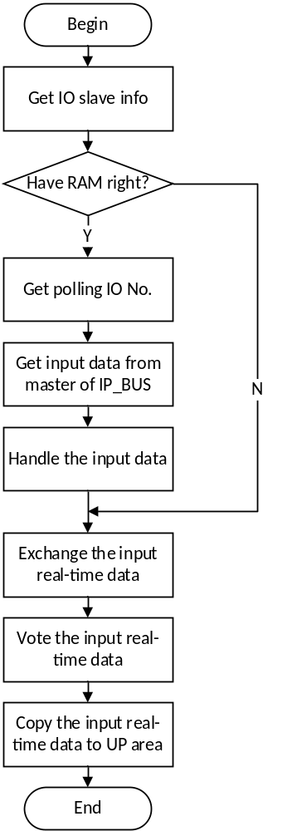
Figure 4-1 input data handle processing flow
图4-1 输入数据处理流程图

DataProcessOutputHandle

Function Description 功能描述
This function is used to process the IO output data cyclically.
本函数用于周期进行IO数据输出处理。

Argument Description 参数说明
- Function Definition 函数定义
void DataProcessOutputHandle(void)
- Input argument 输入参数
No.
无。
- Output argument 输出函数
No.
无。

处理流程
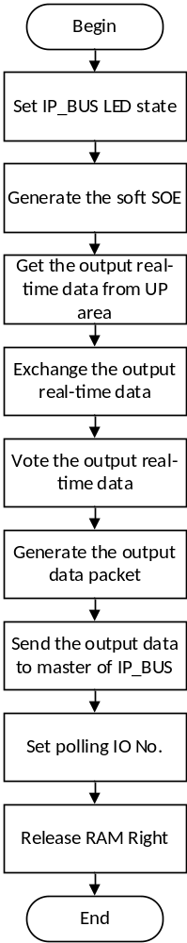
Figure 4-1 input data handle processing flow
图4-1 输入数据处理流程图

DataProcessSlaveSendHandle

Function Description 功能描述
This function is used to generate the output data packet.
本函数用于生成从站输出数据包。

Argument Description 参数说明
- Function Definition 函数定义
static void DataProcessSlaveSendHandle(Task_ID_t emTaskID, uint8_t ucSendDest[], uint8_t ucSlaveNo, bool_t bActiveFV, bool_t bEnableFlg)
- Input argument 输入参数
emTaskID: UP task ID, 任务ID
ucSendDest: Send data buffer, 输出数据缓存
ucSlaveNo: Slave No, 从站号
bActiveFV: Safety flag, 安全标志位
bEnableFlg: Slave enable flag, 模块使能标志位
- Output argument 输出函数
ucSendDest: Send data buffer after handling, 处理后输出数据

处理流程
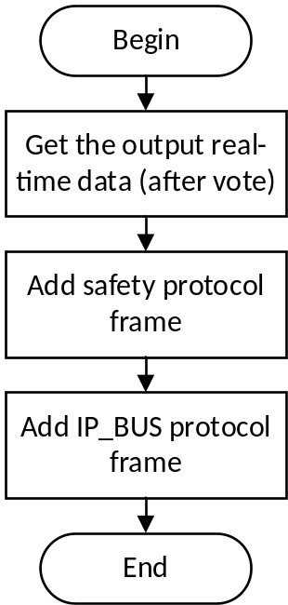
Figure 4-3 generate the output data packet processing flow
图4-3 生成输出数据包

DataProcessSlaveRecvHandle

Function Description 功能描述
This function is used to process the IO slave input data.
本函数用于处理IO模块的输入数据。

Argument Description 参数说明
- Function Definition 函数定义
static uint8_t DataProcessSlaveRecvHandle(Task_ID_t emTaskID, uint8_t ucRecvSrc[], uint8_t ucSlaveNo, uint16_t usModTag)
- Input argument 输入参数
emTaskID: UP task ID, 任务ID
ucRecvSrc: Input data, 输入数据
ucSlaveNo: Slave No, 从站号
usModTag: Module type, 模块类型
- Output argument 输出函数
No.
无。

处理流程
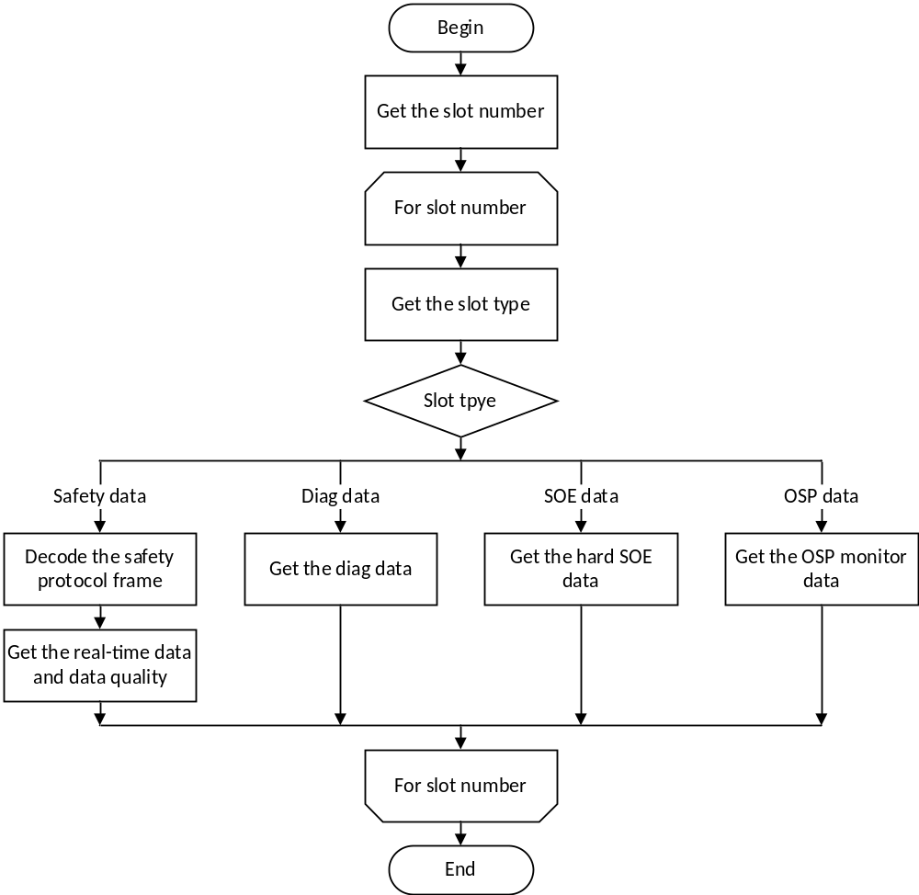
Figure 4-4 parse the input data packet processing flow
图4-4 解析输入数据包

DataProcessGenerateSoftSOERecord

Function Description 功能描述
This function is used to generate soft SOE record.
本函数用于生成软SOE记录。

Argument Description 参数说明
- Function Definition 函数定义
static void DataProcessGenerateSoftSOERecord(uint8_t ucSOEBlockNo)
- Input argument 输入参数
ucSOEBlockNo: SOE block No., 软SOE块号
- Output argument 输出函数
No.
无。

处理流程
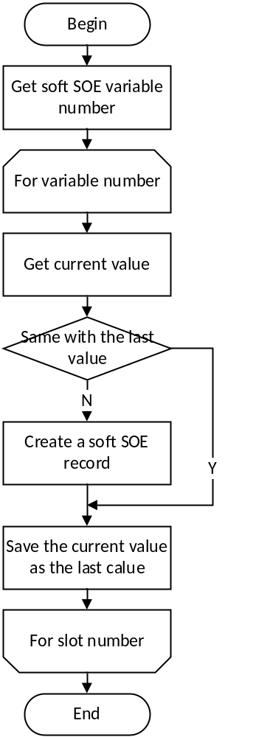
Figure 4-5 generate soft SOE record processing flow
图4-5 生成软SOE记录

IO data exchange IO数据交换
SWDD-PM-DP_SafR_NSecR_A_003

DataExChange

Function Description 功能描述
This function is used to exchange data with other PMs.
该函数负责和其他模块交换数据。

Argument Description 参数说明
- Function Definition 函数定义
void DataExChange(uint8_t ucSrcData[], uint16_t usSrcDataLen,
uint8_t ucPreData[], uint8_t ucNextData[], puint8_t pucPreDataFlg, puint8_t pucNextDataFlg)
- Input argument 输入参数
ucSrcData: data need to be exchange, 需交换的数据
usSrcDataLen: data length, 数据长度
- Output argument 输出函数
ucPreData: Pre PM data, 前一系PM数据
ucNextData: Next PM data, 后一系PM数据
pucPreDataFlg: Pre PM data state, 前一系PM数据状态
pucNextDataFlg: Next PM data state, 后一系PM数据状态

处理流程
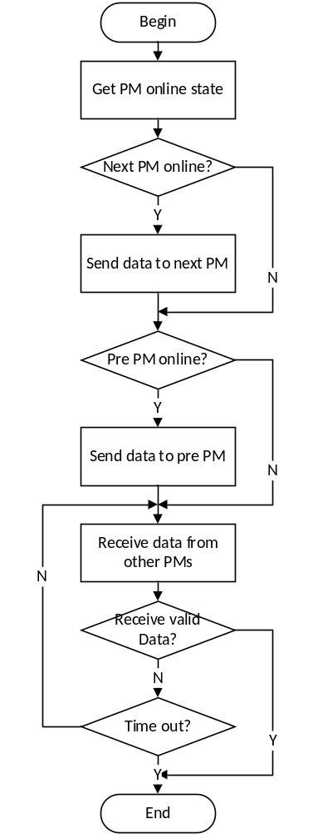
Figure 4-6 data exchange processing flow
图4-6 数据交换

IO data voting IO数据表决
SWDD-PM-DP_SafR_SecR_A_004

DataExChangeVote

Function Description 功能描述
This function is used to vote IO data cyclically.
本函数用于进行IO数据表决。

Argument Description 参数说明
- Function Definition 函数定义
bool_t DataExChangeVote(Task_ID_t emTaskID, uint8_t ucModID , uint8_t ucData1[], uint8_t ucData2[], uint8_t ucData3[], uint8_t ucOldData[],uint8_t ucDestBuff[], uint8_t ucDiagBuff[])
- Input argument 输入参数
emTaskID: UP task ID, 任务ID
ucModID: IO module No, 从站号
ucData1: Data1, 数据1
ucData2: Data2, 数据2
ucData3: Data3, 数据3
ucOldData: old data, 上一拍数据
- Output argument 输出函数
ucDestBuff: data after voting, 表决后数据
ucDiagBuff: vote state, 表决的状态

处理流程
Determine how data are handled: triple voting, double voting or single voting according to the parameters ucData1, ucData2, ucData3 state, or determine to use old value or safe state according to tolerance judgment.
根据参数中ucData1，ucData2，ucData3的状态确定采用三系表决、两系表决、一系表决，或者根据容忍状态使用老值或者是安全值。
This function has no branch and the processing flow is omitted.
此函数无分支，流程图省略。

DataExChangeTriVote

Function Description 功能描述
This function is used to triple vote.
本函数用于三系数据表决。

Argument Description 参数说明
- Function Definition 函数定义
static bool_t DataExChangeTriVote(Task_ID_t emTaskID,uint8_t ucModID , uint8_t ucData1[], uint8_t ucData2[], uint8_t ucData3[], uint8_t ucOldData[],uint8_t ucDestBuff[], uint8_t ucDiagBuff[])
- Input argument 输入参数
emTaskID: UP task ID, 任务ID
ucModID: IO module No, 从站号
ucData1: Data1, 数据1
ucData2: Data2, 数据2
ucData3: Data3, 数据3
ucOldData: old data, 上一拍数据
- Output argument 输出函数
ucDestBuff: data after voting, 表决后数据
ucDiagBuff: vote state, 表决的状态

处理流程
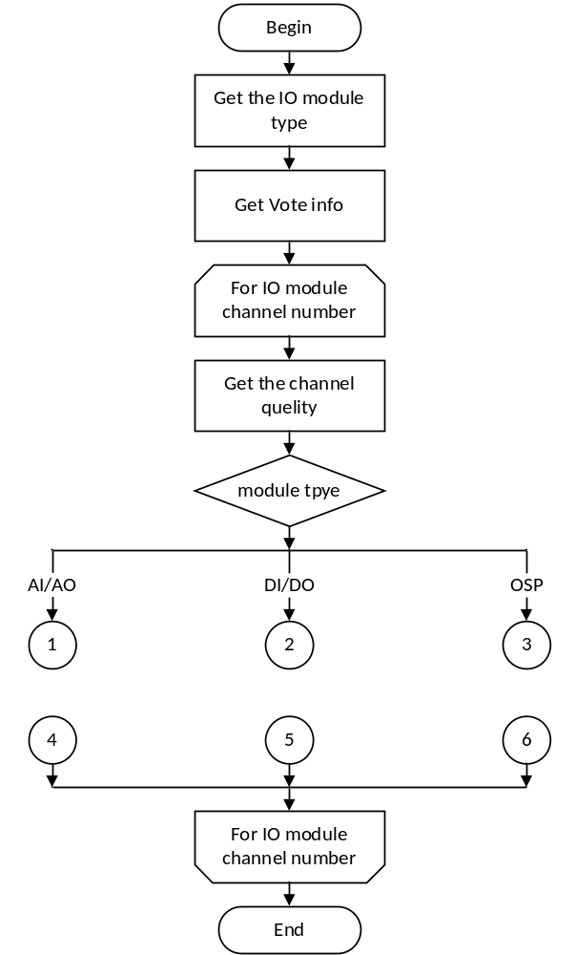
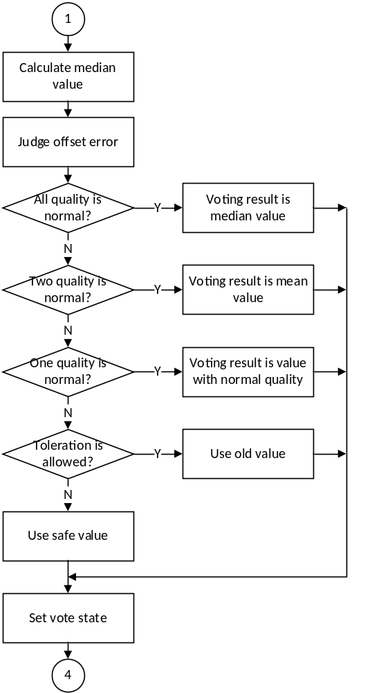
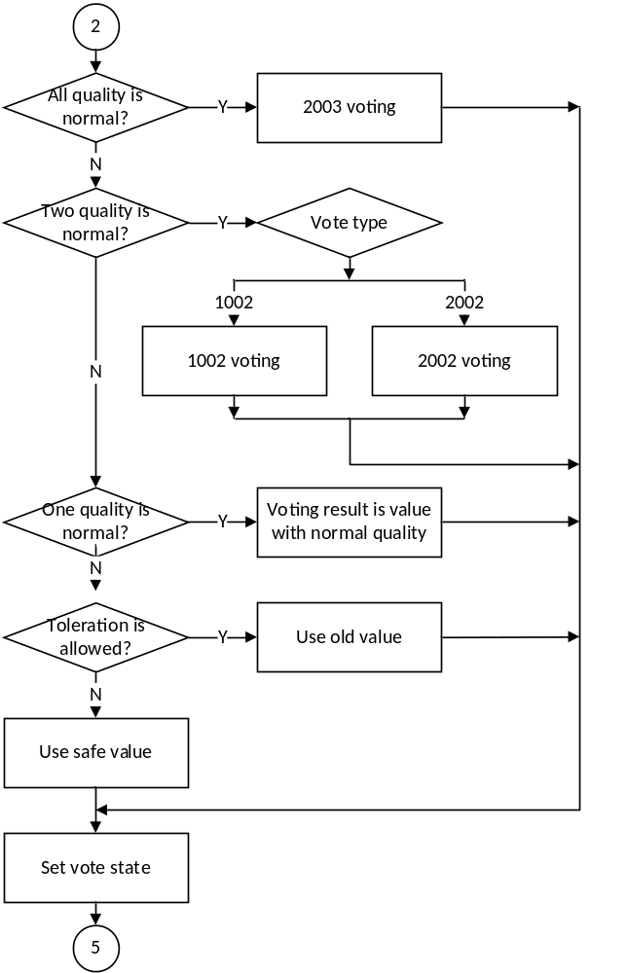
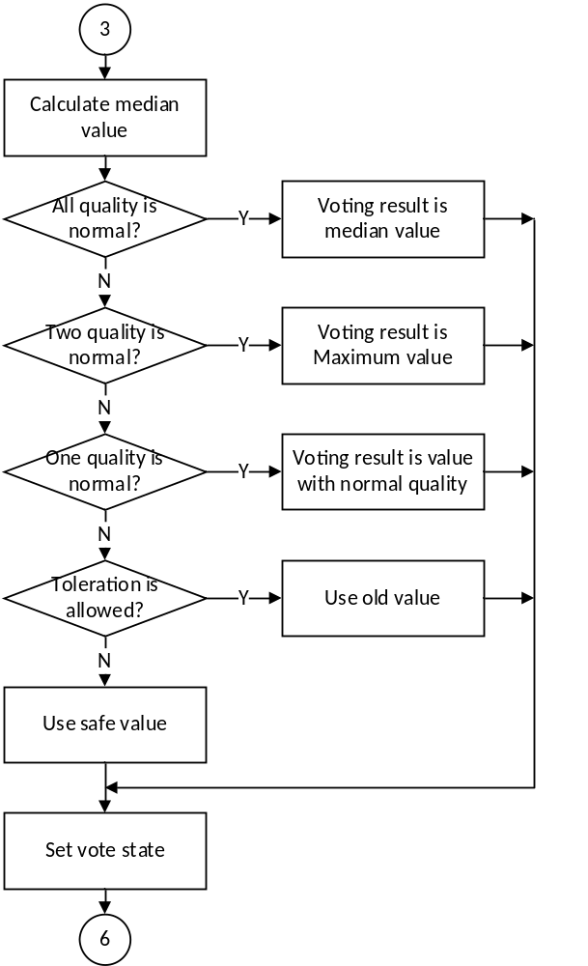
Figure 4-7 triple voting processing flow
图4-7 三系数据表决

DataExChangeDoulVote

Function Description 功能描述
This function is used to double vote.
本函数用于两系数据表决。

Argument Description 参数说明
- Function Definition 函数定义
static bool_t DataExChangeDoulVote(Task_ID_t emTaskID,uint8_t ucModID , uint8_t ucData1[], uint8_t ucData2[], uint8_t ucOldData[],uint8_t ucDestBuff[], uint8_t ucDiagBuff[])
- Input argument 输入参数
emTaskID: UP task ID, 任务ID
ucModID: IO module No, 从站号
ucData1: Data1, 数据1
ucData2: Data2, 数据2
ucOldData: old data, 上一拍数据
- Output argument 输出函数
ucDestBuff: data after voting, 表决后数据
ucDiagBuff: vote state, 表决的状态

处理流程
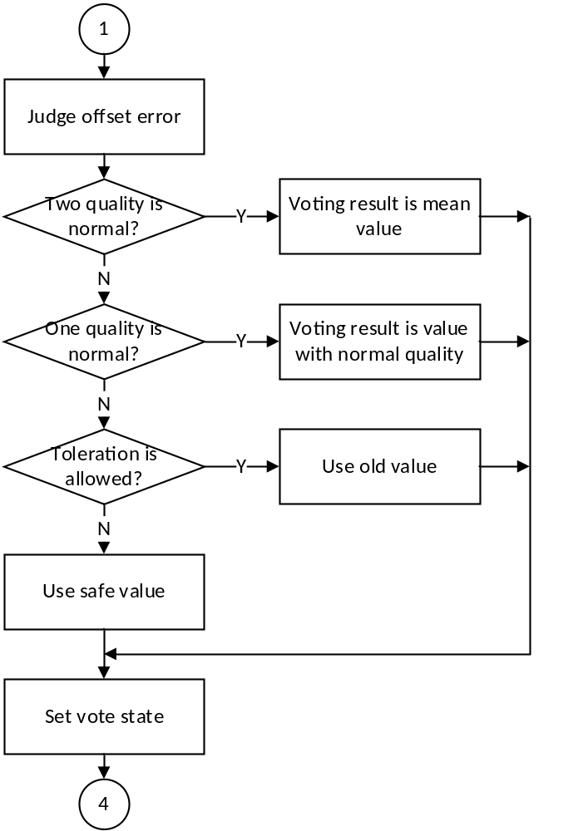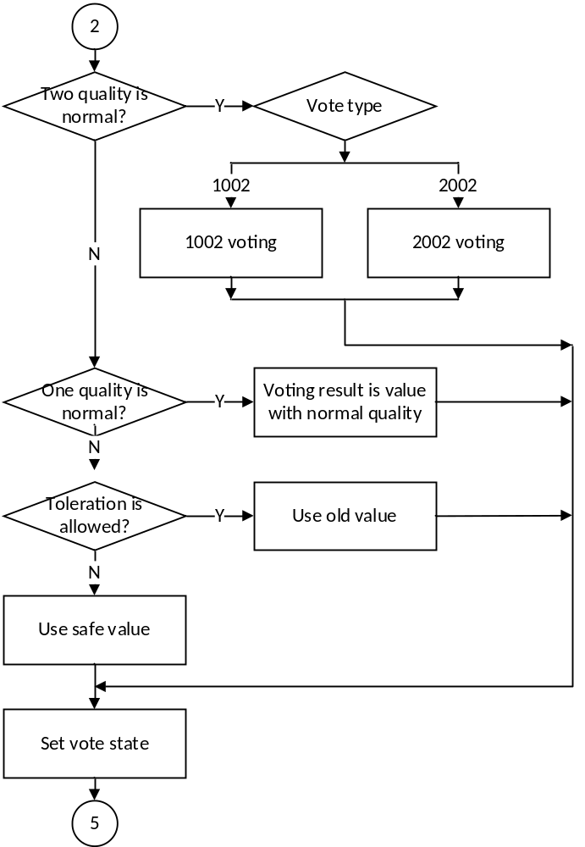
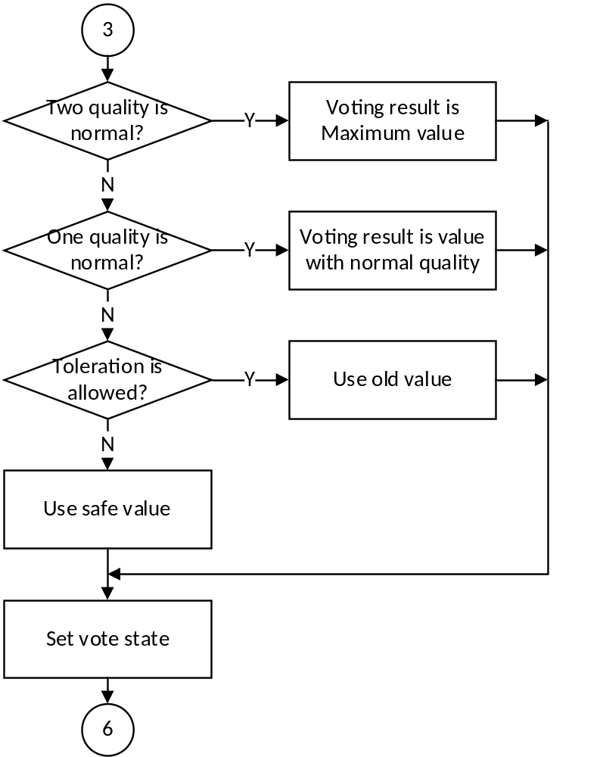
Figure 4-8 double voting processing flow
图4-8 两系数据表决

DataExChangeSingleVote

Function Description 功能描述
This function is used to single vote.
本函数用于单系数据表决。

Argument Description 参数说明
- Function Definition 函数定义
void DataProcessOutputHandle(void)
static bool_t DataExChangeSingleVote(Task_ID_t emTaskID,uint8_t ucModID , uint8_t ucData1[], uint8_t ucOldData[],uint8_t ucDestBuff[], uint8_t ucDiagBuff[])
- Input argument 输入参数
emTaskID: UP task ID, 任务ID
ucModID: IO module No, 从站号
ucData1: Data1, 数据1
ucOldData: old data, 上一拍数据
- Output argument 输出函数
ucDestBuff: data after voting, 表决后数据
ucDiagBuff: vote state, 表决的状态

处理流程
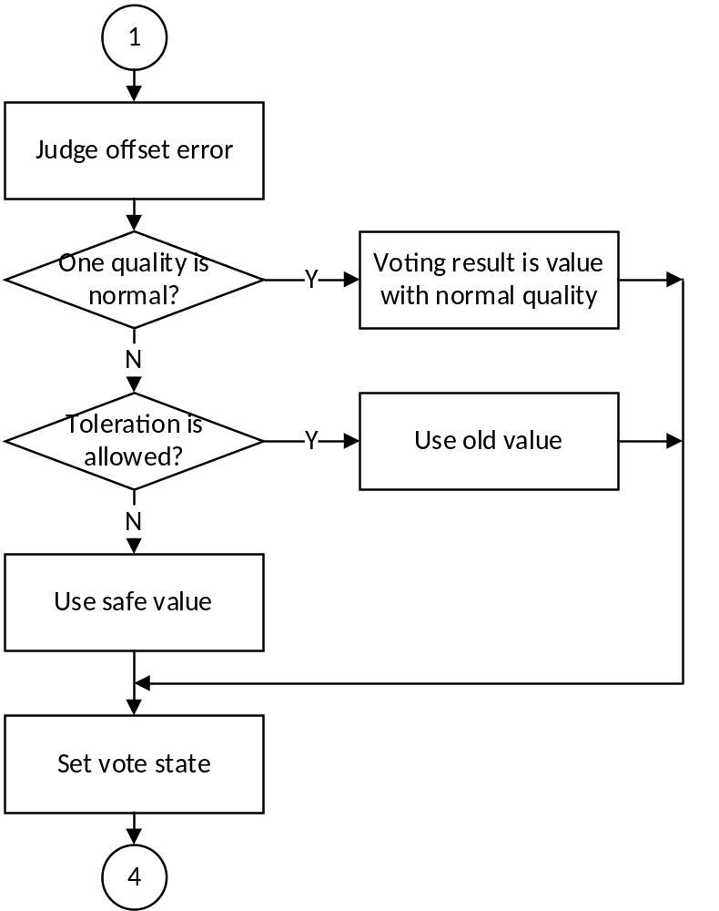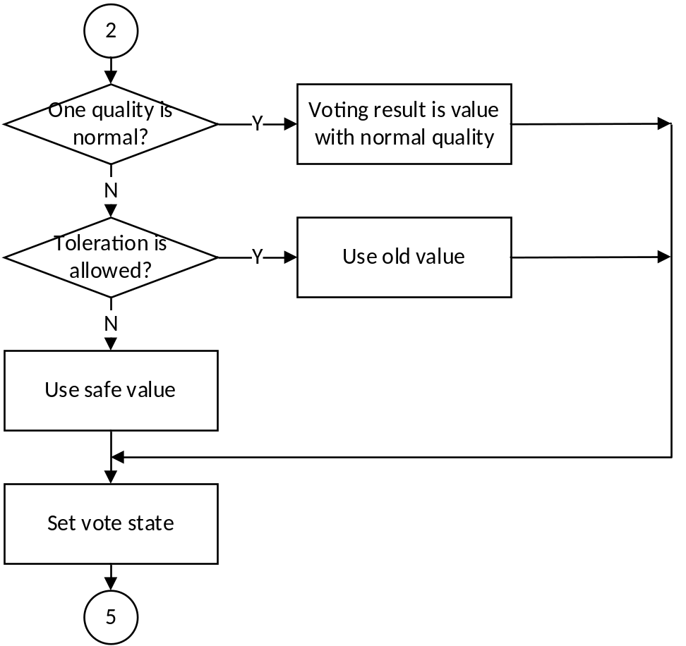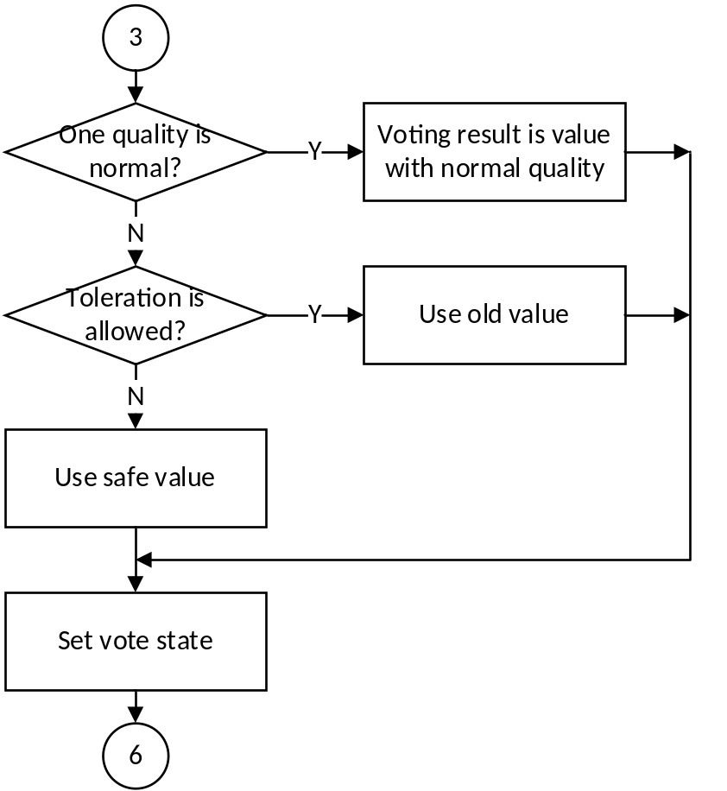
Figure 4-7 single voting processing flow
图4-7 单系数据表决

——以下无正文

