Document Title: CM_FW general design description of Safety Control System
Document Number: 15-Q02-000098
Project Number: SF-RD-1501
Project Name: First phase of Safety Control System Development Project
Material Number: N/A
Document Version: A
Classification Level: Highly secret
Document Status: CFC
Controlled Status: Under control

Prepared by: Li Qi | 2015-09-15
Checked by: Zhu Genghua | 2015-10-15
Countersigned by:
Approved by: Wen Yiming | 2015-10-20

Revision History
No. | Relevant Chapter | Change Description | Date | Version Before Change | Version After Change | Prepared by | Checked by | Approved by
 |  | Document created | 2015-09-15 | None | A | Li Qi | Zhu Genghua | Wen Yiming
Relationship between this version and old versions: None.

文件名称：安全控制系统CM_FW总体设计说明书
文件编号：15-Q02-000098
项目编号：SF-RD-1501
项目名称：安全控制系统开发项目一期
物料编号：--
版本号/修改码：A
文件密级：秘密
文件状态：CFC
受控标识：受控

拟制：李琦 | 2015年09月15日
审核：朱耿华 | 2015年10月15日
会签：
批准：温宜明 | 2015年10月20日

修订页

编  号 | 章节  名称 | 修订内容简述 | 修订  日期 | 订前  版本 | 订后  版本 | 拟制 | 审核 | 批准
 |  | 创建 | 2015-09-15 |  | A | 李琦 | 朱耿华 | 温宜明
本版本与旧文件（版本）的关系：

目录
1 Document overview 文档概述 1
1.1 Introduction 综述 1
1.2 Reference 参考文档 1
1.2.1 Project documents 内部参考文档 1
1.3 Terms and abbreviations 术语及缩略语定义 1
1.3.1 Terms 术语 1
1.3.2 Abbreviations缩略语 2
2 Software Organization Structure 软件组织结构 3
2.1 Software layer 软件层次 3
2.2 Software module division 软件模块划分 3
3 Module function division 模块功能划分 4
3.1 Task module 任务模块 4
3.2 Internal communication module 内部通讯模块 5
3.3 External communication module 外部通讯模块 5
3.4 PC Software application module 上位机软件应用模块 5
3.5 P2P application module P2P应用模块 6
3.6 Modbus application module Modbus应用模块 6
3.7 Timing module 校时模块 6
3.8 System resource management module 系统资源管理模块 6
3.9 Configuration module 配置模块 7
3.10 Device driver module 设备驱动模块 7

Document overview 文档概述

Introduction 综述
The document describes the software hierarchy of the CM_FW, divides the CM_FW into multiple modules, and explains the function of each module.
This document is the output of general design phase of CM_FW, and is the input for the module design phase.
本文是安全控制系统中CM_FW的总体设计。文档描述了CM_FW的软件层次结构，将CM_FW划分为多个模块，并对每个模块的功能加以说明。
本文档是CM嵌入式软件总体设计的输出，也是后续软件模块设计的输入。

Reference 参考文档

Project documents 内部参考文档
[1] Embedded software safety concept of Safety Control System [505], 15-Q02-000059
[1] 安全控制系统嵌入式软件安全概念说明书 [505], 15-Q02-000059

Terms and abbreviations 术语及缩略语定义

Terms 术语
Table 1-1 Terms
表1-1 术语
No.  序号 | Term  术语 | Description  解释
 | IP_BUS | Communication between PM and IO modules.  PM与IO模块之间的通讯总线。
 | CM_BUS | Communication between PM and CM.  PM与CM之间的通讯总线。
 | PM_BUS | Communication between PMs.  PM之间的通讯总线。
 | System Net | Communication between control station and PC.  控制站与上位机之间的通讯网络。
 | Safety Net | Safe communication between control stations.  控制站之间的安全通讯。
 | Control station  控制站 | A set of triple redundant control system, which includes triple redundant PMs and IO modules under control.  一套三冗余的控制系统，包含三冗余PM和PM控制的各种IO模块。
 | System response time  系统响应时间 | Time interval from the moment that transition of demand signal generated at input ETP to the moment that transition of response signal generated at output ETP.  从系统输入端子板上产生需求信号跳变的时刻到输出端子板上产生相应的响应信号跳变之间的时间。
 | Control cycle  控制周期 | Time interval between adjacent two runs of user program execution.  PM两次执行用户程序间隔时间。
 | Project  工程 | Files which contain configuration information for control station and generated by IEC 61131 configuration software. These files contain all the information required by control station to implement control, including user control program (binaries) to be loaded and executed as well as configuration information of task, CM, PM and IO modules.  IEC 61131组态软件在完成编译后，为控制站生成的组态信息文件，该文件包含可加载执行的用户控制程序（二进制程序）、任务配置信息、CM配置信息、PM配置信息和IO模块配置信息等各种控制站完成控制所需的信息。
 | Source project  源工程文件 | Source file of the project before compiling.  工程在编译前的源文件。
 | User program  用户程序 | Part of project which contain user control program (binaries) to be loaded and executed and configuration information of task.  工程中的一部分：可加载执行的用户控制程序（二进制程序）和任务配置信息。

Abbreviations缩略语
Table 1-2 Abbreviations
表1-2 缩略语
No.  序号 | Abbreviation  缩略语 | English description  英文 | Chinese description  中文
 | PM | Processor Module | 主处理器模块
 | PM_FW | PM firmware | PM固件
 | CM | Communication Module | 通讯模块
 | CM_FW | CM firmware | CM固件
 | BI | Bus Interface Module | 总线接口模块
 | AI | Analog Input Module | 模拟量输入模块
 | AO | Analog Output Module | 模拟量输出模块
 | DI | Digital Input Module | 数字量输入模块
 | DO | Digital Output Module | 数字量输出模块
 | OSP | Over Speed Protect Module | 超速保护模块
 | SOE | Sequence Of Events | SOE事件
 | SIL | Safety Integrity Level | 安全完整等级
 | PW | Power Module | 电源模块
 | OPC | OLE for Process Control | 用于过程控制的对象链接与嵌入式技术
 | UP | User Program | 用户程序

Software Organization Structure 软件组织结构

Software layer 软件层次
CM_FW is divided into three layers, including the task layer, the application module layer and the driver layer, as shown in the following figure. The OS is linux, which is not in the CM_FW development scope.
软件层次划分如下图所示，包括任务层，应用模块层和驱动层。OS使用linux，不在CM_FW开发范围内。
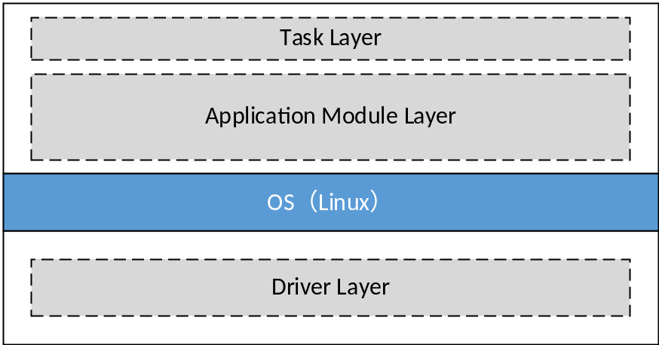
Figure 3-1 software layer
图3-1 软件层次

Software module division 软件模块划分
The software module division is shown in the following figure:
软件模块划分如图3-2所示。
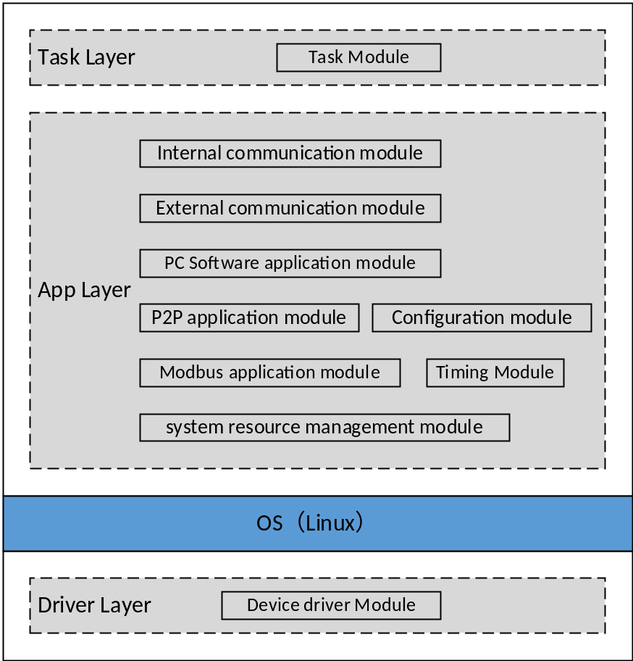
Figure 3-2 module division
图3-2 模块划分
The task layer includes task module. The application module layer includes the internal communication module, the external communication module, the PC Software application module, the P2P application module, the Modbus application module, the configuration module, timing module, and system resource management module. The driver layer includes device driver module.
任务层包括任务模块。应用模块层包括内部通讯模块、外部通讯模块、上位机应用模块、P2P应用模块、Modbus应用模块、配置模块、校时模块及系统资源管理模块。驱动层包括设备驱动模块。

Module function division 模块功能划分

Task module 任务模块
SWOD-CM_NSafR_NSecR_A_001
Initialize each application module at startup, and if a fault is detected during initialization, record the fault and stop the system.
对各应用模块进行初始化，若初始化时检查出故障，则记录故障并停止系统运行。
Call the periodic function of each application module cyclically.
依次调用各应用模块的周期运行函数。

Internal communication module 内部通讯模块
SWOD-CM_NSafR_SecR_A_002
This module implements the periodic communication between PM and CM.
The module gets the data (PC software commands, CM status data, etc) from the system resource management module, packs the data and then sends it to the PM.
The module receives data packets from the PM and parses them. After the analysis, the data (real-time data, SOE data, Modbus data, etc.) will be put into the system resource management module.
本模块完成PM与CM间的周期通讯。模块从系统资源管理模块中取得需要发送给PM的数据、命令等，组包后发送给PM。接收来自PM的数据包，并对其进行解析。解析后将数据（实时数据、SOE数据、Modbus数据等）放入系统资源管理模块中。

External communication module 外部通讯模块
SWOD-CM_NSafR_SecR_A_003
This module provides TCP/UDP protocol interface functions.
This module provides Modbus RTU protocol interface functions.
This module receives data packets from the PC software or a third party system, parse the data packets and put the data into the system resource management module.
提供TCP/UDP协议相关接口函数。
提供Modbus RTU协议相关接口函数。
接受来自上位机软件或第三方系统的数据包，对数据包解析后分类放入系统资源管理模块中。

PC Software application module 上位机软件应用模块
SWOD-CM_NSafR_SecR_A_004
This module processes the data from the PC software. According to the data type, the command that needs PM processing are written into the system resource management module, and the response data from the PM in the system resource management module are sent to the PC software. The commands that do not need PM processing are processed and responsed directly by this module.
PC software includes: SOE software, third-party AMS software, Diagnostic software, Configuration software, OPC Server.
该模块用于处理来自上位机软件的数据。根据数据类型，将需要PM处理的命令写入系统资源管理模块中，并将系统资源管理模块中来自PM的应答数据发送给上位机软件；直接处理不需要PM处理的命令，并将发送应答给上位机软件。
上位机软件主要包括SOE软件，第三方AMS软件，诊断软件，组态软件，OPC Server。

P2P application module P2P应用模块
SWOD-CM_NSafR_SecR_A_005
This module receives P2P data from other control stations, writes the data into the system resource management module, and forwards the response from the PM to the corresponding control station.
The module sends the P2P data in system resource module to other control stations and receives responses from other control stations and stores them in the system resource management module.
接收来自其它控制站的P2P数据，将数据存入系统资源管理模块中，并将来自PM的应答转发给相应控制站。
将系统资源模块中来自PM的P2P数据发送出去，接收来自其它控制站的应答并存入系统资源管理模块。

Modbus application module Modbus应用模块
SWOD-CM_NSafR_SecR_A_006
Construct modbus request message, and send to the modbus slave station. Decode response message from the modbus slave station, and send data to PM module;
Decode request message from the modbus master station, and send data to PM module. Construct modbus response message, and send to the modbus master station.
构造Modbus请求帧，并发送给相应的Modbus从站；解析来自Modbus从站的应答帧，将来自Modbus从站的数据转发到PM模块；
解析来自Modbus主站的请求帧，将来自Modbus主站的数据转发到PM模块；构造Modbus应答帧，并应答给相应的Modbus主站。

Timing module 校时模块
SWOD-CM_NSafR_NSecR_A_007
This module is used to realize timing function.
本模块主要用于实现校时功能。

System resource management module 系统资源管理模块
SWOD-CM_NSafR_NSecR_A_008
The system resource management module stores system status and configuration information, and is used to transfer data between modules.
系统资源管理模块储存系统状态及各种配置信息，并用于模块间传递数据。
The module is also responsible for setting the status of the LED lights, providing the CM version and providing common library functions.
模块同时负责设置LED灯的状态、提供CM的版本及提供公共库函数。

Configuration module 配置模块
SWOD-CM_NSafR_NSecR_A_009
The module obtains the configuration information of the CM from the PM, and puts the parsing result into the system resource management module.
该模块从PM获取CM的配置信息，解析后放入系统资源管理模块。

Device driver module 设备驱动模块
SWOD-CM_SafR_NSecR_A_010
This module provides device drivers, such as FPGA driver, PCIE driver. Nor Flash driver, SPI Flash driver. The network Storm Protection functionality is also implemented in this module.
本模块提供设备驱动，包括：FPGA driver，PCIE驱动等。防网络风暴功能也在本模块实现。

——以下无正文

