Document Title: CM_FW device driver module design description of Safety Control System
Document Number: 17-Q04-000534
Project Number: CT-RD-1601
Project Name: First phase of Safety Control System Development Project
Material Number: N/A
Document Version: A
Classification Level: Highly secret
Document Status: CFC
Controlled Status: Under control

Prepared by: Liu Yue | 2016-12-31
Checked by: Zhu Genghua | 2017-1-10
Countersigned by: Li Qi, Wang Dong
Approved by: Wen Yiming | 2017-1-10

Revision History
No. | Relevant Chapter | Change Description | Date | Version Before Change | Version After Change | Prepared by | Checked by | Approved by
 |  | Document created | 2016-12-31 | None | A | Liu Yue | Zhu Genghua | Wen Yiming
Relationship between this version and old versions: None.

文件名称：安全控制系统CM_FW设备驱动模块设计说明书
文件编号：17-Q04-000534
项目编号：CT-RD-1601
项目名称：安全控制系统开发项目一期
物料编号：
版本号/修改码：A
文件密级：机密
文件状态：CFC
受控标识：受控

拟制：刘跃 | 2016年12月31日
审核：朱耿华 | 2017年1月10日
会签：张磊
批准：温宜明 | 2017年1月10日

修订页

编  号 | 章节  名称 | 修订内容简述 | 修订  日期 | 订前  版本 | 订后  版本 | 拟制 | 审核 | 批准
 |  | 创建 | 2016-12-31 |  | A | 刘跃 | 朱耿华 | 温宜明
本版本与旧文件（版本）的关系：

Content 目录
1 Document overview 文档概述 1
1.1 Introduction 综述 1
1.2 Reference 参考文档 1
1.2.1 Project documents 内部参考文档 1
1.3 Terms and abbreviations 术语和缩略语 1
1.3.1 Terms 术语 1
1.3.2 缩略语 2
2 Module overview 模块概述 3
3 Module design 模块设计 4
3.1 Function description 功能描述 4
3.2 Design concept 设计思路 4
3.2.1 CM_BUS driver CM_BUS驱动 4
3.2.2 FPGA register read and write FPGA寄存器读写 4
3.2.3 SPI controller read/write SPI控制器读写 5
3.2.4 CM network storm protection CM防网络风暴 5
3.2.5 CM Linux configuration CM Linux系统配置 6
3.3 Interface function 接口函数 7
3.3.1 CM_BUS driver CM_BUS驱动 7
3.3.2 FPGA register read and write FPGA寄存器读写 8
3.3.3 SPI controller read/write SPI控制器读写 8
3.3.4 CM network storm protection CM防网络风暴 9
3.4 Global variable 全局变量 9
3.5 Data structure 数据结构 10
3.6 List of sub-function 子功能列表 10
4 Design of sub-function 子功能设计 11
4.1 CM_BUS driver CM_BUS驱动 11
4.1.1 pcie_recv 11
4.1.2 pcie_send 12
4.2 FPGA register read and write FPGA寄存器读写 12
4.2.1 fpga_ioctl 12
4.3 SPI write 写SPI 13
4.3.1 spi_write_data 13
4.4 CM network storm protection CM防网络风暴 14
4.4.1 gfar_clean_rx_ring 14
4.5 SRAM driver SRAM驱动 16
4.5.1 sram_read 16
4.5.2 sram_write 16

Document overview 文档概述

Introduction 综述
This document describes the design description of device driver of CM_FW of Safety Control System. The document describes the overall concept of the function of the module, and then the sub-function of the modules are described in detail.
This document is the output of module design phase of CM_FW, and is the input for the follow-up coding phase.
本文档描述了安全控制系统中CM_FW设备驱动模块的设计方案。文档首先描述了模块功能的总体设计思路，然后将模块功能划分为若干子功能并进行详细说明。
本文档是CM_FW模块设计的输出，也是后续编码的输入。

Reference 参考文档

Project documents 内部参考文档
[1] Embedded software safety concept of Safety Control System [505], 15-Q02-000059
[1] 安全控制系统嵌入式软件安全概念说明书 [505], 15-Q02-000059
[2] PM_FW software overall design description of safety control system [506], 15-Q02-000074
[2] 安全控制系统PM_FW总体设计说明书 [506], 15-Q02-000074

Terms and abbreviations 术语和缩略语

Terms 术语
Table 1-1 Terms
表1-1 术语
No.  序号 | Term  术语 | Description  解释
 | IP_BUS | Communication between PM and IO modules.  PM与IO模块之间的通讯总线。
 | CM_BUS | Communication between PM and CM.  PM与CM之间的通讯总线。
 | PM_BUS | Communication between PMs.  PM之间的通讯总线。
 | System Net | Communication between control station and PC.  控制站与上位机之间的通讯网络。
 | Safety Net | Safe communication between control stations.  控制站之间的安全通讯。
 | Control station  控制站 | A set of triple redundant control system, which includes triple redundant PMs and IO modules under control.  一套三冗余的控制系统，包含三冗余PM和PM控制的各种IO模块。
 | System response time  系统响应时间 | Time interval from the moment that transition of demand signal generated at input ETP to the moment that transition of response signal generated at output ETP.  从系统输入端子板上产生需求信号跳变的时刻到输出端子板上产生相应的响应信号跳变之间的时间。
 | Control cycle  控制周期 | Time interval between adjacent two runs of user program execution.  PM两次执行用户程序间隔时间。
 | Project  工程 | Files which contain configuration information for control station and generated by IEC 61131 configuration software. These files contain all the information required by control station to implement control, including user control program (binaries) to be loaded and executed as well as configuration information of task, CM, PM and IO modules.  IEC 61131组态软件在完成编译后，为控制站生成的组态信息文件，该文件包含可加载执行的用户控制程序（二进制程序）、任务配置信息、CM配置信息、PM配置信息和IO模块配置信息等各种控制站完成控制所需的信息。
 | Source project  源工程文件 | Source file of the project before compiling.  工程在编译前的源文件。
 | User program  用户程序 | Part of project which contain user control program (binaries) to be loaded and executed and configuration information of task.  工程中的一部分：可加载执行的用户控制程序（二进制程序）和任务配置信息。

缩略语
Table 1-2 Abbreviations
表1-2 缩略语
No.  序号 | Abbreviation  缩略语 | English description  英文 | Chinese description  中文
 | PM | Processor Module | 主处理器模块
 | CM | Communication Module | 通讯模块
 | BI | Bus Interface Module | 总线接口模块
 | AI | Analog Input Module | 模拟量输入模块
 | AO | Analog Output Module | 模拟量输出模块
 | DI | Digital Input Module | 数字量输入模块
 | DO | Digital Output Module | 数字量输出模块
 | OSP | Over Speed Protect Module | 超速保护模块
 | SOE | Sequence Of Events | SOE事件
 | SIL | Safety Integrity Level | 安全完整等级
 | PW | Power Module | 电源模块
 | OPC | OLE for Process Control | 用于过程控制的对象链接与嵌入式技术
 | UP | User Program | 用户程序

Module overview 模块概述
The location of the device driver module (marked red) in the software hierarchy is shown below.
设备驱动模块（标红）在软件层次中的位置如下图所示。
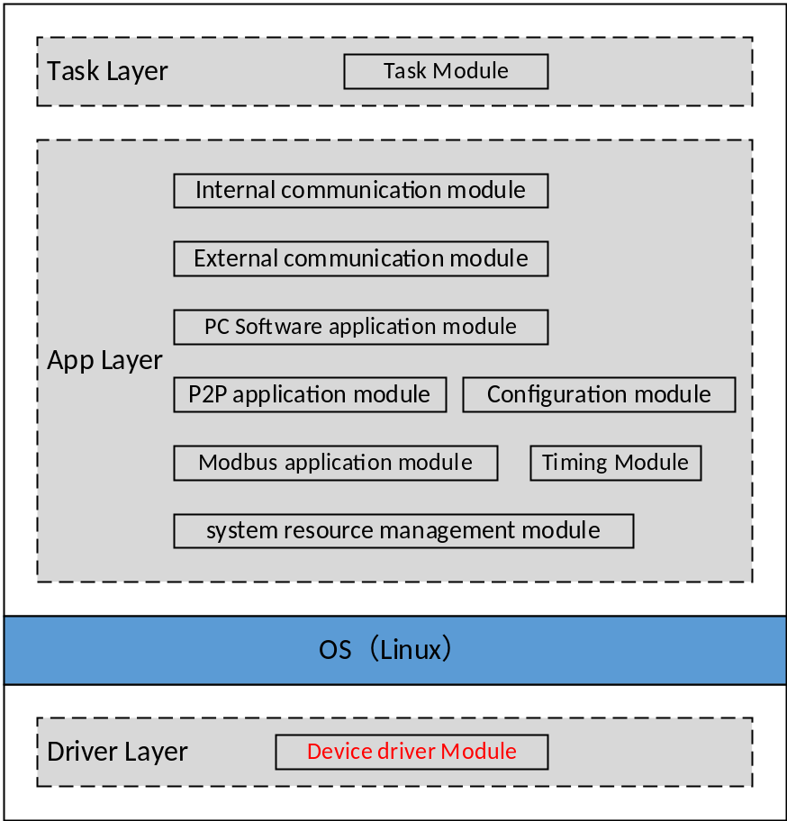
Figure 2-1 the location of the data processing module
图2-1 模块位置
Device driver module is used to operate various device, includes CM_BUS, FPGA, network, etc.
设备驱动模块主要用于操作各种设备，包括CM_BUS、FPGA、网络等。

Module design 模块设计

Function description 功能描述
This document describes four parts of the peripheral driver: the reception and transmission of PCI-E data, the register operation with the FPGA, the read/write of SPI controller and the network storm protection function.
本文档描述了外设驱动的四个部分， PCI-E数据的接收与发送，与FPGA的寄存器操作，SPI控制器的读写，防网络风暴功能。
The driver makes a specific part of the hardware response to a defined internal programming interface that completely hides the details of the device's activities. The user's activities are carried out through a set of standardized calls that are independent of the particular driver. The aim is to map these calls to the actual hardware and device-related operations. The driver can separate the kernel with user program. It is a “plug & play” module and can be loaded when necessary.
驱动程序依据硬件定义了一套内部接口，此内部接口隐藏了硬件的内部细节，使得用户程序可以使用一套标准的API接口来调用驱动程序的功能函数。驱动程序的作用就是将用户程序的API映射到实际的硬件设备上来完成相应的操作。驱动程序是将内核与用户程序隔离开来。驱动程序是即插即用模块，在需要时候加载即可。

Design concept 设计思路

CM_BUS driver CM_BUS驱动
The CM_BUS module receive and send data through the PCIE bus, and the process is as follows:
- Initialize and register the CM_BUS driver.
- Call the Linux ioremap function to map the address area of the FPGA.
- Read and write access to the FPGA's RAM area to receive and send data.
CM_BUS是控制器通过PCIE总线接收和发送数据，处理流程如下：
- 初始化与注册CM_BUS驱动程序。
- 调用Linux ioremap函数映射FPGA的地址区域。
- 通过读写访问FPGA的RAM区来接收和发送数据。

FPGA register read and write FPGA寄存器读写
Read and write FPGA register flow is as follows:
- Initialize and register the FPGA driver.
- Call the Linux ioremap function to map the FPGA's REG address area.
- Read and write access to the FPGA's REG to operate the register.
读写FPGA的寄存器流程如下：
- 初始化与注册FPGA驱动程序。
- 调用Linux ioremap函数映射FPGA的REG地址区域。
- 通过读写访问FPGA的REG来操作寄存器。

SPI controller read/write SPI控制器读写
Read and write SPI controller flow is as follows:
- Configure the GPIO and SPI controller.
- Initialize and register the SPI driver.
- Invoke the Linux ioremap function to map the mapped registers of the SPI controller.
- Read and write access to the SPI registers to send and receive data.
读写SPI的流程如下：
- 配置GPIO以及SPI控制器
- 初始化与注册SPI驱动程序.
- 调用Linux ioremap函数映射SPI 控制器的mapped registers.
- 通过读写访问SPI的registers发送和接收数据.

CM network storm protection CM防网络风暴
By judging the number of data packets to determine whether a network storm occurred. When the network storm occurs, the following steps will be executed:
- Close the network card.
- The application does not send packets.
- Periodically open the network card to detect whether the network storm occurs. If the storm is not over, the network card will close again.
通过判断CM网卡的数据包流量来判断是否发生了网络风暴，当发生网络风暴时下列步骤将被执行：
- 关闭网卡接收数据功能.
- 应用程序不发送数据包.
- 周期性地打开网卡进行探测，如果网络风暴还未结束就再次关闭网卡。

CM Linux configuration CM Linux系统配置
SWDD-CM-DD_NSafR_SecR_A_006
By cutting the Linux configuration file, you can remove some of the extra peripheral drivers and system functions, the system does not support peripheral functions are as follows:
1. Sound Device Driver.
2. eSDHC Driver.
3. SATA driver.
4. USB driver.
5. Graphics driver.
6. I2C device driver.
通过裁剪Linux 配置文件，可以删除一些多余的外设驱动以及系统功能，系统不支持的外设功能如下：
- Sound Device Driver.
- eSDHC Driver.
- SATA driver.
- USB driver.
- Graphics driver.
- I2C device driver.
The root file system is the jffs2 file format, and storage device is Nor Flash. The modified Nor Flash partition structure is shown as follows:
我们使用jffs2格式的根文件系统，存储设备是Nor Flash，修改后的Nor Flash分区结构如下图：
Start offset | End offset | Description | Size
0x00000000 | 0x0001FFFF | DTB image | 128K
0x00020000 | 0x005FFFFF | Kernel image | 5M
0x00600000 | 0x03dbFFFF | JFFS2 file system | 55M
0x03ec0000 | 0x03FFFFFF | Boot loader | 1M
By default, Linux provides many kinds of network services: SSH (port 22), FTP (port 20, 21), TFTP (port 69) and Telnet (port 23). For information security, these services are disabled. The NTP service is enabled and only port 123 is used to send request packets to the NTP server, and a temporary port (port number larger than 30000) is used to receive the reply packets sent from the server.
Linux 系统默认提供了多种网络服务： SSH（port 22）、FTP（port 20,21）、TFTP（port 69）、Telnet（port 23），为了信息安全考虑这些服务均被关闭，对应的端口不再使用。 同时打开了 NTP服务，只使用 123 端口向 NTP 服务器发送请求报文，并且会使用一个临时端口（30000以上的端口）接收服务器发送的应答报文。

Interface function 接口函数

CM_BUS driver CM_BUS驱动
The interface functions which is provided by this module is shown as follows:
模块提供的接口函数如下：
- static long pcie_ioctl(struct file *fp, unsigned int send, unsigned int recv)
Input argument  输入参数 | Output argument  输出参数 | Description  描述
struct file *fp, unsigned int send, unsigned int recv  fp:文件指针，send：写人寄存器的值，recv：读入寄存器的值 | No.  无。 | Read and write registers  读写寄存器
- static ssize_t pcie_send(struct file *fp, const char __user *user_buffer, size_t count, uint32_t cmd)
Input argument  输入参数 | Output argument  输出参数 | Description  描述
struct file *fp, const char __user *user_buffer, size_t count, uint32_t cmd  Fp:文件指针，user_buffer：用户buffer，cmd：命令字 | No.  无。 | Send data interface function.  发送数据处理调用接口
- static ssize_t pcie_recv(struct file *fp, const char __user *user_buffer, size_t count, uint32_t cmd)
Input argument  接口输入参数 | Output argument  接口输出参数 | Description  描述
struct file *fp, const char __user *user_buffer, size_t count, uint32_t cmd  Fp:文件指针，user_buffer：用户buffer，cmd：命令字 | No.  无。 | Receive data interface function.  接收数据处理调用接口

FPGA register read and write FPGA寄存器读写
The interface functions which is provided by this module is shown as follows:
模块提供的接口函数如下：
- static int localbus_init(void)
Input argument  输入参数 | Output argument  输出参数 | Description  描述
No.  无。v | No.  无。 | Module initialization.  模块初始化
- static int localbus_ioctl (struct file *file, unsigned int cmd, unsigned long arg)
Input argument  输入参数 | Output argument  输出参数 | Description  描述
struct file *file, unsigned int cmd, unsigned long arg  Fp:文件指针，cmd：命令字，arg：参数 | No.  无。 | Read and write registers  读写寄存器

SPI controller read/write SPI控制器读写
The interface functions which is provided by this module is shown as follows:
模块提供的接口函数如下：
- static int spi_init(void)
Input argument  输入参数 | Output argument  输出参数 | Description  描述
No.  无。 | No.  无。 | Module initialization.  模块初始化
- static ssize_t spi_write_data(struct file *fp,const char __user *user_buffer, size_t count, uint32_t cmd)
Input argument  输入参数 | Output argument  输出参数 | Description  描述
struct file *fp,const char __user *user_buffer, size_t count, uint32_t cmd  Fp:文件指针，user_buffer：用户buffer，count：写入的长度，cmd：命令字 | No.  无。 | Write data interface function.  写数据调用接口

CM network storm protection CM防网络风暴
The interface functions which is provided by this module is shown as follows:
模块提供的接口函数如下：
- unsigned int get_eth1(void)
Input argument  输入参数 | Output argument  输出参数 | Description  描述
No.  无。v | No.  无。 | Get the network card 1 status  获取网卡1状态
- unsigned int get_eth2(void)
Input argument  输入参数 | Output argument  输出参数 | Description  描述
No.  无。 | No.  无。 | Get the network card 2 status  获取网卡2状态

Global variable 全局变量
Table 3-1 Global variable list
表3-1 全局变量列表
No.  序号 | Type  变量类型 | Name  名称 | Description  描述
 | uint32_t * | ioremap_fpgaram_addr | FPGA RAM address  FPGA RAM地址
 | uint32_t | speedInterval | Threshold  门限值
 | uint32_t | restartTime | Network card open time interval  网卡间隔打开时间

Data structure 数据结构
- File operation structure
static const struct file_operations pcie_xfer_fops = {
.owner = THIS_MODULE,
.read = pcie_recv,
.write = pcie_send,
.unlocked_ioctl = pcie_ioctl,
};
- Device structure
static struct miscdevice pcie_xfer_device = {
.minor = MISC_DYNAMIC_MINOR,
.name = "pcie_xfer",
.fops = &pcie_xfer_fops,
};

List of sub-function 子功能列表
The sub-functions list is shown as follows:
子功能列表如下。
Table 3-2 Sub function list
表3-2 子功能列表
Sub function No.  子功能编号 | Function description  功能描述
SWDD-CM-DD_NSafR_NSecR_A_001 | CM_BUS data input/output.  CM_BUS data输入和输出
SWDD-CM-DD_NSafR_NSecR_A_002 | FPGA register read/write  FPGA寄存器读写
SWDD-CM-DD_NSafR_NSecR_A_003 | SPI controller read/write.  SPI控制器读写
SWDD-CM-DD_NSafR_SecR_A_004 | Network storm protection  网络风暴防护
SWDD-CM-DD_NSafR_NSecR_A_005 | SRAM read/write  读写 SRAM

Design of sub-function 子功能设计

CM_BUS driver CM_BUS驱动
SWDD-CM-DD_NSafR_NSecR_A_001

pcie_recv

Function Description 功能描述
This function is used to process the CM_BUS receive data cyclically.
本函数用于进行CM_BUS数据接收处理。

Argument Description 参数说明
- Function Definition 函数定义
static ssize_t pcie_recv(struct file *fp,const char __user *user_buffer, size_t count, uint32_t cmd)
- Input argument 输入参数
Fp: file pointer, 文件指针
user_buffer: user buffer, 用户buffer
count: data length, 写入的长度
cmd: command word, 命令字
- Output argument 输出参数
Returns the number of bytes received
返回接收的字节数

处理流程
This function has no branch and the processing flow is omitted.
此函数无分支，流程图省略。

pcie_send

Function Description 功能描述
This function is used to process the CM_BUS send data cyclically.
本函数用于进行CM_BUS数据发送处理。

Argument Description 参数说明
- Function Definition 函数定义
static ssize_t pcie_send(struct file *fp,const char __user *user_buffer, size_t count, uint32_t cmd)
- Input argument 输入参数
Fp: file pointer, 文件指针
user_buffer: user buffer, 用户buffer
count: data length, 写入的长度
cmd: command word, 命令字
- Output argument 输出参数
Returns the number of bytes sent
返回发送成功的字节数

处理流程
This function has no branch and the processing flow is omitted.
此函数无分支，流程图省略。

FPGA register read and write FPGA寄存器读写
SWDD-CM-DD_NSafR_NSecR_A_002

fpga_ioctl
SWDD-CM-DD_NSafR_NSecR_A_003

Function Description 功能描述
This function is used to read and write FPGA registers.
本函数用于进行FPGA寄存器的读写操作。

Argument Description 参数说明
- Function Definition 函数定义
static int fpga_ioctl (struct file *file, unsigned int cmd, unsigned long arg)
- Input argument 输入参数
file: file pointer, 文件指针
cmd: command word, 命令字
arg: configuration parameter, 配置参数
- Output argument 输出参数
Returns 0 for successful operation.
Return negative for failed operation.
成功返回0。
失败返回负数。

处理流程
This function has no branch and the processing flow is omitted.
此函数无分支，流程图省略。

SPI write 写SPI

spi_write_data
SWDD-PM-CMDD_NSafR_NSecR_A_003

Function Description 功能描述
This function is used to send data via SPI.
本函数用于进行通过 SPI 发送数据。

Argument Description 参数说明
- Function Definition 函数定义
static ssize_t spi_write_data(struct file *fp, const char __user *user_buffer, size_t count, uint32_t cmd);
- Input argument 输入参数
fp : File pointer. 文件指针
user_buffer : User data buffer. 用户数据缓存。
count : The number of bytes to write. 要写的字节数。
cmd : Operation command. 操作命令。
- Output argument 输出参数
Return OK for successful operation.
操作成功返回 OK。

处理流程
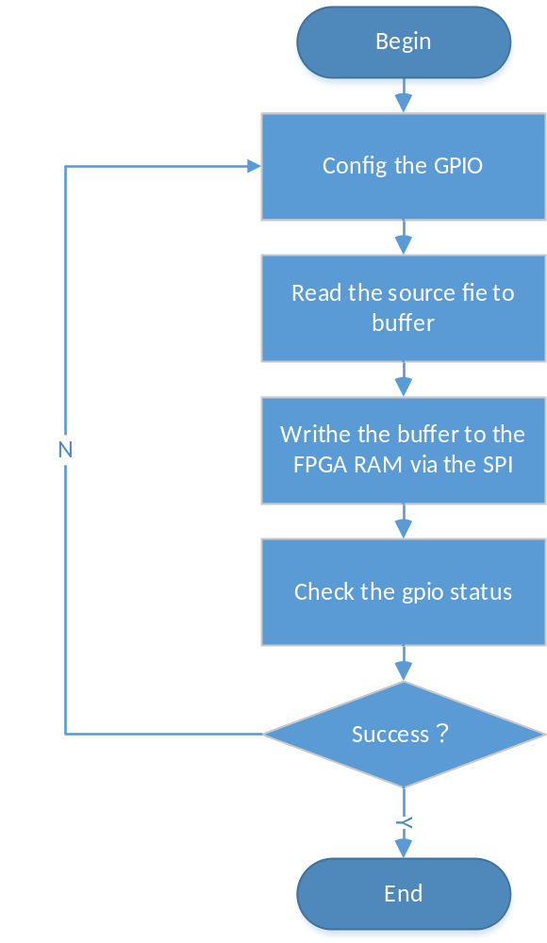
Figure 4-1 FPGA firmware update process
FPGA固件升级

CM network storm protection CM防网络风暴

gfar_clean_rx_ring
SWDD-CM-DD_NSafR_SecR_A_004

Function Description 功能描述
This function is used to determine the flow of data packets and network card shut down.
本函数用于进行数据包的流量判断以及网卡关闭。

Argument Description 参数说明
- Function Definition 函数定义
int gfar_clean_rx_ring(struct gfar_priv_rx_q *rx_queue, int rx_work_limit)
- Input argument 输入参数
rx_queue: Net card’s receive queue. 网卡的接收队列。
rx_work_limit: The maximum number of packets a receive operation can receive. 一次接收操作能接收的最多包数。
- Output argument 输出参数
Return the number of received packets, 返回接收的数据包个数。

处理流程
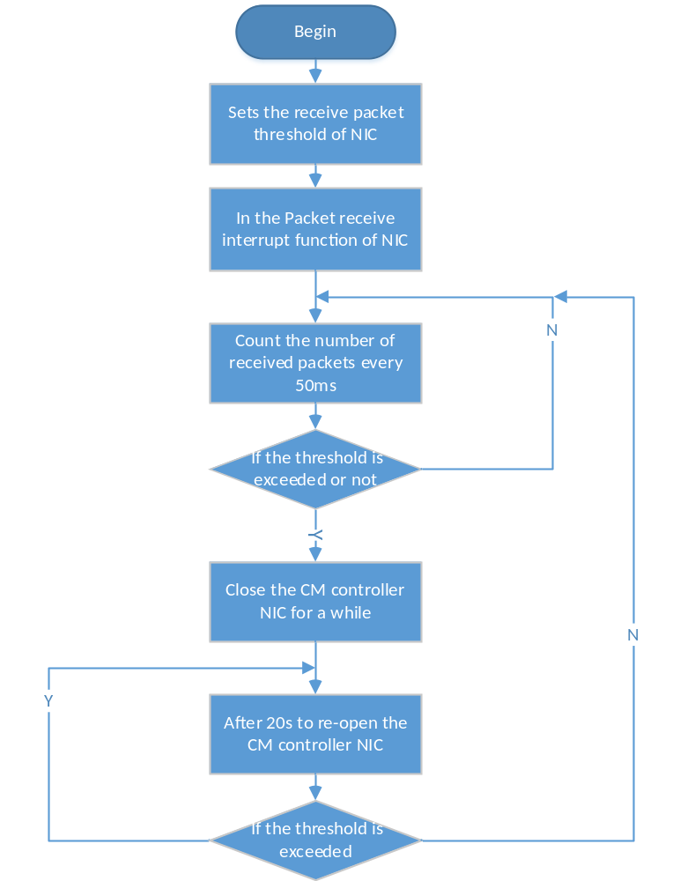
Figure 4-2 network storm protection
防网络风暴流程图

SRAM driver SRAM驱动
SWDD-CM-DD_NSafR_NSecR_A_005

sram_read

Function Description 功能描述
This function is used to read SRAM.
本函数用来读SRAM。

Argument Description 参数说明
- Function Definition 函数定义
static ssize_t sram_read(struct file *file, char __user *buf,size_t count, loff_t *ppos)
- Input argument 输入参数
file: File pointer, 文件指针。
buf: User data buffer, 用户数据缓存。
count: The number of bytes to read, 要读的字节数。
ppos: SRAM’s operation offset, SRAM 的操作偏移量。
- Output argument 输出参数
Return 0 and negative for failed operation, 返回负数表示操作失败。
Returns the number of bytes, 返回读取的字节数。

处理流程
This function has no branch and the processing flow is omitted.
此函数无分支，流程图省略。

sram_write

Function Description 功能描述
This function is used to write SRAM.
本函数用于写SRAM。

Argument Description 参数说明
- Function Definition 函数定义
static ssize_t sram_write(struct file *file, const char __user *buf, size_t count, loff_t *ppos)
- Input argument 输入参数
file: File pointer, 文件指针。
buf: User data buffer, 用户数据缓存。
count: The number of bytes to write, 要写的字节数。
ppos: SRAM’s operation offset, SRAM 的操作偏移量。
- Output argument 输出参数
Return 0 and negative for failed operation, 返回负数表示操作失败。
Returns the number of bytes, 返回写入的字节数。

处理流程
This function has no branch and the processing flow is omitted.
此函数无分支，流程图省略。

——以下无正文

