Document Title: Embedded Software Safety Concept of Safety Control System
Document Number: 15-Q02-000059
Project Number: SF-RD-1501
Project Number: First phase of Safety Control System Development Project
Material Number: N/A
Document Version: A
Classification Level: Highly secret
Document Status: CFC
Controlled Status: Under control

Prepared by: Zhu Genghua | 2015年10月19日
Checked by: Wen Yiming | 2015年11月10日
Countersigned by: Wang Dong, Li Qi, | 2015年11月10日
Liu Yang, Liu Yue
Approved by: Ji Jun | 2015年11月17日

Revision History

No. | Relevant Chapter | Change Description | Date | Version Before Change | Version After Change | Prepared by | Checked by | Approved by
 |  | Document created | 2015-10-19 |  | A | Zhu Genghua | Wen Yiming | Ji Jun
Relationship between this version and old version:

文件名称：安全控制系统嵌入式软件安全概念说明书
文件编号：15-Q02-000059
项目编号：SF-RD-1501
项目名称：安全控制系统开发项目一期
物料编号：
版本号/修改码：A
文件密级：机密
文件状态：CFC
受控标识：受控

拟制：朱耿华 | 2015年10月19日
审核：温宜明 | 2015年11月10日
会签：王东、李琦、刘阳、刘跃 | 2015年11月10日
批准：季俊 | 2015年11月17日

修订页

编  号 | 章节  名称 | 修订内容简述 | 修订  日期 | 订前  版本 | 订后  版本 | 拟制 | 审核 | 批准
 |  | 首次创建 | 2015-6-17 |  | A | 朱耿华 | 温宜明 | 季俊
本版本与旧文件（版本）的关系：

目录
1 Document overview 文档概述 1
1.1 Introduction 综述 1
1.2 Reference 参考文档 1
1.2.1 Project documents 内部参考文档 1
1.3 Terms and abbreviations术语和缩略语 1
1.3.1 Terms 术语 1
1.3.2 Abbreviations 缩略语 3
2 Software architecture 软件架构 4
2.1 Software subsystem division 软件子系统划分 4
2.2 Data flow 数据流 5
2.3 Running process 运行流程 9
2.3.1 Software state transition 软件状态转化 9
2.3.2 PM synchronization PM同步 11
2.3.3 Function assignment 双核任务分配 13
2.4 Multitasking 多任务 14
2.4.1 Task scheduling 任务调度 14
2.4.2 IO polling IO轮询 16
2.4.3 Variable area definition & mapping 变量定义与映射 17
2.4.4 Data consistency 数据一致性 18
2.4.5 The object of operation 操作命令对象 20
2.5 Diagnostic 诊断 21
2.5.1 CPU 21
2.5.2 可变存储器 24
2.5.3 不可变存储器 24
2.5.4 First error restart 故障重启 25
2.6 PM degradation mode 降级模式 25
2.7 COTS component 商用软件 27
2.8 Reused component 复用部分 27
3 Software function 软件具体功能 27
3.1 Control loop 控制回路 27
3.2 Voting mechanism 表决机制 28
3.3 Data monitoring 数据监视 29
3.4 Online operation 在线操作 29
3.5 Download 下装 30
3.5.1 Initialization download 初始化下装 30
3.5.2 Online download 在线下装 31
3.6 Running information record 运行信息记录 32
3.6.1 SOE 32
3.6.2 Control station log 日志 33
3.6.3 Status monitoring状态监视 34
4 Safety communication protocol 安全通讯协议 34
4.1 PM_BUS 34
4.1.1 Safety layer function 安全层功能 35
4.1.2 Protocol message structure 协议消息结构 36
4.2 IP_BUS 37
4.2.1 Safety layer function 安全层功能 37
4.2.2 Protocol message structure 协议消息结构 38
4.3 Peer to Peer 站间安全通讯 39
4.3.1 Safety layer function 安全层功能 41
4.3.2 Protocol message structure 协议消息结构 41
5 Security design 信息安全设计 44
5.1 Identification and Authentication Control 识别和身份验证控制 44
5.2 Use control 使用控制 45
5.3 System Integrity 系统完整性 46
5.4 Data Confidentiality 数据保密性 47
5.5 Restricted Data Flow 受约束的数据流 48
5.6 Timely Response to Events 事件的及时响应 48
5.7 Resource Availability 资源可用性 48

Document overview 文档概述

Introduction 综述
This document describes the PM and CM embedded software safety concept of Safety Control System in detail based on the embedded software safety requirement specification. This document is the input of PM and CM embedded software subsystem design.
本文档依据《安全控制系统嵌入式软件安全需求规格书》的要求，详细描述了安全控制系统中PM和CM嵌入式软件架构设计方案，也是后续PM和CM嵌入式软件各子系统设计的输入。

Reference 参考文档

Project documents 内部参考文档
Table 1-1 Referenced project documents
表1-1内部参考文档
No.  序号 | Document number  文档编号 | Document title  名称
501 | 15-Q01-000058 | Embedded Software Safety Requirements Specification of Safety Control System  安全控制系统嵌入式软件安全需求规格书

Terms and abbreviations术语和缩略语

Terms 术语
Table 1-2 Terms
表1-2术语
No.  序号 | Term  术语 | Description  解释
 | IP_BUS | Communication between PM and IO modules.  PM与IO模块之间的通讯总线。
 | CM_BUS | Communication between PM and CM.  PM与CM之间的通讯总线。
 | PM_BUS | Communication between PMs.  PM之间的通讯总线。
 | System Net | Communication between control station and PC.  控制站与上位机之间的通讯网络。
 | Safety Net | Safe communication between control stations.  控制站之间的安全通讯。
 | Control station  控制站 | A set of triple redundant control system, which includes triple redundant PMs and IO modules under control.  一套三冗余的控制系统，包含三冗余PM和PM控制的各种IO模块。
 | System response time  系统响应时间 | Time interval from the moment that transition of demand signal generated at input ETP to the moment that transition of response signal generated at output ETP.  从系统输入端子板上产生需求信号跳变的时刻到输出端子板上产生相应的响应信号跳变之间的时间。
 | Control cycle  控制周期 | Time interval between adjacent two runs of user program execution.  PM两次执行用户程序间隔时间。
 | Project  工程 | Files which contain configuration information for control station and generated by IEC 61131 configuration software. These files contain all the information required by control station to implement control, including user control program (binaries) to be loaded and executed as well as configuration information of task, CM, PM and IO modules.  IEC 61131组态软件在完成编译后，为控制站生成的组态信息文件，该文件包含可加载执行的用户控制程序（二进制程序）、任务配置信息、CM配置信息、PM配置信息和IO模块配置信息等各种控制站完成控制所需的信息。
 | Source project  源工程文件 | The original project file before compiling.  工程在编译前的原始文件。
 | User program  用户程序 | Part of project which contain user control program (binaries) to be loaded and executed and configuration information of task.  工程中的一部分：可加载执行的用户控制程序（二进制程序）和任务配置信息。

Abbreviations 缩略语
Table 1-3 Abbreviations
表1-3缩略语
No.  序号 | Abbreviation  缩略语 | English description  英文 | Chinese description  中文
 | PM | Processor Module | 主处理器模块
 | CM | Communication Module | 通讯模块
 | BI | Bus Interface Module | 总线接口模块
 | AI | Analog Input Module | 模拟量输入模块
 | AO | Analog Output Module | 模拟量输出模块
 | DI | Digital Input Module | 数字量输入模块
 | DO | Digital Output Module | 数字量输出模块
 | SOE | Sequence Of Events | SOE事件
 | SIL | Safety Integrity Level | 安全完整等级
 | PW | Power Module | 电源模块
 | OPC | OLE for Process Control | 用于过程控制的对象链接与嵌入式技术
 | FW | Firmware | 固件
 | OS | Operating System | 操作系统
 | RTS | Real-time System | 实时系统
 | UP | User Program | 用户程序

Software architecture 软件架构

Software subsystem division 软件子系统划分
SWSC_SafR_NSecR_A_029
The PM and CM embedded software can be divided into three parts, as shown in figure 2-1:
系统中PM和CM的嵌入式软件可分为三个部分，如下图所示：
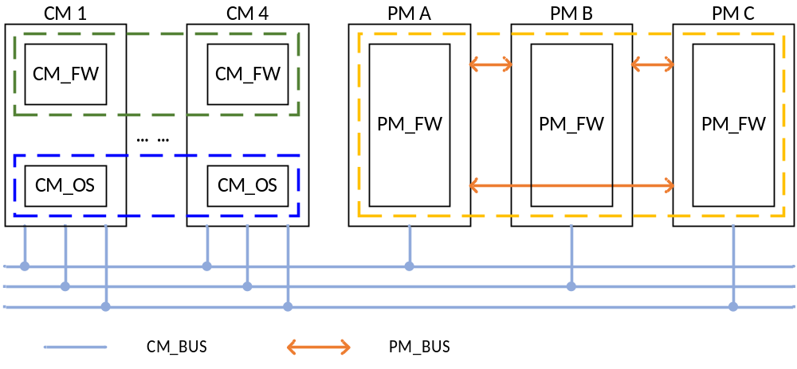
Figure 2-1 Software architecture
图2-1 软件架构
- CM_FW: the part in the green dashed box is CM_FW. It is non-safety-related, but related to security.
- CM_OS: the part in the blue dashed box is CM_OS. It is non-safety-related, but related to security.
- PM_FW: the part in the yellow dashed box is PM_FW. It is safety-related, and related to security.
- CM_FW：图中绿色虚线框包含部分。CM_FW为非安全相关部分，但涉及信息安全。
- CM_OS：图中蓝色虚线框包含部分。该软件为非安全相关部分，但涉及信息安全。
- PM_FW：图中黄色虚线框包含部分。PM_FW为安全相关部分，同时涉及信息安全。

SWSC_SafR_NSecR_A_030
The functions of the above parts are shown as follows:
上述各子系统的具体功能如下图所示：
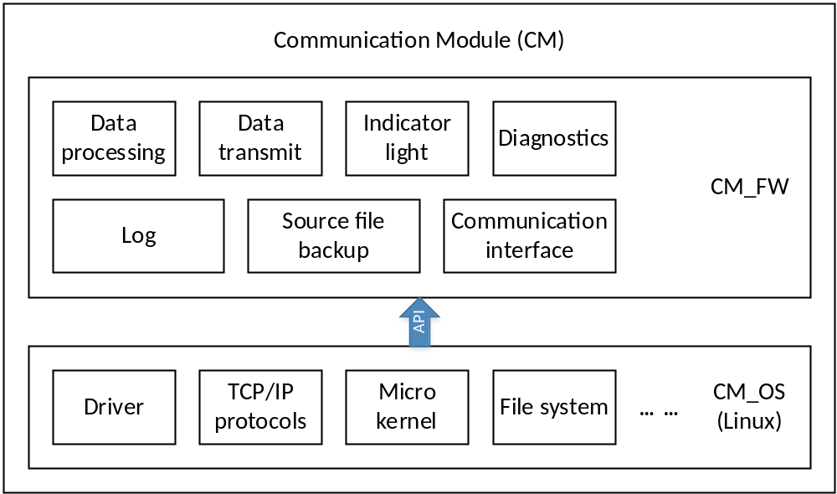
Figure 2-2 CM functions
图2-2 CM嵌入式软件功能
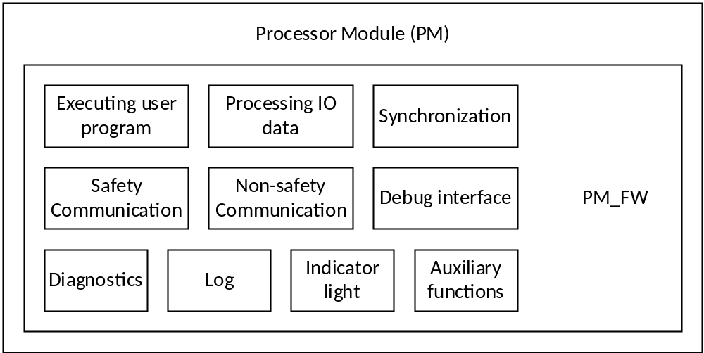
Figure 2-3 PM functions
图2-3 PM嵌入式软件功能

Data flow 数据流
SWSC_SafR_NSecR_A_058
The control station uses System Net to communicate with PC software, uses Modbus RTU/ASCII/TCP to communicate with the third-party device, and uses Safety Net to communicate with other control stations.
控制站对外通过System Net与各个上位机软件进行通讯，通过Modbus RTU/ASCII/TCP和第三方设备通讯，通过Safety Net与其他控制站进行通讯。
In the interior of the control station, CM_BUS is used for communication between CM and PM, PM_BUS is used for data exchange between PMs, and IP_BUS is the communication link between PM and IO modules.
控制站内部，PM和CM之间通过CM_BUS通讯，PM与PM之间通过PM_BUS进行通讯，PM和IO模块之间通过IP_BUS通讯。
The communication links are shown in Figure 2-4:
各通讯链路如下图所示：
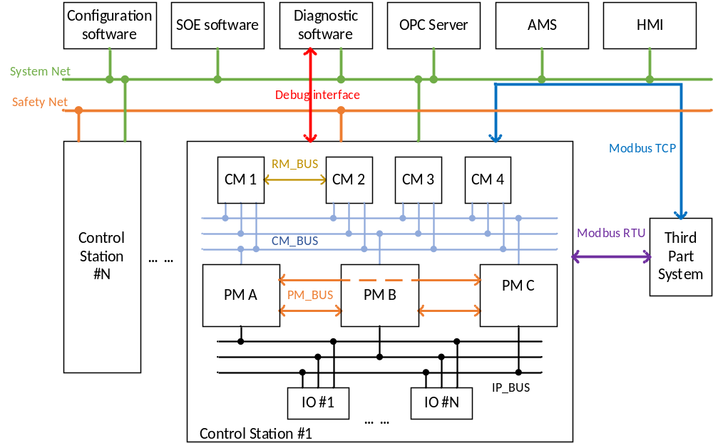
Figure 2-4 Control station communication links
图2-4 控制站通讯示意图
The data streams related to the embedded software are shown in figure 2-5:
和嵌入式软件相关的数据流如下图所示：
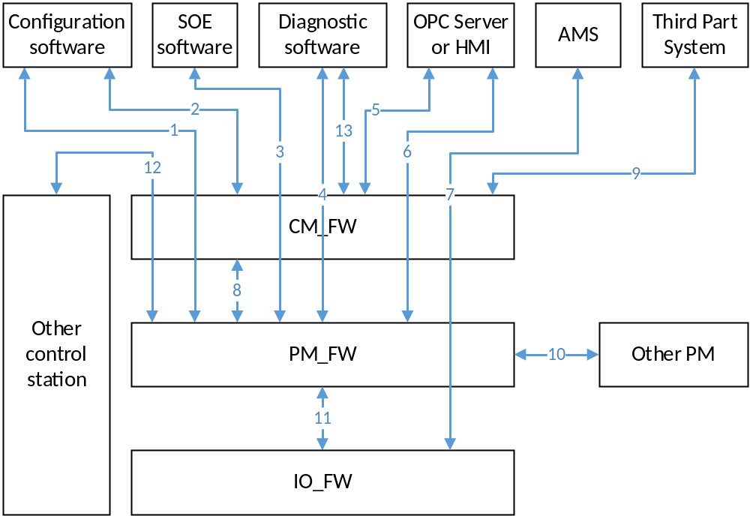
Figure 2-5 Communication data flow
图2-5 数据流示意图
Data flow 1: Download or other debug operations by the Configuration software. CM forwards the data only, but not process the data. The data is protected by CRC to prevent any data corruption.
数据流1：组态软件对控制站进行下装及调试。CM只转发数据，不进行处理。该数据流使用CRC来保护数据的正确性。
Data flow 2: The configuration software reads variable from the control station. This command is directly processed by CM and not related to PM. The data is protected by CRC to prevent any data corruption.
数据流2：组态软件从控制站读取实时数据。该数据流不经过PM，使用CRC来保护数据的正确性。
Data flow 3: SOE software reads SOE records from control station. CM forwards the data only, but not process the data. The data is protected by CRC to prevent any data corruption.
数据流3：SOE软件从控制站读取SOE数据。CM只进行转发，不进行处理。该数据流使用CRC来保护数据的正确性。
Data flow 4: Diagnostic software reads diagnostic data from the control station. CM forward the data only, but not process the data. The data is protected by CRC to prevent any data corruption.
数据流4：诊断软件从控制站读取诊断数据。CM只进行转发，不进行处理。该数据流使用CRC来保护数据的正确性。
Data flow 5: The OPC server (or HMI) reads variable from the control station. This command is directly processed by CM and not related to PM. The data is protected by CRC to prevent any data corruption.
数据流5：OPC Server（或HMI）从控制站读取实时数据。该数据流不经过PM，使用CRC来保护数据的正确性。
Data flow 6: Writing variable operation by the he OPC server (or HMI). CM forward the data only, but not process the data. The data is protected by CRC to prevent any data corruption.
数据流6：OPC Server（或HMI）对控制站进行写变量操作。CM只进行转发，不进行处理。该数据流使用CRC来保护数据的正确性。
Data flow 7: AMS software collects HART data from the IO modules and sends debug command to the IO modules. CM and PM forward the data only, but not process the data. The data is protected by CRC to prevent any data corruption.
数据流7：AMS软件从控制站采集HART数据及进行HART调试。CM、PM只进行转发，不进行处理。该数据流使用CRC来保护数据的正确性。
Data flow 8: PM uploads variable value to the CM cyclically, sends configuration data to CM, and collects status information from the CM. The data is protected by CRC to prevent any data corruption.
数据流8：PM周期向CM上传实时数据、向CM发送配置数据以及从CM得到状态信息。该数据流使用CRC来保护数据的正确性。
Data flow 9: The communication with the third party systems through Modbus TCP or Modbus RTU/ASCII.
数据流9：和第三方设备通过Modbus TCP或者Modbus RTU/ASCII进行数据通讯。
Data flow 10: Data exchanging between PMs through PM_BUS. The data flow uses proprietary safety protocol.
数据流10：PM之间通过PM_BUS通讯。该数据流采用安全协议。
Data flow 11: The communication between the control station and IO module through IP_BUS includes: Process data exchange, configuration information downloading, and diagnostic data uploading, etc. The data flow uses proprietary safety protocol.
数据流11：该数据流用于控制站和IO模块之间的通讯，包括组态配置、实时数据交换、收集IO诊断数据等。该数据流采用安全协议。
Data flow 12: The data exchange between control stations. CM forwards the data only, but not process the data. The data flow uses proprietary safety protocol.
数据流12：多个控制站之间的站间安全通讯。CM只进行转发，不进行处理。该数据流采用安全协议。
Data flow 13: The CM debug interface is mainly used for reading internal fault information and internal log information of CM. This debug interface only can be used by developers. The interface uses serial port as a medium.
数据流13：CM的私有调试接口，主要用于对CM内部调试以及读取内部故障信息和内部日志，这些信息并不开放给用户。私有调试接口采用串口作为介质。
Data flow 14: The PM debug interface is mainly used for reading internal fault information and internal log information of PM. This debug interface only can be used by developers. The interface uses serial port as a medium.
数据流14：CM的私有调试接口，主要用于对CM内部调试以及读取内部故障信息和内部日志，这些信息并不开放给用户。私有调试接口采用串口作为介质。
The resource which is assigned to each data flow shall meet the maximum scale of control station.
分配给上述各数据流的资源大小应能满足系统最大规模的要求。
The data flow 1, 2, 3, 4, 5, 6, 7 and 9 will use System Net. If the maximum load is 40%, the data which is sent and received via System Net shall be less than 5MB per second. Therefore, it is necessary to limit the size of communication variables in the project.
数据流1、2、3、4、5、、7、9使用System Net，按最大40%负荷计算，在正常运行过程中，控制站每秒钟通过System Net发送和接收的数据应小于5MB，因此，需要限制用户工程中通讯点的规模。

Running process 运行流程

Software state transition 软件状态转化
SWSC_SafR_NSecR_A_031
CM is mainly used for communications, which is not affected by the state of the system. The software states of PM and state transition conditions are shown in the following figure:
CM主要用于通讯，不受系统状态的影响。PM软件状态的状态描述以及状态转换条件如下图所示：
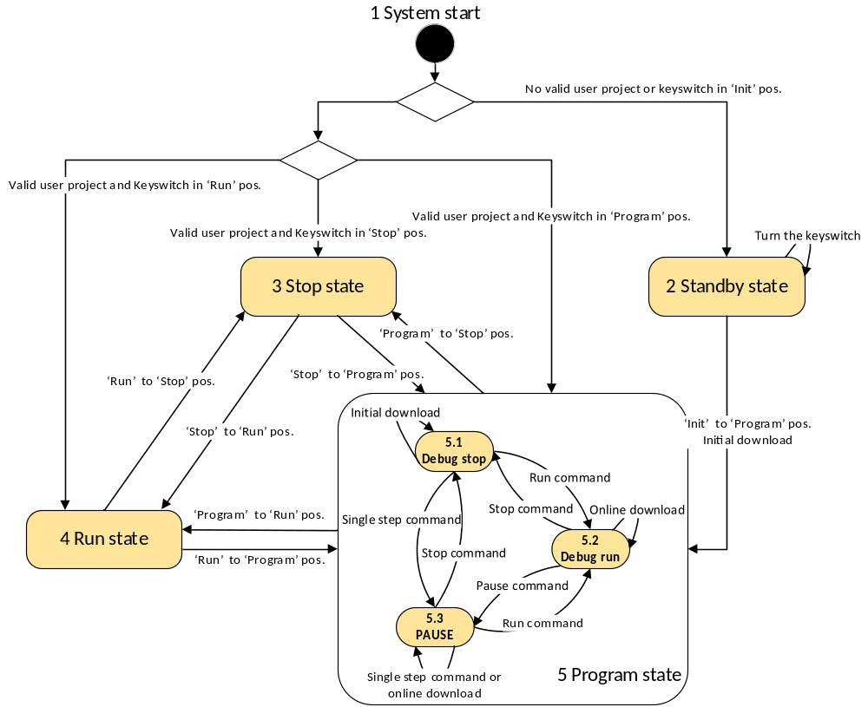
Figure 2-6 Transition of software states
图2-6 软件状态转换图
When the PM has a valid project, the Stop, Run, Program states of PM software are consistent with the ‘Stop’, ‘Run’, ‘Prog’ position of the key switch, and also correspond to the system states. The ‘Init’ position means the project and configuration information in PM will be purged after power on.
当PM中有有效工程时，PM软件的Stop、Run、Program状态和钥匙开关的STOP、RUN、PROG三个档位一一对应，也和系统的三个状态一一对应。钥匙开关中的Init档位代表上电时清空工程及配置信息。
Detailed descriptions of the states are as follows:
状态具体描述如下：
- System start: System start into a different state according to the validity of project and the positon of key switch. When the project is valid and the key switch in the ‘Prog’ position, the software enters into Debug run state.
- System start：系统启动，根据工程的有效性及钥匙开关的档位进入不同的状态。当工程有效，并且钥匙开关在PROG档位时，软件进入Debug run状态。
- Stop state: In this state, PM has a project, but stop executing the user program, stop exchanging data with IO modules, and not support user debug operation. In this state, if the key switch turn from ‘Stop’ to ‘Prog’ position, the software enters into Debug stop state.
- Stop state：PM有用户工程，但不执行用户程序。停止和IO模块交换数据，不支持用户进行调试操作。在此状态下，钥匙开关从STOP到PROG档位，软件进入Debug stop状态。
- Run state: In this state, PM executes user program and exchanges data with IO modules, but does not support user debug operation. In this state, if the key switch turn from ‘Run’ to ‘Prog’ position, the software enters into Debug run state.
- Run state：PM执行用户程序，实时输出，不支持用户进行调试操作。在此状态下，钥匙开关从RUN到PROG档位，软件进入Debug run状态。
- Standby state: There is no valid project in PM.
- Standby state：PM中无用户工程。
- Program state: In this state, PM has a project and supports user debug operation.
- Program state：PM有用户工程，支持用户进行调试操作。
- Pause: PM has a user project, but does not execute the user program. PM exchanges data with IO modules but the outputs is the last execution result before the pause operation. If the user program has not been executed before the pause operation, the output is the initial value.
- Pause：PM有用户工程，但不执行用户程序。保持和IO模块交换数据，输出为暂停前最后一次运算的结果，如暂停前没有经过一次运算，输出为初始值。
- Debug run: In this state, PM executes user program, exchanges data with IO modules, and supports user debug operation.
- Debug run：PM执行用户程序，实时输出，可进行其他调试操作。
- Debug stop: In this state, PM has a project, but does not execute the user program, does not exchange data with IO modules, but supports user debug operation.
- Debug stop：PM有用户工程，但不执行用户程序，停止和IO模块交换数据，可进行其他调试操作。
The states of three PMs are consistent. The reason is show as follows:
- The three PMs can get the key switch position simultaneously.
- The new-inserted PM can be synchronized automatically by other running PMs for the running data, running state and the project.
三系PM状态一致，原因如下：
- 钥匙开关同时作用于三系PM。
- 当PM上电时，会从工作PM同步工程及状态。

PM synchronization PM同步

Running synchronization 同步运行
SWSC_SafR_NSecR_A_032
Hardware synchronization clock ensures that each PM_FW can obtain the same time from the clock, and three PMs agreed to start executing the user program at some fixed time (such as T1 + nT). For the above reason, the user program can be executed synchronously.
硬件同步时钟保证各系PM_FW从该时钟得到的数值一致，三系PM_FW约定在固定时刻（如下图中的T1+nT）开始执行用户程序，最终保证用户程序三系同步执行。
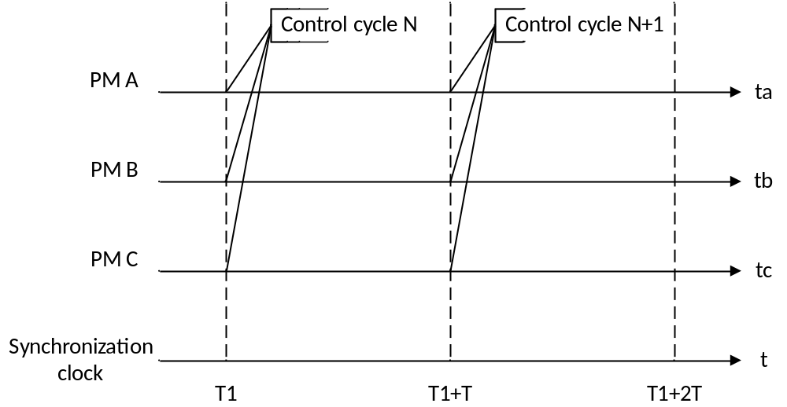 Figure 2-7 Running synchronization
图2-7 同步运行
The user program can be configured as both stop and alarm or only alarm when executing timeout occurs. This property is configured by the user through configuration software for each user program. When safety application is selected by the user, this property can be only configured to ‘stop executing the user program and alarm’; when control application is selected by the user, both “stop executing the user program and alarm” and “only alarm” can be configured.
当执行用户任务超时，可配置停止执行此用户程序并报警或仅报警。该属性由使用者通过组态软件基于每个任务配置。用户选择safety应用时，该属性只能配置为停止执行此用户程序并报警；用户选择control应用时，都可以配置。
The new-inserted PM will synchronize project, real time data and running states from other running PMs automatically, and the new-inserted PM will be automatically running after the synchronization. The user program execution will be delayed due to real time data synchronization, the delayed time is related to the size of real time data. According to data size of the actual user project, the maximum delayed time is no more than three control cycles.
新插入的PM会自动从其他工作PM上同步工程、运行数据及运行状态，同步完成后新PM自动运行，不需要人工干涉。在同步实时数据会暂停工作PM执行用户工程，暂停时间与工程的数据量相关，根据对实际工程数据量的估算，该延后时间不大于3个控制周期。

Operation synchronization 命令同步
SWSC_SafR_NSecR_A_033
The PMs shall synchronize the operations from the PC software. Operation, which is responded directly by CM, such as read variable, does not need synchronization.
PM接收到的上位机软件的操作命令需要同步处理，但是如读变量命令等由CM直接应答的命令不需要同步。

Function assignment of dual CPU cores 双核任务分配
SWSC_SafR_NSecR_A_034
The PM is processing in AMP (Asymmetric multi-processing) mode, and the assignment of the functions of dual CPU cores is shown in follows:
PM双核按照AMP模式运行，双核功能划分如下所示：
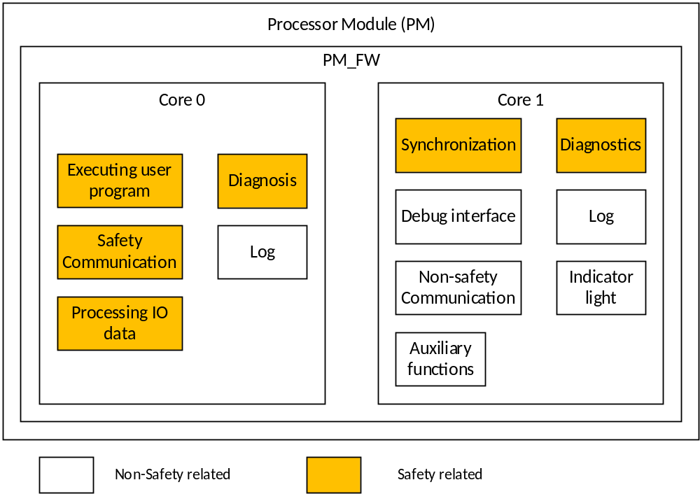
Figure 2-8 Function assignment of dual CPU cores
图2-8 PM双核功能划分

Multitasking 多任务

Task scheduling 任务调度
SWSC_SafR_NSecR_A_035
Multitasking refers to the maximum capability of the system is two user programs. Therefore, PM_FW in Core0 includes three processes, one is the basic functions (i.e. RTS), another one is UP1, and the last one is UP2.
多任务指的是系统最多支持执行2个用户程序，因此，PM_FW中Core1分为三个进程，基本功能为一个进程（简称RTS），UP1为一个进程，UP2为一个进程。
The final minimum control cycle is the maximum of the minimum control cycle (consider the execution time only) and the minimum control cycle (consider the polling time only) described below.
最终的最小控制周期是下述最小控制周期（只考虑执行时间）和最小控制周期（只考虑IO轮询时间）中的最大值。
Core0 uses round-robin mechanism, the size of the time slice is 0.25ms. The switch of time slice relies on clock interrupt, which is provided by hardware synchronization clock, in order to ensure that the three PMs are synchronous.
Core0采用时间片轮转机制，时间片的大小为0.25ms。时间片的轮转依靠时钟中断实现，为了保证三系同步，时钟中断由三系的同步时钟提供。
CPU cycle is 5ms, including RTS time, UP1 time and UP2 time. The allocated time for RTS is 3.5ms. The sum of allocated time for the UP1 and UP2 is 1.5ms, and the default division is 1ms (UP1) + 0.5ms (UP2). Users can adjust the division, and the division proportion moves between 20% - 90%.
CPU cycle为5ms，包括RTS时间、UP1时间和UP2时间。其中，分配给RTS的时间片之和为3.5ms，分配给UP1和UP2的时间片之和为1.5ms，默认按照1ms（UP1）+0.5ms（UP2）划分。用户可以调整UP1和UP2的时间片分配，分配比例在20%-90%之间移动。
Each UP can be executed in one CPU cycle or split into more than one CPU cycle to execute, and the control cycle is a multiple of 5ms. Based on the estimated execution time and the size of the allocated time slice, the minimum control cycle (consider the execution time only) of UP can be obtained. If the actual control cycle set by user is greater than the minimum control cycle, extra time is idle.
UP1、UP2可以在一个CPU cycle内执行或者拆分到多个CPU cycle内执行，UP1、UP2的控制周期为5ms的倍数。对单个UP，根据估算的执行时间以及分配的时间片大小，可以得到最小控制周期（只考虑执行时间），如果用户实际配置的控制周期大于最小控制周期，多余的时间内为空闲。
An example is shown in Figure 2-9:
例子如图2-9所示：
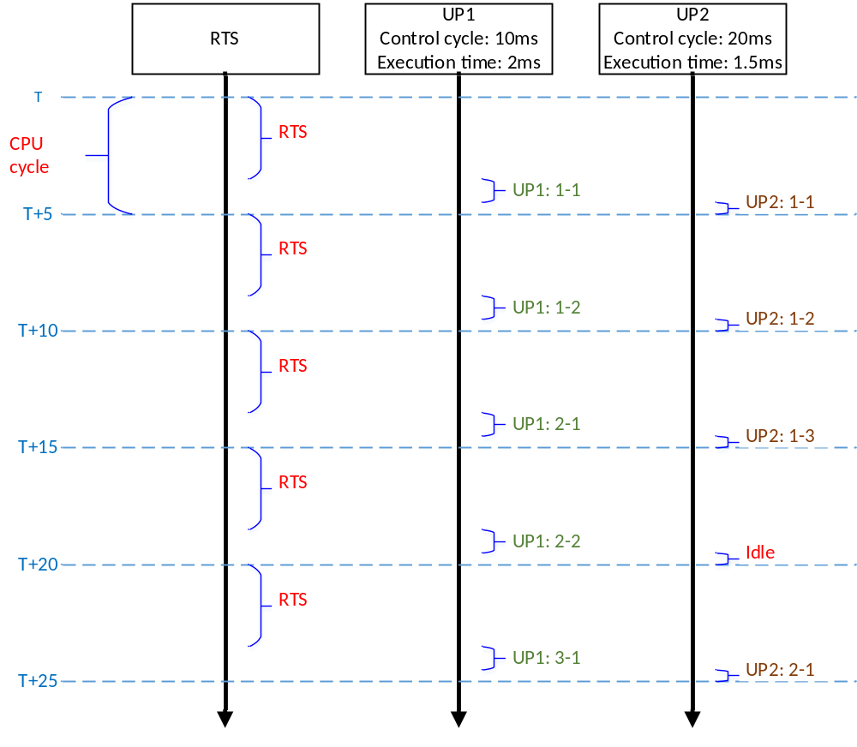 Figure 2-9 PM task scheduling
图2-9 PM任务调度

IO polling IO轮询
SWSC_SafR_NSecR_A_036
The IO modules, which shall be polled by the master of IP_BUS in the current CPU cycle, are assigned by the PM. According to the requirement of the control cycle when the system scale is 300 points, the master shall poll 13 IO modules per cycle. It also meet the requirement of the control cycle when the system scale is 1000 points. The division proportion of the 13 IO modules for each user program is the same as the division proportion of allocated time (1.5ms).
主站当前CPU周期轮询的从站由PM指定。根据系统规模300点时对控制周期的要求，每周期需要轮询13个IO从站。该从站个数同时能够满足系统规模1000点时对控制周期的要求。每周期轮询的IO从站的比例分配和任务的比例分配一致。
An example is shown in Figure 2-10:
例子如图2-10所示：
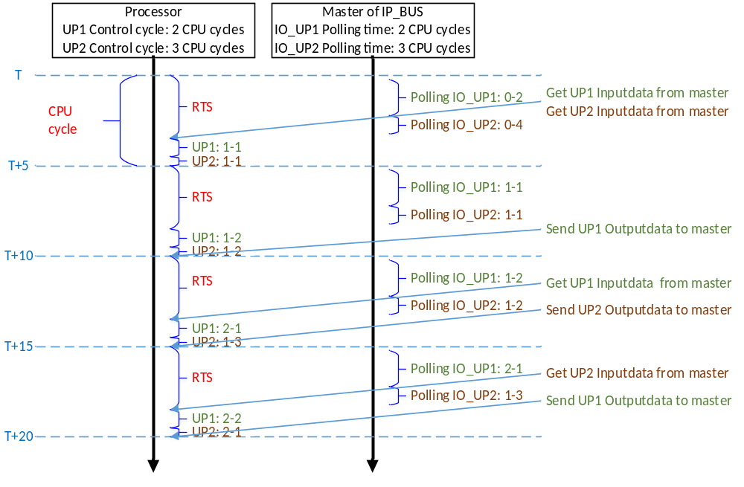
Figure 2-10 IO polling
图2-10 IO轮询
Based on the total number of IO modules and polling number per cycle, the minimum control cycle (consider the polling time only) of UP can be obtained. If the actual control cycle set by user is greater than the minimum control cycle, extra time is idle.
对单个UP，根据总的IO个数以及每周期轮询的模块个数，可以得到最小控制周期（只考虑IO轮询时间），如果用户实际配置的控制周期大于最小控制周期，多余的时间内为空闲。

Variable area definition & mapping 变量定义与映射
SWSC_SafR_NSecR_A_037
In the configuration software, users can define variables for each user programs, and there is no common variables between user programs.
在组态软件中，用户可以为UP1和UP2各自定义变量，UP1和UP2之间无共用的变量。
Users can specify which user program an IO module belongs to, and each user program can only access their own IO variables. The maximum size of the I Area and Q Area based on the system maximum scale.
用户可以为每个IO模块指定属于哪个任务，每个任务只能访问属于自己的IO变量。输入输出数据区大小的应能满足系统最大规模的要求。
Each user program has its own variable area. Two variable areas are independent, and do not overlap. Each user programs can only access their own variable area.
每个任务有自己的变量区，两个变量区独立成片的，互不交叉，每个任务的变量只能在本任务中被访问。
The variable mapping is designed instead of using common variable. For example: variable A is defined in user program 1, if user program 2 wants to use this variable, it can define a variable B, and designated the variable mapping as A -> B.
如果任务间有共用的数据，可以通过变量映射的方式来代替。例如：UP1中有变量A，如果UP2想要使用该变量，可以定义变量B，并且指定为A->B。
The division of variable area is shown in figure 2-11:
变量区划分如下图所示：
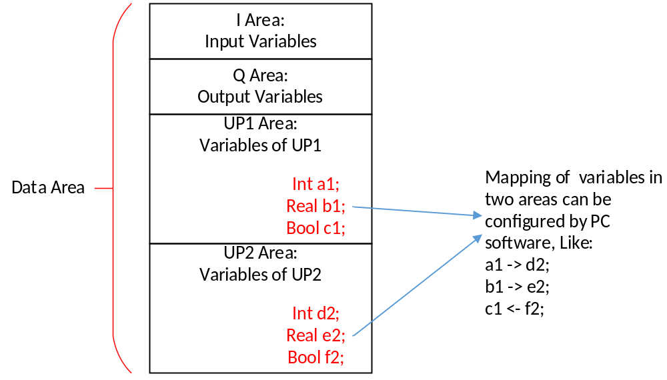
Figure 2-11 Variable area definition & mapping
图2-11 变量定义与映射

Data consistency 数据一致性
SWSC_SafR_NSecR_A_038
Data area is divided into three parts: Data_UP1, Data_UP2 and Data_FW. The user program 1 task uses Data_UP1, user program 2 task uses Data_UP2, and RTS task uses Data_FW. UP1 task copies data in area I of Data_FW to area I in Data_UP1 before executing the user program, and copies data in area Q and G of Data_UP to Data_FW respectively after the user program has been completely executed. The whole process is the same for UP2 task.
数据区分为Data_UP1，Data_UP2和Data_FW三个区，UP1使用Data_UP1，UP2使用Data_UP2，RTS使用Data_FW。UP在执行用户程序前将输入数据从Data_FW的I区拷贝至Data_UP的I区，执行用户程序后将Data_UP的Q区和G区拷贝至Data_FW的Q区和G区。
The debug operation is only handled after the user program has been completely executed.
对每个UP的调试变量操作在用户程序执行结束后进行，执行过程中不执行写变量操作。
The diagram is shown in Figure 2-12 and Figure 2-13:
过程如图2-12和2-13所示：
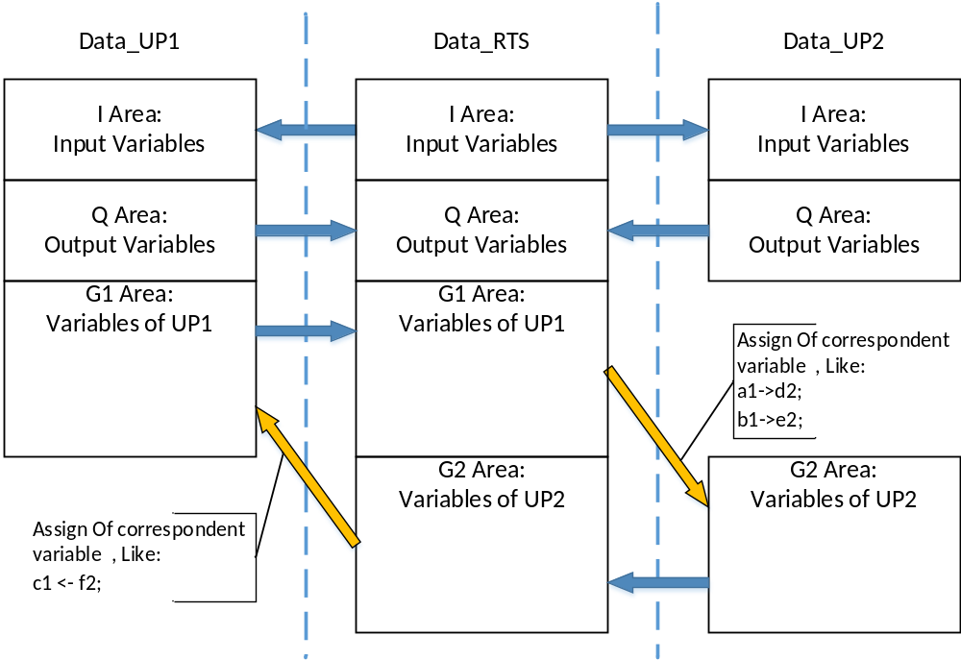
Figure 2-12 Data flow of data consistency
图2-12 数据一致性数据拷贝
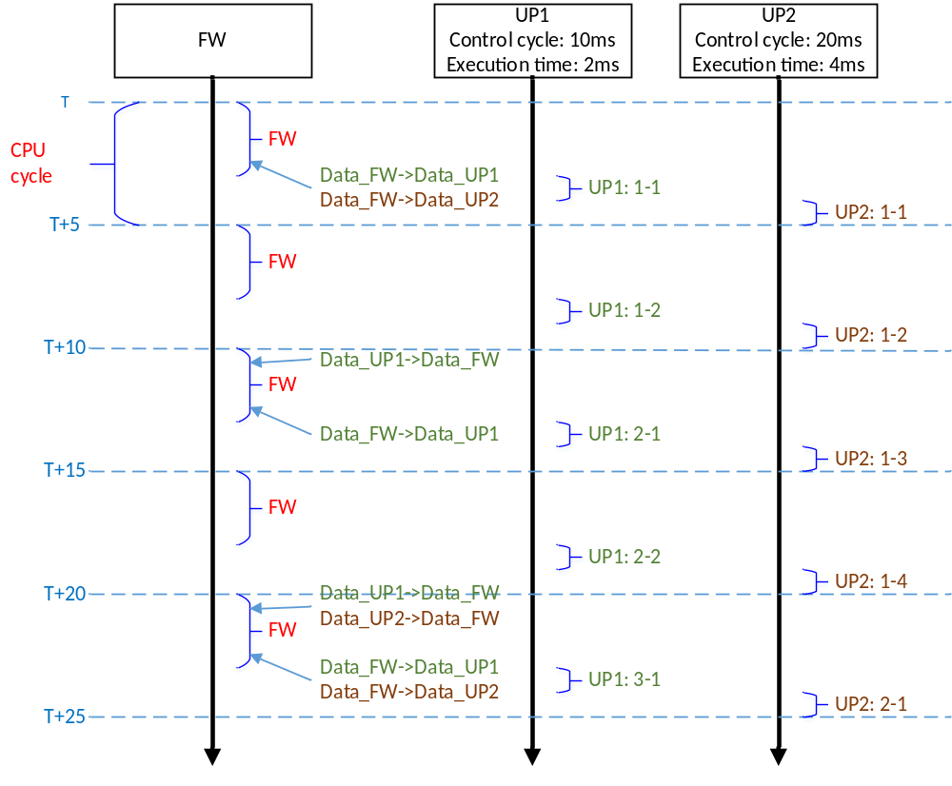
Figure 2-13 Sequence of data consistency
图2-13 数据拷贝时序

The object of operation 操作命令对象
SWSC_SafR_NSecR_A_039
Operation from PC software can be handled by specific user program or handled by both user programs, as shown in table 2-1:
上位机软件的操作命令支持对单个任务或者多个任务操作，区分如下表所示：
Table 2-1 Operation object
表2-1 操作命令对象
Operation  操作命令 | Source  来源 | Support handled by specific user program  是否支持对单个任务操作
Stop  停止 | Configuration software  组态软件 | Supported.  支持。
Pause  暂停 | Configuration software  组态软件 | Supported.  支持。
Single step  单步运行 | Configuration software  组态软件 | Supported.  支持。
Run  运行 | Configuration software  组态软件 | Supported.  支持。
Download  初始化下装 | Configuration software  组态软件 | Not supported.  不支持。
Online download  在线下装 | Configuration software  组态软件 | Not supported.  不支持。
Write variable  写变量 | Configuration software  组态软件 | Unrelated  不相关。
Write variable  写变量 | HMI | Unrelated  不相关。
Write variable  写变量 | OPC Server | Unrelated  不相关。
Enable/disable  使能/禁止 | Configuration software  组态软件 | Unrelated  不相关。

Diagnostics 诊断

CPU
SWSC_SafR_NSecR_A_040
Diagnostic measures for CPU in PM is listed in Table 2-2.
对于PM的CPU，诊断措施列在表2-2中。
Table 2-2 Diagnostic measures for CPU in PM
表2-2 PM CPU诊断措施列表
CPU | Complexity/ HFT  复杂度/HFT | Fault considered [DC]  考虑的故障[DC] | Safety critical?  是否安全相关 | Diagnostics (normal operation)  诊断方法（正常运行） | Diag. interval/ DC  诊断间隔/诊断覆盖率 | Diagnostics (power-on)  诊断方法（上电） | Action after detection of failure  故障处理措施 | Detection and report of “failure of a diagnostic to execute”  对诊断措施未执行的检测和上报措施
CPU register, internal RAM  CPU寄存器与内部RAM | Type B  HFT=1 | DC fault (data & address) [Medium]  DC故障（数据和地址）[中] | Yes  是 | Internal RAM is not used.  March SS for CPU registers.  Instruction cache is checked using dedicated instruction patterns.  Data cache is checked by read after write test.  SFRs are periodically readback or readback after writes  不使用内部RAM；  对寄存器进行March SS；  对指令Cache进行设定的指令操作并检查；  对数据Cache进行先写后读检查；  对SFR周期回读或在写入后回读 | < 24h  DC is medium  DC为中 | The same as in normal operation  同正常运行时 | Alarm and adopt “first error restart” mechanism  故障报警，并使用“首发错误重启”机制 | Temporal and logical program sequence monitoring is used for diagnostic related programs.  对实现诊断功能的CPU软件做基于逻辑和时间的程序流检测
 |  | Soft error [Medium]  软失效[中] | Yes  是 | Temporal and logical monitoring of program sequence including program sequence monitoring and check for validataion before execution.  Other diagnostics regarding corresponding SFR.  基于逻辑和时间的程序流监测，如程序顺序监测、执行前的合法性检查等；  SFR还可在其他与其功能相关的诊断时同时诊断 | Continuous for program sequence monitoring; <24h for other measures  对程序顺序监测为连续；  对其他措施为< 24h  DC is medium  DC为中 | The same as in normal operation  同正常运行时 | Alarm and adopt “first error restart” mechanism  故障报警，并使用“首发错误重启”机制 | Temporal and logical program sequence monitoring is used for diagnostic related programs.  对实现诊断功能的CPU软件做基于逻辑和时间的程序流检测
CPU coding & execution  CPU编码与执行 | Type B  HFT=1 | Wrong coding or wrong execution (including flag registers) [Medium]  错误的编码与执行（包括标志寄存器）[中] | Yes  是 | Full instruction set test.  Check the flag registers by test patterns resulting in register transition.  CPU illegal operation and instruction trapping.  Periodic software readback of static configuration registers.  External watchdog (in FPGA) with separate time base (Clock of FPGA) and time window.  全指令集检测；  制造标志寄存器复位/置位条件并检查结果；  CPU异常处理；  周期回读静态的配置寄存器；  带时间窗和独立时基（FPGA诊断时钟）的外部看门狗（FPGA中） | Continuous for exception handling and watchdog. <24h for other measures  对异常处理和看门狗为连续；  对其他措施为< 24h  DC is medium  DC为中 | The same as in normal operation  同正常运行时 | Alarm and adopt “first error restart” mechanism  故障报警，并使用“首发错误重启”机制 | Temporal and logical program sequence monitoring is used for diagnostic related programs.  Redundant status pulse added from CPU to watchdog to indicate whether CPU is properly reset.  Self-diagnostics of watchdog logic inside FPGA.  对实现诊断功能的CPU软件做基于逻辑和时间的程序流检测；  CPU到看门狗增加冗余状态脉冲指示是否被复位；  FPGA内的看门狗逻辑自诊断
Address calculation  地址计算 | Type B  HFT=1 | DC fault [Medium]  DC故障[中] | Yes  是 | March SS of address lines in unused memory space.  Other diagnostics regarding CPU registers, variable memories and invariable memories.  在未使用的存储空间内，对地址线进行March SS；  在进行CPU寄存器、可变存储器、不可变存储器诊断时同时诊断 | < 24h  DC is medium  DC为中 | The same as in normal operation  同正常运行时 | Alarm and adopt “first error restart” mechanism  故障报警，并使用“首发错误重启”机制 | Temporal and logical program sequence monitoring is used for diagnostic related programs.  对实现诊断功能的CPU软件做基于逻辑和时间的程序流检测
 |  | Soft error [Medium]  软失效[中] | Yes  是 | Temporal and logical monitoring of program sequence including program sequence monitoring and check for validataion before execution.  基于逻辑和时间的程序流监测，如程序顺序监测、执行前的合法性检查等 | Continuous  连续  DC is medium  DC为中 | The same as in normal operation  同正常运行时 | Alarm and adopt “first error restart” mechanism  故障报警，并使用“首发错误重启”机制 | Temporal and logical program sequence monitoring is used for diagnostic related programs.  对实现诊断功能的CPU软件做基于逻辑和时间的程序流检测
Program counter, stack pointer  程序计数器，堆栈指针 | Type B  HFT=1 | DC fault [Medium]  DC故障[中] | Yes  是 | Diagnostics regarding CPU coding and execution.  Check during stack push and pop.  Stack range detection.  March SS for stack pointer registers.  在进行CPU编码与执行诊断时同时诊断；  对堆栈指针做压栈、出栈和范围检测；  对堆栈指针寄存器做March SS | Continuous for stack diagnostics; <24h for other measures  对堆栈诊断为连续；  对其他措施为< 24h  DC is medium  DC为中 | The same as in normal operation  同正常运行时 | Alarm and adopt “first error restart” mechanism  故障报警，并使用“首发错误重启”机制 | Temporal and logical program sequence monitoring is used for diagnostic related programs.  对实现诊断功能的CPU软件做基于逻辑和时间的程序流检测
 |  | Soft error [Medium]  软失效[中] | Yes  是 | Temporal and logical monitoring of program sequence including program sequence monitoring and check for validataion before execution.  基于逻辑和时间的程序流监测，如程序顺序监测、执行前的合法性检查等 | Continuous  连续  DC is medium  DC为中 | The same as in normal operation  同正常运行时 | Alarm and adopt “first error restart” mechanism  故障报警，并使用“首发错误重启”机制 | Temporal and logical program sequence monitoring is used for diagnostic related programs.  对实现诊断功能的CPU软件做基于逻辑和时间的程序流检测
Interrupt  中断 | Type B  HFT=1 | No, continuous or crossover of interruptions [Medium]  无中断、Continuous  连续中断或中断串扰[中] | Yes  是 | Temporal monitoring of multi-tasking interrupt.  Watchdog of PM_BUS communication protocol.  Software check by creating interrupt condition (except the multi-tasking interrupt)  Disable and monitoring of unused interrupt.  对多任务中断，使用基于时间的程序流监测；  PM_BUS通讯协议的看门狗；  制造中断条件并检查（除多任务中断外）；  禁用并监视未使用的中断 | <24h  DC is medium  DC为中 | The same as in normal operation  同正常运行时 | Alarm and adopt “first error restart” mechanism  故障报警，并使用“首发错误重启”机制 | Temporal and logical program sequence monitoring is used for diagnostic related programs.  对实现诊断功能的CPU软件做基于逻辑和时间的程序流检测
Reset circuitry  复位电路 | Type B  HFT=1 | DC fault; Drift & oscillation; individual components do not initialize to reset state [Medium]  DC故障；漂移和振荡；  单个器件未初始化到复位状态[中] | Yes  是 | Abnormal operation of PM due to the fault of reset circuitry can be detected by other PMs.  Periodic software readback of reset related configuration registers.  复位电路故障导致的PM运行异常可被其他PM检测到；  周期读取复位相关寄存器状态并检查 | < 24h  DC is medium  DC为中 | The same as in normal operation, and software check of info of last reset after power-on.  同正常运行时，且在上电后读取上次复位信息并检查 | Alarm and adopt “first error restart” mechanism  故障报警，并使用“首发错误重启”机制 | Temporal and logical program sequence monitoring is used for diagnostic related programs.  对实现诊断功能的CPU软件做基于逻辑和时间的程序流检测
Program sequence  程序顺序 | Not relevant  不相关 | Systematic failure  系统性失效 | Yes  是 | External watchdog (in FPGA) with separate time base (Clock of FPGA) and time window.  Checked by set program sequence monitoring varibles in the program.  带时间窗和独立时基（FPGA诊断时钟）的外部看门狗（FPGA中）；  程序中设置顺序检测变量进行记录并检查 | Continuous  连续  DC is medium  DC为中 | The same as in normal operation  同正常运行时 | Alarm and adopt “first error restart” mechanism  故障报警，并使用“首发错误重启”机制 | Temporal and logical program sequence monitoring is used for diagnostic related programs.  Redundant status pulse added from CPU to watchdog to indicate whether CPU is properly reset.  Self-diagnostics of watchdog logic inside FPGA.  对实现诊断功能的CPU软件做基于逻辑和时间的程序流检测；  CPU到看门狗增加冗余状态脉冲指示是否被复位；  FPGA内的看门狗逻辑自诊断
ECC  ECC功能 | Type B  HFT=1 | DC fault [Medium]  DC故障[中] | Yes  是 | Test by forcing ECC errors on memory bus writes (CPU built-in)  在存储器总线写入时制造故障并测试ECC功能（CPU自带） | < 24h  DC is medium  DC为中 | The same as in normal operation  同正常运行时 | Alarm and adopt “first error restart” mechanism  故障报警，并使用“首发错误重启”机制 | Temporal and logical program sequence monitoring is used for diagnostic related programs.  对实现诊断功能的CPU软件做基于逻辑和时间的程序流检测
Exception handling  异常处理 | Type B  HFT=1 | DC fault [Medium]  DC故障[中] | No  否 | Check of CPU exception handling by test patterns resulting in exception  制造条件触发异常处理并检查 | < 24h  DC is medium  DC为中 | The same as in normal operation  同正常运行时 | Alarm  故障报警 | Not required  无，不需考虑
MMU  DMA |  |  |  | Not checked because not used  未使用，不诊断
Bus arbitration  总线仲裁 | Type B  HFT=1 | No, continuous or wrong arbitration [Medium]  无仲裁、Continuous  连续仲裁或错误仲裁[中] | Yes  是 | Checked by set program sequence monitoring varibles in the program.  Other diagnostics regarding functions related to bus arbitration.  程序中设置顺序检测变量进行记录并检查；  还可在其他与其功能相关的诊断时同时诊断 | < 24h  DC is medium  DC为中 | The same as in normal operation  同正常运行时 | Alarm and adopt “first error restart” mechanism  故障报警，并使用“首发错误重启”机制 | Temporal and logical program sequence monitoring is used for diagnostic related programs.  对实现诊断功能的CPU软件做基于逻辑和时间的程序流检测

Variable memory 可变存储器
SWSC_SafR_NSecR_A_041
Diagnostic measures for variable memories are listed in Table 2-3.
PM的可变存储器的诊断方法列在表2-3中。
Table 2-3 Diagnostic measures for variable memories in PM
表2-3 PM可变存储器诊断措施列表
Variable memory  可变存储器 | Complexity/ HFT  复杂度/HFT | Fault considered [DC]  考虑的故障[DC] | Safety critical?  是否安全相关 | Diagnostics (normal operation)  诊断方法（正常运行） | Diag. interval/ DC  诊断间隔/诊断覆盖率 | Diagnostics (power-on)  诊断方法（上电） | Action after detection of failure  故障处理措施 | Detection and report of “failure of a diagnostic to execute”  对诊断措施未执行的检测和上报措施
DDR dynamic data  DDR数据区（非全局和静态数据） | Type B  HFT=1 | DC fault (data & address) [Medium]  DC故障（数据和地址）[中] | Yes  是 | The data area is divided into three parts, one part will be used and the other two will be tested with March SS, and the three parts rotation will be completed in the diagnostic test interval.  March SS of address lines in unused memory space.  DDR data ECC.  Periodic scrubbing of DDR contents.  将数据区分为三片，每次使用其中一片，对另外两片进行March SS，在诊断间隔内完成三片轮换。  在未使用的存储空间内，对地址线进行March SS；  DDR数据ECC；  周期刷新DDR内容 | Continuous for ECC. < 24h for other measures  对ECC为连续；  对其他措施为< 24h  DC is medium  DC为中 | The same as in normal operation  同正常运行时 | Alarm and adopt “first error restart” mechanism  故障报警，并使用“首发错误重启”机制 | Temporal and logical program sequence monitoring is used for diagnostic related programs.  Test by forcing ECC errors on memory bus writes (CPU built-in)  对实现诊断功能的CPU软件做基于逻辑和时间的程序流检测；  在存储器总线写入时制造故障并测试ECC功能（CPU自带）
 |  | Soft error [Medium]  软失效[中] | Yes  是 | DDR data ECC.  Correctable ECC profiling.  Data and ECC stored in multiple physical DDR chips.  DDR数据ECC；  可纠错ECC计数；  ECC和受保护的数据存储在不同物理DDR芯片中 | Continuous  连续  DC is medium  DC为中 | The same as in normal operation  同正常运行时 | Alarm and adopt “first error restart” mechanism  故障报警，并使用“首发错误重启”机制 | Test by forcing ECC errors on memory bus writes (CPU built-in)  在存储器总线写入时制造故障并测试ECC功能（CPU自带）
DDR static and global data, PM firmware code  DDR数据区（CPU运行代码、全局和静态数据） | Type B  HFT=1 | DC fault (data & address) [Medium]  DC故障（数据和地址）[中] | Yes  是 | Protected by CRC-32.  DDR data ECC.  计算CRC-32并检查；  DDR数据ECC； | Continuous for ECC. < 24h for other measures  对ECC为连续；  对其他措施为< 24h  DC is high  DC为高 | The same as in normal operation  同正常运行时 | Alarm and adopt “first error restart” mechanism  故障报警，并使用“首发错误重启”机制 | Test by forcing ECC errors on memory bus writes (CPU built-in).  CPU uses the same CRC polynomial in calculation as the one used to protect invariable memory contents  在存储器总线写入时制造故障并测试ECC功能（CPU自带）；  CPU嵌入式软件使用相同多项式计算CRC并与存储的数据CRC进行比较
 |  | Soft error [Medium]  软失效[中] | Yes  是 | DDR data ECC  DDR数据ECC | Continuous  连续  DC is medium  DC为中 | The same as in normal operation  同正常运行时 | Alarm and adopt “first error restart” mechanism  故障报警，并使用“首发错误重启”机制 | Test by forcing ECC errors on memory bus writes (CPU built-in).  在存储器总线写入时制造故障并测试ECC功能（CPU自带）
SRAM |  |  | No  否 | Not checked because non-safety related  非安全相关，不诊断

Invariable memory 不可变存储器
SWSC_SafR_NSecR_A_042
Diagnostic measures for invariable memories are listed in Table 2-4.
PM的不可变存储器的诊断方法列在表2-4中，。
Table 2-4 Diagnostic measures for invariable memories in PM
表2-4 PM不可变存储器诊断措施列表
Invariable memory  不可变存储器 | Complexity/ HFT  复杂度/HFT | Fault considered [DC]  考虑的故障[DC] | Safety critical?  是否安全相关 | Diagnostics (normal operation)  诊断方法（正常运行） | Diag. interval/ DC  诊断间隔/诊断覆盖率 | Diagnostics (power-on)  诊断方法（上电） | Action after detection of failure  故障处理措施 | Detection and report of “failure of a diagnostic to execute”  对诊断措施未执行的检测和上报措施
Nor FLASH for PM firmware code and FPGA configuration information  Nor FLASH（存储CPU代码、FPGA配置信息） | Type B  HFT=1 | DC fault (data & address) [Medium]  DC故障（数据和地址）[中] | Yes  是 | Not checked because CPU firmware code is running in DDR, and FPGA configuration information is not relevant during run time.  CPU代码运行在DDR中，且FPGA运行时与配置信息无关，因此不诊断 | Not relevant  不相关  DC is high  DC为高 | CRC-32 is calculated and checked for CPU firmware code and FPGA configuration information  对CPU代码、FPGA配置信息计算CRC-32并检查 | Alarm and adopt “first error restart” mechanism  故障报警，并使用“首发错误重启”机制 | CPU uses the same CRC polynomial in calculation as the one used to protect invariable memory contents  CPU嵌入式软件使用相同多项式计算CRC并与存储的数据CRC进行比较
SPI FLASH for project  SPI FLASH（存储工程） | Type B  HFT=1 | DC fault (data & address) [Medium]  DC故障（数据和地址）[中] | Yes  是 | CRC-32 is calculated and checked after each download and online download  每次全下装或在线下装后对工程计算CRC-32并检查 | Not relevant  不相关  DC is high  DC为高 | CRC-32 is calculated and checked for project  对工程计算CRC-32并检查 | Alarm and synchronization of project from other PMs if failure occurs during download.  Alarm and run the original project continuously if failure occurs during online download  全下装时故障，故障报警，并从其他PM同步工程；  在线下装时故障，故障报警，系统正常运行原工程 | CPU uses the same CRC polynomial in calculation as the one used to protect invariable memory contents  CPU嵌入式软件使用相同多项式计算CRC并与存储的数据CRC进行比较

First error restart 故障重启
SWSC_SafR_NSecR_A_059
After an error restart, if an error is detected in the power on diagnose, the CPU will keep in reset state; if no error is detected, the CPU will enter into the normal CPU cycle. This feature can be set by user in the configuration software.
故障重启后，如果在上电自检时发现故障则保持复位，不再重启；如果未发现故障则进入正常运行周期。该功能可由用户在组态软件中配置。

PM degradation mode PM降级模式
SWSC_SafR_NSecR_A_043
The PM supports degradation mode of 3-2-1-0, 2-1-0, as shown in follow:
PM降级模式为3-2-1-0，2-1-0，如下图所示。
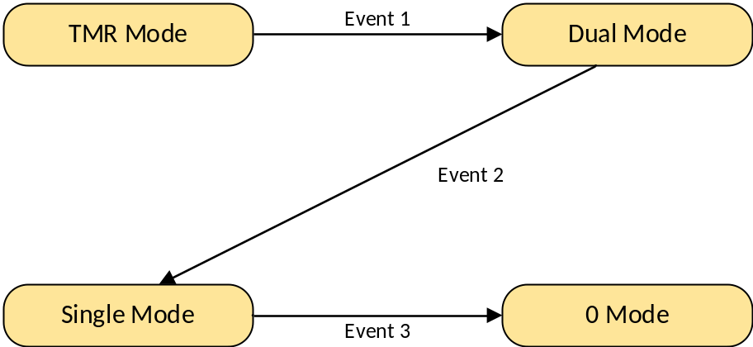
Figure 2-14 PM degradation mode
图2-14 PM降级模式示意图
Detailed description of the states as follows:
图中状态及事件具体描述如下：
- TMR Mode: Three channels work normally.
- Dual Mode: Only two channels work normally. When a task is configured as “Control” property, the task can be configured as 1oo2 or 2oo2 voting. When a task is configured as “Safety” property, only 1oo2 voting can be configured. The property can be set in the configuration software for each task.
- Single Mode: Only one channel works normally. When the maximum operation time exceeded, SIL3 is no more fulfilled.
- Event 1: One PM has a fault, the system occurs 3-2 degradation.
- Event 2: One of the remaining PMs has a fault, therefore the system occurs 2-1 degradation.
- Event 3: The last PM has a fault.
- TMR Mode：三系正常运行。
- Dual Mode：两系正常运行。用户配置成control应用时，可选择按照1oo2或者2oo2方式表决；配置成safety应用时，只能按照1oo2方式表决。control应用、safety应用的选择在组态软件中配置，可基于每个任务配置。
- Single Mode：单系运行。Single Mode下，超过允许运行的最大时间后，系统不满足SIL3。
- Event 1：一系PM出现故障，发生3-2降级。
- Event 2：一系PM出现故障后，又有一系PM出现故障，发生2-1降级。
- Event 3：单系PM运行，剩余该系PM出现故障。

COTS component 商用软件
SWSC_SafR_NSecR_A_044
No.
无。

Reused component 复用部分
SWSC_SafR_NSecR_A_045
No.
无。

Software function 软件具体功能

Control loop 控制回路
SWSC_SafR_NSecR_A_046
The control loop relevant to PM_FW includes the following steps, as shown in follows:
控制回路和PM_FW相关部分主要包括以下几个步骤，如下图所示：
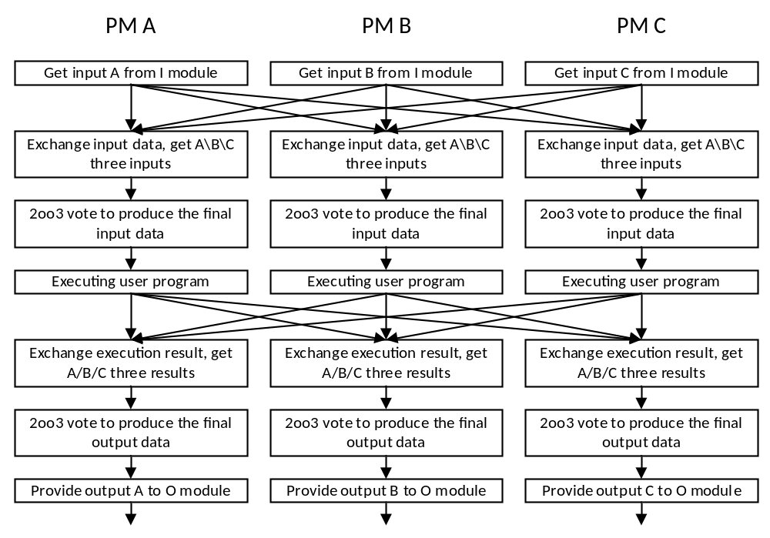
Figure 3-1 Control loop in PM
图3-1 PM控制回路示意图
The control loop is not relevant to CM_FW and CM_OS.
控制回路和CM_FW和CM_OS不相关。
For the executing user program, the enable of ‘Divided-by-zero error protection, array bounds exceeded error protection and exception handling’ can be selected by user. This property can be configured via configuration software for each user program. The property must be configured to enabled, if user selects the safety application mode; the property can be configured to enabled or disabled, if user selects the control application mode. If the user chooses to enable ‘Divided-by-zero error protection, array bounds exceeded error protection and exception handling’, when an exception occurs, the current statement will be skipped, and a function block can report this error.
对于执行用户程序，用户可选择是否开启“除零和数组越界的错误保护及异常处理”，该属性由使用者通过组态软件基于每个任务配置。用户选择safety应用时，该属性只能配置为开启；用户选择control应用时，都可以配置。如果用户选择开启“除零和数组越界的错误保护及异常处理”，当有错误发生时，跳过当前语句继续执行，并可通过功能块报出此错误。

Data retention 数据掉电保持
SWSRS_SafR_NSecR_A_060
The variables which need to be retained can be defined by the user in configuration software. The embedded software stored these variables in the SRAM after each control cycle. After power on, if the key switch is not in the ‘Init’ position, the embedded software will copy these variables from SRAM to the data area in DDR.
期望掉电保持的变量由使用者通过组态软件指定，嵌入式软件在每个控制周期后将这些数据保存在SRAM上。再次上电后，如果开关不在init档位，这些变量会从SRAM恢复到内存上。

Voting mechanism 表决机制
SWSC_SafR_NSecR_A_047
The voting mechanism is shown in the following table:
表决机制如下表所示：
Table 3-1 voting mechanism
表3-1 表决机制
 | Quality  Channel A | Quality  Channel B | Quality  Channel C | Voting  Configuration | Voting Result
DI | Normal | Normal | Normal | — | Result of 2oo3
DI | Normal | Normal | Bad | 2oo2 | Result of 2oo2
 |  |  |  | 1oo2 | Result of 1oo2
DI | Normal | Bad | Bad | — | Channel A's value
DI | Bad | Bad | Bad | — | Value set by user
DO | Normal | Normal | Normal | — | Result of 2oo3
DO | Normal | Normal | Bad | 2oo2 | Result of 2oo2
 |  |  |  | 1oo2 | Result of 1oo2
DO | Normal | Bad | Bad | — | Channel A's value
DO | Bad | Bad | Bad | — | Safety value
AI | Normal | Normal | Normal | — | Median
AI | Normal | Normal | Bad | — | Mean
AI | Normal | Bad | Bad | — | Channel A's value
AI | Bad | Bad | Bad | — | Value set by user
AO | Normal | Normal | Normal | — | Median
AO | Normal | Normal | Bad | — | Mean
AO | Normal | Bad | Bad | — | Channel A's value
AO | Bad | Bad | Bad | — | Safety value
PI | Normal | Normal | Normal | — | Median
PI | Normal | Normal | Bad | — | Maximum
PI | Normal | Bad | Bad | — | Channel A's value
PI | Bad | Bad | Bad | — | Value set by user
- The quality of input channel is Normal only when the quality of data, the quality of IP_BUS and the quality of PM_BUS are all Normal
- The quality of output channel is Normal only when quality of data and the quality of PM_BUS are both Normal
- If an analog data is out of the tolerance, the quality is bad.
- When a task is configured as “Control” property, the task can be configured as 1oo2 or 2oo2 voting. When a task is configured as “Safety” property, only 1oo2 voting can be configured.
- 对于输入数据来说，某系数据的质量取决于数据本身的质量、IP_BUS的质量和PM_BUS的质量。如果这三个质量有一个为坏，则该系质量为坏，即该系输入数据无效。
- 对于输出数据来说，数据质量取决于数据本身的质量和PM_BUS的质量。如果这两个质量有一个为坏，则该系质量为坏，即该系输出数据无效。
- 对于模拟量输入来说，如果其中某一系的值超过偏差允许的范围，则该系质量为坏，即该系输入数据无效。
- 对于数字量数据来说，在control方式下，用户可配置两系质量好时按照1oo2或2oo2表决；在safety运行方式下，两系质量好时只能按照1oo2表决。

Data monitoring 数据监视
SWSC_NSafR_NSecR_A_048
The data monitoring function refers to PC software (OPC software, HMI software and configuration software) monitor run-time data of PM. All the PMs sent the run-time data to CM cyclically, and CM handles the read variable request from the PC software and sends response with run-time data.
数据监视主要指上位机软件（OPC Server、HMI软件和组态软件）监视PM的实时数据。PM周期主动将实时数据发送给CM，CM接受上位机软件的请求，按照不同的要求进行应答。
Therefore, the request from PC software is directly handled by the CM, and PM is not affected.
因此，数据监视功能和PM无直接关系，不会对PM的运行造成影响。

Online operation 在线操作
SWSC_NSafR_NSecR_A_049
Online operation function refers to that the user sends the debug command to the PM through the configuration software. The debug command includes STOP, RUN, PAUSE, Single step, Set variable, Disable/Enable variable, etc. This function only can be used in Program state. The diagram is shown in Figure 3-2:
在线操作主要指用户通过组态软件下发写调试命令给PM，主要包括停止命令、运行命令、暂停命令、单步命令、写变量命令、使能/禁止命令。在线操作只有在调试状态下才能运行。这些在线操作命令的流程如下图所示：
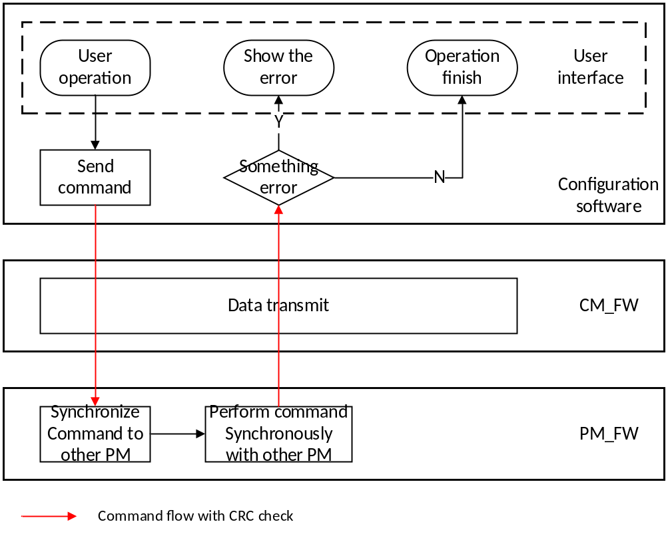
Figure 3-2 Diagram of online operation
图3-2 在线操作示意图

Download 下装

Initialization download 初始化下装
SWSC_NSafR_NSecR_A_050
There are two types of download: initialization download and online download. This function only can be allowed in debug stop state or standby state. After the initialization download, all the variables will be initialized, and control station will use the new project. The diagram is shown in Figure 3-3:
下装分为初始化下装和在线下装。初始化下装只能在debug stop state或者standby state下进行，下装后，控制站中的用户程序从初始状态运行。初始化下装的流程如下图所示：
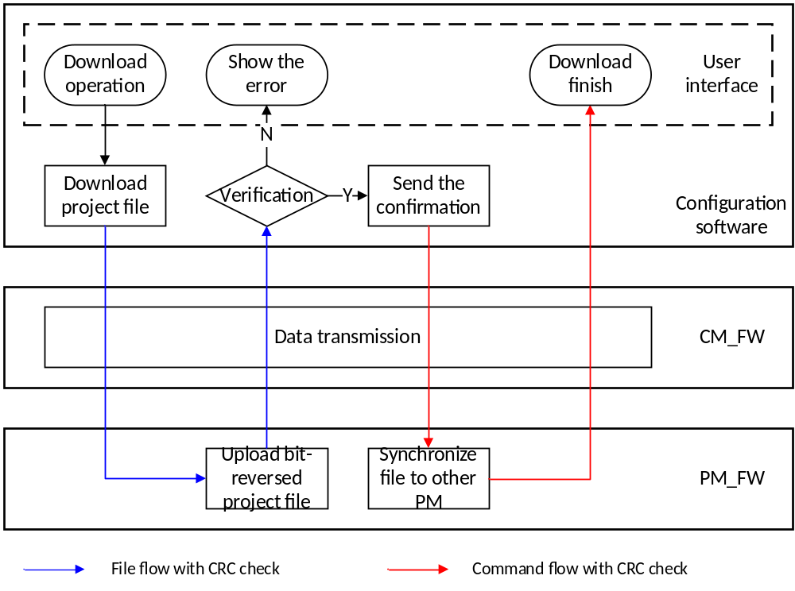 Figure 3-3 Diagram of initialization download
图3-3 初始化下装示意图

Online download 在线下装
SWSC_NSafR_NSecR_A_051
The online download function only can be allowed in debug run state or pause state. During the online download process, the control station still used the old project until the completion of the online download. After the online download, the changed variables or new variables will be initialized, and the remaining variables will remain unchanged. The diagram is shown in Figure 3-4:
当PM处于debug run state或者pause state时，允许组态软件进行在线下装。在线下装时，控制站一直运行上次下装的用户程序，直到在线下装完成。在线下装后，新增变量或者修改的变量会被初始化，其余变量值保持不变。在线下装的流程如下图所示：
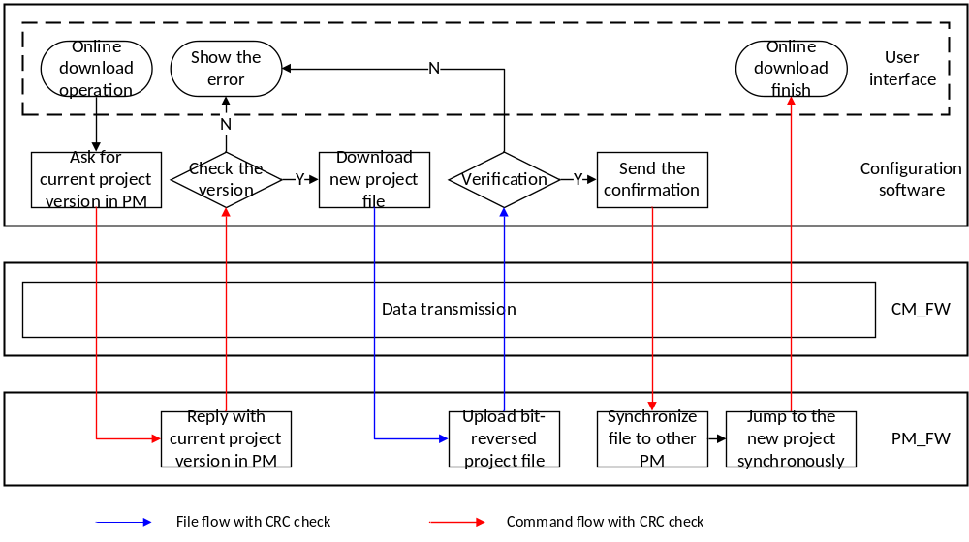 Figure 3-4 Diagram of online download
图3-4 在线下装示意图

Running information record 运行信息记录

SOE
SWSC_NSafR_NSecR_A_052
SOE function is realized by DI module, AI module, OSP module, PM, CM and configuration software. Each PM stores SOE records and provides the records to the SOE software respectively.
系统的SOE功能由DI模块、AI模块、OSP模块、PM、CM、组态软件共同完成，三系PM各自存储SOE，并能分别将SOE记录提供给上位机SOE软件。
The sources of SOE records are shown as follows:
SOE记录的来源如下：
- DI module, which is hard SOE. DI module records status change of input signal. The SOE accuracy resolution is 1ms if the modules belong to one control station, and it is 2ms if the modules belong to different stations.
- DI模块，该类型属于硬SOE。DI模块记录输入开关量信号的状态变化，控制站内DI的SOE精度优于分辨率为1ms，控制站间DI的SOE精度优于分辨率为2ms。
- AI module, which is hard SOE. AI module generates a SOE record if the point value exceeds the threshold values. Up to four threshold values can be set by configuration software. The SOE resolution of AI is 2ms if the modules belong to one control station, and it is 4ms if the modules belong to different stations.
- AI模块，该类型属于硬SOE。AI模块在通道采集值超过阈值门限时进行SOE记录，通道阈值可组态配置，最大支持4个通道阈值。AI模块SOE分辨率站内为2ms，站间为4ms
- OSP module, which is hard SOE. OSP module generates SOE records when PI signal reaches trip threshold and transition in DI signals.
- OSP模块，该类型属于硬SOE。OSP模块在PI信号达到trip阈值时、以及DI信号发生跳变时记录SOE。
- Internal BOOL variable, which is soft SOE. PM monitors the status change of the special variables that are labeled as ‘SOE variable’ by configuration software. The accuracy of soft SOE is one control cycle.
- 内部BOOL类型变量，该类型属于软SOE。PM监视组态为SOE点的BOOL类型变量的状态变化，精度要求为一个控制周期。BOOL类型变量是否为SOE点由工程人员在组态软件上组态完成。
The SOE record is rolling recorded, and the maximum number is 60000. The latest 5000 records can be maintained after power-off.
SOE记录总数为6万条，其中，掉电保持的SOE条数为5000条。
SOE records can be grouped by configuration software, and each group can be set individually for the capacity, recording method and whether need to be maintained after power-off. Hard SOE and soft SOE cannot be in one group. The maximum number of SOE groups is 16.
组态软件可以对SOE记录的来源进行分组，并设置每组的记录容量、记录方式及是否掉电保护，但硬SOE和软SOE不能设置在一个组内。最多支持16组SOE。

Control station log 日志
SWSC_NSafR_SecR_A_053
PM and CM can save 10000 latest log records respectively, the latest 1000 records have power loss retain function.
PM、CM保存各自最近的10000条日志记录，其中各自最近的1000条日志具有掉电保持功能。
The log records contain power on event, fault event, configuration download and debug event.
日志记录内容包括：上电事件、故障事件、组态下装及调试事件。
The diagnostic software can read all the log records from PM and CM.
诊断软件能够从PM和CM读取所有的日志记录。

Status monitoring 状态监视
SWSC_SafR_NSecR_A_054
The status, which is monitored and recorded by PM, includes PM status, Safety Net status, IP_BUS status, IO module status, PM temperature, CM_BUS status.
The status, which is monitored and recorded by CM, includes CM status, CM memory usage, CM CPU load, CM temperature, System Net status, Modbus communication status.
All the CMs send the status data to the PM cyclically. PM handles the request of the diagnostic software, and send a response to it with status data. The system supports the function that the user can use the diagnostic software to clear the IO module diagnostic information in Program state.
PM需要记录的状态数据包括PM状态、Safety Net状态、IP_BUS状态、IO模块状态、PM温度、CM_BUS状态。
CM需要记录的状态数据包括CM状态、CM内存使用率、CM的CPU负荷、CM温度、System Net状态、Modbus通讯状态
CM周期主动将状态数据发送给PM，PM响应诊断软件的请求，按照不同的要求进行应答。系统支持用户在调试模式下通过诊断软件清除IO模块故障信息。

Safety communication protocol 安全通讯协议

PM_BUS
SWSC_SafR_NSecR_A_055
PM_BUS is used for data exchange between PMs. The embedded software is responsible for handling safety layer, and the communication link between PMs is the black channel.
PM_BUS用于三系PM间交换数据，PM中的嵌入式软件负责处理安全层数据，PM之间的通信链路为安全通信对应的黑通道。
Network topology is shown in Figure 4-1:
网络拓扑如图4-1所示：
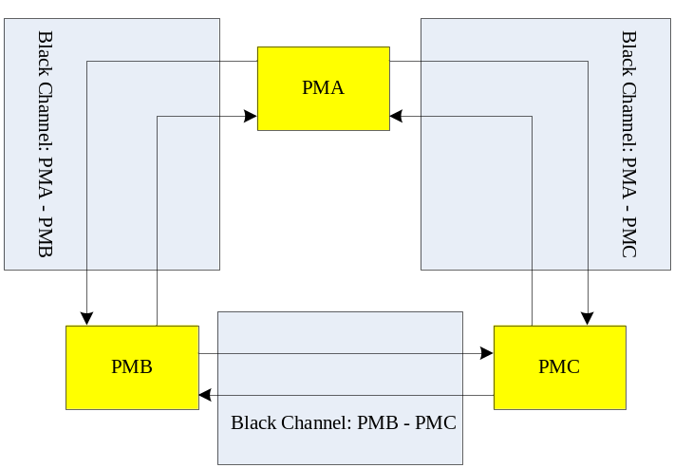
Figure 4-1 Communication topology of PM_BUS
图4-1 PM_BUS网络拓扑结构示意图

Safety layer function 安全层功能
The measures including Sequence number, Time expectation - Watchdog, Connection authentication, Data integrity assurance - CRC are implemented to avoid communication errors.
使用序列号、时间预期、连接验证、CRC防御通讯威胁。
The fault control matrix is shown in the table 4-1:
安全层提供的保护如表4-1所示：
Table 4-1 Fault Control Matrix
表4-1 威胁/防御矩阵
Communication failure  通信错误 | Safety measure 安全措施
Communication failure  通信错误 | Sequence number  序号 | Watchdog  看门狗 | CRC | Connection authentication  连接验证
Data Corruption  数据损坏 |  |  | X
Repetition  重复 | X
Incorrect sequence  不正确的序列 | X
Loss  丢失 | X
Unacceptable delay  不可接受的延迟 |  | X
Insertion  插入 | X |  |  | X
Masquerade  伪装 |  |  |  | X
Addressing  寻址异常 |  |  |  | X

Protocol message structure 协议消息结构
Table 4-2 Frame structure
表4-2 帧结构
Header | Safety relevant data | CRC-32-0 | Non-safety relevant data
14 bytes | variable | 4 bytes | variable

Table 4-3 Header structure
表4-3 头结构
 | Data Type | Length | Value | Description
Total Length | unsigned int | 4 bytes |  | Total length including Header.  数据帧总长度，包括帧头
SrcAddr | unsigned char | 1 byte | 0-2 | ID of source PM: 0->PMA; 1->PMB; 2->PMC  源PM编号：0->PMA；1->PMB；2->PMC
DstAddr | unsigned char | 1 byte | 0-2 | ID of destination PM: 0->PMA; 1->PMB; 2->PMC  目的PM编号：0->PMA；1->PMB；2->PMC
Sequence Number | unsigned short | 2 bytes |  | Increment after each send.  每发送一次，数值增加1
Block Number | unsigned short | 2 bytes | n | Number of safety relevant data blocks.  安全相关数据中数据块的个数
Safety Length | unsigned int | 4 bytes |  | Number of safety relevant data bytes.  安全相关数据的长度（字节）

IP_BUS
SWSC_SafR_NSecR_A_056
IP_BUS is used for data exchange between PM and IO module. The embedded software and the firmware in IO module are responsible for handling safety layer, and the communication link between them is the black channel.
IP_BUS用于PM和IO模块之间交换数据，PM中的嵌入式软件和IO模块固件负责处理安全层数据，两者之间的通信链路为安全通信对应的黑通道。
Network topology is shown in Figure 4-2:
网络拓扑如图4-2所示：
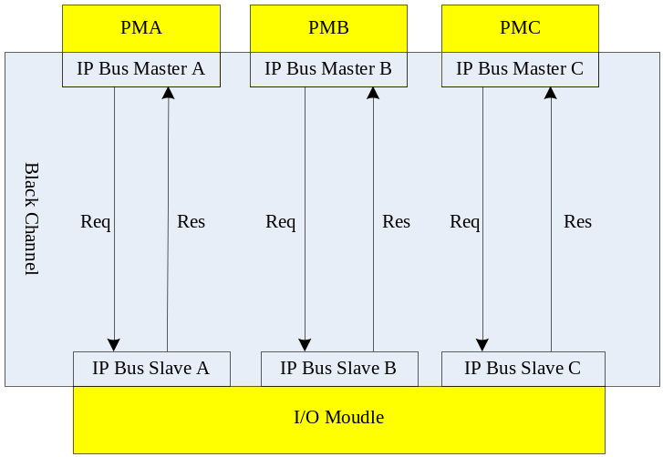
Figure 4-2 Communication topology of IP_BUS
图4-2 IP_BUS网络拓扑结构示意图

Safety layer function 安全层功能
The measures including Sequence number, Time expectation - Watchdog, Connection authentication, Data integrity assurance – CRC, Feedback message are implemented to avoid communication errors.
使用序列号、时间预期、连接验证、CRC、应答包等技术防御通讯威胁。
The fault control matrix is shown in the table 4-4:
安全层提供的保护如表4-4所示：
Table 4-4 Fault Control Matrix
表4-4 威胁/防御矩阵
Communication failure  通信错误 | Safety measure 安全措施
Communication failure  通信错误 | Sequence number  序号 | Watchdog  看门狗 | CRC | Feedback message  应答包 | Connection authentication  连接验证
Data Corruption  数据损坏 |  |  | X
Repetition  重复 | X
Incorrect sequence  不正确的序列 | X
Loss  丢失 | X |  |  | X
Unacceptable delay  不可接受的延迟 |  | X |  | X
Insertion  插入 | X |  |  | X | X
Masquerade  伪装 |  |  |  |  | X
Addressing  寻址异常 |  |  |  |  | X

Protocol message structure 协议消息结构
Table 4-5 Frame structure
表4-5 帧结构
Header 1 | Header 2 | Safety IO data 1 | Safety IO data 2 | CRC 1 | CRC 2
8 bytes | 8 bytes | variable | variable | 4 bytes | 4 bytes
As show in Table 4-5, ‘Header 2’ is the bit-reversed data of ‘Header 1’, ‘Safety IO data 2’ is the bit-reversed data of ‘Safety IO data 1’, and ‘CRC 2’ is the bit-reversed data of ‘CRC 1’.
上述结构中，第二份数据是第一份数据的反转。
Table 4-6 Header structure
表4-6 头结构
 | Data Type | Length | Value | Desc
Codename | unsigned int | 4 bytes |  | Unique relationship between master and slave obtained by (PM ID << 16) | Slave address  代表主从唯一的对应关系：PM号<<16 | 从站地址
Sequence Number | unsigned short | 2 bytes |  | Increment after each REQ in master, and Slave ACK uses the identical number as REQ  主站每发送一次增加1，从站应答时序号与请求帧一致
Control/Status | unsigned char | 1 byte |  | Control byte / Status byte  控制/状态字节
Frame Length | unsigned char | 1 byte |  | Number of total bytes in frame without Header  此数据帧的总长度（字节），不包括帧头

Table 4-7 Control byte
表4-7 控制字节
Bit | Value 值 | Description 描述
0 | Active_FV: Fail-safe values to be activated | Set to ‘1’ when using fail-safe value  使用故障安全值时，置1：
1 | iPar_En: parameter is ready | Set to ‘1’ when master is ready to send slave module parameters  主站准备下发从站模块参数时，置1
2~7 | Reserved

Table 4-8 Status byte
表4-8 状态字节
Bit | Value 值 | Description 描述
0 | Failure exists | Set to ‘1’ when detected faults.  存在失效时，置1。
1 | Communication failure: Codename | Set to ‘1’ when Codename failure.  Codename错误时，置1。
2 | Communication failure: CRC or Sequence Number | Set to ‘1’ when CRC or Sequence number failure.  CRC或序号错误时，置1。
3 | Communication failure: WD-timeout | Set to ‘1’ when Watchdog timeout.  看门狗超时，置1。
4 | Fail-safe values (FV) activated | Set to ‘1’ when slave using FV.  从站使用故障安全值时，置1。  After IP_BUS interruption, the necessity of the user confirmation for re-connection can be configured in the configuration software. If the user confirmation is necessary, this value remains at 1 before the user confirms.  IP_BUS中断后，使用者通过组态软件配置再次建立连接是否需要用户确认。如配置为需确认，在用户确认前，该值保持为1。
5 | new i-Parameter OK(iPar_OK) | Set to ‘1’ when slave has adopted the new parameter.  从站采用主站下发的新参数后，置1。
6-7 | Reserved

Peer to Peer safety communication between control stations 站间安全通讯
SWSC_SafR_NSecR_A_057
Safety communication between control stations (Peer-to-Peer) is used for the safety data exchange between control stations. Whole link of Peer-to-Peer includes the following parts: the PM of the source control station, the CM_BUS of the source control station, the CM of the source control station, Safety Net, the CM of the destination control station, the CM_BUS of the destination control station, and the PM of the destination control station. The safety layer protocol of Peer-to-Peer is implemented by PM. The data flow is shown in Figure 4-3:
控制站间安全通讯功能（Peer to Peer）用于多个控制站之间的安全数据通讯，整个链路包括以下几部分：源控制站的PM、源控制站的CM_BUS、源控制站的CM、Safety Net、目的控制站的CM、目的控制站的CM_BUS、目的控制站的PM。PM实现通讯安全层。数据流如图4-3所示：
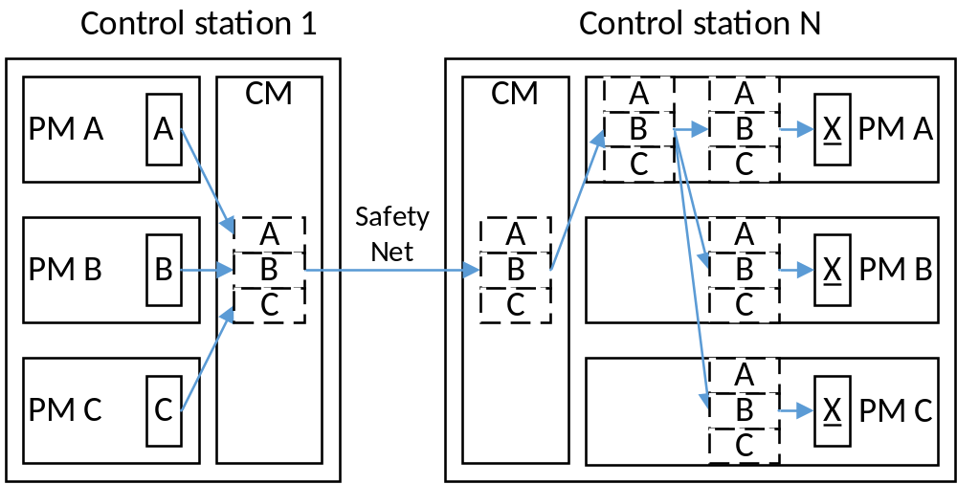
Figure 4-3 Data flow of Peer to Peer safety communication
图4-3 安全站间通讯数据流示意图
As show in Figure 4-3, the data flow includes the following steps:
如上图所示，整个发送数据流分为以下几步：
- Each PM sends the message to CM. The send period can be configured in the configuration software. When the period is less than the actual interval (the actual interval is the time between send requests and receive the response), the actual interval will replace the set cycle.
- The CM packs the messages of all PMs into one packet, and sends it through the Safety Net.
- The CM in destination control station receives the packet and transmits it to one PM that works normally.
- The PM send the packet to other PMs.
- Each PM handles the safety layer synchronously, and then gets the final results by voting.
- 各个PM将数据帧发送给CM。发送周期可配置，当配置的发送周期小于实际间隔（从数据发送到接收到对方控制器的应答）时，按实际间隔发送数据。
- CM将本站所有PM的安全帧打包，并通过Safety Net发送。
- 目的控制站的CM收到数据包后，发给其中一个正常工作的PM。
- 该PM处理安全层将数据包同步给其他PM。
- 三系PM同步处理数据包，各自通过表决得到最后结果。

Safety layer function 安全层功能
The measures including Sequence number, Time expectation - Watchdog, Connection authentication, Data integrity assurance – CRC, Feedback message are implemented to avoid communication errors.
使用序列号、时间预期、连接验证、CRC、应答包等技术防御通讯威胁。
The fault control matrix is shown in the table 4-9:
安全层提供的保护如表4-9所示：
Table 4-9 Fault Control Matrix
表4-9 威胁/防御矩阵
Communication failure  通信错误 | Safety measure 安全措施
Communication failure  通信错误 | Sequence number  序号 | Watchdog  看门狗 | CRC | Feedback message  应答包 | Connection authentication  连接验证
Data Corruption  数据损坏 |  |  | X
Repetition  重复 | X
Incorrect sequence  不正确的序列 | X
Loss  丢失 | X |  |  | X
Unacceptable delay  不可接受的延迟 |  | X |  | X
Insertion  插入 | X |  |  | X | X
Masquerade  伪装 |  |  |  |  | X
Addressing  寻址异常 |  |  |  |  | X

Protocol message structure 协议消息结构
Table 4-10 Frame structure in CM
表4-10 CM帧结构
Additional Info | PMA Safety Frame | PMB Safety Frame | PMC Safety Frame | FCS
4 bytes | variable | variable | variable | 4 bytes

Table 4-11 Additional Info structure
表4-11 附加信息结构
 | Data Type | Length | Desc
Total Length | unsigned short | 2 bytes | Number of bytes in data frame with Additional Info  打包后的数据帧的总长度（字节），包括附加信息
PM Info. | unsigned char | 1 byte | Bit 0->PMA; Bit 1->PM B; Bit 2->PM C. Set corresponding bit to ‘1’ when the data frame contains the safety frame from corresponding PM.  Bit 0->PMA；Bit 1->PMB；Bit 2->PMC，当此数据帧包含相应PM的安全帧时，相应的位置1。
Reserved | unsigned char | 1 byte

Table 4-12 REQ safety frame structure of one PM
表4-12 单个PM请求帧结构
Header 1 | Header 2 | Safety data 1 | Safety data 2 | CRC 1 | CRC 2
8 bytes | 8 bytes | Variable | variable | 4 bytes | 4 bytes
As show in Table 4-12, ‘Header 2’ is the bit-reversed data of ‘Header 1’, ‘Safety data 2’ is the bit-reversed data of ‘Safety data 1’, and ‘CRC 2’ is the bit-reversed data of ‘CRC 1’.
上述结构中，第二份数据是第一份数据的反转。

Table 4-13 REQ safety frame header structure
表4-13 请求帧头结构
 | Data Type | Length | Value | Desc
Sequence Number | unsigned short | 2 bytes |  | Increment after each REQ in source PM  递增序号
SrcAddr | unsigned char | 1 byte |  | (ID of source PM (0, 1, 2) << 6) | ID of control station (0~63)  源地址：PM编号+控制站节点号
DstAddr | unsigned char | 1 byte |  | ID of destination control station (0~63)  目的控制站节点号（0~63）
Block Number | unsigned char | 1 byte | n | Number of safety relevant data blocks  数据块的个数
Control Byte | unsigned char | 1 byte
Frame Length | unsigned short | 2 bytes |  | Number of total bytes in safety frame with Header  安全层数据帧的总长度（字节），包括帧头

Table 4-14 Control Byte
表4-14 控制字节
Bit | Value | Description
0 | Failure flag | Set to ‘1’ when using fail-safe value  倒向安全状态标志位
1-7 | Reserved

Table 4-15 ACK safety frame structure of one PM
表4-15 单个PM应答帧结构
Header 1 | Header 2 | CRC 1 | CRC 2
8 bytes | 8 bytes | 4 bytes | 4 bytes
As show in Table 4-16, ‘Header 2’ is the bit-reversed data of ‘Header 1’ and ‘CRC 2’ is the bit-reversed data of ‘CRC 1’.
上述结构中，第二份数据是第一份数据的反转。
Table 4-16 ACK safety frame header structure
表4-16 应答帧头结构
 | Data Type | Length | Value | Desc
Sequence Number | unsigned short | 2 bytes |  | Increment after each REQ in source PM  序号，同请求包
SrcAddr | unsigned char | 1 byte |  | (ID of source PM (0, 1, 2) << 6) | ID of control station (0~63)  源地址：PM编号+控制站节点号
DstAddr | unsigned char | 1 byte |  | ID of destination control station (0~63)  目的控制站节点号（0~63）
Status Byte | unsigned char | 2 byte
Reserved | unsigned char | 1 byte
Frame Length | unsigned short | 1 bytes |  | Number of total bytes in safety frame with Header  安全层数据帧的总长度（字节），包括帧头

Table 4-17 Status Byte
表4-17 状态字节
Bit | Value | Description
0 | Communication failure: WD-timeout | Set to ‘1’ when Watchdog timeout  通信错误：看门狗超时时，置1
1 | Communication failure: PMA CRC | Set to ‘1’ when CRC of PM A failure  PM A的CRC错误时，置1
2 | Communication failure: PMB CRC | Set to ‘1’ when CRC of PM B failure  PM B的CRC错误时，置1
3 | Communication failure: PMC CRC | Set to ‘1’ when CRC of PM V failure  PM C的CRC错误时，置1
4 | Communication failure: PMA Addr | Set to ‘1’ when SrcAddr or DesAddr of PM A failure  PM A源地址或目的地址出错时，置1
5 | Communication failure: PMB Addr | Set to ‘1’ when SrcAddr or DesAddr of PM B failure  PM B源地址或目的地址出错时，置1
6 | Communication failure: PMC Addr | Set to ‘1’ when SrcAddr or DesAddr of PM C failure  PM C源地址或目的地址出错时，置1
7 | Communication failure: PMA SQ | Set to ‘1’ when Sequence number of PM A failure  PM A序号错误时，置1
8 | Communication failure: PMB SQ | Set to ‘1’ when Sequence number of PM B failure  PM B序号错误时，置1
9 | Communication failure: PMC SQ | Set to ‘1’ when Sequence number of PM C failure  PM C序号错误时，置1
10 | Alarm | PM Info in Additional Info not matched with safety data frame.  附加信息中的PM Info，与安全帧中的PM信息不一致。
11~13 | Reserved
14, 15 | Data Source | Source PM ID of adopted data, 1: PMA; 2: PMB; 3: PMC  源PM ID，1：PMA；2：PMB；3：PMC

Functional security design 信息安全设计

Identification and Authentication Control 识别和身份验证控制
SWSC_NSafR_SecR_A_001
The user can set a password for the control station in configuration software, and the PC software must use this password to connect the controller. Each PC software has a unique ID and operating range. When the control station received a command from PC software, the embedded software will check it. If the ID is invalid or the command is out of the operating range, an alarm will be provided to the user. The project version will be verified when the control station received a debugging operation from PC software.
组态软件可配置连接密码，所有上位机软件和控制站通讯时都需要输入此密码。每个上位机软件均具备唯一的ID和服务码范围。嵌入式软件验证ID有效性，并且根据ID及其服务码范围，检查上位机软件下发的操作是否有效，如果无效，则拒绝服务并且报错。调试操作时需验证工程版本信息。
For identification and authentication control between control stations, the embedded software will check the validation of the stations ID.
其他控制站识别（站间通信）：嵌入式软件负责验证源控制站ID和目的控制站ID是否有效。
For device (Modbus or IO module) identification and authentication, the embedded software will check the ID and the actual use port to ensure that they are accord with the project configuration.
对于设备（Modbus设备或者IO模块）的识别和身份验证，嵌入式软件检查实际使用的端口或ID号和工程中的配置是否一致。
Support IP access control, and user can configure read/write authority and communication protocol for each IP address.
支持IP访问控制，可以为每个IP配置读写权限及可使用的通讯协议。

Use control 使用控制
SWSC_NSafR_SecR_A_002
Control station must be accessed with password, and the read/ write authority of communication between control stations as well as communication to the third party devices must be explicitly configured when editing the project in PC software.
控制站必须使用密码才能够访问，控制站站间通信的读写权限由工程唯一确定，Modbus设备的读写权限由工程唯一确定。
SWSC_NSafR_SecR_A_004
Option is provided to support session locking after an administrator specified period of time of inactivity for the session until re-established by authorized user.
一段时间无任何通讯操作后，上位机软件需要重新登录。该非活动时间的大小用户可配。
SWSC_NSafR_SecR_A_005
Records which are relevant to security with timestamp, source, category, type, event ID & results are generated and stored in control station, including: access control, power on, error event, backup & restore event, download and other debug operation event, and audit log events.
嵌入式软件保存与信息安全相关的日志记录。日志类型包括：访问控制、上电记录、故障记录、备份与恢复、组态下装和调试记录，以及审计日志。日志内容包含：时间戳、故障源、日志类型、日志ID和事件结果。
SWSC_NSafR_SecR_A_006
Each PM, CM can save the latest 10000 log records. When the space which is used for storing log is less than the threshold value, an alarm will be provided to the user. The threshold is 5%.
PM、CM各自保存最近的10000条日志记录。当有未被读取的日志将要被最新日志覆盖时，产生报警，该预警门限为5%。
SWSC_NSafR_SecR_A_007
Failure of audit processing will not influence the safety critical functions, and an alarm will be provided to the user.
日志记录失败不会影响到安全功能，但会提供一个警告给用户。
SWSC_NSafR_SecR_A_008
Timestamp is synchronized with system-wide time source. Detection of unauthorized alteration of time source and discrepancy of time is implemented, and it will cause an audit event upon alteration or discrepancy.
时间戳所用的时间在系统内部同步，当检测非法的时间源或者校时偏差超限时会产生日志记录。
SWSC_NSafR_SecR_A_009
Debug operation of PC software or abnormal access of the device will be recorded in the SRAM with a time stamp. The battery on chassis provides power for SRAM to ensure the records can be maintained after power-off.
上位机软件的调试操作以及接入设备的异常访问会作为记录保存在SRAM中，有带时间戳。机架上的电池保证SRAM中的记录掉电不丢失。

System Integrity 系统完整性
SWSC_NSafR_SecR_A_010
Safety measures are applied for all the safety communications. Measures such as CRC and odd-even check is used to protect other non-safety related communications.
安全相关的通讯采用安全协议来保证通讯完整性，非安全的通讯采用CRC或者奇偶校验来保证通讯完整性。
SWSC_NSafR_SecR_A_028
Separation of data and executable code in control station, and measures are in place to prevent execution of code located in data space. For CM, MMU is used for memory separation. For PM, the separation is implemented by software design.
Only specified functionalities in CM OS (Linux) are used in dedicated way, while other functionalities are not used to avoid the opportunity of attacking from malicious code.
控制站中数据和代码分离，用于防止代码在数据区中执行。CM中使用MMU来进行内存分配，PM通过软件设计来进行内存分配。
在CM中的OS（Linux）已经裁剪为实际需要的最小功能，用于减少来自恶意代码攻击的机会。
SWSC_NSafR_SecR_A_012
Protection measures such as CRC are used to detect modifications to firmware, libraries and project. If an unauthorized change occurs, the embedded software will record it and provide an alarm to the user.
固件、库和工程等均带有CRC信息，嵌入式软件可通过计算CRC，然后与其自带的CRC进行比较，从而判断得知上述内容是否被意外损坏。当损坏发生时，嵌入式软件记录日志并报警。
SWSC_NSafR_SecR_A_013
The control station is responsible for judging whether the data is valid, such as whether the data address is out of the range, whether the data value is overrun, and so on.
控制站判断数据是否有效，如数据地址范围是否正确、数据值是否超限等等。
The software checks the value of the key switch whether it is in the allowed range。
软件检查钥匙开关的值是否在允许范围内。
SWSC_NSafR_SecR_A_015
Error messages are handled by dedicated diagnostic software with account and password IAC which is in an expeditious manner without providing information that could be exploited.
错误记录只能被诊断软件获取，诊断软件带有IAC和UC控制，保证信息不被非法利用。
SWSC_NSafR_SecR_A_016
It does not support the modification of the log with diagnostic software, and support the clear of the log.
不支持对日志的修改，支持诊断软件清除日志。

Data Confidentiality 数据保密性
SWSC_NSafR_SecR_A_017
Password is encrypted, neither stored internally nor sent over shared network in clear text format
连接密码为加密传输和加密保存。
SWSC_NSafR_SecR_A_018
The log file and the source project can be cleared by diagnostic software. If the key switch is in ‘Init’ when power on, the project will be cleared.
日志和源工程文件支持内部诊断软件通过相应的服务清除。如果上电时钥匙开关在init档位，上电后工程无效。

Restricted Data Flow 受约束的数据流
SWSC_NSafR_SecR_A_019
User configuration of network parameters (IP, masks, etc.) is supported.
网络参数，如IP地址，子网掩码等，用户可配。

Timely Response to Events 事件的及时响应
SWSC_NSafR_SecR_A_020
Diagnostic software can be configured to read the log automatically.
诊断软件可配置为自动读取日志。

Resource Availability 资源可用性
SWSC_NSafR_SecR_A_021
Operation under degradation mode during flooding type attack with IP_BUS or IO module.
IP_BUS通讯或I/O模块故障后，控制站降级模式下运行。
When network storm occurs, all the functions of the PM and CM except system net communication shall be remain normal. System net communication shall be recovered after the network storm.
当网络风暴发生时，除系统网通讯功能外，PM、CM的其他功能不受影响。网络风暴结束后系统网通讯功能恢复工作。
Communication and safety functions independent of each other, communication failure does not affect the safety function.
通讯功能和安全功能相互独立，通讯故障不影响安全功能。
SWSC_NSafR_SecR_A_022
All resources are statically allocated.
所有资源都是静态分配。
SWSC_NSafR_SecR_A_023
The CM support to store the source project in FLASH, and does not affect normal operation.
嵌入式固件支持备份源工程文件在CM中，备份过程不影响其他功能。
SWSC_NSafR_SecR_A_024
After power on, the system will be running according to the project configuration. If the project is missing, the configuration software can read the source project from CM, and then download the project again.
上电后，系统按照工程配置运行。如果工程丢失，组态软件可读取CM中备份的源工程文件，然后重新下装工程。
SWSC_NSafR_SecR_A_026
The properties of physical port (such as Ethernet port and serial port) can be configured by user though configuration software. Some functions of the protocol can be prohibited by the configuration software, such as writing function of Modbus protocol.
物理端口（网口和串口）的相关属性用户可配，如协议类型、是否使能，可通过上位机软件进行设置。协议的某些功能可通过上位机软件禁止，如可禁止通过Modbus协议写变量。
Only specified functionalities in CM OS (Linux) are used in dedicated way, while other functionalities are not used to avoid the opportunity of attacking from malicious code
CM的linux操作系统中，不用的功能都会被裁剪，用于保护受到恶意代码的攻击。
SWSC_NSafR_SecR_A_027
The embedded software collects information of installed component including ID, revision & configuration, etc. The information will be send to diagnostic software.
嵌入式软件负责收集已安装模块的信息：ID、版本和配置信息等，此信息可被诊断软件读取。

——以下无正文
The last requirement number is SWSC_SafR_NSecR_A_060
本文档最后一个需求编号为SWSC_SafR_NSecR_A_060

