**CS 2208B Assignment 4**

By: Jakob Wanger

Date: March 17, 2019

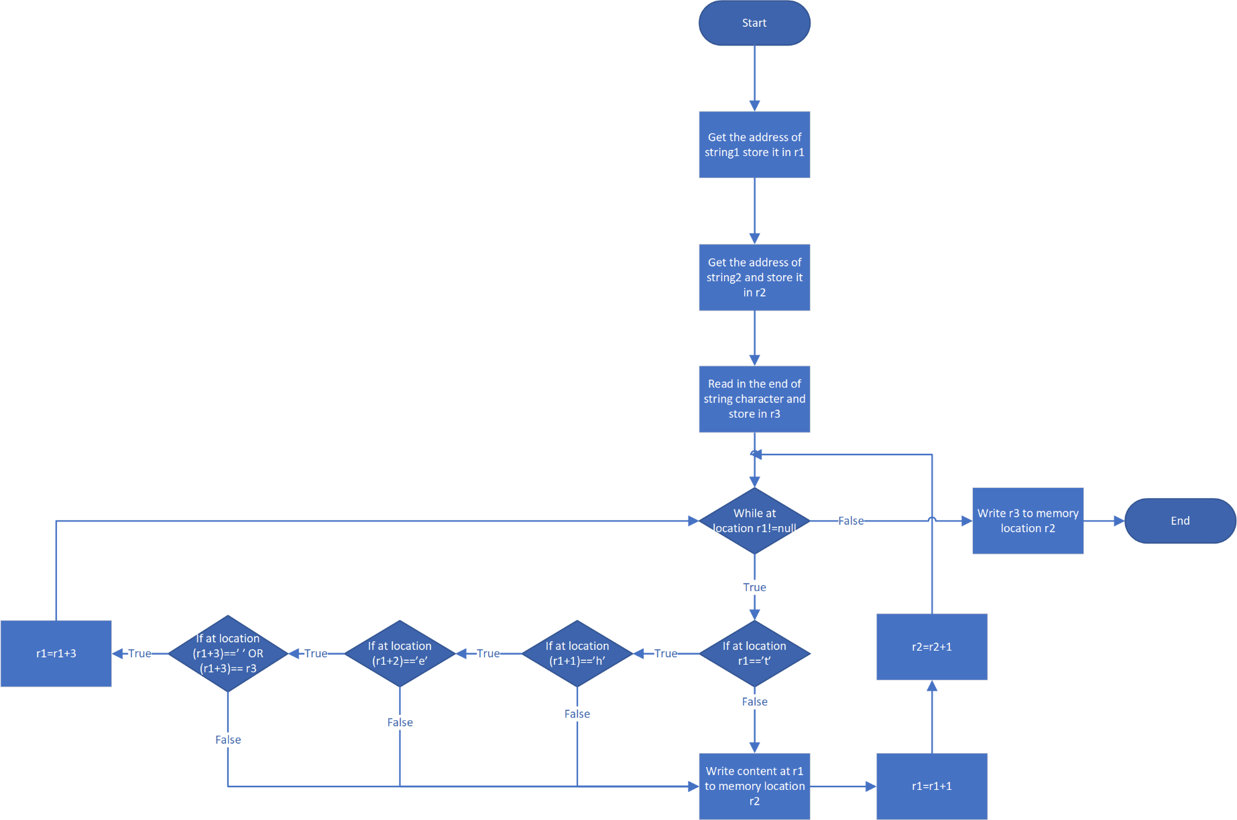Student Number: 250950022