

AWS First Cloud AI Journey – Project Plan

D2F – FPT University HCM – IoT Security Monitoring & Alert System for Smart Home on AWS Cloud Platform

September 30, 2025
Table of Contents
1 BACKGROUND and motivation 3
1.1 executive summary 3
1.2 PROJECT SUCCESS CRITERIA 3
1.3 Assumptions 3
2 SOLUTION ARCHITECTURE / ARCHITECTURAL DIAGRAM 3
2.1 Technical Architecture Diagram 3
2.2 Technical Plan 4
2.3 Project Plan 4
2.4 Security Considerations 4
3 Activities AND Deliverables 5
3.1 Activities and deliverables 5
3.2 OUT OF SCOPE 5
3.3 PATH TO PRODUCTION 5
4 EXPECTED AWS COST BREAKDOWN BY SERVICES 5
5 TEAM 6
6 resources & cost estimates 6
7 Acceptance 7

BACKGROUND and motivation

executive summary
FPT University HCM - 3rd year students D2F Team consisting of 5 members (2 IC Design Engineers, 2 Software Engineers, 1 Security Specialist).
Development of a comprehensive IoT security monitoring and alert system for smart homes, combining hardware sensor integration, advanced security protocols, server-less back-end architecture, and real-time dashboard visualization. The system provides end-to-end monitoring capabilities for environmental parameters (temperature, humidity, gas detection, motion) with robust security measures and cloud-based analytic.
Smart Home Environmental Monitoring: Real-time tracking of temperature, humidity, gas levels, and motion detection with immediate alert capabilities. Remote monitoring through web and mobile interfaces with 24/7 security coverage and sub-second response times for critical events.
The IoT Security Team will deliver a production-ready prototype within 3 months and $100 budget, featuring: (1) Hardware sensor nodes with ESP32 micro-controllers, (2) Secure MQTT over TLS 1.3 communication, (3) Server-less AWS back-end with Lambda, DynamoDB, and IoT Core, (4) Real-time dashboard with responsive web interface, and (5) Comprehensive security implementation following AWS best practices.

PROJECT SUCCESS CRITERIA
- Device Connectivity: 99.9% uptime for IoT device connections
- Real-time Performance: <100ms latency for critical alerts
- User Experience: Responsive dashboard accessible on web and mobile
- Cost Efficiency: Stay within $100 budget while achieving production-ready prototype
- Security: Implementation of TLS 1.3, PKI, and AWS security best practices

Assumptions
- AWS free tier and student credits are available for the 3-month project duration
- Team members have basic knowledge of AWS services and will undergo training in Week 1-2
- Hardware components (ESP32, sensors) can be sourced within budget constraints ($40 allocated)
- University provides necessary development environment and internet connectivity
- 3 sensor nodes are sufficient for smart home prototype deployment
- MQTT over TLS 1.3 is supported by all components in the architecture

SOLUTION ARCHITECTURE / ARCHITECTURAL DIAGRAM

Technical Architecture Diagram
The proposed architecture consists of three layers: (1) Hardware Layer with ESP32 micro-controllers and integrated sensors (DHT11 temperature/humidity, MQ series gas detection, MKE-S04 IR fire sensor), (2) AWS Cloud Layer utilizing IoT Core for device gateway, Lambda for server-less logic, DynamoDB for data storage, API Gateway for RESTful endpoints, Cognito for authentication, and SES for notifications, (3) Application Layer with React.js/Vue.js front-end hosted on AWS Amplify with responsive design for web and mobile access. All communications use MQTT over TLS 1.3 for security.
Architecture follows AWS Well-Architected Framework across five pillars: Operational Excellence, Security, Reliability, Performance Efficiency, and Cost Optimization.
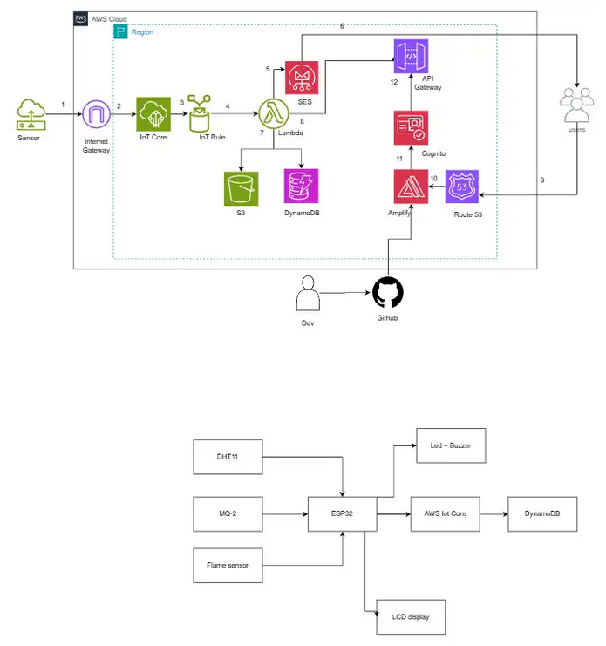

- Hardware: ESP32 development boards, DHT11, MQ series sensors, MKE-S04 IR sensor
- AWS Services: IoT Core, Lambda, DynamoDB, S3, SES, API Gateway, Cognito, Amplify, Route 53, IoT Rules, CloudWatch
- Development Tools: React.js/Vue.js, MQTT client libraries, Chart.js, Material-UI
- Security: TLS 1.3, X.509 certificates, AWS IAM

Technical Plan
The D2F Team will develop firmware using Arduino IDE and ESP-IDF for ESP32 micro-controllers. Infrastructure as Code (IaC) using AWS CloudFormation or Terraform will enable quick and repeatable deployments into AWS accounts. Back-end Lambda functions will be developed in Python/Node.js with comprehensive unit testing coverage. Configuration for AWS IoT Core policies, Cognito user pools, and API Gateway endpoints will follow security best practices with least privilege access. All critical data paths will include extensive testing. Device provisioning follows AWS IoT best practices with secure certificate management.

Project Plan
The D2F Team will adopt an Agile development approach over 12 weeks divided into 3 phases: Foundation (Month 1), Integration (Month 2), and Testing & Deployment (Month 3). Team responsibilities: 2 IC Design Engineers handle hardware/firmware, 2 Software Engineers manage backend/frontend, 1 Security Specialist oversees security implementation and PKI. Weekly sprint reviews will track progress with daily stand-ups for coordination. Communication occurs via university collaboration tools and GitHub for version control. Knowledge transfer sessions will be conducted in Week 11-12 with comprehensive technical documentation.

Security Considerations
- Access: AWS Cognito for user authentication, MFA enabled, IAM roles with least privilege, certificate-based device authentication
- Infrastructure: VPC security groups, private subnets where applicable, TLS 1.3 for all communications
- Data: Encryption at rest (DynamoDB, S3), encryption in transit (MQTT over TLS), secure key storage in AWS Secrets Manager
- Detection: AWS CloudTrail for activity logging, CloudWatch for monitoring, IoT Device Defender for anomaly detection
- Incident Management: Automated alerts via SES, CloudWatch alarms for threshold violations, comprehensive logging for forensics

Activities AND Deliverables

Activities and deliverables

Project Phase | Timeline | Activities | Deliverables/Milestones | Total man-day
Assessment and Planning | Week 1-2 | System architecture design, AWS setup, development environment preparation, team training | Architecture documentation, AWS account configured, development tools ready | 20 man-days
Core Development | Week 3-4 | Hardware schematic design, component sourcing, firmware development, back-end API design, database schema | Hardware design complete, basic firmware, Lambda functions, database schema | 30 man-day
Hardware-Software Integration | Week 5-6 | Component assembly, device-to-cloud communication, real-time pipeline, authentication setup | Functional hardware prototypes, working IoT connectivity, user authentication | 25 man-days
Frontend Development | Week 7-8 | Dashboard UI/UX design, frontend development, mobile responsive implementation | Responsive web dashboard, real-time monitoring interface | 25 man-days
System Integration Testing | Week 9-10 | End-to-end testing, performance optimization, load testing, UAT, bug fixes | Tested system, performance benchmarks, bug fixes completed | 20 man-days
Production Preparation | Week 11-12 | Documentation completion, production deployment, monitoring setup, final validation, presentation | Complete documentation, deployed system, project presentation | 15 man-days

OUT OF SCOPE
- Integration with third-party smart home platforms (Google Home, Alexa)
- Advanced machine learning models for predictive analytics
- Mobile native applications (iOS/Android) - only PWA included
- Multi-language support - English only
- Commercial-scale deployment beyond smart home prototype
- Integration with existing home automation systems

PATH TO PRODUCTION
This prototype will be built with targeted use-cases for smart home monitoring (3 sensor nodes). It demonstrates core functionality including sensor data collection, cloud processing, and dashboard visualization. For full production deployment, additional features are recommended: (1) Enhanced error handling and edge cases, (2) Comprehensive automated testing suites, (3) Disaster recovery procedures, (4) Multi-region deployment for high availability, (5) Advanced analytics and ML integration, (6) Native mobile applications, (7) Third-party platform integrations. The current $100 budget covers proof-of-concept; production scaling would require additional investment in infrastructure, testing, and operational excellence features.

EXPECTED AWS COST BREAKDOWN BY SERVICES
[Include a link to the AWS monthly calculator pricing created specifically for this project. Pricing should include all AWS Services like EC2, S3, EBS and others expected to be deployed based on the architecture listed above in this document
[Calculator Data should take RI and on-demand EC2 instances into considerations wherever applicable]
[In addition, include tooling cost also to the migration cost of the project]
[Call out assumptions made to create cost estimation]

TEAM
Partner Executive Sponsor
Name | Title | Description | Email / Contact Info
Trần Quang Huy | Project Manager & Security Lead | Overall project accountability, security implementation, team coordination | huytqse182122@fpt.edu.vn
Project Stakeholders
Name | Title | Stakeholder for | Email / Contact Info
Ivan Doctorow Sr. Manager, QA IT – Testing / QA
Jane Smith Director, PMO Program Management Office
Dan Jacobs VP, IT Operations IT Operations – Networking
Partner Project Team
Name | Title | Role | Email / Contact Info
Trần Quang Huy | Project Manager & Security Lead | Overall project accountability, security implementation, team coordination | huytqse182122@fpt.edu.vn
Phan Tấn Hải | IC Design engineer | Firmware development, sensor programming | haiptse180327@fpt.edu.vn
Nguyễn Phúc Đạt | IC Design engineer | Hardware schematic design, component integration | datnpse182125@fpt.edu.vn
Lê Nguyễn Hoàng Anh | Software engineer | Frontend dashboard, UI/UX | anhlnhse184416@fpt.edu.vn
Trần Khải Hoàng | Software engineer | Backend API, AWS infrastructure | HoangTKSE182767@fpt.edu.vn
Project Escalation Contacts
Name | Title | Role | Email / Contact Info
Trần Quang Huy | Project Manager & Security Lead | Primary escalation contact | huytqse182122@fpt.edu.vn

resources & cost estimates

Resource | Responsibility | Rate (USD) / Hour
Solution Architects [2 IC Design Engineers] | Hardware/Firmware design and implementation | Student project (no hourly rate)
Engineers [2 Software Engineers + 1 Security] | Backend, Frontend, Security implementation | Student project (no hourly rate)

Project Phase | Solution Architects | Engineers | Other  (Please specify) | Total Hours
Assessment & Planning | 40 hours | 40 hours | - | 80 hours
Core Development | 80 hours | 80 hours | - | 160 hours
Hardware-Software Integration | 60 hours | 60 hours | - | 120 hours
Frontend Development | 20 hours | 100 hours | - | 120 hours
System Testing | 40 hours | 60 hours | - | 100 hours
Production Preparation | 30 hours | 30 hours | - | 60 hours
Total Hours | 270 hours | 370 hours | - | 640 hours
Total Cost | $0 | $0 | - | $100

Explanation:
Labor Cost: $0
- This is a student academic project (not commercial)
- All team members contribute labor as part of their university coursework
- No hourly rates apply - work is contributed for academic credit
Total Project Cost: $100
This represents the out-of-pocket expenses allocated as follows:
- AWS Services (3 months): ~$50 (estimated $15-17/month)
- Hardware Components: ~$40 (ESP32 boards, sensors)
- Web Development/Hosting: ~$10 (AWS S3/CloudFront)

Cost Contribution distribution between Partner, Customer, AWS:
Contribution (USD) | % Contribution of Total
$100 (budget allocation) | 100%
Infrastructure support | In-kind support
Free tier services | Service credits

Acceptance
Upon completion of each Phase, the IoT Security Team will submit the associated Deliverables for internal review and validation. Each phase includes a 3-day review period where team members evaluate deliverables against acceptance criteria: (1) Hardware functionality meets specifications, (2) Software components pass unit and integration tests, (3) Security requirements are validated, (4) Documentation is complete and accurate, (5) Performance metrics meet defined thresholds (99.9% uptime, <100ms latency).

Final project acceptance occurs at Week 12 with comprehensive demonstration including: live hardware operation, cloud connectivity validation, dashboard functionality, security protocol verification, and complete documentation review. The project will be considered complete when all acceptance criteria are met and the final presentation is delivered to university stakeholders.

