mysql> use tianmao;

Database changed

mysql> create table shoucang(

-> id int primary key auto_increment,

-> name varchar(20) not null,

-> xihuan varchar(1),

-> money varchar(3));

Query OK, 0 rows affected (0.11 sec)

mysql> desc shoucang;

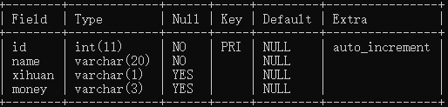

mysql> insert into shoucang(

-> id,name,xihuan,money) values(

-> 1,'snacks',1,100),

-> (2,'dress',1,120),(3,'shoes',1,360);

Query OK, 3 rows affected (0.07 sec)

Records: 3 Duplicates: 0 Warnings: 0

mysql> select * from shoucang;

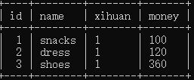

mysql> insert into shoucang(

-> id,name,xihuan,money) values(

-> 4,'clothes',1,666);

Query OK, 1 row affected (0.03 sec)

mysql> select * from shoucang;

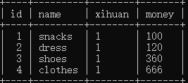

mysql> alter table shoucang add num varchar(2);

Query OK, 0 rows affected (0.09 sec)

Records: 0 Duplicates: 0 Warnings: 0

mysql> select * from shoucang;

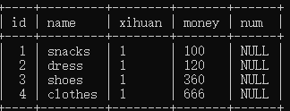

mysql> alter table shoucang drop num;

Query OK, 0 rows affected (0.33 sec)

Records: 0 Duplicates: 0 Warnings: 0

mysql> select * from shoucang;

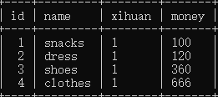

mysql> alter table shoucang add num varchar(2);

Query OK, 0 rows affected (0.09 sec)

Records: 0 Duplicates: 0 Warnings: 0

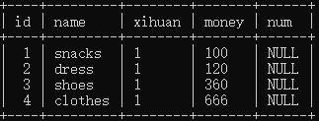

mysql> select * from shoucang;

mysql> delete from shoucang where id=4;

Query OK, 1 row affected (0.03 sec)

mysql> select * from shoucang;

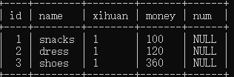

mysql> select * from shoucang where id=2;

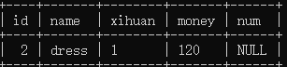

mysql> alter table shoucang add unique(id);

Query OK, 0 rows affected (0.17 sec)

Records: 0 Duplicates: 0 Warnings: 0

mysql> select * from shoucang;

