mysql> create database tianmao;

Query OK, 1 row affected (0.04 sec)

mysql> use tianmao;

Database changed

mysql> create table tianmao(

-> id int(11) primary key not null auto_increment,

-> name varchar(20) not null,

-> num int(3) default 1,

-> money varchar(5));

Query OK, 0 rows affected (0.13 sec)

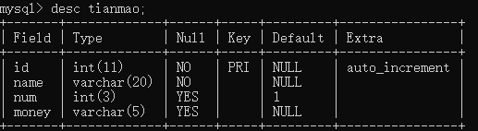4 rows in set (0.00 sec)

mysql> alter table tianmao add xihuan varchar(1);

Query OK, 0 rows affected (0.12 sec)

Records: 0 Duplicates: 0 Warnings: 0

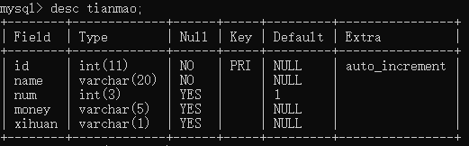5 rows in set (0.00 sec)

mysql> alter table tianmao add zhekoutixing varchar(1);

Query OK, 0 rows affected (0.13 sec)

Records: 0 Duplicates: 0 Warnings: 0

mysql> alter table tianmao add shuangshiyiyuanwang varchar(1);

Query OK, 0 rows affected (0.07 sec)

Records: 0 Duplicates: 0 Warnings: 0

mysql> desc tianmao;

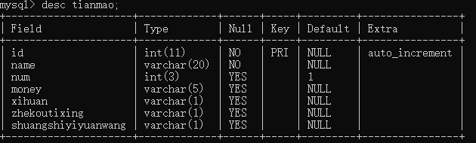7 rows in set (0.00 sec)

mysql> insert into tianmao(

-> id,name,num,money,xihuan,zhekoutixing,shuangshiyiyuanwang) values(

-> 1,'Joker',100,'100.0',1,0,1);

Query OK, 1 row affected (0.02 sec)

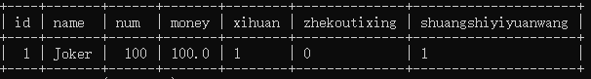1 row in set (0.00 sec)

mysql> insert into tianmao (id,name,num,money,xihuan,zhekoutixing,shuangshiyiyuanwang) values(2,"wang",101,"101.0",0,1,0);

Query OK, 1 row affected (0.09 sec)

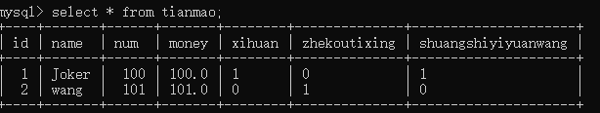2 rows in set (0.00 sec)

mysql> insert into tianmao (id,name,num,money,xihuan,zhekoutixing,shuangshiyiyuanwang) values(2,"wang",222,"123.3",1,1,0),(3,"hann",111,"123.9",1,1,1),(4,"kong",158,"199.9",0,1,1);

ERROR 1062 (23000): Duplicate entry '2' for key 'PRIMARY'

mysql> insert into tianmao (id,name,num,money,xihuan,zhekoutixing,shuangshiyiyuanwang) value(3,"hann",111,"123.9",1,1,1),(4,"kong",158,"199.9",0,1,1);

Query OK, 2 rows affected (0.07 sec)

Records: 2 Duplicates: 0 Warnings: 0

mysql> select * from tianmao;

+----+-------+------+-------+--------+--------------+---------------------+

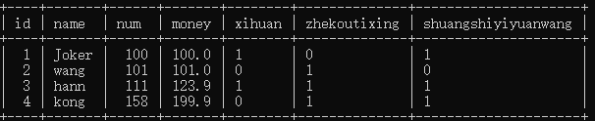4 rows in set (0.00 sec)

mysql> update tianmao set shuangshiyiyuanwang="0" where id=1;

Query OK, 1 row affected (0.04 sec)

Rows matched: 1 Changed: 1 Warnings: 0

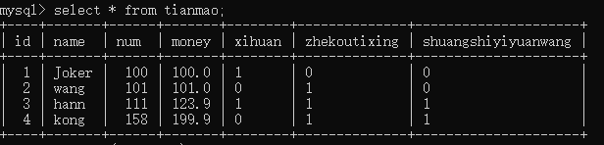4 rows in set (0.00 sec)

mysql> delete from tianmao where id=3;

Query OK, 1 row affected (0.05 sec)

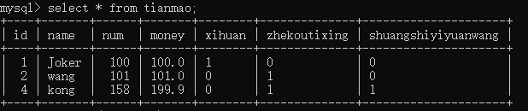3 rows in set (0.00 sec)