mysql> use tianmao;

Database changed

mysql> create table ying(

-> id int(20) auto_increment primary key,

-> name varchar(15) not null,

-> year int(4),

-> director varchar(15) not null,

-> grade int(4));

Query OK, 0 rows affected (0.15 sec)

mysql> desc ying;

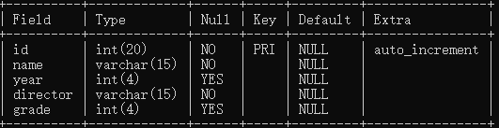

mysql> insert into ying(

-> id,name,year,director,grade) values(

-> 1,'yewen',2016,'ye','6.66'),(2,'huhuhu',2011,'ku','3.33'),(3,'dedede',2018,'fu','8.95');

Query OK, 3 rows affected (0.06 sec)

Records: 3 Duplicates: 0 Warnings: 0

mysql> select * from ying;

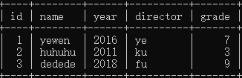

mysql> select director from ying where director like'k%';

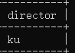

mysql> select name from ying where name like'ye%';

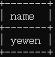

mysql> select name from ying where (year=2011);

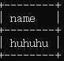

mysql> select max(grade) from ying;

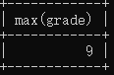

mysql> select name from ying where (grade=9);

