mysql> use tianmao;

Database changed

mysql> create table part(

-> part_id smallint unsigned not null auto_increment,

-> part_name varchar(20) not null,

-> part_mima int not null,

-> primary key(part_id))engine=innodb default charset=utf8;

Query OK, 0 rows affected, 1 warning (0.18 sec)

mysql> create table zhuangbei(

-> zhuangbei_id smallint unsigned not null auto_increment primary key,

-> zhuangbei_name varchar(20) not null,

-> zhuangbei_money int not null,

-> part_id smallint unsigned not null,

-> last_update timestamp not null default current_timestamp on update current_timestamp,

-> key idx_fk_part_id (part_id),

-> constraint fk_zhuangbei_part foreign key(part_id) references part(part_id) on delete restrict on update cascade)engine=innodb default charset=utf8;

Query OK, 0 rows affected, 1 warning (0.21 sec)

mysql> select md5("part_mima");

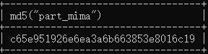

mysql> desc part;

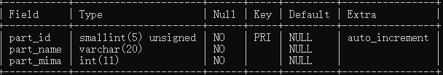

mysql> insert into part(

-> part_name,part_mima) values(

-> 'pp',123456),('tu',456789),('hu',123789);

Query OK, 3 rows affected (0.04 sec)

Records: 3 Duplicates: 0 Warnings: 0

mysql> select * from part;

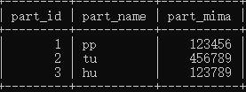

mysql> desc zhuangbei;

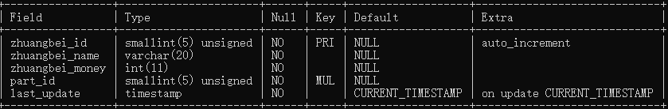

mysql> insert into zhuangbei(

->zhuangbei_name,zhuangbei_money,part_id) values('baobao',20,1),('qiang',30,2),('dun',10,3);

Query OK, 3 rows affected (0.07 sec)

Records: 3 Duplicates: 0 Warnings: 0

mysql> select * from zhuangbei;

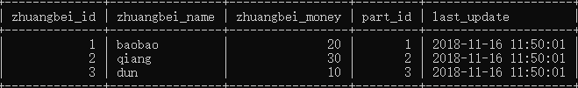

mysql> delete from part where part_id=1;

ERROR 1451 (23000): Cannot delete or update a parent row: a foreign key constraint fails (`tianmao`.`zhuangbei`, CONSTRAINT `fk_zhuangbei_part` FOREIGN KEY (`part_id`) REFERENCES `part` (`part_id`) ON UPDATE CASCADE)

mysql> update part set part_id=4 where part_id=3;

Query OK, 1 row affected (0.14 sec)

Rows matched: 1 Changed: 1 Warnings: 0

mysql> select * from part;

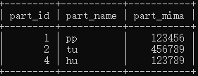

mysql> select * from zhuangbei;

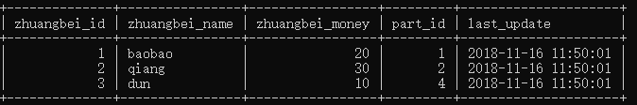

mysql> select * from zhuangbei where zhuangbei.part_id in (select part_id from part);

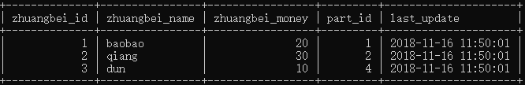

mysql> update zhuangbei set zhuangbei_name='baoabo,hujia' where part_id=1;

Query OK, 1 row affected (0.07 sec)

Rows matched: 1 Changed: 1 Warnings: 0

mysql> select * from zhuangbei;

