use tianmao;

create or replace view view_p_p(part_name,zhuangbei_money) as

select part.part_name,zhuangbei.zhuangbei_money from part,zhuangbei;

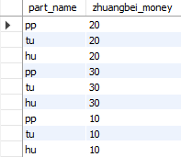

mysql> update view_p_p set zhuangbei_money=25;

Query OK, 3 rows affected (0.08 sec)

Rows matched: 3 Changed: 3 Warnings: 0

mysql> select * from view_p_p;

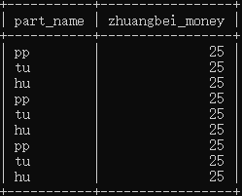

use tianmao;

create or replace view view_m_m(zhuangbei_money,count_zhuangbei_money) as

select zhuangbei_money,count(zhuangbei_money) from zhuangbei group by zhuangbei_money;

